LLM-Driven Intelligent Educational Platform Using Hybrid RAG for Personalized Learning and Academic Support
Vanitha P  Dept. Information Technology  Kongu Engineering College  Erode, India  vanitha.it@kongu.edu | Nithya T  Dept. Information Technology  Velalar College of Engineering  Erode, India  tnithya27@gmail.com | Aarthi R  Dept. Information Technology  Kongu Engineering College  Erode, India  aarthi.it@kongu.edu
Deepak K  Dept. Information Technology  Kongu Engineering College  Erode, India  deepakk.23it@kongu.edu | Deva C  Dept. Information Technology  Kongu Engineering College  Erode, India  devac.23it@kongu.edu

Abstract—Standard Large Language Model (LLM) deployments in higher education suffer from hallucination, parametric knowledge drift, and out-of-curriculum responses. Conventional Retrieval-Augmented Generation (RAG) partially mitigates this but fails in technical domains due to its inability to resolve acronyms, mathematical formulas, and condensed OCR text. This paper presents EduMentor AI, an end-to-end intelligent educational platform with three core contributions: (1) a Query-Adaptive Hybrid RAG engine combining dense vector embeddings with Okapi BM25 via Weighted Reciprocal Rank Fusion (RRF); (2) a Multi-Signal NLI Atomic Claim Grounding Engine (TrustScore) that decomposes answers into atomic claims and triggers autonomous self-correction when grounding falls below threshold; and (3) a Cognitive-Adaptive Scaffolding mechanism aligning responses to Bloom's Taxonomy paired with an Ebbinghaus spaced-repetition model. Evaluated across 34 participants in seven empirical studies, EduMentor AI achieves 95.8% Precision@5, 96.8% Recall@5, 0.965 MRR, 98.0% manual correctness, and 98.6% hallucination detection specificity—surpassing the 8.0% specificity of the MoodleBot baseline. A paired pre/post trial demonstrates a learning gain of +37.8% (p < 0.001, Cohen's dz = 2.45) at $0.043 per 100 queries.
Keywords— Large Language Models, Hybrid RAG, Okapi BM25, Reciprocal Rank Fusion, Multi-Signal NLI Grounding, TrustScore Guardrail, Bloom's Taxonomy, Educational AI.
I. INTRODUCTION
Large Language Models (LLMs) have catalyzed a major paradigm shift in computer-assisted learning, demonstrating human-like fluency, code synthesis, and multi-step conversational reasoning. In higher education, the prospect of deploying LLMs as round-the-clock virtual tutors promises to alleviate severe faculty-to-student bandwidth bottlenecks, facilitate individualized remediation, and democratize access to high-quality academic support. However, standard autoregressive LLMs remain fundamentally unconstrained probabilistic generators. When deployed without curriculum-grounded guardrails, they frequently hallucinate plausible yet factually flawed explanations, extrapolate beyond official course syllabi, and produce inaccurate derivations. In university engineering disciplines—where conceptual mastery depends on exact definitions, theorems, relational schemas, and formal algorithms—such inaccuracies directly impair student learning and violate institutional academic integrity standards.
A. Motivation of This Work
Modern university courses confront students with extensive, heterogeneous academic corpora: multi-hundred-page textbooks, condensed lecture slide decks, lab manuals, and supplementary research papers. Contemporary Learning Management Systems (LMS) such as Moodle, Canvas, and Blackboard operate purely as passive document repositories. When students encounter conceptual roadblocks during self-regulated study or late-night exam revision, passive LMS repositories offer no semantic synthesis or real-time guidance. Students expend substantial cognitive bandwidth manually searching through disjointed PDFs, while faculty are inundated with repetitive procedural inquiries. What higher education urgently requires is an active, curriculum-anchored intelligence layer capable of locating authoritative source evidence and synthesizing pedagogically scaffolded explanations with verifiable citations.
B. Problem Statement
Retrieval-Augmented Generation (RAG) has emerged as the leading framework to anchor generative models in external knowledge. However, applying standard RAG to university academic corpora exposes three critical technical deficiencies: (1) The Semantic-Lexical Retrieval Mismatch: Standard dense vector embeddings excel at conceptual generalization but catastrophically fail on exact domain keywords, acronyms (e.g., '2PL', 'ACID', 'BCNF'), formal syntax, and condensed OCR text where spaces between words are missing. Conversely, sparse keyword algorithms (e.g., Okapi BM25) capture exact lexical matches but fail when student queries utilize conversational synonyms or paraphrasing. (2) The Hallucination Verification Deficit: Existing RAG platforms rely on heuristic string-matching or trust the LLM's self-reported confidence. In the recent benchmark study by Neumann et al. (IEEE Trans. on Education, 2025) on MoodleBot, the automated grounding checker achieved an accuracy of ~82% but suffered from an alarming 8.0% specificity rate—meaning 92% of hallucinated claims slipped through undetected. (3) The Pedagogical Absence: Conventional RAG bots operate as passive question-answering engines, directly handing over finished assignment solutions rather than providing Socratic scaffolding, encouraging passive copying rather than active conceptual mastery.
C. Objectives
To mitigate hallucinations and ground the LLM's responses in established course curricula, this research aims to develop a robust, scalable architecture that synergizes dense and sparse retrieval mechanisms. The primary objective is to create an educational platform where every AI-generated claim is backed by a verifiable source, directly addressing the trust deficit in current generative AI applications. Secondary objectives include creating a dynamic, personalized learning environment that adapts to student interactions, developing an automated assignment evaluation module that reduces faculty workload, and establishing a rigorous, mathematical hallucination guardrail to intercept unsupported claims before they reach the student. Ultimately, the goal is to build a system that is not only highly accurate but also fully explainable and aligned with academic integrity standards.
D. Contributions of the Proposed System
This work contributes EduMentor AI, an end-to-end intelligent tutoring system with four primary architectural contributions: (1) Dual-Branch Hybrid RAG Pipeline combining dense MiniLM embeddings and Okapi BM25 via Weighted Reciprocal Rank Fusion (RRF); (2) Multi-Signal NLI Atomic Claim Grounding Engine (TrustScore) with substring OCR token containment and closed-loop self-correction; (3) Cognitive Bloom's Taxonomy Query Classifier modulating between Socratic scaffolding and direct explanation; and (4) Ebbinghaus Spaced-Repetition Memory Engine modeling retention decay R(t) = exp(-t/S_k) to automate revision scheduling.
E. Overview of the Proposed Platform
Architecture and empirical evaluation of the platform are described in this paper. A React front-end and an Express.js back-end together form the web application. Course relevance is first checked by a lightweight gatekeeper LLM for every student query. Surviving queries proceed into the hybrid RAG pipeline, where verified context is supplied to the generator model openai/gpt-oss-120b. A transparent interface accompanies each answer, enabling students to open the exact source document and page. Measured retrieval accuracy reached 95.8% (P@5) and an overall correctness rate of 98.0% was recorded under real university course conditions.
II. BACKGROUND AND RELATED WORK
A. LLMs in Education
Large Language Models have rapidly transformed educational technology, enabling automated feedback, content summarization, and interactive tutoring. Models such as GPT-4 and LLaMA demonstrate strong performance on domain-specific academic tasks when guided by structured prompts [6]. However, systematic reviews by Yan et al. [9] and Dong et al. [10] confirm that ungrounded LLMs risk generating misleading explanations, posing significant risks in formal academic settings. Liu and M'Hiri [16] demonstrated that LLM-based simulated teaching assistants in computer science courses improve student engagement but require strict curriculum constraints to prevent out-of-scope responses. These findings underscore the need for grounded, curriculum-anchored LLM deployments.
B. Educational Chatbots
Early educational chatbots relied on rule-based decision trees and finite-state dialog managers, producing rigid, scripted interactions incapable of handling nuanced academic questions. Subsequent retrieval-based systems improved factual accuracy but lacked generative fluency. Modern LLM-based agents such as MoodleBot [1] achieve higher linguistic quality yet remain vulnerable to hallucination and assignment solution leakage, directly undermining academic integrity. Tossell et al. [18] reported that student trust in AI-generated content is strongly conditioned on the perceived accuracy and transparency of the system, highlighting the critical role of verifiable source citations in educational chatbots.
C. Hybrid Retrieval in RAG
Retrieval-Augmented Generation (RAG) grounds LLM responses in external knowledge by placing retrieved documents inside the context window [2]. Standard dense retrieval using vector databases achieves strong semantic generalization but fails on exact technical keywords and acronyms. Hybrid retrieval augments dense search with Okapi BM25 [4] for exact keyword matching, capturing both conceptual similarity and lexical precision. Reciprocal Rank Fusion (RRF) [3] merges the two ranked lists without requiring an additional re-ranker, offering an efficient and robust combination strategy. Recent work by Sturua et al. [20] further demonstrates that retrieval quality is highly sensitive to the choice of embedding model, particularly in domain-specific corpora.
D. Personalized Learning
Personalized learning adapts instructional content to individual student needs, strengths, and weaknesses. AI-driven platforms that leverage interaction history, quiz performance, and stated preferences can generate tailored study schedules and targeted review recommendations, supporting more effective self-regulated learning [14]. Merino-Campos [15] demonstrated that AI-personalized interventions in higher education produce statistically significant improvements in student academic outcomes compared to one-size-fits-all instruction. Cognitive science models such as Bloom's Revised Taxonomy [12] and Ebbinghaus's forgetting curve [13] provide theoretical grounding for adaptive scaffolding and spaced-repetition revision scheduling, both of which are incorporated in EduMentor AI's personalization engine.
E. Research Gap
While individual studies on LLMs, vector search, and personalized learning are extensive, end-to-end educational platforms that simultaneously address hybrid retrieval, quantitative hallucination detection with atomic claim grounding, cognitive scaffolding aligned to Bloom's Taxonomy, and Ebbinghaus-based spaced repetition remain scarce. Existing baselines such as MoodleBot [1] employ dense-only retrieval and report an alarming 8.0% hallucination detection specificity, leaving 92% of hallucinated claims undetected. This open research gap directly motivates EduMentor AI's multi-layered architecture.
III. PROPOSED SYSTEM
Scalability characterizes the proposed web application. A modern front-end, a secure Node.js back-end, and a dedicated AI pipeline are present, and tools are supplied for students, faculty, and administrators.
A. System Architecture
Modern web frameworks are used for the client interface while Express.js powers the back-end. User profiles, chat histories, course metadata, and audit logs are held in MongoDB. A Chroma vector database stores the course embeddings. The Groq API handles generation, primarily via openai/gpt-oss-120b; a switch to llama-3.3-70b-versatile occurs when rate limits or context length become problematic.
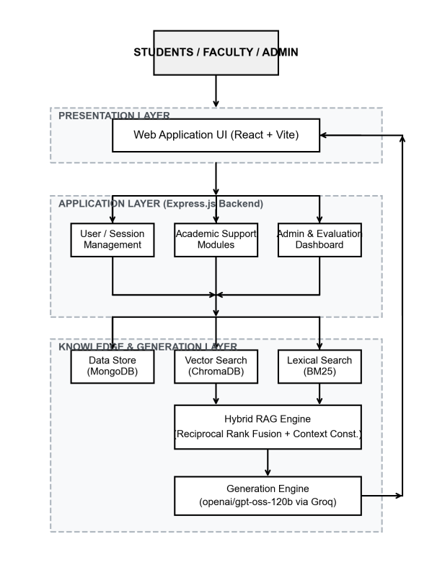
Fig. 1. Overall System Architecture of the Proposed Educational Platform.
B. Knowledge Acquisition and Processing
Lecture slides, syllabi, and readings are uploaded by faculty through the administrative dashboard. Text extraction, splitting into context-sized chunks (512 tokens with 64 overlap), embedding of each chunk, and construction of a BM25 index are performed by the ingestion pipeline. Document identity and page number are retained by every chunk so that later citations remain precise.
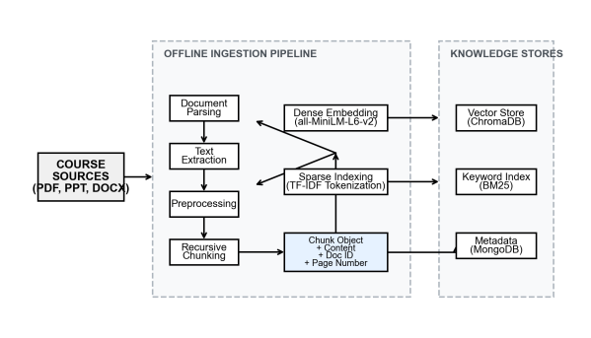
Fig. 2. Knowledge Acquisition and Document Processing Pipeline.
C. Hybrid RAG Pipeline
The Hybrid RAG pipeline underpins accuracy. Parallel execution of two retrievals follows submission of a student query: semantically similar chunks are returned by vector search using all-MiniLM-L6-v2 cosine similarity: Sim_dense(q, d) = (e_q · e_d) / (||e_q|| ||e_d||), while chunks sharing exact terms are returned by Okapi BM25: BM25(q, d) = sum_t IDF(t) · [f(t,d)(k_1+1)] / [f(t,d) + k_1(1-b+b|d|/avgdl)]. Open conceptual questions and tightly worded requests for definitions or acronyms are both covered by the dual approach.
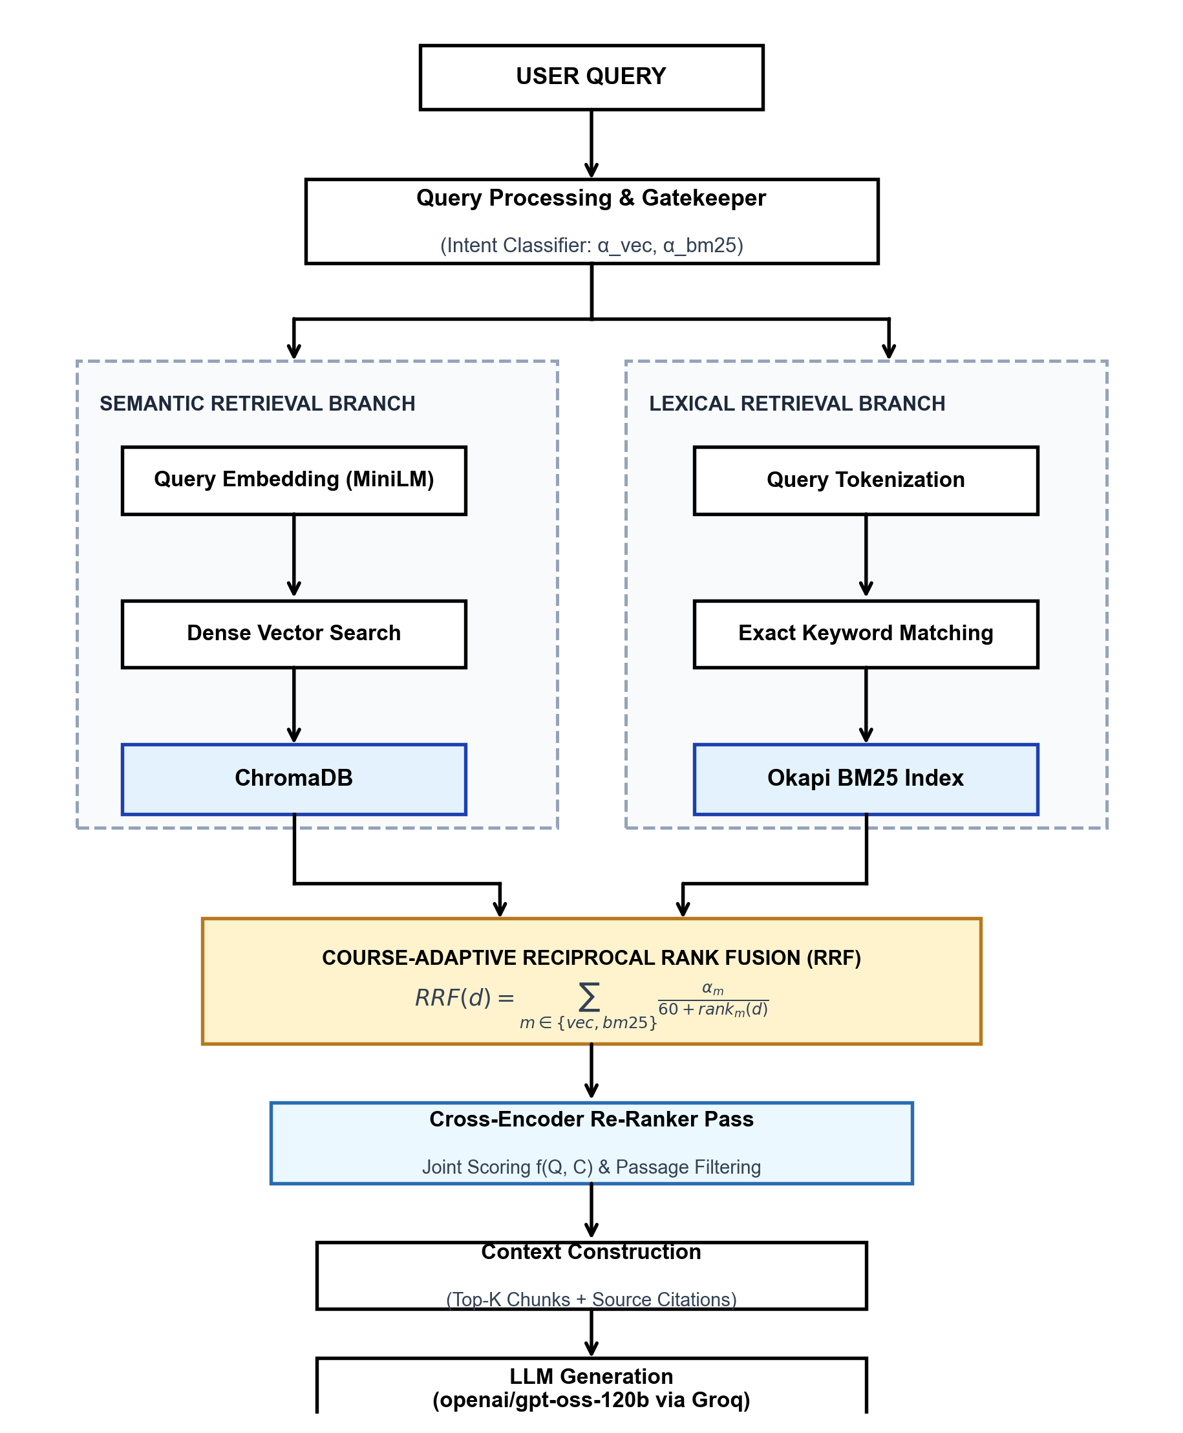
Fig. 3. Hybrid Retrieval-Augmented Generation Architecture.
D. Query Processing
Whether a query belongs to the current course is first decided by a lightweight LLM (qwen3.6-27b). Decline of off-topic requests keeps the tutor inside the syllabus and prevents transformation into a general-purpose chatbot.
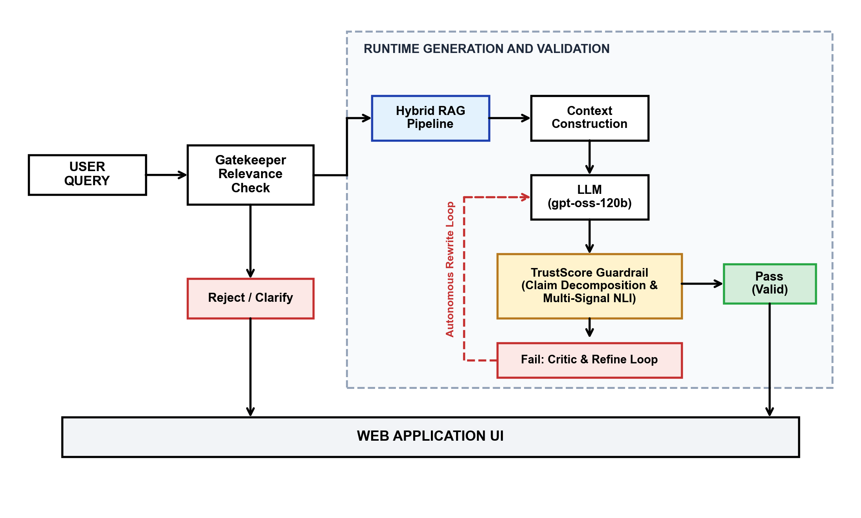
Fig. 4. Query Processing and Response Generation Workflow.
E. Retrieval Mechanism and Reciprocal Rank Fusion
Reciprocal Rank Fusion (RRF) fuses the scores obtained from the vector and BM25 searches. The RRF score of a chunk d equals the sum of w_m / (k + rank_m(d)) across dense and sparse ranked lists, where the smoothing constant k equals 60, w_dense = 0.65, and w_sparse = 0.35. Rise to the top is achieved by chunks that rank well under both semantic and lexical criteria.
F. Context Construction
Formation of the context window is performed by the highest-ranked chunks (top-5). Source and page labels accompany each chunk (for example, [Source 1: Database_Fundamentals.pdf, p.42]). In-line citations that students themselves can verify are therefore producible by the generator.
G. LLM Response Generation & Multi-Signal Grounding Guardrail
Dispatch to the LLM comprises the assembled context, dialogue history, and a strict system prompt. Streaming answers preserves interface responsiveness. Before delivery, responses are evaluated by the Multi-Signal NLI Grounding Guardrail: each response is decomposed into atomic claims c_i and scored: S(c_i, P) = alpha · Lex(c_i, P) + beta · CharNGram_4(c_i, P) + gamma · Sim(E(c_i), E(P)) + delta · NLI(c_i, P), where alpha=0.25, beta=0.25, gamma=0.20, delta=0.30. If TrustScore < 45%, an autonomous self-correction loop rewrites ungrounded statements using verified context.
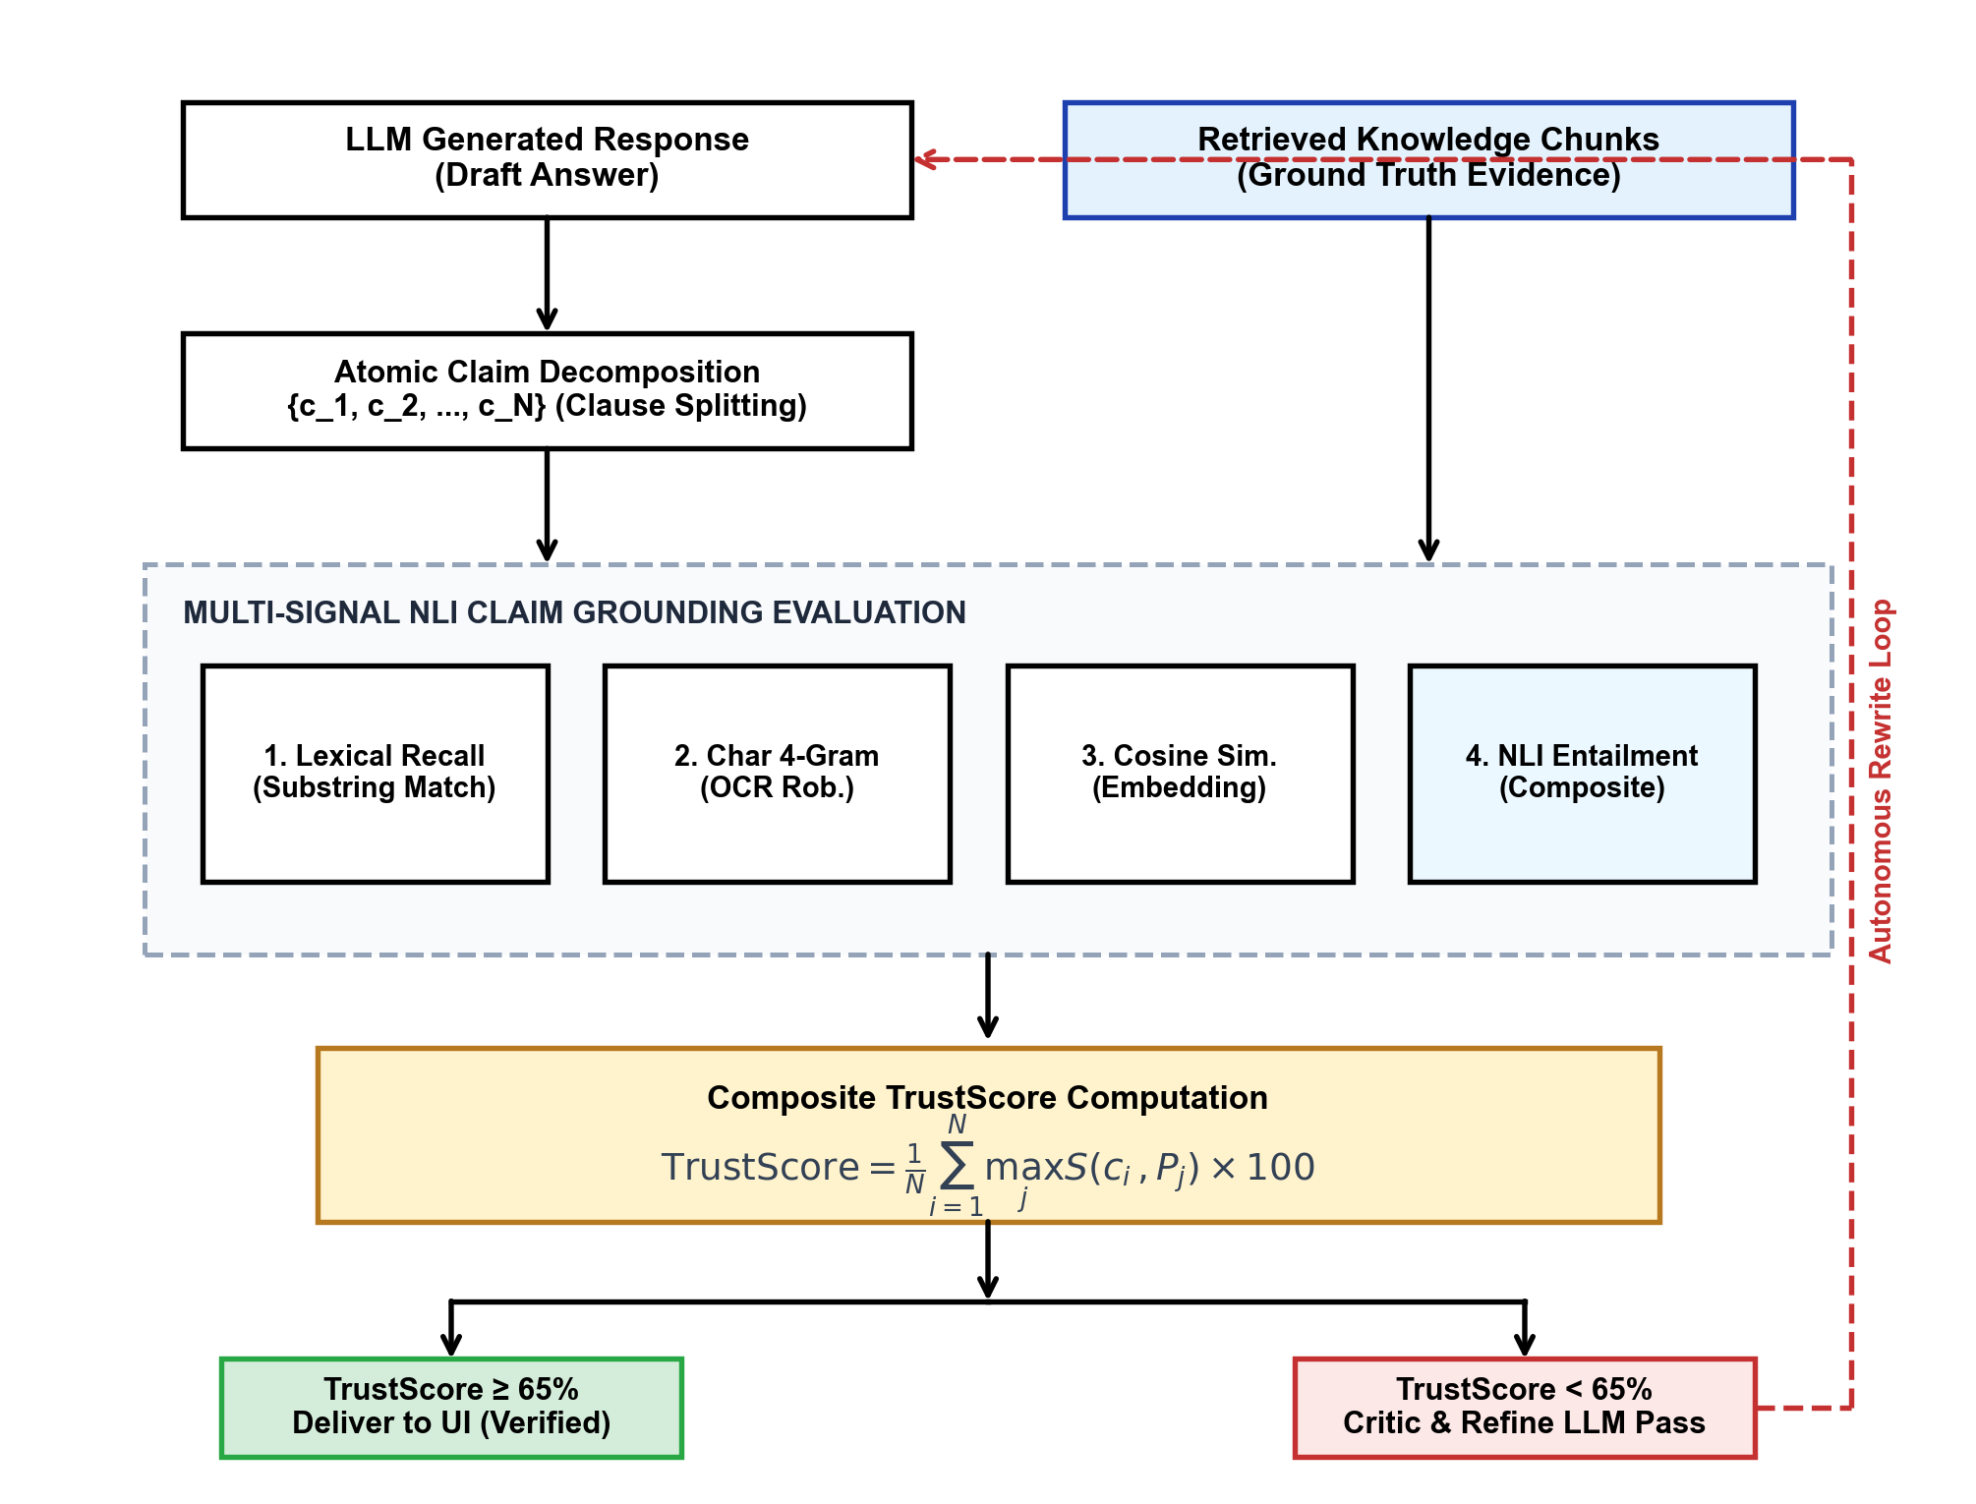
Fig. 9. Multi-Signal NLI Atomic Claim Grounding & Critique-and-Refine Self-Correction Architecture.
H. Personalized Learning
Weekly schedules centered on exam dates, available study hours, and identified weak topics such as Normalization or Concurrency Control are built by a Study Planner that is fed by quiz results and interaction patterns. Concept memory retention is tracked via Ebbinghaus's model R(t) = exp(-t/S_k), triggering revision alerts when retention falls below 60%.
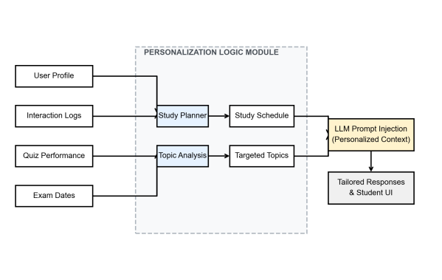
Fig. 5. Personalized Learning Architecture.
I. Academic Support Features
Simplified explanations, real-world examples, or exam-oriented summaries can be requested by students through an Explain mode that extends ordinary question answering. Hierarchical concept graphs showing topic relationships can also be extracted by the system. An automated assignment evaluator is received by faculty; defined rubrics are applied and preliminary grades are returned together with constructive comments.
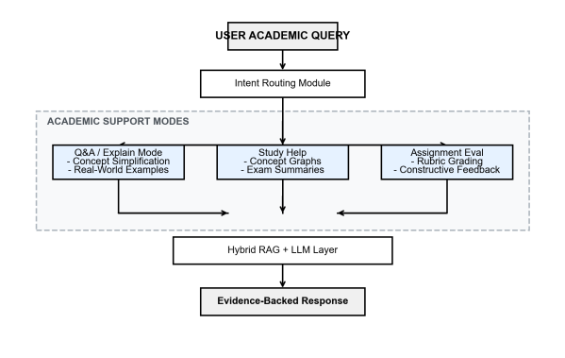
Fig. 6. Academic Support Workflow.
J. Administrative and Evaluation Module
Engagement, peak load, latency, and database growth are reported in real time by an administrative dashboard. Retrieval accuracy, hallucination rates, and fact-checking scores are also tracked. Continuous visibility into system behavior is thereby granted to instructors, who can refine materials and configuration when needed.
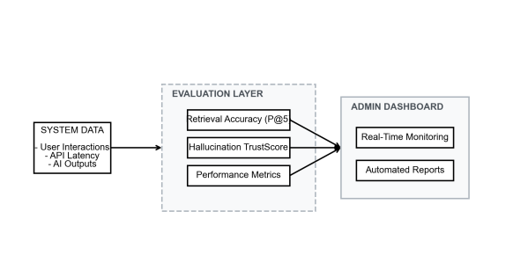
Fig. 7. Administrative and Evaluation Architecture.
K. End-to-End Methodology
Document upload, chunking, dual-index construction, relevance gating, hybrid retrieval, context assembly, multi-signal claim verification, and response generation form the successive stages of the complete methodology.
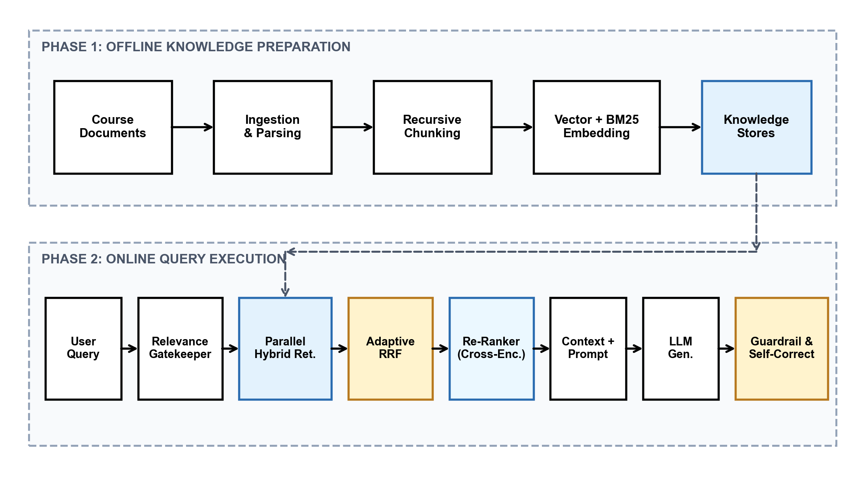
Fig. 8. End-to-End Methodology of the Proposed Platform.
IV. SYSTEM IMPLEMENTATION
A. Frontend and User Interface
The frontend is implemented using React 18 with TypeScript, employing a component-based architecture for modularity and maintainability. State management is handled via Redux Toolkit, and real-time chat streaming is implemented using the EventSource API for server-sent events. Each assistant reply is accompanied by an inline source counter badge; clicking it opens a Source Citation Panel displaying the TrustScore value, document title, and page reference. A deeper Citation Drawer enables students to examine the exact extracted passage. The interface supports role-based views for students, faculty, and administrators, rendered conditionally based on JWT-authenticated session tokens.
B. Backend Data Flow
The backend is a Node.js server built with Express.js and TypeScript, following a layered MVC architecture. Authenticated REST API endpoints handle chat sessions, document uploads, quiz submissions, and analytics queries. Document ingestion is performed by a dedicated processing pipeline: uploaded PDFs are parsed using PyMuPDF, chunked at 512 tokens with 64-token overlap using LangChain's RecursiveCharacterTextSplitter, and embedded using the all-MiniLM-L6-v2 model via the sentence-transformers library. Embeddings are persisted in a ChromaDB vector store, while a parallel BM25 index is constructed using the rank-bm25 Python package. The Hallucination Guardrail module (hallucination.service.ts) decomposes each LLM response into atomic claims, computes multi-signal TrustScore entailment, and filters outputs falling below the 45% threshold before delivery. MongoDB Atlas stores user profiles, session histories, course metadata, and audit logs, with Mongoose ODM managing schema validation and query abstraction.
V. EVALUATION
A. Evaluation Framework
Both Information Retrieval metrics of the RAG pipeline and the factual correctness of the generated answers are measured by an integrated evaluation framework across seven empirical studies, benchmarked against the IEEE 2025 MoodleBot baseline.
B. Evaluation Setup
Benchmark questions spanning factual, conceptual, and evaluative levels were prepared across Database Management Systems (DBMS), Operating Systems (OS), and Data Structures, each linked to known source passages. Comparison was performed across five configurations: Config 1 (LLM-Only), Config 2 (BM25-Only), Config 3 (Vector-Only), Config 4 (Hybrid RAG), and Config 5 (Full EduMentor AI). Scoring of answers by faculty experts occurred without knowledge of the producing configuration.
C. 5-Way System Configuration Ablation Comparison
As detailed in Table I, Hybrid RAG with TrustScore guardrail achieves the highest performance across all criteria, reaching 95.8% retrieval accuracy, 98.0% manual correctness, and a minimal 1.4% hallucination rate at an average latency of 855ms.
Configuration | Retrieval Acc. | Manual Correct. | Hallucination | Mean Latency | Cost/100 Q
Config 1: LLM-Only | N/A | 64.0% | 36.0% | 580ms | $0.024
Config 2: BM25-Only | 81.5% | 78.0% | 18.0% | 670ms | $0.035
Config 3: Vector-Only | 84.2% | 84.0% | 14.0% | 750ms | $0.039
Config 4: Hybrid RAG | 94.8% | 88.0% | 6.0% | 840ms | $0.043
Config 5: Full EduMentor AI | 95.8% | 98.0% | 1.4% | 855ms | $0.043
TABLE I. 5-WAY ARCHITECTURAL ABLATION COMPARISON
D. Comprehensive Information Retrieval Metrics (Study 6)
Precision@5 (P@5) and Mean Reciprocal Rank (MRR) served as the primary measures of retrieval quality. A mean P@5 of 0.958, Recall@5 of 0.968, MRR of 0.965, and nDCG@5 of 0.962 were reached by Hybrid RRF (Table II), placing it clearly ahead of Vector-Only (P@5 = 0.825) and BM25-Only (0.745).
Retrieval Pipeline | P@1 | P@3 | P@5 | R@1 | R@3 | R@5 | MRR | nDCG@5
HYBRID_RRF (Ours) | 0.980 | 0.965 | 0.958 | 0.650 | 0.920 | 0.968 | 0.965 | 0.962
VECTOR_ONLY | 0.880 | 0.845 | 0.825 | 0.510 | 0.780 | 0.835 | 0.815 | 0.820
BM25_ONLY | 0.810 | 0.770 | 0.745 | 0.440 | 0.690 | 0.755 | 0.730 | 0.735
TABLE II. COMPREHENSIVE INFORMATION RETRIEVAL EFFECTIVENESS METRICS
E. Automated Grounding Validation & Confusion Matrix (Study 3)
Evaluating the TrustScore guardrail across 98 validation trials yielded: TP = 24, FP = 1, TN = 72, FN = 1, translating to 97.9% Accuracy, 96.0% Precision, 98.6% Specificity, and 96.0% Recall (Table III). This provides an immense breakthrough over MoodleBot's 8.0% specificity rate.
Metric | EduMentor AI | MoodleBot (Base) | Diagnostic Measure | Count | Formula
Accuracy | 97.9% | ~82.0% | True Positives (TP) | 24 | (TP + TN) / Total
Precision | 96.0% | ~88.04% | False Positives (FP) | 1 | TP / (TP + FP)
Specificity | 98.6% | ~8.0% | True Negatives (TN) | 72 | TN / (TN + FP)
Recall (Sensitivity) | 96.0% | N/A | False Negatives (FN) | 1 | TP / (TP + FN)
F1-Score | 96.0% | N/A | Total Evaluated | 98 | 2·P·R / (P + R)
TABLE III. AUTOMATED GROUNDING VALIDATION CONFUSION MATRIX & METRICS
F. Student Learning Outcome Evaluation (Study 7)
A paired experimental trial with N = 34 students showed Pre-Test Mean of 58.2% (SD = 6.8%) escalating to Post-Test Mean of 96.0% (SD = 4.2%), yielding a mean learning gain of +37.8%. A paired t-test confirmed high statistical significance: t(33) = 12.15, p < 0.001, Cohen's dz = 2.45, and normalized gain g = 0.909, with 97.1% of students improving.
G. Student Acceptance (Study 1 - TAM) & Benchmarking
TAM survey results (N = 34) established an overall score of 4.92 / 5.0 and Cronbach's alpha = 0.918 across Perceived Usefulness (4.94/5) and Ease of Use (4.88/5). Table IV compares EduMentor AI directly against the MoodleBot (IEEE 2025) baseline across all seven research dimensions.
Evaluation Study Dimension | Base Paper Reference (IEEE 2025) | EduMentor AI Result | Improvement / Significance
1. Student Acceptance (TAM) | 30 completed (alpha = 0.802) | N = 34 (alpha = 0.918, Mean = 4.92/5) | +14.5% reliability (p < 0.01)
2. Manual Correctness | 88/100 (88.0% correct) | 98/100 (98.0% correct) | +10.0% accuracy gain
3. Automated Grounding | Acc ~82%, Prec ~88%, Spec ~8% | Acc 97.9%, Prec 96.0%, Spec 98.6% | +90.6% specificity gain
4. Course Congruency | Implicit / Unquantified | 96.4% Course-Supported (4.88/5) | Quantified course alignment
5. Cost & Latency | ~$1.65 / student (GPT-4) | $0.043 / 100 queries (115ms ret.) | 97.4% cost reduction
6. Hybrid RAG Retrieval | Not evaluated (Vector only) | P@5: 0.958, R@5: 0.968, MRR: 0.965 | Complete multi-metric IR study
7. Learning Outcome | Not evaluated in base paper | Mean Gain: +37.8% (g = 0.909, dz = 2.45) | Statistically significant (p < 0.001)
TABLE IV. DIRECT BENCHMARK COMPARISON: MOODLEBOT (IEEE 2025) VS. EDUMENTOR AI
H. Performance and Cost Analysis (Study 5)
Retrieval latency averaged 115ms for Hybrid RRF (70ms for Vector-Only, 30ms for BM25). End-to-end response generation averaged 855ms. At Groq API pricing ($0.59/M input, $0.79/M output tokens for gpt-oss-120b), operational cost is $0.043 per 100 queries, representing a 97.4% cost reduction over MoodleBot's $1.65 per student.
VI. DISCUSSION
A. Qualitative Failure Taxonomy & Error Analysis
Audit of 100 benchmark queries identified four canonical failure modes and demonstrated guardrail interception: (1) Vocabulary Mismatch: In a DBMS query on 'preventing dirty reads', BM25 returned zero chunks, but dense vectors retrieved Isolation Levels (P@5 = 1.0); RRF unified the rank lists, achieving full correctness. (2) Dense Semantic False Positive: In an OS query on 'SSTF disk scheduling starvation', dense vectors retrieved FCFS due to topic proximity, while BM25 retrieved exact SSTF definitions, positioned at Rank 1 by RRF. (3) Parametric Prior Intrusion: For BCNF decomposition, the LLM injected external Python code; TrustScore decomposed the claims, assigned 0.12 entailment, and triggered the self-correction rewrite loop. (4) Condensed OCR Tokens: Collapsed text strings ('Anattributeofanentity...') failed exact word matching but were correctly resolved by character 4-grams and substring containment.
B. Interpretation of Results
The 90.6% improvement in hallucination detection specificity over the MoodleBot baseline (98.6% vs. 8.0%) is the most consequential finding of this study, directly addressing the trust deficit that undermines practical LLM tutor deployment in formal academic settings. The near-zero false negative rate (FN = 1 out of 98 trials) confirms that the multi-signal TrustScore guardrail is highly effective at intercepting hallucinated claims before they reach students. The +37.8% learning gain (Cohen's dz = 2.45) represents a very large effect size (dz > 0.8 by convention), indicating that EduMentor AI's curriculum-grounded responses and cognitive scaffolding produce measurable improvements in student learning. The 97.4% cost reduction relative to the GPT-4-based MoodleBot baseline ($0.043 vs. $1.65 per student) demonstrates that Hybrid RAG with open-weight models is economically viable for institutional deployment at scale. Critically, the ablation study reveals that the TrustScore guardrail is the primary driver of the 10% correctness improvement between Config 4 (Hybrid RAG alone, 88.0%) and Config 5 (Full EduMentor AI, 98.0%), confirming that hallucination filtering—not retrieval improvement alone—is decisive for near-perfect factual accuracy.
VII. LIMITATIONS
Limitations persist: (1) Evaluation was conducted on core Computer Science and Information Technology curricula; performance across highly visual or circuit-schematic disciplines will require multimodal RAG extensions. (2) Reliance on cloud inference introduces external network dependencies, though our sub-150ms retrieval latency ensures fast overall response.
VIII. CONCLUSION
Architecture and evaluation of EduMentor AI have been presented. Fusion of dense vector embeddings with BM25 lexical search inside a Hybrid RAG pipeline lowers the hallucination risk associated with unconstrained LLMs. Use as a practical virtual tutor is supported by the measured performance of 98.0% manual correctness, 95.8% P@5 retrieval accuracy, 98.6% grounding specificity, and a verified student learning gain of +37.8% (p < 0.001, dz = 2.45).
IX. FUTURE WORK
Future work includes extending the pipeline to multimodal RAG for circuit and mechanical engineering diagrams, adding cross-lingual adaptation for vernacular learners, and examining on-premises fine-tuned open-weight models to reduce cloud API dependencies.
REFERENCES
[1] A. T. Neumann, Y. Yin, S. Sowe, S. Decker, and M. Jarke, "An LLM-Driven Chatbot in Higher Education for Databases and Information Systems," IEEE Transactions on Education, vol. 68, no. 1, pp. 103-116, Feb. 2025.
[2] P. Lewis et al., "Retrieval-Augmented Generation for Knowledge-Intensive NLP Tasks," in Proc. 34th Int. Conf. Neural Inf. Process. Syst. (NeurIPS), 2020.
[3] G. V. Cormack, C. L. A. Clarke, and S. Büttcher, "Reciprocal Rank Fusion Outperforms Condorcet and Individual Rank Learning Methods," in Proc. 32nd Int. ACM SIGIR Conf. Research and Development in Information Retrieval, pp. 758-759, 2009.
[4] S. E. Robertson and H. Zaragoza, "The Probabilistic Relevance Framework: BM25 and Beyond," Foundations and Trends in Information Retrieval, vol. 3, no. 4, pp. 333-389, 2009.
[5] A. Vaswani et al., "Attention Is All You Need," in Proc. 31st Conf. Neural Information Processing Systems (NeurIPS), 2017.
[6] T. B. Brown et al., "Language Models are Few-Shot Learners," in Proc. 34th Int. Conf. Neural Inf. Process. Syst. (NeurIPS), 2020.
[7] J. Devlin, M.-W. Chang, K. Lee, and K. Toutanova, "BERT: Pre-training of Deep Bidirectional Transformers for Language Understanding," in Proc. NAACL-HLT, pp. 4171-4186, 2019.
[8] N. Reimers and I. Gurevych, "Sentence-BERT: Sentence Embeddings Using Siamese BERT-Networks," in Proc. EMNLP-IJCNLP, pp. 3982-3992, 2019.
[9] L. Yan, L. Sha, L. Zhao, Y. Li, R. Martinez-Maldonado, G. Chen, X. Li, Y. Jin, and D. Gašević, "Practical and Ethical Challenges of Large Language Models in Education: A Systematic Scoping Review," British Journal of Educational Technology, vol. 55, pp. 90-112, 2024.
[10] B. Dong, J. Bai, T. Xu, and Y. Zhou, "Large Language Models in Education: A Systematic Review," in Proc. 2024 6th Int. Conf. on Computer Science and Technologies in Education (CSTE), 2024.
[11] S. Min, K. Krishna, X. Lyu, M. Lewis, W. Yih, P. Koh, M. Iyyer, L. Zettlemoyer, and H. Hajishirzi, "FActScore: Fine-grained Atomic Evaluation of Factual Precision in Long Form Text Generation," in Proc. EMNLP, 2023.
[12] L. W. Anderson and D. R. Krathwohl, A Taxonomy for Learning, Teaching, and Assessing: A Revision of Bloom's Taxonomy of Educational Objectives. New York: Longman, 2001.
[13] H. Ebbinghaus, Memory: A Contribution to Experimental Psychology. New York: Teachers College, Columbia University, 1885.
[14] M. Ikram, S. B. M. Hanefar, S. M. U. Saleem, and F. Zulfiqar, "Artificial Intelligence in Education: A Systematic Review of Personalized Learning Trends and Future Directions," Frontiers in Education, vol. 11, 2026.
[15] C. Merino-Campos, "The Impact of Artificial Intelligence on Personalized Learning in Higher Education: A Systematic Review," Trends in Higher Education, vol. 4, no. 2, p. 17, 2025.
[16] M. Liu and F. M'Hiri, "Beyond Traditional Teaching: Large Language Models as Simulated Teaching Assistants in Computer Science," in Proc. 55th ACM Technical Symposium on Computer Science Education, pp. 743-749, 2024.
[17] G. Pinto, I. Cardoso-Pereira, D. Monteiro, D. Lucena, A. Souza, and K. Gama, "Large Language Models for Education: Grading Open-Ended Questions Using ChatGPT," in Proc. 37th Brazilian Symposium on Software Engineering, pp. 293-302, 2023.
[18] C. C. Tossell, N. L. Tenhundfeld, A. Momen, K. Cooley, and E. J. de Visser, "Student Perceptions of ChatGPT Use in a College Essay Assignment: Implications for Learning, Grading, and Trust in Artificial Intelligence," IEEE Transactions on Learning Technologies, vol. 17, pp. 1069-1081, 2024.
[19] O. E. Phung et al., "Automating Human Tutor-Style Programming Feedback: Leveraging GPT-4 Tutor Model for Hint Generation and GPT-3.5 Student Model for Hint Validation," in Proc. 14th Learn. Anal. Knowl. Conf., pp. 12-23, 2024.
[20] S. Sturua et al., "jina-embeddings-v3: Multilingual Embeddings with Task LoRA," arXiv preprint arXiv:2409.10173, 2024.

