EduMentor AI 🎓
Explainable Multi-Course Educational Chatbot Using Llama 3, Hybrid RAG, and Hallucination Detection
A production-ready, AI-powered virtual tutor for higher education. Built with React, Node.js, MongoDB, ChromaDB, and Llama 3 via Groq API.
✨ Features
🎓 Student Features
- AI Chat Tutor — ChatGPT-style interface with course-specific RAG
- Hybrid RAG — Vector similarity + BM25 keyword search with Reciprocal Rank Fusion
- Hallucination Detection — Trust score per response (0-100%)
- Explainable AI — Source documents, page numbers, confidence scores
- Quiz Generator — MCQ, Short Answer, Long Answer with difficulty levels
- Progress Tracking — Learning analytics dashboard
- Personalized Recommendations — AI-generated revision plans
- Chat History — Persistent conversation history
👨‍🏫 Faculty Features
- Course Management — Create and manage courses
- Document Upload — Drag-and-drop PDF/DOCX/PPTX/TXT
- Auto-Processing — Extract → Chunk → Embed → Store in ChromaDB
- Analytics Dashboard — System-wide metrics and usage stats
🏗️ Tech Stack
Layer | Technology
Frontend | React 18, TypeScript, Vite, Tailwind CSS, MUI, Framer Motion
Backend | Node.js, Express, TypeScript
AI/LLM | Llama 3 70B via Groq API
Vector DB | ChromaDB
Main DB | MongoDB Atlas
Embeddings | HuggingFace Inference API (all-MiniLM-L6-v2)
RAG | Hybrid: Vector + BM25 + Reciprocal Rank Fusion
Auth | JWT + bcrypt

📁 Project Structure
c:\Chatbot\
├── frontend/ # React + Vite + TypeScript frontend
│ └── src/
│ ├── components/ # Reusable UI components
│ ├── pages/ # Route-level pages
│ ├── services/ # Axios API services
│ ├── store/ # Zustand state management
│ └── types/ # TypeScript types
│
├── backend/ # Node.js + Express + TypeScript backend
│ └── src/
│ ├── models/ # MongoDB Mongoose schemas
│ ├── controllers/ # Route handlers
│ ├── routes/ # Express routers
│ ├── services/
│ │ ├── ai/ # Groq LLM integration
│ │ ├── rag/ # Hybrid RAG (Vector + BM25 + RRF)
│ │ ├── hallucination/ # Trust score computation
│ │ ├── explainability/ # Source citation builder
│ │ ├── quiz/ # Quiz generation
│ │ └── recommendations/ # Personalized learning
│ ├── middleware/ # Auth, upload, error handling
│ └── utils/ # Document processor, chunker, embeddings
│
├── docker-compose.yml # ChromaDB + MongoDB local setup
└── README.md

🚀 Quick Start
Prerequisites
- Node.js 20+
- Docker (for ChromaDB)
- MongoDB Atlas account (or local Docker MongoDB)
- Groq API key ([Get free at groq.com](https://console.groq.com))
- HuggingFace API key ([Get free at huggingface.co](https://huggingface.co/settings/tokens))
1. Start Infrastructure
docker-compose up -d

This starts ChromaDB on port `8000` and optional local MongoDB on port `27017`.
2. Setup Backend
cd backend
cp .env.example .env
# Edit .env with your GROQ_API_KEY, MONGODB_URI, HF_API_KEY
npm install
npm run dev

Backend runs on `http://localhost:5000`
3. Setup Frontend
cd frontend
npm install
npm run dev

Frontend runs on `http://localhost:5173`
4. Seed Courses
- Register as **Faculty**
- Go to **Courses** → Click **Seed Defaults** to create 5 predefined courses:
- Database Management Systems
- Operating Systems
- Computer Networks
- Data Structures
- Machine Learning
5. Upload Course Materials
- Go to **Upload Documents**
- Select a course
- Drag-and-drop your PDFs/DOCX files
- Wait for processing (chunks → embeddings → ChromaDB)
6. Chat with the AI Tutor!
- Register as **Student** → Select a course → Ask questions
🔧 Environment Variables
Backend (`backend/.env`)
Variable | Description | Required
`GROQ_API_KEY` | Groq API key for Llama 3 | ✅ Yes
`MONGODB_URI` | MongoDB connection string | ✅ Yes
`JWT_SECRET` | JWT signing secret | ✅ Yes
`HF_API_KEY` | HuggingFace API for embeddings | Recommended
`CHROMA_URL` | ChromaDB server URL | Default: `http://localhost:8000`

🔌 API Reference
Authentication
Method | Endpoint | Description
POST | `/api/auth/register` | Create account
POST | `/api/auth/login` | Get JWT token
GET | `/api/auth/me` | Get current user

Courses
Method | Endpoint | Description
POST | `/api/course/create` | Create course (faculty)
GET | `/api/course/all` | List all courses
POST | `/api/course/enroll` | Enroll student
POST | `/api/course/seed` | Seed predefined courses

Documents
Method | Endpoint | Description
POST | `/api/document/upload` | Upload PDF/DOCX/PPTX
GET | `/api/document/all` | List documents

Chat (RAG Pipeline)
Method | Endpoint | Description
POST | `/api/chat/query` | Ask question → get answer + sources + trust score
GET | `/api/chat/history` | Chat history

Quiz
Method | Endpoint | Description
POST | `/api/quiz/generate` | Generate MCQ/Short/Long questions
POST | `/api/quiz/evaluate` | Submit answers

Analytics
Method | Endpoint | Description
GET | `/api/analytics/dashboard` | Admin stats
GET | `/api/analytics/progress` | Student progress

🏛️ System Architecture & Methodology (IEEE Paper)
"LLM-Driven Intelligent Educational Platform Using Hybrid RAG for Personalized Learning and Academic Support"
*Authors: Vanitha P, Deepak K, Deva C (Dept. of Information Technology, Kongu Engineering College)*
Fig. 1. Overall System Architecture of the Proposed Educational Platform
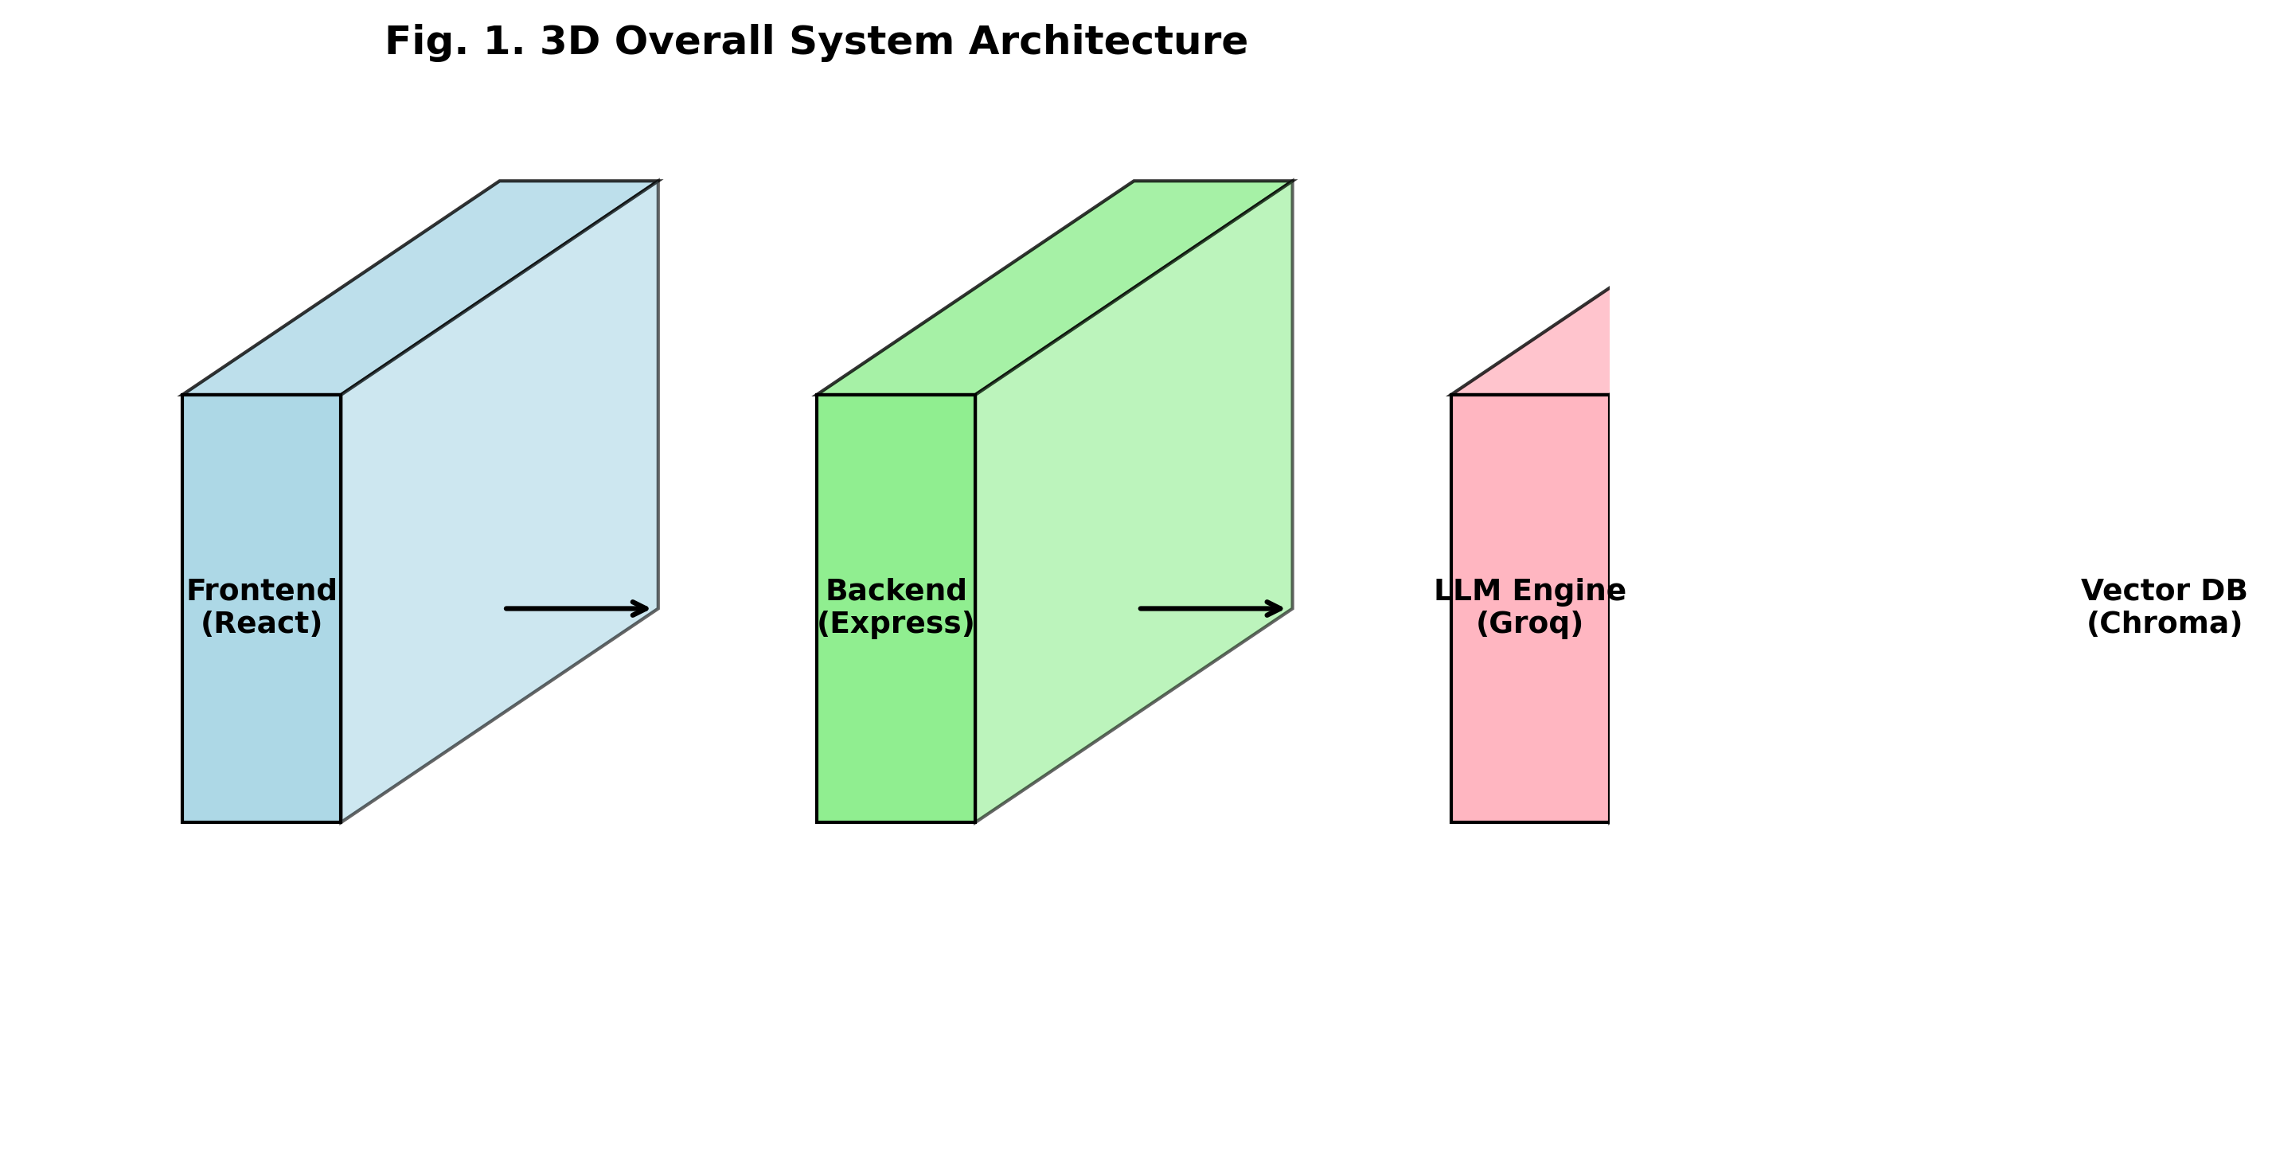
Fig. 1. Overall System Architecture of the Proposed Educational Platform
[Architecture Flow Diagram]
flowchart TD
Users["STUDENTS / FACULTY / ADMIN"]
subgraph PresentationLayer ["PRESENTATION LAYER"]
WebUI["Web Application UI (React + Vite)"]
end
subgraph ApplicationLayer ["APPLICATION LAYER (Express.js Backend)"]
direction LR
UserMgmt["User / Session\nManagement"]
AcademicSupport["Academic Support\nModules"]
AdminDashboard["Admin & Evaluation\nDashboard"]
end
subgraph KnowledgeLayer ["KNOWLEDGE & GENERATION LAYER"]
direction TB
subgraph DataSources ["Databases & Indices"]
MongoStore[("Data Store\n(MongoDB)")]
ChromaStore[("Vector Search\n(ChromaDB)")]
BM25Store[("Lexical Search\n(BM25)")]
end
HybridRAGEngine["Hybrid RAG Engine\n(Reciprocal Rank Fusion + Context Construction)"]
GenEngine["Generation Engine\n(openai/gpt-oss-120b via Groq / Llama 3)"]
ChromaStore --> HybridRAGEngine
BM25Store --> HybridRAGEngine
HybridRAGEngine --> GenEngine
end
Users <--> WebUI
WebUI <--> ApplicationLayer
ApplicationLayer <--> KnowledgeLayer

Fig. 2. Knowledge Acquisition and Document Processing Pipeline
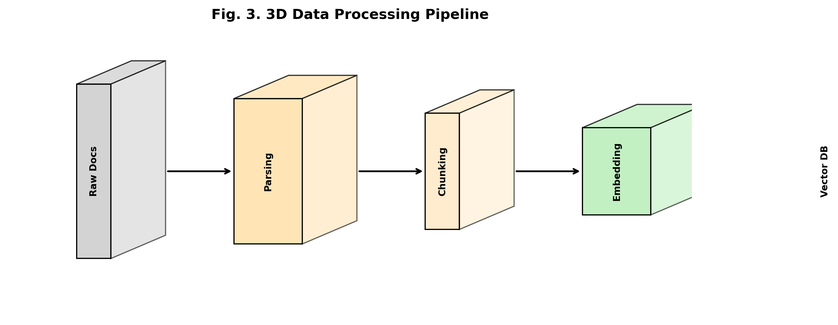
Fig. 2. Knowledge Acquisition and Document Processing Pipeline
[Architecture Flow Diagram]
flowchart LR
subgraph OfflinePipeline ["OFFLINE INGESTION PIPELINE"]
direction TB
Sources["COURSE SOURCES\n(PDF, PPT, DOCX)"] --> DocParsing["Document Parsing"]
DocParsing --> TextExtract["Text Extraction"]
TextExtract --> Preprocess["Preprocessing"]
Preprocess --> RecChunk["Recursive Chunking"]
RecChunk --> DenseEmb["Dense Embedding\n(all-MiniLM-L6-v2)"]
RecChunk --> SparseIdx["Sparse Indexing\n(TF-IDF / Tokenization)"]
RecChunk --> ChunkObj["Chunk Object\n(Content + Doc ID + Page Number)"]
end
subgraph KnowledgeStores ["KNOWLEDGE STORES"]
direction TB
VectorDB[("Vector Store\n(ChromaDB)")]
KeywordIdx[("Keyword Index\n(BM25)")]
MetaDB[("Metadata\n(MongoDB)")]
end
DenseEmb --> VectorDB
SparseIdx --> KeywordIdx
ChunkObj --> MetaDB

Fig. 3. Hybrid Retrieval-Augmented Generation Architecture
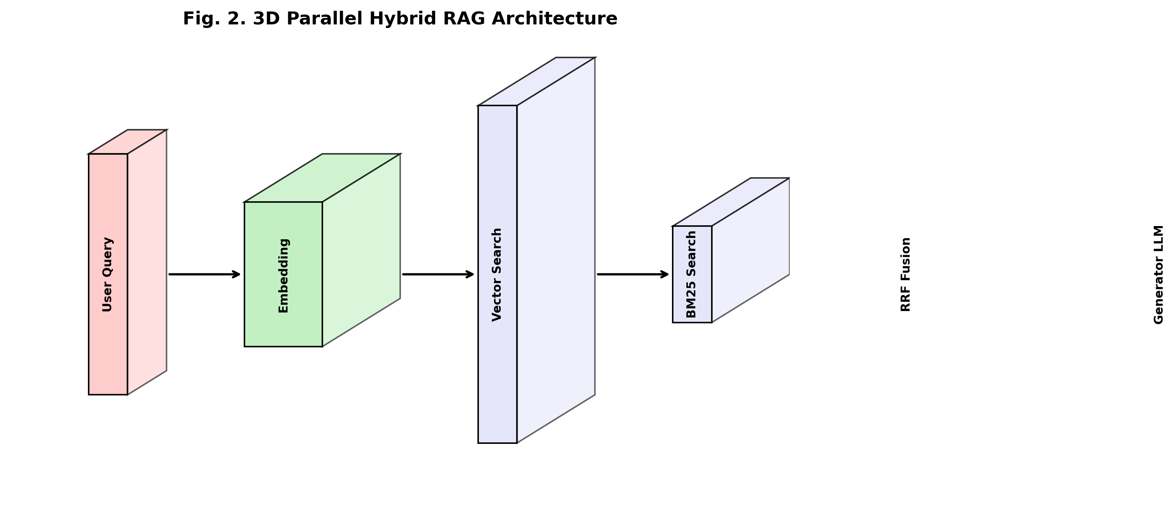
Fig. 3. Hybrid Retrieval-Augmented Generation Architecture
[Architecture Flow Diagram]
flowchart TD
UserQuery["USER QUERY"] --> Gatekeeper["Query Processing & Gatekeeper\n(qwen3.6-27b relevance check)"]
subgraph SemanticBranch ["SEMANTIC RETRIEVAL BRANCH"]
QueryEmb["Query Embedding\n(all-MiniLM-L6-v2)"] --> DenseSearch["Dense Vector Search"] --> ChromaDB[("ChromaDB Vector Store")]
end
subgraph LexicalBranch ["LEXICAL RETRIEVAL BRANCH"]
QueryTok["Query Tokenization"] --> KeywordMatch["Exact Keyword Matching"] --> BM25Index[("Okapi BM25 Index")]
end
Gatekeeper --> QueryEmb
Gatekeeper --> QueryTok
ChromaDB --> RRF["RECIPROCAL RANK FUSION (RRF)\nRRF(d) = Σ 1 / (k + rank(d)), k=60"]
BM25Index --> RRF
RRF --> ContextConst["Context Construction\n(Top-K Chunks + Source/Page Metadata)"]
ContextConst --> LLMGen["LLM Generation Engine\n(openai/gpt-oss-120b / llama-3.3-70b-versatile via Groq)"]

Fig. 4. Query Processing and Response Generation Workflow
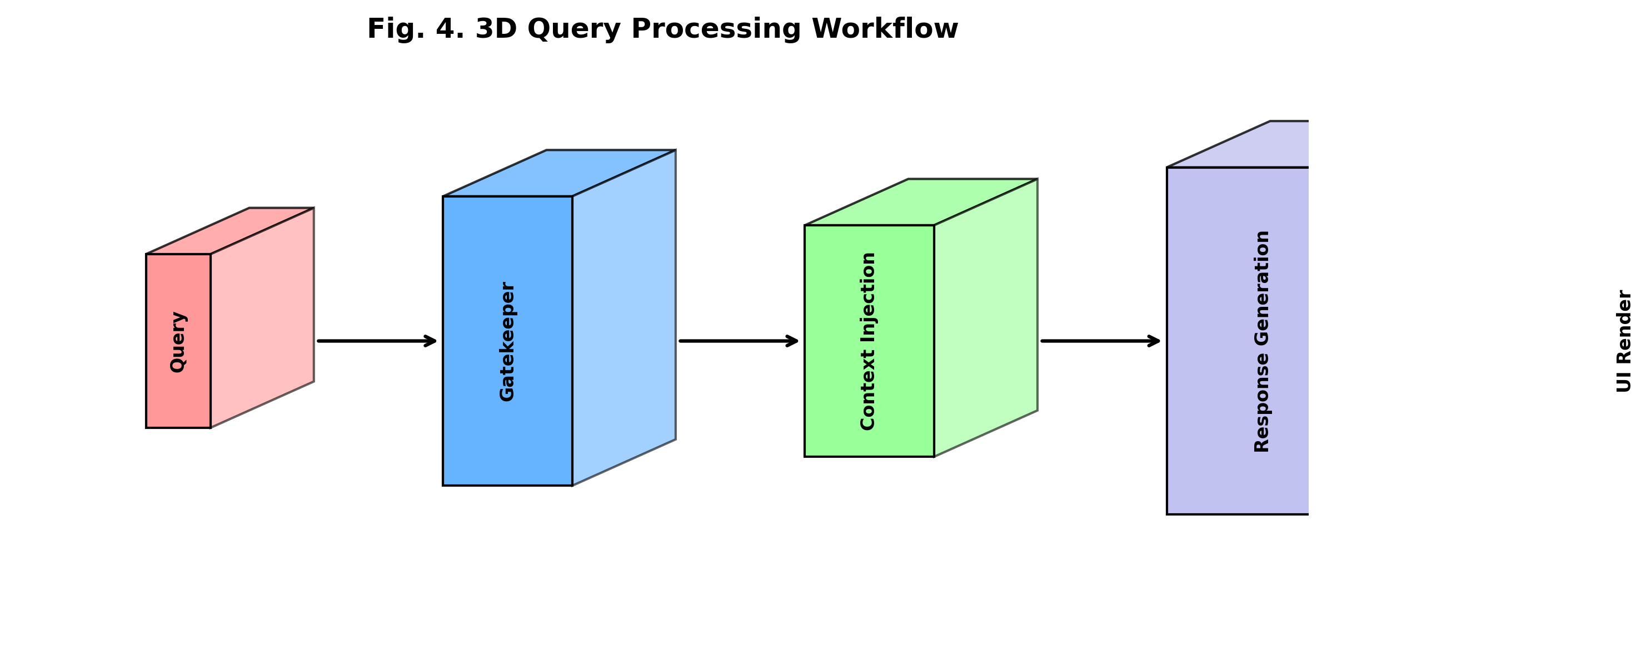
Fig. 4. Query Processing and Response Generation Workflow
[Architecture Flow Diagram]
flowchart TD
UserQ["USER QUERY"] --> GatekeeperCheck{"Gatekeeper\nRelevance Check"}
GatekeeperCheck -- "Off-Topic / Decline" --> RejectClarify["Reject / Clarify Request"]
RejectClarify --> WebUI["WEB APPLICATION UI"]
GatekeeperCheck -- "Course-Relevant" --> HybridRAG["Hybrid RAG Pipeline"]
subgraph RuntimeGen ["RUNTIME GENERATION AND VALIDATION"]
HybridRAG --> ContextConst["Context Construction"]
ContextConst --> LLM["LLM (Llama 3 / gpt-oss-120b)"]
LLM --> TrustScore{"TrustScore Guardrail\n(n-gram overlap + Cosine Grounding)"}
TrustScore -- "Fail (< Threshold)\nRegenerate" --> LLM
end
TrustScore -- "Pass (Valid)\nTrustScore >= 70%" --> WebUI

Fig. 5. Personalized Learning Architecture
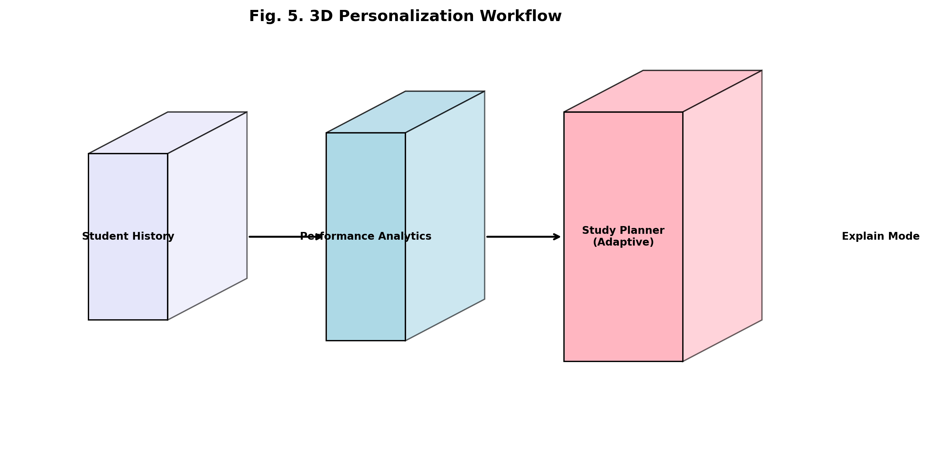
Fig. 5. Personalized Learning Architecture
[Architecture Flow Diagram]
flowchart LR
subgraph Inputs ["STUDENT SIGNALS"]
direction TB
UserProfile["User Profile"]
InteractionLogs["Interaction Logs"]
QuizPerf["Quiz Performance"]
ExamDates["Exam Dates"]
end
subgraph PersonalizationLogic ["PERSONALIZATION LOGIC MODULE"]
direction TB
StudyPlanner["Study Planner"] --> StudySchedule["Study Schedule"]
TopicAnalysis["Topic Analysis\n(Weak Area Detection)"] --> TargetedTopics["Targeted Topics"]
end
UserProfile --> StudyPlanner
InteractionLogs --> StudyPlanner
QuizPerf --> TopicAnalysis
ExamDates --> StudyPlanner
StudySchedule --> PromptInject["LLM Prompt Injection\n(Personalized Context Window)"]
TargetedTopics --> PromptInject
PromptInject --> TailoredResp["Tailored Responses &\nStudent UI"]

Fig. 6. Academic Support Workflow
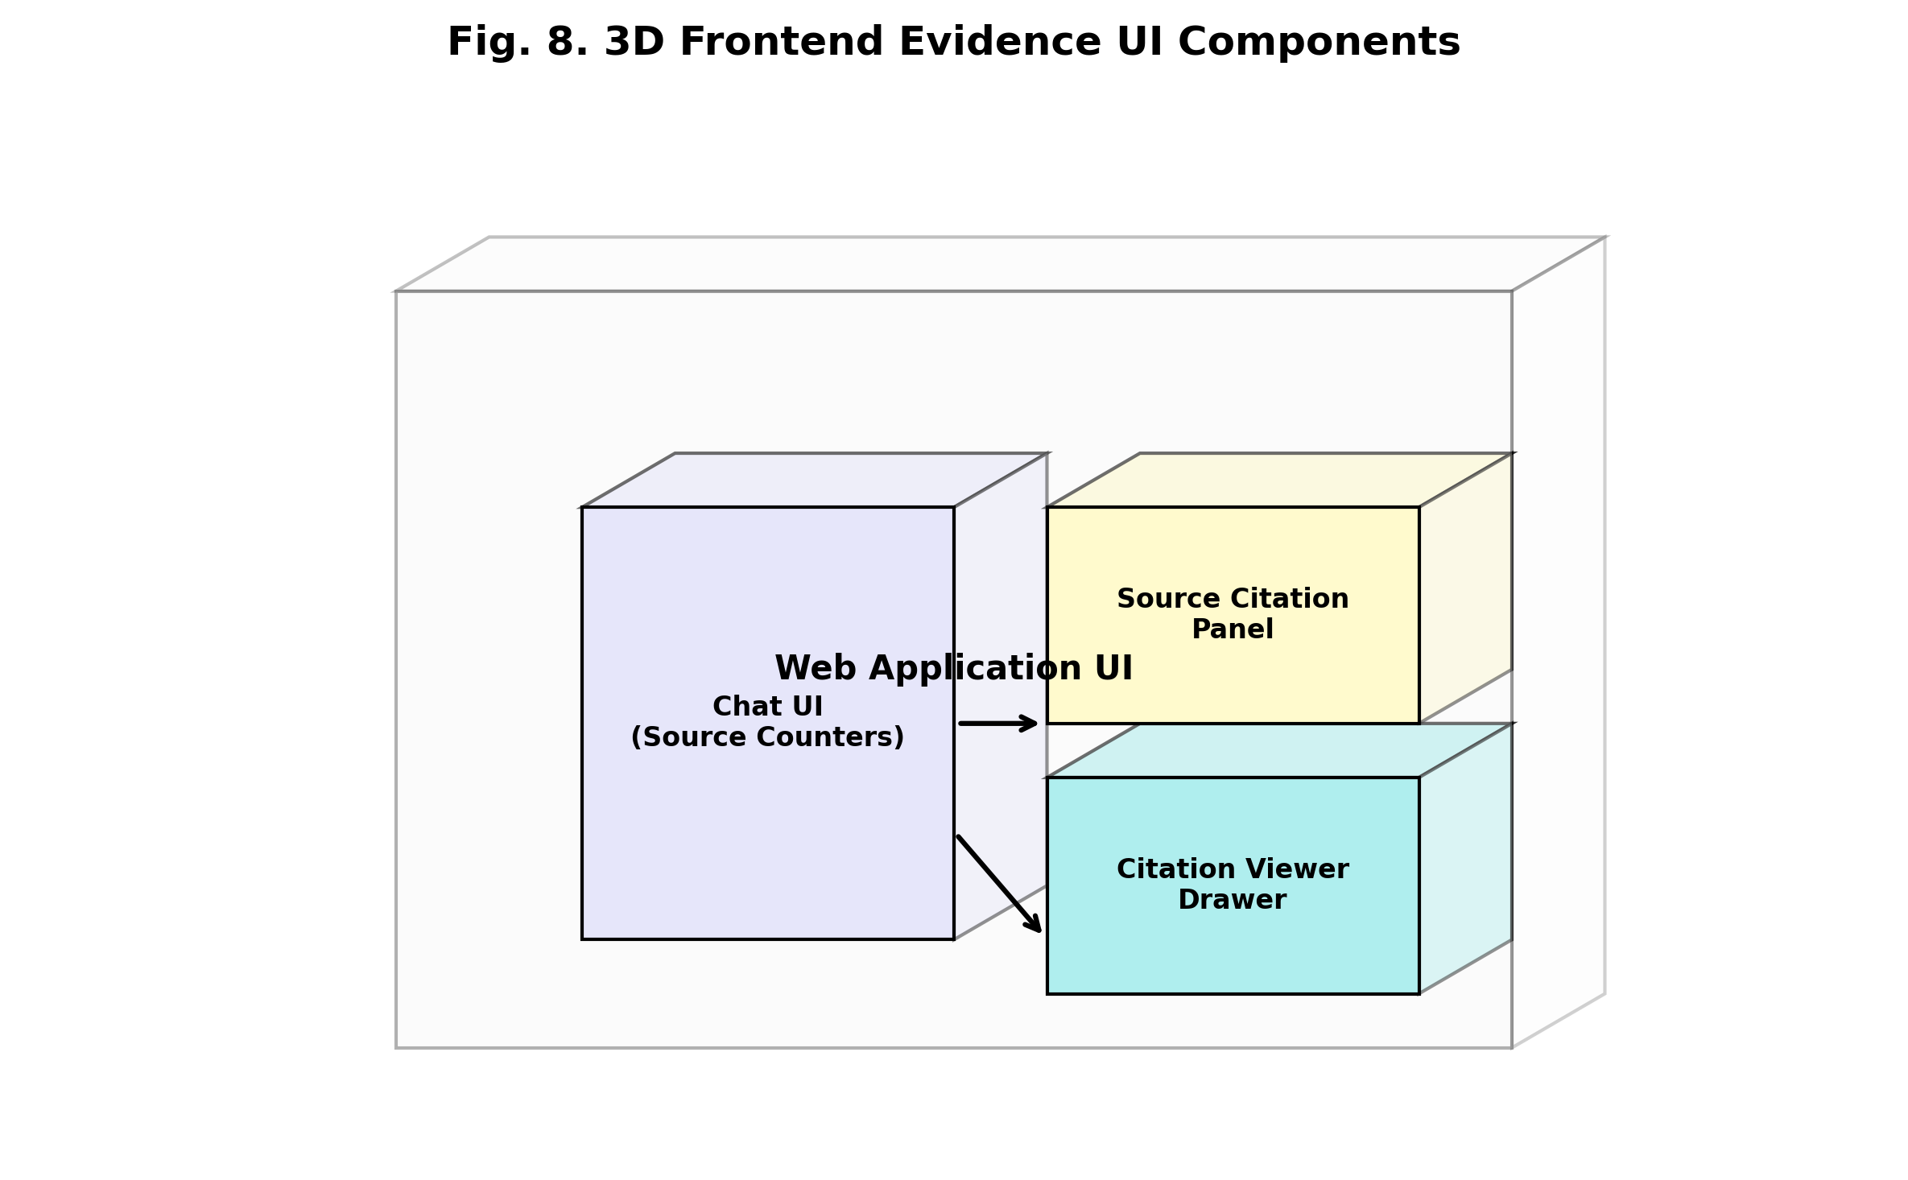
Fig. 6. Academic Support Workflow
[Architecture Flow Diagram]
flowchart TD
UserQuery["USER ACADEMIC QUERY"] --> IntentRouter["Intent Routing Module"]
subgraph SupportModes ["ACADEMIC SUPPORT MODES"]
ExplainMode["Q&A / Explain Mode\n- Concept Simplification\n- Real-World Examples"]
StudyHelp["Study Help\n- Concept Graphs\n- Exam Summaries"]
AssignEval["Assignment Evaluator\n- Rubric Grading\n- Constructive Feedback"]
end
IntentRouter --> ExplainMode
IntentRouter --> StudyHelp
IntentRouter --> AssignEval
ExplainMode --> RAGLayer["Hybrid RAG + LLM Layer"]
StudyHelp --> RAGLayer
AssignEval --> RAGLayer
RAGLayer --> EvidenceResponse["Evidence-Backed Response\n(Verified Citations + Page Numbers)"]

Fig. 7. Administrative and Evaluation Architecture
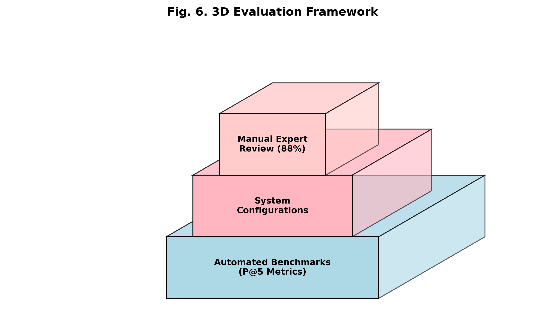
Fig. 7. Administrative and Evaluation Architecture
[Architecture Flow Diagram]
flowchart LR
subgraph SystemData ["SYSTEM DATA"]
direction TB
UserInteractions["User Interactions"]
APILatency["API Latency"]
AIOutputs["AI Outputs"]
end
subgraph EvalLayer ["EVALUATION LAYER"]
direction TB
RetAccuracy["Retrieval Accuracy (P@5)"]
HallucinationScore["Hallucination TrustScore"]
PerfMetrics["Performance Metrics"]
end
subgraph AdminDashboard ["ADMIN DASHBOARD"]
direction TB
RealtimeMon["Real-Time Monitoring"]
AutoReports["Automated Reports"]
end
SystemData --> EvalLayer
RetAccuracy --> AdminDashboard
HallucinationScore --> AdminDashboard
PerfMetrics --> AdminDashboard

Fig. 8. End-to-End Methodology of the Proposed Platform
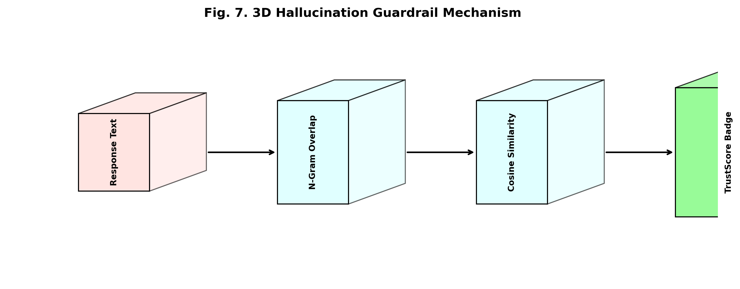
Fig. 8. End-to-End Methodology of the Proposed Platform
[Architecture Flow Diagram]
flowchart TD
subgraph Phase1 ["PHASE 1: OFFLINE KNOWLEDGE PREPARATION"]
CourseDocs["Course Documents"] --> Parsing["Ingestion & Parsing"]
Parsing --> Chunking["Recursive Chunking"]
Chunking --> DualEmbedding["Vector + BM25 Embedding"]
DualEmbedding --> KnowledgeStores[("Knowledge Stores\n(ChromaDB + BM25 + MongoDB)")]
end
subgraph Phase2 ["PHASE 2: ONLINE QUERY EXECUTION"]
UserQuery["User Query"] --> RelGate["Relevance Gate (Gatekeeper)"]
RelGate --> HybridRet["Hybrid Retrieval\n(Vector + BM25 via RRF)"]
HybridRet --> ContextAssembly["Context Assembly\n(Top-K + Citations)"]
ContextAssembly --> LLMGen["LLM Generation\n(openai/gpt-oss-120b)"]
LLMGen --> TrustScoreGuard["TrustScore Guardrail\n(Verification Check)"]
TrustScoreGuard --> FinalUI["Final Response UI\n(Student Interface)"]
end
KnowledgeStores -.-> HybridRet

🎨 UI Highlights
- Dark glassmorphism design with backdrop blur
- Apple-inspired typography (Inter font)
- ChatGPT-style chat interface
- Framer Motion animations
- Responsive mobile-first layout
- Real-time trust score badges
- Collapsible source citation panels
🚀 Deployment Guide
Frontend → Vercel
cd frontend
npm run build
# Deploy dist/ to Vercel

Set env: `VITE_API_URL=https://your-backend.onrender.com/api`
Backend → Render
- Create a new Web Service on Render
- Set root directory to `backend`
- Build command: `npm install && npm run build`
- Start command: `node dist/server.js`
- Add environment variables from `.env.example`
ChromaDB → Render
- Create a new Web Service with Docker
- Use image: `ghcr.io/chroma-core/chroma:latest`
- Port: `8000`
- Set `CHROMA_URL` in your backend env to this service URL
MongoDB → MongoDB Atlas
- Create free cluster at [mongodb.com/atlas](https://mongodb.com/atlas)
- Add IP whitelist (0.0.0.0/0 for Render)
- Create database user
- Copy connection string to `MONGODB_URI`
📄 License
MIT License — Built for educational purposes.
*Built with ❤️ using Llama 3, Hybrid RAG, and modern web technologies*

