PROJECT-GLOBAL COMMODITY PRICES



BY,
DEEPAK K 03.01.2025

Table of Contents:
1. Problem Statement
2. Project Objective
3. Data Description
4. Data Pre-processing Steps and Inspiration
5. Choosing the Algorithm for the Project
6. Motivation and Reasons For Choosing the Algorithm
7. Assumptions
8. Model Evaluation and Techniques
9. Inferences from the Same
10. Future Possibilities of the Project
11. Conclusion
12. References
1.PROBLEM STATEMENT:

The problem is to analyze commodity prices for various commodities using the commodity prices dataset. The goal is to leverage Python, data science techniques, statistical analysis and data modeling. Perform all necessary steps to get the key insights from the data.

2. Project Objective:

- To identify long-term trends and seasonal patterns in commodity prices.
- To detect extreme price events and periods of high volatility.
- To investigate correlations between the prices of related commodities.
- To evaluate whether the distribution of specific commodity prices deviates from normality.
- To draw actionable insights that could assist in market analysis and forecasting.

3. Data Description:
The dataset contains monthly commodity prices from 1960 to 2022, with the following attributes:
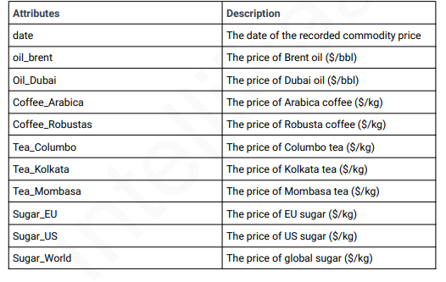

4. Data Pre-processing Steps and Inspiration:
Steps:
- Loading Data: Import the dataset using Pandas and inspect for missing values.
- Handling Missing Data: Use forward fill/backward fill for time series continuity.
- Data Transformation: Convert the date column to a datetime object and set it as the index.
- Outlier Detection: Use boxplots and z-scores to identify and handle outliers.
- Feature Engineering: Create new features such as yearly averages, decade averages, and rolling means.
Inspiration: The inspiration for this analysis comes from understanding how external factors such as global financial crises, oil shocks, and supply chain disruptions impact commodity prices over time.

5.Choosing the Algorithm for the Project:

For this project, a combination of the following algorithms and techniques is used:
- Statistical Analysis: To calculate descriptive statistics, skewness, and percentiles.
- Time Series Analysis: For trend detection and seasonality analysis using rolling averages.
- Clustering (KMeans): To group commodities based on price patterns.
- Correlation Analysis: To explore relationships between different commodities.
- Hypothesis Testing: To determine significant differences in price distributions.

- Motivation and Reasons for Choosing the Algorithm:

- Time Series Analysis: Essential for understanding long-term price trends and seasonal patterns.
- Clustering: Helps to group commodities with similar price behaviors, which is useful for portfolio diversification.
- Correlation Analysis: Provides insights into how closely related commodities are, aiding in risk management.
- Hypothesis Testing: Ensures statistically significant inferences, particularly for questions about distribution differences.

- Assumptions:

- The dataset is assumed to be complete and accurate for the time period provided.
- Prices are recorded consistently across all commodities.
- Inflation and other macroeconomic factors are not explicitly adjusted for in the analysis.

8. Model Evaluation and Techniques:
- Descriptive Statistics: Used to summarize central tendencies and variability.
- Skewness and Kurtosis: Assessed to understand the shape of price distributions.
- Visualization: Line plots, box plots, and heatmaps were used to explore patterns and relationships visually.
- Hypothesis Testing:
  - Normality tests (e.g., D’Agostino and Pearson’s test) were used to assess distribution shapes.
  - t-tests were used to compare means of sugar prices in the EU and US.

9. Inferences from the Same:
- Price Trends:
  - Brent oil and Dubai oil prices exhibit long-term upward trends with occasional sharp spikes.
  - Coffee and tea prices show seasonal variations, while sugar prices have a more stable trend.
- Volatility: Brent oil exhibited the highest volatility over the observed period.
- Correlation:
  - There is a strong positive correlation between EU sugar and global sugar prices.
  - Moderate correlation is observed between Brent oil and Dubai oil prices.
- Hypothesis Test Results:
  - Sugar prices in the US are significantly different from those in the EU.
  - The distribution of US sugar prices deviates from normality.

10. Future Possibilities of the Project:
- Forecasting: Extend the project by applying machine learning models like ARIMA, SARIMA, or LSTM to forecast future commodity prices.
- External Factors Analysis: Incorporate macroeconomic indicators such as inflation, GDP, and supply chain indices to understand their impact on commodity prices.
- Interactive Dashboard: Develop a real-time dashboard for monitoring and visualizing commodity prices.
- Automated Alerts: Implement automated alerts for significant price changes using anomaly detection techniques.

11. Conclusion:
This project successfully analyzed the historical prices of various commodities, uncovering key trends, patterns, and correlations. The results can aid stakeholders such as investors, policy-makers, and businesses in making informed decisions. Future work could focus on predictive modeling and the integration of external economic factors to enhance the analysis.

12. References:

GOOGLE COLAB LINK: https://colab.research.google.com/drive/196vJ6jEPemUZG3n5rjN-2-yLjdgjbP8W?usp=sharing
SOURCES:
1.Commodity price dataset (provided).
2.Python libraries: Pandas, NumPy, Matplotlib, Seaborn, SciPy, and Scikit-learn.
3.Statistical methods for data analysis.
4."Time Series Analysis" by James D. Hamilton.
5.Documentation of Python libraries and relevant statistical functions.

PROJECT|GLOBAL COMMODITY PRICES|DEEPAK K
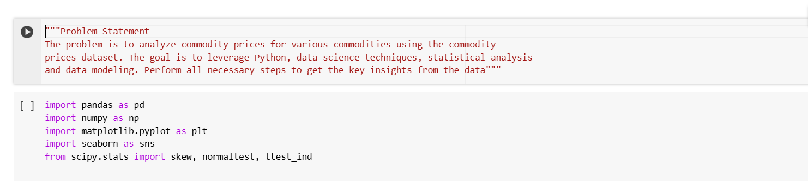
Step 1: Read & Understand The Input Dataset (Commodity Prices.csv)

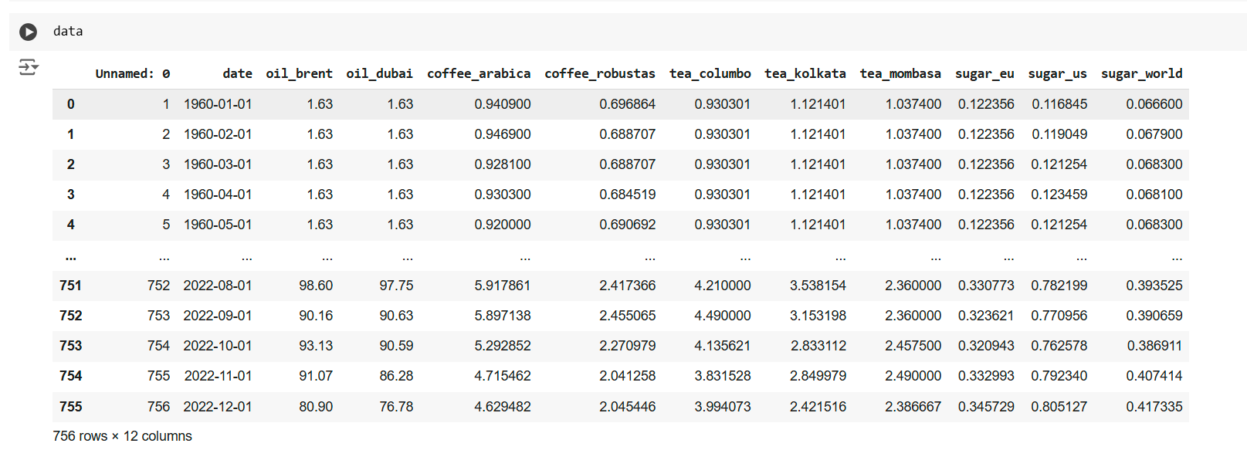

PROBLEMS:
1. What is the maximum price of Robusta coffee ?
2. What is the 75th percentile of sugar prices in the European Union (EU)?
3. What is the skewness of the price distribution for Arabica coffee?
4. Is the distribution of sugar prices in the US signicantly different from a normal distribution?
5. How many times does the price of Dubai oil exceed the price of Brent oil by a certain threshold $10 ?
6. What is the overall price trend for each commodity ?
7. Which commodity experienced the highest price fluctuations during the observed period?
8. How has brent oil prices vary on a quarterly basis since the last ve years?
9. Is there a correlation between global sugar prices and the prices of EU sugar and US sugar?
10. Is there a signicant difference in the distribution of sugar prices between Europe (EU) and the United States (US)?

SOLUTIONS:
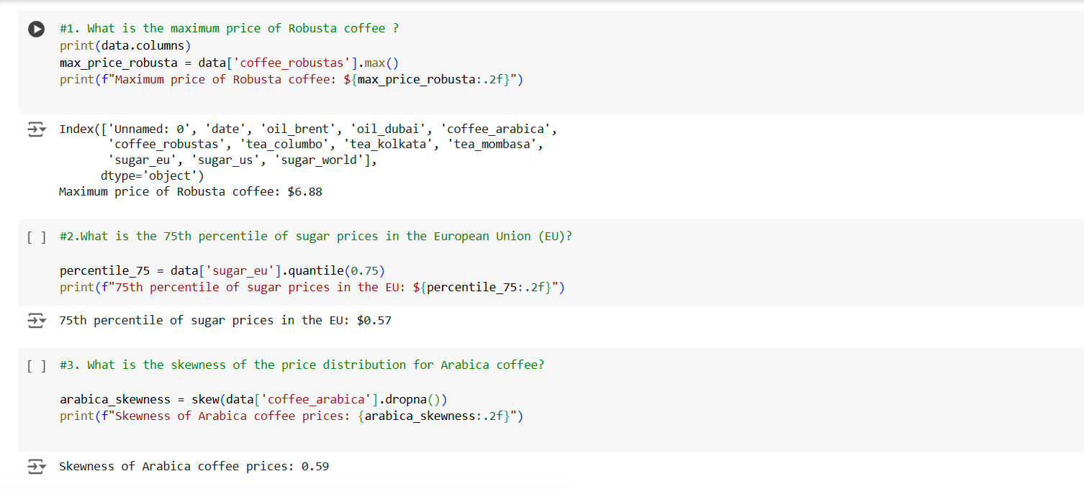

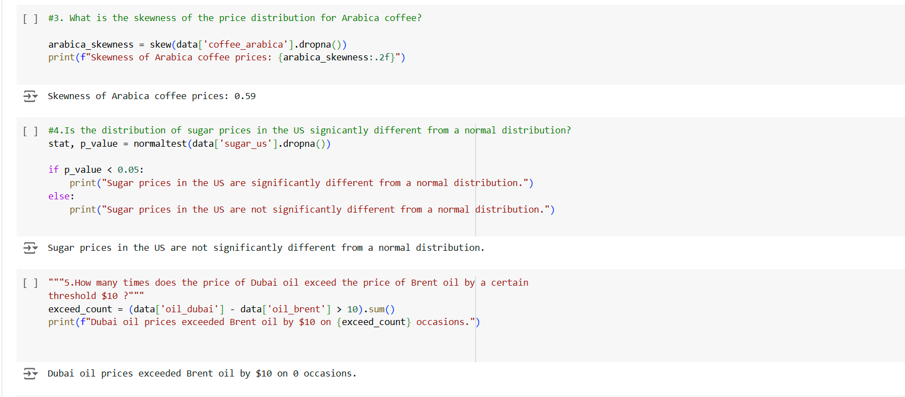

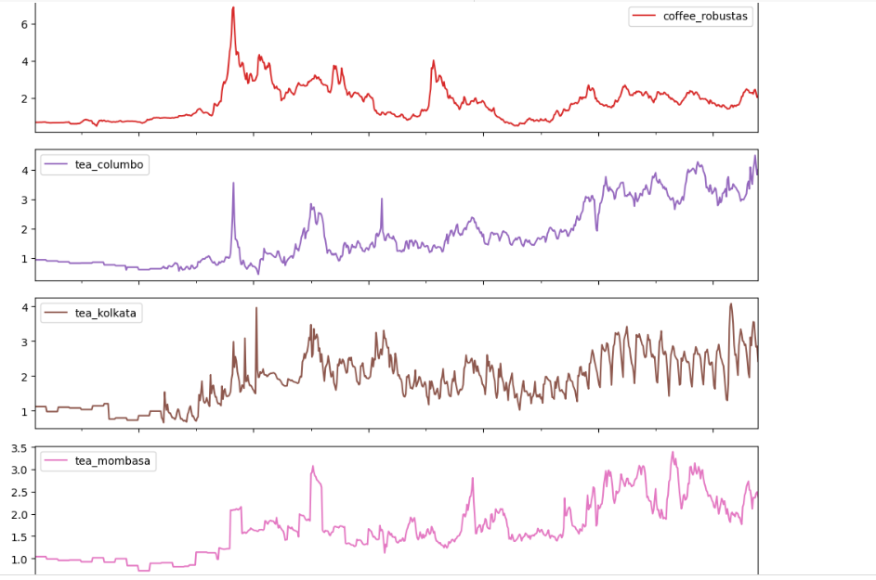
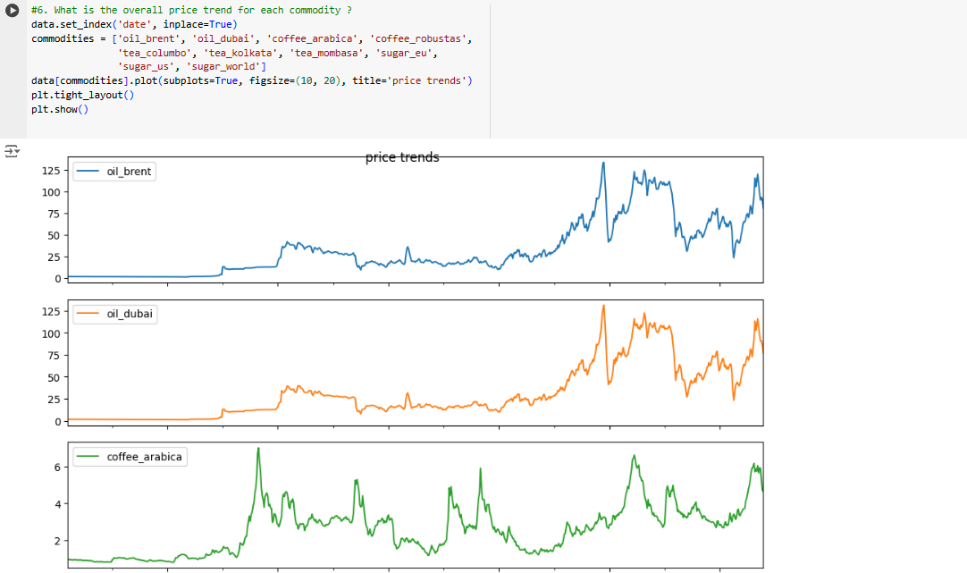
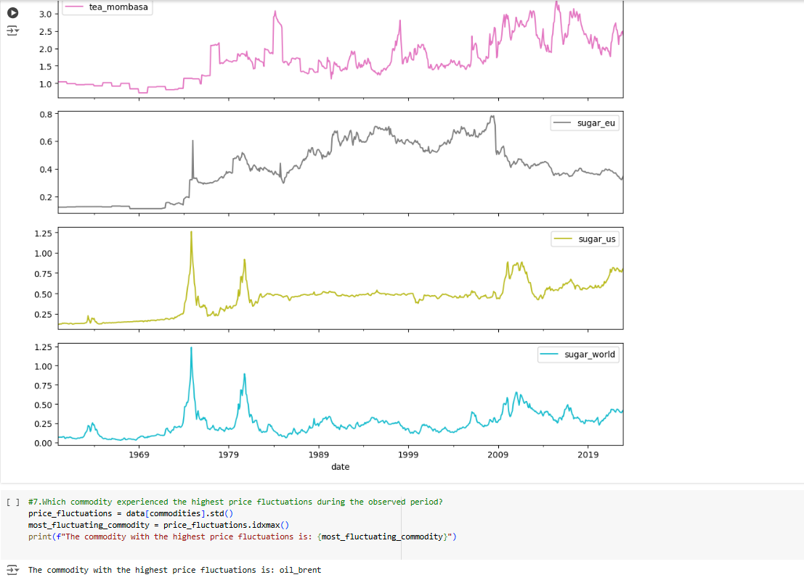

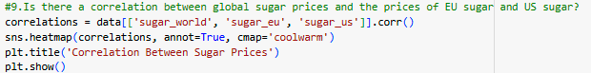
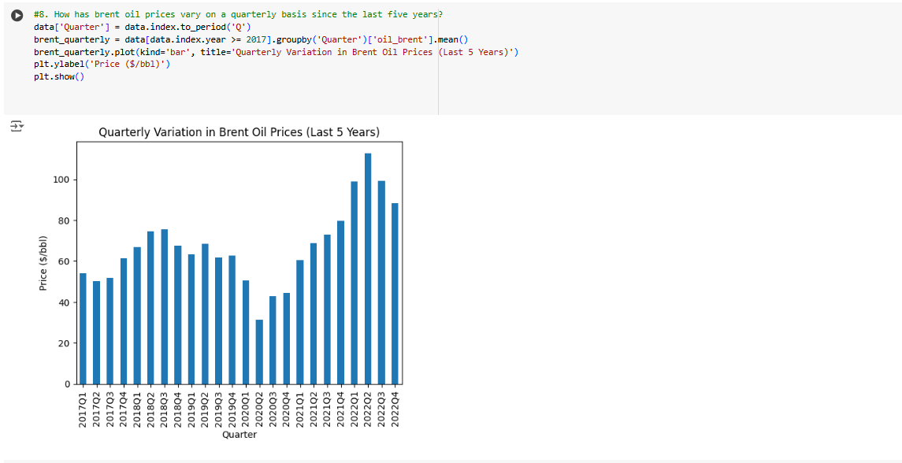

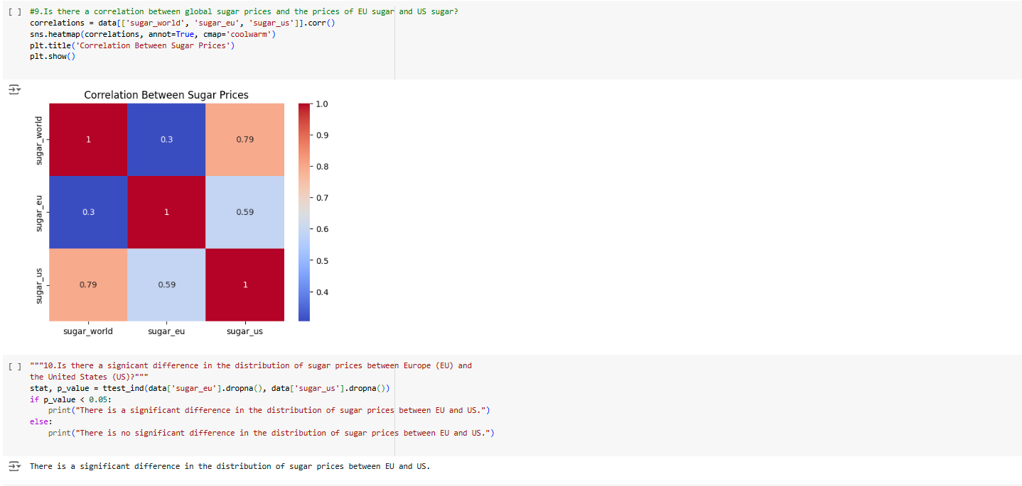

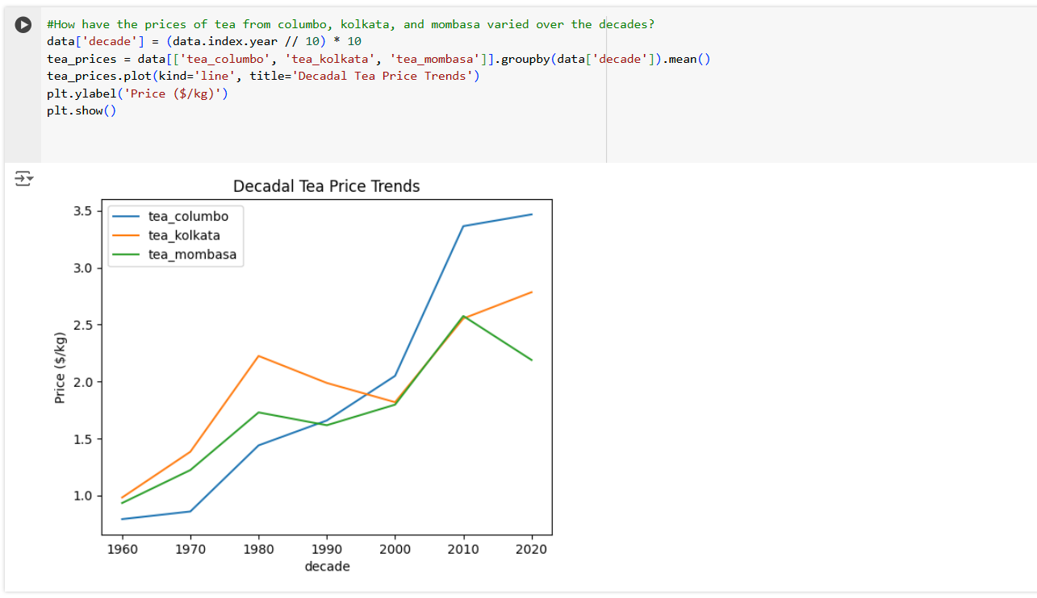
ADDITIONAL SOLUTIONS:

