**RESUME**

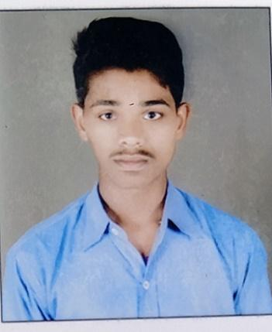

**Name**: Khaire Deepak Rajkumar

**Contact No.** : 9172888406

**Email address**: dkhaire54@gmail.com

**Address**: Anand Gade Nagar, Naregaon,

Dist. Aurangabad, Maharashtra

**OBJECTIVES**

* Effectively contribute my skills as a programmer and to perform up to my fullest potential for the company & to accept various challenges from IT industry.

**AREA OF INTREST TO WORK IN PREMISES**

* Coding
* Testing

**ACADEMIC CREDENTIALS**

|  |  |  |  |  |  |
| --- | --- | --- | --- | --- | --- |
| **Sr. No.** | **Description** | **College** | **Year** | **Percentage** | **University** |
| 1 | M.Sc. IT  (Final year) | Marathwada Institute of Technology Cidco, Aurangabad | 2021-2023 | pursuing | BAMU,  Aurangabad. |
| 2 | M.Sc. IT  (First year) | Marathwada Institute of Technology Cidco, Aurangabad | 2021-2022 | 71.43% | BAMU,  Aurangabad. |
| 3 | Graduation  (B.Sc. IT) | MGM’s  Dr. G. Y. Pathrikar College Of CS & IT, Aurangabad | 2017-2020 | 68.37% | BAMU,  Aurangabad. |
| 4 | HSC | Shiv Chhatrapati College, Aurangabad | 2015-2016 | 70.31% | Pune Board |
| 5 | SSC | Jijamata High School,  Aurangabad | 2013-2014 | 50.20% | Pune Board |

* quick learner and hard working

**STRENGTH**

* Able to work in team to achieve a desired goal
* Ability to adapt new environment quickly
* Creative, self-motivated

**HOBBIES**

* Programming
* Swimming
* Travelling
* Listening Music

**SOFTWARE SKILLS**

* Java Programming
* HTML/CSS/javaScript
* c/c++ Programming
* PHP
* Computer Typing (Eng 30 wpm)

**PROFILE LINKS**

GitHub : <https://github.com/Deepakkhaire>  
CodePen : <https://codepen.io/deepakkhaire98>  
LinkedIn : <https://www.linkedin.com/in/deepak-khaire-2993b11b5/>

**PERSONAL DETAILS**

**Father Name**: Khaire Rajkumar Raghuji

**Mother Name**: Khaire Manisha Rajkumar

**Date of birth**: 09th Dec 1996

**Blood group**: B +ve **Gender**: Male **Marital status**: Unmarried

**DECLARATION**

I hereby declare that the information furnished above is true to the best of my knowledge and belief. Also, I keenly look forward for an opportunity which is in tune to my expectations that puts me on the right platform to prove my credentials.

Date: / /20 Yours Sincerely,

Place: Aurangabad Deepak Rajkumar Khaire