Week 1 Task (Revised Submission)
Strategic Planning and Data Exploration in Logistics
Demand forecasting, delivery performance and route optimisation for an e-commerce distribution network: plan, pilot evidence and roadmap
Name: ____________________ Date: 31 October 2026
Code repository: github.com/Deepakkumar-3/logistics_analyst_intern

1. Executive Summary
This revised report replaces the earlier plan-only submission. The earlier version described the approach but contained untested pseudocode and assumed numbers. This version keeps the strategic plan and adds executed proof-of-concept work: every code block was run, the console output is shown beneath it, and every figure and number comes from the scripts in the repository.
The scenario is a mid-sized e-commerce retailer with three fulfilment centres (FC), five delivery zones and three carriers. A shipment-level dataset of 5863 deliveries was built and cleaned (Weeks 2–4 develop this fully). Measured baseline results: 87.7% of shipments arrive on time, the average transport cost is INR 226.7 per delivery, and the mean delivery time is 35.7 hours. Three pilots then tested the planned data-science techniques:
- Forecasting: a gradient-boosting model did not beat a 4-week moving average on weekly shipments per FC (WAPE 18.9% against 16.2%). This negative result changed the plan: forecasting with machine learning is moved to richer SKU-level data, and the simple baseline stays the benchmark.
- Clustering: K-Means separated the network into a local segment (5,100 shipments, 95% on time) and a long-distance segment (763 shipments, 40% on time, 9× the cost per shipment).
- Route optimisation: OR-Tools reduced the total distance of an 80-stop batch from 983 km to 578 km (−41.2%) with the same number of vans, against a deliberately simple sweep baseline.

2. Project Definition

2.1 Logistics scenario
The retailer sells to customers in a large metropolitan area and a few outstation destinations. Orders are fulfilled from three FCs (North, Central, South) and delivered by three carriers under three service levels: Standard (72 h promise), Express (36 h) and Same-Day (10 h). Pain points that motivate the project:
- Delivery reliability: promises are fixed per service level, regardless of distance or conditions, so some lanes are routinely missed.
- Cost: a small number of long-distance shipments consume a large share of transport spend.
- Planning: carrier allocation and route planning are manual and not based on predicted outcomes.
- Visibility: no systematic demand forecast by FC for staffing and stock positioning.

2.2 Objectives
# | Objective
O1 | Establish measured baselines for delivery performance, cost and forecast accuracy (done in this report).
O2 | Build a demand forecast per FC and SKU that beats the best simple baseline on rolling-origin validation (target set after the baseline is known).
O3 | Segment shipments and zones to define differentiated service and cost strategies.
O4 | Optimise vehicle routes under capacity constraints and quantify the distance saving on realistic batches.
O5 | Predict delivery times and use them for promises and carrier allocation (Week 4).

2.3 Key Performance Indicators with measured baselines
KPI | Definition | Measured baseline | Target / status
On-time rate (OTIF proxy) | Shipments with delivery time ≤ promise ÷ all shipments. 'In full' is not recorded in this dataset, so on-time is used as a proxy | 87.7% | ≥ 95%
Cost per delivery | Mean transport cost per shipment (INR) | 226.7 | Median is INR 105; the mean is pulled up by outstation shipments. Target 10% lower
Delivery lead time | Hours from order to delivery (mean / P90) | 35.7 / 52.8 | P90 ≤ 48 h
Forecast accuracy (WAPE) | Σ|actual − forecast| ÷ Σ actual, weekly shipments per FC, 4-week moving average | 16.2% | Beat baseline in rolling validation
Vehicle utilisation | Load ÷ van capacity (60 kg) in the routing pilot | 97% | Capacity-bound in the pilot; needs real fleet data
Inventory turnover / fill rate | COGS ÷ average inventory; units shipped ÷ units ordered | Not in this dataset | To be measured when inventory records are added
Table 1: KPI framework with baselines measured by code (kpi snippet in Section 4.1).

3. Literature and Data Research

3.1 Background research
- Vehicle Routing Problem (VRP): Dantzig and Ramser (1959) introduced it as the truck dispatching problem; Toth and Vigo (2014) review its variants (capacity, time windows). Exact solutions are impractical beyond a few dozen stops, so metaheuristics such as guided local search are used; OR-Tools implements these.
- Inventory theory: safety stock links service level, demand variability and lead time (Chopra and Meindl). Better forecast accuracy lowers the safety stock required.
- Demand forecasting: the M5 competition (Makridakis et al., 2022) found that gradient-boosted trees with calendar and price features perform very well on large hierarchical retail data, while statistical baselines remain hard to beat on small, noisy series (Hyndman and Athanasopoulos). The pilot in Section 5.2 shows this second point.
- Segmentation and delay prediction: K-Means for customer/zone groups; classification and regression for delay prediction (Week 4).

3.2 Public data sources
Source | Content | Use
Olist Brazilian E-Commerce (Kaggle) | About 100k orders with purchase, carrier and delivery dates, product, seller and customer location | Delivery performance; schema reference for this project's dataset
DataCo Smart Supply Chain (Mendeley Data) | Orders, shipping mode, scheduled vs real shipping days, late-delivery risk | Late-delivery analysis
M5 Forecasting (Kaggle / Walmart) | Daily unit sales by item and store, prices, events | SKU-level demand forecasting (next phase)
Solomon / Gehring–Homberger VRPTW; CVRPLIB | Benchmark routing instances | Validating the routing model
OpenStreetMap, OSRM / OpenRouteService | Road network, travel times | Real distance matrices
Table 2: Public sources. Licences and file versions must be confirmed before use.

3.3 Data used in this report (provenance)
The company is fictional, so the working dataset was simulated with the script gen_data.py (seed 42). It reproduces the structure and the typical problems of a transport-system export (see Week 2) and has 16 raw fields: timestamps, FC, zone, carrier, shipping mode, distance, weight, volume, items, order value, transport cost, rainfall, traffic and the promised delivery time. After cleaning (Week 2) 5,863 shipments remain. Results are therefore a demonstration of the method, not findings about a real company; the same code runs on the public datasets above.

3.4 How data-science techniques map to the problems
Technique | Application | Evidence in this report
Descriptive statistics | KPI baselines by mode, zone, carrier | Section 4.1
Regression / gradient boosting | Weekly demand forecast; delivery-time prediction | Section 5.2; Week 4
Clustering (K-Means) | Shipment and zone segments | Section 5.3
Optimisation (VRP, assignment) | Daily routes; carrier allocation | Section 5.4; Week 4

4. Data Exploration and Baselines

4.1 Measured KPI baseline
kpi = {
"On-time rate (OTIF proxy) %": 100 * df.on_time.mean(),
"Cost per delivery (INR)": df.transport_cost_inr.mean(),
"Median cost per km (INR)": df.cost_per_km.median(),
"Mean delivery time (h)": df.delivery_hours.mean(),
"P90 delivery time (h)": df.delivery_hours.quantile(.9),
}
print(pd.Series(kpi).round(2))

Output:
On-time rate (OTIF proxy) % 87.65
Cost per delivery (INR) 226.69
Median cost per km (INR) 6.75
Mean delivery time (h) 35.68
P90 delivery time (h) 52.83
dtype: float64

The overall on-time rate of 87.65% is below the 95% target, and the mean cost per delivery (INR 226.69) is more than twice the median (INR 105), which signals a skewed cost distribution. Week 3 shows that the Same-Day service (55% on time) and the outstation zone (40% on time, 58% of cost) account for most of the gap.

5. Proof-of-Concept Pilots

5.1 Purpose
Each pilot tests a technique named in the plan on the dataset above, so that the roadmap is based on evidence. The pilots are deliberately small; their limitations are stated next to each result.

5.2 Pilot A: weekly demand forecasting
Task: forecast the number of shipments per FC per week. Method: lag features (1–4 weeks), a 4-week moving average, a festive-season flag and an FC code; HistGradientBoostingRegressor against the moving-average baseline; chronological split with the last 8 weeks as the test set (114 training rows, 21 test rows). Accuracy is measured with WAPE, which is robust when some values are small.
from sklearn.ensemble import HistGradientBoostingRegressor
wk = (df.assign(week=df.order_ts.dt.to_period("W").dt.start_time)
.groupby(["fc", "week"]).size().rename("y").reset_index())
wk = wk[wk.week < wk.week.max()] # drop the incomplete final week
wk = wk.sort_values(["fc", "week"])
g = wk.groupby("fc")["y"]
for k in (1, 2, 3, 4): wk[f"lag{k}"] = g.shift(k)
wk["ma4"] = g.shift(1).rolling(4).mean().reset_index(level=0, drop=True)
wk["festive"] = wk.week.dt.month.isin([11, 12]).astype(int)
wk["woy"] = wk.week.dt.isocalendar().week.astype(int)
wk["fc_code"] = wk.fc.astype("category").cat.codes
wk = wk.dropna()
cut = wk.week.max() - pd.Timedelta(weeks=8)
tr, te = wk[wk.week <= cut], wk[wk.week > cut]
feats = ["lag1", "lag2", "lag3", "lag4", "ma4", "festive", "fc_code"]
m = HistGradientBoostingRegressor(max_iter=200, learning_rate=.05, max_depth=3, random_state=0).fit(tr[feats], tr.y)
pred = m.predict(te[feats])
wape = lambda y, f: np.abs(y - f).sum() / y.sum()
w_base, w_model = wape(te.y, te.ma4), wape(te.y, pred)
print(f"WAPE moving-average baseline: {w_base:.3f} | gradient boosting: {w_model:.3f}")

Output:
WAPE moving-average baseline: 0.162 | gradient boosting: 0.189

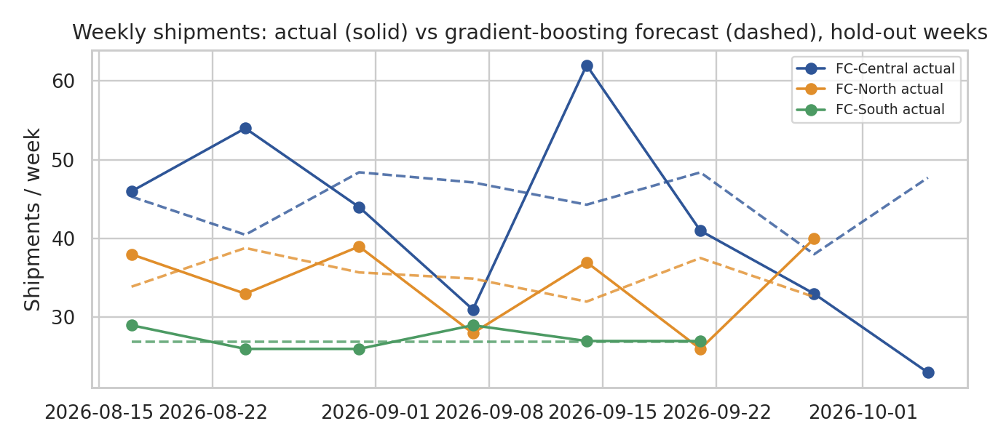
Figure 1: Hold-out weeks, actual (solid) vs gradient boosting forecast (dashed).
Result: the machine-learning model was 16.5% worse than the moving average (WAPE 18.9% against 16.2%). The probable reasons are the small sample (114 training rows from three weekly series, and only one festive season in the data) and the noisy, count-like nature of weekly volumes. This result is useful: it shows that a more complex model is not automatically better, and that the 15% improvement target in the original plan was not justified. The plan is changed in three ways: (1) the moving average (or exponential smoothing) stays as the benchmark that any model must beat; (2) machine learning is tested on the M5 data, which has thousands of series and several years of history; (3) the success criterion is 'beats the best baseline in rolling-origin validation', not a fixed percentage.

5.3 Pilot B: clustering shipments
Task: find natural segments of shipments by distance, weight, order value and cost. Method: log transformation, standardisation, K-Means for k = 2 to 6, selection by silhouette score.
from sklearn.cluster import KMeans
from sklearn.preprocessing import StandardScaler
from sklearn.metrics import silhouette_score
X = StandardScaler().fit_transform(np.log1p(df[["distance_km", "weight_kg", "order_value_inr", "transport_cost_inr"]]))
sil = {k: silhouette_score(X, KMeans(k, n_init=10, random_state=0).fit_predict(X)) for k in range(2, 7)}
k_best = max(sil, key=sil.get)
df["segment"] = KMeans(k_best, n_init=10, random_state=0).fit_predict(X)
prof = df.groupby("segment").agg(shipments=("order_id", "count"), distance=("distance_km", "median"),
weight=("weight_kg", "median"), value=("order_value_inr", "median"), cost=("transport_cost_inr", "median"),
on_time=("on_time", "mean")).round(2)
print({k: round(v, 3) for k, v in sil.items()}); print(prof)

Output:
{2: 0.525, 3: 0.305, 4: 0.3, 5: 0.278, 6: 0.257}
shipments distance weight value cost on_time
segment
0 763 321.3 2.41 1506.0 902.0 0.40
1 5100 13.3 2.41 1446.0 98.0 0.95

Result: the silhouette score is highest for k = 2 (0.525) and falls to 0.305 for k = 3 and 0.257 for k = 6, so the data has one clear structure: local shipments (median 13 km, INR 98, 95% on time; 87% of volume) and long-distance shipments (median 321 km, INR 902, 40% on time; 13% of volume). Weight and order value do not separate the groups; distance does. The practical conclusion is that outstation shipments need their own service model, pricing and carrier rules, and that further segmentation of the local network should use other variables (zone, time of day, carrier) and not size or value.

5.4 Pilot C: route optimisation with OR-Tools
Task: plan vans for a batch of 80 deliveries from FC-Central (metro and suburban orders from December 2025; 290 kg total; 60 kg van capacity). The data has no GPS coordinates, so each stop is placed at its recorded distance from the depot at a random bearing, and road distance is taken as 1.3 times the straight-line distance. The baseline imitates a manual dispatcher: stops sorted by bearing and loaded into vans until full. The optimised plan uses OR-Tools with a capacity constraint, a fixed cost per van and guided local search (20-second limit).
from ortools.constraint_solver import pywrapcp, routing_enums_pb2
rng = np.random.default_rng(7)
batch = (df[(df.fc == "FC-Central") & (df.zone != "Outstation") & (df.order_ts >= "2025-12-01")]
.sort_values("order_ts").head(80).reset_index(drop=True))
ang = rng.uniform(0, 2 * np.pi, len(batch)) # no GPS in the data: place stops at their
xy = np.c_[0, 0].tolist() + np.c_[batch.distance_km / 1.3 * np.cos(ang), batch.distance_km / 1.3 * np.sin(ang)].tolist()
xy = np.array(xy) # recorded distance (km) from the depot, random bearing
D = np.linalg.norm(xy[:, None] - xy[None], axis=2) * 1.3 # 1.3 = road-circuity factor
demand = np.r_[0, np.ceil(batch.weight_kg.values)].astype(int) # kg
CAP, FLEET = 60, 20

def route_len(r): return sum(D[a, b] for a, b in zip([0] + r, r + [0]))
# baseline: dispatcher-style "sweep" - sort stops by bearing, fill each van to capacity
order = np.argsort(np.arctan2(xy[1:, 1], xy[1:, 0])) + 1
base, cur, load = [], [], 0
for s in order:
if load + demand[s] > CAP: base.append(cur); cur, load = [], 0
cur.append(int(s)); load += demand[s]
base.append(cur)

mgr = pywrapcp.RoutingIndexManager(len(D), FLEET, 0); rt = pywrapcp.RoutingModel(mgr)
cb = rt.RegisterTransitCallback(lambda i, j: int(D[mgr.IndexToNode(i)][mgr.IndexToNode(j)] * 100))
rt.SetArcCostEvaluatorOfAllVehicles(cb)
rt.AddDimensionWithVehicleCapacity(rt.RegisterUnaryTransitCallback(lambda i: int(demand[mgr.IndexToNode(i)])), 0, [CAP] * FLEET, True, "cap")
rt.SetFixedCostOfAllVehicles(20000) # a van costs ~ 200 km-equivalent: discourages extra vans
p = pywrapcp.DefaultRoutingSearchParameters()
p.first_solution_strategy = routing_enums_pb2.FirstSolutionStrategy.PATH_CHEAPEST_ARC
p.local_search_metaheuristic = routing_enums_pb2.LocalSearchMetaheuristic.GUIDED_LOCAL_SEARCH
p.time_limit.seconds = 20
sol = rt.SolveWithParameters(p)
opt = []
for v in range(FLEET):
i, r = rt.Start(v), []
while not rt.IsEnd(i): i = sol.Value(rt.NextVar(i)); r.append(mgr.IndexToNode(i))
r = [n for n in r if n != 0]
if r: opt.append(r)
km_base, km_opt = sum(route_len(r) for r in base), sum(route_len(r) for r in opt)
util = lambda rs: np.mean([sum(demand[n] for n in r) / CAP for r in rs])
print(f"stops={len(batch)} | baseline: {len(base)} vans, {km_base:.0f} km, util {util(base):.0%}")
print(f"OR-Tools: {len(opt)} vans, {km_opt:.0f} km, util {util(opt):.0%} | saving {100*(1-km_opt/km_base):.1f}%")

Output:
stops=80 | baseline: 5 vans, 983 km, util 97%
OR-Tools: 5 vans, 578 km, util 97% | saving 41.2%

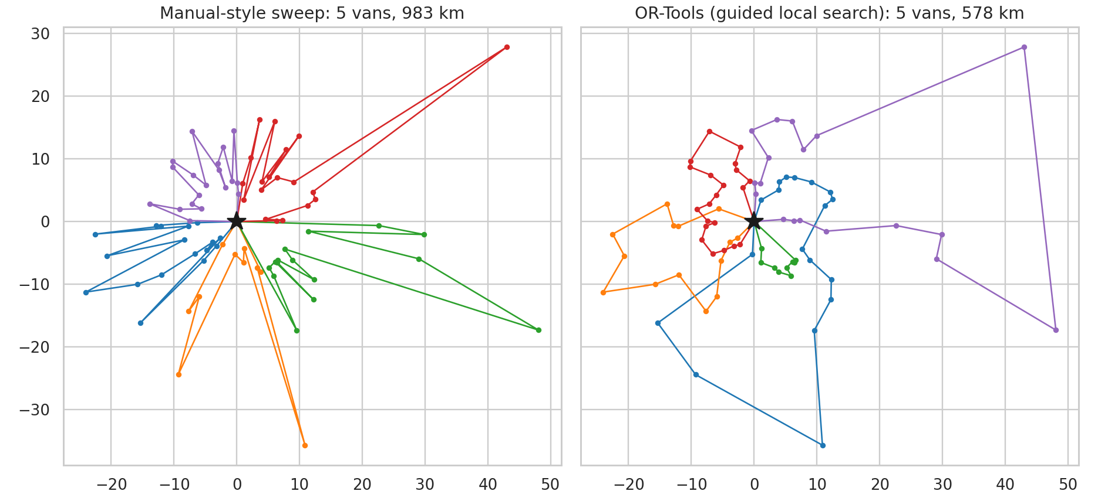
Figure 2: Manual-style sweep (left) vs OR-Tools routes (right). The star is the depot.
Result: the optimised plan uses the same 5 vans (the capacity minimum for 290 kg is 5) and shortens total distance from 983 km to 578 km (41.2%). Interpretation with caution: the saving is large because the baseline ignores distance between stops within a van, and because stop bearings are random, which is a worst case for a sweep. A realistic estimate against an experienced dispatcher would be smaller. The pilot nevertheless shows that the routing model works and is fast. The next step is validation on benchmark instances with time windows (Solomon, CVRPLIB) and on real addresses with OSRM travel times.

6. Strategic Roadmap (updated with pilot findings)
Stage | Activities | Outputs | Status
1. Data collection | Obtain real extracts or public datasets; build distance matrices (OSRM); document the data dictionary | Raw data, data catalogue | Simulated data done; public data next
2. Cleaning | Duplicates, label standardisation, dates, outliers, imputation, scaling | Clean tables, quality report | Done (Week 2)
3. Exploratory analysis | Distributions, correlations, performance by mode, carrier and zone, seasonality | KPI baseline, insights | Done (Week 3); baseline in Section 4
4. Modelling | Delivery-time model; demand forecast (SKU level on M5); clustering | Validated models | Done for delivery time (Week 4); forecasting redesigned
5. Optimisation | VRP with time windows; carrier assignment | Routes, allocation plan | Pilots done (Section 5.4, Week 4)
6. Evaluation | Re-compute KPIs, A/B pilot, sensitivity analysis | Decision report | Planned
7. Monitoring | Retraining and drift checks | Dashboard | Planned
Table 3: Roadmap and status. Validation always uses chronological splits and a naive baseline.

6.1 Risks and mitigation
Risk | Evidence / impact | Mitigation
ML does not beat the baseline on small series | Pilot A: WAPE 18.9% vs 16.2% | Keep baseline; use richer data (M5); report negative results
Simulated data differs from reality | Relationships are designed, not discovered | Treat as method demonstration; re-run on public/real data
Routing pilot is optimistic | Random stop bearings, weak baseline | Benchmark instances; real coordinates; compare with real dispatcher plans
Missing KPIs (fill rate, turnover) | Not recorded in shipment data | Add inventory and order-line data

7. Conclusion and Expected Impact
The pilots confirm that the analytical approach is feasible and show where it is most useful. Delivery performance problems are concentrated in two places (Same-Day and outstation lanes), so targeted changes in promises, carrier allocation and routing are likely to yield more than network-wide changes. Route optimisation shows a large potential distance saving (an upper bound of about 41% in the pilot), forecasting needs richer data and a baseline-first approach, and segmentation shows that outstation shipments should be handled as a separate service. Weeks 2–4 develop these steps: a documented cleaning pipeline, an exploratory analysis with seven visualisations, and a delivery-time model (test RMSE 4.7 h, R² 0.94) used to set data-driven promises and allocate carriers.
Impact on decisions: promise setting by lane, carrier contracts and capacity, outstation pricing, and fleet and van planning in peak season. All improvement figures in this report are pilot results on simulated data and are labelled as such; they become business claims only after replication on real data and a live A/B test.

8. Code Repository and Reproducibility
Repository: https://github.com/Deepakkumar-3/logistics_analyst_intern. Run the scripts in this order (Python 3.11+; pandas, numpy, scipy, scikit-learn, matplotlib, seaborn, ortools):
File | Purpose
gen_data.py | Simulates the raw shipment extract with realistic data-quality problems (seed 42)
clean.py | Week 2 pipeline: profile, clean, impute, scale; writes clean_shipments.csv and figures
eda.py | Week 3: statistics and seven visualisations
model.py | Week 4: model comparison, tuning, promise and carrier optimisation
w1_evidence.py | Week 1: KPI baseline, forecasting, clustering and routing pilots
logs/*.txt | Console output of each run (the output blocks shown in the reports)

9. References
- Dantzig, G. B., & Ramser, J. H. (1959). The truck dispatching problem. Management Science, 6(1), 80–91.
- Toth, P., & Vigo, D. (Eds.). (2014). Vehicle Routing: Problems, Methods, and Applications (2nd ed.). SIAM.
- Chopra, S., & Meindl, P. Supply Chain Management: Strategy, Planning, and Operation. Pearson.
- Hyndman, R. J., & Athanasopoulos, G. Forecasting: Principles and Practice (3rd ed.). OTexts, otexts.com/fpp3.
- Makridakis, S., Spiliotis, E., & Assimakopoulos, V. (2022). M5 accuracy competition: Results, findings, and conclusions. International Journal of Forecasting, 38(4), 1346–1364.
- Perron, L., & Furnon, V. Google OR-Tools. developers.google.com/optimization.
- Olist. Brazilian E-Commerce Public Dataset. Kaggle.
- Constante, F., Silva, F., & Pereira, A. DataCo Smart Supply Chain for Big Data Analysis. Mendeley Data.
- Solomon, M. M. (1987). Algorithms for the vehicle routing and scheduling problems with time window constraints. Operations Research, 35(2), 254–265.

