Week 2 Task
Data Collection, Cleaning and Preprocessing
A reproducible preprocessing pipeline for shipment-level logistics data
Name: ____________________ Date: 31 October 2026
Code repository: github.com/Deepakkumar-3/logistics_analyst_intern

1. Introduction and Objectives
Poor data quality is one of the most common reasons logistics analytics projects fail: a late-delivery model trained on wrong timestamps, or a cost model trained on unit errors, produces confident but wrong answers. This report documents a complete preprocessing pipeline, built and executed in Python (pandas, NumPy, scikit-learn, SciPy), for a shipment-level logistics dataset. Every number, table and chart below comes from the code in the accompanying repository, not from assumptions.
Objectives: (1) describe the data collection and its characteristics; (2) detect the main quality problems (duplicates, inconsistent labels, missing values, outliers, invalid dates); (3) fix each one with a justified method; (4) normalise and encode the data for modelling; (5) verify that the fixes worked; and (6) reflect on how data quality affects logistics decisions.

2. Data Collection Simulation

2.1 Reference dataset and provenance
The reference design follows public e-commerce logistics datasets such as the Olist Brazilian E-Commerce data and the DataCo Smart Supply Chain data, which record order timestamps, shipping mode, carrier, distances and delivery outcomes. Because those files differ in schema and country, a shipment-level extract was simulated for a Chennai-style metropolitan network, with the script gen_data.py (random seed 42), so that the true values are known and the quality of the cleaning can be measured objectively. The simulated extract mimics what a transport management system export looks like: manual entries, mixed date formats and system defaults. The same pipeline applies unchanged to a real extract.

2.2 Dataset characteristics
The raw extract has 6,180 rows and 16 columns covering 1 Nov 2025 to 15 Oct 2026, three fulfilment centres (FC), five delivery zones, three carriers and three shipping modes.
Column | Type | Description
order_id | text (key) | Unique shipment identifier
order_ts, delivery_ts | datetime (as text) | Order placement and delivery times; two formats mixed
fc, zone | category | Fulfilment centre; delivery zone (Metro-Core, Metro-North, Metro-South, Suburban, Outstation)
carrier, shipping_mode | category | Carrier-A/B/C; Standard, Express, Same-Day
distance_km | numeric | Road distance from FC to customer
weight_kg, volume_m3, n_items | numeric | Parcel weight, volume, item count
order_value_inr, transport_cost_inr | numeric | Order value and cost of transport, in INR
rain_mm, traffic_index | numeric | Rainfall on the order day; traffic index 1–10 at order time
promised_hours | numeric | Delivery promise: Standard 72 h, Express 36 h, Same-Day 10 h
Table 1: Raw data dictionary.
Reading everything as text first is deliberate: it stops pandas from silently guessing types and lets bad tokens such as "N/A" or "-" be found and handled explicitly.
raw = pd.read_csv("data/raw_shipments.csv", dtype=str, keep_default_na=False) # read everything as text first
R["raw_shape"] = list(raw.shape)
print(raw.info())
print(raw.head())

Output:
RangeIndex: 6180 entries, 0 to 6179
Data columns (total 16 columns):
# Column Non-Null Count Dtype
--- ------ -------------- -----

3. Data Quality Assessment
Before changing anything, the data is profiled: missing values per column, duplicates, and the minimum, median and maximum of every numeric column. The profile is what exposes problems such as a distance of 9999 km or a weight of 12,400 kg.
MISSING_TOKENS = ["", "N/A", "n/a", "NA", "-", "null", "None"]
df = raw.replace(MISSING_TOKENS, np.nan) # unify all "missing" encodings
num_cols = ["distance_km", "weight_kg", "volume_m3", "n_items", "order_value_inr",
"transport_cost_inr", "rain_mm", "traffic_index", "promised_hours"]
for c in num_cols:
df[c] = pd.to_numeric(df[c], errors="coerce") # text -> numbers (bad tokens -> NaN)
miss_before = df.isna().mean().mul(100).round(2).sort_values(ascending=False)
print(miss_before[miss_before > 0])
print("Duplicate rows:", df.duplicated().sum(), "| duplicate order_id:", df.order_id.duplicated().sum())
print(df[num_cols].describe().T[["min", "50%", "max"]])

Output:
rain_mm 8.07
weight_kg 6.04
volume_m3 5.03
distance_km 3.95
traffic_index 3.03
transport_cost_inr 1.99
carrier 1.96
delivery_ts 1.47
dtype: float64
Duplicate rows: 180 | duplicate order_id: 180
min 50% max
distance_km 3.1000 14.9000 9999.0000
weight_kg -10.3600 2.4300 12400.0000
volume_m3 0.0008 0.0188 0.5476
n_items 1.0000 2.0000 15.0000
order_value_inr 150.0000 1446.5000 35654.0000
transport_cost_inr 44.0000 106.0000 18552.0000
rain_mm 0.0000 0.4000 77.4000
traffic_index 1.0000 4.0000 10.0000
promised_hours 10.0000 72.0000 72.0000

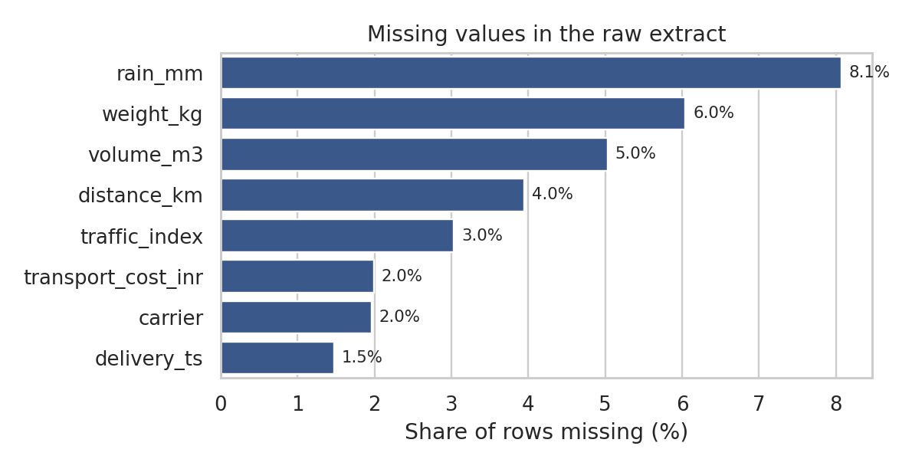
Figure 1: Share of missing values per column in the raw extract.
Summary of the issues found:
Issue | Size in raw data | How it was identified
Duplicate records | 180 rows (2.9%) | df.duplicated() and duplicate order_id
Inconsistent category labels | 12 spellings of 3 shipping modes; 13 of 3 carriers; 13 of 5 zones | value_counts() on each category column
Missing values | rain_mm 8.07%, weight_kg 6.04%, volume_m3 5.03%, distance_km 3.95%, traffic_index 3.03%, cost 1.99%, carrier 1.96% | isna() after converting 'N/A', '-' and blanks to NaN
Missing or impossible dates | 89 missing delivery times; 48 deliveries before the order | pd.to_datetime(errors='coerce') and delivery_ts < order_ts
Unit errors | 52 weights above 100 kg (max 12,400): grams entered as kg | describe(): max far above the median; domain rule
Impossible values | 18 negative weights; 29 distances of 9999 km (placeholder) | describe(): negative minimum; domain rule
Cost outliers | 65 implausible transport costs (decimal slips, up to INR 18,552) | IQR fences on cost per km within each shipping mode
Table 2: Data-quality issues found before cleaning.

4. Cleaning Methodology
The order of the steps matters: duplicates and labels first (so group statistics are right), then dates and the target variable, then outliers (which turn bad values into missing values), then imputation, then feature creation and scaling.

4.1 Duplicates and inconsistent labels
- Why: duplicates double-count volume and bias every KPI; inconsistent spellings split one category into many, so group-by averages and one-hot encoders produce meaningless columns.
- How: drop exact duplicates and then duplicates by key (order_id); standardise labels by trimming, lower-casing and removing separators, and mapping to a canonical name. Missing carriers become an explicit 'Unknown' category instead of a guessed carrier.
- Effect: the 3 category columns drop from 12 / 13 / 13 spellings to 3 / 4 / 5 clean levels, and 180 duplicate rows are removed.
n0 = len(df)
df = df.drop_duplicates().drop_duplicates(subset="order_id", keep="first") # exact, then key-based
R["dups_removed"] = n0 - len(df)

# standardise categorical labels: trim, lower-case, remove separators, then map to canonical names
def canon(s, mapping):
key = s.str.strip().str.lower().str.replace(r"[\s_-]+", "", regex=True)
return key.map(mapping)
df["shipping_mode"] = canon(df.shipping_mode, {"standard": "Standard", "std": "Standard", "express": "Express",
"sameday": "Same-Day"})
df["carrier"] = canon(df.carrier.fillna("unknown"), {"carriera": "Carrier-A", "carrierb": "Carrier-B",
"carrierc": "Carrier-C", "unknown": "Unknown"})
df["zone"] = canon(df.zone, {"metrocore": "Metro-Core", "metronorth": "Metro-North", "metrosouth": "Metro-South",
"suburban": "Suburban", "outstation": "Outstation"})
print(df[["shipping_mode", "carrier", "zone"]].apply(lambda s: s.value_counts(dropna=False).to_dict()))

shipping_mode {'Standard': 3591, 'Express': 1791, 'Same-Day': 618}
carrier {'Carrier-A': 2623, 'Carrier-B': 1786, 'Carrier-C': 1471, 'Unknown': 120}
zone {'Metro-Core': 1778, 'Metro-South': 1208, 'Metro-North': 1143, 'Suburban': 1093, 'Outstation': 778}

4.2 Dates and the target variable
- Why: mixed date formats (2026-01-05 vs 05/01/2026) are ambiguous, and a delivery before its order is physically impossible. The delivery time in hours is the key metric for the later analysis and modelling weeks.
- How: parse the ISO format first and the day-first format only for the rows that failed, which avoids day/month swaps. Rows with a missing or impossible delivery timestamp are removed, because the target cannot be reconstructed honestly.
- Effect: 89 rows with missing and 48 rows with impossible delivery times were dropped (about 2.3% of rows). Deleting is acceptable here as the share is small, and imputing a target would bias the models.
# Pass 1: ISO format; pass 2: day-first format for the rows that failed (avoids day/month ambiguity)
def parse_dt(s):
out = pd.to_datetime(s, format="%Y-%m-%d %H:%M:%S", errors="coerce")
alt = pd.to_datetime(s[out.isna()], format="%d/%m/%Y %H:%M", errors="coerce")
return out.fillna(alt)
df["order_ts"] = parse_dt(df.order_ts)
df["delivery_ts"] = parse_dt(df.delivery_ts)
bad_missing = df.delivery_ts.isna() | df.order_ts.isna()
bad_logic = df.delivery_ts < df.order_ts # delivery before order = impossible
R["bad_dates_missing"], R["bad_dates_logic"] = int(bad_missing.sum()), int(bad_logic.sum())
df = df[~(bad_missing | bad_logic)].copy()
df["delivery_hours"] = (df.delivery_ts - df.order_ts).dt.total_seconds() / 3600 # target variable

4.3 Outlier detection and treatment
Not every extreme value is an error. A 300 km outstation parcel is rare but real; a 12,400 kg parcel is not. The pipeline therefore combines three rules and treats the cases differently:
- Domain rules (certain errors): weight ≤ 0 and distance > 1000 km are impossible, so they are set to missing and re-estimated.
- Unit-error correction: weights above 100 kg whose conversion from grams gives a plausible value are divided by 1000 (corrected, not deleted, so the record is kept).
- Statistical rule (IQR): cost per km is compared within each shipping mode using fences of 3 × IQR beyond the quartiles; flagged costs are set to missing. Using cost per km instead of raw cost protects genuine long-distance shipments.
- Winsorising: remaining right-skewed values of weight and order value are clipped at the 1st and 99th percentiles to limit the leverage of rare extremes on linear models.
# (a) domain rules: physically impossible values are errors, not "extreme but real"
R["neg_weight"] = int((df.weight_kg <= 0).sum())
df.loc[df.weight_kg <= 0, "weight_kg"] = np.nan
df.loc[df.distance_km > 1000, "distance_km"] = np.nan # 9999 = placeholder; metro/outstation network < 1000 km

# (b) unit error: a value > 100 kg whose gram->kg conversion is plausible is rescaled
unit_err = df.weight_kg > 100
R["unit_errors"] = int(unit_err.sum())
df.loc[unit_err, "weight_kg"] = df.loc[unit_err, "weight_kg"] / 1000

# (c) statistical rule: cost per km by shipping mode -> IQR fences flag decimal slips
df["cost_per_km"] = df.transport_cost_inr / df.distance_km
def iqr_flag(s, k=3.0):
q1, q3 = s.quantile([.25, .75]); i = q3 - q1
return (s < q1 - k * i) | (s > q3 + k * i)
cost_out = df.groupby("shipping_mode")["cost_per_km"].transform(lambda s: iqr_flag(s))
cost_out |= df.transport_cost_inr > df.transport_cost_inr.quantile(.995) * 3
R["cost_outliers"] = int(cost_out.sum())
df.loc[cost_out, "transport_cost_inr"] = np.nan

# (d) remaining right-skew values are genuine (heavy parcels): winsorise at 1st/99th percentile
for c in ["weight_kg", "order_value_inr"]:
lo, hi = df[c].quantile([.01, .99]); df[c] = df[c].clip(lo, hi)
df = df.drop(columns="cost_per_km")

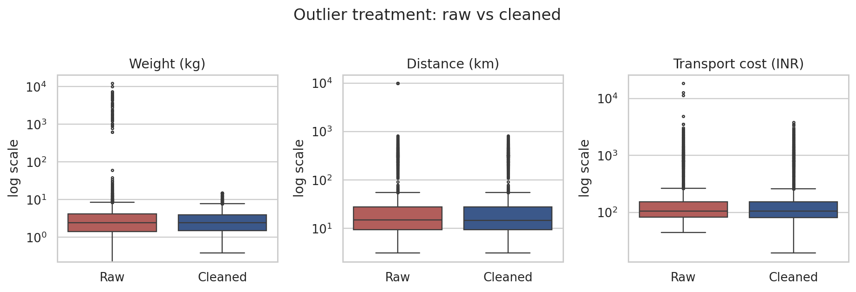
Figure 2: Raw vs cleaned distributions (log scale). The 4-digit weight and 9999 km placeholders disappear and the boxes keep their shape.
Column | Raw min / max | Cleaned min / max | Median (raw → cleaned)
weight_kg | -10.36 / 12,400 | 0.38 / 14.95 | 2.43 → 2.41
distance_km | 3.1 / 9,999 | 3.1 / 818.8 | 14.9 → 14.8
transport_cost_inr | 44 / 18,552 | 19.25 / 3823.44 | 106 → 105
Table 3: Effect of outlier treatment. Medians barely move, which shows the typical shipment was not distorted.

4.4 Missing-value imputation
Dropping all rows with any missing value would discard about 27% of the rows and, worse, would not be random (for example, rain data may be missing more on rainy days). Instead each variable is filled using its logistics logic:
Variable | Method | Reason
distance_km | Median by delivery zone | Zone largely determines distance: an outstation order is never 10 km
weight_kg | Global median | Skewed, so the median is robust; no strong group driver
rain_mm | Median by month | Rainfall is seasonal (monsoon months)
traffic_index | Median by hour of day | Traffic follows the daily rush-hour pattern
volume_m3 | weight × median volume-to-weight ratio | Physical relationship between weight and volume
transport_cost_inr | Median cost per km (by mode) × distance | Preserves the pricing structure of each service
carrier | 'Unknown' category | Guessing a carrier would invent information
Table 4: Imputation methods.
An indicator column (e.g. distance_km_was_missing) is added before imputation, so models can use the fact that a value was missing, and analysts can audit what was filled.
# keep a record of what was imputed (missingness can itself be informative)
for c in ["distance_km", "weight_kg", "rain_mm", "traffic_index"]:
df[f"{c}_was_missing"] = df[c].isna().astype(int)

df["month"] = df.order_ts.dt.month; df["hour"] = df.order_ts.dt.hour
df["distance_km"] = df.distance_km.fillna(df.groupby("zone")["distance_km"].transform("median")) # zone drives distance
df["weight_kg"] = df.weight_kg.fillna(df.weight_kg.median()) # skewed -> median
df["rain_mm"] = df.rain_mm.fillna(df.groupby("month")["rain_mm"].transform("median")) # seasonal
df["traffic_index"] = df.traffic_index.fillna(df.groupby("hour")["traffic_index"].transform("median")).round()
ratio = (df.volume_m3 / df.weight_kg).median() # physical relationship
df["volume_m3"] = df.volume_m3.fillna(df.weight_kg * ratio)
rate = (df.transport_cost_inr / df.distance_km).groupby(df.shipping_mode).transform("median")
df["transport_cost_inr"] = df.transport_cost_inr.fillna(rate * df.distance_km)
df["n_items"] = df.n_items.fillna(1).astype(int)

4.5 Verifying the imputation
Since the true values are known for this simulated data, the quality of the imputation can be tested directly. For the 261 shipments with missing distance, the zone-based median has a mean absolute error of 15.9 km, versus 47.6 km if the overall median had been used, which is 67% smaller. For missing weights, the mean absolute error is 2.11 kg, against a typical weight of about 2.4 kg, which is large relative to the typical weight, so weight is the least well-reconstructed field and its missing flag is kept for modelling. After all steps the dataset has 0 missing values.

5. Feature Engineering, Normalisation and Encoding
- Derived features: delivery_hours (target), on_time flag, cost per km, weight density, weekday, hour, month and weekend flag, which expose the time and cost patterns used in Weeks 3 and 4.
df["is_weekend"] = (df.order_ts.dt.dayofweek >= 5).astype(int)
df["weekday"] = df.order_ts.dt.dayofweek
df["on_time"] = (df.delivery_hours <= df.promised_hours).astype(int)
df["cost_per_km"] = df.transport_cost_inr / df.distance_km
df["density_kg_m3"] = df.weight_kg / df.volume_m3

- Log transformation: distance, weight, order value and cost are right-skewed (skewness 1.8 to 3.6). log1p compresses long tails so that distance-based and distance-sensitive algorithms are not dominated by a few outstation orders.
- Standardisation (z-score): centres each variable at 0 with unit variance, which matters for regularised regression, K-Means and any distance-based method.
- Min–max scaling: rescales bounded variables (traffic index, rainfall) to 0–1.
- One-hot encoding: converts categorical variables into binary columns. No ordering is implied between carriers or zones.
from sklearn.preprocessing import StandardScaler, MinMaxScaler
skewed = ["distance_km", "weight_kg", "order_value_inr", "transport_cost_inr"]
sk_before = {c: float(skew(df[c])) for c in skewed}
logged = np.log1p(df[skewed]) # tame right skew first
sk_after = {c: float(skew(logged[c])) for c in skewed}
z = pd.DataFrame(StandardScaler().fit_transform(logged), columns=[c + "_z" for c in skewed], index=df.index)
mm = pd.DataFrame(MinMaxScaler().fit_transform(df[["traffic_index", "rain_mm"]]),
columns=["traffic_mm", "rain_mm_mm"], index=df.index)
model_ready = pd.concat([df, z, mm], axis=1)
model_ready = pd.get_dummies(model_ready, columns=["shipping_mode", "carrier", "zone", "fc"], dtype=int)
print(z.describe().loc[["mean", "std"]].round(3)); print(mm.describe().loc[["min", "max"]])

Output:
distance_km_z weight_kg_z order_value_inr_z transport_cost_inr_z
mean -0.0 -0.0 -0.0 0.0
std 1.0 1.0 1.0 1.0
traffic_mm rain_mm_mm
min 0.0 0.0
max 1.0 1.0

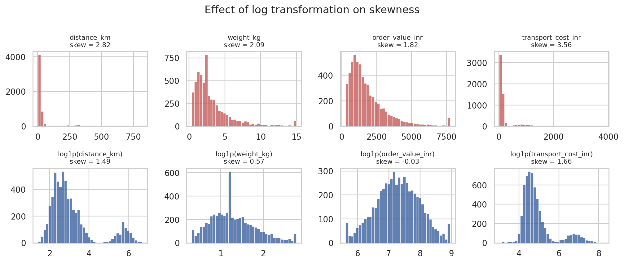
Figure 3: Distributions before (top) and after (bottom) log transformation.
Variable | Skewness before | Skewness after log1p | Comment
distance_km | 2.82 | 1.49 | Still bimodal: metro vs outstation
weight_kg | 2.09 | 0.57 | Close to symmetric
order_value_inr | 1.82 | -0.03 | Symmetric
transport_cost_inr | 3.56 | 1.66 | Improved; outstation cluster remains
Table 5: Skewness before and after transformation. Log transformation reduces but does not remove the outstation effect, which is real structure, not noise.
Methodological note: the scaling shown above is applied to the whole file for demonstration. In the modelling stage (Week 4) the scalers are fitted inside a scikit-learn Pipeline on the training period only, to prevent information from the test period leaking into training.
df.to_csv("data/clean_shipments.csv", index=False)
model_ready.to_csv("data/model_ready_shipments.csv", index=False)

6. Results of the Pipeline
Measure | Raw | Clean | Change
Rows | 6,180 | 5,863 | −317 (5.1%)
Duplicate order_id | 180 | 0 | removed
Category spellings (mode / carrier / zone) | 12 / 13 / 13 | 3 / 4 / 5 | standardised
Missing values in numeric fields | about 2–8% per column | 0 | imputed + flagged
Impossible values (weight ≤ 0, distance 9999, delivery before order) | presented in Table 2 | 0 | corrected or removed
Columns | 16 | 28 | + derived features
Model-ready columns (scaled and one-hot) | – | 45 | clean + encoded
Table 6: Summary of the pipeline impact.
Output files: clean_shipments.csv (5,863 rows, 28 columns) and model_ready_shipments.csv (45 columns). They feed the analysis in Week 3 and the models in Week 4.

7. Reflection: Why Data Quality Matters in Logistics
The cleaning steps are not cosmetic; each one changes a business number:
- KPIs: left uncorrected, the gram-entry weights and 9999 km placeholders inflate the mean weight to 36.2 kg (clean: 3.2 kg, about 11× too high) and the mean distance to 106.8 km (clean: 57.8 km, nearly double), so cost-per-kg and cost-per-km KPIs would be meaningless.
- Service levels: deliveries 'before the order' and missing timestamps would silently drop or distort on-time delivery calculations, hiding the very late shipments that customers complain about.
- Models: regression and tree models learn the pattern in the data they are given. Outliers distort the fitted line; inconsistent labels cause the same carrier to be treated as three different ones; leakage makes accuracy look better than it will be in production.
- Decisions: carrier negotiation, fleet sizing and promise-date setting depend on correct distances, weights and times. Errors propagate: a wrong input leads to a wrong forecast, and then to wrong staffing or wrong stock.
- Trade-offs: every cleaning choice has a cost. Deleting rows loses information; imputing adds assumptions; winsorising hides rare real events. The pipeline therefore keeps flags, documents each rule and verifies imputation against known values.
Limitations: the dataset is simulated, so the injected errors are more regular than real-world ones, and a real extract would need additional business rules (for example from warehouse and carrier staff). The method, however, transfers directly.

8. References
- McKinney, W. (2022). Python for Data Analysis (3rd ed.). O'Reilly Media.
- Little, R. J. A., & Rubin, D. B. (2019). Statistical Analysis with Missing Data (3rd ed.). Wiley.
- Tukey, J. W. (1977). Exploratory Data Analysis. Addison-Wesley (IQR outlier rule).
- Pedregosa, F. et al. (2011). Scikit-learn: Machine learning in Python. Journal of Machine Learning Research, 12, 2825–2830.
- pandas development team. pandas documentation. pandas.pydata.org
- Olist. Brazilian E-Commerce Public Dataset (Kaggle); DataCo Smart Supply Chain for Big Data Analysis (Mendeley Data).

