Week 3 Task
Advanced Data Analysis and Visualization in Logistics
Exploratory analysis of 5,863 shipments: efficiency, cost drivers and bottlenecks
Name: ____________________ Date: 31 October 2026
Code repository: github.com/Deepakkumar-3/logistics_analyst_intern

1. Introduction
This report analyses a shipment-level logistics dataset to answer three operational questions: (1) where is delivery performance weak, (2) what drives delivery time and cost, and (3) which bottlenecks should be addressed first. The analysis uses Python (pandas, NumPy, matplotlib, seaborn); every figure and number is generated by the scripts in the repository. Each visualisation is chosen for a specific analytical purpose, which is justified next to the chart.

2. Dataset Definition
The dataset is the cleaned output of the Week 2 pipeline: 5,863 shipments from 1 Nov 2025 to 15 Oct 2026, simulated for a metropolitan e-commerce network with three fulfilment centres (FC), five zones, three carriers and three service levels. It was generated with a fixed random seed and then cleaned (see Week 2), so all results are reproducible. Because the data is simulated, the relationships described below are the ones built into the simulator plus noise; they demonstrate the method, and conclusions about a real company would need its own data.
Variable | Role | Meaning
delivery_hours | Target / KPI | Hours between order and delivery
on_time | KPI | 1 if delivery_hours ≤ promised_hours (Standard 72 h, Express 36 h, Same-Day 10 h)
shipping_mode, carrier, zone, fc | Dimensions | Service level, carrier, delivery zone, fulfilment centre
distance_km, weight_kg, n_items | Shipment volume / size | Distance from FC; parcel weight and item count
transport_cost_inr, cost_per_km | Cost | Cost per shipment and per kilometre
rain_mm, traffic_index, hour, month, is_weekend | External / time drivers | Weather, congestion, calendar effects
Table 1: Key variables.
df = pd.read_csv("data/clean_shipments.csv", parse_dates=["order_ts", "delivery_ts"])
df["month_p"] = df.order_ts.dt.to_period("M").dt.to_timestamp()
print(df.shape); print(df.dtypes.value_counts())

Output:
(5863, 29)
int64 11
float64 10
str 5
datetime64[us] 3
Name: count, dtype: int64

3. Exploratory Data Analysis

3.1 Central tendency and dispersion
num = ["delivery_hours", "distance_km", "weight_kg", "transport_cost_inr", "rain_mm", "traffic_index"]
desc = df[num].agg(["mean", "median", "std", "skew"]).T.round(2)
desc["mode"] = [df[c].round(0).mode().iloc[0] for c in num]
print(desc)
by_mode = df.groupby("shipping_mode").agg(orders=("order_id", "count"), mean_hours=("delivery_hours", "mean"),
p90_hours=("delivery_hours", lambda s: s.quantile(.9)), on_time=("on_time", "mean"),
cost=("transport_cost_inr", "mean"))
by_carrier = df.groupby("carrier").agg(orders=("order_id", "count"), mean_hours=("delivery_hours", "mean"),
on_time=("on_time", "mean"), cost_per_km=("cost_per_km", "median"))
by_zone = df.groupby("zone").agg(orders=("order_id", "count"), mean_hours=("delivery_hours", "mean"),
on_time=("on_time", "mean"), cost=("transport_cost_inr", "mean"), cost_per_km=("cost_per_km", "median"))
corr = df[num + ["n_items", "order_value_inr"]].corr(method="spearman")
print(by_mode.round(2)); print(by_carrier.round(2)); print(by_zone.round(2)); print(corr["delivery_hours"].round(2))

Output:
mean median std skew mode
delivery_hours 35.68 38.32 18.38 0.72 42.0
distance_km 57.84 14.80 115.66 2.82 8.0
weight_kg 3.23 2.41 2.70 2.09 2.0
transport_cost_inr 226.69 105.00 354.07 3.56 74.0
rain_mm 2.05 0.30 4.88 5.22 0.0
traffic_index 4.35 4.00 2.23 0.42 3.0

Delivery time has a mean of 35.7 h and a median of 38.3 h, with a standard deviation of 18.4 h. Distance, weight, and cost are strongly right-skewed (skewness 2.8, 2.1 and 3.6), and their means (57.8 km, INR 226.7) are far above the medians (14.8 km, INR 105.0). This means the average hides the typical shipment: a small group of long-distance outstation shipments pulls the mean up. The median and the mode (the most common distance is only 8 km) are better descriptions of a 'typical' order, and the mean is better for total-cost planning.

3.2 Performance by service level, carrier and zone
Output:
orders mean_hours p90_hours on_time cost
shipping_mode
Express 1747 22.26 36.81 0.89 328.82
Same-Day 600 9.52 14.60 0.55 149.18

Output:
orders mean_hours on_time cost_per_km
carrier
Carrier-A 2561 35.39 0.90 6.82
Carrier-B 1745 38.87 0.82 6.09
Carrier-C 1437 32.68 0.91 7.48

Output:
orders mean_hours on_time cost cost_per_km
zone
Metro-Core 1739 31.20 0.96 83.11 9.88
Metro-North 1114 31.59 0.94 104.97 7.22
Metro-South 1186 31.85 0.95 108.38 6.76
Outstation 758 61.28 0.40 1020.25 2.73

Overall on-time delivery is 87.7%. The result differs strongly by dimension: Same-Day on-time is only 55.3% against 89.2% for Express and 92.4% for Standard; Carrier-B reaches 81.8% against 89.5% (A) and 91.2% (C); and the Outstation zone reaches only 39.8% against 94–96% in every metro and suburban zone.

3.3 Correlations
Output:
delivery_hours 1.00
distance_km 0.29
weight_kg 0.04
transport_cost_inr 0.02
rain_mm 0.05
traffic_index 0.06
n_items 0.03
order_value_inr -0.00
Name: delivery_hours, dtype: float64

Spearman (rank) correlation is used instead of Pearson because most variables are skewed and the relationships are not necessarily linear.

4. Visualizations and Interpretation

4.1 Distribution of delivery time (histogram)
Why this chart: a histogram shows the full shape of a metric, not just its average; layering by shipping mode shows whether one 'overall' number is hiding several different processes.
fig, ax = plt.subplots(figsize=(8, 4))
sns.histplot(data=df, x="delivery_hours", hue="shipping_mode", palette=PAL, bins=50, element="step", ax=ax)
ax.axvline(df.delivery_hours.median(), ls="--", c="k", lw=1); ax.text(df.delivery_hours.median() + 1, ax.get_ylim()[1] * .9, "overall median", fontsize=9)
ax.set(xlabel="Delivery time (hours)", ylabel="Shipments", title="Delivery-time distribution by shipping mode")
fig.tight_layout(); fig.savefig("figs/w3_hist.png", dpi=170)

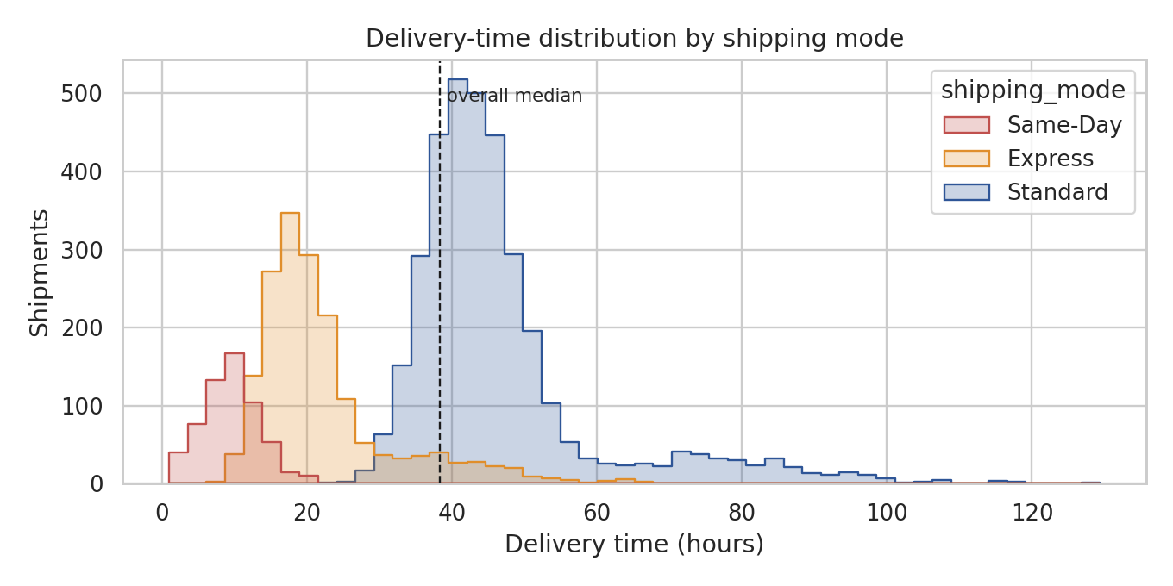
Figure 1: Delivery-time distribution by shipping mode.
Three separate populations are visible. Same-Day peaks near 9.5 h, Express near 22.3 h and Standard near 46.8 h. The Standard curve has a long right tail out to about 130 h, which is made up of outstation parcels. The Same-Day distribution overlaps its 10 h promise, which is why only 55.3% are on time: the promise sits in the middle of the distribution, not above it.

4.2 Carrier and zone comparison (box plots)
Why this chart: box plots compare medians, spread and outliers across many groups at once and show reliability (spread), not just speed. Standard shipments are used for the zone comparison to remove the effect of service level.
fig, axes = plt.subplots(1, 2, figsize=(11, 4))
sns.boxplot(data=df, x="carrier", y="delivery_hours", hue="carrier", order=["Carrier-A", "Carrier-B", "Carrier-C", "Unknown"],
palette="Blues", legend=False, ax=axes[0], fliersize=2)
axes[0].set(title="Delivery time by carrier", xlabel="", ylabel="Hours")
sns.boxplot(data=df[df.shipping_mode == "Standard"], x="zone", y="delivery_hours", hue="zone",
order=["Metro-Core", "Metro-North", "Metro-South", "Suburban", "Outstation"], palette="Blues", legend=False, ax=axes[1], fliersize=2)
axes[1].set(title="Standard shipments: delivery time by zone", xlabel="", ylabel="Hours"); axes[1].tick_params(axis="x", rotation=20)
fig.tight_layout(); fig.savefig("figs/w3_box.png", dpi=170)

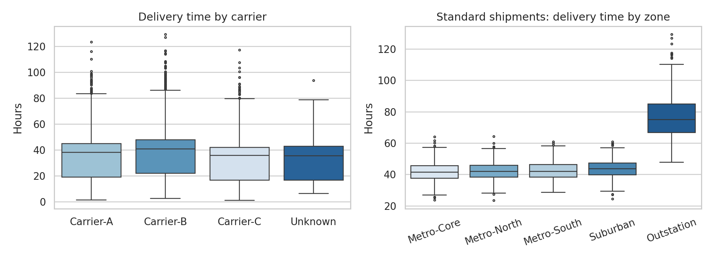
Figure 2: Delivery time by carrier (left) and by zone for Standard shipments (right).
Carrier-B has the highest median and the widest spread, and averages 38.9 h against 32.7 h for Carrier-C. The zone plot shows that the four metro and suburban zones are almost identical (median 42–44 h for Standard), but Outstation is a separate regime at a median of about 75 h. Performance does not degrade smoothly with distance: there is a step change between local delivery and line-haul.

4.3 Trend over time (dual-axis bar and line)
Why this chart: a time view is the natural way to see seasonality and capacity stress. Volume is shown as bars and the on-time rate as a line so that the relationship between load and service is visible at a glance.
monthly = df.groupby("month_p").agg(shipments=("order_id", "count"), on_time=("on_time", "mean"))
monthly = monthly[monthly.shipments > 100] # drop the partial final month
fig, ax1 = plt.subplots(figsize=(9, 4))
ax1.bar(monthly.index, monthly.shipments, width=20, color="#9DB4D8", label="Shipments")
ax1.set_ylabel("Shipments per month"); ax1.set_xlabel("")
ax2 = ax1.twinx(); ax2.plot(monthly.index, monthly.on_time * 100, color="#C0504D", marker="o", label="On-time %")
ax2.set_ylabel("On-time rate (%)"); ax2.set_ylim(60, 100); ax2.grid(False)
ax1.set_title("Monthly volume and on-time rate")
fig.legend(loc="lower left", bbox_to_anchor=(.08, .12)); fig.tight_layout(); fig.savefig("figs/w3_trend.png", dpi=170)

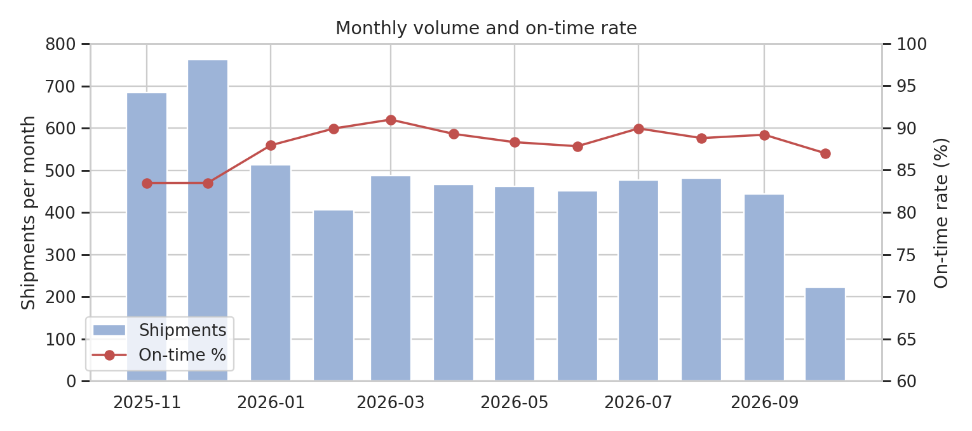
Figure 3: Monthly shipment volume and on-time rate (partial October 2026 excluded).
November and December 2025 are the peak: 684 and 763 shipments against 407–514 in most other months, and on-time performance falls to 83.5% in both peak months, versus about 88–91% in the rest of the year. The network works well at normal volume but has little capacity headroom in the festival and monsoon season.

4.4 Distance vs delivery time (scatter with regression lines)
Why this chart: a scatter plot shows the form of the relationship between two continuous variables and exposes clusters; a fitted line per mode quantifies the marginal effect of one extra kilometre.
fig, ax = plt.subplots(figsize=(7.5, 6))
sub = df.sample(1800, random_state=1)
sns.scatterplot(data=sub, x="distance_km", y="delivery_hours", hue="shipping_mode", palette=PAL, s=14, alpha=.6, ax=ax)
for m_, g in df.groupby("shipping_mode"):
k, b = np.polyfit(g.distance_km, g.delivery_hours, 1); xs = np.linspace(0, g.distance_km.max(), 50)
ax.plot(xs, k * xs + b, color=PAL[m_], lw=1.6)
R.setdefault("slopes", {})[m_] = round(float(k), 4)
ax.set(xlabel="Distance (km)", ylabel="Delivery time (hours)", title="Delivery time vs distance (lines = OLS fit per mode)")
fig.tight_layout(); fig.savefig("figs/w3_scatter.png", dpi=170)

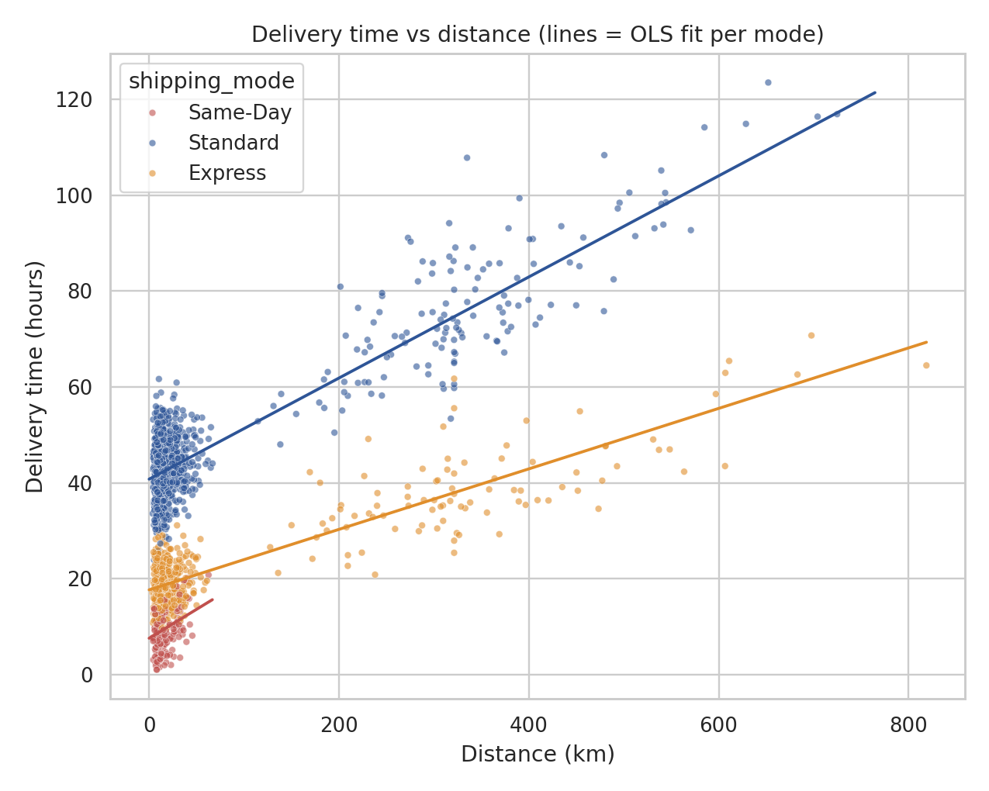
Figure 4: Delivery time vs distance, with OLS lines per shipping mode.
The fitted slopes are 10.5 extra hours per 100 km for Standard, 6.3 for Express and 12.1 for Same-Day. The intercepts differ much more than the slopes: a Standard shipment takes about 40 h even over a very short distance. Most of the delay is therefore handling and dispatch time, not driving, which suggests that process changes in the FC, such as cut-off times and picking waves, matter more than faster vehicles for metro deliveries.

4.5 Correlation heatmap
Why this chart: a heatmap summarises many pairwise relationships on one page and quickly reveals redundant variables (multicollinearity) before modelling.
fig, ax = plt.subplots(figsize=(7, 5.5))
labels = {"delivery_hours": "Delivery hrs", "distance_km": "Distance", "weight_kg": "Weight", "transport_cost_inr": "Cost",
"rain_mm": "Rain", "traffic_index": "Traffic", "n_items": "Items", "order_value_inr": "Order value"}
c2 = corr.rename(index=labels, columns=labels)
sns.heatmap(c2, annot=True, fmt=".2f", cmap="RdBu_r", center=0, vmin=-1, vmax=1, square=True, linewidths=.5, ax=ax, cbar_kws={"shrink": .8})
ax.set_title("Spearman correlation matrix"); fig.tight_layout(); fig.savefig("figs/w3_corr.png", dpi=170)

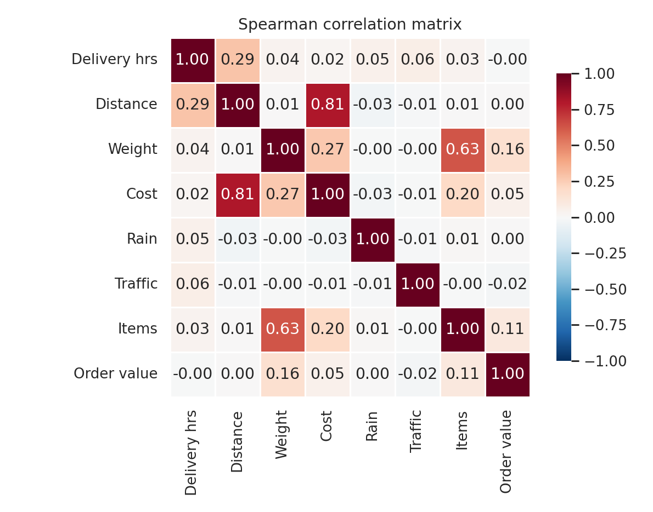
Figure 5: Spearman correlation matrix.
Distance and cost are strongly related (0.81), so they carry mostly the same information and one of them should be handled carefully in linear models. Weight and item count are also related (0.63). Distance has a modest correlation with delivery hours overall (0.29): shipping mode and zone, which are categorical, explain a large part of the remaining variation. Rain (0.05), traffic (0.06) and order value (0.00) show almost no rank correlation with delivery time overall; their effect appears only after splitting by mode (Section 4.7), a reminder that a weak overall correlation does not prove a variable is unimportant.

4.6 On-time rate by zone and carrier (heatmap)
Why this chart: a two-way colour table highlights the cells where the problem is concentrated, which a one-dimensional average cannot do.
pt = df.pivot_table(index="zone", columns="carrier", values="on_time", aggfunc="mean").loc[
["Metro-Core", "Metro-North", "Metro-South", "Suburban", "Outstation"], ["Carrier-A", "Carrier-B", "Carrier-C"]] * 100
fig, ax = plt.subplots(figsize=(6.5, 4))
sns.heatmap(pt, annot=True, fmt=".0f", cmap="RdYlGn", vmin=60, vmax=100, linewidths=.5, ax=ax, cbar_kws={"label": "On-time %"})
ax.set(title="On-time rate (%) by zone and carrier", xlabel="", ylabel=""); fig.tight_layout(); fig.savefig("figs/w3_heat.png", dpi=170)

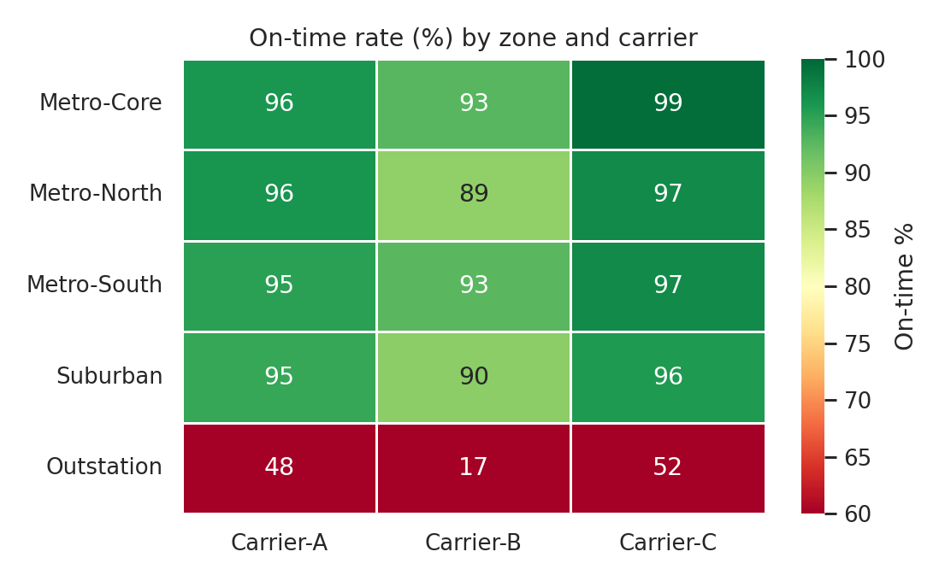
Figure 6: On-time rate (%) by zone and carrier.
All metro and suburban cells are between 89.4% and 99.5%. The outstation row is the bottleneck: 48.3% (A), 17.3% (B) and 51.8% (C). Carrier-B is on average 10.2 h slower than Carrier-A in the outstation zone, so almost every Carrier-B outstation shipment is late. Outstation shipments are 12.9% of orders but 63.0% of all late deliveries (456 of 724).

4.7 External drivers: rainfall and cost per km
Why this chart: grouped bars compare a mean across categories and are easy to read for non-technical audiences. Rainfall is binned so that its effect can be compared across service levels.
df["rain_band"] = pd.cut(df.rain_mm, [-.1, 0.5, 5, 15, 200], labels=["None", "Light (0.5-5)", "Moderate (5-15)", "Heavy (>15)"])
df["hour_band"] = pd.cut(df.hour, [5, 11, 16, 20, 23], labels=["06-11", "12-16", "17-20", "21-23"])
fig, axes = plt.subplots(1, 2, figsize=(11, 4))
rb = df.groupby(["rain_band", "shipping_mode"], observed=True).delivery_hours.mean().unstack()
rb.plot(kind="bar", ax=axes[0], color=[PAL[c] for c in rb.columns]); axes[0].set(title="Mean delivery hours by rainfall", xlabel="", ylabel="Hours")
axes[0].tick_params(axis="x", rotation=0)
cz = df.groupby("zone").agg(cost_per_km=("cost_per_km", "median"), cost=("transport_cost_inr", "mean")).loc[
["Metro-Core", "Metro-North", "Metro-South", "Suburban", "Outstation"]]
sns.barplot(x=cz.index, y=cz.cost_per_km, ax=axes[1], color="#2E5597"); axes[1].set(title="Median cost per km by zone (INR)", xlabel="", ylabel="INR / km")
axes[1].tick_params(axis="x", rotation=20)
fig.tight_layout(); fig.savefig("figs/w3_drivers.png", dpi=170)

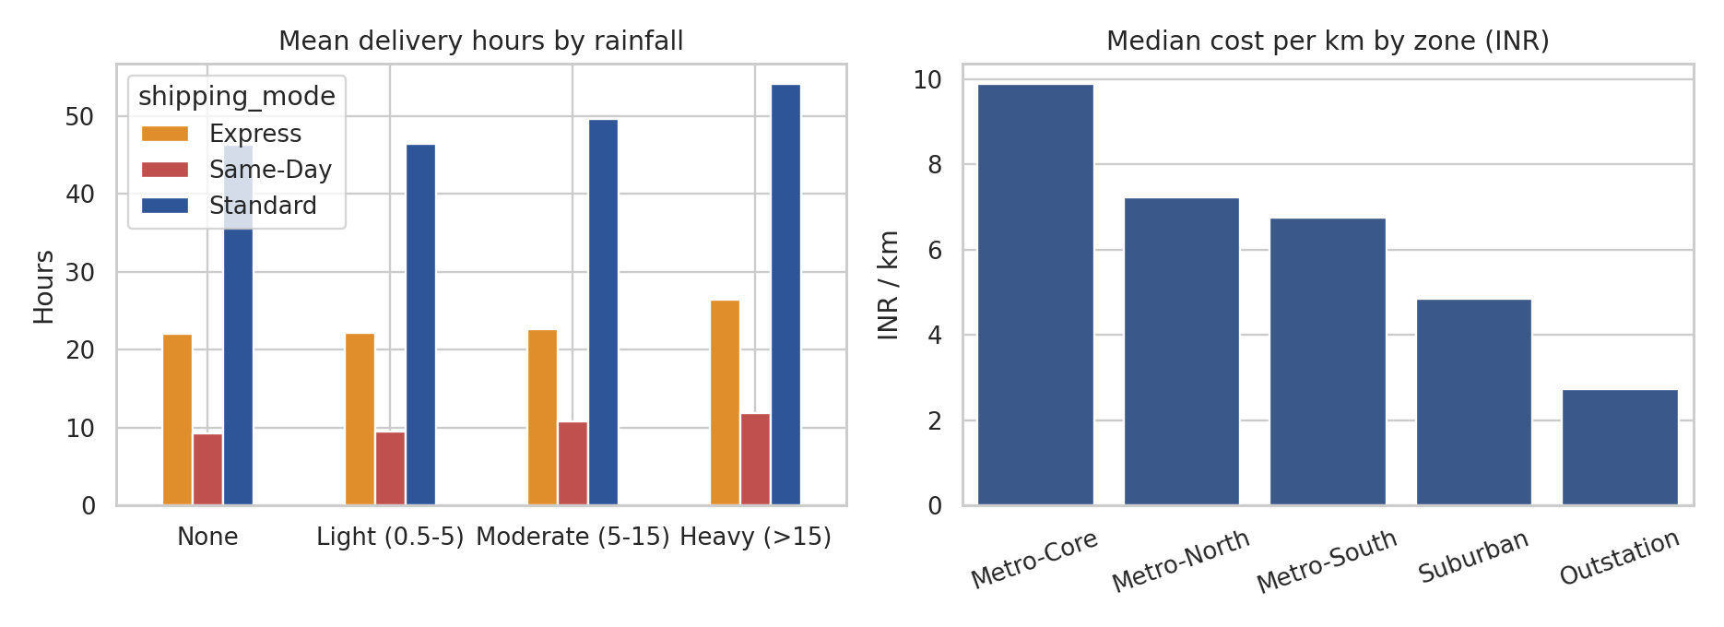
Figure 7: Mean delivery hours by rainfall band (left); median cost per km by zone (right).
Heavy rain (above 15 mm) lengthens Standard deliveries by 7.8 h (46.3 → 54.0 h), Express by 4.3 h and Same-Day by 2.6 h. In absolute terms, Same-Day is least affected, but because its promise is only 10 h, even small delays matter. Cost per km falls with distance (INR 9.88 in Metro-Core against INR 2.73 in Outstation) because fixed costs are spread over more kilometres, yet total spend is dominated by outstation volume.

4.8 Calendar effects
Standard shipments ordered on weekends take 49.7 h on average against 45.9 h on weekdays (+3.8 h). Orders placed in the 17:00–20:00 evening rush have an on-time rate of 85.5% against 88.5% for the midday window.

5. Analytical Insights

5.1 Operational efficiency
- Overall service is acceptable, but averages hide the problem: 87.7% on time overall, while Same-Day (55.3%) and Outstation (39.8%) are far below target.
- Handling time dominates metro delivery: the intercepts in Figure 4 and the near-identical metro zones show that delay is created before the vehicle leaves the FC.

5.2 Cost drivers
- Outstation: 12.9% of shipments generate 58.2% of transport cost (average INR 1020 per shipment against INR 83–155 elsewhere).
- Distance and shipping mode explain most of the cost (distance–cost correlation 0.81); Express costs on average INR 329 per shipment against INR 189 for Standard.

5.3 Bottlenecks
- Same-Day promise: 44.7% of Same-Day shipments miss the 10 h promise; the promise is set inside the normal range of delivery times.
- Outstation lane: the zone is a different process (about 61 h on average) judged against promises designed for metro delivery.
- Carrier-B: accounts for 43.9% of all late shipments but handles only 29.8% of the volume.
- Peak season: on-time rates drop by 5 percentage points in November and December.

6. Recommendations
# | Recommendation | Evidence
1 | Reset delivery promises by lane (zone × mode), or move the outstation lane to a dedicated line-haul process, rather than using one promise per service level | Outstation on-time 40%; Same-Day 55%; Figures 1, 6
2 | Re-allocate outstation volume away from Carrier-B (or renegotiate its service-level agreement) | Carrier-B outstation on-time 17%, +10 h vs Carrier-A; Figure 6
3 | Add peak-season capacity (temporary carrier capacity, extended FC shifts) for November–December | Volume +50% and on-time −5 points; Figure 3
4 | Review FC dispatch cut-offs and picking waves for Standard orders | Large intercept: about 40 h even at short distance; Figure 4
5 | Use weather alerts to extend promises or add buffer on heavy-rain days | +7.8 h for Standard shipments in heavy rain; Figure 7
6 | Review the cost-to-serve for outstation customers (minimum order value or surcharge) | 13% of orders but 58% of transport cost
Table 2: Recommendations linked to evidence. These are the hypotheses for the predictive and optimisation work in Week 4.
Limitations: results come from a simulated dataset with relationships built in by design. Correlations are descriptive and do not by themselves prove causation. Carrier comparisons assume that carriers handle comparable shipments, which a real study would need to verify.

7. Tools and Techniques
pandas (groupby, pivot_table, resample, cut) for aggregation; NumPy for fitting trend lines; matplotlib and seaborn for plots; Spearman correlation for skewed data; log scales and rank-based statistics where distributions are skewed. All code is in eda.py in the repository.

8. References
- Tukey, J. W. (1977). Exploratory Data Analysis. Addison-Wesley.
- Hunter, J. D. (2007). Matplotlib: A 2D graphics environment. Computing in Science & Engineering, 9(3), 90–95.
- Waskom, M. (2021). seaborn: statistical data visualization. Journal of Open Source Software, 6(60), 3021.
- Cleveland, W. S. (1993). Visualizing Data. Hobart Press.
- Chopra, S., & Meindl, P. Supply Chain Management: Strategy, Planning, and Operation. Pearson.

