Week 4 Task
Predictive Modeling and Optimization in Logistics Systems
Forecasting delivery time and using the forecasts to set promises and allocate carriers
Name: ____________________ Date: 31 October 2026
Code repository: github.com/Deepakkumar-3/logistics_analyst_intern

1. Problem Definition
Late deliveries are costly (refunds, support contacts, lost repeat business), yet the promise given to the customer is a fixed number per service level (72 h, 36 h, 10 h) and carriers are allocated by habit. If the delivery time of each shipment could be predicted at the moment of dispatch, the company could (1) quote realistic, shipment-specific promises, and (2) send each shipment to the carrier with the best expected cost and on-time performance.
- Prediction task: regression: predict delivery_hours (time from order to delivery) for a new shipment using only information available at order or dispatch time.
- Business use: promise setting, carrier allocation and, later, route time-window planning (Week 1 routing pilot).
- Success criteria: clearly better than a naive baseline on an unseen future period; error small relative to the promise windows (a few hours); stable across cross-validation folds.

1.1 Dataset and features
The dataset is the cleaned Week 2 output (5,863 shipments, simulated, 1 Nov 2025 to 15 Oct 2026). The data is sorted by time. The first 4,690 shipments form the training set and the last 1,173 (from 2026-07-30) the test set. A chronological split is used instead of a random one, because in production the model always predicts the future; a random split would let the model 'see' neighbouring days and overstate accuracy.
Group | Features | Notes
Shipment | distance_km, weight_kg, volume_m3, n_items, order_value_inr | Numeric; log scaling is not needed for tree models
Service and network | shipping_mode, carrier, zone, fc | One-hot encoded
Context | rain_mm, traffic_index, hour, month, is_weekend | Weather, congestion, calendar
Target | delivery_hours | Mean 35.7 h, SD 18.4 h
Excluded (leakage) | delivery_ts, on_time, promised_hours, transport_cost | Known only after delivery or determined by the outcome
Table 1: Features and target.
from sklearn.compose import ColumnTransformer
from sklearn.pipeline import Pipeline
from sklearn.preprocessing import OneHotEncoder, StandardScaler
df = pd.read_csv("data/clean_shipments.csv", parse_dates=["order_ts", "delivery_ts"]).sort_values("order_ts").reset_index(drop=True)
target = "delivery_hours"
num = ["distance_km", "weight_kg", "volume_m3", "n_items", "order_value_inr", "rain_mm", "traffic_index", "hour", "month", "is_weekend"]
cat = ["shipping_mode", "carrier", "zone", "fc"]
# leakage control: no delivery_ts, on_time, promised_hours or transport_cost (known only after / determined by the outcome)
X, y = df[num + cat], df[target]
cut = int(len(df) * 0.8) # chronological split: last 20% of time is the test set
X_tr, X_te, y_tr, y_te = X.iloc[:cut], X.iloc[cut:], y.iloc[:cut], y.iloc[cut:]
def prep(scale):
return ColumnTransformer([("num", StandardScaler() if scale else "passthrough", num),
("cat", OneHotEncoder(handle_unknown="ignore"), cat)])
print(X_tr.shape, X_te.shape, "| test period starts", df.order_ts.iloc[cut].date())

Output:
(4690, 14) (1173, 14) | test period starts 2026-07-30

2. Model Selection and Implementation
Model | Why it was chosen | Expected strength / weakness
Baseline (mean) | Reference: anything useful must beat predicting the average | No information used
Linear / Ridge regression | Simple, fast, interpretable coefficients; Ridge adds shrinkage for correlated inputs | Cannot capture interactions (distance matters differently by mode) unless added by hand
Decision tree | Captures non-linear splits and interactions; easy to explain | Single trees overfit and are unstable
Random forest | Averages many trees: robust, handles mixed features, little tuning | Slower; less smooth predictions
Gradient boosting (HistGradientBoosting) | Builds trees sequentially to correct errors; strong accuracy on tabular data | Needs tuning to avoid overfitting
Table 2: Candidate models and rationale.
Each model is placed in a scikit-learn Pipeline together with its preprocessing (one-hot encoding for all; standardisation for linear models). This guarantees that scaling statistics are computed from the training data only, which prevents leakage.
from sklearn.dummy import DummyRegressor
from sklearn.linear_model import LinearRegression, Ridge
from sklearn.tree import DecisionTreeRegressor
from sklearn.ensemble import RandomForestRegressor, HistGradientBoostingRegressor
from sklearn.model_selection import TimeSeriesSplit, cross_val_score
from sklearn.metrics import mean_squared_error, mean_absolute_error, r2_score
models = {
"Baseline (mean)": Pipeline([("p", prep(False)), ("m", DummyRegressor())]),
"Linear regression": Pipeline([("p", prep(True)), ("m", LinearRegression())]),
"Ridge": Pipeline([("p", prep(True)), ("m", Ridge(alpha=10))]),
"Decision tree": Pipeline([("p", prep(False)), ("m", DecisionTreeRegressor(max_depth=6, min_samples_leaf=20, random_state=0))]),
"Random forest": Pipeline([("p", prep(False)), ("m", RandomForestRegressor(300, min_samples_leaf=5, n_jobs=-1, random_state=0))]),
"Gradient boosting": Pipeline([("p", prep(False)), ("m", HistGradientBoostingRegressor(random_state=0))]),
}
tscv = TimeSeriesSplit(n_splits=5)
rows = []
for name, mdl in models.items():
cv = -cross_val_score(mdl, X_tr, y_tr, cv=tscv, scoring="neg_root_mean_squared_error")
mdl.fit(X_tr, y_tr); p = mdl.predict(X_te)
rows.append(dict(model=name, cv_rmse=cv.mean(), cv_sd=cv.std(), rmse=mean_squared_error(y_te, p) ** .5,
mae=mean_absolute_error(y_te, p), r2=r2_score(y_te, p)))
res = pd.DataFrame(rows).set_index("model").round(3); print(res)

Output:
cv_rmse cv_sd rmse mae r2
model
Baseline (mean) 18.295 0.518 18.632 14.233 -0.002
Linear regression 5.190 0.330 5.651 4.254 0.908
Ridge 5.191 0.338 5.652 4.257 0.908
Decision tree 5.486 0.560 5.173 3.964 0.923
Random forest 4.944 0.395 4.773 3.693 0.934
Gradient boosting 4.850 0.474 4.826 3.689 0.933

3. Evaluation and Validation

3.1 Metrics
- RMSE (hours): square root of the mean squared error. It penalises large misses, which matter for late-delivery risk, and is in the same unit as the target.
- MAE (hours): average absolute miss; easy to communicate ('on average the prediction is off by about 3.6 hours').
- R²: share of the variance of delivery time explained by the model (the baseline gives about 0 by definition).

3.2 Cross-validation and tuning
Standard k-fold cross-validation shuffles time, so TimeSeriesSplit with 5 folds is used: each fold trains on the past and validates on the next block of time. The cross-validated RMSE (cv_rmse) is used for model comparison and tuning, and the test set is touched only once, for the final scores. Hyperparameters of the gradient-boosting model are tuned with RandomizedSearchCV (25 random combinations of learning rate, number of iterations, tree depth, leaf size and L2 regularisation), which explores a wide space far more cheaply than a full grid.
from sklearn.model_selection import RandomizedSearchCV
from scipy.stats import randint, uniform
base = Pipeline([("p", prep(False)), ("m", HistGradientBoostingRegressor(random_state=0))])
space = {"m__learning_rate": uniform(0.02, 0.18), "m__max_iter": randint(150, 600), "m__max_depth": randint(3, 9),
"m__min_samples_leaf": randint(10, 80), "m__l2_regularization": uniform(0, 5)}
search = RandomizedSearchCV(base, space, n_iter=25, cv=tscv, scoring="neg_root_mean_squared_error", random_state=0, n_jobs=-1)
search.fit(X_tr, y_tr)
best = search.best_estimator_; pb = best.predict(X_te)
tuned = dict(cv_rmse=-search.best_score_, rmse=mean_squared_error(y_te, pb) ** .5, mae=mean_absolute_error(y_te, pb), r2=r2_score(y_te, pb))
print(search.best_params_); print({k: round(v, 3) for k, v in tuned.items()})

Output:
{'m__l2_regularization': np.float64(0.41556246315301193), 'm__learning_rate': np.float64(0.06998934103058584), 'm__max_depth'
{'cv_rmse': np.float64(4.661), 'rmse': 4.692, 'mae': 3.618, 'r2': 0.936}

Model | CV RMSE (h) | Test RMSE (h) | Test MAE (h) | Test R²
Baseline (mean) | 18.30 | 18.63 | 14.23 | -0.002
Linear regression | 5.19 | 5.65 | 4.25 | 0.908
Ridge | 5.19 | 5.65 | 4.26 | 0.908
Decision tree | 5.49 | 5.17 | 3.96 | 0.923
Random forest | 4.94 | 4.77 | 3.69 | 0.934
Gradient boosting | 4.85 | 4.83 | 3.69 | 0.933
Gradient boosting (tuned) | 4.66 | 4.69 | 3.62 | 0.936
Table 3: Model comparison. CV RMSE is the mean over 5 time-ordered folds on the training period.
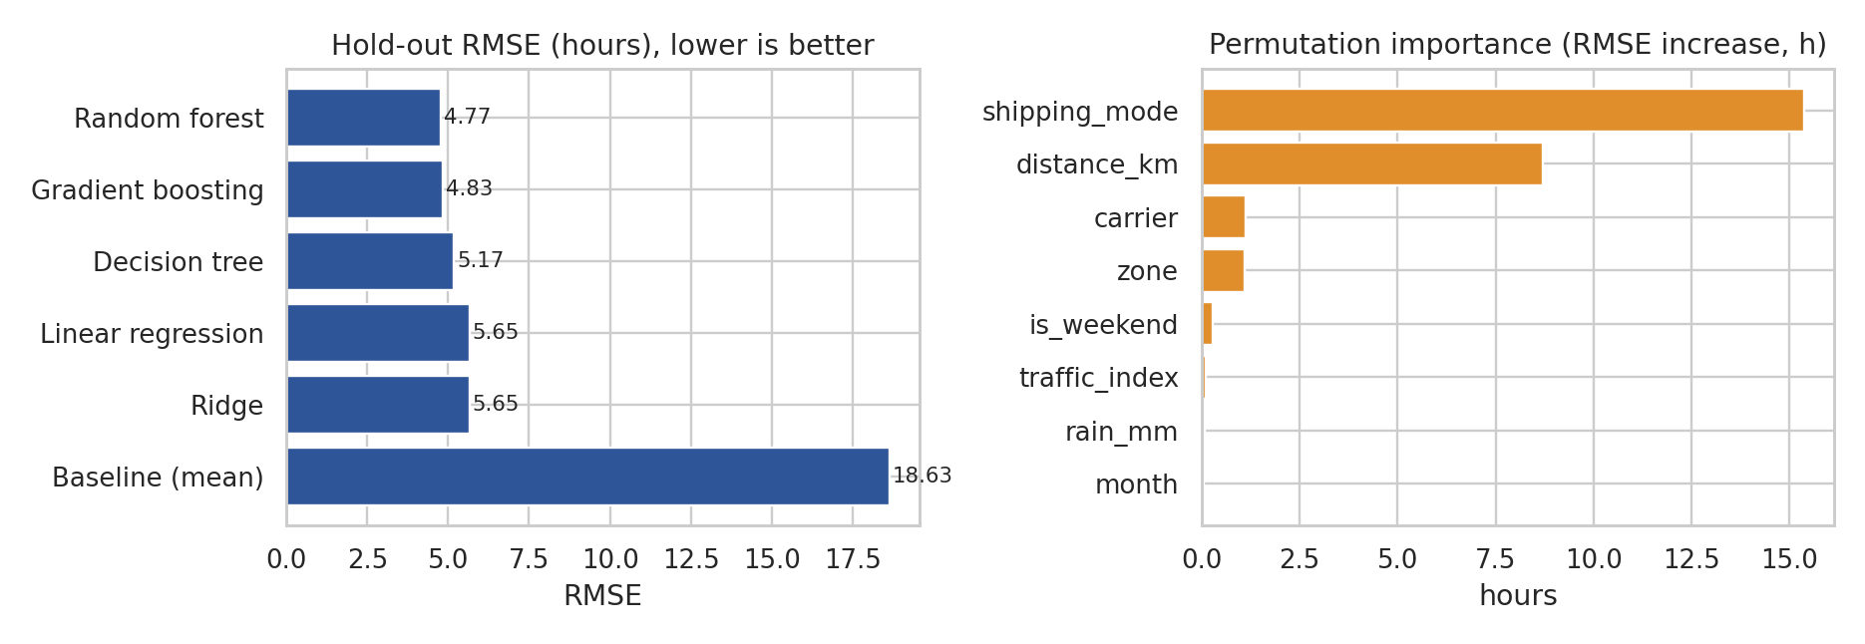
Figure 1: Hold-out RMSE by model (left) and permutation feature importance of the tuned model (right).

3.3 Interpretation
- All models beat the baseline by a wide margin: RMSE falls from 18.6 h to 5.7 h with plain linear regression, which shows that delivery time is largely determined by information known at dispatch.
- Non-linear models add a further gain: random forest and gradient boosting reach about 4.8 h, and the tuned boosting model reaches 4.69 h (R² 0.936), roughly 17% lower RMSE than linear regression. The reason is interaction: the effect of one kilometre is different by service level and zone, which a linear model without interaction terms cannot represent.
- Tuning helps modestly: the tuned model improves RMSE from 4.83 h to 4.69 h. The CV RMSE (4.66 h) and the test RMSE (4.69 h) agree closely, a sign that the model is not overfitted to the training period.
- Drivers: permutation importance (increase in RMSE when a feature is shuffled) is dominated by shipping_mode (15.4 h) and distance_km (8.7 h). Carrier (1.1 h) and zone (1.1 h) come next; weekend, traffic and rainfall each contribute under 0.3 h on average.
from sklearn.inspection import permutation_importance
pi = permutation_importance(best, X_te, y_te, n_repeats=8, random_state=0, scoring="neg_root_mean_squared_error")
imp = pd.Series(pi.importances_mean, index=X_te.columns).sort_values(ascending=False)
print(imp.head(8).round(2))

Output:
shipping_mode 15.38
distance_km 8.70
carrier 1.13
zone 1.09
is_weekend 0.29
traffic_index 0.10
rain_mm 0.07
month 0.07
dtype: float64

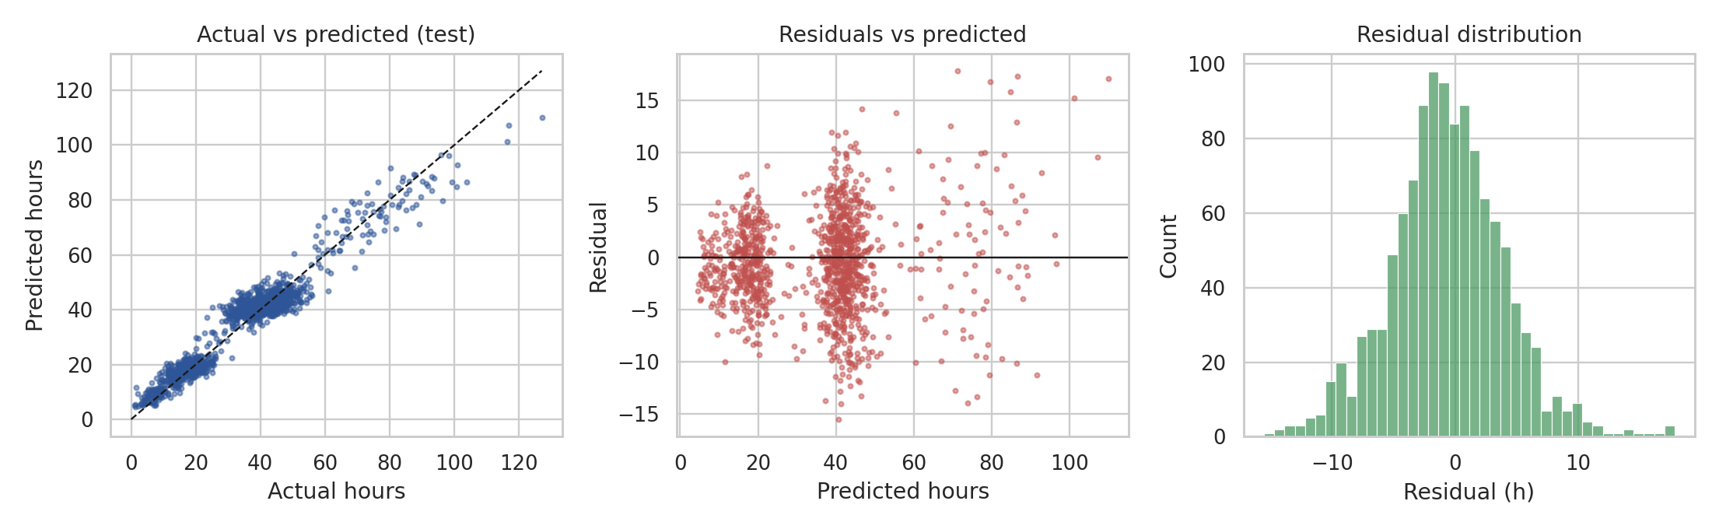
Figure 2: Actual vs predicted (left), residuals vs predicted (middle), residual distribution (right).
Residual diagnostics: the points lie close to the diagonal and the residuals are centred (mean -0.62 h, SD 4.65 h), so the model is slightly biased towards over-predicting by about half an hour. The errors are largest for long Standard shipments: mean absolute error is 4.18 h for Standard, against 2.90 h for Express and 2.47 h for Same-Day, which is partly a scale effect, since variability grows with delivery time. The residual spread is not perfectly constant (heteroscedastic), which is why the safety margins in Section 4.1 are computed per service level.

4. Optimization Strategies Based on the Model

4.1 Strategy 1: data-driven delivery promises
Instead of promising a fixed 72 / 36 / 10 hours, the promise for each shipment is set to the predicted delivery time plus a safety margin, namely the 90th percentile of the model's errors for that service level. The margin is estimated on a calibration period inside the training data (the model is refit on earlier data only), then applied on the untouched test period.
# calibrate residual quantiles on a held-out slice of the training period (refit on earlier data only)
c0 = int(len(X_tr) * 0.8)
cal_model = Pipeline([("p", prep(False)), ("m", HistGradientBoostingRegressor(random_state=0))]).set_params(**search.best_params_)
cal_model.fit(X_tr.iloc[:c0], y_tr.iloc[:c0])
cal_res = y_tr.iloc[c0:] - cal_model.predict(X_tr.iloc[c0:])
q = cal_res.groupby(X_tr.iloc[c0:].shipping_mode).quantile(0.90) # per-mode 90th percentile of error
promise = pd.Series(pb, index=X_te.index) + X_te.shipping_mode.map(q) # promise = prediction + safety margin
fixed = df.loc[X_te.index, "promised_hours"]
out = pd.DataFrame({"mode": X_te.shipping_mode, "fixed": fixed, "dyn": promise, "act": y_te})
tab = out.groupby("mode").apply(lambda g: pd.Series({"avg_fixed_promise_h": g.fixed.mean(), "avg_dynamic_promise_h": g.dyn.mean(),
"on_time_fixed_%": 100 * (g.act <= g.fixed).mean(), "on_time_dynamic_%": 100 * (g.act <= g.dyn).mean()}))
tab.loc["All"] = [out.fixed.mean(), out.dyn.mean(), 100 * (out.act <= out.fixed).mean(), 100 * (out.act <= out.dyn).mean()]
print(tab.round(1))

Output:
avg_fixed_promise_h avg_dynamic_promise_h on_time_fixed_% on_time_dynamic_%
mode
Express 36.0 27.4 87.9 95.3
Same-Day 10.0 12.7 68.1 93.8
Standard 72.0 52.1 92.1 87.5

Service level | Avg. fixed promise (h) | Avg. model-based promise (h) | On-time with fixed promise | On-time with model promise
Express | 36.0 | 27.4 | 87.9% | 95.3%
Same-Day | 10.0 | 12.7 | 68.1% | 93.8%
Standard | 72.0 | 52.1 | 92.1% | 87.5%
All | 54.9 | 40.6 | 88.5% | 90.5%
Table 4: Fixed vs model-based promises on the test period (1,173 shipments).
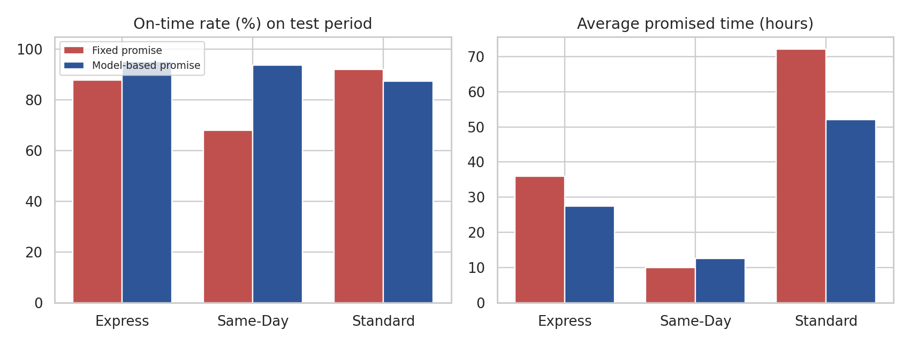
Figure 3: On-time rate and average promised time, fixed vs model-based.
Results: Same-Day on-time rises from 68.1% to 93.8% by quoting about 2.7 hours more (12.7 h instead of 10 h); Express on-time rises from 87.9% to 95.3% while the average promise becomes 8.6 hours shorter. For Standard, the promise could be cut by about 20 hours (52.1 h instead of 72 h), but on-time falls from 92.1% to 87.5%, because the 90% margin target is below the current 92% for that group. The overall result is an average promise of 40.6 h instead of 54.9 h with on-time at 90.5%, against 88.5%. The business can choose the trade-off by selecting a different percentile per service level (for example 95% for Standard).

4.2 Strategy 2: carrier allocation as an assignment problem
Each shipment can be given to Carrier-A, B or C. Using the trained delivery-time model and a second model for transport cost, the expected result of sending each test shipment with each carrier is predicted ('what if' scenarios). The expected cost of an assignment is the predicted transport cost plus a penalty of INR 150 times the probability of lateness (assumed cost of a refund or support contact). The probability comes from the predicted time, the promise and the per-service-level error spread, assuming normal errors. Carrier contracts limit how much each carrier can take (A up to 45% of volume, B 35%, C 40%). This is a linear assignment problem: choose a carrier for each shipment to minimise total expected cost subject to capacity, which is solved exactly with the Hungarian method (scipy.optimize.linear_sum_assignment) by giving every carrier one column per unit of capacity.
from scipy.optimize import linear_sum_assignment
from scipy.stats import norm
carriers = ["Carrier-A", "Carrier-B", "Carrier-C"]
cost_model = Pipeline([("p", prep(False)), ("m", HistGradientBoostingRegressor(random_state=0))])
cost_model.fit(X_tr, np.log(df.loc[X_tr.index, "transport_cost_inr"]))
sigma = (y_te - pb).groupby(X_te.shipping_mode).std() # per-mode error spread
PENALTY = 150 # INR cost of one late delivery (refund / support)
exp_cost = np.zeros((len(X_te), 3)); p_late = np.zeros((len(X_te), 3))
for j, c in enumerate(carriers): # counterfactual: "what if this order went with carrier c?"
Xc = X_te.copy(); Xc["carrier"] = c
exp_cost[:, j] = np.exp(cost_model.predict(Xc))
h = best.predict(Xc)
p_late[:, j] = 1 - norm.cdf((df.loc[X_te.index, "promised_hours"].values - h) / Xc.shipping_mode.map(sigma).values)
total = exp_cost + PENALTY * p_late # expected cost incl. lateness penalty
n = len(X_te); caps = {"Carrier-A": int(.45 * n), "Carrier-B": int(.35 * n), "Carrier-C": int(.40 * n)} # contract capacity
cols = np.concatenate([[j] * caps[c] for j, c in enumerate(carriers)]) # one column per available "slot"
r_i, c_i = linear_sum_assignment(total[:, cols])
assigned = cols[c_i]
cur = X_te.carrier.map({c: j for j, c in enumerate(carriers)}).fillna(0).astype(int).values # 'Unknown' treated as A
cur_total = total[np.arange(n), cur].sum(); new_total = total[np.arange(n), assigned].sum()

Metric (1,173 test shipments) | Current allocation | Optimised allocation | Change
Expected transport cost (INR) | 269,969 | 254,063 | −5.9%
Average probability of late delivery | 12.8% | 10.0% | −2.7 pts
Total cost incl. lateness penalty (INR) | 292,441 | 271,703 | −7.1%
Share A / B / C | 44 / 32 / 25% | 45 / 35 / 20% | more to B, less to C
Table 5: Carrier allocation, model-based estimate (not a realised saving).
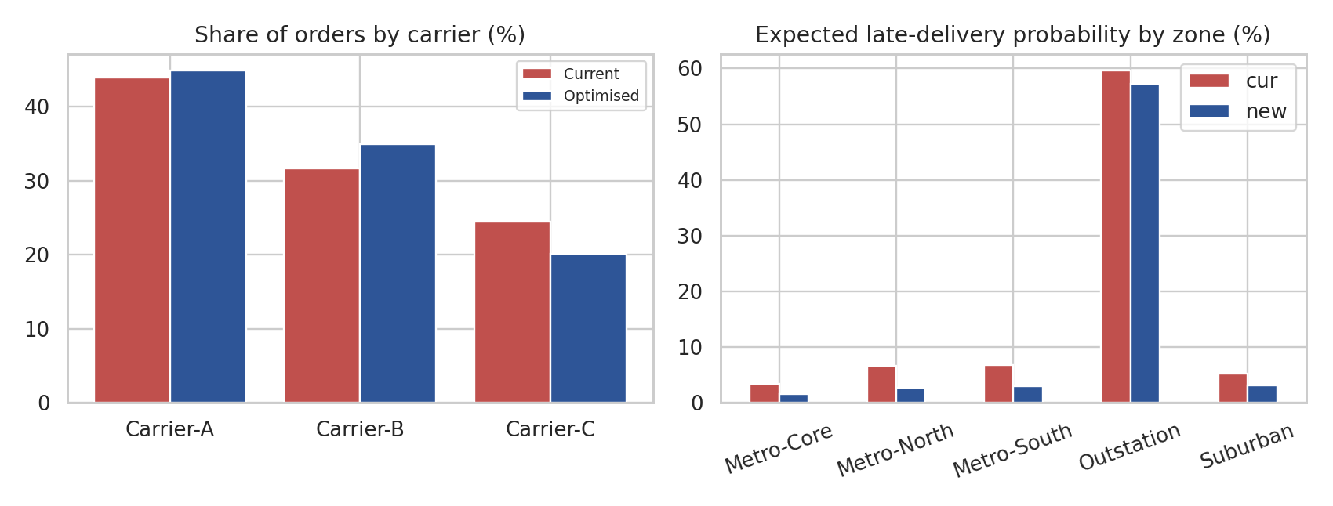
Figure 4: Carrier shares (left) and expected late probability by zone (right), current vs optimised.
The optimised plan lowers expected transport cost by about 5.9% and the average lateness probability by 2.7 percentage points. By zone (Figure 4), the improvement comes mainly from the metro and suburban zones, where the late probability roughly halves (for example Metro-North 6.6% to 2.7%, Metro-Core 3.4% to 1.6%) because volume moves towards Carrier-A and Carrier-C in the core (Carrier-C share in Metro-Core rises from 25% to 34%) and towards Carrier-B in the suburbs (about 69% of Suburban shipments), where it performs well.
The outstation result needs care. With the default penalty of INR 150 the optimiser sends 46% of outstation shipments to Carrier-B and none to Carrier-C, because outstation shipments cost about INR 1,000 each and Carrier-B is roughly 10% cheaper, so the saving outweighs the modelled penalty even though the late probability in this zone stays high (about 57%, against 60% today). The answer therefore depends on a business input, the cost of a late delivery. The sensitivity analysis below shows what happens when that penalty is raised:
# sensitivity: how does the answer change if a late delivery is more expensive than INR 150?
sens = []
for pen in (150, 500, 1500):
tot = exp_cost + pen * p_late
_, ci = linear_sum_assignment(tot[:, cols]); a_ = cols[ci]; o = (X_te.zone.values == "Outstation")
sens.append(dict(penalty=pen, cost=exp_cost[np.arange(n), a_].sum(), p_late=p_late[np.arange(n), a_].mean(),
outstation_to_B=(a_[o] == 1).mean(), outstation_p_late=p_late[np.arange(n), a_][o].mean()))
sens = pd.DataFrame(sens).round(3); print(sens)

Output:
penalty cost p_late outstation_to_B outstation_p_late
0 150 254063.095 0.100 0.463 0.573
1 500 255579.160 0.095 0.302 0.538
2 1500 261036.365 0.091 0.259 0.508

Penalty per late order (INR) | Expected transport cost (INR) | Avg. late probability | Outstation: share to Carrier-B / late probability
150 | 254,063 | 10.0% | 46.3% / 57.3%
500 | 255,579 | 9.5% | 30.2% / 53.8%
1500 | 261,036 | 9.1% | 25.9% / 50.8%
Table 6: Sensitivity of the optimised allocation to the lateness penalty.
A higher penalty moves outstation volume away from Carrier-B and lowers lateness (outstation late probability 57% to 51%), at a modest cost increase (about 2.7% more transport spend between INR 150 and INR 1,500). Carrier capacity limits (A 45%, C 40%) force some outstation volume to Carrier-B in every scenario, which is a reason to renegotiate capacity with Carrier-A or Carrier-C for the outstation lane. These are model-based estimates from historical data in which carriers were not assigned randomly, so the 'what if' predictions rely on the model being right about carriers that did not serve those lanes; a small A/B pilot (for example one FC for two weeks) is needed before any saving is booked.

4.3 Strategy 3: route and resource planning with predicted times
The predicted delivery time and its error give realistic service times and time-window slack for a vehicle routing model (OR-Tools in the Week 1 pilot, which cut distance by 41% against a naive sweep on a simulated batch). Using the predictions for dispatch cut-offs, the same model can also show how many Same-Day shipments the FC can accept before the promise becomes unrealistic, supporting capacity decisions, for example adding temporary vans in November and December, the periods in which the Week 3 analysis found the lowest on-time performance.

5. Recommendations
# | Action | Evidence from this report
1 | Deploy the gradient-boosting model as a delivery-time estimator at checkout and dispatch | Test RMSE 4.7 h, MAE 3.6 h vs baseline 18.6 h; CV and test errors agree
2 | Replace fixed promises by model-based promises, with the percentile chosen per service level | Same-Day on-time 68% → 94%; average promise −14 h
3 | Run a two-week A/B pilot of optimised carrier allocation at one FC | Expected cost −5.9%, lateness −2.7 pts, to be confirmed
4 | Set lane-specific lateness penalties (higher for outstation) before using the optimiser, and renegotiate carrier capacity and SLA for outstation | Week 3: Carrier-B 17% on-time in outstation; Table 6: with an INR 150 penalty the optimiser still sends 46% of outstation volume to B
5 | Retrain monthly; monitor MAE by service level and zone; alert if drift exceeds 1 h | Seasonality visible in Week 3 (Nov–Dec peak)
6 | Add features that would reduce the remaining error: real traffic, warehouse queue length, driver and vehicle data | Current features explain 93.6% of the variance; the rest is operational noise
Table 7: Actionable recommendations.

6. Limitations
- The data is simulated. The high R² (0.936) is partly a consequence of a clean, well-structured simulator. Real data usually has more noise, and accuracy will be lower. The workflow, including leakage control, time-based validation, and the optimisation methods, carries over unchanged.
- Test-set evaluation is based on one chronological split (the last 20% of the data, the August–October period), so seasonal effects of November–December are absent from the test period. A rolling evaluation over a full year is advisable.
- Carrier allocation results use counterfactual predictions and normal-error assumptions; the lateness penalty (INR 150) and capacity limits are assumptions that should be replaced with contract values.
- The 90% margin gives a coverage target, not a guarantee; coverage should be monitored by service level (Standard under-covered in this test).

7. References
- Hastie, T., Tibshirani, R., & Friedman, J. (2009). The Elements of Statistical Learning (2nd ed.). Springer.
- Breiman, L. (2001). Random forests. Machine Learning, 45(1), 5–32.
- Friedman, J. H. (2001). Greedy function approximation: a gradient boosting machine. Annals of Statistics, 29(5), 1189–1232.
- Bergstra, J., & Bengio, Y. (2012). Random search for hyper-parameter optimization. Journal of Machine Learning Research, 13, 281–305.
- Hyndman, R. J., & Athanasopoulos, G. Forecasting: Principles and Practice (3rd ed.). OTexts, otexts.com/fpp3 (time-series cross-validation).
- Kuhn, H. W. (1955). The Hungarian method for the assignment problem. Naval Research Logistics Quarterly, 2, 83–97.
- Pedregosa, F. et al. (2011). Scikit-learn: Machine learning in Python. Journal of Machine Learning Research, 12, 2825–2830.

