**LAB FILE**

**APPLICATION PROGRAMMING**



Submitted To: Submitted By:

Prof. Md Arquam DEEPAK KUAMR

Roll No:11911026

Branch:CSE

**1). Creating an HTML web page form**

**Source Code:**

<html lang="en" dir="ltr">

<head>

<title>Registration Form</title>

<link rel="stylesheet" href="AP.css">

<script src="javascript.js"> </script>

</head>

<body>

<div class="ab">

<h1>Create Your Account</h1></div>

<img src="Capture.jpg" width="100%" height="100px">

<br>

<br>

<br>

<div id="error\_message"></div>

<div>

<div class="dv">

<form method="post" id="MY\_FORM" onsubmit="return validate()">

<table width="100%">

<th><label>First Name</label>

<input type="text" placeholder="Enter your Firstname here" id="Firstname"></th>

<th><label for="">Last Name</label>

<input type="text" placeholder="Enter your Lastname here" id="Lastname"></th>

</table>

<br>

<table width="100%">

<th><label>First Name</label>

<input type="text" placeholder="Enter your Usermane here" name="username"></th>

<th><label for="">Last Name</label>

<input type="password" placeholder="Enter your Password here" name="password"></th>

</table>

<div>

<label class="abc"><b>E-mail:</b></label>

<br>

<input type="email" placeholder="Enter your email here" id="mail">

<br>

<br>

<br>

<br>

<label class="abc">Gender:</label>

<input type="radio" name="Gender" value="male" id="MALE">Male

<input type="radio" name="Gender" value="female" id="FEMALE">Female

<input type="radio" name="Gender" value="others" id="OTHERS">Others

<br>

<br>

<br>

<br>

<label class="abc">Mobile No:</label><br>

<table width="100%">

<th>

<select id="country\_code" name="codes">

<option value="select\_code">Select your country code</option>

<option>+91</option>

<option>+310</option>

<option>+55</option>

<option>+1</option>

<option>+355</option>

</select></th>

<th>

<input type="text" placeholder="Enter your Mobile number " id="phone"></th>

</table>

</div>

<hr>

<table width="100%">

<th><input type="submit" value="REGISTER"></th>

<th><input type="reset" value="CLEAR"></th>

</table>

</form>

</div>

</div>

</body>

</html>

OUTPUT:

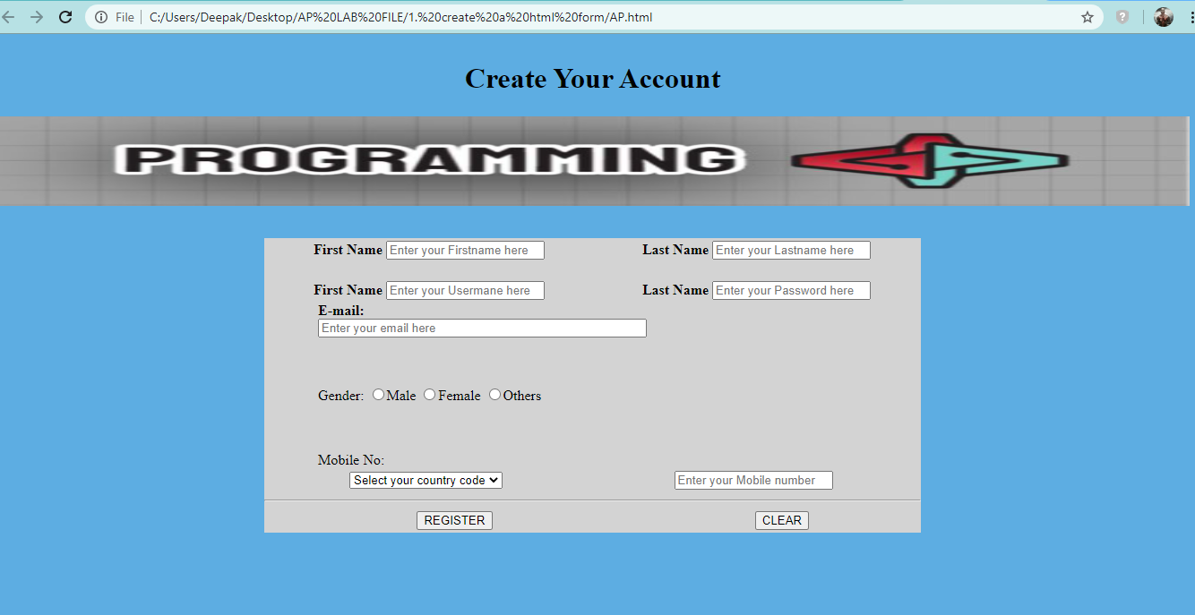

2). Creating a home page using HTML

Source Code:

<!DOCTYPE html>

<html>

<head>

<title>DEEPAK KUMAR</title>

<style>

p

{

font-family:courier

}

a:link,a:visited

{

background-color:tomato;

color:white;

padding:25px 25px;

text-align:center;

display:inline-block;

text-decoration:none;

}

a:hover,a:active

{

background-color:#D0D3D4;

text-decoration:underline;

}

table,th,td

{

border:10px solid orange;

border-collapse: collapse;

background-color:#2ECC71;

}

th,td

{

padding:20px

}

</style>

</head>

<body style="background-color:dodgerblue">

<h1 style="font-family:courier"><center><u>ROMAN REIGNS:THE BIG DOG OF WWE</u></center></h1>

<center><a href="https://www.wwe.com/superstars/roman-reigns" target="\_blank" title="click here to visit WWE"><img src="reigns.jpg" alt="ROMAN REIGNS" width="900" height="500" border="0"></a></center><hr>

<p style="color:orange" title="LIFE HISTORY OF ROMAN REIGNS">THE REAL NAME OF ROMAN REIGNS IS <u><strong><mark>LEATI JOSEPH ANOA'I JOE</mark></strong></u> AND BELONGS TO THE GREAT SAMOAN BACKGROUND.</p>

<p title="ROMAN REIGNS-'THE BIG DOG' OF WWE"><i>Roman reigns was born in pensacola, florida on 25th of may 1985.</i></p>

<p title='ROMAN REIGNS-"THE BIG DOG" OF WWE'><i>Roman reigns is an wwe superstar of all time and former football player.

He belongs to famous ANOA'I family of professional wrestlers and attached with the SMACKDOWN WWE under the ring name of "ROMAN REIGNS".

He signed the contract with WWE in 2010 and made his main roaster debut with SETH ROLLINS and DEAN AMBROSE in November 2012 as "THE SHIELD".By his great efforts

and continuous hard work behind and in the ring ; He is main event wrestlmania four years in a row.ROMAN REIGNS is one of the best performers among all WWE superstars.

</i></p>

<center><a href="https://https://www.instagram.com/romanreigns/?hl=en" target="\_blank" title="click here to visit ROMAN REIGNS on instagram">CLICK HERE</a></center>

<center><img src="https://media.tenor.com/images/c5f28c1782ecda4f96b48d00be86f923/tenor.gif" title="ROMAN REIGNS TREMENDOUS ENTRY" width="800px" height="400px"></center>

<p> Roman Reigns is a four-time world champion in WWE ,having held the <strong><mark> WORLD HEAVYWEIGHT CHAMPIONSHIP </mark></strong>three times and <strong><mark>

UNIVERSAL CHAMPIONSHIP </mark></strong> for once.He is also a one-time INTERCONTINENTAL CHAMPION ,one-time UNITED STATES CHAMPION as well as a one-time WWE TAG

TEAM CHAMPION (WITH SETH ROLLINS).He is the ROYAL RUMBLE WINNER 2105 and held the record of most eliminations into a royal rumble match in the 2104 event.Besides

all these facts;<strong><mark> HE IS THE 2014 "SUPERSTAR OF THE YEAR" with an outsatnding track record.</mark></strong></p><br><br><hr>

<table style="width:100%">

<caption style="color:#D0D4D0; font-size:30px"><strong>PICTURES OF SOME WWE ALL TIME PERFORMERS.</strong></caption>

<tr>

<th>ROMAN REIGNS</th>

<th>BROCK LESNAR</th>

<th>BILL GOLDBERG</th>

<th>THE ROCK</th>

</tr>

<tr>

<td><img src="j1.jpg" style="width:300px;height:250px"></td>

<td><img src="brock1.jpg" style="width:300px ; height:250px"></td>

<td><img src="bill1.jpg" style="width:300px ; height:250px"></td>

<td><img src="rock1.jpg" style="width:300px ; height:250px"></td>

</tr>

<tr>

<td><img src="roman.jpg" style="width:300px; height:250px"></td>

<td><img src="brock2.jpg" style="width:300px ; height:250px"></td>

<td><img src="bill2.jpg" style="width:300px ; height:250px"></td>

<td><img src="rock2.jpg" style="width:300px ; height:250px"></td>

</tr>

<tr>

<td><img src="joe.jpg" style="width:300px; height:250px"></td>

<td><img src="brock3.jpg" style="width:300px ; height:250px"></td>

<td><img src="bill3.jpg" style="width:300px ; height:250px"></td>

<td><img src="rock3.jpg" style="width:300px ; height:250px"></td>

</tr>

</body>

</html>

OUTPUT:

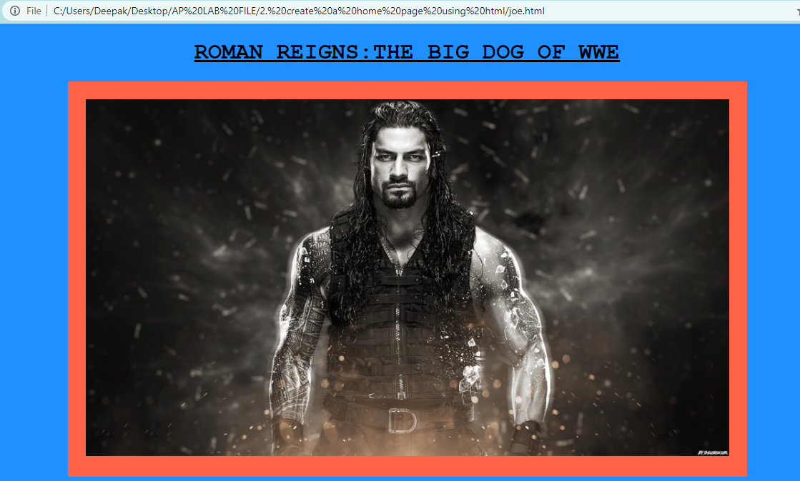

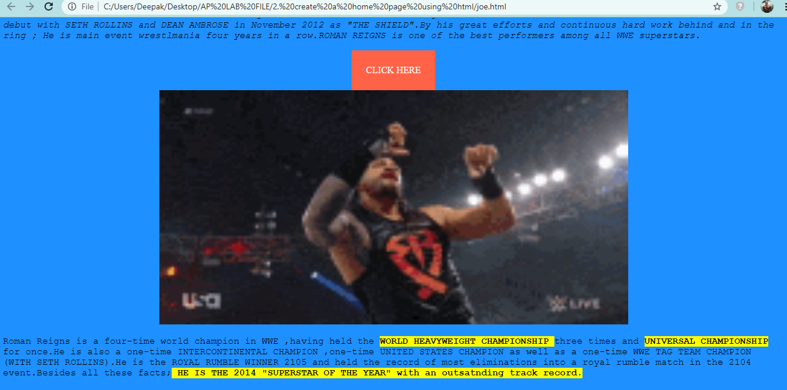

**3). Creating XHTML and CSS and understanding its use in creating web pages.**

**Source Code:**

|  |  |
| --- | --- |
|  | <!DOCTYPE html PUBLIC "-//W3C//DTD XHTML 1.1//EN" |
|  | "http://www.w3.org/TR/xhtml11/DTD/xhtml11.dtd"> |
|  | <html lang="en" dir="ltr"> |
|  | <head> |
|  | <title>Registration Form</title> |
|  | <link rel="stylesheet" href="[AP.css](file:///C:\Users\gaurav\Desktop\Data\AP%20Lab%20File\3).%20%20Creating%20XHTML%20and%20CSS%20and%20understanding%20its%20use%20in%20creating%20web%20pages\AP.css)"> |
|  | </head> |
|  | <body> |
|  | <div class="ab"> |
|  | <h1>Create Your Account</h1></div> |
|  | <img src="[Capture.jpg](file:///C:\Users\gaurav\Desktop\Data\AP%20Lab%20File\3).%20%20Creating%20XHTML%20and%20CSS%20and%20understanding%20its%20use%20in%20creating%20web%20pages\Capture.jpg)" width="100%" height="100px"> |
|  | <div> |
|  | <div class="dv"> |
|  | <form method="post"> |
|  | <table width="100%"> |
|  | <th><label>First Name</label> |
|  | <input type="text" placeholder="Enter your Firstname here"></th> |
|  | <th><label for="">Last Name</label> |
|  | <input type="text" placeholder="Enter your Lastname here"></th> |
|  | </table> |
|  | <br> |
|  | <br> |
|  | <div> |
|  | <label class="abc"><b>E-mail:</b></label> |
|  | <br> |
|  | <input type="email" placeholder="Enter your email here"> |
|  | <br> |
|  | <br> |
|  | <br> |
|  | <br> |
|  | <label class="abc">Gender:</label> |
|  | <input type="radio" name="ab" value="male">Male |
|  | <input type="radio" name="ab" value="female">Female |
|  | <input type="radio" name="ab" value="others">Others |
|  | <br> |
|  | <br> |
|  | <br> |
|  | <br> |
|  | <label class="abc">Mobile No:</label><br> |
|  | <table width="100%"> |
|  | <th> |
|  | <select > |
|  | <option>Select</option> |
|  | <option>+91</option> |
|  | <option>+310</option> |
|  | <option>+55</option> |
|  | <option>+1</option> |
|  | <option>+355</option> |
|  | </select></th> |
|  | <th> |
|  | <input type="text" placeholder="Enter your Mobile number "></th> |
|  | </table> |
|  | </div> |
|  | <hr> |
|  | <table width="100%"> |
|  | <th><input type="submit" value="Register"></th> |
|  | <th><input type="reset" value="Clear"></th> |
|  | </table> |
|  | </form> |
|  | </div> |
|  | </div> |
|  | </body> |
|  | </html> |
|  | **AP.css**  .dv{ background-color:Lightgrey;  margin: 0px 300px 300px 300px;}  .abc{margin-left: 60px;}  input[type=email]{width:50%;  margin-left: 60px;  }  body{background-color:#fccfcc}  .ab{text-align: center;  text-shadow: 5px;  padding: 2px;  margin: auto;} |

**Output:**

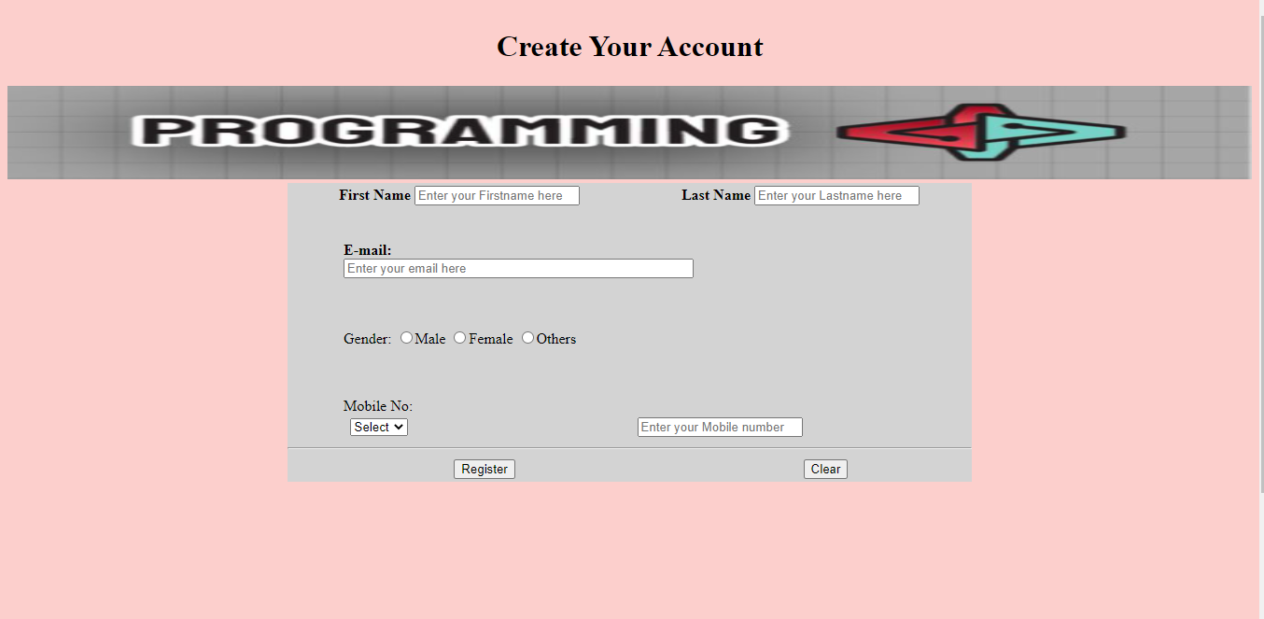

**4). Setting up and configuration of Apache Tomcat server.**

**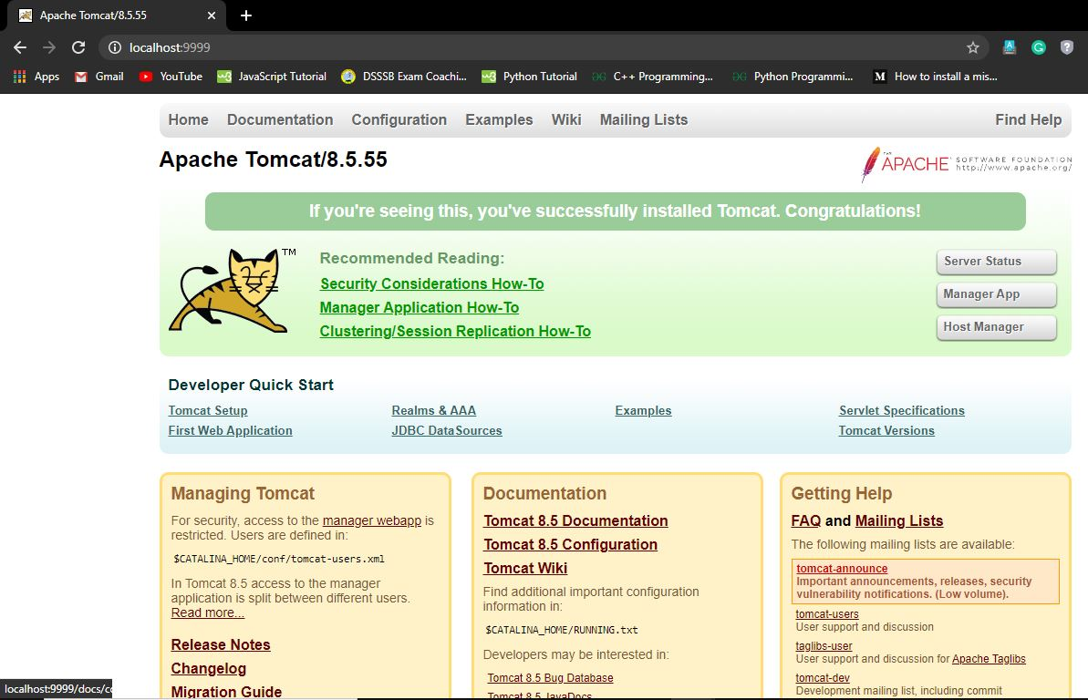**

**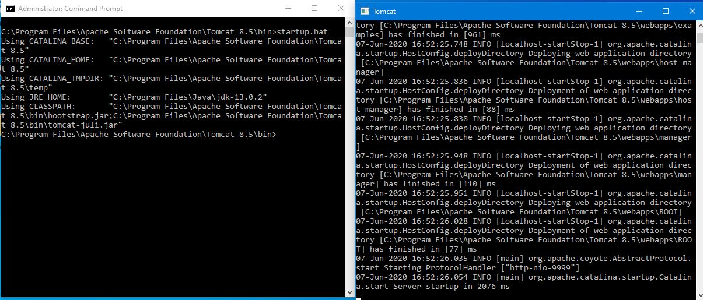**

**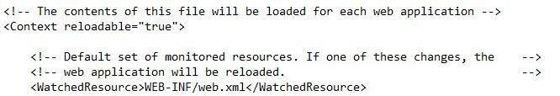**

**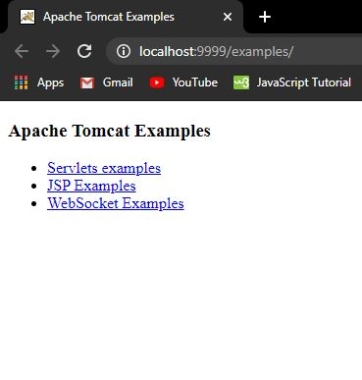**

**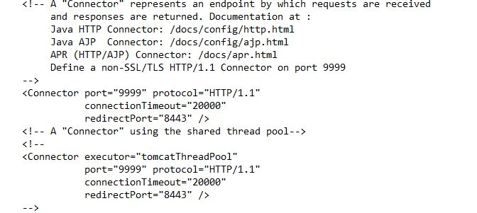**

**5). Understanding modification of Web.XML**

The web.xml Deployment Descriptor file describes how to deploy a web application in a servlet container such as Tomcat.

This file is required for every application you deploy on Tomcat. You will find one in the jsp-examples, servlet-examples and ROOT applications provided on a new Tomcat website, and every web application example you download, including inside WAR files.

The location of the file is always the same: application root/WEB-INF/web.xml

At minimum, the file needs to contain an XML descriptor and an opening and closing <web-app> tag. Open the configuration file "web.xml". We shall enable the directory listing by changing "listings" from "false" to "true" for the "default" servlet. < param - value > true < / param - value > like :

**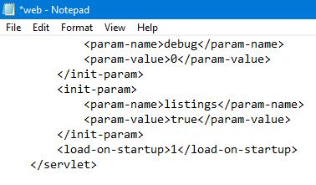**

**6). Creating Websites using PHP.**

**Source Codes:**

index.php

<?php echo file\_get\_contents("header.html");?>

<?php echo file\_get\_contents("navigation.html");?>

<?php echo file\_get\_contents("body.html");?>

<?php echo file\_get\_contents("footer.html");?>

about.php

<?php echo file\_get\_contents("header.html");?>

<?php echo file\_get\_contents("navigation.html");?>

<?php echo file\_get\_contents("ft.html");?>

contact.php

<?php echo file\_get\_contents("header.html");?>

<?php echo file\_get\_contents("navigation.html");?>

<?php echo file\_get\_contents("abt.html");?>

navigation.html

|  |  |
| --- | --- |
|  | <!DOCTYPE html> |
|  | <html lang="en" dir="ltr"> |
|  | <head> |
|  | <style> |
|  | .topnav { |
|  | overflow: hidden; |
|  | background-color: #333; |
|  | width : 100%; |
|  | } |
|  | .topnav a { |
|  | float: left; |
|  | display: block; |
|  | color: #f2f2f2; |
|  | text-align: center; |
|  | padding: 14px 16px; |
|  | text-decoration: none; |
|  | } |
|  | .topnav a:hover { |
|  | background-color: #ddd; |
|  | color: black; |
|  | } |
|  | </style> |
|  | </head> |
|  | <body> |
|  |  |
|  | <div class="topnav"> |
|  | <a href="[index.php](file:///C:\\Users\\gaurav\\Desktop\\Data\\AP%20Lab%20File\\6).%20Creating%20Websites%20using%20PHP\\index.php" \t "_blank)">Home</a> |
|  | <a href="[about.php](file:///C:\\Users\\gaurav\\Desktop\\Data\\AP%20Lab%20File\\6).%20Creating%20Websites%20using%20PHP\\about.php" \t "_blank)">About Us</a> |
|  | <a href="[contact.php](file:///C:\\Users\\gaurav\\Desktop\\Data\\AP%20Lab%20File\\6).%20Creating%20Websites%20using%20PHP\\contact.php" \t "_blank)">Contact Us</a> |
|  | </div> |
|  | </body> |
|  | </html> |
|  | header.html  <!DOCTYPE html>  <html lang="en" dir="ltr">  <head>  <meta charset="utf-8">  <title>Programeeez</title>  </head>  <body>  <div >  <img src="logo.jpg" alt="logo" width="100%" height="100px;">  </div>  </body>  </html>  body.html  <!DOCTYPE html>  <html lang="en" dir="ltr">  <head>  <style>  .mySlides {display:none;}  </style>  </head>  <body style="background-color:#DDDDDD;">  <div style="max-height:800px">  <img class="mySlides" src="1.jpg" style="width:100%">  <img class="mySlides" src="2.jpg" style="width:100%">  <img class="mySlides" src="3.jpg" style="width:100%">  <img class="mySlides" src="4.jpg" style="width:100%">  <img class="mySlides" src="5.jpg" style="width:100%">  <img class="mySlides" src="6.jpg" style="width:100%">  </div>  <script>  var myIndex = 0;  carousel();  function carousel() {  var i;  var x = document.getElementsByClassName("mySlides");  for (i = 0; i < x.length; i++) {  x[i].style.display = "none";  }  myIndex++;  if (myIndex > x.length) {myIndex = 1}  x[myIndex-1].style.display = "block";  setTimeout(carousel, 2000); // Change image every 2 seconds  }  </script>  </body>  </html> |

ft.html

<!DOCTYPE html>

<html lang="en" dir="ltr">

<head>

<style media="screen">

body{

background-image: url("8.jpg");

background-repeat: no-repeat;

background-size : cover;

display: block;

color: white;

text-align: left;

padding: 14px 16px;

text-decoration: none;

}

</style>

</head>

<body>

<div >

<p><pre><b>

Programeeez is optimized for learning, testing, and training.Examples might be simplified to improve reading and basic understanding.

Tutorials, references, and examples are constantly reviewed to avoid errors, but we cannot warrant full correctness of all content.

While using this site, you agree to have read and accepted our terms of use, cookie and privacy policy.

Copyright 2020. All Rights Reserved.

</b>

</pre>

</p>

</div>

<div >

<footer>

<address>

Charkhi Dadri , Haryana

124001

</address>

</footer>

<p> Copyright © GT 2019</p>

</div>

</body>

</html>

abt.html

<html>

<head>

<style >

a{ text-decoration :none;}

body {

background-image: url("7.jpg");

background-repeat: no-repeat;

background-color: #cccccc;

background-size : cover;

}

div{ color: white;

}

</style>

</head>

<body>

<a href="mailto:programeeez@abc.com?subject=feedback">Email Us</a>

<br>

<br>

<div >

<footer>

<address>

Charkhi Dadri , Haryana

124001

</address>

</footer>

<p> Copyright © GT 2019</p>

</div>

</body>

</html>

**Output:**

**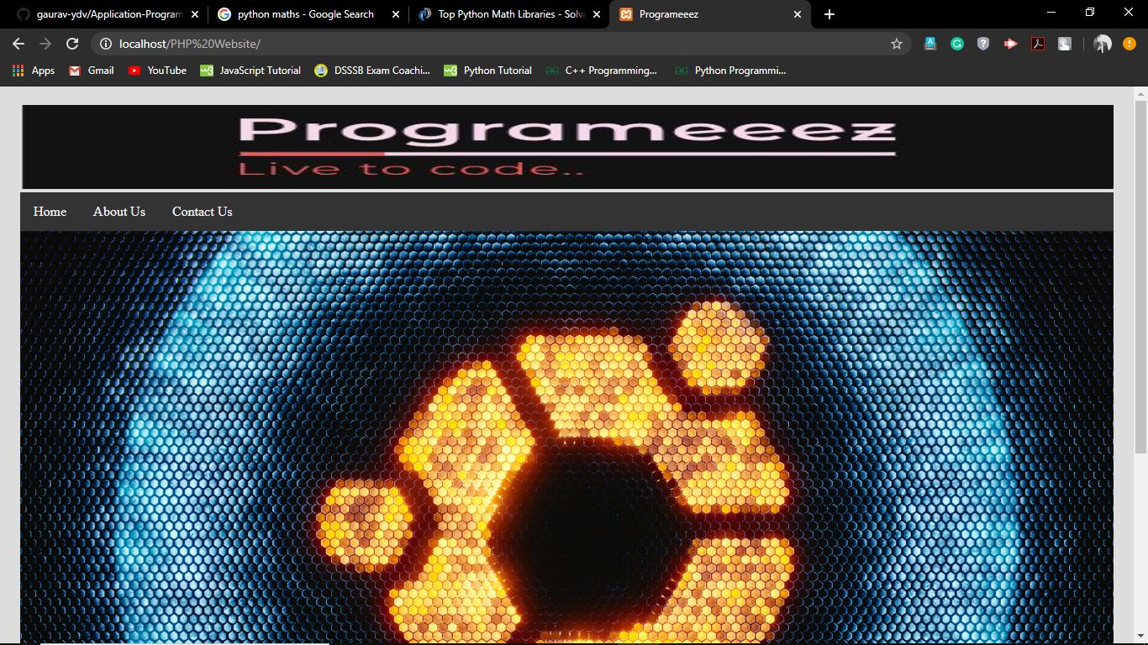**

**7). Understanding JavaScript.**

**Source Codes:**

<!DOCTYPE html>

<html>

<head>

<title>Regular Expression</title>

<script type="text/javascript">

function validate()

{

var username=document.getElementById("username").value;

var regx=/A00/;

if(regx.test(username))

{

alert("valid username");

}

else

{

alert("Invalid username");

}

}

</script>

</head>

<body>

<form action="message.html">

<input type="text" id="username" placeholder="username"/>

<button onclick="validate()">Submit</button>

</form>

</body>

</html>

OUTPUT:

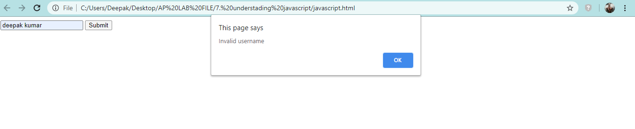

**8). Creating a Web page with back end in PHP and front end in JavaScript and hosting it on Apache Tomcat Server.**

**Source Code:**

**HTML FORM:**

<html lang="en" dir="ltr">

<head>

<title>Registration Form</title>

<link rel="stylesheet" href="AP.css">

<script src="javascript.js"> </script>

</head>

<body>

<div class="ab">

<h1>Create Your Account</h1></div>

<img src="Capture.jpg" width="100%" height="100px">

<br>

<br>

<br>

<div id="error\_message"></div>

<div>

<div class="dv">

<form method="post" id="MY\_FORM" onsubmit="return validate()">

<table width="100%">

<th><label>First Name</label>

<input type="text" placeholder="Enter your Firstname here" id="Firstname"></th>

<th><label for="">Last Name</label>

<input type="text" placeholder="Enter your Lastname here" id="Lastname"></th>

</table>

<br>

<table width="100%">

<th><label>First Name</label>

<input type="text" placeholder="Enter your Usermane here" name="username"></th>

<th><label for="">Last Name</label>

<input type="password" placeholder="Enter your Password here" name="password"></th>

</table>

<div>

<label class="abc"><b>E-mail:</b></label>

<br>

<input type="email" placeholder="Enter your email here" id="mail">

<br>

<br>

<br>

<br>

<label class="abc">Gender:</label>

<input type="radio" name="Gender" value="male" id="MALE">Male

<input type="radio" name="Gender" value="female" id="FEMALE">Female

<input type="radio" name="Gender" value="others" id="OTHERS">Others

<br>

<br>

<br>

<br>

<label class="abc">Mobile No:</label><br>

<table width="100%">

<th>

<select id="country\_code" name="codes">

<option value="select\_code">Select your country code</option>

<option>+91</option>

<option>+310</option>

<option>+55</option>

<option>+1</option>

<option>+355</option>

</select></th>

<th>

<input type="text" placeholder="Enter your Mobile number " id="phone"></th>

</table>

</div>

<hr>

<table width="100%">

<th><input type="submit" value="REGISTER"></th>

<th><input type="reset" value="CLEAR"></th>

</table>

</form>

</div>

</div>

</body>

</html>

CSS CODE:

.dv{ background-color:Lightgrey;

margin: 0px 300px 300px 300px;}

.abc{margin-left: 60px;}

input[type=email]{width:50%;

margin-left: 60px;

}

body{background-color:#5DADE2 }

.ab{text-align: center;

text-shadow: 5px;

padding: 2px;

margin: auto;}

.ab #error\_message

{

margin-bottom: 20px;

padding: 0px;

background: red ;

text-align: center;

font-size: 14px ;

}

JAVASCRIPT VALIDATION CODE:

function validate()

{

var fname = document.getElementById("Firstname").value ;

var lname = document.getElementById("Lastname").value ;

var mail = document.getElementById("mail").value ;

var phone = document.getElementById("phone").value ;

const form = document.getElementById("MY\_FORM") ;

var text ;

form.addEventListener('submit' ,(e) => { // for checking the submission

e.preventDefault() ;

})

if(fname == 0 || fname == " ") // for checking the firstname

{

text = "PLEASE ENTER YOUR FIRST NAME" ;

alert(text) ;

return false ;

}

if(lname == 0 || lname == " ") // for checking the last name

{

text = "PLEASE ENTER YOUR LAST NAME" ;

alert(text) ;

return false ;

}

if(mail == 0 || mail == " ") // for validating the email address

{

text = "PLEASE ENTER A VALID EMAIL" ;

alert(text) ;

return false ;

}

if( !document.getElementById("MALE").checked && !document.getElementById("FEMALE").checked && // for validating the gender

! document.getElementById("OTHERS").checked )

{

text = "PLEASE SELECT YOUR GENDER FIRST " ;

alert(text) ;

return false ;

}

if(true) // function for validating the country code

{

var code = document.getElementById("country\_code") ;

var selected\_value = code.options[code.selectedIndex].value ;

if ( selected\_value == "select\_code" )

{

text = "PLEASE SELECT YOUR COUNTRY CODE FIRST" ;

alert(text) ;

return false ;

}

}

if( isNaN(phone) || phone.indexOf(" ") != -1 || phone.length != 10) // for validating the mobile number

{

text = "PLEASE ENTER A VALID MOBILE NUMBER " ;

alert(text) ;

return false ;

}

else // for successfull submission

{

form.submit() ;

alert("YOU HAVE REGISTERED SUCCESSFULLY !") ;

return true ;

}

}

PHP VALIDATION CODE:

<?php

if(isset($\_POST['submit']))

{

$usrnm=$\_POST['username'];

$pss=$\_POST['password'];

if((strlen($usrnm)<=5) or (strlen($pss)<=8) )

{

echo "Username must be 5 characters long and Password must be 8 characters long";

}

}

?>

**OUTPUT:**

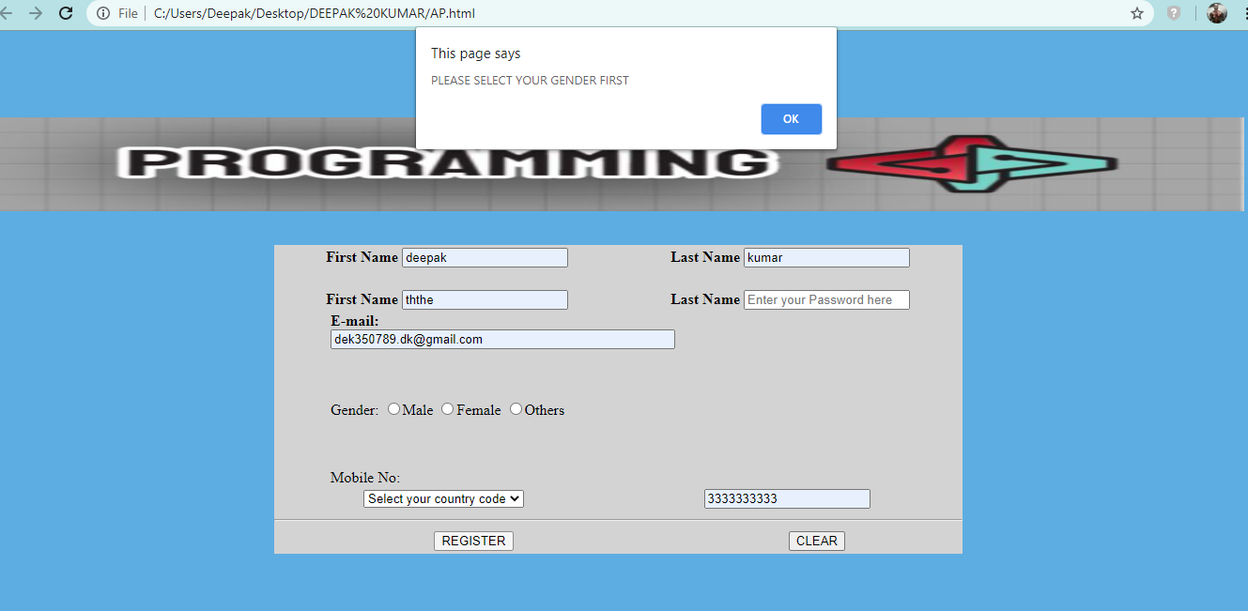

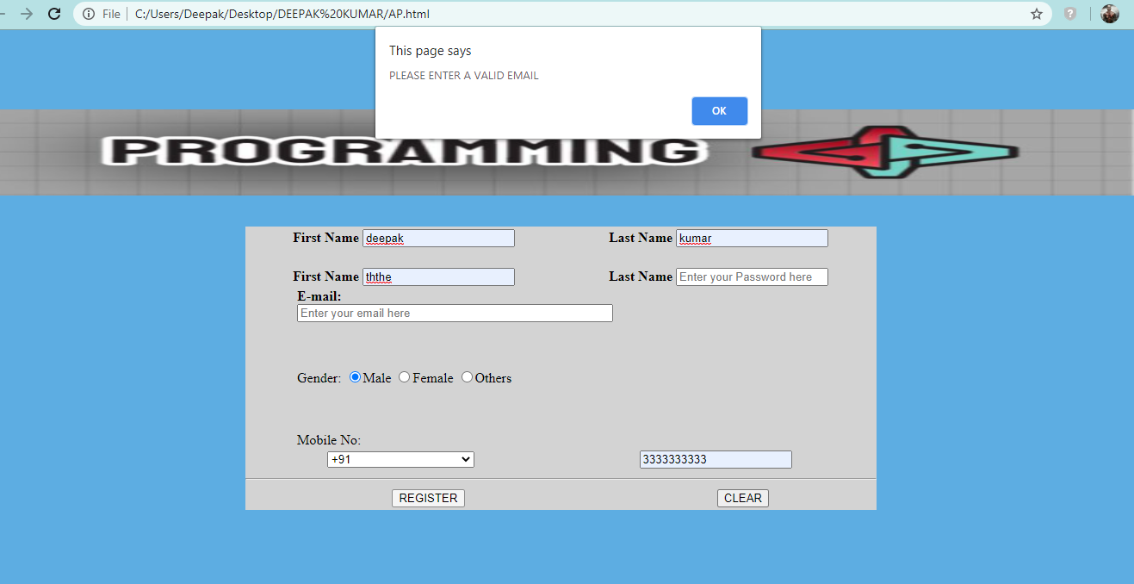

**9). Writing and understanding program in Python.**

**Source Code:**

**#guessing the number game**

import random

def my\_function():

print("The random number is between and equal 0 and 20")

number = random.randint(0,20)

while(True):

inp = int(input("GUESS NOW:"))

if(inp<number):

print("WRONG GUESS , TRY WITH A GREATER NUMBER.")

elif(inp>number):

print("WRONG GUESS , TRY WITH A SMALLER NUMBER.")

else:

print("CONGRATS , YOU HIT THE RIGHT NUMBER.")

break;

my\_function()

OUTPUT:

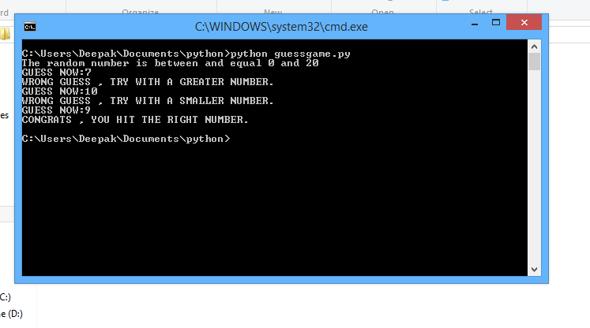

**10). Use Python Libraries like Math statistics to create programs for Scientific Computations.**

**Source Code:**

print("This is a program to plot a graph between axes:-")

import matplotlib.pyplot as plt

k = int(input("Enter the number of elements:"))

print("Enter the elements to be plotted on the x-axis:")

x=[]

print("Please select the type of input:")

print("0 for integer value")

print("1 for strings")

print("2 for float value")

choice1 = int(input())

if choice1==0:

for i in range(0,k):

element= int(input())

x.append(element)

elif choice1==1:

for i in range(0,k):

element= input()

x.append(element)

elif choice1==2:

for i in range(0,k):

element= float(input())

x.append(element)

else :

print("Invalid Choice")

print("Enter the elements to be plotted on the y-axis:")

y=[]

print("Please select the type of input:")

print("0 for integer value")

print("1 for strings")

print("2 for float value")

choice2 = int(input())

if choice2==0:

for i in range(0,k):

ele= int(input())

y.append(ele)

elif choice2==1:

for i in range(0,k):

ele= input()

y.append(ele)

elif choice2==2:

for i in range(0,k):

ele= float(input())

y.append(ele)

else :

print("Invalid Choice")

plt.plot(x,y)

n=input("X label:")

m=input("Y label:")

g=input("Graph Title:")

plt.xlabel(n)

plt.ylabel(m)

plt.title(g)

plt.show()

**Output:**

