**Assignment**

**DSD**

**Digital System Design**

Submitted to: Dr. Safeer Hyder Laghari

Submitted By: Deepak Lal

CMS ID: 041-18-0030

**Design Code:**

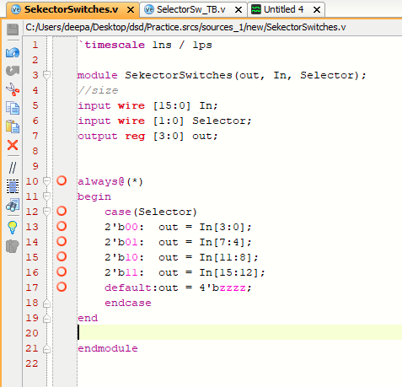

**Simulation Code (TB):**

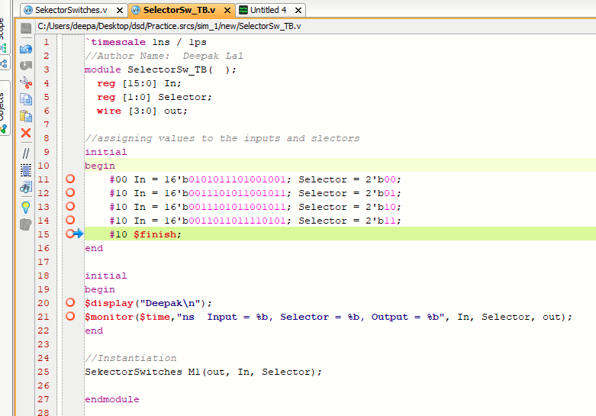

**Simulation Graph:**

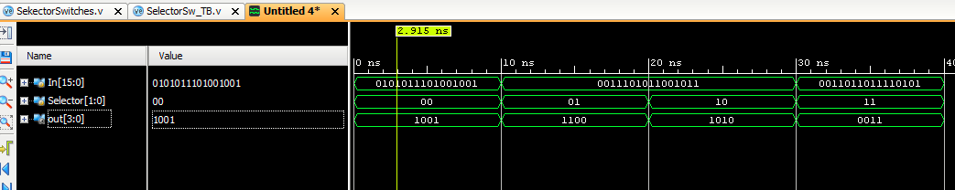

**TCL Console**

