**Fitting an exponential model to the Bitcoin opening values**

In order to fit an exponential model to the Bitcoin opening values, we have taken several steps. The first step is to clean the data. For this purpose, we removed all rows that contain missing values in their opening values. After that, using qreference() method, we found out that our data is far from an exponential model because there are no similar patterns between our data and exponential reference plots.

setwd**(**'E:/cosc505-project/'**)**

install.packages**(**"DAAG"**)**

library**(**"DAAG"**)**

csv**<-**read.csv**(**'bitcoin.csv'**)**

csv2**<-**csv**[**complete.cases**(**csv**)**, **]**

open**<-**csv2**[**,2**]**

# Plotting qrefrence plots for checking if our data follows an exponential model

qreference**(**open, xlab**=**" ",

distribution **=** **function(**x**)** qexp**(**x, rate **=** 1**/**mean**(**open**))** **)**

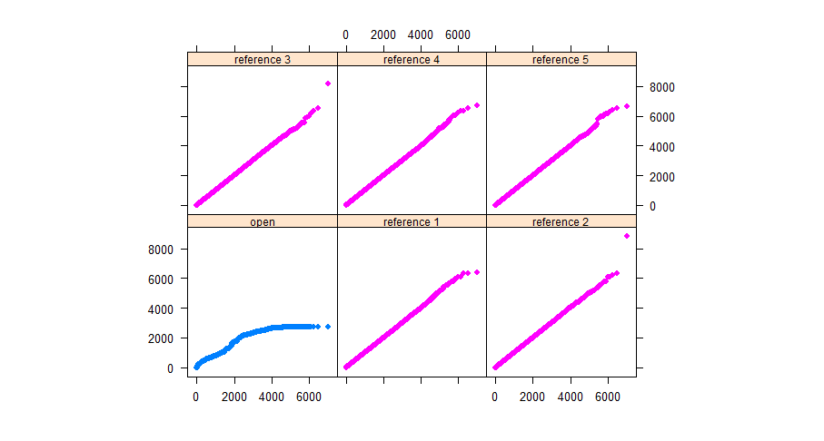

In the next step, we fitted an exponential model to our data and then plotted it. For doing that, we fitted the linear model of log of the opening values, which is the same as fitting an exponential model of timestamp against opening values. From the plot, we realized that the trend of the Bitcoin opening values does not follow an exponential pattern.

#Fitting an exponential model

tstamp**<-**csv2**$**Timestamp

exponential.model **<-** lm**(**log**(**open**)~** tstamp**)**

summary**(**exponential.model**)**

r1**<-**range**(**tstamp**)**

timevalues **<-** seq**(**r1**[**1**]**, r1**[**2**]**, 10**)**

Counts.exponential2 **<-** exp**(**predict**(**exponential.model,list**(**tstamp**=**timevalues**)))**

plot**(**tstamp, open,pch**=**16**)**

lines**(**timevalues, Counts.exponential2,lwd**=**2, col **=** "red", xlab **=** "Time (s)", ylab **=** "Counts"**)**

