Collections:

Users:

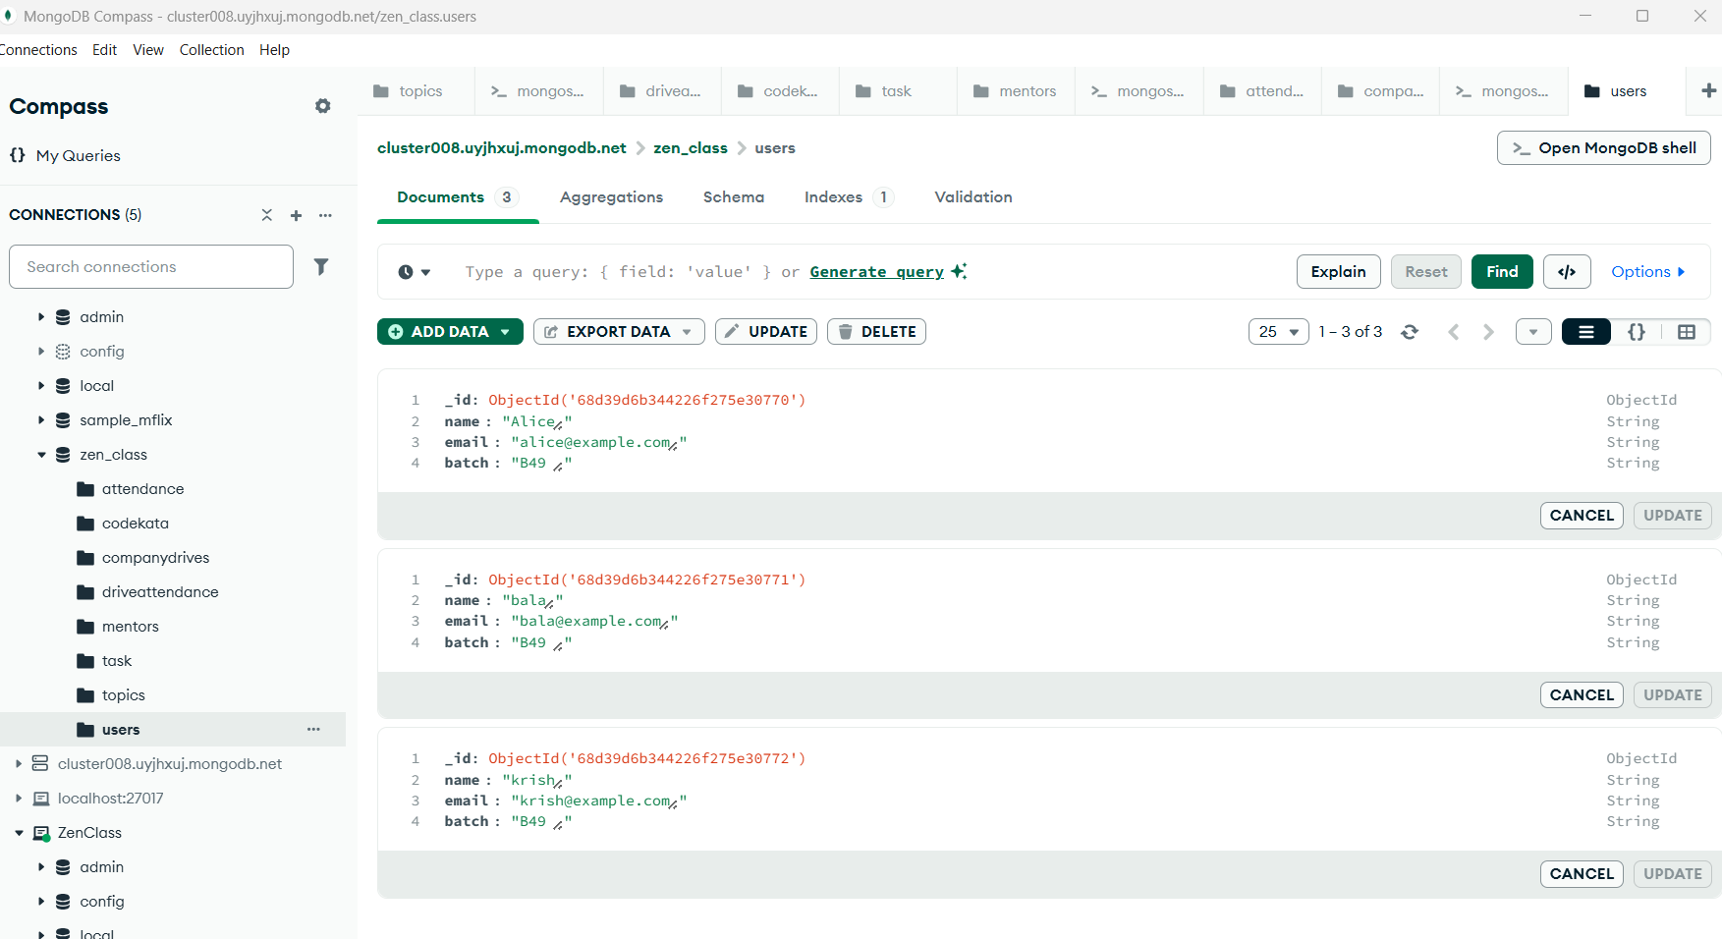

Attendance:

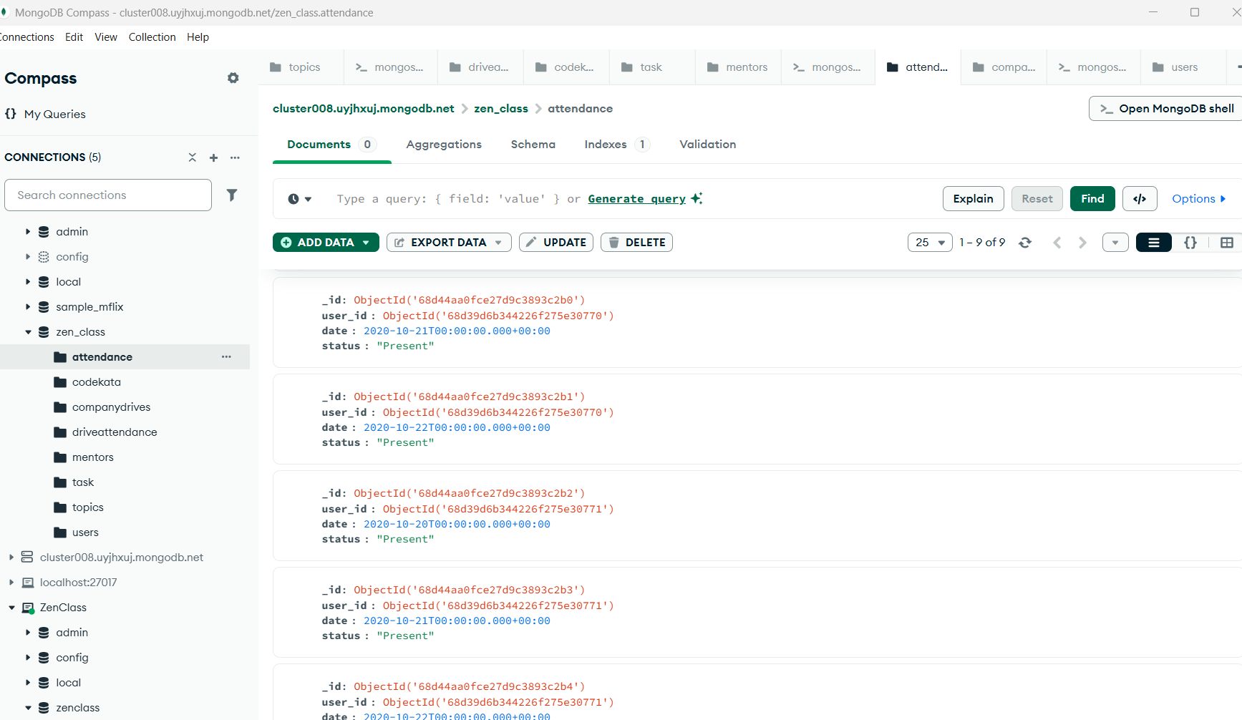

Topics:

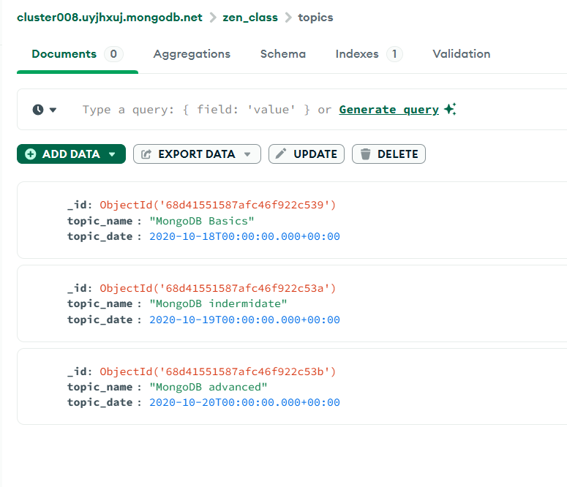

Task:

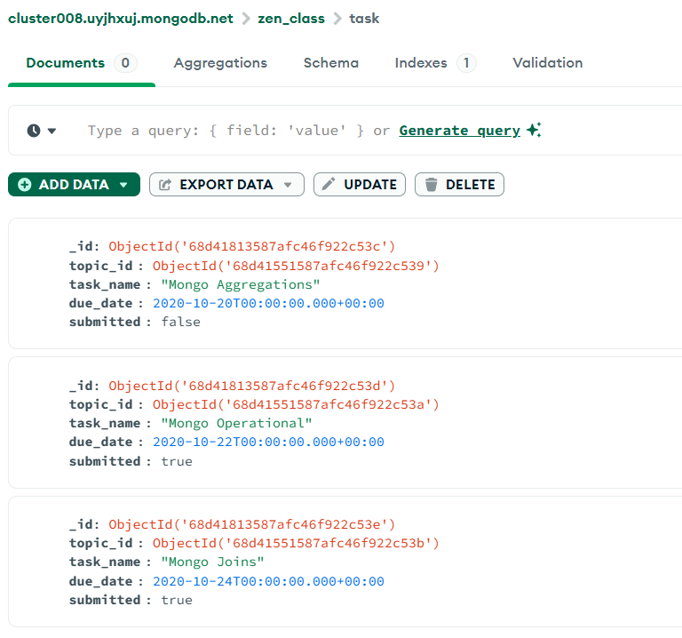

Mentors: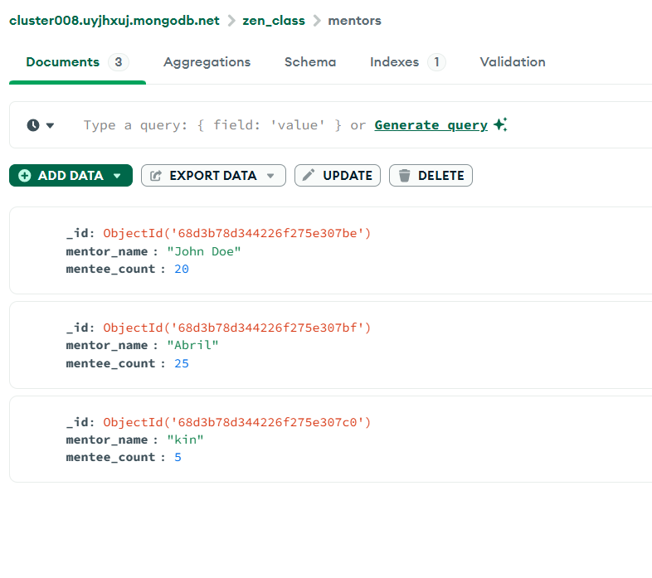

Driveattendance: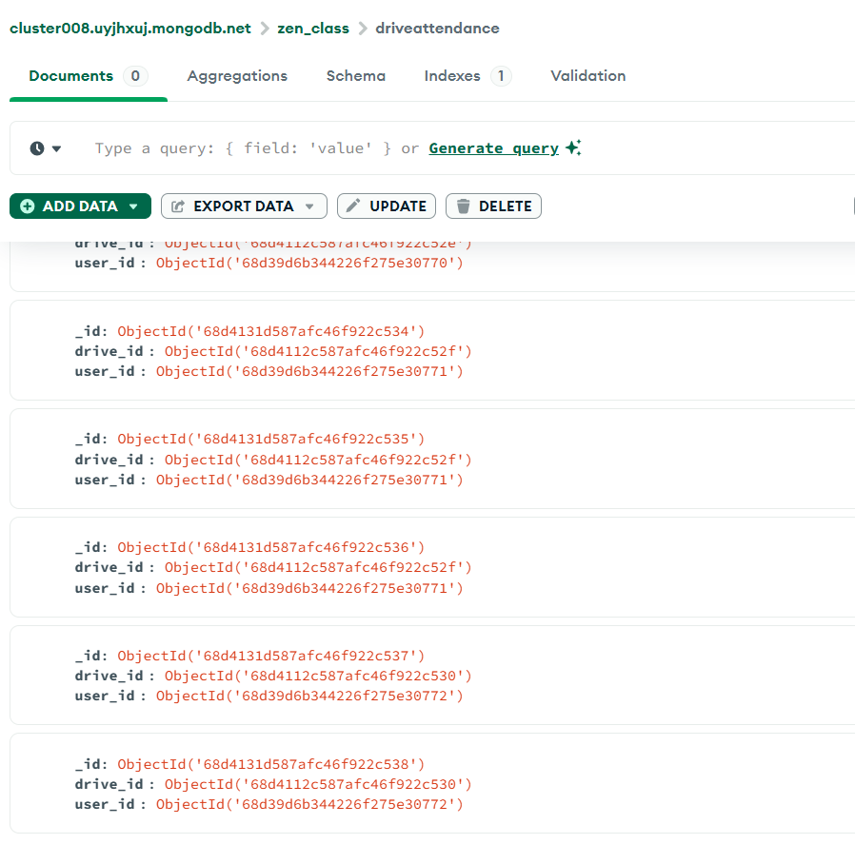

Companydrives:

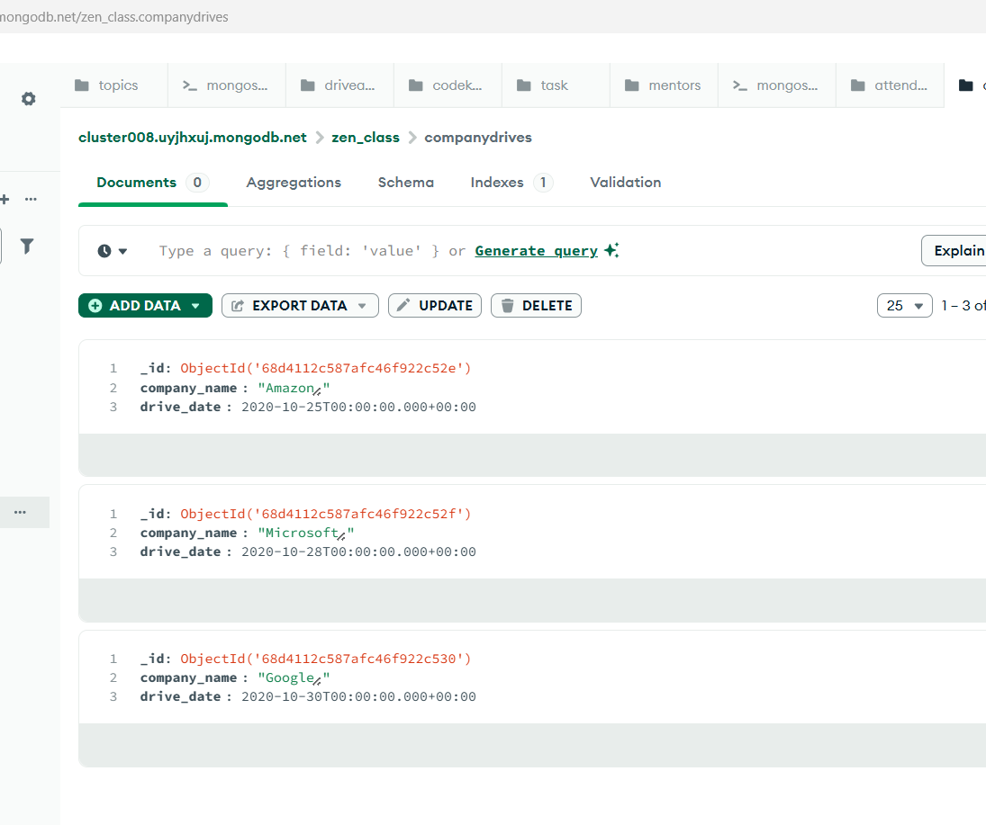

Codekata: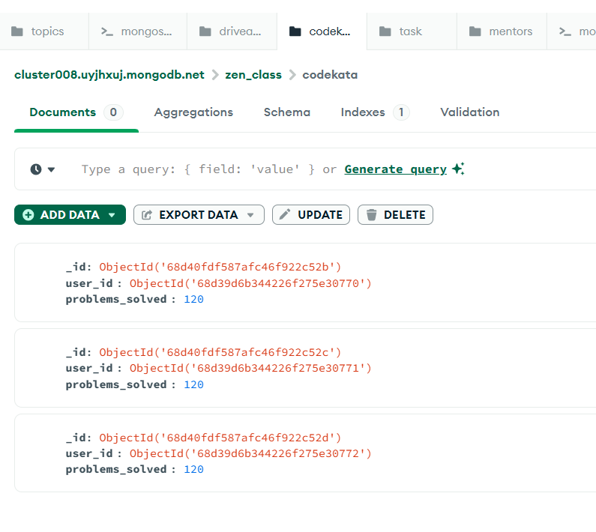

1. Find all the topics and tasks which are thought in the month of October

db.topics.aggregate([

{ $match: {

topic_date: {

$gte: "2020-10-01",

$lt: "2020-11-01"

} } }, {

$lookup: {

from: "tasks",

localField: "_id",

foreignField: "topic_id",

as: "tasks"

} }]);

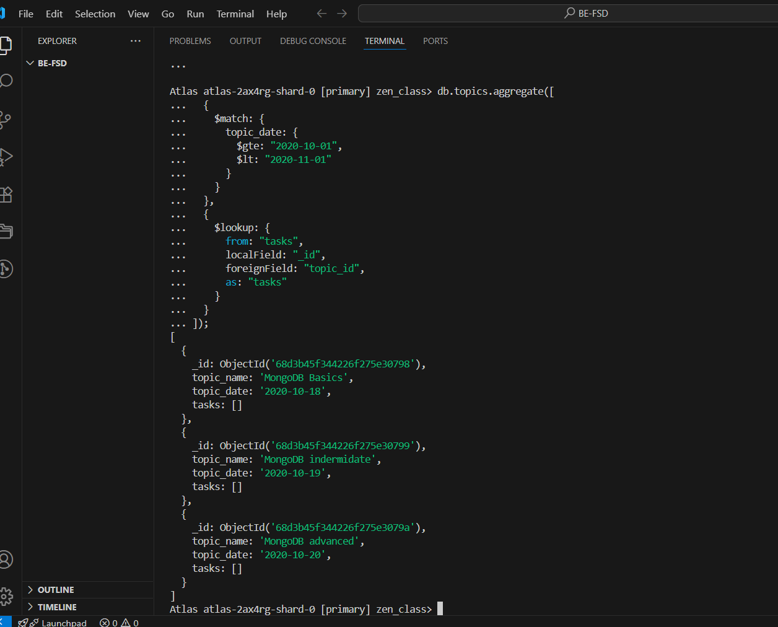

1. Find all the company drives which appeared between 15 oct-2020 and 31-oct-2020

db.companydrives.find({

drive_date: {

$gte: "2020-10-15",

$lte: "2020-10-31"

}});

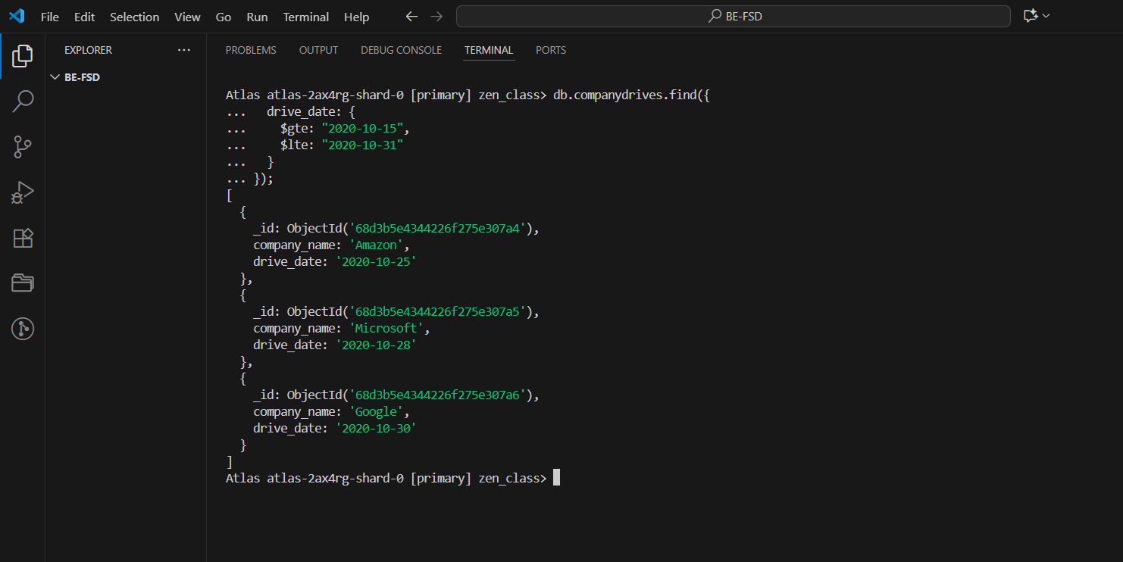

1. Find all the company drives and students who are appeared for the placement.

db.companydrives.aggregate([

{

$lookup: {

from: "driveattendance",

localField: "_id",

foreignField: "drive_id",

as: "attendees"

}

},

{ $unwind: "$attendees" },

{

$lookup: {

from: "users",

localField: "attendees.user_id",

foreignField: "_id",

as: "student"

}

},

{ $unwind: "$student" },

{

$project: {

company_name: 1,

drive_date: 1,

student_name: "$student.name"

}

}

]);

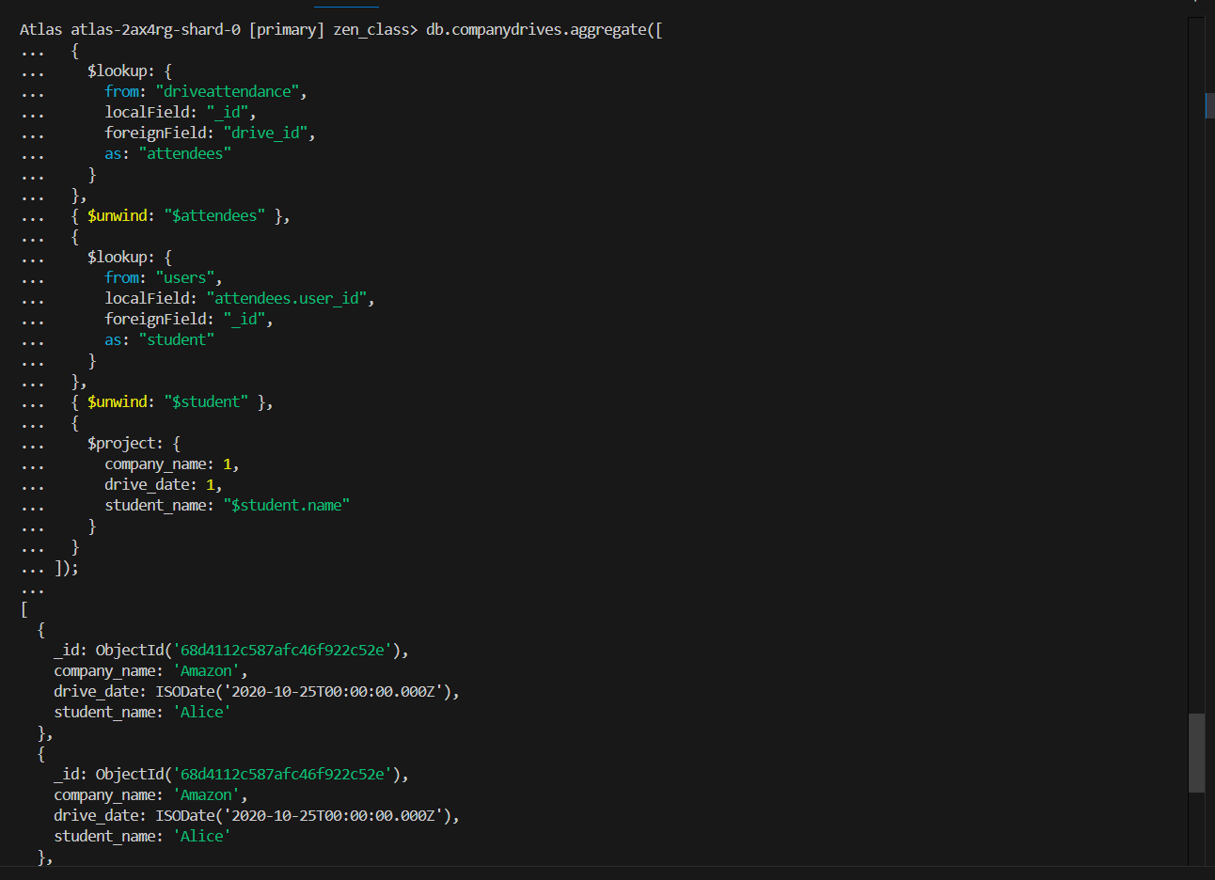

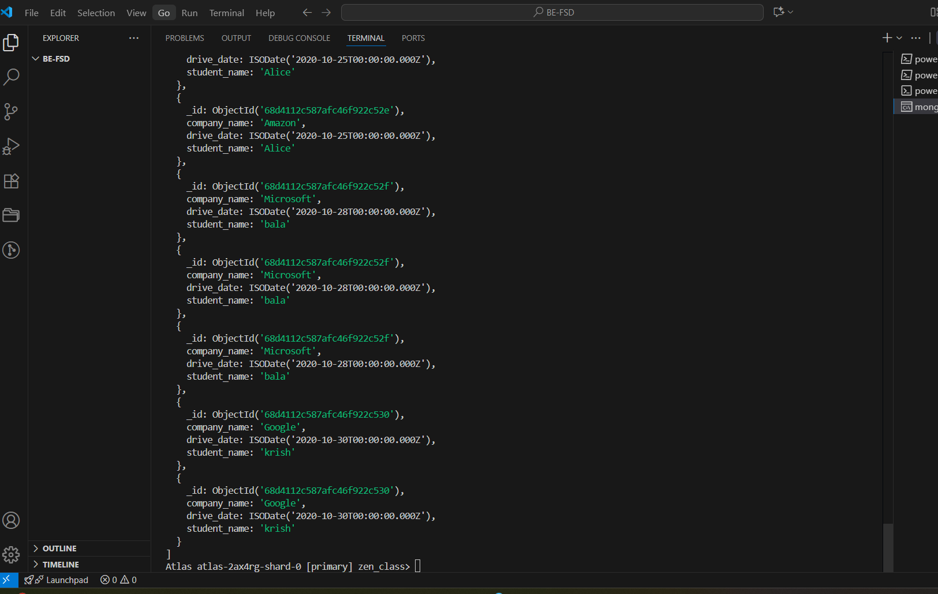

1. Find the number of problems solved by the user in codekata

db.companydrives.aggregate([

{

$lookup: {

from: "driveattendance",

localField: "_id",

foreignField: "drive_id",

as: "attendees"

}

},

{ $unwind: "$attendees" },

{

$lookup: {

from: "users",

localField: "attendees.user_id",

foreignField: "_id",

as: "student"

}

},

{ $unwind: "$student" },

{

$project: {

company_name: 1,

drive_date: 1,

student_name: "$student.name"

} }]);

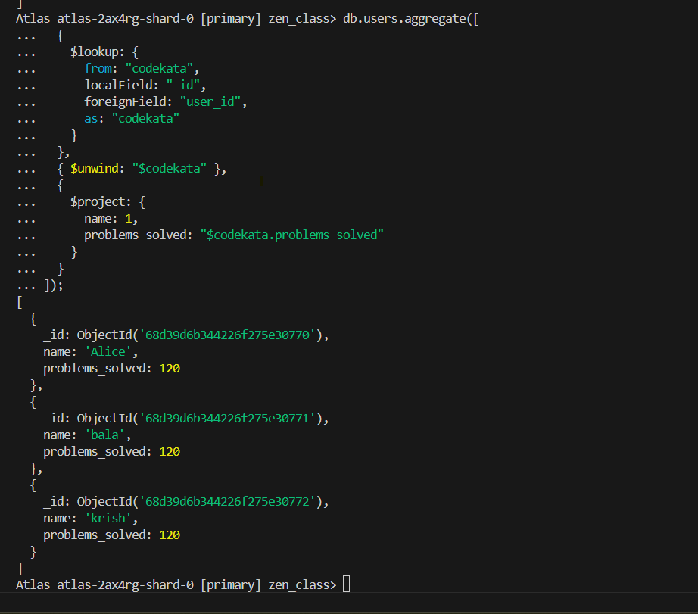

1. Find all the mentors with who has the mentee's count more than 15

db.mentors.find({

mentee_count: { $gt: 15 }

});

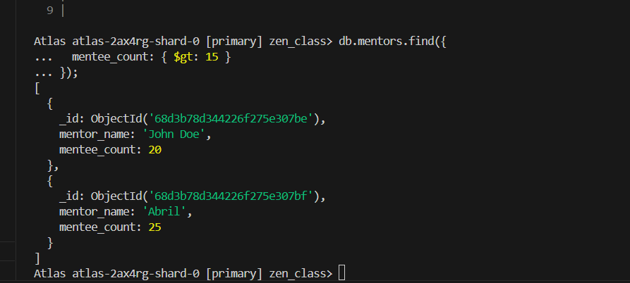

1. Find the number of users who are absent and task is not submitted  between 15 oct-2020 and 31-oct-2020

db.attendance.aggregate([

{

$match: {

status: "Absent",

date: {

$gte: ISODate("2020-10-20"),

$lte: ISODate("2020-10-31")

}

}

},

{

$lookup: {

from: "tasks",

let: { uid: "$user_id" },

pipeline: [

{

$match: {

$expr: {

$and: [

{ $eq: ["$user_id", "$$uid"] },

{ $gte: ["$due_date", ISODate("2020-10-20")] },

{ $lte: ["$due_date", ISODate("2020-10-31")] },

{ $eq: ["$submitted", false] }

]

}

}

}

],

as: "pending_tasks"

}

},

{

$match: { "pending_tasks.0": { $exists: true } }

},

{

$group: {

_id: null,

users_absent_and_not_submitted: { $sum: 1 }

}

}

]);

