**1. Creating and Renaming Files/Directories:**

Creating test_dir:

deepak@PRODLAP5AAPINB4:~/linux_training/Assessment1_linuxcommand$ mkdir test_dir

Creating example.txt under test_dir:

deepak@PRODLAP5AAPINB4:~/linux_training/Assessment1_linuxcommand$ touch test_dir/example.txt

deepak@PRODLAP5AAPINB4:~/linux_training/Assessment1_linuxcommand$ cd test_dir/

deepak@PRODLAP5AAPINB4:~/linux_training/Assessment1_linuxcommand/test_dir$ ls

example.txt

Renaming file to Renamed_example.txt:

deepak@PRODLAP5AAPINB4:~/linux_training/Assessment1_linuxcommand/test_dir$ mv example.txt renamed_example.txt

deepak@PRODLAP5AAPINB4:~/linux_training/Assessment1_linuxcommand/test_dir$ ls

renamed_example.txt

deepak@PRODLAP5AAPINB4:~/linux_training/Assessment1_linuxcommand/test_dir$

**2. Viewing File Contents**

deepak@PRODLAP5AAPINB4:~$ cat /etc/passwd

root:x:0:0:root:/root:/bin/bash

daemon:x:1:1:daemon:/usr/sbin:/usr/sbin/nologin

bin:x:2:2:bin:/bin:/usr/sbin/nologin

sys:x:3:3:sys:/dev:/usr/sbin/nologin

sync:x:4:65534:sync:/bin:/bin/sync

games:x:5:60:games:/usr/games:/usr/sbin/nologin

man:x:6:12:man:/var/cache/man:/usr/sbin/nologin

lp:x:7:7:lp:/var/spool/lpd:/usr/sbin/nologin

mail:x:8:8:mail:/var/mail:/usr/sbin/nologin

news:x:9:9:news:/var/spool/news:/usr/sbin/nologin

uucp:x:10:10:uucp:/var/spool/uucp:/usr/sbin/nologin

proxy:x:13:13:proxy:/bin:/usr/sbin/nologin

www-data:x:33:33:www-data:/var/www:/usr/sbin/nologin

backup:x:34:34:backup:/var/backups:/usr/sbin/nologin

list:x:38:38:Mailing List Manager:/var/list:/usr/sbin/nologin

irc:x:39:39:ircd:/run/ircd:/usr/sbin/nologin

gnats:x:41:41:Gnats Bug-Reporting System (admin):/var/lib/gnats:/usr/sbin/nologin

nobody:x:65534:65534:nobody:/nonexistent:/usr/sbin/nologin

systemd-network:x:100:102:systemd Network Management,,,:/run/systemd:/usr/sbin/nologin

systemd-resolve:x:101:103:systemd Resolver,,,:/run/systemd:/usr/sbin/nologin

messagebus:x:102:105::/nonexistent:/usr/sbin/nologin

systemd-timesync:x:103:106:systemd Time Synchronization,,,:/run/systemd:/usr/sbin/nologin

syslog:x:104:111::/home/syslog:/usr/sbin/nologin

_apt:x:105:65534::/nonexistent:/usr/sbin/nologin

tss:x:106:112:TPM software stack,,,:/var/lib/tpm:/bin/false

uuidd:x:107:113::/run/uuidd:/usr/sbin/nologin

tcpdump:x:108:114::/nonexistent:/usr/sbin/nologin

sshd:x:109:65534::/run/sshd:/usr/sbin/nologin

pollinate:x:110:1::/var/cache/pollinate:/bin/false

landscape:x:111:116::/var/lib/landscape:/usr/sbin/nologin

fwupd-refresh:x:112:120:fwupd-refresh user,,,:/run/systemd:/usr/sbin/nologin

deepak:x:1000:1000:,,,:/home/deepak:/bin/bash

rtkit:x:113:121:RealtimeKit,,,:/proc:/usr/sbin/nologin

usbmux:x:114:46:usbmux daemon,,,:/var/lib/usbmux:/usr/sbin/nologin

avahi:x:115:122:Avahi mDNS daemon,,,:/run/avahi-daemon:/usr/sbin/nologin

geoclue:x:116:123::/var/lib/geoclue:/usr/sbin/nologin

pulse:x:117:124:PulseAudio daemon,,,:/run/pulse:/usr/sbin/nologin

Display only the first 5 lines

deepak@PRODLAP5AAPINB4:~$ head -5 /etc/passwd

root:x:0:0:root:/root:/bin/bash

daemon:x:1:1:daemon:/usr/sbin:/usr/sbin/nologin

bin:x:2:2:bin:/bin:/usr/sbin/nologin

sys:x:3:3:sys:/dev:/usr/sbin/nologin

sync:x:4:65534:sync:/bin:/bin/sync

Display only the last 5 lines:

deepak@PRODLAP5AAPINB4:~$ tail -5 /etc/passwd

rtkit:x:113:121:RealtimeKit,,,:/proc:/usr/sbin/nologin

usbmux:x:114:46:usbmux daemon,,,:/var/lib/usbmux:/usr/sbin/nologin

avahi:x:115:122:Avahi mDNS daemon,,,:/run/avahi-daemon:/usr/sbin/nologin

geoclue:x:116:123::/var/lib/geoclue:/usr/sbin/nologin

pulse:x:117:124:PulseAudio daemon,,,:/run/pulse:/usr/sbin/nologin

grep to find all lines containing the word "root" in /etc/passwd.

deepak@PRODLAP5AAPINB4:~$ grep root /etc/passwd

root:x:0:0:root:/root:/bin/bash

4. Zipping and Unzipping

zipping test_dir using command **zip -q test_dir.zip test_dirt**

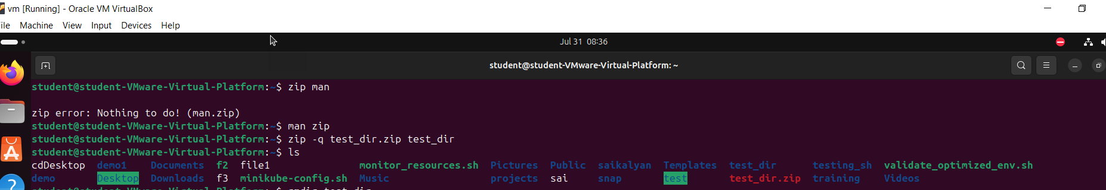

unzipping test_dir.zip using command **unzip test_dir.zip**

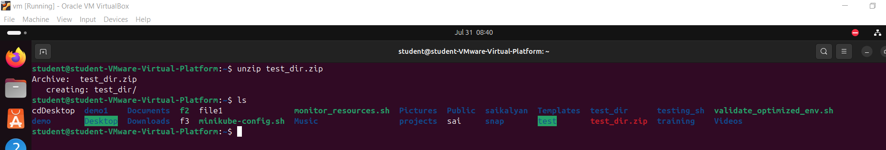

5. Downloading Files

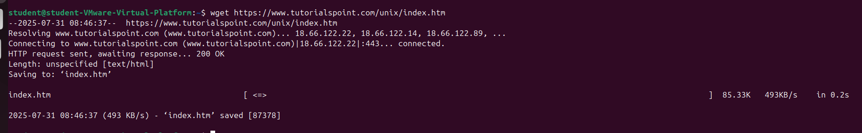

6. Changing Permissions:

Using the command chmod 444 secure.txt we can set readonly access to all user. Her 4 is the octane number for read only. 444 set read only to all users, group and other to

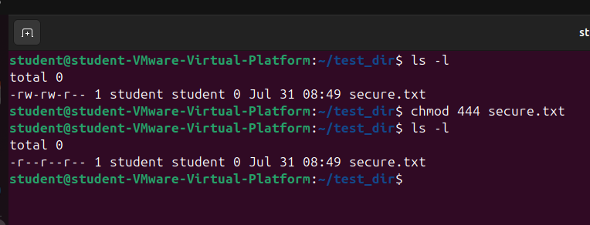

7. Working with Environment Variables:

Created a variable called MY_VAR and assigned “Hello Linux!’ and using export command made to Environment variable.

