CAPSTONE PROJECT::THE BATTLE OF NEIGHBORHOODS

INTRODUCTION::
In this project I am going to find out the neighborhood for a person who just moved to Toronto or the one who is looking to move to Toronto. Obviously , there would be many factors on which user can choose its residency like there should be some grocery stored, hospitals, restaurants and Gym etc. As whenever anybody changes its location it is difficult for him to adjust himself and adopt himself according to that surroundings. Therfore I am going to analyze the region od toronto that would be the best solution for a person who is moving from pakistan . As now toronto, Canada became the favorite destination for many pakistan Students.

BUSINESS PROBLEM::
The City of Lahore, is the most populous city in the Lahore. Lahore is a city with an extremely rich food culture. People from Lahore are famous all over the country for their love for food. The city offers a vast variety of options when it comes to gastronomy. In recent times, the style of food has achieved popularity in a number of different countries, because of its palatable and milder taste, mainly through the Pakistani diaspora. Moreover, there are many young people from lahore who visit Canada or some foreign countries for higher studies and they oftenly miss their home taste, therefore they face many difficulties to find some good food. Mostly people of lahore loves to eat "Daisi Food", Chinese Food and Italian Food. Therefore in this way they can find suitable place to get food easily.

SOLUTION::
By using the Foursquare API I will analyze the nearest neighbors/location in toronto some person can get to know what would be the most suitable place where he/she can feel like home

DATA ACQUISITION AND CLEANING ::

The coordinates of the neighborhood is to be obtained using Google Maps API geocoding to get the final dataset

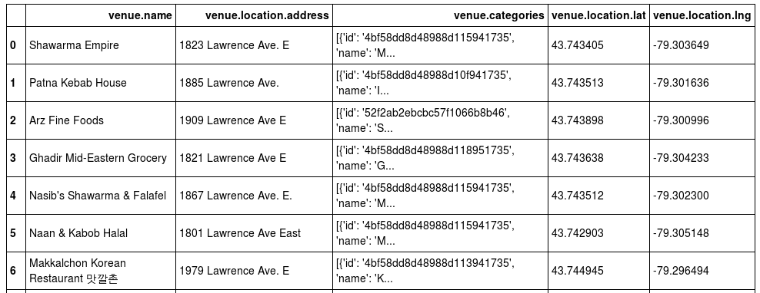

EXPLORATORY DATA ANALYSIS ::
The statistical exploratory and the other fuctions is used to get the data cleaning and the other exploratory analysis .the below columns show the colums which are cleaned and the other functions are used to get the data as shown in fig

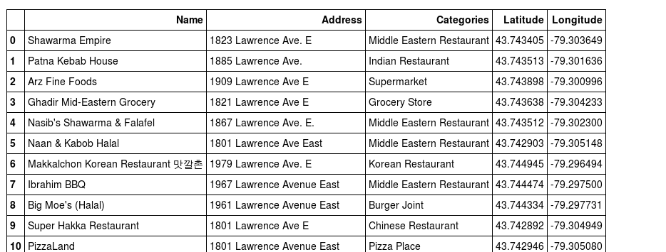

NEIGHBORHOODS IN THE TORONTO NEAR LA EAST::
These are the neighborhoods near Lawrence avenue street, they are visualized on a map using folium on python as shown in figure below

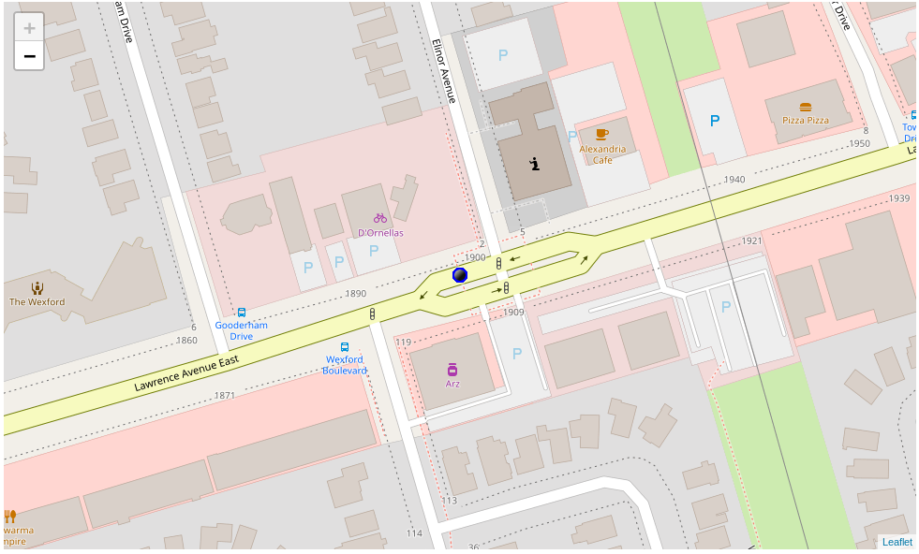

MODELLING AND RESULT::
Using the final dataset containing the neighborhoods in the Toronto with the latitude and longitude , We can find all the venues within 500 meter radius of each neighborhood by connecting to the foursquare API. This returns a json file containing all the venues in each neighborhood which is converted to a pandas data frame. This data frame all the venues along with their coordinated and category.
After running the K-means clustering we can access each cluster created to see which neighborhood were assigned to each of the five clusters. Looking nto the neighborhoods in the cluster. Upon closely examining these neighborhoods we can see that the most common venues in these are Restaurants,Pubs and the supermarkets

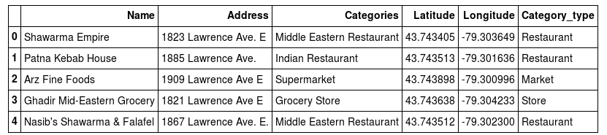

CONCLUSION ::
After mapping the data which I got from Foursquare API converted that data into specific and generalized category so it can be differentiated easily and person may get to know the frequencies of categories . Like there are 8 restaurants and 1 hospital near the residency as shown in the plot

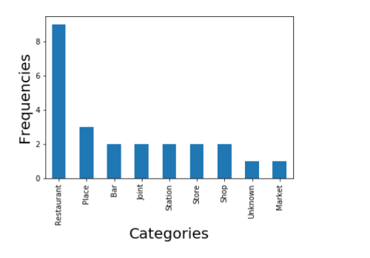

If we see this in Pie chart ,then:

