**PIPELINE:**

**Declerative pipeline**: Go to your Jenkins portal:

**STEP1**:Manage Jenkins->Manage plugins->Available[pipeline]->install without restart

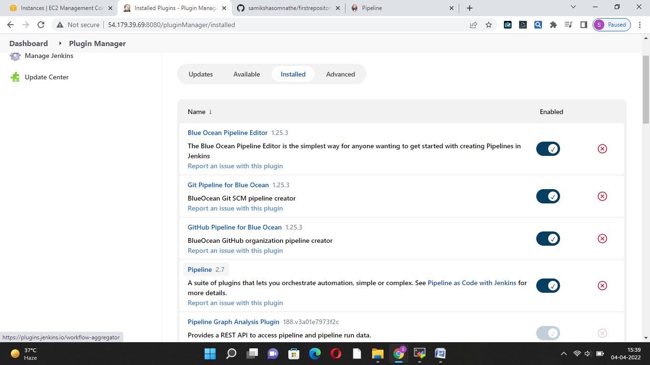

**STEP2:**New iteam->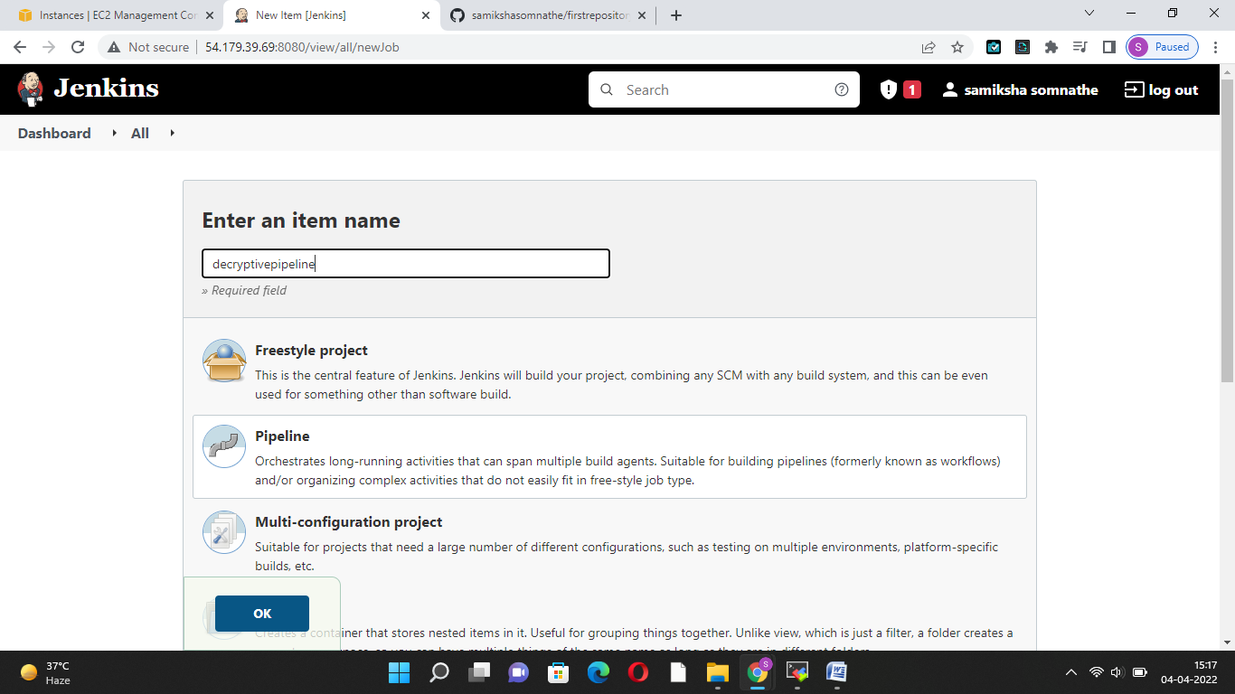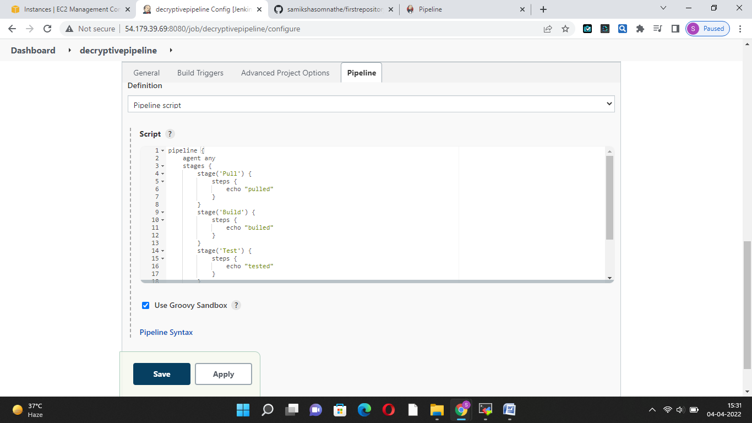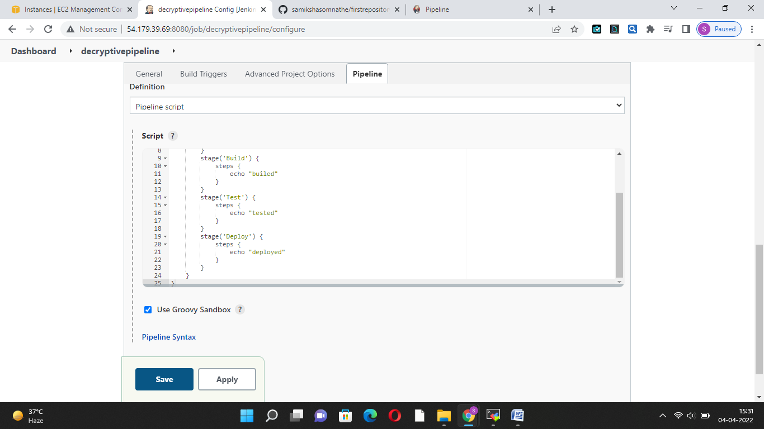

**RESULT:**

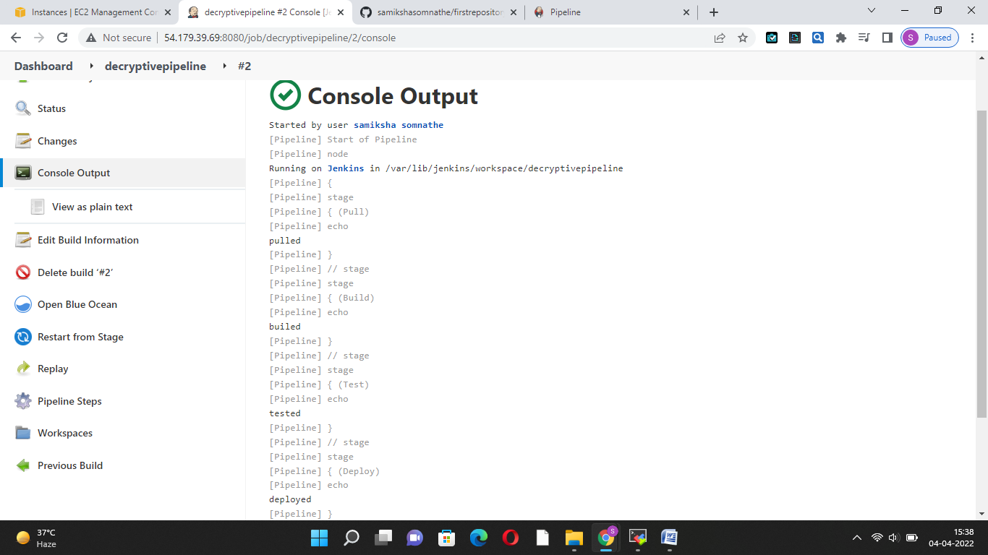

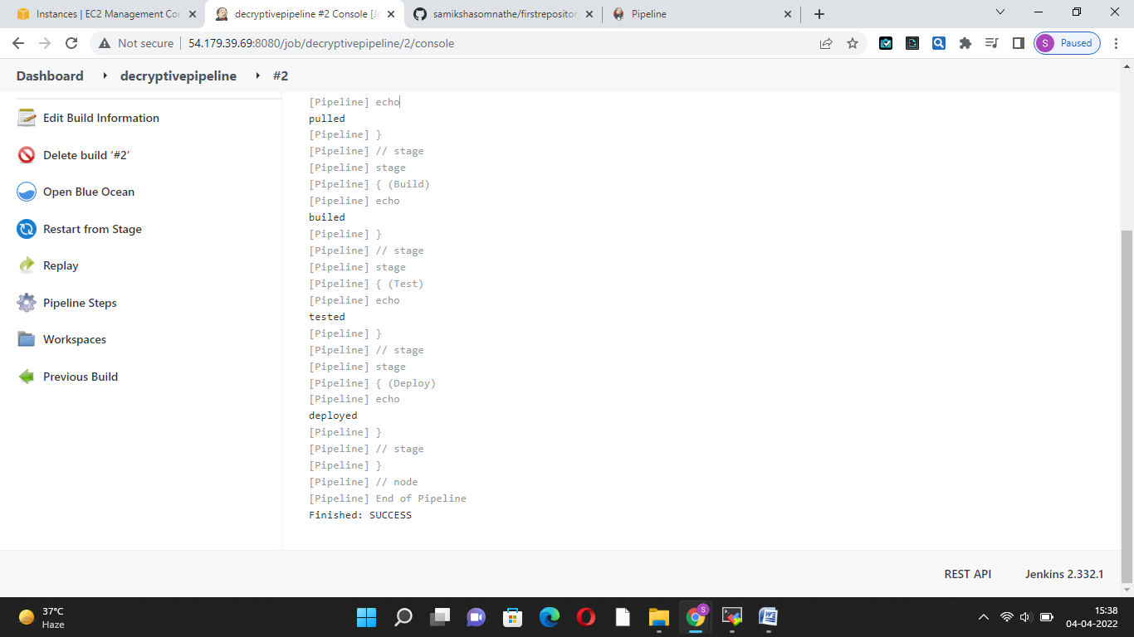

Scripted: