**WEBHOOK:**

**STEPS:1-manage Jenkins :**

Configure system->github->advance->copy the following url:

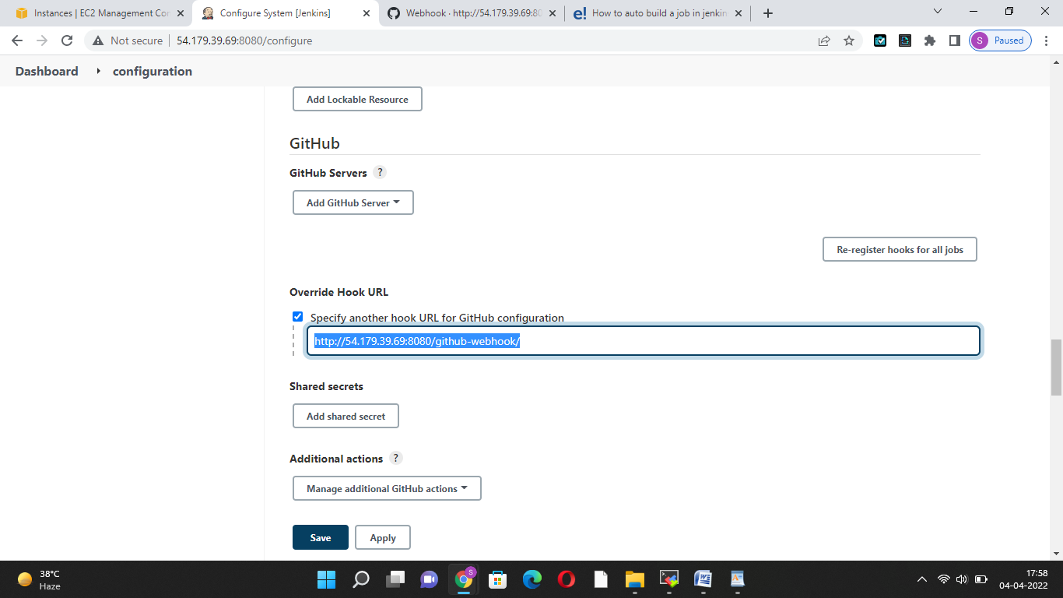

2:GIT LAB : settings->webhooks->add webhook->pest url into played->do following configuration:

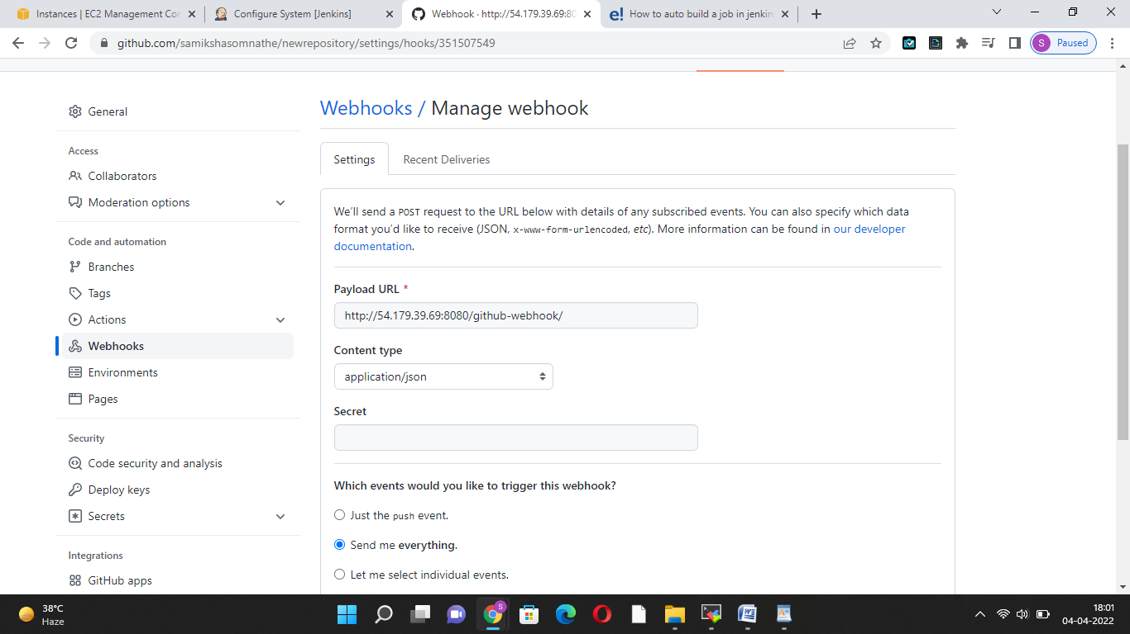

3:Jenkins:-

New item[webhooks]

Freestyle

Ok

And do following changes

