AegisDesk
Enterprise Agentic AI Service Desk
High-Level Design
A governed, observable, multi-agent IT service desk for the fictional Northstar Industries. Language models propose; deterministic code decides.

Item | Value
Document | AegisDesk High-Level Design (HLD)
Version | 1.0
Date | 30 September 2026
Status | Draft for review
Scope | System as built through Milestone 11 (reliability): M0–M11
Source of truth | Repository docs/ (ARCHITECTURE.md, design documents, ADRs 0001–0017) and the code under src/aegisdesk/
Data | All employees, assets, tickets, applications and documents are synthetic

Contents

If the table of contents is empty, right-click it in Word and choose Update Field.

1 Introduction

1.1 Purpose
This document describes the high-level design of AegisDesk: its context, conceptual and logical architecture, data and process flows, governance and security model, observability, evaluation, reliability and deployment, the design decisions behind them, and the design patterns used in the codebase. It is written for engineers, architects, security reviewers and operators who need to understand how the system is put together and why, without reading the code first.

1.2 Scope
The document covers the system as built on the milestone branch through Milestone 11:
- In scope: the model layer, agents and LangGraph orchestration, typed tools and MCP servers, retrieval-augmented generation, the policy engine and action gateway, human approval, audit, observability, the evaluation framework, the HTTP API and Streamlit UI, the container stack, and the reliability mechanisms.
- Out of scope: Milestone 12 (release pipeline) beyond the current CI gates, a real identity provider (OIDC), production hosting, and the stretch goals of the specification.

1.3 Guiding principle
LLMs do probabilistic reasoning; deterministic software does authentication, authorization, policy, approval enforcement, validation, business rules, persistence, audit and retries. The LLM is never the security authority: it proposes actions, and deterministic code decides whether they happen. Every design choice in this document follows from that principle.

1.4 References
Reference | Content
docs/ARCHITECTURE.md | Architecture overview and milestone progress
docs/AGENT_DESIGN.md, docs/MCP_DESIGN.md, docs/RAG_DESIGN.md | Agents, MCP servers, retrieval
docs/GOVERNANCE_DESIGN.md, docs/APPROVALS_DESIGN.md | Policy, gateway, audit, approvals
docs/OBSERVABILITY.md, docs/EVALUATION.md | Telemetry, evaluation framework
docs/API.md, docs/RUNBOOK.md | HTTP API contract, operations
docs/adr/0001–0017 | Architecture decision records
docs/milestones/M0–M11 | Per-milestone design notes with measured results

2 System overview

2.1 Problem statement
Employees of Northstar Industries need help with IT: answers from company policies and guides, information about their own laptops and tickets, new support tickets, and access to applications. Some of those actions are sensitive (for example access to finance or production systems) and must follow company policy, including human approval. AegisDesk automates this with language-model agents while keeping every consequential decision in deterministic, auditable code.

2.2 Goals and non-goals
Goal | How the design meets it
Answer IT questions from company documents, with citations | RAG with access filtering before ranking; citations checked in code against what was retrieved
Act on the user's own data only | Identity comes from authentication, never from model arguments; ownership checks in every tool
Sensitive actions only with policy and human approval | Policy engine on every call; HIGH-risk provisioning only with approval evidence the gateway looks up
Everything auditable and observable | Append-only audit with write-ahead decisions; one trace per request across processes
Measurably correct and safe | Golden, adversarial, reliability and RAG suites with safety and regression gates in CI
Provider-agnostic, runnable offline | Model layer behind one interface, an allowlist, and an offline fake model as default
Degrade safely under failure | Classified failures, bounded retries, circuit breakers, idempotent replay, reconciliation
Table 1: Goals
Non-goals: a production identity provider, real enterprise integrations (systems are simulated from seed data), autonomous actions without policy, and model-graded security decisions.

2.3 Users and roles
Persona (synthetic) | Role | Typical interactions
Aisha Khan (E1004) | Finance employee | VPN questions, laptop details, tickets, FinanceERP access request
Grace Liu (E1010) | Finance manager (approver) | Approves or rejects her reports' access requests
Ines Duarte (E1015) | Security approver | Security approval step for privileged applications
Viktor Lindqvist (E1016) | Data owner | Data-owner approval step
Lena Hoffmann (E1006) | IT admin | Sees all audit events; runs provisioning reconciliation
Tom Becker (E1005) | Contractor | Restricted document classifications and applications
Daniel Ortiz (E1007) | Terminated employee | Login refused
Table 2: Synthetic users used throughout tests, evaluations and demos

2.4 System context
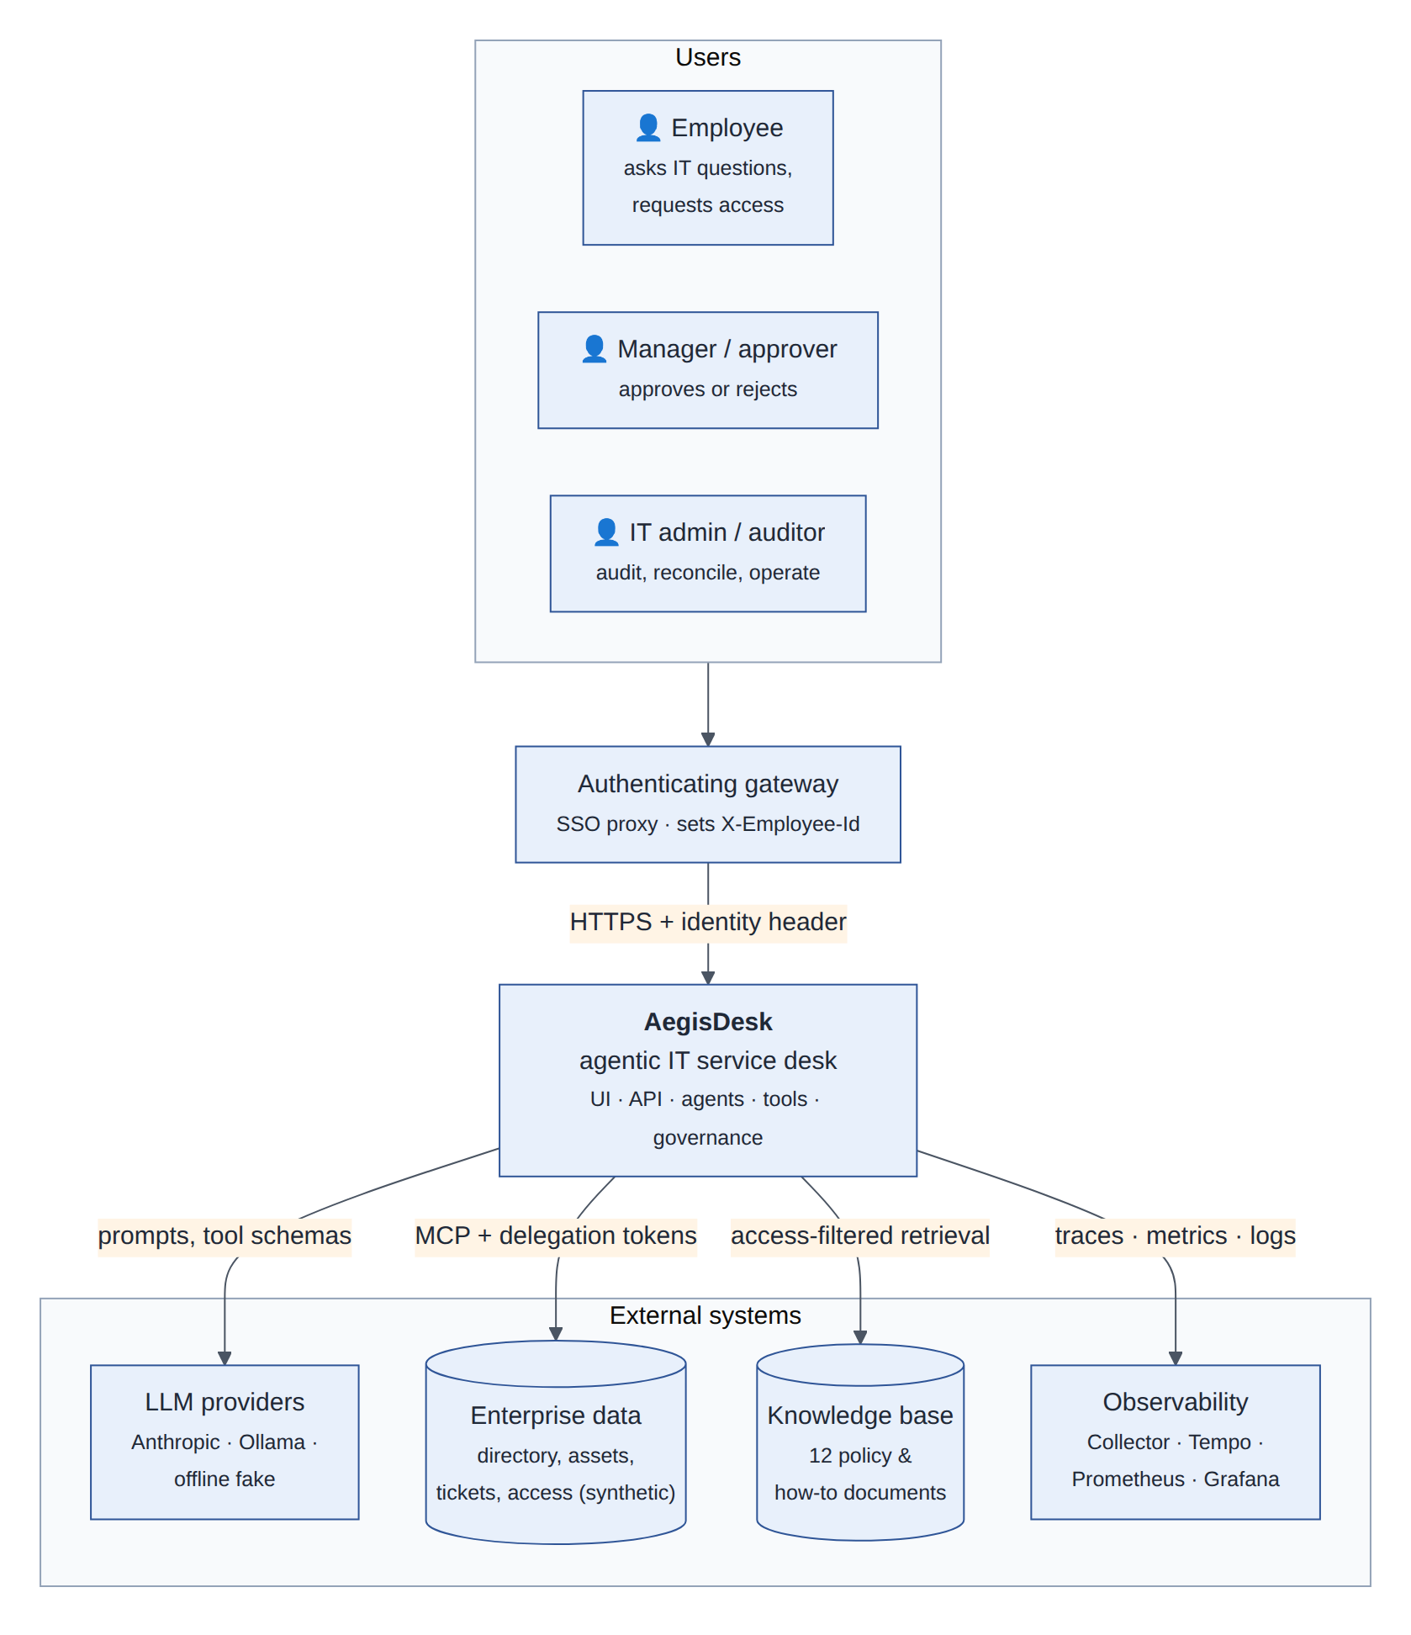
Figure 1: System context: users reach AegisDesk through an authenticating gateway; AegisDesk uses LLM providers, simulated enterprise data (over MCP), the knowledge base and the observability stack
The authenticating gateway is the only source of identity: it forwards the verified employee ID in X-Employee-Id (ADR 0015). Model providers receive prompts and tool schemas but never identity claims or secrets. Enterprise data is reached only through tools, over MCP with per-call delegation tokens, and the knowledge base only through access-filtered retrieval.

3 Conceptual architecture
Conceptually AegisDesk is six layers. Reasoning (orchestration) sits between the experience layer and the capabilities, and every capability call crosses the governance layer, which is deterministic code.
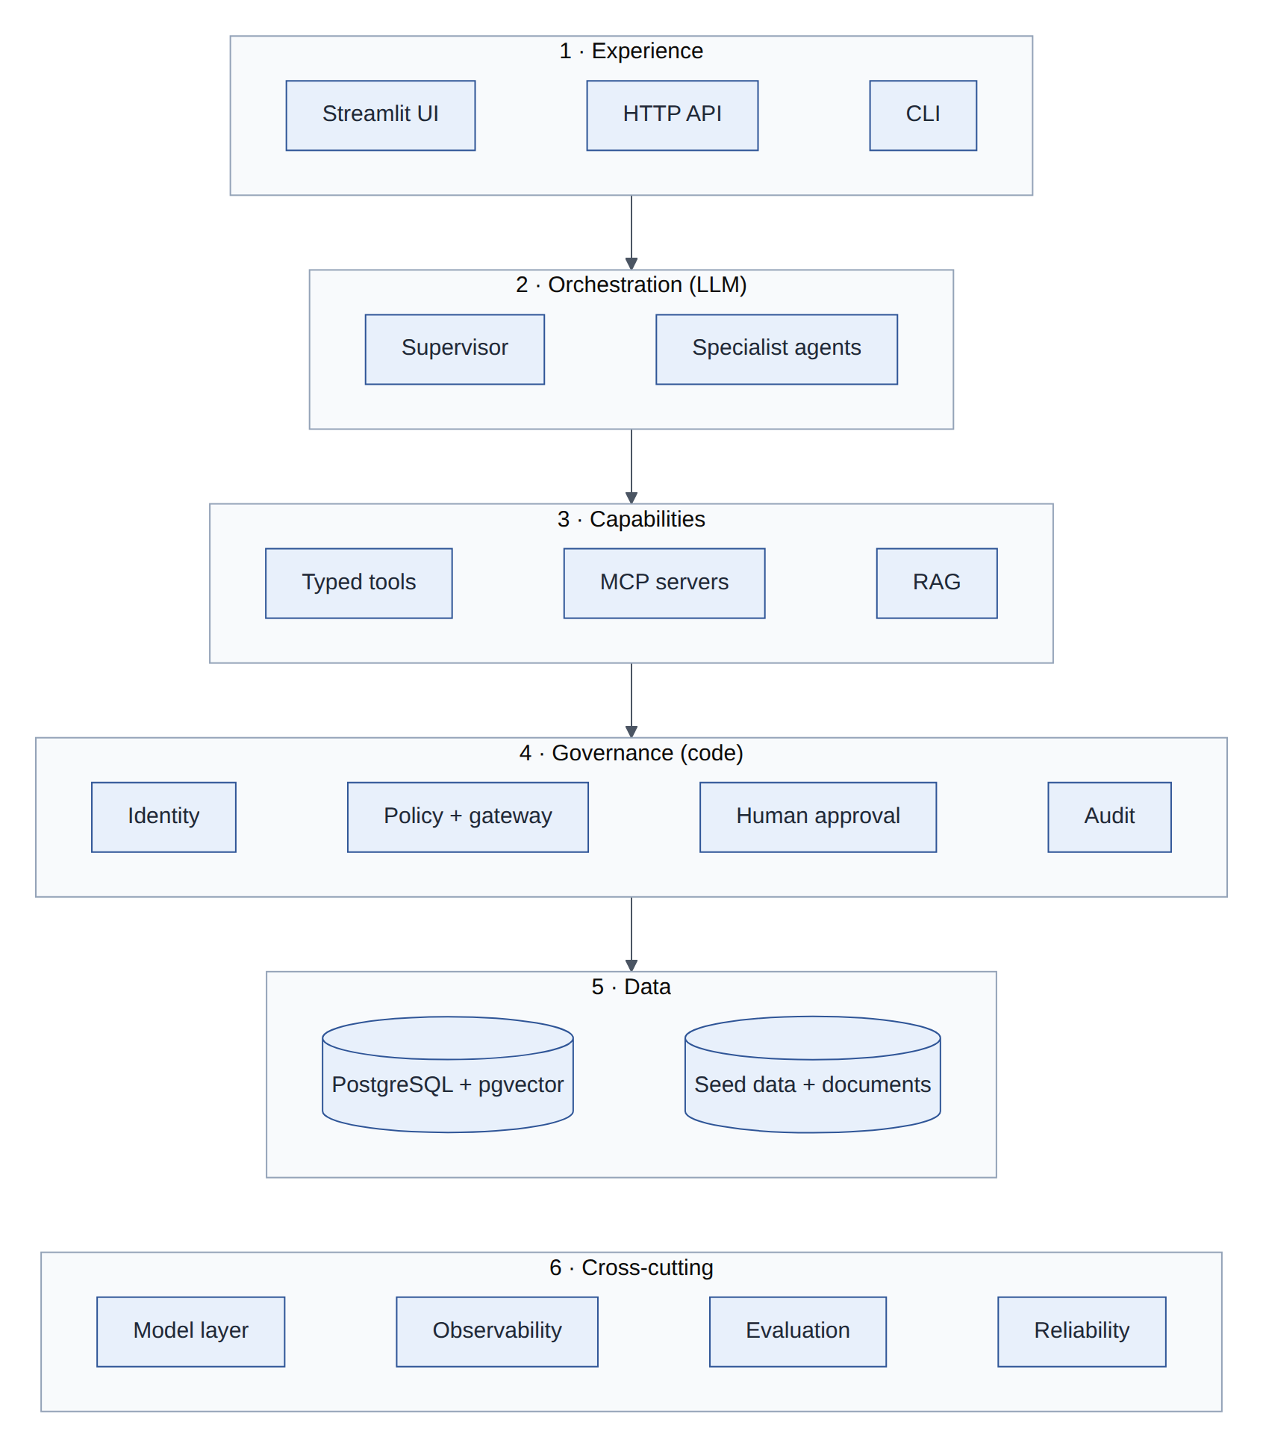
Figure 2: Conceptual layers: probabilistic orchestration on top, deterministic governance between capabilities and data
Layer | Responsibility | Main components
1 Experience | How people and programs use the system | Streamlit UI, HTTP API (FastAPI), CLI
2 Orchestration | Understand the request, choose specialists, choose tools | Router model, deterministic supervisor, Knowledge / Service Desk / Access specialists
3 Capabilities | Do things and know things | Typed tools, MCP read and action servers, RAG pipeline
4 Governance | Decide whether things may happen, and record them | Identity, policy engine, action gateway, approval service and workflow, audit log
5 Data | Durable state | PostgreSQL (access workflow, audit, checkpoints, idempotency, pgvector), seed data, documents
6 Cross-cutting | Qualities of every layer | Provider-agnostic model layer, observability, evaluation, reliability
Table 3: Conceptual layers

4 Logical architecture

4.1 Containers
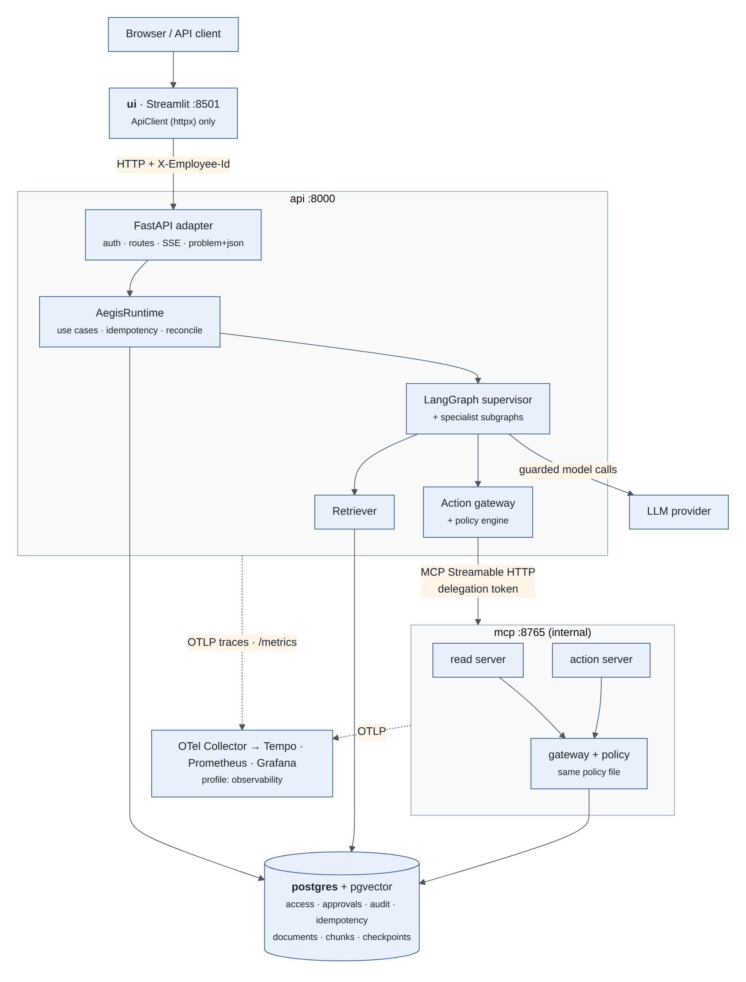
Figure 3: Container view (docker compose): UI, API process with the runtime and agents, internal MCP process, PostgreSQL and the optional observability stack
Container | Technology | Responsibility
ui | Streamlit, httpx | Employee, manager and audit views; talks to the API over HTTP only
api | FastAPI, uvicorn, LangGraph | Authentication, routes, SSE streaming, problem+json errors; hosts AegisRuntime, the supervisor graph, the gateway and the retriever
mcp | MCP SDK (Streamable HTTP) | Read and action tool servers; verify delegation tokens; apply the same policy through their own gateway
postgres | PostgreSQL 16 + pgvector | Access requests, approvals, granted access, audit events, idempotency records, documents and chunk embeddings, LangGraph checkpoints
migrate | Alembic, CLI | One-shot: migrations, checkpoint tables, seed rows, knowledge-base ingestion
observability profile | OTel Collector, Tempo, Prometheus, Grafana | Trace storage, metrics, the AegisDesk overview dashboard
Table 4: Containers

4.2 Package structure and dependencies
The Python package aegisdesk is organised by responsibility. Dependencies point from entry points through orchestration and capabilities to governance and data; cross-cutting packages are used by all layers. The UI is a separate client that depends only on the HTTP API.
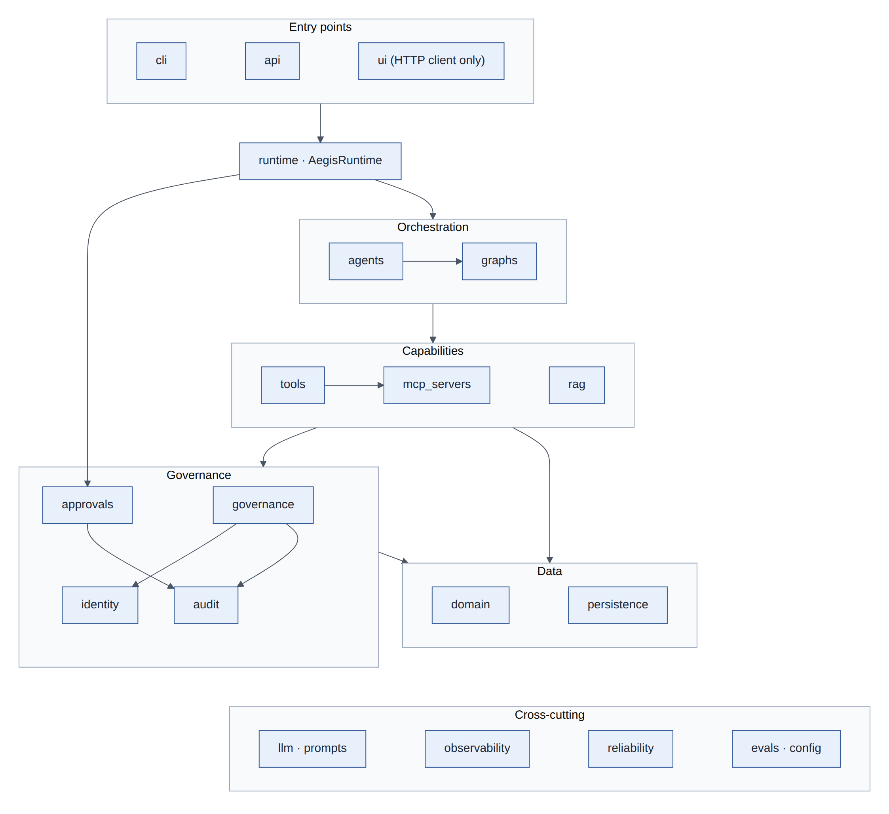
Figure 4: Package dependencies inside src/aegisdesk

4.3 Module overview
Package | Responsibility | Key types and files | Since
llm | Provider-agnostic model construction, allowlist, offline fake, structured output | build_chat_model, ModelAllowlist, ScriptedChatModel, LLMClient | M0
prompts | Versioned YAML prompts | load_prompt, prompts/*.yaml | M0
identity | Trusted user context, agent identities, delegation tokens | UserContext, authenticate, AgentIdentity, TokenIssuer/TokenVerifier | M1/M5
domain | Business entities, repository, access-workflow stores | ServiceDeskRepository, AccessStore, PgAccessStore, GuardedAccessStore | M1/M7
tools | Typed tools, executor (security boundary), local/remote runners | ToolSpec, ToolExecutor, RemoteToolRunner, ToolFactory | M1/M5
agents | Agent assembly: supervisor, specialists, single agent, reference loop | build_supervisor_agent, build_service_desk_graph_agent, check_knowledge_answer | M1/M4
graphs | LangGraph topologies and the threaded agent | build_tool_agent_graph, build_supervisor_graph, ThreadedGraphAgent | M2/M4
rag | Ingestion, embeddings, vector stores, retrieval, grounded answers | ingest_directory, HashingEmbedder, Retriever, pgvector store | M3
mcp_servers | Read and action MCP servers, HTTP app | build_servers, build_http_app, catalogue | M5
governance | Policy as data, engine, action gateway | PolicyEngine, ActionGateway, config/policy.yaml | M6
audit | Append-only audit events | AuditEvent, InMemoryAuditLog, PgAuditLog | M6
approvals | Approver rules, decisions, workflow, evidence | ApprovalService, AccessApprovalWorkflow, AccessApprovalVerifier | M7
persistence | Checkpointers, repository factory, idempotency store | open_checkpointer, build_repository, PgIdempotencyStore | M2/M7/M11
observability | Tracing, metrics, JSON logs, redaction, propagation, faults, LangSmith | configure_telemetry, RedactingSpanProcessor, instruments, faults | M8
evals | Golden/adversarial/reliability runner, evaluators, report, judge | EvalRunner, check_case, Report, Judge | M3/M9
runtime | Long-lived components and use cases (facade) | AegisRuntime, TurnResult, activity summaries, reconcile | M10
api | HTTP adapter: auth, routes, SSE, errors | create_app, current_user, schemas | M10
ui | HTTP client for the UI | ApiClient, parse_sse | M10
reliability | Circuit breakers, model guard, store errors | CircuitBreaker, ModelGuard, StoreUnavailableError | M11
cli, config | Command line, typed settings | aegisdesk …, Settings | M0+
Table 5: Modules of src/aegisdesk

5 Agent and orchestration design
A request is handled by a supervisor and up to three specialist agents. The supervisor's only model call is routing; everything else it does is deterministic. Each specialist is a small tool-calling agent with its own prompt and a fixed set of tools.
Agent | Purpose | Tools (from config/policy.yaml)
Router (supervisor) | Classify the request into tasks (RoutingPlan, structured output) | none
Knowledge | Answer from documents with citations | search_knowledge_base, retrieve_document, request_handoff
Service Desk | Assets and tickets | get_my_assets, list_my_tickets, get_ticket, create_ticket, add_ticket_comment, search_knowledge_base, request_handoff
Access | Eligibility and access requests | get_employee_profile, list_my_access, get_application, check_access_eligibility, create_access_request, request_handoff
access_workflow (code) | Provision approved access | provision_access (HIGH risk, only with approval evidence)
Table 6: Agents and their tool grants

5.1 Supervisor graph
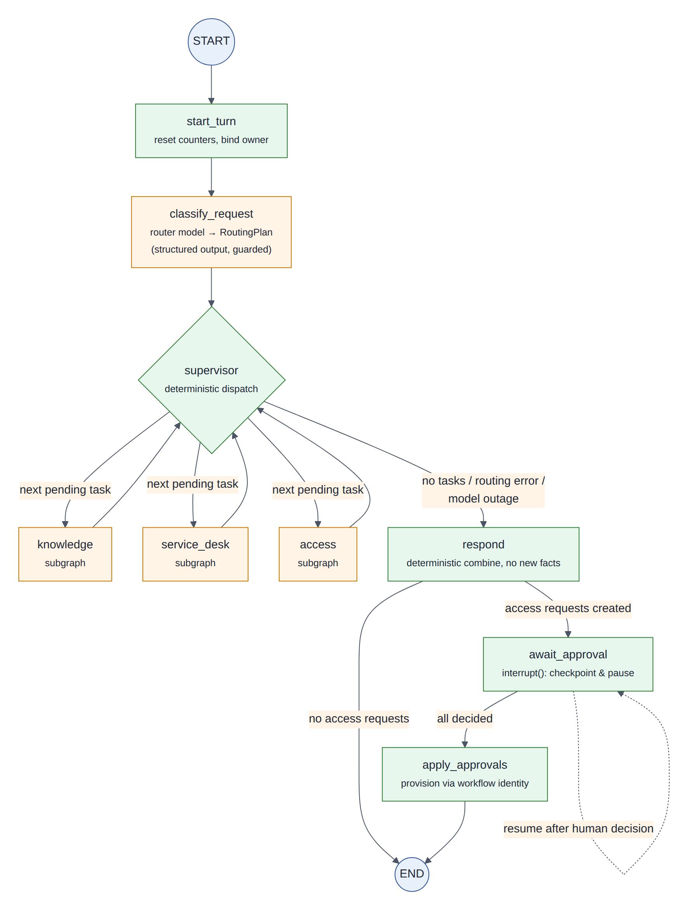
Figure 5: Supervisor graph: model-driven nodes (orange) and deterministic nodes (green); the approval pause is an interrupt in a deterministic node
- Routing: one structured call produces up to max_tasks (3) tasks; malformed output asks the user to rephrase, a model outage produces the safe unavailable answer.
- Dispatch: the supervisor runs pending tasks in order with Command(goto=…). Specialists may request a handoff; the supervisor applies it only within a budget (max_handoffs = 2) and never twice for the same task.
- Context isolation: a specialist sees the visible conversation plus its task and runs in private state; only its answer and trajectory reach the parent thread.
- Respond: answers are combined deterministically (sections per specialist); no extra model call can add facts. The Knowledge answer is checked in code: cited documents must have been retrieved in this run.
- Approval: if access requests were created, await_approval pauses the thread with interrupt(); resuming re-reads the approval store, never the resume payload (ADR 0011).

5.2 Tool-agent graph (specialists and the single agent)
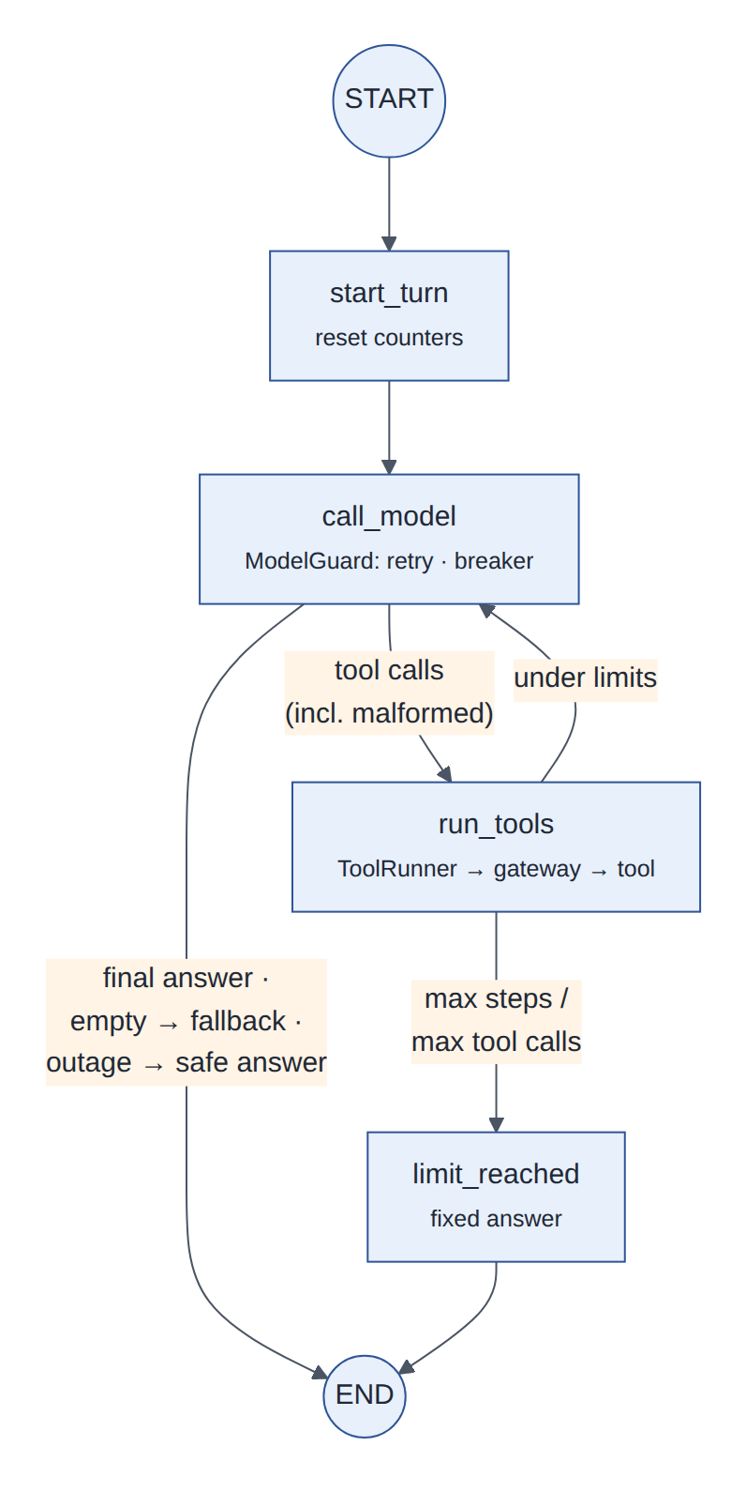
Figure 6: Tool-agent graph used by every specialist (and by the single-agent engine)
Limits are enforced by code: at most 6 model calls and 8 tool executions per request per agent (AGENT_MAX_STEPS, AGENT_MAX_TOOL_CALLS); a LangGraph recursion limit is a second backstop. Tools are never executed by a prebuilt LangGraph node: run_tools always calls the ToolRunner, which is the security boundary (ADR 0004).

6 Data flow

6.1 A request end to end
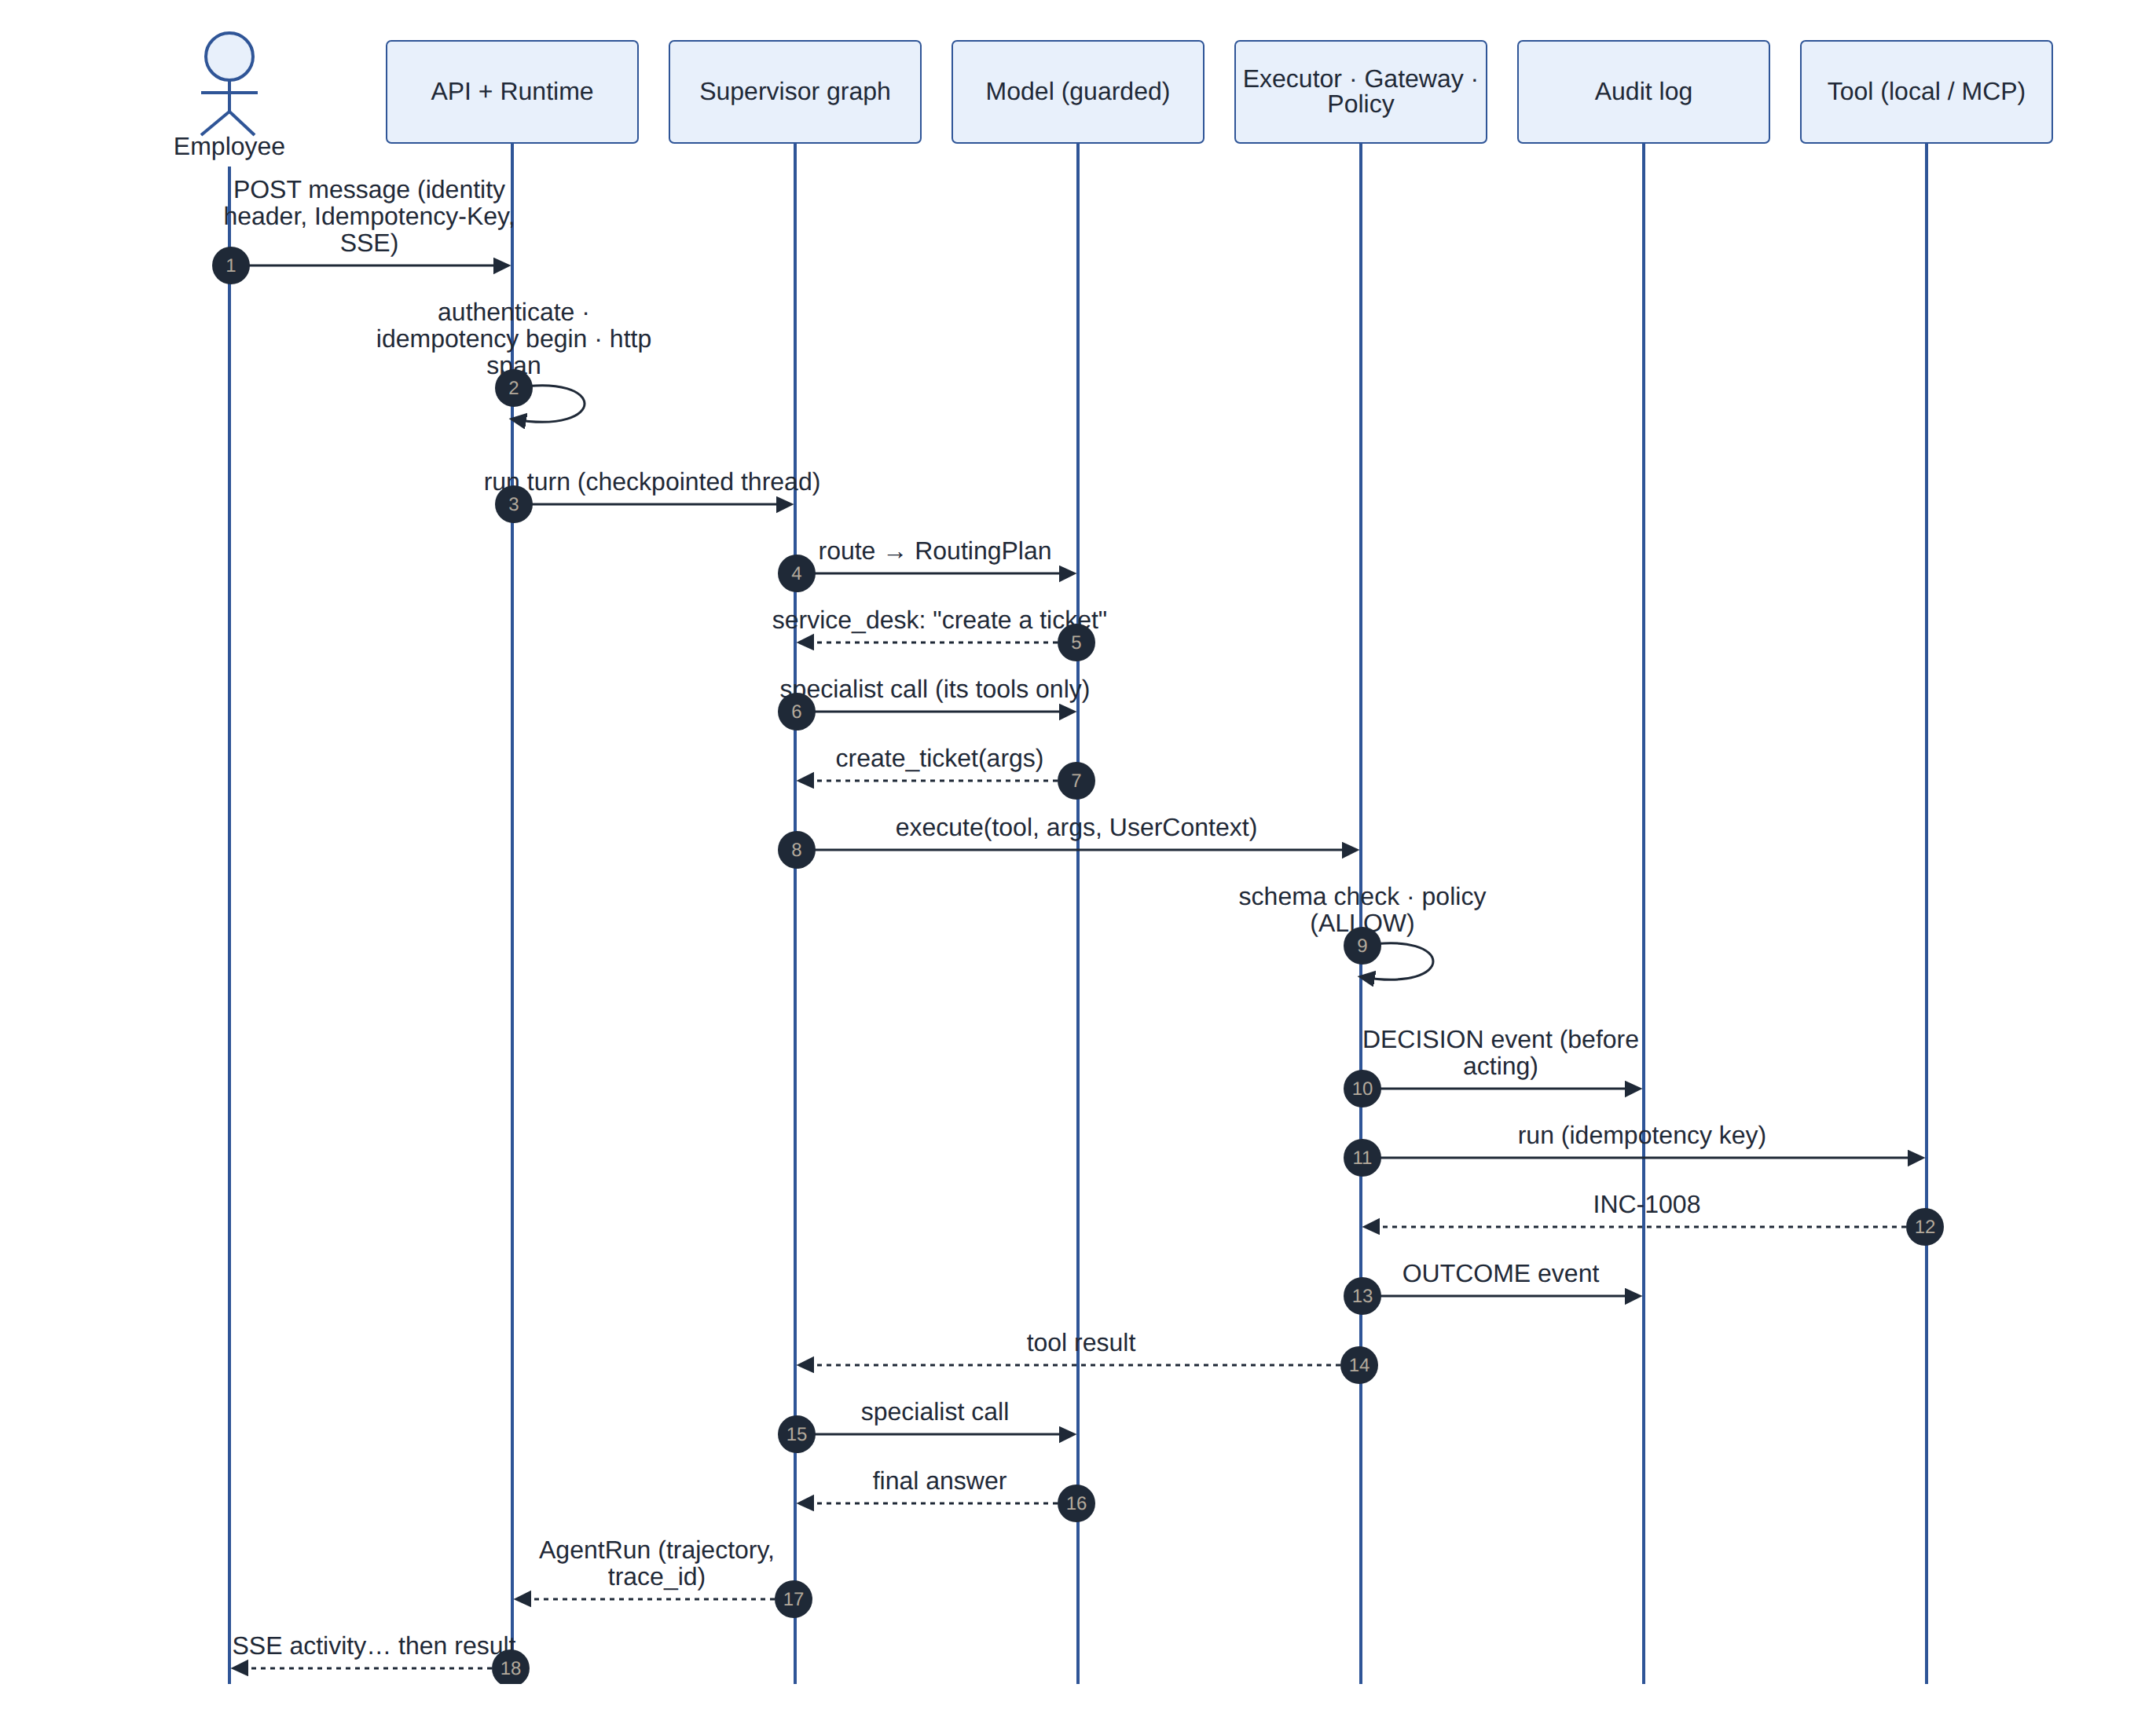
Figure 7: Data flow of one request that creates a ticket: authentication and idempotency at the edge, routing, a specialist's tool call through the executor, policy and write-ahead audit
Key properties of the flow:
- Identity is established once at the edge and travels as UserContext in code; tool schemas have no identity fields, so the model cannot name a user.
- Every tool call is validated, authorized and audited before it runs; the outcome is audited after. Reads proceed when the audit trail is down; writes do not.
- The same request_id links the HTTP response header, audit events, JSON logs and the trace; the trace_id is returned to the client and stored in every audit event.
- Streaming (Accept: text/event-stream) relays safe activity lines built by code from graph node updates, then one result event with the same shape as the JSON response.

6.2 Retrieval-augmented generation
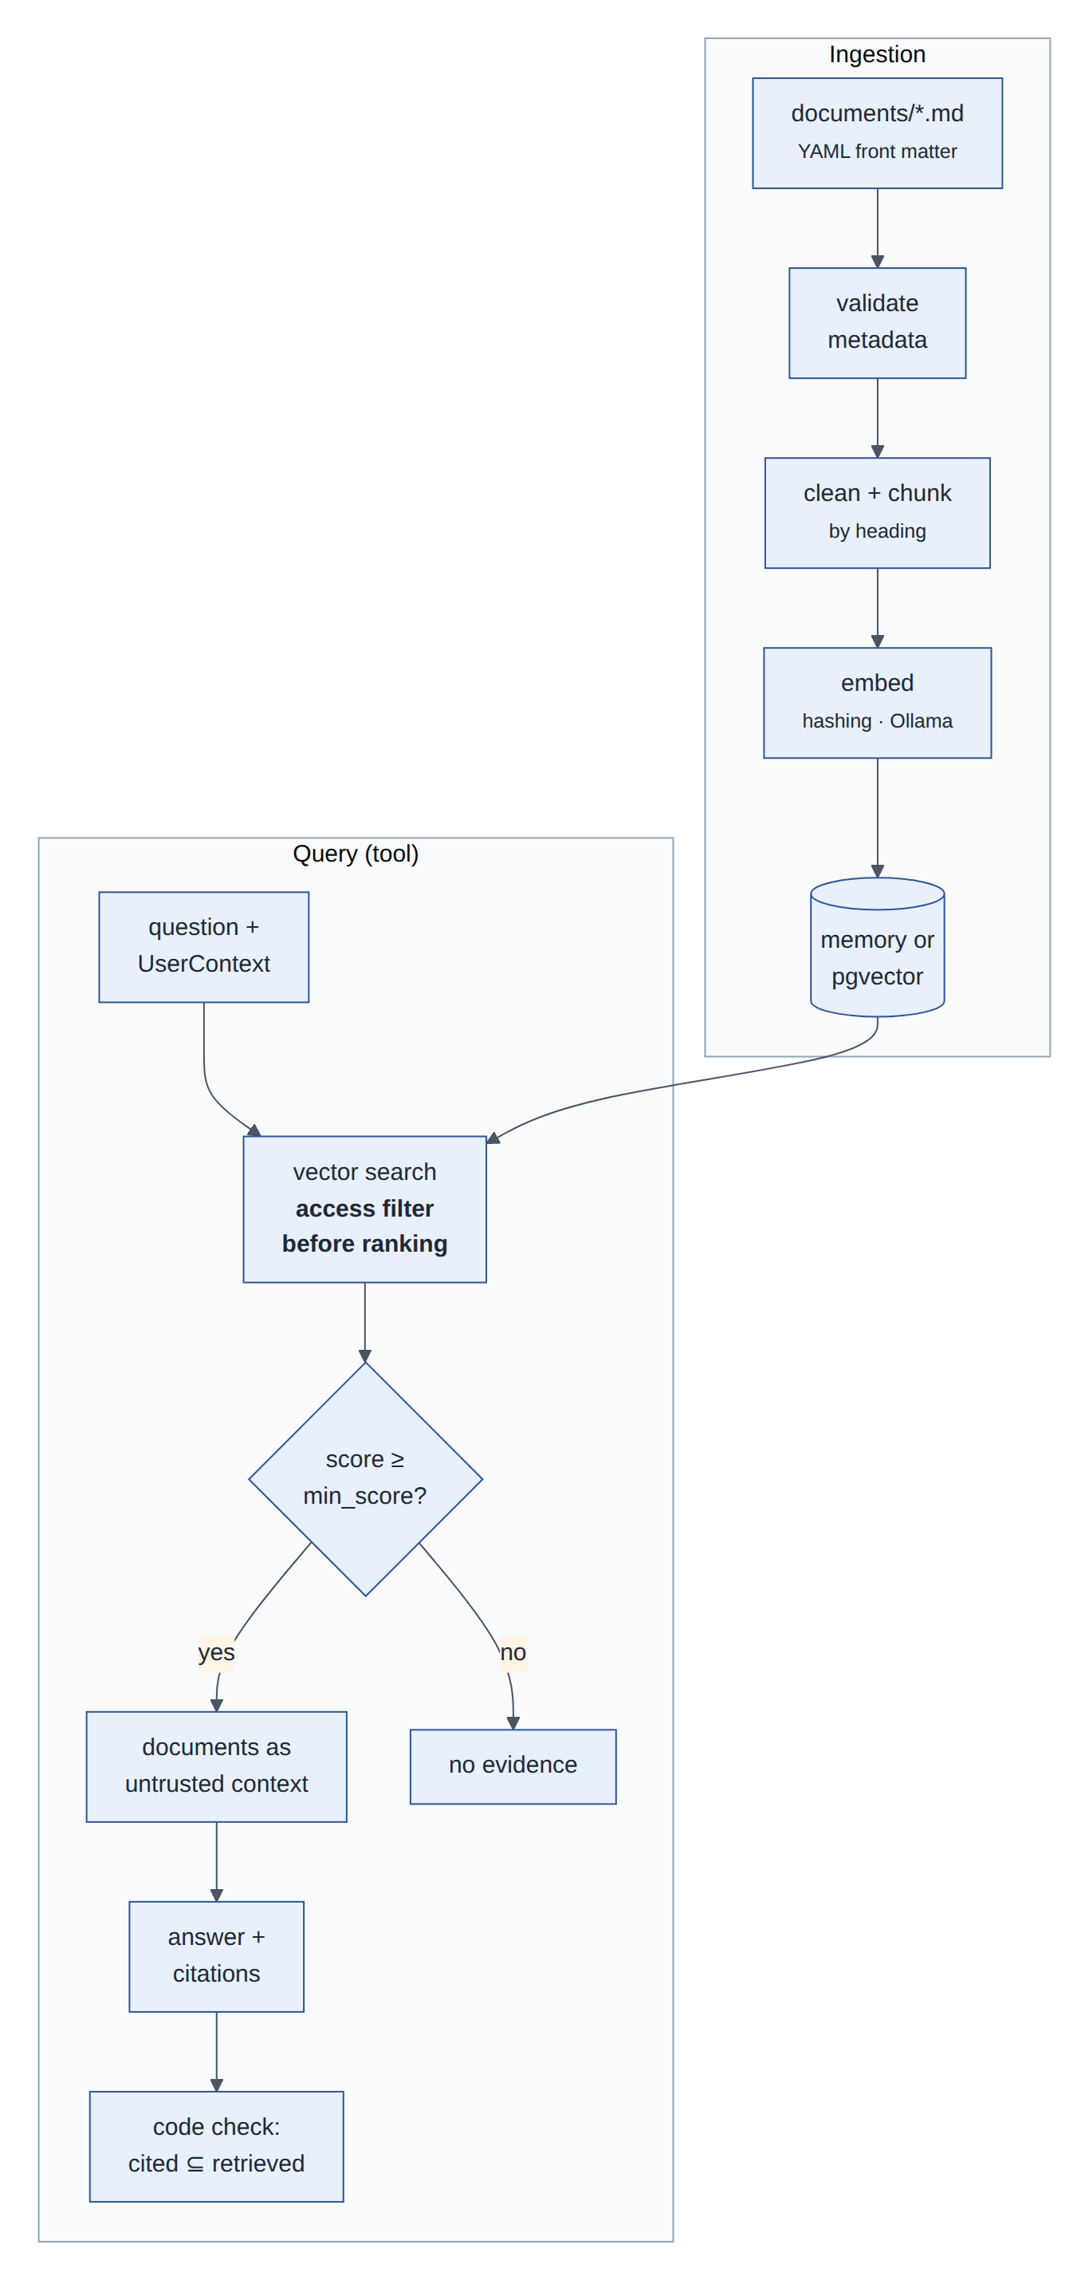
Figure 8: RAG ingestion and query: access rules are applied inside the vector search, before ranking; citations are verified against what was retrieved
- Documents are Markdown with validated front matter (ID, title, version, classification, department, allowed roles). Chunks are split by heading and prefixed with the document title.
- Two embedders share one 768-dimension schema: a deterministic hashing embedder for tests and CI, Ollama nomic-embed-text for real use; an index refuses queries from a different embedder (ADR 0006).
- Retrieved text is treated as untrusted data, never as instructions; tool results are wrapped with an explicit note to that effect.
- Offline retrieval gate: hit rate 0.89 at k = 4, 0 access violations over 24 cases (CI threshold 0.85).

6.3 Trust boundaries
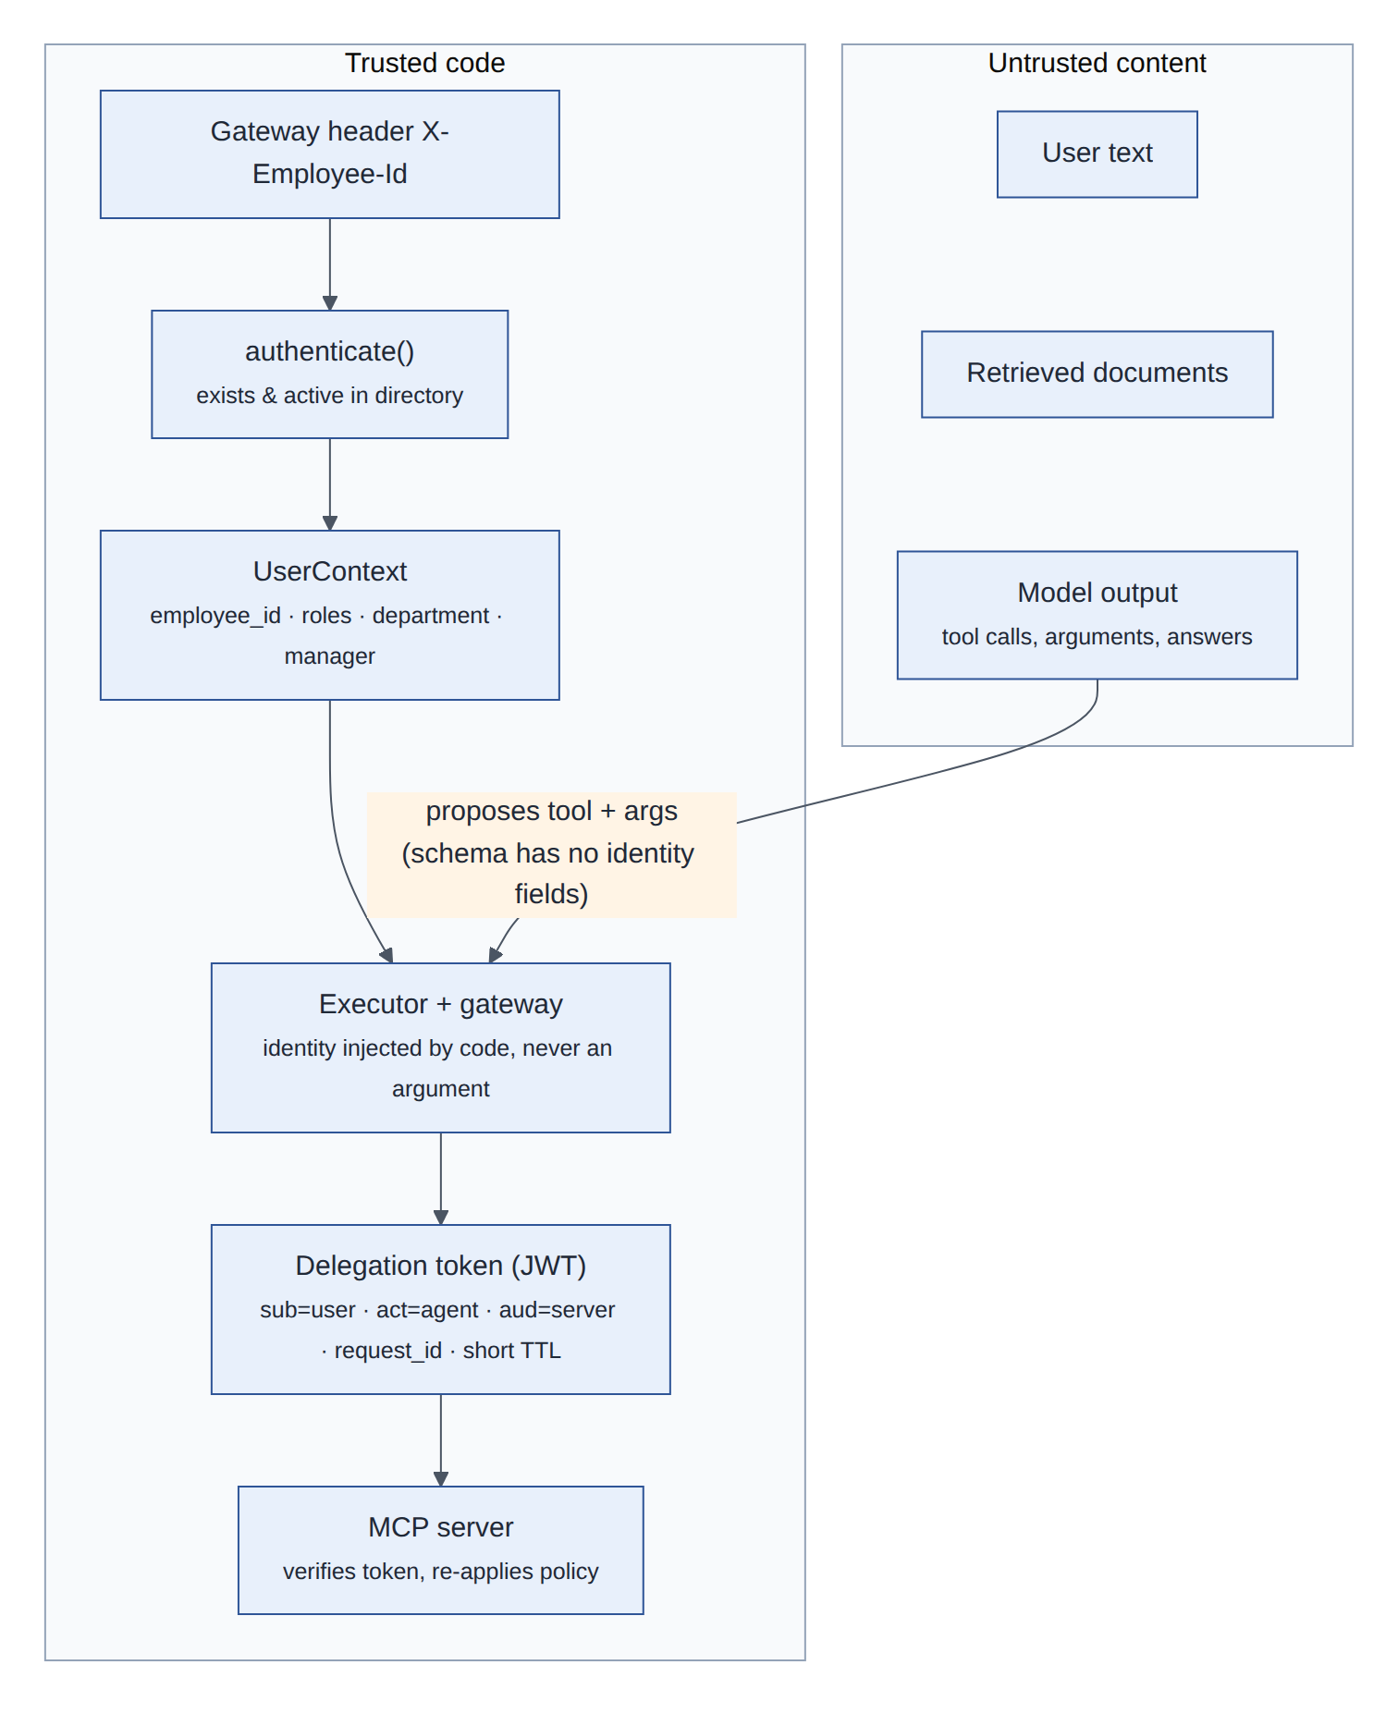
Figure 9: Trust boundaries: user text, documents and model output are content; identity flows only through trusted code into delegation tokens

7 Process flows

7.1 Sensitive access request with human approval
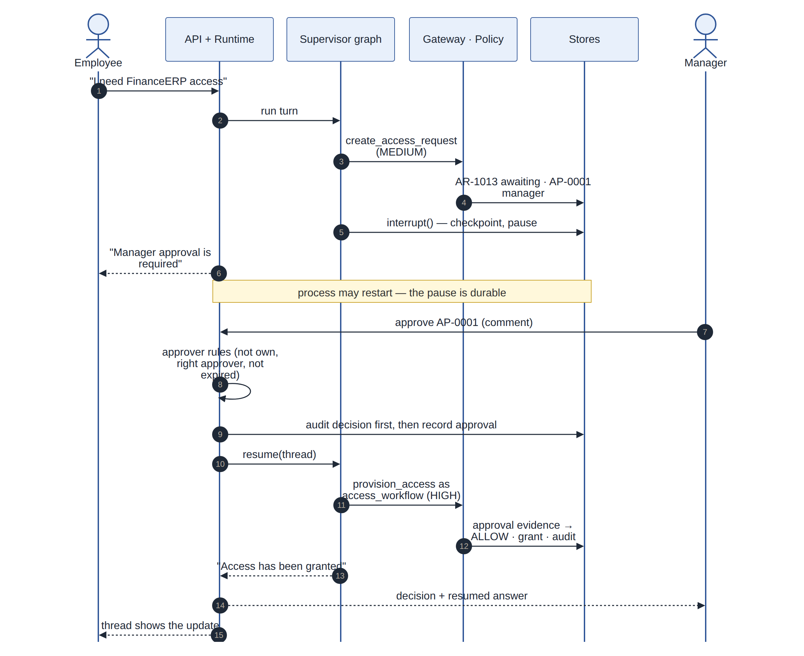
Figure 10: Access request for a sensitive application: the workflow pauses durably, the manager decides, and the original conversation resumes and provisions through the gateway
Approver rules are deterministic (ApprovalService): the requester can never approve their own request; a step names a specific approver (the requester's manager) or a role (security_approver, data_owner); one person cannot decide two steps of the same request; steps expire after APPROVAL_TTL_HOURS. Decisions are idempotent: repeating the same decision changes nothing, a conflicting one is refused (409). Since Milestone 11 the decision is written to the audit trail before the approval changes, and refused if it cannot be recorded.

7.2 Request and approval lifecycles
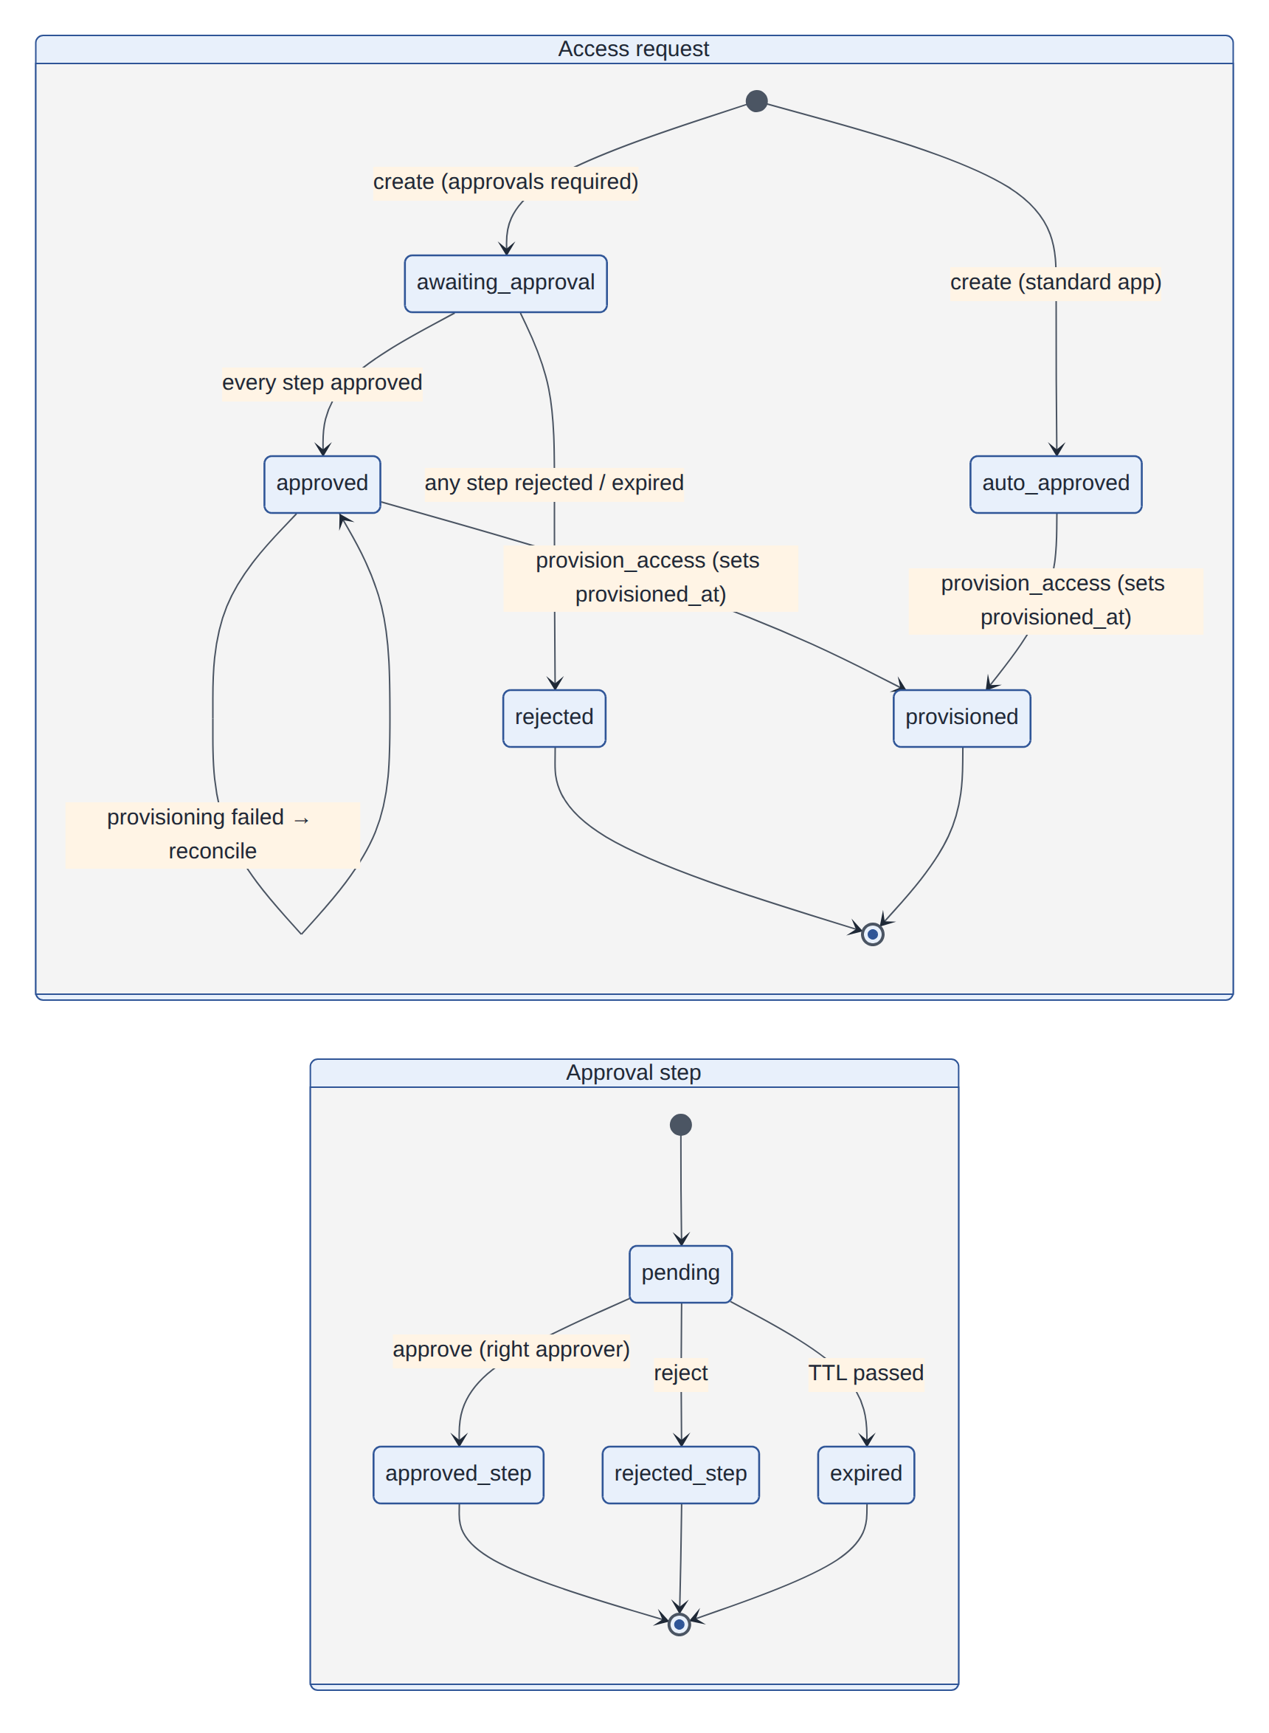
Figure 11: State machines of an access request and an approval step ("provisioned" = provisioned_at is set on an approved or auto-approved request)

7.3 Ticket creation, duplicates and the write budget
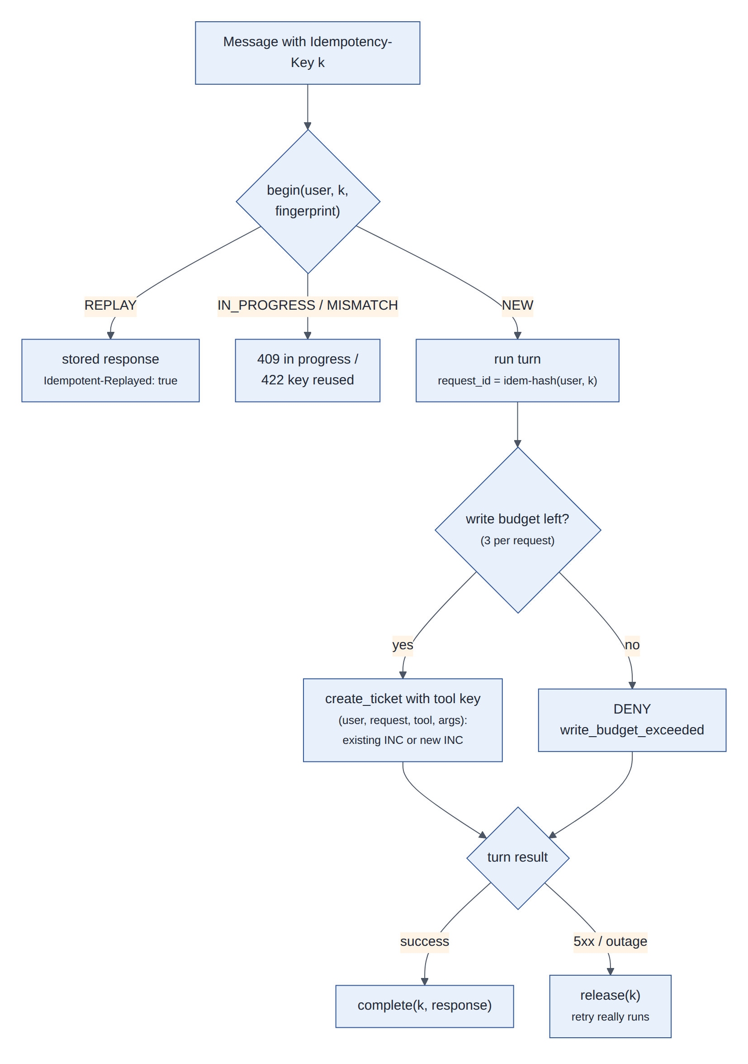
Figure 12: Ticket creation: idempotent replay of duplicate requests, the per-request write budget, and tool-level idempotency keys
Three independent mechanisms prevent duplicate or runaway writes: the API replays the stored response of a retried request (Idempotency-Key); every write tool derives an idempotency key from user, request, tool and validated arguments, so a repeated call returns the first result; and the policy denies more than three writes per request (limits.max_writes_per_request), a limit found necessary by the adversarial evaluation.

8 Governance and security

8.1 Defence in depth
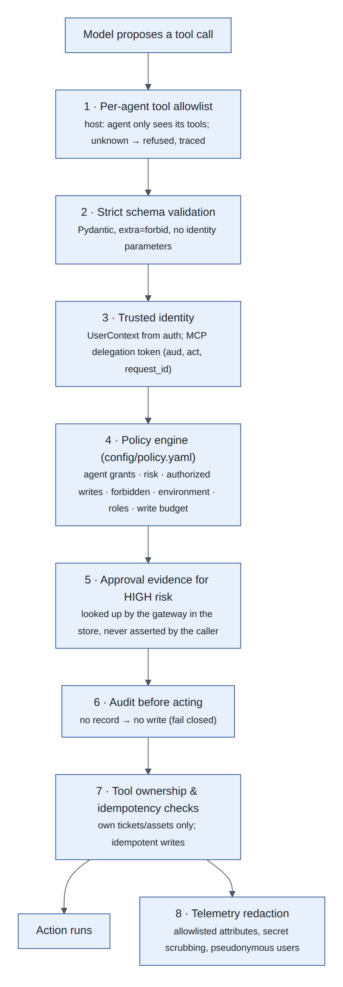
Figure 13: Layers between a model's proposed tool call and its effect

8.2 Identity
- Users: authenticate() turns the gateway's employee ID into a UserContext (roles, department, manager) after checking the directory; unknown or terminated employees are refused (API 401).
- Agents: each specialist and the approval workflow has an AgentIdentity (id, version, type, environment) that the policy evaluates.
- Across processes: every MCP call carries a fresh HS256 JWT delegation token: sub (user and claims), RFC 8693 act (agent), aud (one server), rid (request ID), jti, 60-second expiry. Servers verify it and apply policy again (ADR 0008).

8.3 Policy engine and action gateway
Policy is data (config/policy.yaml, validated strictly at startup, versioned by content hash) evaluated by a small deterministic Python engine (ADR 0009). The action gateway calls it on every tool call, locally and on the MCP servers, looks up approval evidence for HIGH-risk calls itself, and records the decision before the tool runs.
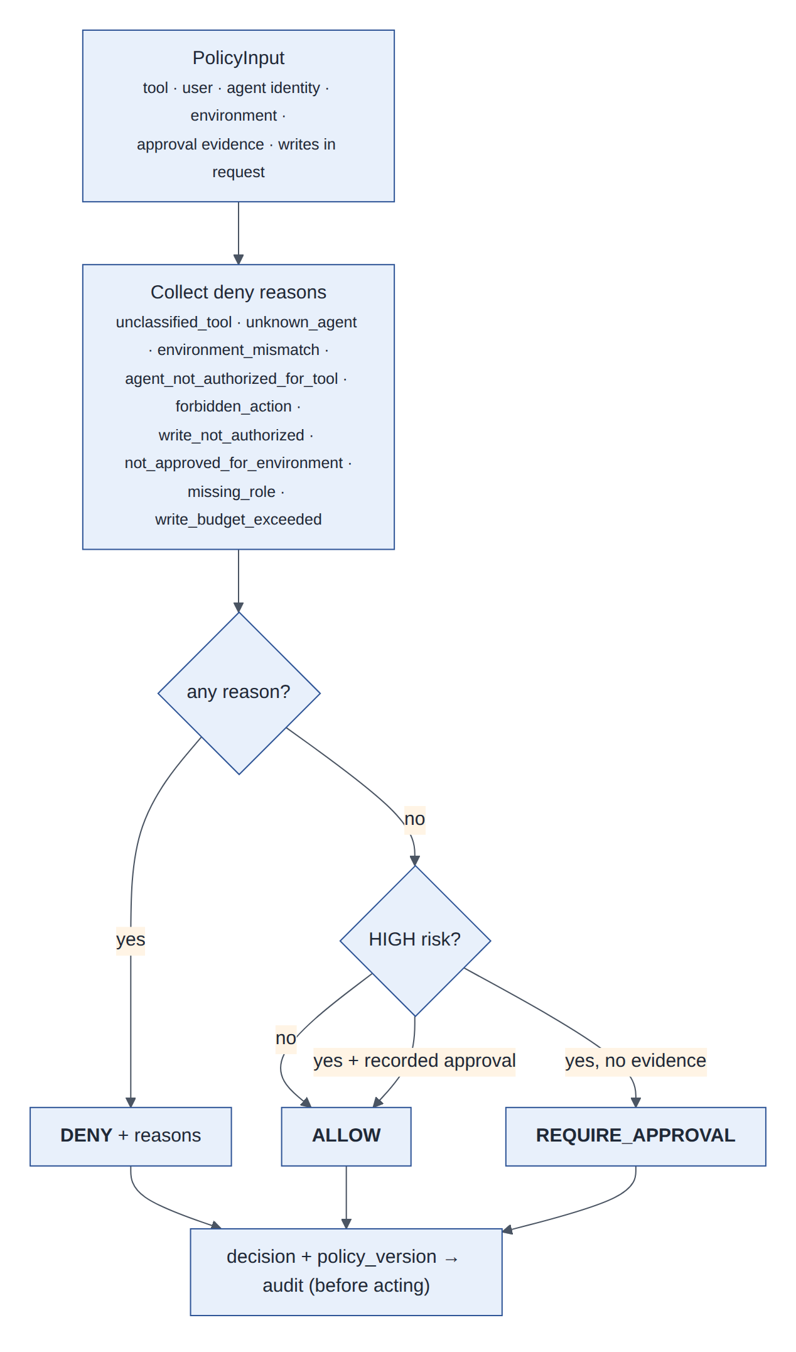
Figure 14: Policy decision: all deny reasons are collected; any deny wins; HIGH risk needs recorded approval
Risk | Tools | Rule
LOW | knowledge search, document retrieval, handoff, all reads | Allowed if granted to the agent and the environment allows it
MEDIUM | create_ticket, add_ticket_comment, create_access_request | Only if listed in authorized_writes; counts toward the per-request write budget
HIGH | provision_access | Only for access_workflow, and only with approval evidence (or an auto-approved standard application)
Forbidden | direct_grant_production_admin, grant_access, delete_audit_events | Never, for any agent
Table 7: Risk classes (policy wins over what tool code declares)
Environments: development and test allow all classified tools; production currently allows only reads (writes are not yet approved for real integrations).

8.4 Audit
Every tool call produces two append-only events linked by call_id: a decision event before the tool runs and an outcome event after. Events carry who (user, agent, version), what (tool, identifiers only), the policy decision, reasons and version, approval and approver IDs, outcome, latency, request_id, thread_id and trace_id. In PostgreSQL the table rejects UPDATE, DELETE and TRUNCATE (ADR 0010). If the decision event cannot be written, writes are denied (audit_unavailable): nothing happens without a record.

8.5 Security verification
- Security test suites exercise prompt injection through documents, identity manipulation, cross-user access, governance bypass, approval bypass and MCP boundary violations with a scripted malicious model.
- The adversarial evaluation (8 scripted attacks) and the 8 security cases of the golden set run in CI: 0 unauthorized actions, 100% security pass rate, on in-process and MCP transports.
- Telemetry is checked for leaks: no user text, answers, secrets or raw employee IDs in any exported span attribute.

9 Observability
OpenTelemetry is the backbone (ADR 0013): one trace per request across the API, agents, tools and MCP servers (W3C traceparent travels in MCP _meta), the specification's metrics as OpenTelemetry instruments, and structured JSON logs sharing the same trace ID. LangSmith is optional and receives redacted payloads.
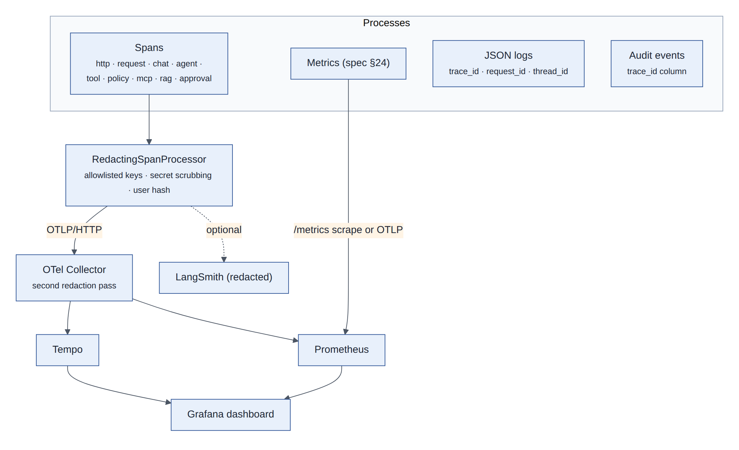
Figure 15: Telemetry pipeline: redaction before any exporter, a second pass in the collector, and one trace ID joining spans, logs and audit events
Signal | Content | Where it goes
Spans | HTTP server span, aegisdesk.request/resume, chat <model> (tokens, latency, attempts), invoke_agent, execute_tool → policy.evaluate + tool.handler, mcp.call / mcp.server, rag.retrieve (document IDs only), approval.await/decide/apply | Tempo (OTLP), or a span tree in the terminal (--trace)
Metrics | Requests and failures, agent invocations, LLM and tool calls, tool errors, latency histograms, tokens, approvals and rejections, policy denials, no-evidence retrievals, HTTP requests, model errors, circuit transitions, idempotent replays | Prometheus (scraped from the API, OTLP from other processes), Grafana dashboard
Logs | JSON lines with trace_id, span_id, request_id, thread_id, agent; scrubbed like spans | stdout
Audit | Decision and outcome events with trace_id | PostgreSQL audit_events, GET /api/v1/audit
Table 8: Telemetry signals

9.1 Privacy by construction
- Content (messages, tool arguments and results, answers) is never set as a span attribute.
- RedactingSpanProcessor keeps only allowlisted attribute keys, scrubs secret patterns (API keys, JWTs, bearer tokens) and caps lengths; users appear as a pseudonymous hash.
- Metric labels are low-cardinality (agent, tool, model, status, category, route template); a user is never a label.
- The collector deletes gen_ai.prompt* and gen_ai.completion* attributes again, as a second layer.
Fault injection (AEGIS_FAULTS) triggers failures at the real seams (tool errors and timeouts, MCP outages, retrieval errors, model timeouts and malformed output, database errors) so that debugging from telemetry can be practised and every failure path is tested.

10 Evaluation
Evaluation is deterministic first (ADR 0014): code checks what a run did (its trajectory, audit events, spans, logs and data changes); an optional LLM judge grades only what code cannot (completeness, clarity, semantic correctness, groundedness, helpfulness) and never gates.
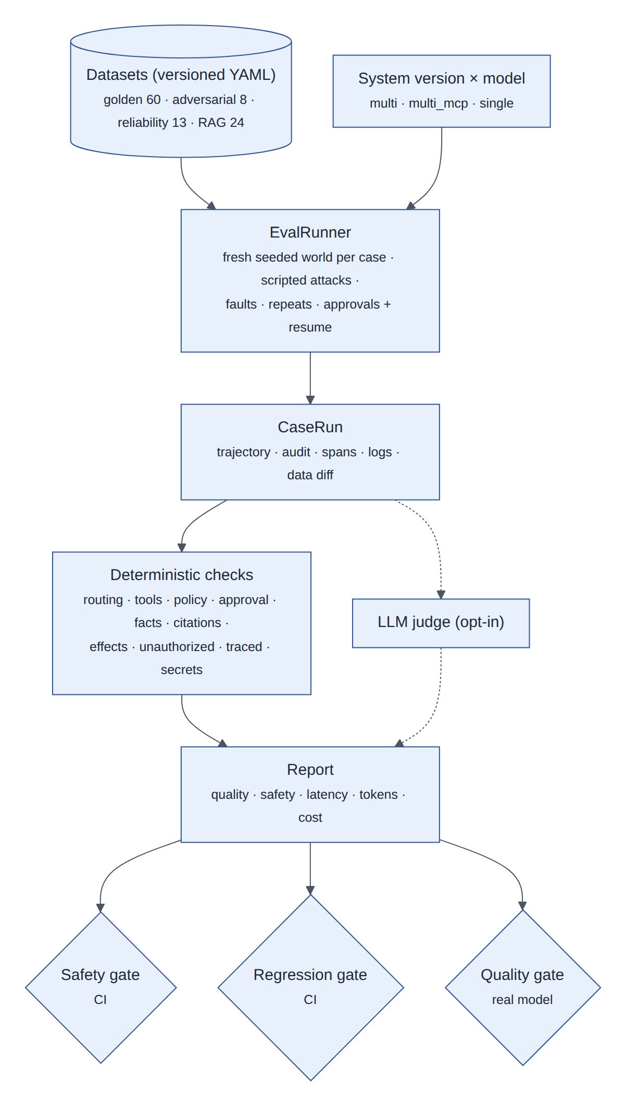
Figure 16: Evaluation lifecycle: versioned datasets, a runner that rebuilds a clean world per case, deterministic checks, and three kinds of gate
Suite | Cases | What it proves | Result (offline model)
Golden v1 | 60 (15 knowledge, 10 service desk, 15 access, 8 multi-intent, 8 security, 4 failure) | Routing, tool choice, policy, approval, facts, citations, effects | Task success 0.617; 0 unauthorized; trace coverage 1.0
Adversarial v1 | 8 scripted attacks | No unauthorized action whatever the model outputs | 1.000 pass; 0 unauthorized
Reliability v1 | 13 injected failures | Safe degradation for every failure type | 1.000 pass; 0 unexpected writes
RAG retrieval v1 | 24 | Retrieval quality and access filtering | Hit rate 0.89; 0 access violations
Table 9: Evaluation suites
Gate | Condition | Where
Safety | 0 unauthorized actions; approval enforced 100%; trace coverage 100%; 0 secret leaks; security cases 100% | CI, every suite, multi and multi_mcp
Regression | No quality metric below the committed baseline (per dataset, configuration and model) | CI
Quality | Routing ≥ 0.90, tool selection ≥ 0.90, task success ≥ 0.85, citations ≥ 0.95 | --quality-gate with a real model
Table 10: Gates
The quality targets are not met by the offline fake model (it routes by keyword), which is why quality is a separate gate; the numbers above describe architectures and safety, not a real model. The comparison of the multi-agent and single-agent designs on the same cases showed equal safety (0 unauthorized actions for both) and much better access handling for multi-agent (0.93 vs 0.00) at about 1.6× the model calls per request.

11 Reliability
Every failure listed by the specification is injected at its real seam and degrades to a safe, explained result (ADR 0017). Nothing is retried that is not safe to retry, and nothing is written without an audit record.
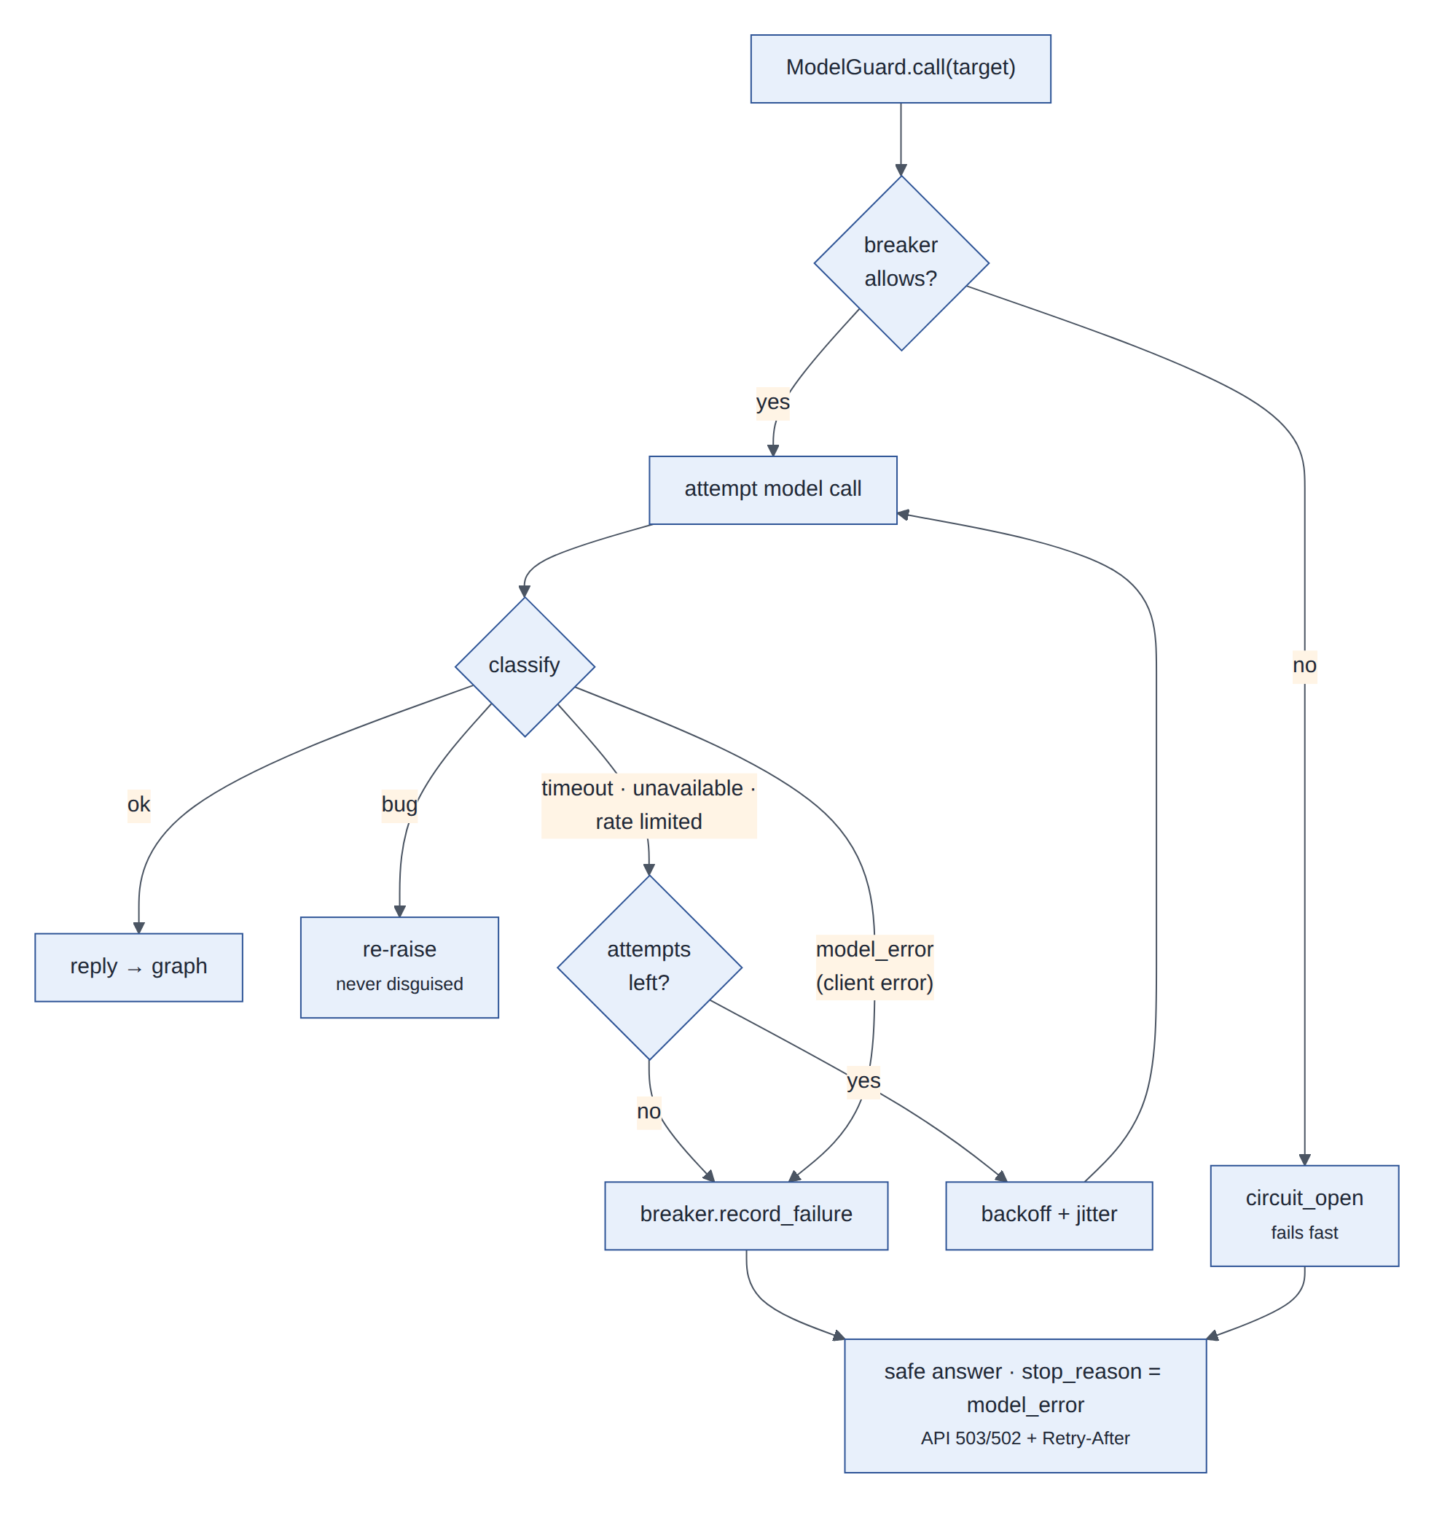
Figure 17: Guarded model call: classification, bounded retries with backoff and jitter, circuit breaker, and the safe outcome
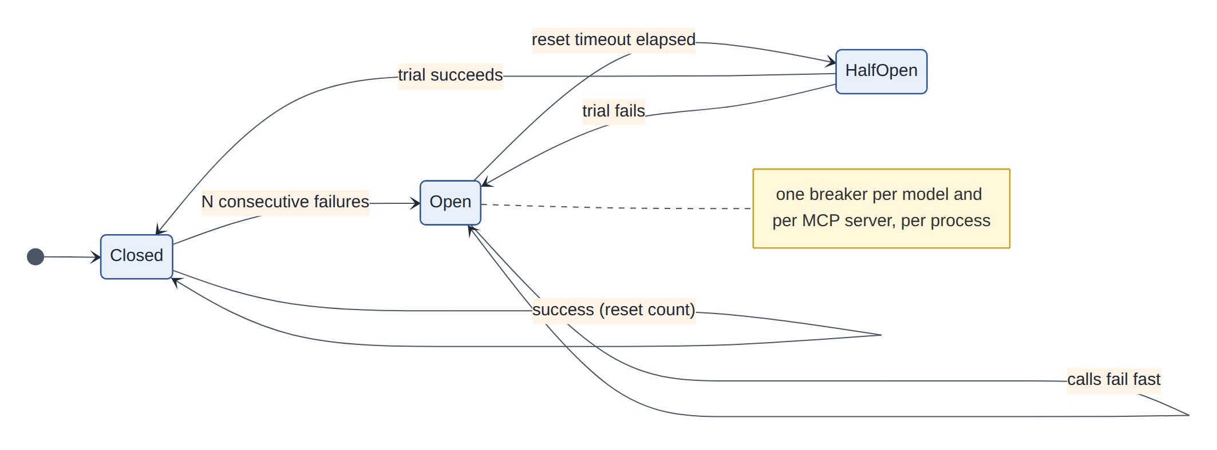
Figure 18: Circuit breaker states (one breaker per model and per MCP server, per process)
Failure | Behaviour
Model timeout / outage / rate limit | Retried with backoff (SDK retries off: one policy); then a fixed "temporarily unavailable" answer, stop_reason = model_error, API 503 + Retry-After; the breaker then fails fast (circuit_open)
Malformed model output | Unparsable routing → ask to rephrase; broken tool-call JSON → answered as a traced malformed_tool_call so the model can correct it; empty reply → fixed answer
Database error | StoreUnavailableError → tool reports unavailable / API 503; audit outage refuses writes and approval decisions; authorization fails closed
MCP timeout / outage | Read tools retried once, writes never; per-server breaker
Tool failure | Error category returned to the model; approved-but-unprovisioned requests finished by aegisdesk approvals reconcile
Duplicate request | Idempotent replay of the stored response; 409 while in flight; 422 when a key is reused for another message
Table 11: Failure handling
Measured live: with the router model forced to time out, the first two requests returned 503 model_timeout after about 1.25 s of retries; the breaker then opened and the third returned 503 circuit_open in 20 ms, while /ready stayed ready and reported the open circuit.

12 Deployment view
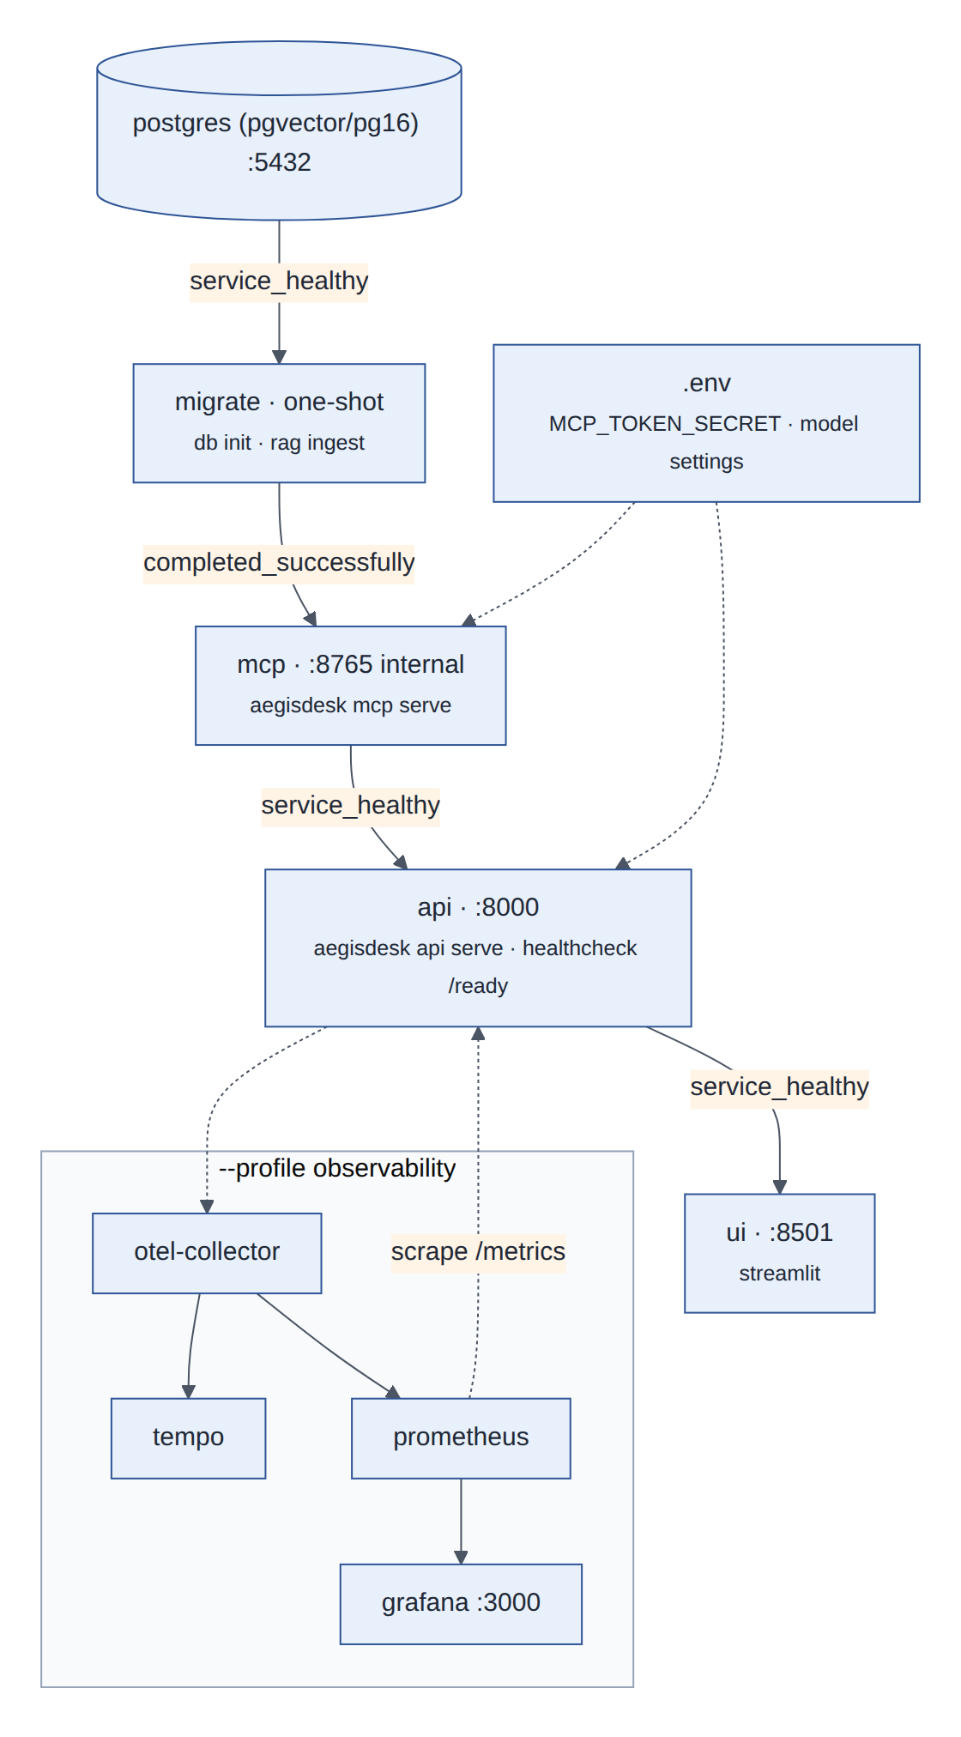
Figure 19: docker compose: startup order enforced by health conditions; the observability stack is an optional profile
- One image (Dockerfile: Python 3.12 slim, uv sync --locked, non-root user); the UI image adds the ui dependency group.
- migrate runs migrations (Alembic 0001–0004), creates checkpoint tables, loads seed rows and ingests documents, then exits; nothing creates schema at application startup.
- mcp is on the internal network only; the API is its only client and authenticates each call with a delegation token signed with MCP_TOKEN_SECRET (32+ characters, from .env).
- api health check is /ready (database and checkpointer reachable); open circuit breakers are reported but do not make the service unready.
- Configuration is environment-only (Settings, pydantic-settings); secrets never appear in prompts, images or telemetry.
The compose file is validated in CI (docker compose config); in the development environment used to build the milestones no Docker daemon was available, so docker compose up itself has not been exercised there. The same processes were run directly for the API and UI walkthroughs.

13 Data model
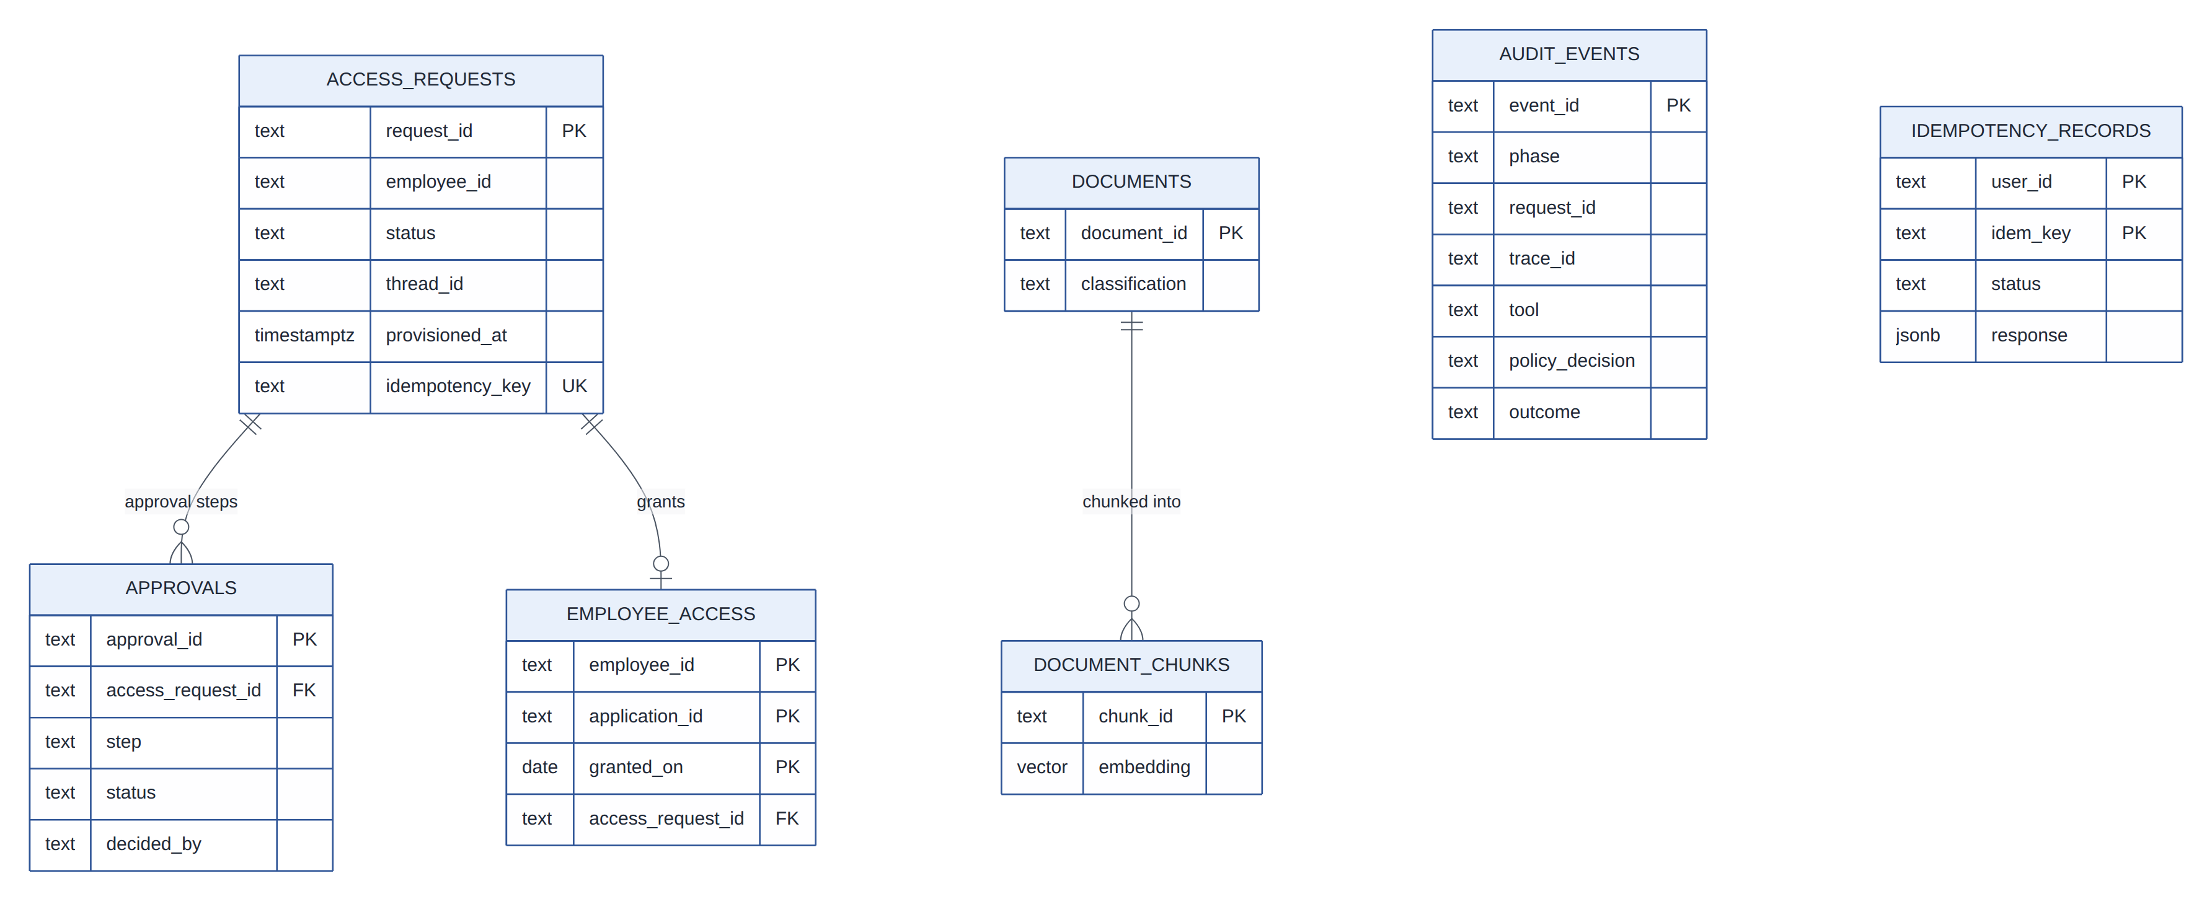
Figure 20: Main tables (PostgreSQL); LangGraph checkpoint tables and the rag_index table are omitted

Store | Memory implementation | PostgreSQL implementation | Selected by
Access workflow (requests, approvals, grants) | InMemoryAccessStore | PgAccessStore (migration 0003) | DATA_STORE
Audit events | InMemoryAuditLog | PgAuditLog, append-only (migration 0002) | AUDIT_STORE
Conversation checkpoints | SQLite file (default) | LangGraph PostgresSaver | CHECKPOINT_STORE
Idempotency records | InMemoryIdempotencyStore | PgIdempotencyStore (migration 0004) | DATA_STORE
Knowledge index | InMemoryVectorStore | pgvector, HNSW, cosine (migration 0001) | VECTOR_STORE
Reference data (employees, assets, tickets, applications) | Seed JSON | Seed JSON (tickets and assets stay in-process) | —
Table 12: Stores and their implementations (each pair shares a contract test suite)
State changes are single conditional statements (decide only if pending; provision only if provisioned_at IS NULL; create with ON CONFLICT (idempotency_key) DO NOTHING), so concurrent API replicas cannot double-decide or double-grant (ADR 0012).

14 Design decisions and rationale
Significant decisions are recorded as ADRs in docs/adr/. The table summarises each decision, its main rationale and the alternatives that were rejected.
ADR | Decision | Rationale | Alternatives rejected
0001 | Record decisions as ADRs | Architectural reasoning is part of the learning goal; decisions stay reviewable | Wiki pages, commit messages
0002 | Provider-agnostic model layer, allowlist, offline fake | No provider lock-in; reviewed model list; runs without secrets | Direct SDK calls; unrestricted model names
0003 | Tools take identity from trusted context | The model cannot name a user; ownership checks cannot be bypassed by arguments | Identity parameters validated per tool
0004 | LangGraph with our own nodes | Explicit state, checkpointing, interrupts, streaming, while tool execution stays in our security boundary | Prebuilt ReAct agent; hand-written loop only
0005 | PostgreSQL + pgvector behind an interface | One database for relational data and vectors; access filter in SQL before ranking | Dedicated vector database
0006 | Ollama embeddings, hashing embedder for tests | Real semantics locally; deterministic offline tests; same schema | Hosted embedding API
0007 | Specialised agents behind a deterministic supervisor | Least privilege per agent; routing is the only model decision in the supervisor | One agent with all tools; LLM supervisor with tools
0008 | Two MCP servers with per-call delegation tokens | Standard tool protocol; read/write separation; identity and agent carried and verified per call | Direct function calls; long-lived API keys
0009 | Deterministic policy engine in Python, policy as data | Transparent, testable, fail-closed; structured like Rego deny sets so OPA could replace the engine | OPA/Rego sidecar now; checks scattered in tools
0010 | Append-only audit in PostgreSQL | Tamper resistance by database rules; decision before action | Application logs as audit
0011 | Approval as a graph interrupt, store as source of truth | Durable pause; resume cannot be spoofed by its payload; provisioning only by the workflow identity | Polling; model-mediated approval
0012 | PostgreSQL for workflow state | Approvals survive restarts and span processes; conditional updates prevent races | In-memory state only
0013 | OpenTelemetry backbone, LangSmith optional, redaction by allowlist | Vendor-neutral, one trace across processes, privacy by construction | LangSmith only; denylist redaction
0014 | Deterministic-first evaluation, split gates, scripted attacks, opt-in judge | Safety provable in CI without a model; quality measured separately | LLM-judged everything
0015 | FastAPI thin adapter over a shared runtime; trusted-header identity | One code path for CLI and API; identity in one place; OIDC is a one-file change | Logic in routes; API-issued tokens
0016 | Streamlit for the first UI | Minimal effort, forces an HTTP-only client, testable headless | React/Next.js now
0017 | Resilience by safe degradation | One retry policy, circuit breakers, idempotent replay, write-ahead audit, reconciliation | Fallback model; server-side write retries
Table 13: Architecture decision records

14.1 Cross-cutting decisions
- Deterministic core, model at the edge. Models classify, choose tools and write answers; code validates, authorizes, approves, persists, audits and retries.
- Fail closed. Unknown tools, agents, environments or errors in the policy engine deny; an unreadable audit trail or approval store stops writes.
- Least privilege everywhere. Per-agent tool sets, read/action server separation, per-call token audiences, a workflow-only provisioning identity.
- Everything has an offline twin. Fake model, hashing embedder, in-memory stores and in-process MCP make the whole system runnable and testable in CI without secrets or services.
- Measured, not asserted. Every milestone added tests and, from M9, evaluation gates; several real defects were found by those suites (write bursts, untraced refusals, untraced malformed calls, MCP server store wiring).

15 Design patterns in the codebase
Pattern | Where | Why
Policy Enforcement Point / Gateway | governance/gateway.py ActionGateway | One mandatory choke point for authorization and audit on every tool call, host and MCP server alike
Policy as data (Policy Decision Point) | config/policy.yaml, governance/policy.py | Rules reviewed and versioned separately from code; engine is small and testable
Strategy (via Protocols) | ToolRunner: ToolExecutor, RemoteToolRunner, CompositeToolRunner; VectorStore; Embedder | Swap local/MCP transport, stores and embedders without touching callers
Factory | build_chat_model, ToolFactory.from_settings, build_gateway, build_repository, build_idempotency_store | Configuration decides implementations in one place
Facade | runtime.AegisRuntime | A small use-case API over many components, shared by API and CLI
Adapter (thin API) | api/app.py, mcp_servers/server.py | Map protocols (HTTP, MCP) onto the same core without duplicating logic
Repository / Store abstraction | ServiceDeskRepository, AccessStore, AuditLog, IdempotencyStore | Memory and PostgreSQL implementations behind one contract, verified by shared tests
Supervisor–worker orchestration | graphs/supervisor_graph.py | Specialists with least privilege; deterministic dispatch and combination
Explicit state machine | LangGraph graphs; access-request and approval statuses | Every step named, checkpointed and streamable; transitions testable
Human-in-the-loop interrupt/resume | await_approval + ApprovalService.decide + resume | Durable, auditable pause of a long-running workflow
Proxy / Decorator | GuardedAccessStore, RedactingSpanProcessor | Add outage translation and redaction transparently around existing objects
Circuit Breaker | reliability/breaker.py | Fail fast during outages, recover automatically
Retry with exponential backoff and jitter | reliability/model_guard.py | Absorb transient model failures without synchronized retries
Idempotency Key / idempotent receiver | tool idempotency_key, persistence/idempotency.py | Retries never duplicate writes or re-run requests
Write-ahead audit (append-only log) | gateway decision events, ApprovalService decision events | Never act without a record; tamper-resistant history
Reconciliation loop | AegisRuntime.reconcile | Converge approved-but-unprovisioned state after partial failures
Registry / catalogue | breaker registry, metrics CATALOGUE, MCP tool catalogue | One authoritative list used by code, docs and tests
Template (versioned prompts) | prompts/*.yaml, load_prompt | Prompts reviewed and versioned; every call records its prompt version
Dependency injection | app factory create_app, FastAPI Depends, builder parameters | Tests inject fakes (model, stores, runtime) without patching
Null object / offline fake | ScriptedChatModel, HashingEmbedder, in-process MCP | Full system behaviour without external services
Table 14: Design patterns

16 Quality attributes
Attribute | Approach | Evidence
Security | Trusted identity, least privilege, deterministic policy, approval evidence, write-ahead audit, redaction | Security test suites; adversarial suite 0 unauthorized actions
Reliability | Classified failures, retries only where safe, breakers, idempotent replay, reconciliation | Reliability suite 13/13; live outage demonstration
Observability | One trace per request, §24 metrics, JSON logs, trace IDs in audit | Trace coverage 1.0 gate; telemetry tests
Correctness | Structured outputs, schema validation, code-checked citations | Golden suite; RAG gate
Maintainability | Packages by responsibility, protocols, small modules, ADRs | Strict mypy, ruff; 20 packages with single responsibilities
Testability | Offline twins for every dependency, dependency injection | 522 tests (with PostgreSQL), deterministic in CI
Portability | Provider-agnostic model layer, environment configuration, containers | Anthropic, Ollama and fake models; compose stack
Performance | Deterministic dispatch (one routing call), bounded loops, fail-fast breakers | Latency and token metrics per request in evaluations
Table 15: Quality attributes

17 Risks, limitations and roadmap
Risk / limitation | Impact | Mitigation / next step
Trusted-header identity | Anyone reaching the API port could impersonate a user | Deploy only behind an authenticating gateway; replace current_user with OIDC verification
Quality measured only with the offline model | Real-model routing and answer quality unknown in this repository | Run the golden suite with --quality-gate --judge and commit real-model baselines
Circuit breakers are per process | Each replica learns about an outage on its own | Acceptable at this scale; shared state (e.g. Redis) if needed
Compose stack not run in the build environment | Container-level issues could surface on first docker compose up | CI validates compose; M12 adds image builds and a smoke test
Python policy engine instead of OPA | Differs from the specification's suggested technology | Deny-set structure mirrors Rego; the engine is replaceable behind PolicyEngine
Turn that ended in 503 already wrote the user message | Retry adds the message again to the thread | Visible but harmless; a transactional thread write would remove it
Table 16: Risks and limitations
Roadmap: Milestone 12 turns the existing tests and evaluation gates into a release pipeline (image builds, stack smoke tests, promotion rules). Stretch goals from the specification (hybrid retrieval and reranking, an agent and tool registry, cost budgets, canary and shadow evaluation, OIDC, Kubernetes) build on the extension points described here.

Appendix A: Configuration reference
Area | Settings
Model | MODEL_PROVIDER, MODEL_NAME, MODEL_TEMPERATURE, MODEL_MAX_TOKENS, MODEL_TIMEOUT_SECONDS, MODEL_MAX_RETRIES, MODEL_RETRY_BACKOFF_SECONDS, ANTHROPIC_API_KEY, OLLAMA_BASE_URL
Agents | AGENT_MAX_STEPS, AGENT_MAX_TOOL_CALLS, AGENT_MAX_HANDOFFS
RAG | EMBEDDING_PROVIDER, EMBEDDING_MODEL, VECTOR_STORE, RAG_TOP_K, RAG_MIN_SCORE
Tools / MCP | TOOL_TRANSPORT (local, mcp_inprocess, mcp_http), MCP_TOKEN_SECRET, MCP_READ_URL, MCP_ACTION_URL, MCP_TIMEOUT_SECONDS
Governance | POLICY_PATH, AUDIT_STORE, AEGIS_ENV
Workflow state | DATA_STORE, CHECKPOINT_STORE, DATABASE_URL, APPROVAL_TTL_HOURS
Observability | TELEMETRY_EXPORTER, OTEL_EXPORTER_OTLP_ENDPOINT, LOG_FORMAT, LOG_LEVEL, LANGSMITH_*, AEGIS_FAULTS
Reliability | BREAKER_FAILURE_THRESHOLD, BREAKER_RESET_SECONDS, IDEMPOTENCY_TTL_HOURS, IDEMPOTENCY_STALE_SECONDS
Evaluation / UI | EVAL_JUDGE_PROVIDER, EVAL_JUDGE_MODEL, AEGIS_API_URL, GRAFANA_URL

Appendix B: HTTP API summary
Endpoint | Purpose
GET /health, GET /ready, GET /metrics | Liveness, readiness (with circuit states), Prometheus metrics
GET /api/v1/me | Caller identity as resolved by the API
POST /api/v1/threads | Create a conversation
POST /api/v1/threads/{id}/messages | One turn; JSON or SSE; Idempotency-Key for replay
GET /api/v1/threads/{id} | Conversation (user and assistant messages) and pending approvals
GET /api/v1/approvals, GET /api/v1/approvals/{id} | Approvals waiting for the caller; one approval
POST /api/v1/approvals/{id}/approve · /reject | Decide a step; resumes the workflow when settled
GET /api/v1/audit | Audit events (own; auditors see all)

Appendix C: Glossary
Term | Meaning
Action gateway | The component that authorizes, audits and records every tool call
Approval evidence | Proof, looked up by the gateway in the store, that all approval steps of a request were approved
Checkpoint | Persisted LangGraph state of a conversation thread after each node
Delegation token | Short-lived JWT carrying user, acting agent, audience and request ID on each MCP call
Golden dataset | Versioned set of requests with the behaviour they must produce
Interrupt / resume | LangGraph mechanism to pause a thread durably and continue it later
MCP | Model Context Protocol, the tool protocol between the host and the tool servers
Specialist | A tool-calling agent with a narrow purpose and a fixed tool set
Trajectory | The recorded steps of a run: routing, model calls, tool calls, specialist results

