UNIT 1 ( PART 1 )
- DATA COMMUNICATIONS : Components, Data Representation, Data Flow

Data Communication :

When we communicate, we are sharing information. This sharing can be local or remote. Between individuals, local communication usually occurs face to face, while remote communication takes place over distance.

Components:
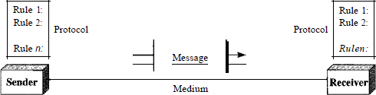
A data communications system has five components.

- Message. The message is the information (data) to be communicated. Popular forms of information include text, numbers, pictures, audio, and video.
- Sender. The sender is the device that sends the data message. It can be a computer, workstation, telephone handset, video camera, and so on.
- Receiver. The receiver is the device that receives the message. It can be a computer, workstation, telephone handset, television, and so on.
- Transmission medium. The transmission medium is the physical path by which a message travels from sender to receiver. Some examples of transmission media include twisted-pair wire, coaxial cable, fiber-optic cable, and radio waves
- Protocol. A protocol is a set of rules that govern data communications. It represents an agreement between the communicating devices. Without a protocol, two devices may be connected but not communicating, just as a person speaking French cannot be understood by a person who speaks only Japanese.

Data Representation:
Information today comes in different forms such as text, numbers, images, audio, and video.
Text:
In data communications, text is represented as a bit pattern, a sequence of bits (Os or Is). Different sets of bit patterns have been designed to represent text symbols. Each set is called a code, and the process of representing symbols is called coding. Today, the prevalent coding system is called Unicode, which uses 32 bits to represent a symbol or character used in any language in the world. The American Standard Code for Information Interchange (ASCII), developed some decades ago in the United States, now constitutes the first 127 characters in Unicode and is also referred to as Basic Latin.
Numbers:
Numbers are also represented by bit patterns. However, a code such as ASCII is not used to represent numbers; the number is directly converted to a binary number to simplify mathematical operations. Appendix B discusses several different numbering systems.
Images:
Images are also represented by bit patterns. In its simplest form, an image is composed of a matrix of pixels (picture elements), where each pixel is a small dot

Audio:
Audio refers to the recording or broadcasting of sound or music. Audio is by nature different from text, numbers, or images. It is continuous, not discrete
Video:
Video refers to the recording or broadcasting of a picture or movie. Video can either be produced as a continuous entity (e.g., by a TV camera), or it can be a combination of images, each a discrete entity, arranged to convey the idea of motion. Again we can change video to a digital or an analog signal.

Data Flow
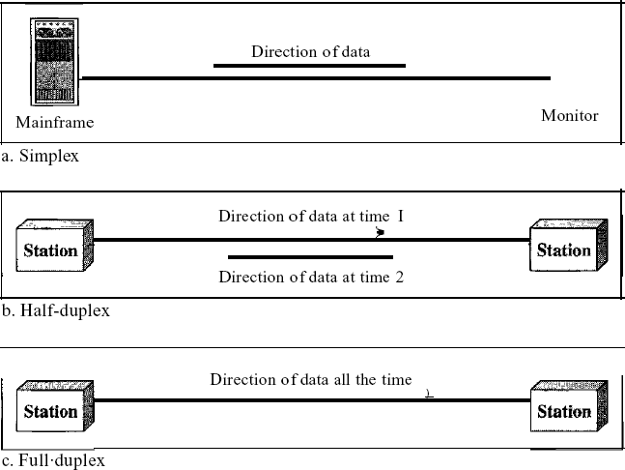
Communication between two devices can be simplex, half-duplex, or full-duplex as shown in Figure
Simplex:
In simplex mode, the communication is unidirectional, as on a one-way street. Only one of the two devices on a link can transmit; the other can only receive (see Figure a). Keyboards and traditional monitors are examples of simplex devices. The keyboard can only introduce input; the monitor can only accept output. The simplex mode can use the entire capacity of the channel to send data in one direction.
Half-Duplex:
In half-duplex mode, each station can both transmit and receive, but not at the same time. When one device is sending, the other can only receive, and vice versa The half-duplex mode is like a one-lane road with traffic allowed in both directions.
When cars are traveling in one direction, cars going the other way must wait. In a half-duplex transmission, the entire capacity of a channel is taken over by whichever of the two devices is transmitting at the time. Walkie-talkies and CB (citizens band) radios are both half-duplex systems.
The half-duplex mode is used in cases where there is no need for communication in both directions at the same time; the entire capacity of the channel can be utilized for each direction.
Full-Duplex:
In full-duplex both stations can transmit and receive simultaneously One common example of full-duplex communication is the telephone network. When two people are communicating by a telephone line, both can talk and listen at the same time. The full-duplex mode is used when communication in both directions is required all the time. The capacity of the channel, however, must be divided between the two directions.

NETWORKS: Network Criteria, Physical Structures

NETWORKS
A network is a set of devices (often referred to as nodes) connected by communication links. A node can be a computer, printer, or any other device capable of sending and/or receiving data generated by other nodes on the network.
- Distributed Processing
Most networks use distributed processing, in which a task is divided among multiple computers. Instead of one single large machine being responsible for all aspects of a process, separate computers (usually a personal computer or workstation) handle a subset.

Network Criteria
A network must be able to meet a certain number of criteria. The most important of these are performance, reliability, and security.
Performance:
Performance can be measured in many ways, including transit time and response time.Transit time is the amount of time required for a message to travel from one device to another. Response time is the elapsed time between an inquiry and a response. The performance of a network depends on a number of factors, including the number of users, the type of transmission medium, the capabilities of the connected hardware, and the efficiency of the software. Performance is often evaluated by two networking metrics:
throughput and delay. We often need more throughput and less delay. However, these two criteria are often contradictory. If we try to send more data to the network, we may increase throughput but we increase the delay because of traffic congestion in the network.
Reliability:
In addition to accuracy of delivery, network reliability is measured by the frequency of failure, the time it takes a link to recover from a failure, and the network's robustness in a catastrophe.
Security:
Network security issues include protecting data from unauthorized access, protecting data from damage and development, and implementing policies and procedures for recovery from breaches and data losses.

Distributed Systems
A distributed system is a software system in which components located on networked computers communicate and coordinate their actions by passing messages. The components interact with each other in order to achieve a common goal.

Distributed systems Principles

A distributed system consists of a collection of autonomous computers, connected through a network and distribution middleware, which enables computers to coordinate their activities and to share the resources of the system, so that users perceive the system as a single, integrated computing facility.

Centralised System Characteristics
      - One component with non-autonomous parts
      - Component shared by users all the time
      - All resources accessible
      - Software runs in a single process
      - Single Point of control
      - Single Point of failure

Distributed System Characteristics
      - Multiple autonomous components
      - Components are not shared by all users
      - Resources may not be accessible
      - Software runs in concurrent processes on different processors
      - Multiple Points of control
      - Multiple Points of failure

Examples of distributed systems and applications of distributed computing include the following:

- telecommunication networks:
- telephone networks and cellular networks,
- computer networks such as the Internet,
- wireless sensor networks,
- routing algorithms;
- network applications:
- World wide web and peer-to-peer networks,
- massively multiplayer online games and virtual realitycommunities,
- distributed databases and distributed database managementsystems,

- network file systems,
- distributed information processing systems such as banking systems and airlinereservation systems;
- real-time process control:
- aircraft control systems,
- industrial control systems;
- parallel computation:
- scientific computing, including cluster computing and grid computing and various volunteer computing projects (see the list of distributed computing projects),
- distributed rendering in computer graphics.

Features of distributed systems
Certain common characteristics can be used to assess distributed systems

      - Resource Sharing
      - Openness
      - Concurrency
      - Scalability
      - Fault Tolerance
      - Transparency

Resource Sharing

- Ability to use any hardware, software or data anywhere in thesystem.
- Resource manager controls access, provides naming scheme and controls concurrency.
- Resource sharing model (e.g. client/server or object-based) describing how

  - resources are provided,
  - they are used and
  - provider and user interact with each other.

Openness

- Openness is concerned with extensions and improvements of distributed systems.
- Detailed interfaces of components need to be published.
- New components have to be integrated with existing components.
- Differences in data representation of interface types on different processors(of different vendors) have to be resolved.

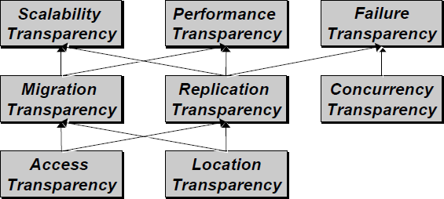
Concurrency

Components in distributed systems are executed in concurrent processes.

  - Components access and update shared resources (e.g. variables, databases, device drivers).
  - Integrity of the system may be violated if concurrent updates are not coordinated.
    - Lost updates
    - Inconsistent analysis

Scalability

  - Adaption of distributed systems to
- accomodate more users
- respond faster (this is the hard one)
  - Usually done by adding more and/or faster processors.
  - Components should not need to be changed when scale of a system increases.
  - Design components to be scalable

Fault Tolerance

Hardware, software and networks fail!

- Distributed systems must maintain availability even at low levelsof hardware/software/network reliability.
- Fault tolerance is achieved by

  - recovery
  - redundancy

Transparency
Distributed systems should be perceived by users and application programmers as a whole rather than as a collection of cooperating components.

  - Transparency has different dimensions that were identified by ANSA.
  - These represent various properties that distributed systems should have.

Access Transparency

Enables local and remote information objects to be accessed using identical operations.

  - Example: File system operations in NFS.
  - Example: Navigation in the Web.
  - Example: SQL Queries

Location Transparency
Enables information objects to be accessed without knowledge of their location.

  - Example: File system operations in NFS
  - Example: Pages in the Web
  - Example: Tables in distributed databases

Concurrency Transparency
Enables several processes to operate concurrently using shared information objects without interference between them.

  - Example: NFS
  - Example: Automatic teller machine network
  - Example: Database management system

Replication Transparency
Enables multiple instances of information objects to be used to increase reliability and performance without knowledge of the replicas by users or application programs

  - Example: Distributed DBMS
  - Example: Mirroring Web Pages.

Failure Transparency
  - Enables the concealment of faults
  - Allows users and applications to complete their tasks despite the failure ofother components.
  - Example: Database Management System

Migration Transparency

Allows the movement of information objects within a system without affecting the operations of users or application programs

  - Example: NFS
  - Example: Web Pages

Performance Transparency
Allows the system to be reconfigured to improve performance as loads vary.

  - Example: Distributed make.

Scaling Transparency

Allows the system and applications to expand in scale without change to the system structure or the application algortithms.

  - Example: World-Wide-Web
  - Example: Distributed Database

Model of distributed systems
Systems that are intended for use in real-world environments should be designed to function correctly in the widest possible range of circumstances and in the face of many possible difficulties and threats .

Each type of model is intended to provide an abstract, simplified but consistent description of a relevant aspect of distributed system design:
Physical models are the most explicit way in which to describe a system; they capture the hardware composition of a system in terms of the computers (and other devices, such as mobile phones) and their interconnecting networks.

    - Architectural models describe a system in terms of the computational and communication tasks performed by its computational elements; the computational elements being individual computers or aggregates of them supported by appropriate network interconnections.
Fundamental models take an abstract perspective in order to examine individual aspects of a distributed system. The fundamental models that examine three important aspects of distributed systems: interaction models, which consider the structure and sequencing of the communication between the elements of the system; failure models, which consider the ways in which a system may fail to operate correctly and; security models, which consider how the system is protected against attempts to interfere with its correct operation or to steal its data.

Architectural models
The architecture of a system is its structure in terms of separately specified components and their interrelationships. The overall goal is to ensure that the structure will meet present and likely future demands on it. Major concerns are to make the system reliable, manageable, adaptable and cost-effective. The architectural design of a building has similar aspects – it determines not only its appearance but also its general structure and architectural style (gothic, neo-classical, modern) and provides a consistent frame of reference for the design.

Software layers
The concept of layering is a familiar one and is closely related to abstraction. In a layered approach, a complex system is partitioned into a number of layers, with a given layer making use of the services offered by the layer below. A given layer therefore offers a software abstraction, with higher layers being unaware of implementation details, or indeed of any other layers beneath them.

In terms of distributed systems, this equates to a vertical organization of services into service layers. A distributed service can be provided by one or more server processes, interacting with each other and with client processes in order to maintain a consistent system-wide view of the service‟s resources. For example, a network time service is implemented on the Internet based on the Network Time Protocol (NTP) by server processes running on hosts throughout the Internet that supply the current time to any client that requests it and adjust their version of the current time as a result of interactions with each other. Given the complexity of distributed systems, it is often helpful to organize such services into layers. the important terms platform and middleware, which define as follows:

The important terms platform and middleware, which is defined as follows:

A platform for distributed systems and applications consists of the lowest-level hardware and software layers. These low-level layers provide services to the layers above them, which are implemented independently in each computer, bringing the system‟s programming interface up to a level that facilitates communication and coordination between processes. Intel x86/Windows, Intel x86/Solaris, Intel x86/Mac OS X, Intel x86/Linux and ARM/Symbian are majorexamples.

- Remote Procedure Calls – Client programs call procedures in server programs
- Remote Method Invocation – Objects invoke methods of objects on distributed hosts
- Event-based Programming Model – Objects receive notice of events in other objects in which they have interest

Middleware
- Middleware: software that allows a level of programming beyond processes and message

passing
- Uses protocols based on messages between processes to provide its higher-level abstractions such as remote invocation and events
- Supports location transparency
- Usually uses an interface definition language (IDL) to define interfaces
Applications, services
Middleware
Operating system
Computer and networkhardware

-

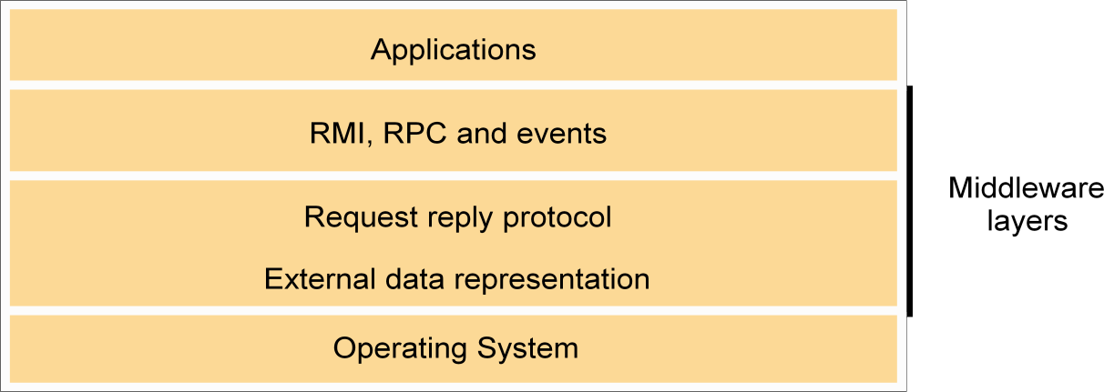

Interfaces in Programming Languages
- Current PL allow programs to be developed as a set of modules that communicate witheach other. Permitted interact ions between modules are defined by interfaces
- A specified interface can be implemented by different modules without the need to modify other modules using the interface

Interfaces in Distributed Systems

- When modules are in different processes or on different hosts there are limitations
on the interactions that can occur. Only actions with parameters that are fully specified and understood can communicate effectively to request or provide services to modules in another process
- A service interface allows a client to request and a server to provide particular services
- A remote interface allows objects to be passed as arguments to and results fromdistributed modules

Object Interfaces
- An interface defines the signatures of a set of methods, including arguments, argument types, return values and exceptions. Implementation details are not included in an interface.
A class may implement an interface by specifying behavior for each method in the interface. Interfaces do not have constructors.

System architectures

1.2.2. Client-server: This is the architecture that is most often cited when distributed systems are discussed. It is historically the most important and remains the most widely employed. Figure 2.3 illustrates the simple structure in which processes take on the roles of being clients or servers. In particular, client processes interact with individual server processes in potentially separate host computers in order to access the shared resources that they manage.
Servers may in turn be clients of other servers, as the figure indicates. For example, a web server is often a client of a local file server that manages the files in which the web pages are stored. Web servers and most other Internet services are clients of the DNS service, which translates Internet domain names to network addresses.

Clients invoke individual servers
Client
invocation
invocation
Server
result
Server
result
Client
Computer:
Process:
Key:

Another web-related example concerns search engines, which enable users to look up summaries of information available on web pages at sites throughout the Internet. These summaries are made by programs called web crawlers, which run in the background at a search engine site using HTTP requests to access web servers throughout the Internet. Thus a search engine is both a server and a client: it responds to queries from browser clients and it runs web crawlers that act as clients of other web servers. In this example, the server tasks (responding to user queries) and the crawler tasks (making requests to other web servers) are entirely independent; there is little need to synchronize them and they may run concurrently. In fact, a typical search engine would normally include many
concurrent threads of execution, some serving its clients and others running web crawlers. In Exercise 2.5, the reader is invited to consider the only synchronization issue that does arise for a concurrent search engine of the type outlined here.
    - Peer-to-peer: In this architecture all of the processes involved in a task or activity play similar roles, interacting cooperatively as peers without any distinction between client and server processes or the computers on which they run. In practical terms, all participating processes run the same program and offer the same set of interfaces to each
other. While the client-server model offers a direct and relatively simple approach to the sharing of data and other resources, it scales poorly.

Peer 1

A distributed application based on peer processes
Peer 2

Application

Application





Shara
ble obje cts
Peer 3

Applicat ion

A number of placement strategies have evolved in response to this problem, but none of them addresses the fundamental issue – the need to distribute shared resources much more widely in order to share the computing and communication loads incurred in accessing them amongst a much larger number of computers and network links. The key insight that led to the development of peer-to-peer systems is that the network and computing resources owned by the users of a service could also be put to use to support that service. This has the useful consequence that the resources available to run the service grow with the number of users.
Models of systems share some fundamental properties. In particular, all of them are composed of processes that communicate with one another by sending messages over a computer network. All of the models share the design requirements of achieving the performance and reliability characteristics of processes and networks and ensuring the security of the resources in the system.

About their characteristics and the failures and security risks they might exhibit. In general, such a fundamental model should contain only the essential ingredients that need to consider in order to understand and reason about some aspects of a system‟s behaviour. The purpose of such a model is:

- To make explicit all the relevant assumptions about the systems we are modelling.
- To make generalizations concerning what is possible or impossible, given those assumptions. The generalizations may take the form of general-purpose algorithms or desirable properties that are guaranteed. The guarantees are
dependent on logical analysis and, where appropriate, mathematical proof.

The aspects of distributed systems that we wish to capture in our fundamental models are intended to help us to discuss and reason about:

Interaction: Computation occurs within processes; the processes interact by passing messages, resulting in communication (information flow) and coordination (synchronization and ordering of activities) between processes. In the analysis and design of distributed systems we are concerned especially with these interactions. The interaction model must reflect the facts that communication takes place with delays that are often of considerable duration, and that the accuracy with which independent processes can be coordinated is limited by these delays and by the difficulty of maintaining the same notion of time across all the computers in a distributed system.

Failure: The correct operation of a distributed system is threatened whenever a fault occurs in any of the computers on which it runs (including software faults) or in the network that connects them. Our model defines and classifies the faults. This provides a basis for the analysis of their potential effects and for the design of systems that are able to tolerate faults of each type while continuing to run correctly.

Security: The modular nature of distributed systems and their openness exposes them to attack by both external and internal agents. Our security model defines and classifies the forms that such
attacks may take, providing a basis for the analysis of threats to a system and for the design of systems that are able to resist them.

1.2.4 Interaction model
Fundamentally distributed systems are composed of many processes, interacting in complex ways. For example:

- Multiple server processes may cooperate with one another to provide a service; the examples mentioned above were the Domain Name System, which partitions and replicates its data at servers throughout the Internet, and Sun‟s Network Information Service, which keeps replicated copies of password files at several servers in a local area network.
- A set of peer processes may cooperate with one another to achieve a common goal: for example, a voice conferencing system that distributes streams of audio data in a similar manner, but with strict real-time constraints.

Most programmers will be familiar with the concept of an algorithm – a sequence of
steps to be taken in order to perform a desired computation. Simple programs are controlled by algorithms in which the steps are strictly sequential. The behaviour of the program and the state of the program‟s variables is determined by them. Such a program is executed as a single process. Distributed systems composed of multiple processes such as those outlined above are more complex. Their behaviour and state can be described by a distributed algorithm – a definition of the steps to be taken by each of the processes of which the system is composed, including the transmission of messages between them. Messages are transmitted between processes to transfer information between them and to coordinate their activity.

Two significant factors affecting interacting processes in a distributed system:
- Communication performance is often a limiting characteristic.
- It is impossible to maintain a single global notion of time.

1.2.5 Failure model

In a distributed system both processes and communication channels may fail – that is, they may depart from what is considered to be correct or desirable behaviour. The failure model defines the ways in which failure may occur in order to provide an understanding of the effects of failures. Hadzilacos and Toueg provide a taxonomy that distinguishes between the failures of processes and communication channels. These are presented under the headings omission failures, arbitrary failures and timing failures.

Omission failures • The faults classified as omission failures refer to cases when a process or communication channel fails to perform actions that it is supposed to do.

Process omission failures: The chief omission failure of a process is to crash. When, say that a process has crashed we mean that it has halted and will not execute any further steps of its program ever. The design of services that can survive in the presence of faults can be simplified if it can be assumed that the services on which they depend crash cleanly – that is, their processes either function correctly or else stop. Other processes may be able to detect such a

crash by the fact that the process repeatedly fails to respond to invocation messages. However, this method of crash detection relies on the use of timeouts – that is, a method in which one process allows a fixed period of time for
something to occur. In an asynchronous system a timeout can indicate only that a process is not responding – it may have crashed or may be slow, or the messages may not have arrived.

Communication omission failures: Consider the communication primitives send and receive. A process p performs a send by inserting the message m in its outgoing message buffer. The communication channel transports m to q‟s incoming message buffer. Process q performs a receive by taking m from its incoming message buffer and delivering it. The outgoing and incoming message buffers are typically provided by the operating system.

send m

receive

processp process q

Communication channel
Outgoingmessagebuffer Incomingmessagebuffer

Arbitrary failures • The term arbitrary or Byzantine failure is used to describe the worst possible failure semantics, in which any type of error may occur. For example, a process may set wrong values in its data items, or it may return a wrong value in response to an invocation.
An arbitrary failure of a process is one in which it arbitrarily omits intended processing steps or

takes unintended processing steps. Arbitrary failures in processes cannot be detected by seeing whether the process responds to invocations, because it might arbitrarily omit to reply.

Communication channels can suffer from arbitrary failures; for example, message contents may be corrupted, nonexistent messages may be delivered or real messages may be delivered more than once. Arbitrary failures of communication channels are rare because the communication software is able to recognize them and reject the faulty
messages. For example, checksums are used to detect corrupted messages, and message sequence numbers can be used to detect nonexistent and duplicated messages.

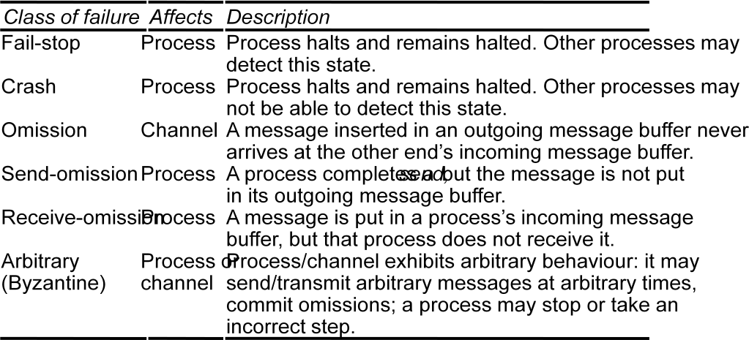

Timing failures • Timing failures are applicable in synchronous distributed systems where time limits are set on process execution time, message delivery time and clock drift rate. Timing failures are listed in the following figure. Any one of these failures may result in responses being unavailable to clients within a specified time interval.
In an asynchronous distributed system, an overloaded server may respond too slowly, but we cannot say that it has a timing failure since no guarantee has been offered. Real-time operating systems are designed with a view to providing timing guarantees, but they are more complex to design and may require redundant hardware.
Most general-purpose operating systems such as UNIX do not have to meet real-time constraints.

Masking failures • Each component in a distributed system is generally constructed from a collection of other components. It is possible to construct reliable services from components that exhibit failures. For example, multiple servers that hold replicas of data can continue to provide a service when one of them crashes. A knowledge of the failure characteristics of a component can enable a new service to be designed to mask the failure of the components on which it depends. A service masks a failure either by hiding it altogether or by converting it into a more acceptable type of failure. For an example of the latter, checksums are used to mask corrupted messages, effectively converting an arbitrary failure into an omission failure. The omission failures can be hidden by using a protocol that retransmits messages that do not arrive at their destination. Even process crashes may be masked, by replacing the process and restoring its memory from information stored on disk by its predecessor.
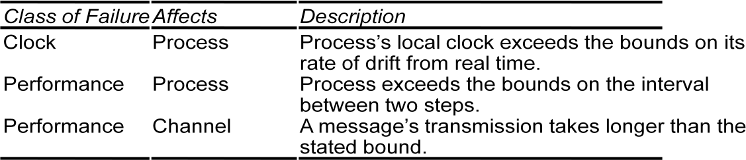

Reliability of one-to-one communication • Although a basic communication channel can exhibit the omission failures described above, it is possible to use it to build a communication service that masks some of those failures.

The term reliable communication is defined in terms of validity and integrity as follows:

Validity: Any message in the outgoing message buffer is eventually delivered to the incoming message buffer.
Integrity: The message received is identical to one sent, and no messages are delivered twice.

The threats to integrity come from two independent sources:
- Any protocol that retransmits messages but does not reject a message that arrives twice. Protocols can attach sequence numbers to messages so as to detect those that are deliveredtwice.
- Malicious users that may inject spurious messages, replay old messages or tamper with messages. Security measures can be taken to maintain the integrity property in the face of such attacks.

Security model
The sharing of resources as a motivating factor for distributed systems, and in Section 2.3 we described their architecture in terms of processes, potentially encapsulating higher-level abstractions such as objects, components or services, and providing access to them through interactions with other processes. That architectural model provides the basis for our security model:
the security of a distributed system can be achieved by securing the processes and the channels used for their interactions and by protecting the objects that they encapsulate against unauthorized access.
Protection is described in terms of objects, although the concepts apply equally well to resources of all types

Protecting objects :
Server that manages a collection of objects on behalf of some users. The users can run client programs that send invocations to the server to perform operations on the objects. The server carries out the operation specified in each invocation and sends the result to the client.
Objects are intended to be used in different ways by different users. For example, some objects may hold a user‟s private data, such as their mailbox, and other objects may hold shared data such as web pages. To support this, access rights specify who is allowed to perform the operations of an object – for example, who is allowed to read or to write its state.


Access rights
Object
invocation
Client
result
Server
Principal (user) Network Principal (server)

Securing processes and their interactions • Processes interact by sending messages. The messages are exposed to attack because the network and the communication service that theyuse
are open, to enable any pair of processes to interact. Servers and peer processes expose their interfaces, enabling invocations to be sent to them by any other process.

The enemy • To model security threats, we postulate an enemy (sometimes also known as the adversary) that is capable of sending any message to any process and reading or copying any message sent between a pair of processes, as shown in the following figure. Such attacks can be made simply by using a computer connected to a network to run a program that reads network messages addressed to other computers on the network, or a program that generates messages that make false requests to services, purporting to come from authorized users. The attack may come from a computer that is legitimately connected to the network or from one that is connected in an unauthorized manner. The threats from a potential enemy include threats to processes and threats to communication channels.
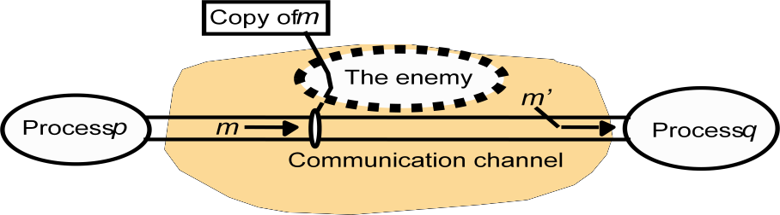
Defeating security threats
Cryptography and shared secrets: Suppose that a pair of processes (for example, a particular client and a particular server) share a secret; that is, they both know the secret but no other process in the distributed system knows it. Then if a message exchanged by that pair of processes includes information that proves the sender‟s knowledge of the
shared secret, the recipient knows for sure that the sender was the other process in the pair. Of course, care must be taken to ensure that the shared secret is not revealed to an enemy.

Cryptography is the science of keeping messages secure, and encryption is the process of scrambling a message in such a way as to hide its contents. Modern cryptography is based on encryption algorithms that use secret keys – large numbers that are difficult to guess – to transform data in a manner that can only be reversed with knowledge of the corresponding decryption key.

Authentication: The use of shared secrets and encryption provides the basis for the authentication of messages – proving the identities supplied by their senders. The basic authentication technique is to include in a message an encrypted portion that contains enough of the contents of the message to guarantee its authenticity. The authentication portion of a request to a file server to read part of a file, for example, might include a representation of the requesting principal‟s identity, the identity of the file and the date and time of the request, all encrypted with
a secret key shared between the file server and the requesting process. The server would decrypt this and check that it corresponds to the unencrypted details specified in the request.

Secure channels: Encryption and authentication are used to build secure channels as a service layer on top of existing communication services. A secure channel is a communication channel connecting a pair of processes, each of which acts on behalf of a principal, as shown in the following figure. A secure channel has the following properties:
- Each of the processes knows reliably the identity of the principal on whose behalf the other process is executing. Therefore if a client and server communicate via a secure channel, the server knows the identity of the principal behind the invocations and can check their access rights before performing an operation. This enables the server to protect its objects correctly and allows the client to be sure that it is receiving results from a bona fide server.

- A secure channel ensures the privacy and integrity (protection against tampering) of the data transmitted across it.
- Each message includes a physical or logical timestamp to prevent messages from being replayed or reordered.
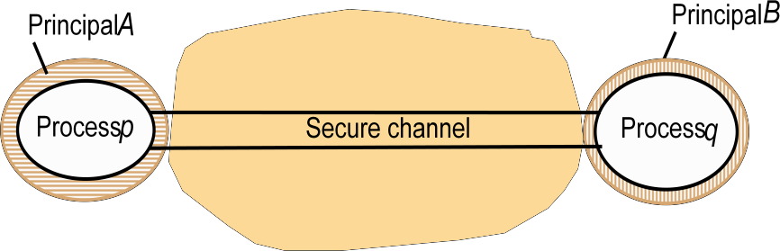

Communication aspects of middleware, although the principles discussed are more widely applicable. This one is concerned with the design of the components shown in the darker layer in the following figure.

Applications,services RMI and RPC
UDP and TCP

request-replyprotocol marshalling and external data representation

Middle ware layer

Nodes of a distributed system

Multiprocessors and Multicomputers Distinguishing features:

- Private versus shared memory
- Bus versus switched interconnection

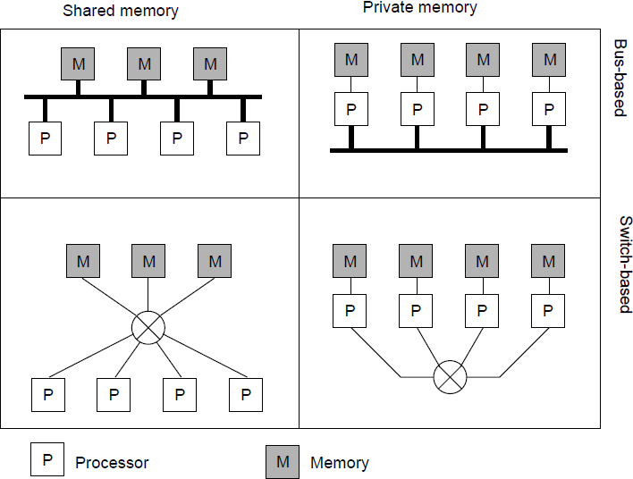

Networks of Computers

High degree of node heterogeneity:
- High-performance parallel systems (multiprocessors as well as multicomputers)
- High-end PCs and workstations (servers)
- Simple network computers (offer users only network access)
- Mobile computers (palmtops, laptops)
- Multimedia workstations

High degree of network heterogeneity:
- Local-area gigabit networks
- Wireless connections
- Long-haul, high-latency connections
- Wide-area switched megabit connections

Distributed Systems: Software Concepts
Distributed operating system
_ Network operating system
_ Middleware


