ELL715 Assignment 7

Deepali Gupta
2013MT60079

Python pydicom library was used to implement this assignment.
The steps followed are:

- Load/Import dcm images
- get_pixels_hu converts raw values into Houndsfeld units
- The transformation is linear. Therefore, so long as you have a slope and an intercept, you can rescale a voxel value to HU.
- Both the rescale intercept and rescale slope are stored in the DICOM header at the time of image acquisition (these values are scanner-dependent, so you will need external information).
- save the new data set to disk so we don't have to reprocess the stack every time.
- create a histogram of all the voxel data in the study.
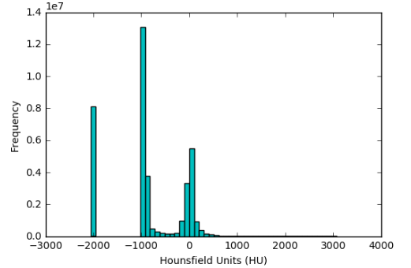
- The histogram suggests the following:
- There is lots of air
- There is some lung
- There's an abundance of soft tissue, mostly muscle, liver, etc, but there's also some fat.
- There is only a small bit of bone (seen as a tiny sliver of height between 700-3000)
This observation means that we will need to do significant preprocessing if we want to process lesions in the lung tissue because only a tiny bit of the voxels represent lung.
- Displaying an image stack
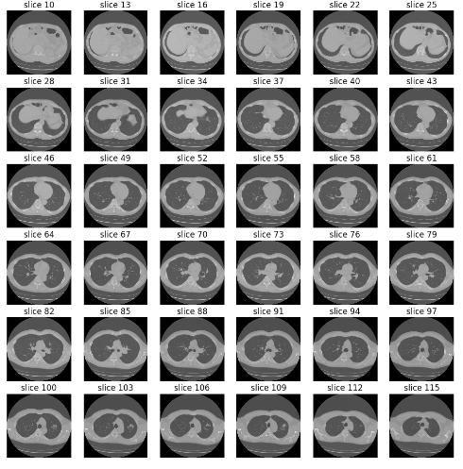
- Resampling to ensure
- Resampling to ensure that each slice is resampled in 1x1x1 mm pixels and slices.
- 3D plotting
- Visualisation Toolkit was used for this step
- Create a high-quality static using 3D capability of matplotlib
- Create a lower-quality but interactive render using plotly, which has WebGL support via JavaScript.
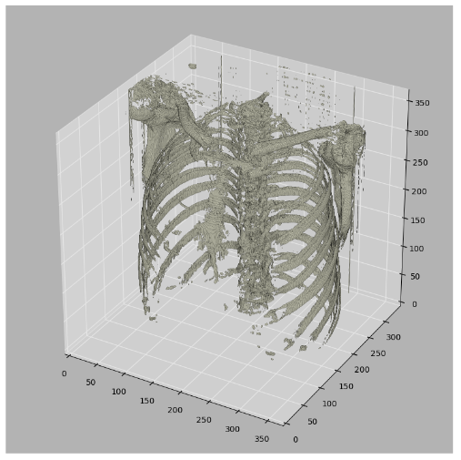
- Interactive visualization
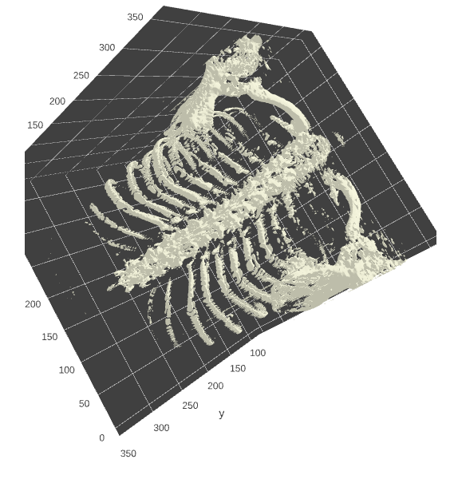
- Segmentation
- Standardize the pixel value by subtracting the mean and dividing by the standard deviation
- Identify the proper threshold by creating 2 KMeans clusters comparing centered on soft tissue/bone vs lung/air.
- Using Erosion) and Dilation) which has the net effect of removing tiny features like pulmonary vessels or noise
- Identify each distinct region as separate image labels (think the magic wand in Photoshop)
- Using bounding boxes for each image label to identify which ones represent lung and which ones represent "every thing else"
- Create the masks for lung fields.
- Apply mask onto the original image to erase voxels outside of the lung fields.
- Single slice example at each step
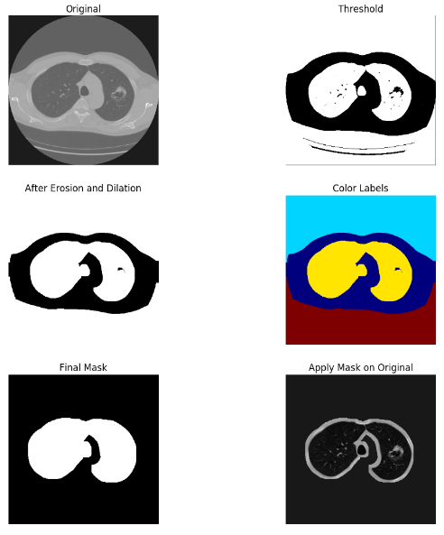
- Apply mask to all slices
