Vsts

VSTS - **Visual Studio Team Services** (VSTS) is an extension of the Microsoft Visual Studio architecture that allows it to encompass development teams, with special roles and tools for software architects, developer specialties and testers. With VSTS, you connect over the public internet

How to add code in vsts:

1. Click on new team
2. Create a repository
3. Add files
4. Click on commit

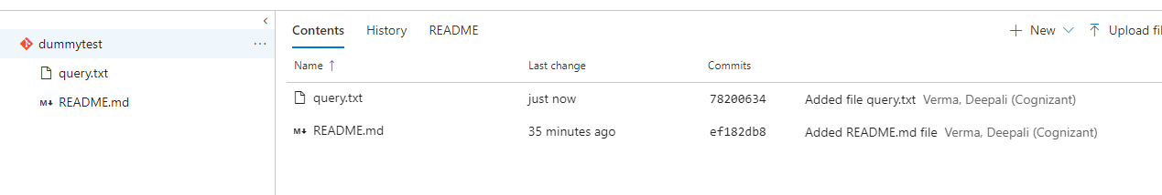

1. Click on build n release tab
2. Click on new
3. Clicl n vsts git and continue
4. Se;ect empty pipeline
5. Click on save and queue

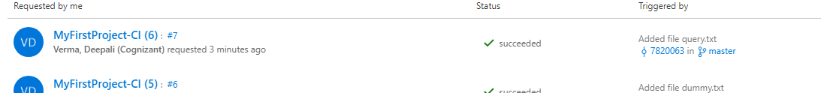

1. Click on release tab
2. Select environment
3. Click on +release
4. Create release
5. Save

