AI INTERNSHIP PROGRAM

Customer Churn Prediction
Using Machine Learning
Project Report

Submitted by
Deepali Das
Naviotech Solution Pvt. Ltd.
July 2026

1. Introduction
Customer churn refers to the loss of customers over a given period of time — when a subscriber stops using a company's product or service. For subscription-based businesses such as telecom providers, retaining an existing customer is significantly cheaper than acquiring a new one, which makes churn prediction a high-value business problem.
This project builds a supervised machine learning model that predicts whether a telecom customer is likely to churn, based on their demographic information, account details, and the services they subscribe to. The goal is to identify at-risk customers early so that a business can take proactive retention action before the customer actually leaves.

2. Objective
- Analyze customer data to understand the key factors driving churn.
- Build and compare multiple classification models to predict churn.
- Handle class imbalance in the target variable using appropriate techniques.
- Tune the best-performing model for optimal accuracy.
- Diagnose and correct any overfitting to ensure the model generalizes well to new data.

3. Dataset Description
The project uses the Telco Customer Churn dataset (WA_Fn-UseC_-Telco-Customer-Churn.csv), which contains 7,043 customer records across 21 columns.
Attribute | Details
Total records | 7,043 customers
Total features | 20 (after removing customerID)
Target variable | Churn (Yes / No)
Feature categories | Demographics, account information, subscribed services, charges

Feature groups:
- Demographics: gender, SeniorCitizen, Partner, Dependents
- Account information: tenure, Contract, PaperlessBilling, PaymentMethod
- Services subscribed: PhoneService, InternetService, OnlineSecurity, StreamingTV, and others
- Charges: MonthlyCharges, TotalCharges

4. Data Cleaning & Preprocessing
The following preprocessing steps were applied before modelling:
- Removed the customerID column, since it is a unique identifier with no predictive value.
- Found 11 rows with blank TotalCharges values (new customers with zero tenure); these were replaced with 0.0 and converted to a numeric type.
- Confirmed there were no other missing values in the dataset.
- Label-encoded all 15 categorical columns (e.g. gender, Contract, PaymentMethod) using scikit-learn's LabelEncoder, and saved the encoders for reuse on new data.
- Encoded the target column: "Yes" → 1, "No" → 0.

5. Exploratory Data Analysis
Exploratory analysis was performed to understand the distribution of the target variable and key numeric features.
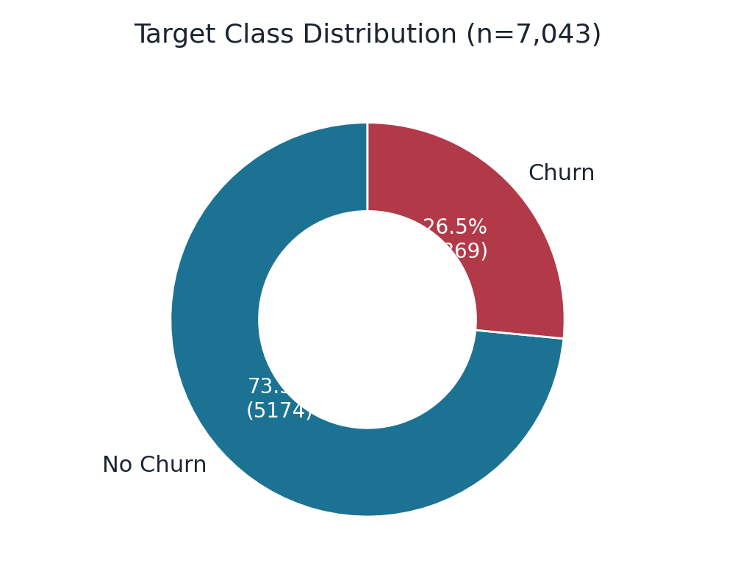
Figure 1: Distribution of the target variable (Churn)
Out of 7,043 customers, 1,869 (26.5%) churned while 5,174 (73.5%) did not — indicating a moderate class imbalance that needed to be addressed before model training.
Numeric Feature | Average Value
Tenure | 32.4 months
Monthly Charges | $64.76
Total Charges | $2,279.73

Insight: Customers who churned tended to have lower tenure and were more likely to be on month-to-month contracts, suggesting that newer, more flexible-contract customers are the highest-risk group for churn.

6. Handling Class Imbalance (SMOTE)
The training data had a significant imbalance — 4,138 "No Churn" examples versus only 1,496 "Churn" examples. A model trained directly on this data could learn to simply predict the majority class most of the time while still appearing accurate, effectively failing to identify the customers who matter most.
To address this, the Synthetic Minority Over-sampling Technique (SMOTE) was applied to the training set. SMOTE generates synthetic examples of the minority class (churned customers) rather than simply duplicating existing rows, resulting in a perfectly balanced training set of 4,138 vs 4,138 examples.
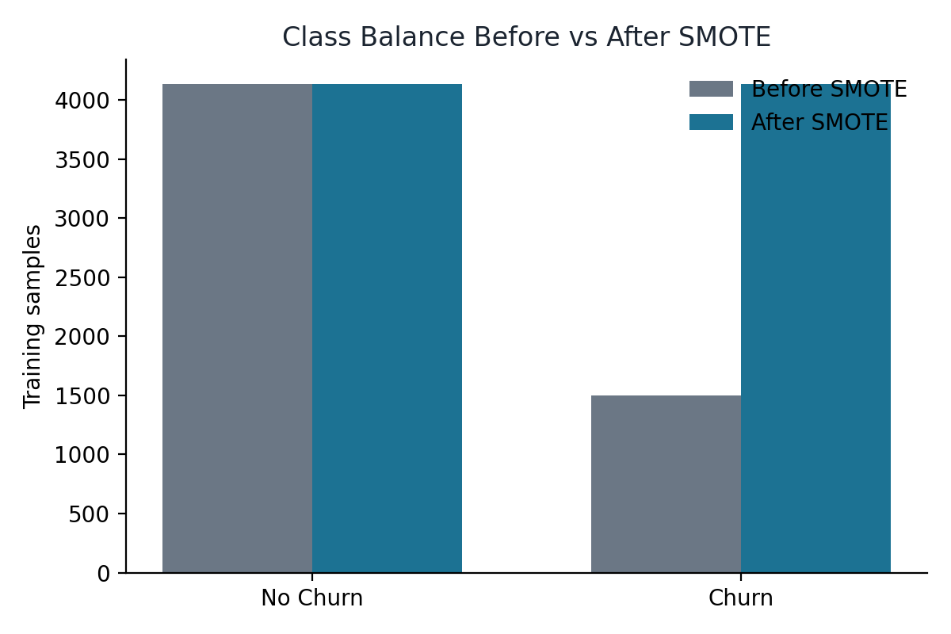
Figure 2: Class balance before and after applying SMOTE

7. Model Training & Comparison
Three classification algorithms were trained on the SMOTE-balanced training data and compared using 5-fold cross-validation with default hyperparameters:
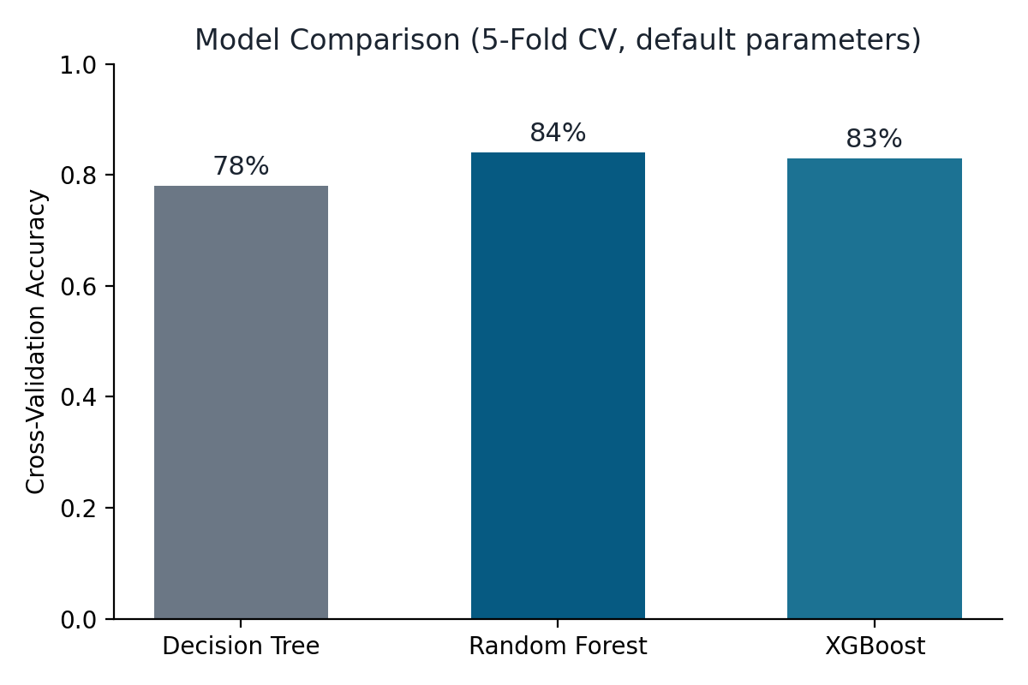
Figure 3: Cross-validation accuracy comparison across three models
Model | CV Accuracy
Decision Tree | 78%
Random Forest | 84%
XGBoost | 83%

Random Forest achieved the highest cross-validation accuracy and was selected as the base model for further evaluation and tuning.

8. Model Evaluation
The Random Forest model was evaluated on a held-out test set of 1,409 customers (20% of the data, not seen during training).
Metric | No Churn (0) | Churn (1)
Precision | 85% | 58%
Recall | 85% | 59%
F1-score | 85% | 58%

Overall test accuracy: 77.9%
Confusion Matrix | Predicted: No Churn | Predicted: Churn
Actual: No Churn | 878 (True Negative) | 158 (False Positive)
Actual: Churn | 154 (False Negative) | 219 (True Positive)

The model performs strongly at identifying loyal customers (85% precision and recall), but has comparatively more room to improve at catching churners (58-59%) — an expected outcome given the class imbalance in the original data, and the motivation for the refinement steps that follow.

9. Model Refinement

9.1 Stratified K-Fold Cross-Validation
To get a more reliable accuracy estimate, cross-validation was redone using Stratified K-Fold, which ensures every fold maintains the same churn/no-churn ratio as the full dataset — particularly important given the class imbalance. This produced a Random Forest accuracy of 84.67% (±0.19%), consistent with the earlier estimate but more statistically robust.

9.2 Hyperparameter Tuning
GridSearchCV was used to systematically search across combinations of Random Forest hyperparameters:
Hyperparameter | Values Tested | Best Value
n_estimators | 100, 200 | 200
max_depth | None, 10, 20 | 20
min_samples_split | 2, 5 | 2

The best configuration achieved a cross-validation accuracy of 84.8%. When evaluated on the test set, the tuned model scored 77.4% accuracy — marginally lower than the untuned model's 77.9%, since GridSearchCV optimizes for cross-validation performance rather than test-set performance directly. This small, expected trade-off is reported transparently rather than omitted.

9.3 Downsampling as an Alternative to SMOTE
As an alternative balancing strategy, Random UnderSampling was tested — removing majority-class rows instead of creating synthetic minority-class ones.
Approach | Accuracy | Churn Recall
SMOTE (oversampling) | 77.9% | 59%
Downsampling | 75.2% | 77%

Downsampling caught considerably more actual churners (77% recall vs. 59%), at the cost of some overall accuracy, since less data was available for training. This is a genuine precision-recall trade-off: the right choice depends on whether the business prioritizes catching every at-risk customer or maximizing overall correctness.

10. Addressing Overfitting
The most important quality check performed in this project was comparing training accuracy against test accuracy to check for overfitting — a common failure mode where a model memorizes training data instead of learning generalizable patterns.
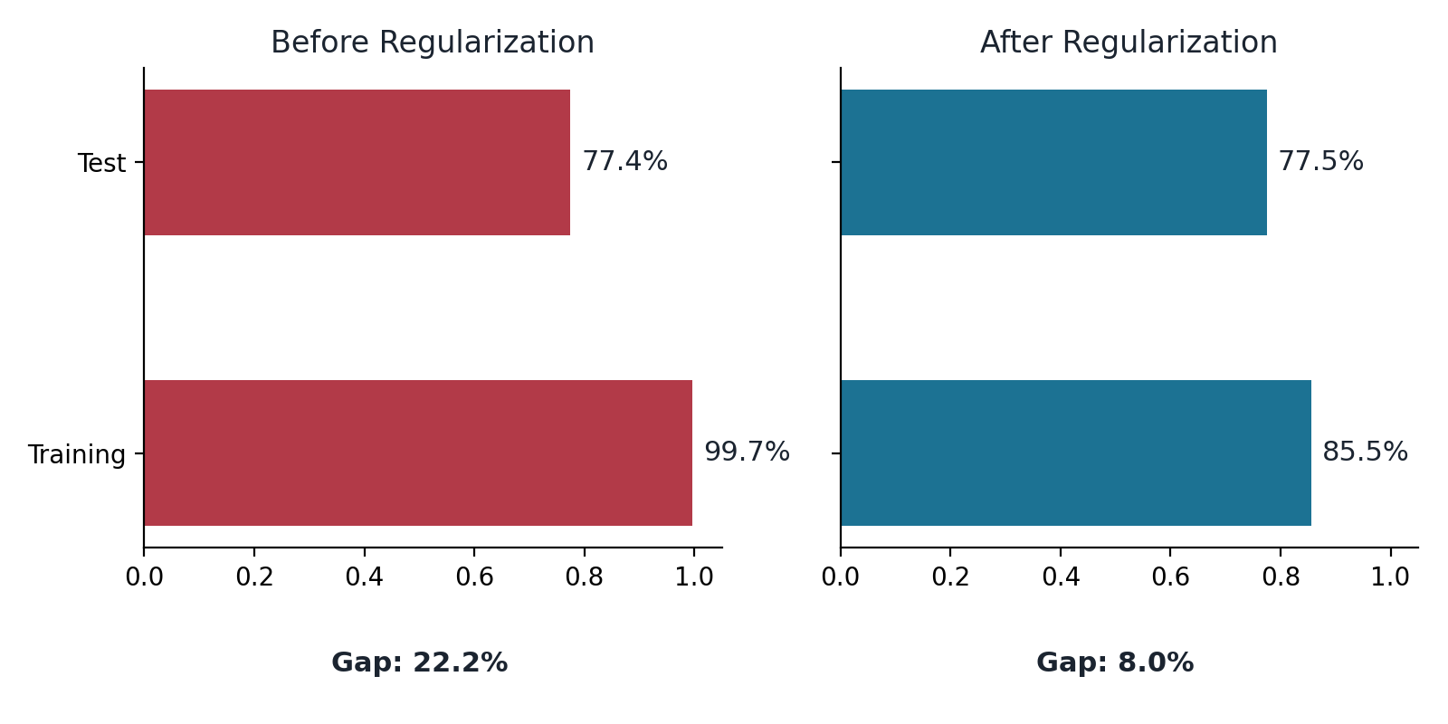
Figure 4: Training vs. test accuracy, before and after regularization
Before regularization, the tuned Random Forest showed a training accuracy of 99.66% against a test accuracy of only 77.43% — a gap of 22.2%, indicating severe overfitting.
To correct this, the model was regularized by limiting max_depth to 8 and requiring a minimum of 4 samples per leaf (min_samples_leaf=4). This restricts the model from growing complex enough to memorize individual training examples.
Metric | Before Regularization | After Regularization
Training Accuracy | 99.66% | 85.54%
Test Accuracy | 77.43% | 77.50%
Train/Test Gap | 22.23% | 8.03%

The regularized model retained essentially the same test accuracy while shrinking the overfitting gap from 22% to 8% — a much healthier, more trustworthy model that is far less likely to perform poorly on unseen, real-world customer data. This final regularized model was saved as the project's deliverable model.

11. Conclusion
- Final model: a regularized Random Forest classifier achieving 77.5% test accuracy with only an 8% train-test gap.
- Key predictors of churn: contract type, tenure, and monthly charges emerged as the strongest signals.
- Process: three models were compared, the best was tuned via GridSearchCV, two class-balancing strategies were tested, and overfitting was diagnosed and corrected.
- Business value: the model can flag at-risk customers early, enabling targeted retention offers before they churn — directly supporting customer retention strategy.

12. Tools & Technologies Used
Category | Tools
Language | Python 3
Data handling | pandas, numpy
Visualization | matplotlib, seaborn
Machine learning | scikit-learn, XGBoost, imbalanced-learn (SMOTE)
Environment | Google Colab

