Launching Lab Test Cases for Status & Approval Dropdowns in ODL page  
  
  
Status:-Registeration Open  
  
Approval:-Reg Req.  
  
Approval:- Registration & email Validation req.  
  
Approval:- Registration& Activation Code Req.  
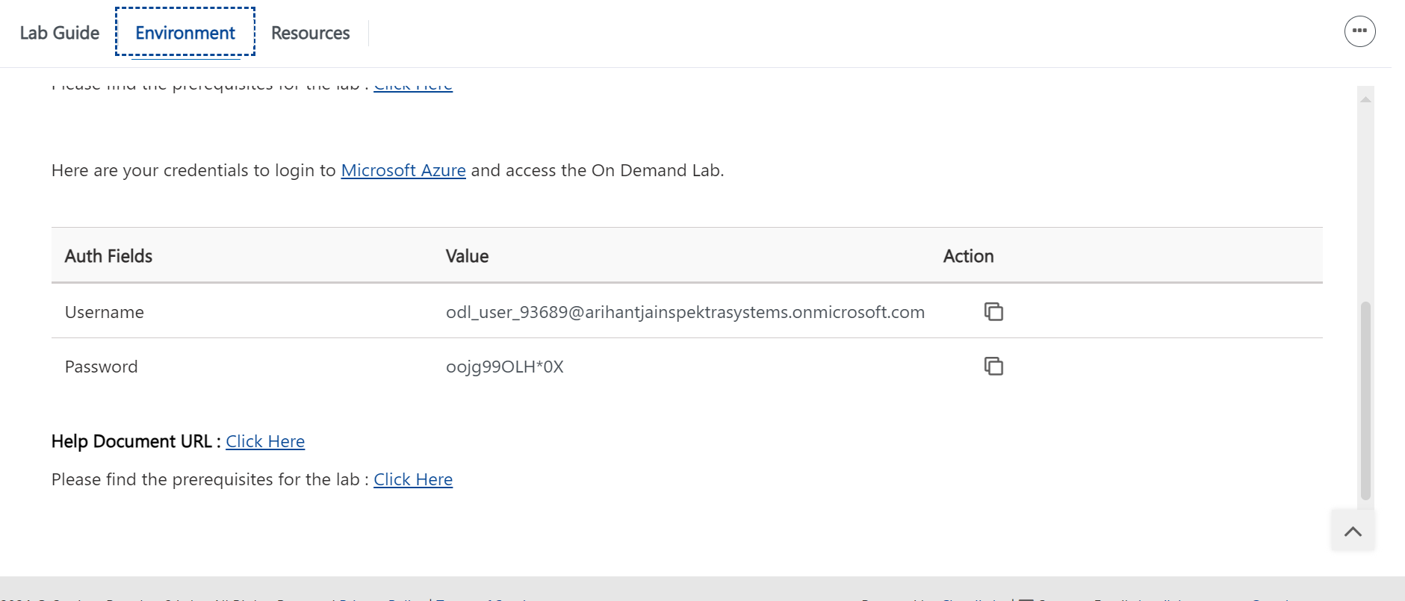  
  
Approval:- Anonymous & Activation Code Req.  
below Api Is getting failed

Approval:- Registration & Activation Code Req.

Approval:- Anonymous & Auto Luanch   
https://cloudlabs-ea-qa-multi-api.azurewebsites.net/api/AttendeeTestDrive/InitiateMulticloudDeployment/3743594B77444A4B423466344C5741423552697353413D3D  
