**VOTING SYSTEM:**

I have designed Voting System using Spring MVC, RSET API and MYSQL. It consumes Messenger REST API which has two resources, Messages and Votes. Messenger REST service is useful in posting messages, submitting votes, retrieving messages and votes. In Voting system, all users can register to the system based on their type (‘Admin’ or ‘Participant’). Database to maintain User information is **VotingSystem.User.** When the user registers, call goes to **RegistrationPostController.** Through which userDAO gets called and create method creates the record in the database using Hibernate ORM. Existing users can login to the system.

**1)HOME Page 🡪 (home.jsp)**

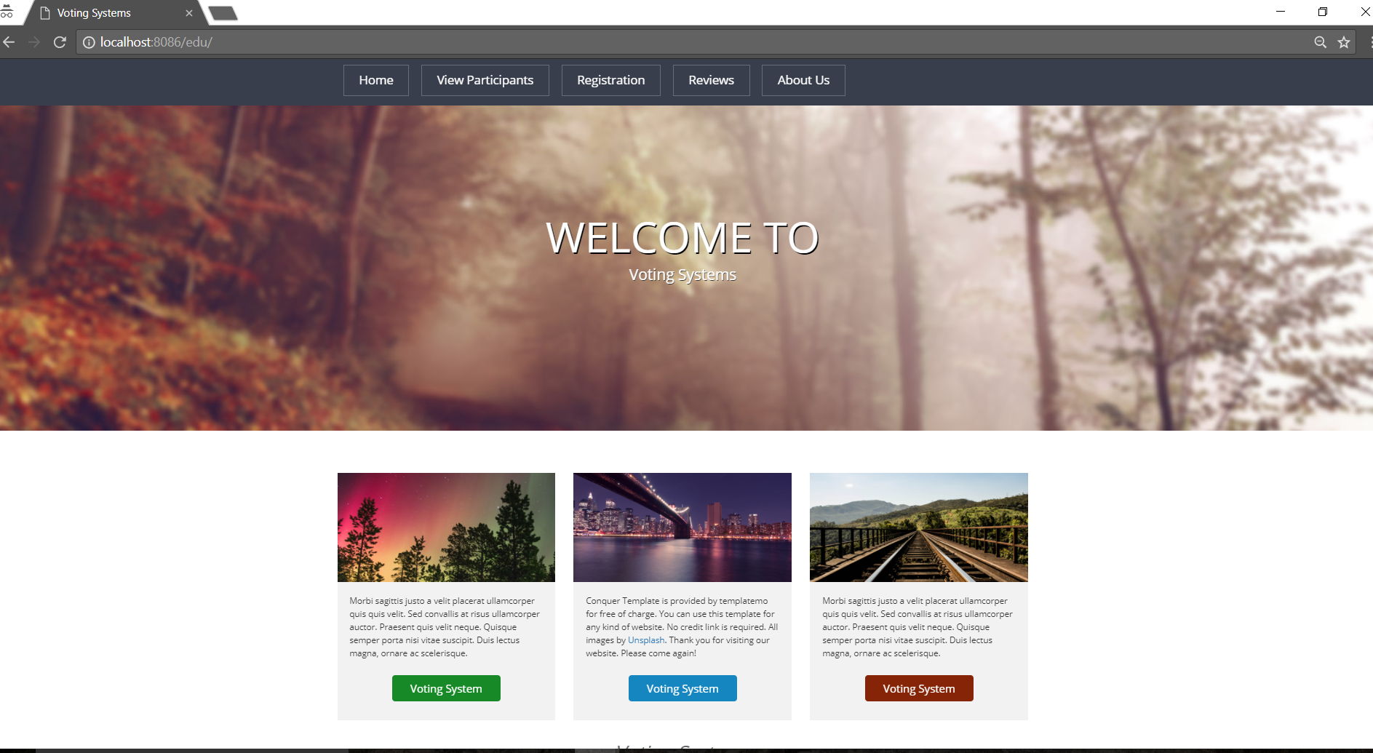

**2) REGISTRATION Page:**

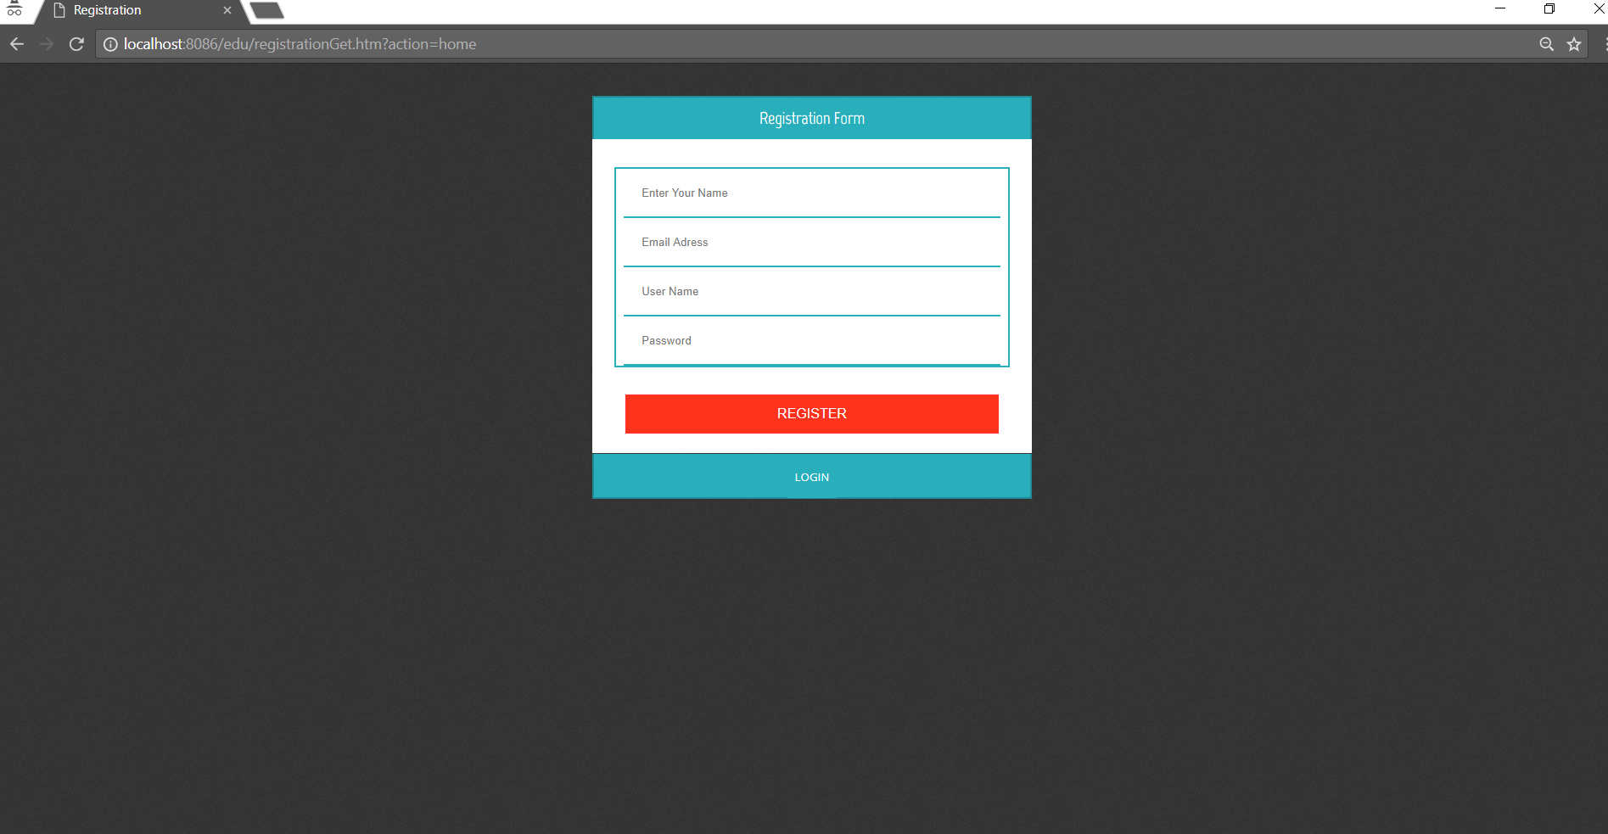

**3) Validation For Registration Page:**

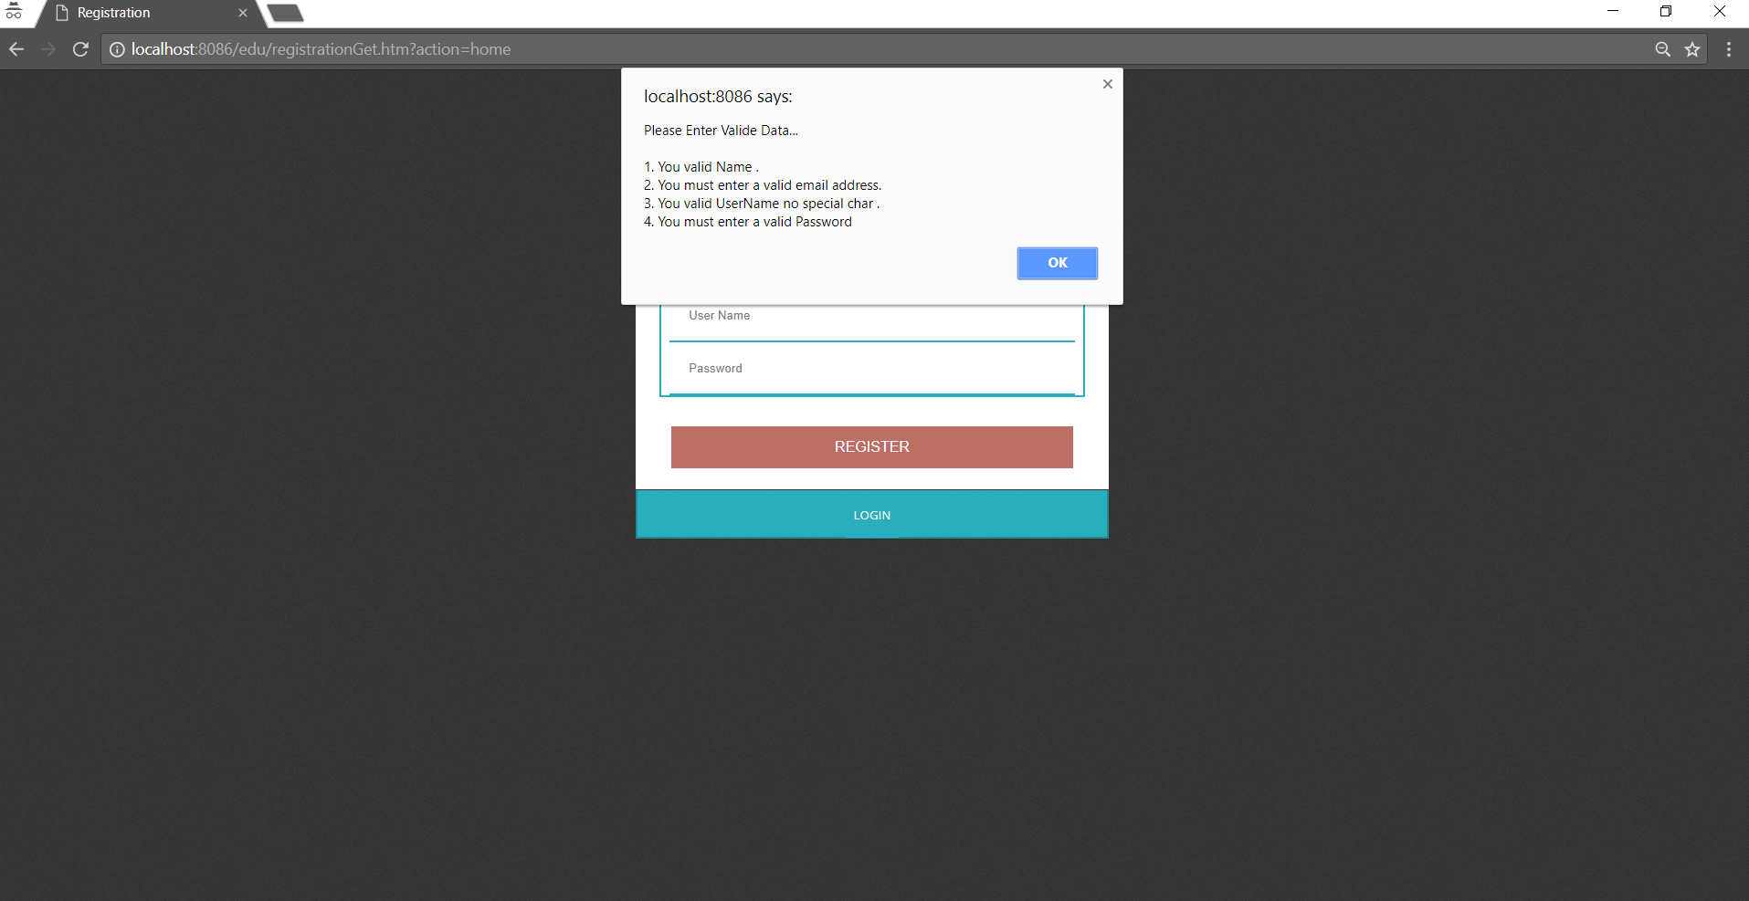

**4) LOGIN Page:**

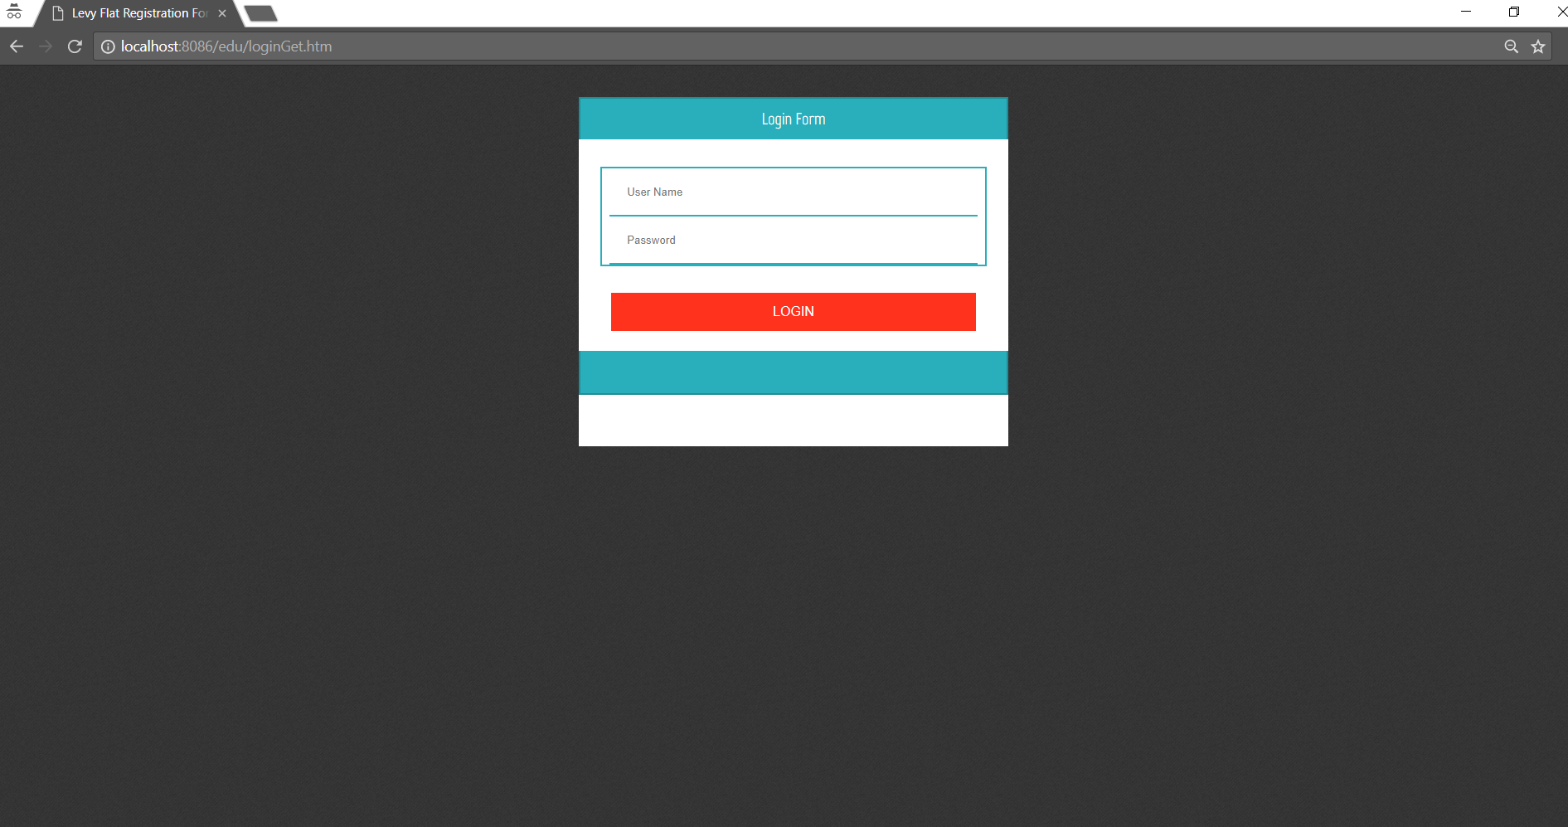

**5) Validations For LOGIN Page:**

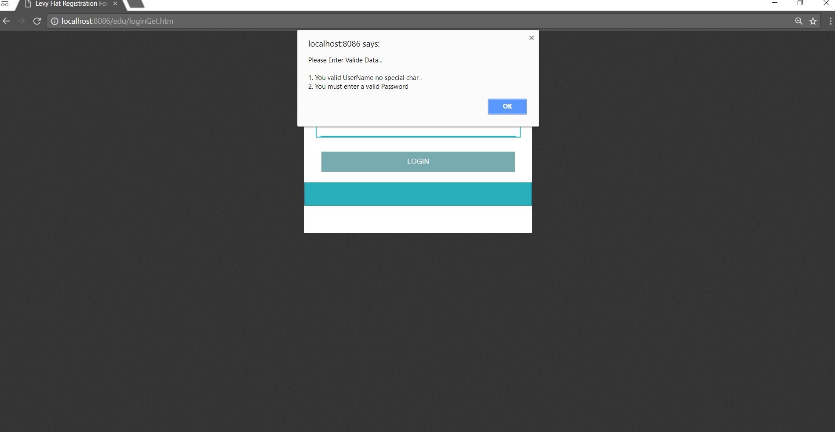

**ADMIN:**

Based on the type of the user, page navigation takes place. If a user is Admin then AdminLogin.jsp is called through home.jsp.

**AdminLogin.jsp**: As we can see in the screenshot below, Admin can enter the message to be sent in the textarea(MESSAGE). Admin should click (+) and (-) buttons to increase the number of choices of food. Maximum 4 options can be added. In the END DATE field, expiry date for a message is supposed to be entered using calendar along with the time. As soon as endDate is entered, time clock starts in the TIME CLOCK field. For which countdown function gets called in the JavaScript. In the countdown function, endDate gets converted to timestamp. Current Timestamp gets deducted from this timestamp, and when it becomes 0, winner is displayed in the WINNER field.

WINNER can be determined by making a AJAX call to REST API. I have developed Messenger REST service. This service has 2 resources. First is Messages and other is Votes. TO determine the winner, call goes to Votes Resource. <http://localhost:8080/messenger/webapi/Votes/>In this, winnerOption () finds out the winner.

When POST button gets clicked, AJAX call is made to the REST service <http://localhost:8080/messenger/webapi/messages/>along with Message json object. This service uses **(@POST) creatMessage**() to insert data into **Messenger.MESSAGE database**.

**6) Admin Logged in Page: (AdminLogin.jsp)**

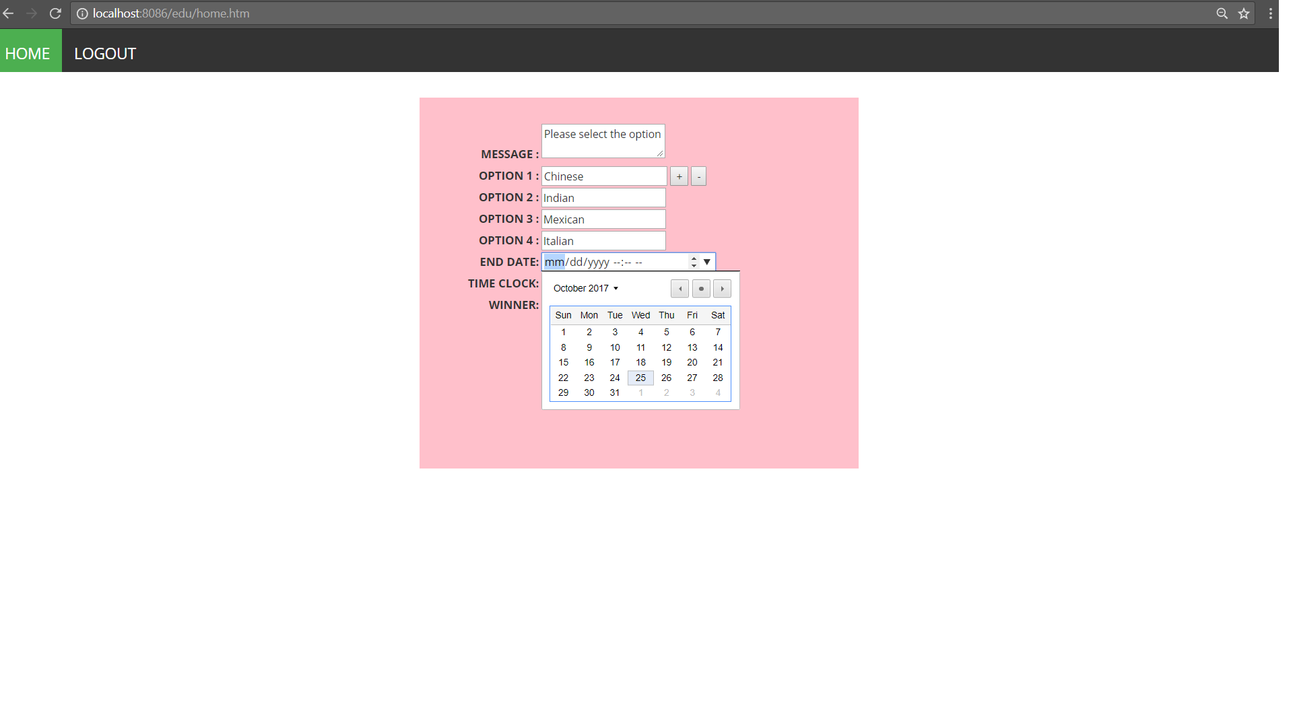

**7) Admin Logged in Page: (AdminLogin.jsp) 🡪 When countDown starts:**

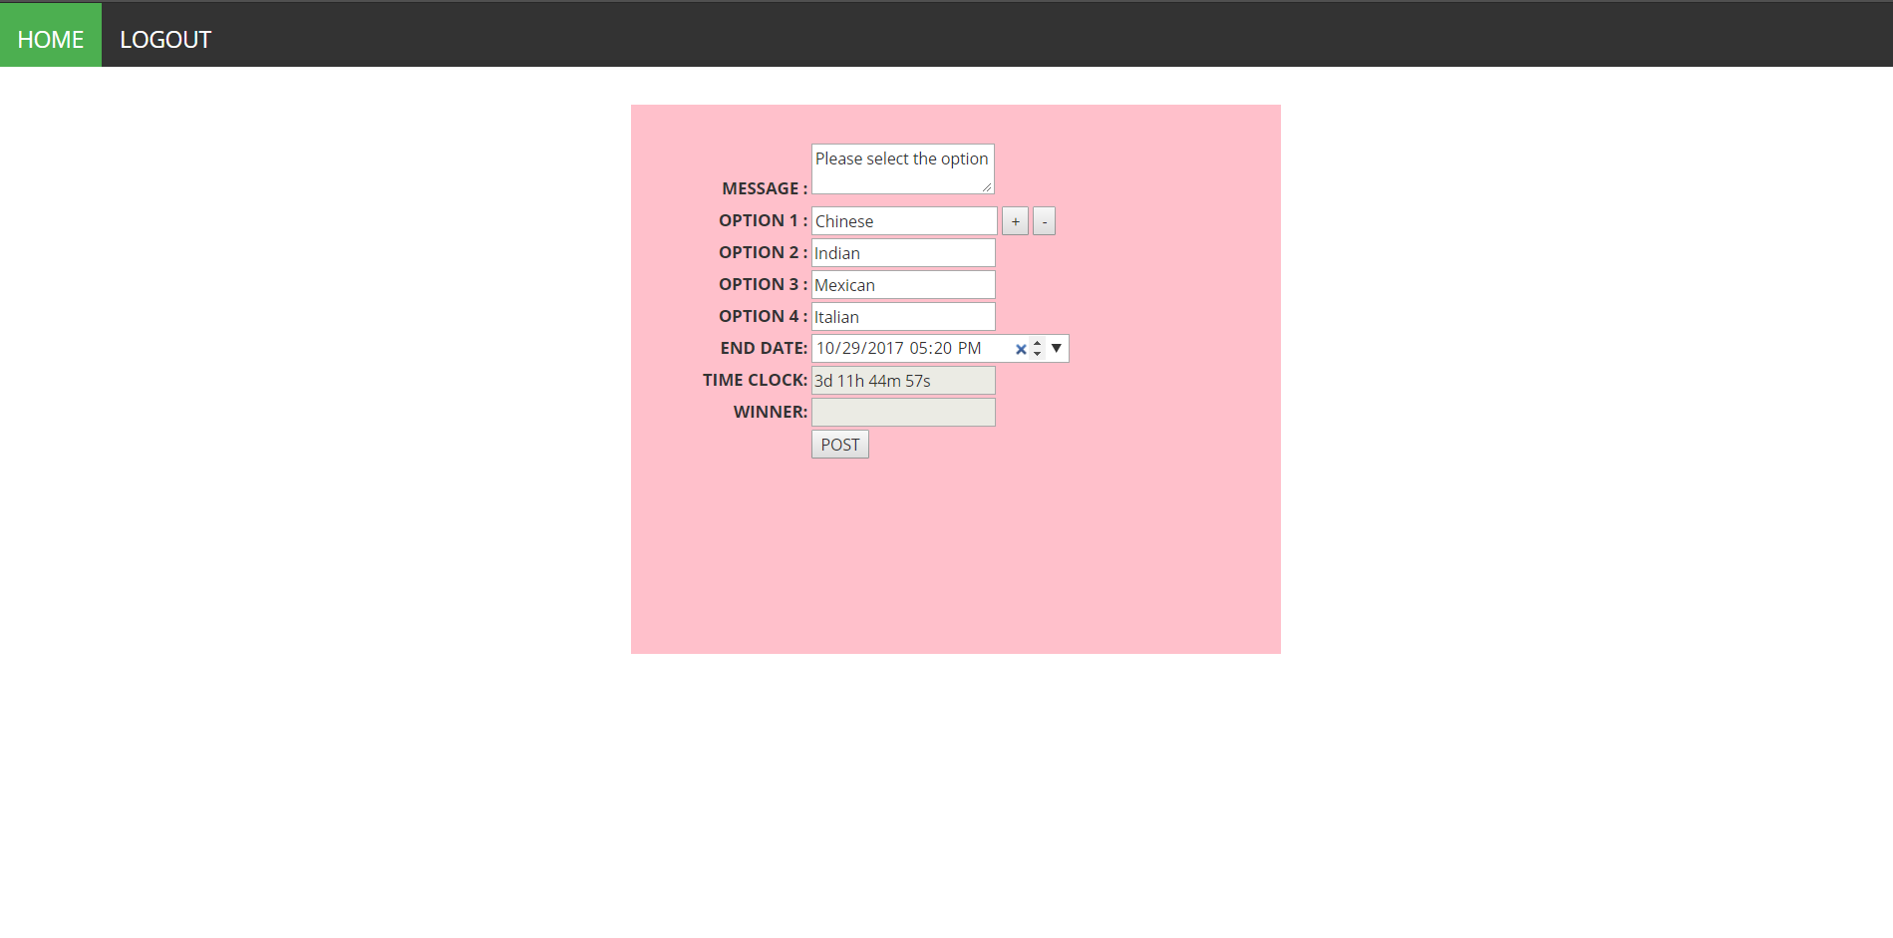

**PARTICIPANT:**

When type is “participant”, ParticipantLoggedin.jsp gets called. In this page, I have included Messages.jsp page which displays message, food options, submit button to submit the choice. Edit and update button to modify the input. To display the message and list of options, REST API call (@GET) is made to <http://localhost:8080/messenger/webapi/messages/>. This happens on the page load and call is made using AJAX.

When SUBMIT is clicked food option along with username, messegeID and date gets inserted into **Messenger.VOTE** table through <http://localhost:8080/messenger/webapi/Votes/>(@POST).

If a participate wants to edit the choice, he/she can do that by EDIT and UPDATE buttons. When user clicks UPDATE, REST call is made to @PUT and updated information is inserted into table.

I have maintained session object to perform session management. When user logs out, user gets navigated to home.jsp

**8)Participant Logged in Page 🡪 ParticipantLoggedin.jsp & Messages.jsp**

