1.The whole project is in webedu folder.

2. First open the "how to run website on local PC" Doc.

3.Do the installations and please note your MySQL and php port if you can't set it to 8888 and 8889 respectively then you have to change it from the code.

\*\*\*Also I am giving you some video for installing and using mamp.

\*mydb contains the whole database

4. For MySQL, you will have you own username ,host, password and database name. You can access it from Mamp.

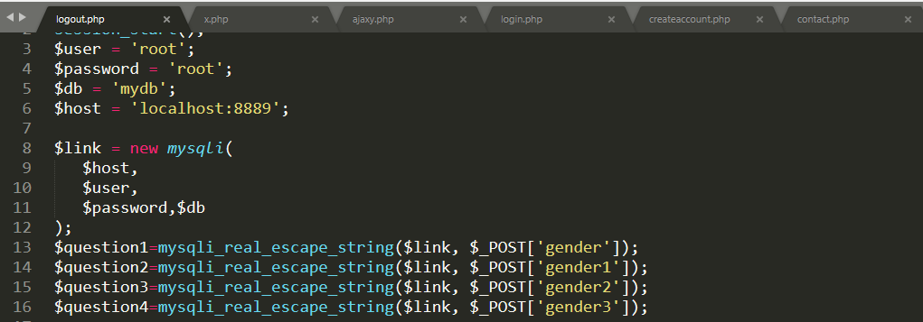

5. For my PC they are being set to these values and you have to change it for all the files shown in the image. Like ajazy1.php, x.php, login.php ,logout.php,.etc.

6. Also there are redirects and if your port for php is not equal to 8888 then you have to change it in the code where ever 8888 is used.

\*\*\*I have commented the code wherever change may be required you only need to replace the port no.

Also remember to start mamp server before the website.

7. After changing the port names, password I am pretty sure that this will work.

8.Also there is a file that explain all the functions of the website.