PHP Rest API

# Software Requirements:

* XAMPP- <https://www.apachefriends.org/index.html>
* PostMan - <https://www.postman.com/>

Create a file called .htaccess in api folder and paste the following

RewriteEngine On # Turn on the rewriting engine

RewriteRule ^students/?$ students.php [NC,L]

RewriteRule ^students/([0-9]+)/?$ students.php?student_id=$1 [NC,L]

# Steps to Run the Project:

1. Extract the File
2. Copy and Paste the ‘Internship’ File in C:\xampp\htdocs
3. Open xampp and start the apache server and mysql server
4. Click on the admin of mysql and phpMyAdmin page will open
5. Create a new database with name student-record
6. Import the students.sql file in student-record Database in phpMyAdmin

# **Display the Records:**

1. Go to PostMan and Choose method as GET
2. And Enter this Url to Display all Records From database: <http://localhost/internship/api/students>

and click send button

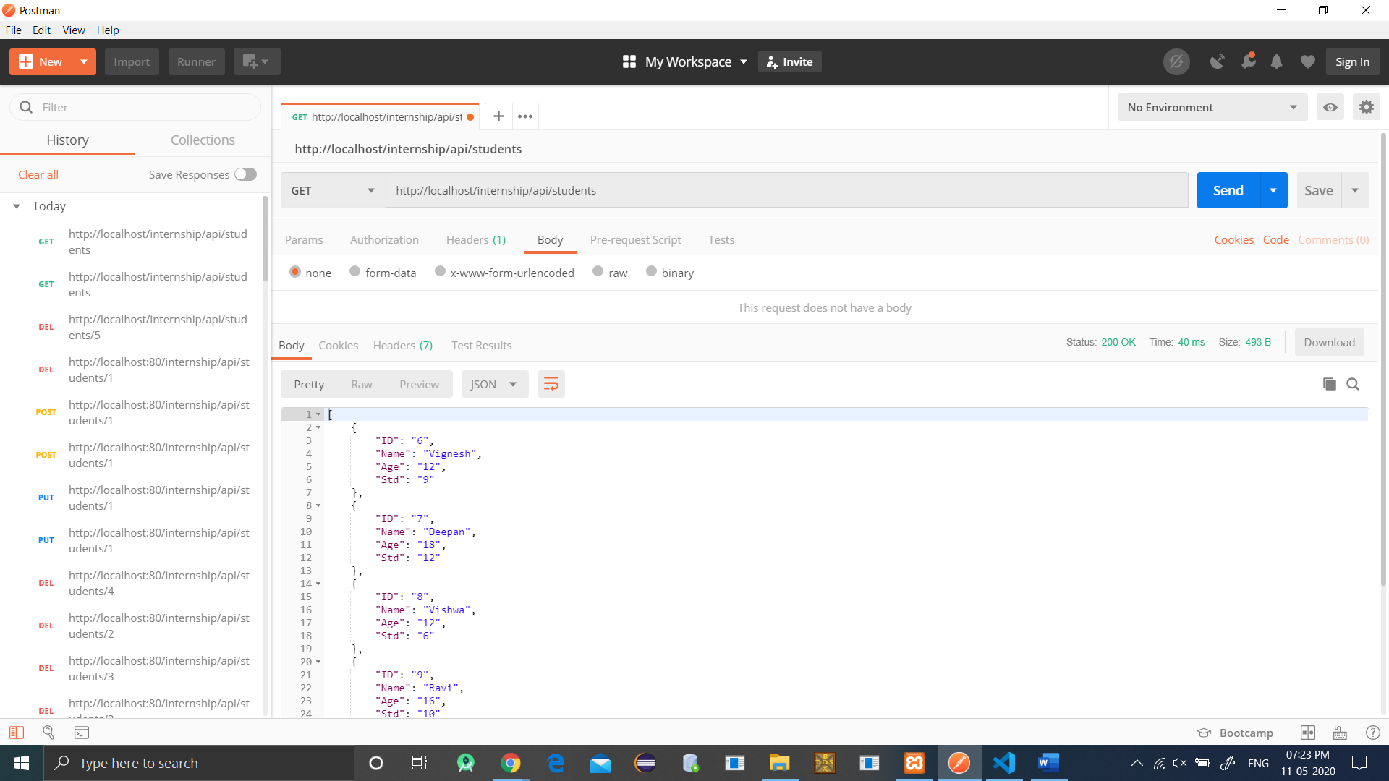

1. To Display a Particular Record, enter url: [http://localhost/internship/api/students/[ID](http://localhost/internship/api/students/%5bID)]

Eg: <http://localhost/internship/api/students/6>

and click Send Button

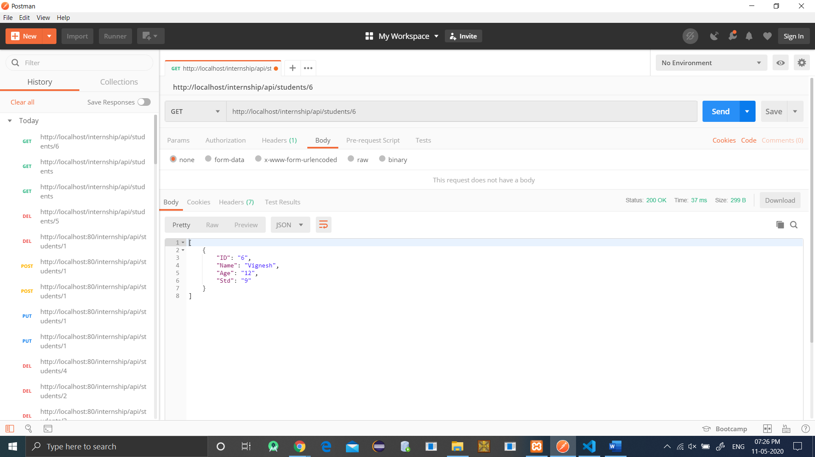

# **Insert a Record:**

1. Go to Post Man and Choose Method as POST
2. On PostMan Go to Body Tab and Choose x-www-form-urlencoded
3. In Key Property Enter These Values(Should Not Change the order and string)
   1. student_name
   2. student_age
   3. student_std
4. And Enter values For Each. Eg. Student_name = deepan, student_age = 16 ,student_std = 9.
5. Enter the url: <http://localhost/internship/api/students> And Click send Button. 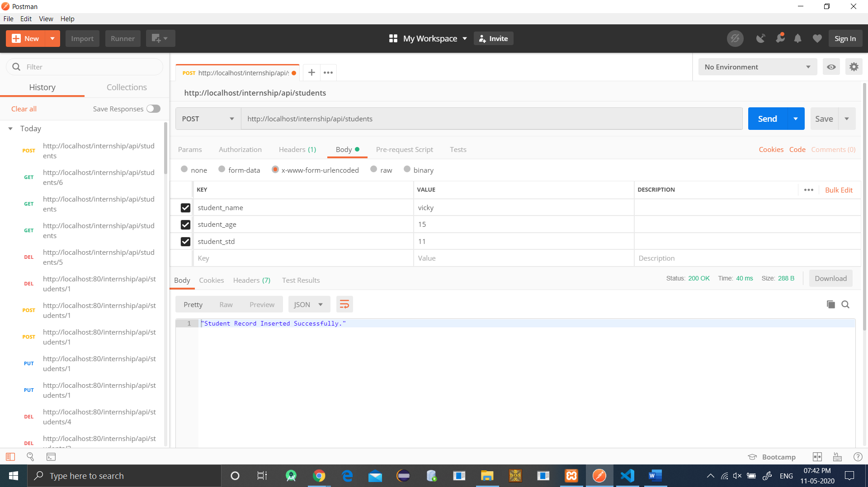

# **Update a Record:**

1. Go to Post Man and Choose Method as PUT
2. On PostMan Go to Body Tab and Choose x-www-form-urlencoded
3. In Key Property Enter These Values(Should Not Change the order and string)
   1. student_name
   2. student_age
   3. student_std
4. And Enter values For Each. Eg. Student_name = deepan, student_age = 16 ,student_std = 9.

Enter the url: [http://localhost/internship/api/students/[ID](http://localhost/internship/api/students/%5bID)]

Eg: <http://localhost/internship/api/students/7> . And Click send Button

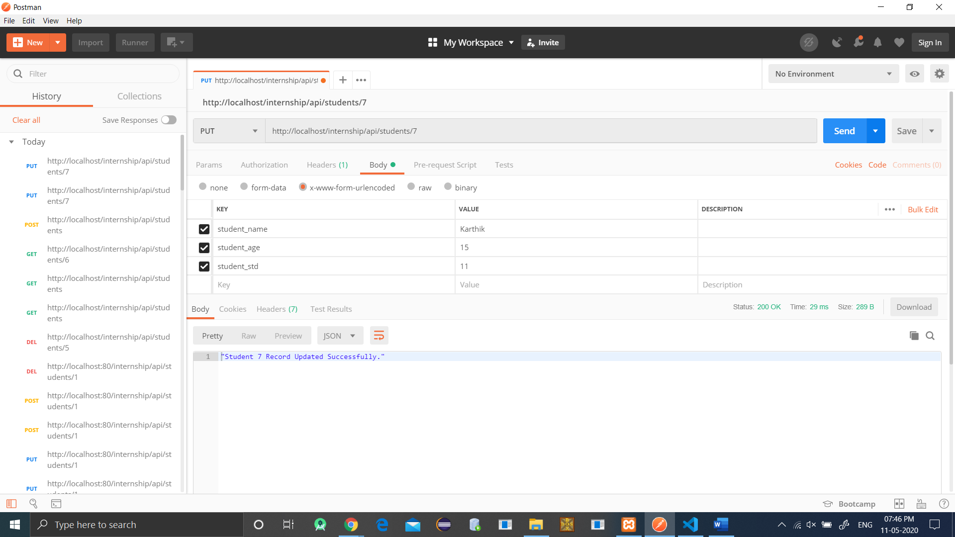

# **Delete a Record:**

1. Go to Post Man and Choose Method as DELETE
2. Enter the url: [http://localhost/internship/api/students/[ID](http://localhost/internship/api/students/%5bID)]

Eg: <http://localhost/internship/api/students/7> . And Click send Button

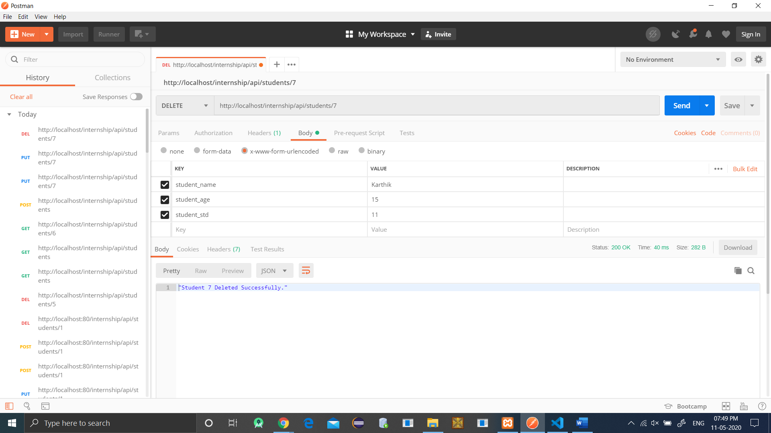

# Rating My self on the skills in the scale of 10:

* WordPress : 5
* HTML: 8
* CSS: 8
* JavaScript: 6
* Node JS: 5