SIMATS ENGINEERING
CSA 1065 - SOFTWARE ENGINEERING FOR CHAOS ENGINEERING

NAME: DEEPAN | REG NO: 192421297
FACULTY: Dr. HEMAVATHI R | ASSESSMENT TOOL - 10

Reverse Engineering Analysis of a Food Delivery System
Integrated with GitHub Actions, Jenkins, and Docker

Introduction:
The QuickBite Food Delivery System is a web application that allows customers to browse food menus, add items to a cart, place orders, and track delivery status in real-time. Restaurant admins can manage their menu items, accept or reject orders, and update order statuses. To improve software development and deployment, the system uses a DevOps pipeline consisting of GitHub, GitHub Actions, Jenkins, and Docker.

Reverse engineering is the process of analyzing an existing system to understand its structure, components, and workflow. This document studies the Food Delivery System and reconstructs its architecture and DevOps pipeline process.

System Functionality
The main purpose of the system is to manage food ordering and delivery operations efficiently between customers and restaurant administrators.

Customer Features:
- Register and Login with email and password
- Browse Food Menu with search and category filters
- View Food Details (name, price, description, image)
- Add Food Items to Database-Backed Cart
- Adjust Quantities and Remove Items from Cart
- Place Orders with delivery address at Checkout
- View Order History with timestamps and totals
- Track Order Status with visual timeline steps
- View Customer Profile

Admin (Restaurant Admin) Features:
- Secure Admin Login via dedicated Admin Portal
- Admin Dashboard with revenue, order counts, and quick stats
- Add, Edit, and Delete Food Items in the catalog
- View all Incoming Customer Orders
- Accept or Reject Pending Orders
- Update Order Status through the pipeline:
- Pending → Accepted → Preparing Food → Food Ready → Out For Delivery → Delivered
- View Sales Statistics and Revenue Reports
- Category Breakdown and Top 5 Selling Dishes Report

Outcome
The system eliminates manual food ordering processes and provides real-time visibility into order preparation and delivery. It improves customer satisfaction by providing accurate order tracking and instant admin response.

Component Decomposition
The system can be divided into the following components:

Module 1: Application Layer
Frontend
- Built using HTML5, CSS3, and Vanilla JavaScript.
- Provides dynamic single-page routing for all views (14 pages).
- Renders Food Cards, Cart Table, Checkout Form, Order Timeline Tracker.
Backend
- Built using Python Flask framework.
- Processes all user and admin REST API requests.
- Handles order logic, cart syncing, status validation, and seeding.
Database
- SQLite database stored as food_delivery.db.
- Stores 5 relational tables: users, food_items, cart, orders, order_items.
- Managed via Flask-SQLAlchemy ORM.

Module 2: DevOps Layer
GitHub
- Stores project source code and all configuration files.
- Maintains two branches: main (production) and development.
GitHub Actions
- Automatically triggers on push and pull requests to main/development.
- Runs unit tests, validates code, and builds a Docker image.
Jenkins
- Automates build, test, Docker image building, deployment, and health checks.
- Uses a declarative Jenkinsfile with 7 pipeline stages.
Docker
- Packages the Flask application and all dependencies into a container image.
- Ensures consistent deployment across any machine or environment.
- Port 5000 is exposed and mapped for web access.

Interaction Analysis
The interaction between system components is shown below:

Customer / Admin User
Frontend (HTML5 / CSS3 / JavaScript)
Flask Backend REST API Server
SQLite Database (food_delivery.db)

Explanation:
- Customer submits a login or places an order from the frontend.
- Frontend sends a REST API HTTP request (JSON) to the Flask backend.
- Backend validates the request and performs business logic.
- SQLite database stores or retrieves the required data.
- Response is returned as JSON and displayed to the user in the browser.

Database Schema
The Food Delivery System uses 5 relational SQLite tables:

Table: users
- id (Integer, Primary Key)
- name (String - Full Name)
- email (String, Unique)
- password (String - Hashed)
- role (String: customer / admin)

Table: food_items
- id (Integer, Primary Key)
- food_name (String)
- description (String)
- category (String: Pizza/Burgers/Drinks/Desserts)
- price (Float)
- image (String - Image URL)

Table: cart
- id (Integer, Primary Key)
- user_id (Foreign Key → users.id)
- food_id (Foreign Key → food_items.id)
- quantity (Integer)

Table: orders
- id (Integer, Primary Key)
- user_id (Foreign Key → users.id)
- total_amount (Float)
- status (String: Pending / Accepted / Rejected / Preparing Food / Food Ready / Out For Delivery / Delivered)
- order_date (DateTime)

Table: order_items
- id (Integer, Primary Key)
- order_id (Foreign Key → orders.id)
- food_id (Foreign Key → food_items.id)
- quantity (Integer)
- subtotal (Float)

REST API Endpoints
Method | Endpoint | Description
POST | /register | Register new customer account
POST | /login | Authenticate user (customer or admin)
POST | /logout | Clear user session
GET | /me | Get current session user info
GET | /foods | Get all food items (supports search & category filter)
GET | /foods/{id} | Get specific food item details
POST | /foods | Add new food item (Admin only)
PUT | /foods/{id} | Update food item (Admin only)
DELETE | /foods/{id} | Delete food item (Admin only)
GET | /cart | Get customer cart items
POST | /cart | Add item to cart
PUT | /cart/{id} | Update cart item quantity
DELETE | /cart/{id} | Remove item from cart
POST | /orders | Place order from cart (empties cart)
GET | /orders | Get orders (own orders or all if Admin)
GET | /orders/{id} | Get specific order details
PUT | /orders/{id}/status | Update order status (Admin only)
GET | /sales-stats | Get revenue and statistics (Admin only)

Reverse Engineered DevOps Workflow
The development and deployment workflow was reconstructed by analyzing the configuration tools involved:

Developer (Writes and commits code)
GitHub Repository (Stores code, tracks branches: main & development)
GitHub Actions CI (Checkout → Install → Test → Compile → Docker Build)
Jenkins CD Server (Checkout → Install → Test → Build → Docker → Deploy → Health Check)
Docker Container (Containerized Flask app, Port 5000)
Application Deployment (Live at http://localhost:5000)

Explanation:
Step 1: Code Development
The developer writes code and pushes it to the GitHub repository using Git commit messages (e.g., feat: order placement, fix: cart issue).

Step 2: Continuous Integration (GitHub Actions)
GitHub Actions automatically triggers the ci.yml pipeline. It checks out code, installs Python dependencies, runs 13 unit tests, validates code syntax using py_compile, and builds a Docker image.

Step 3: Build Automation (Jenkins)
Jenkins retrieves the latest code from GitHub and runs 7 pipeline stages defined in the Jenkinsfile.

Step 4: Container Creation (Docker)
Docker packages the Flask application and all dependencies into a lightweight container image using the Dockerfile (Python 3.11 slim base).

Step 5: Deployment
The Docker container is deployed and exposed on port 5000. A health check verifies HTTP 200 response before the pipeline completes.

Architecture Diagram and DevOps Pipeline Diagram

Application Architecture:
Customer / Admin User
↓
Frontend (HTML5 / CSS3 / JavaScript)
↓ REST API Calls (JSON)
Flask Backend (app.py)
↓ SQLAlchemy ORM
SQLite Database (food_delivery.db)

DevOps Pipeline Flow:
Developer
↓ (git push)
GitHub Repository
↓ (webhook trigger)
GitHub Actions (CI)
↓ (on success)
Jenkins (CD Pipeline)
↓ (docker build & run)
Docker Container
↓ (port 5000)
Deployed Application

Website Pages and Steps
Step 1 - Home Page
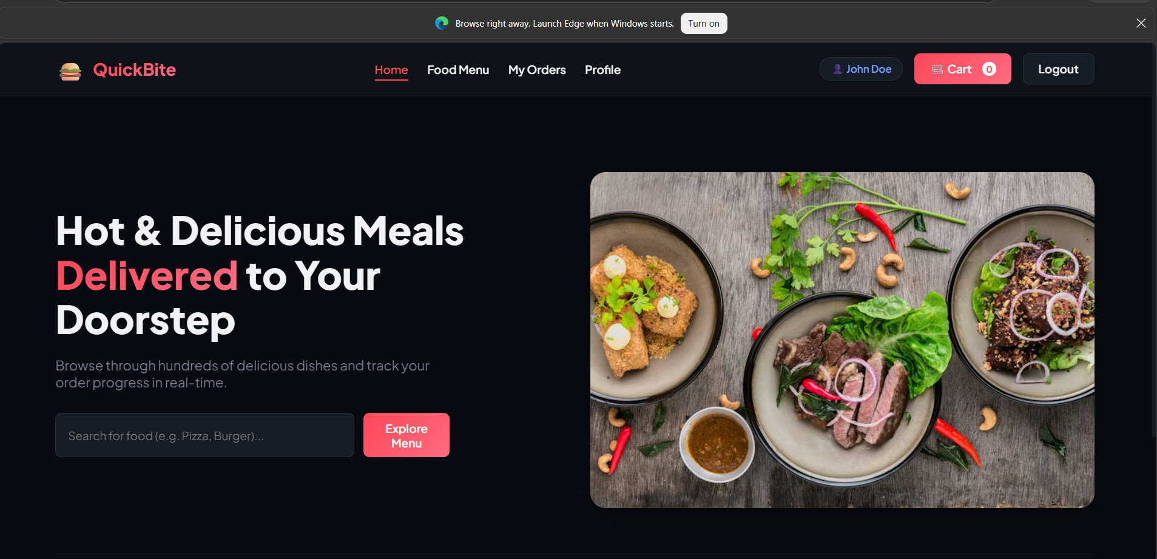
This is the home page where users can view the website hero section with a search bar and category browser. Customers can see featured food categories like Pizza, Burgers, Drinks, and Desserts. A sticky navigation bar provides quick access to all pages.

Step 2 - Register Page
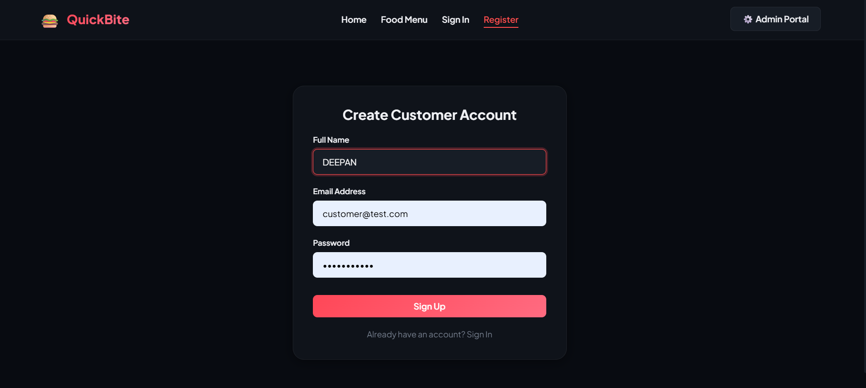
This is the customer registration page where new users can create an account by entering their full name, email address, and a secure password. The form validates inputs before submitting to the /register API endpoint.

Step 3 - Login Page
This is the customer login page where registered users can sign in using their email and password. Demo credentials are shown below the form (customer@test.com / customer123).
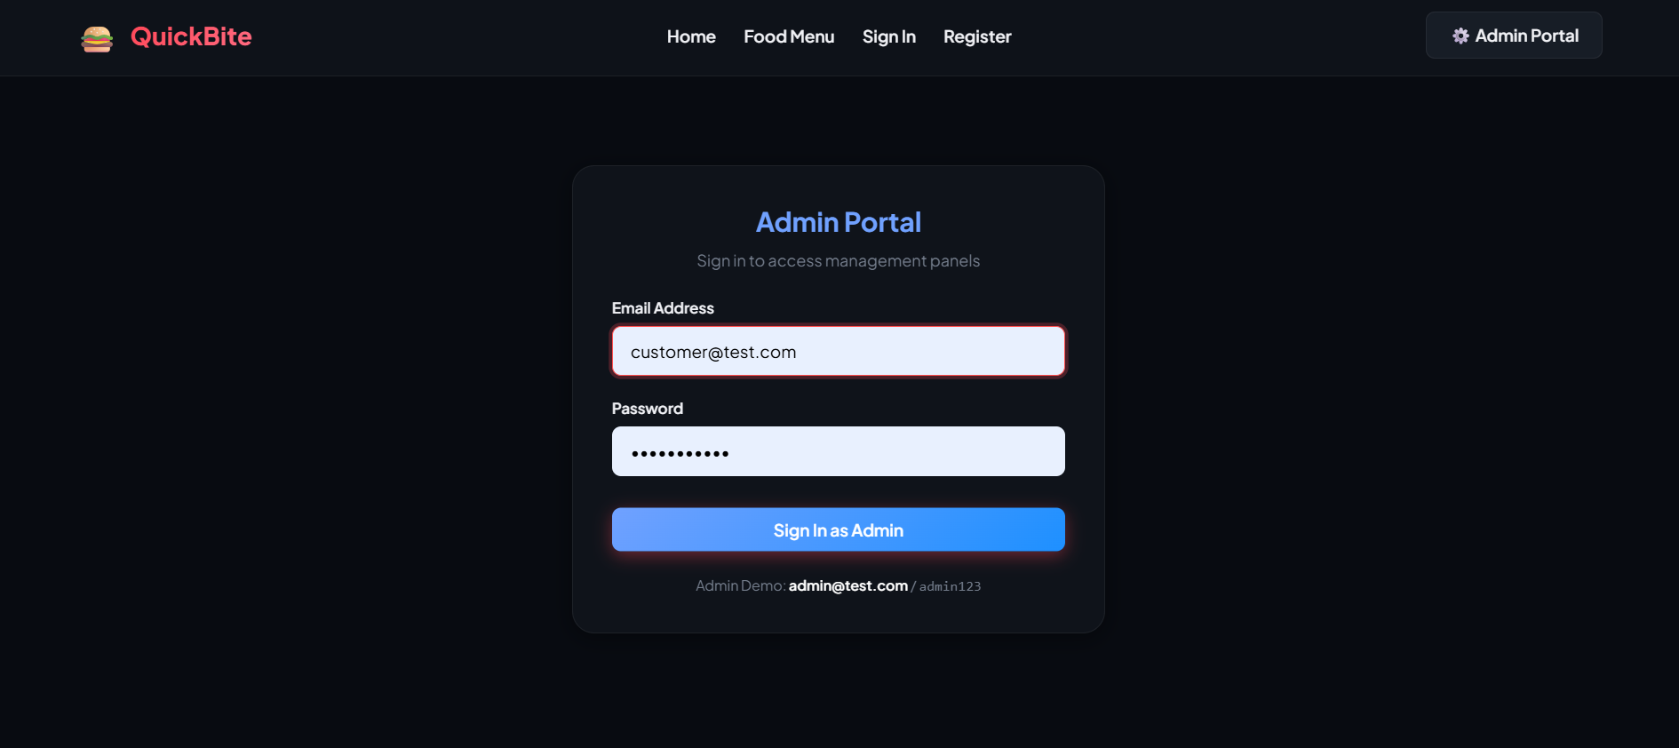
Step 4 - Food Menu Page
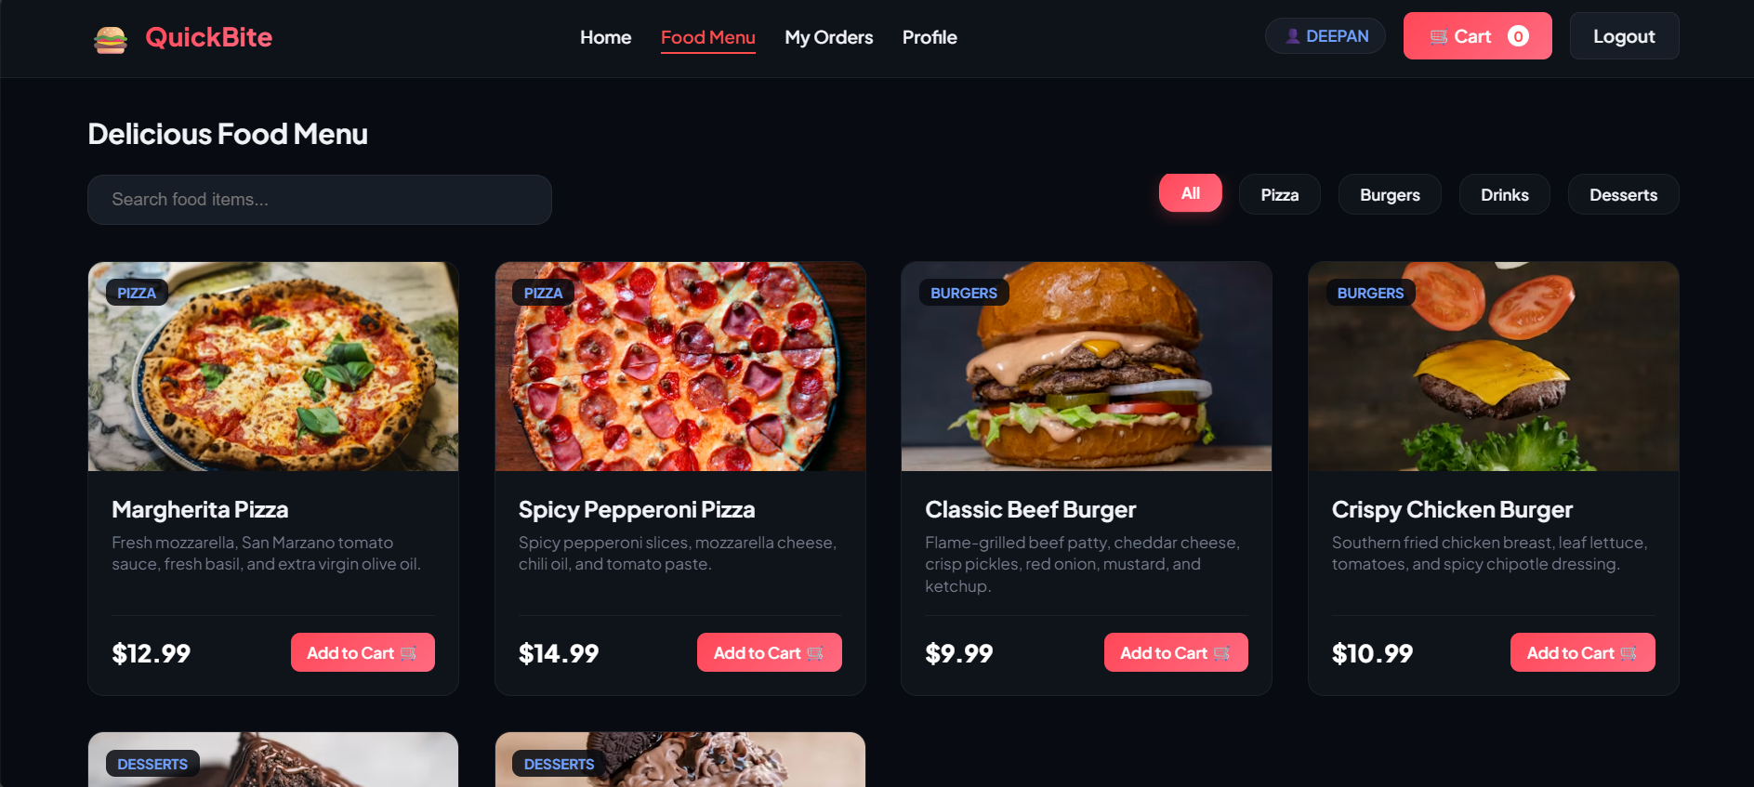
This is the food menu page where customers can browse all available food items in a responsive card grid. Users can filter by category (All, Pizza, Burgers, Drinks, Desserts) or use the search bar to find specific dishes.

Step 5 - Food Details Modal
This is the food details popup modal where customers can see the food name, description, category badge, price, and adjust the quantity before adding the item to their database-backed shopping cart.

Step 6 - Cart Page
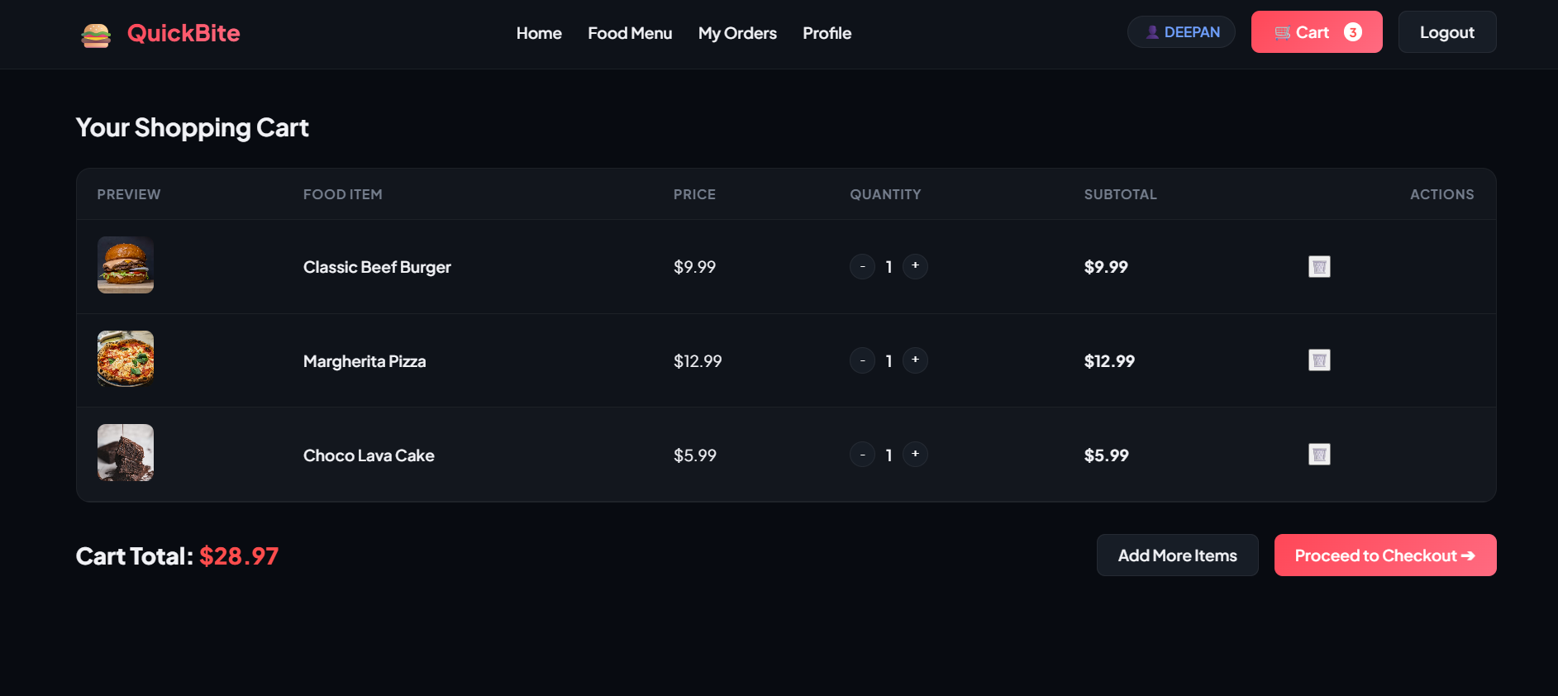
This is the shopping cart page where customers can review added items, adjust quantities using + / - buttons, remove items, and see the running cart total before proceeding to checkout.

Step 7 - Checkout Page
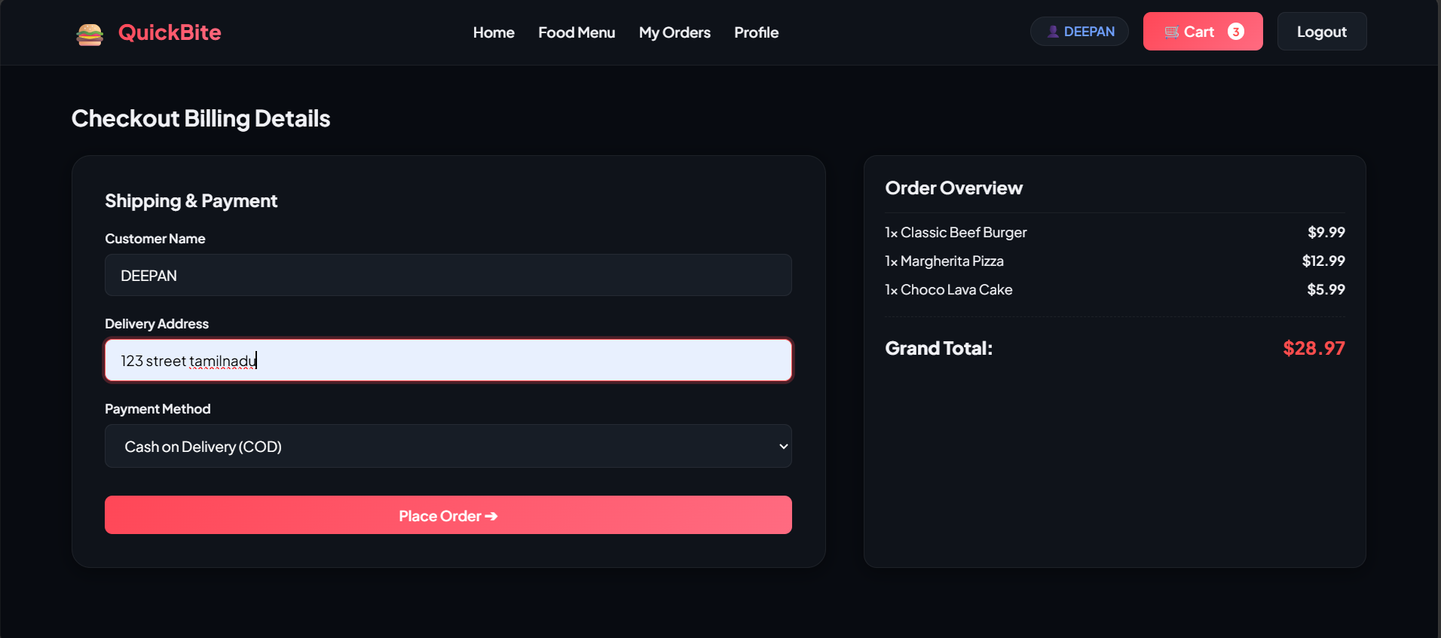
This is the checkout page where customers enter a delivery address and select a payment method (Cash on Delivery or Card). An order summary panel displays all selected items and the grand total.

Step 8 - Order History Page
This is the order history page where customers can view all past and current orders in a table showing Order ID, Date, Items Ordered, Total Amount, and current Status badge (Pending, Preparing, Delivered, etc.).

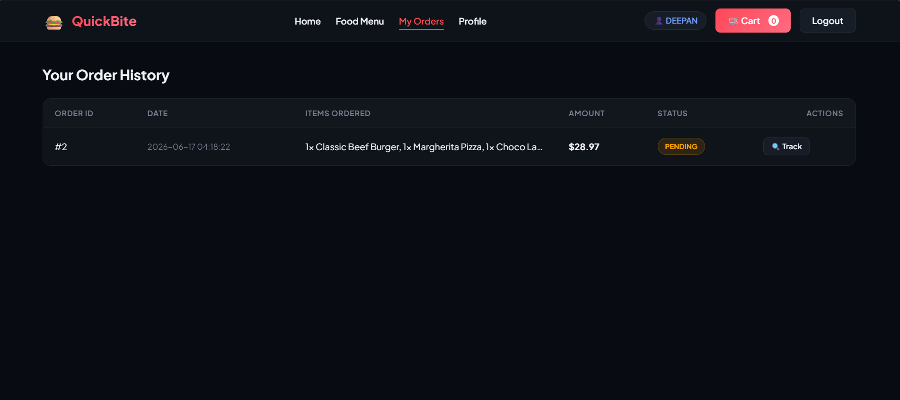
Step 9 - Track Order Page
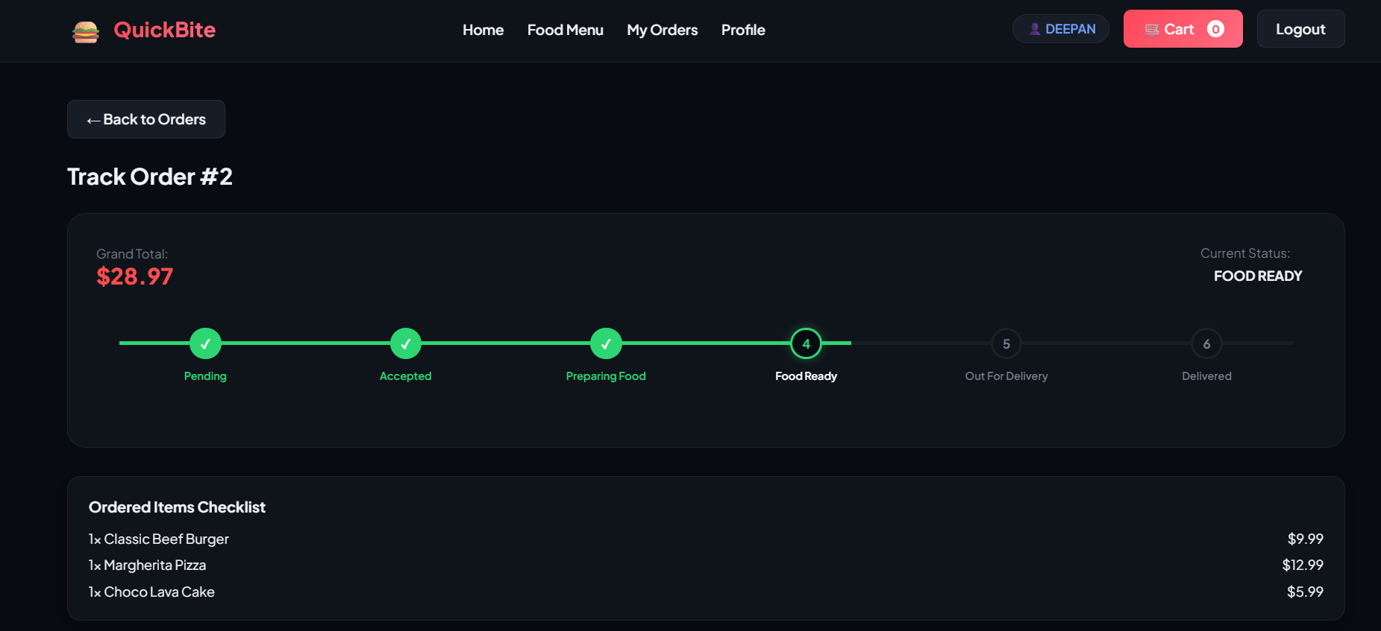
This is the order tracking page where customers can view a visual timeline progress tracker. Each stage is shown as a step node: Pending → Accepted → Preparing Food → Food Ready → Out For Delivery → Delivered. Completed steps are highlighted in green.

Step 10 - Admin Login Page
This is the dedicated admin login portal where restaurant administrators sign in using their credentials (admin@test.com / admin123). It is accessed separately from the customer login page.
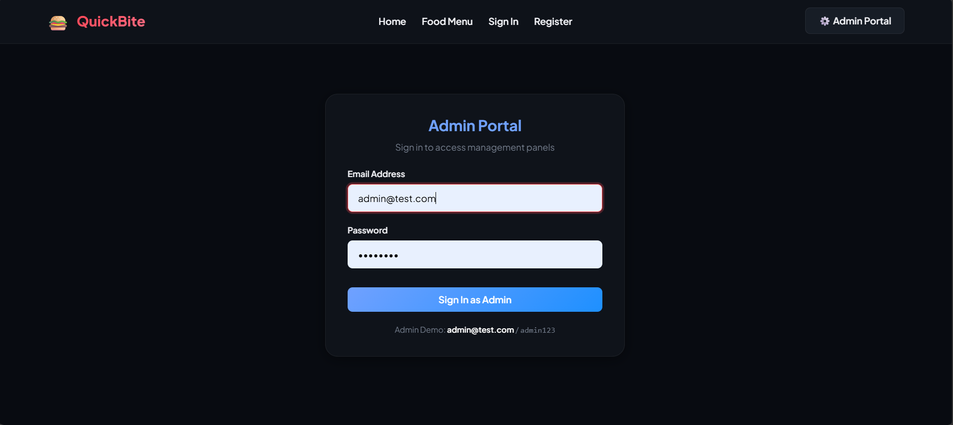

Step 11 - Admin Dashboard
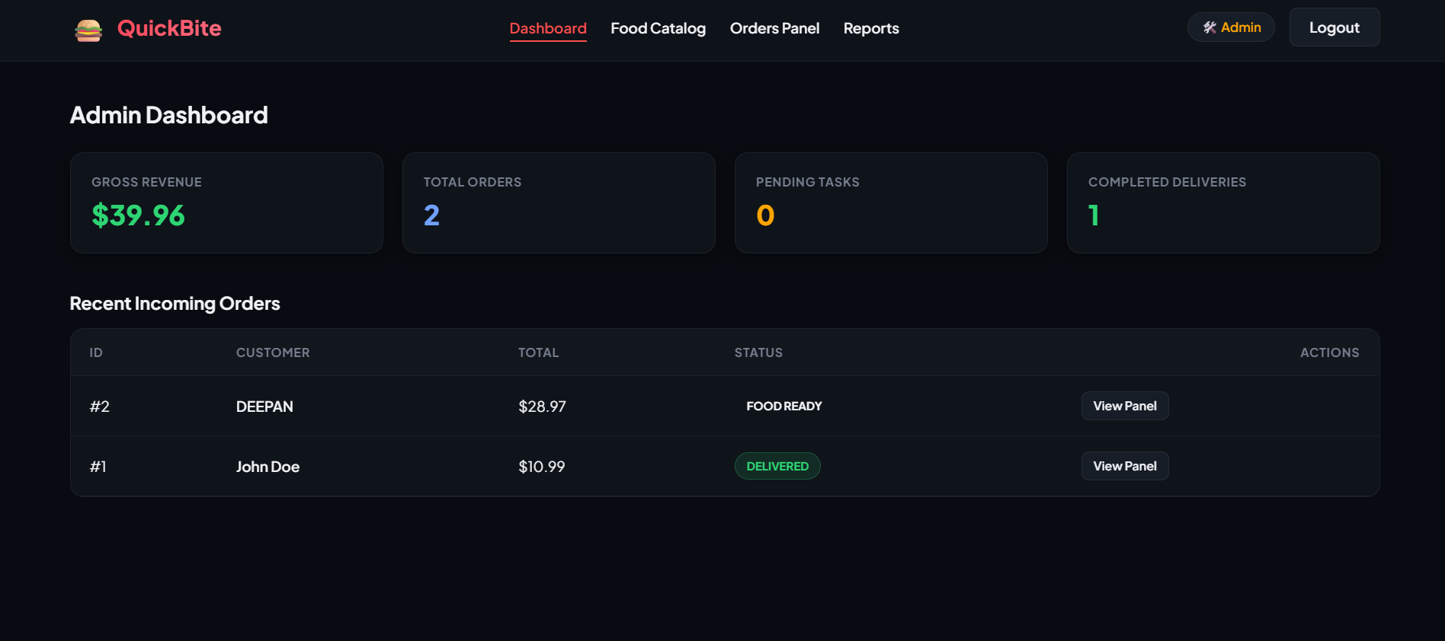
This is the admin dashboard page showing quick metrics: Gross Revenue, Total Orders, Pending Tasks, and Completed Deliveries. A recent orders table provides fast access to incoming customer orders.

Step 12 - Food Management Page
This is the admin food management page where administrators can view all food items in a table and Add new dishes using a popup form (Name, Description, Category, Price, Image URL). Edit and Delete buttons are available for each row.
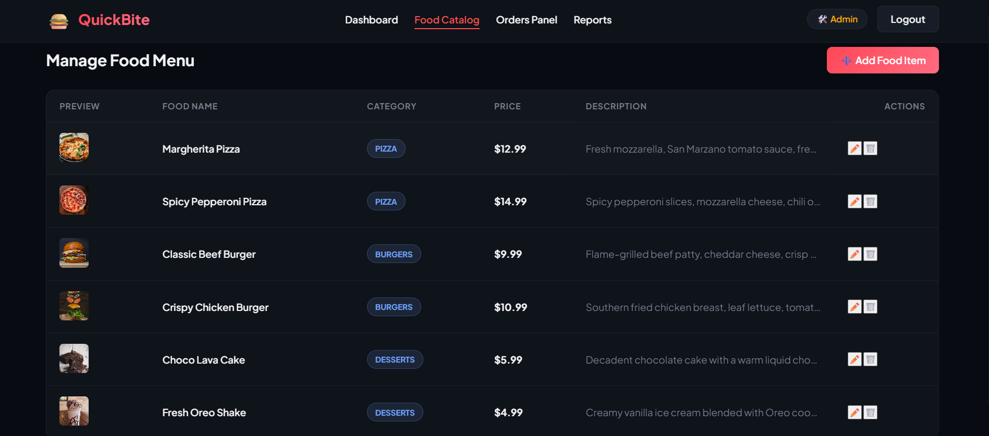
Step 13 - Order Management Page
This is the order pipeline management page where admins see all customer orders. Pending orders have Accept and Reject action buttons. Accepted orders show a status dropdown to advance through: Preparing Food → Food Ready → Out For Delivery → Delivered.
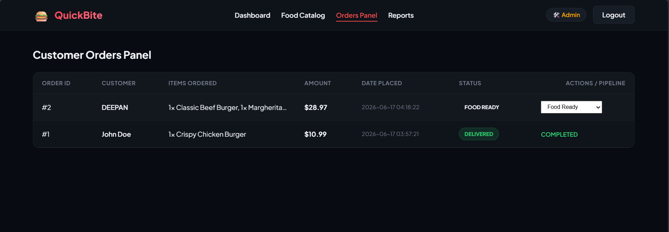
Step 14 - Reports Page
This is the sales reports and statistics page showing Gross Business Revenue, Completed Order Count, Category-wise Sales Table (items sold + revenue per category), and the Top 5 Best-Selling Food Items ranked by quantity sold.
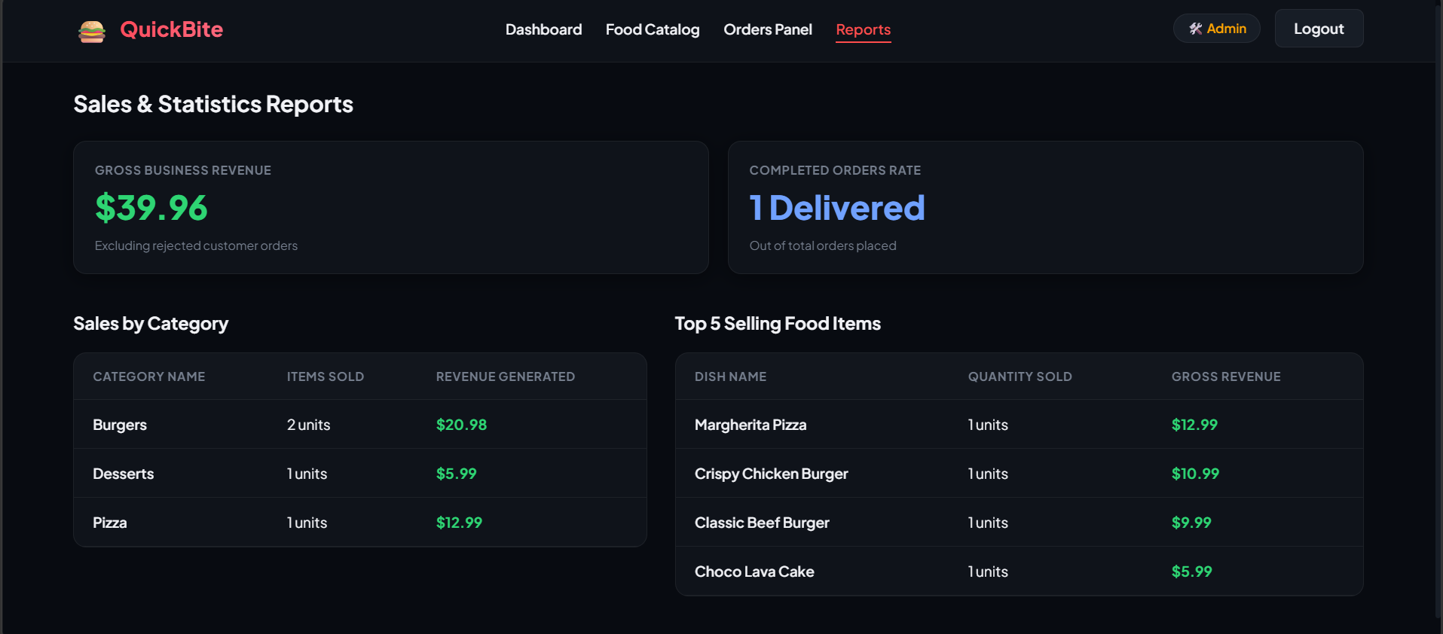
Findings
- The system follows a clean client-server architecture with clear separation between frontend, backend, and database layers.
- The Frontend uses HTML5, CSS3, and Vanilla JavaScript with hash-based SPA routing for smooth page transitions across 14 views.
- The Flask Backend exposes 18 REST API endpoints covering authentication, food CRUD, cart database sync, orders, status workflow, and sales reports.
- The SQLite database uses 5 relational tables: users, food_items, cart, orders, and order_items, linked via foreign keys.
- GitHub manages source code versions across two branches: main and development.
- GitHub Actions provides automated CI with code checkout, dependency installation, 13 unit tests, syntax validation, and Docker image builds.
- Jenkins automates the full CD pipeline with 7 stages including a health check verifying HTTP 200 on port 5000.
- Docker ensures portability and consistent execution across any deployment environment using a Python 3.11 slim base image.
- The Order Status workflow follows a strict pipeline: Pending → Accepted or Rejected → Preparing Food → Food Ready → Out For Delivery → Delivered.
- The DevOps pipeline reduces manual deployment effort and human errors by fully automating the build, test, and deployment lifecycle.
- 13 unit tests are included covering Registration, Login, Food CRUD, Cart Operations, Order Placement, Order Approval, and Status Workflow updates.
- Role-Based Access Control (RBAC) ensures customers can only access customer routes and admins can only access admin management routes.

Conclusion
The reverse engineering analysis successfully identified the complete structure and workflow of the QuickBite Food Delivery System. The application layer handles food ordering operations through a well-defined REST API backend built with Python Flask and a SQLite relational database. Customers can browse menus, manage carts, place orders, and track delivery status in real-time through a visual timeline interface.

The DevOps layer automates software testing, building, containerization, and deployment using GitHub Actions and Jenkins pipelines. Docker packages the application ensuring consistent and repeatable deployments on any target machine. This complete integration of software engineering principles and modern DevOps practices significantly improves software reliability, deployment speed, and system maintainability.

This explanation is concise, professional, and suitable for directly writing into a Word document while also being easy to explain during academic evaluation.

