Reports

*A report is a collection of visualizations that together give an informative account and insight on the imported data.*

*Dashboards*

*A dashboard is a canvas on which you bring different elements or visualizations representing data sets together.*

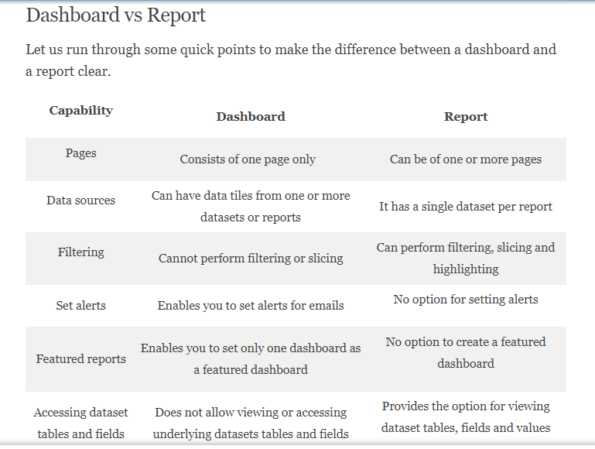

**Creating Reports**

- Using a Single Data Set with Slicers and Filters

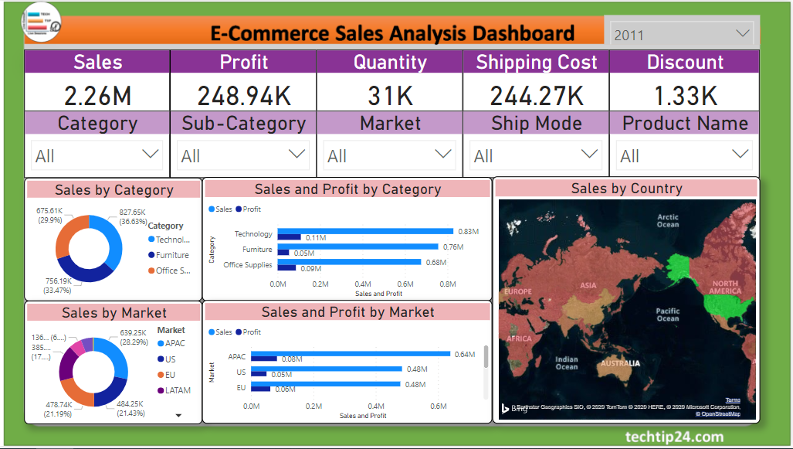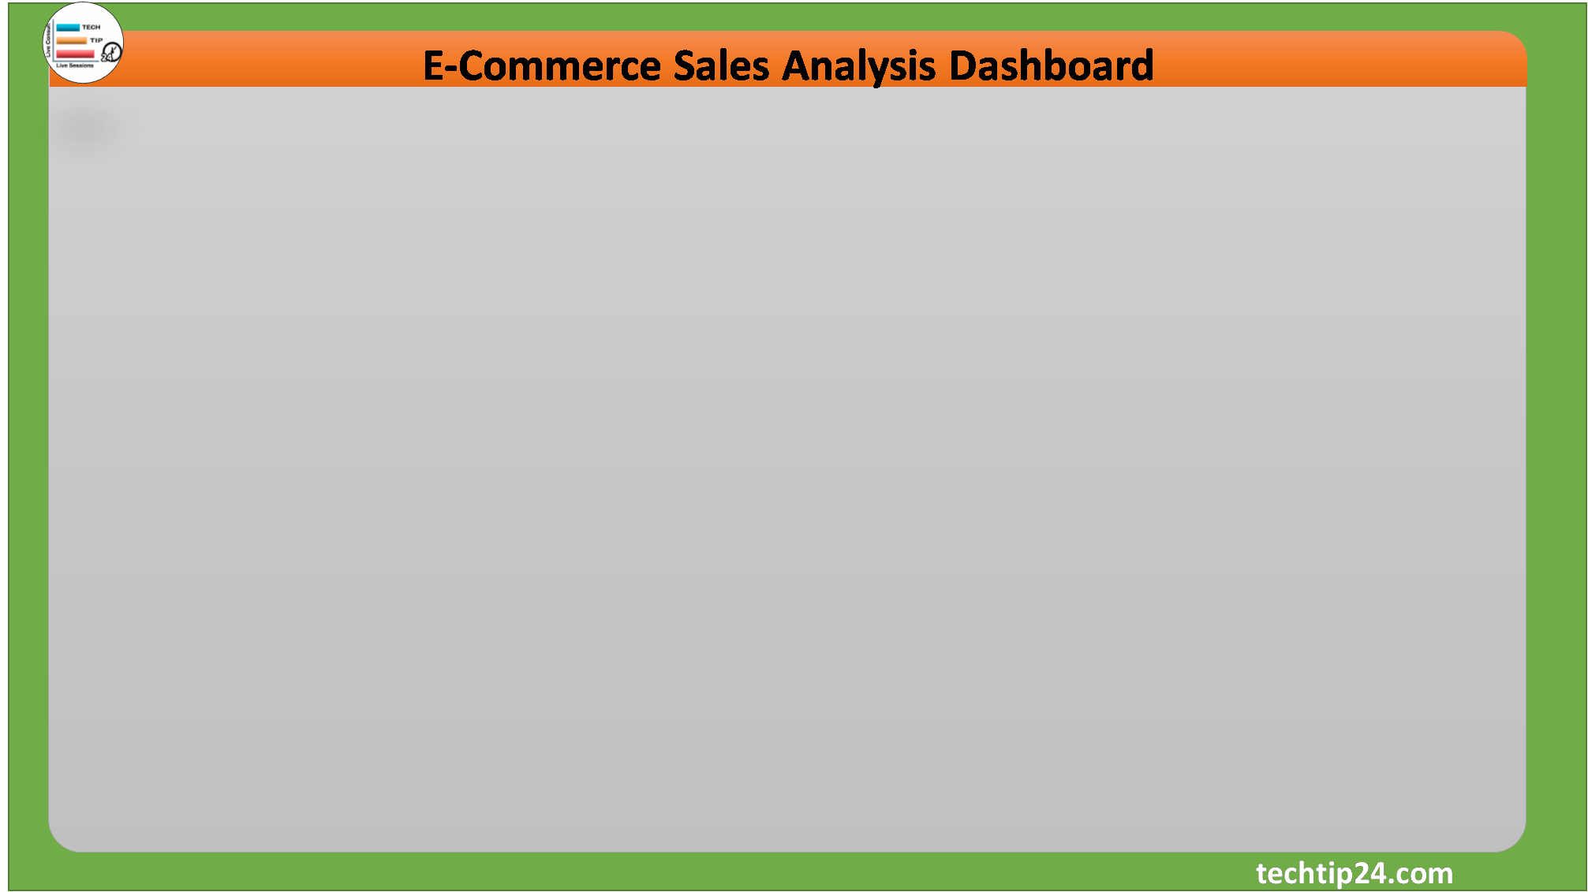

**Publish Reports**

Sign in -> Home Tab -> Click on publish -> Open app.powerbi.com -> Go to reports -> Export to web, pdf, power point etc.

**Creating Dashboards**

It will give you an overview of the story that lies in the detailed BI report as it contains all the important elements from a report. A dashboard is always a single page whereas a report can be many pages long.

Each visualization is represented as a tile on the dashboard. Tiles make a dashboard look more organized and understandable. To add a visualization from your report to a dashboard, simply pin it on the dashboard.

A consumer cannot make changes in a dashboard. Rather, they use the dashboard for analytical purposes like getting a quick*insight into their business, making an important decision based on the information given on a dashboard,* etc.

