**AWS vs Azure vs GCP & AWS vs Azure vs GCP Comparison Overview**

**Amazon Web Service, Microsoft Azure and Google Cloud Platform** are the **top 3** cloud giants in this field. They serve excellent services like Storage, Computing and Networking to industries worldwide. This post will compare leading cloud vendors **AWS vs Azure vs GCP.**

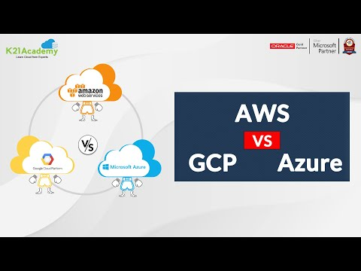

.  
[Overview of Cloud Computing](https://k21academy.com/amazon-web-services/aws-solutions-architect/aws-vs-azure-vs-gcp/#1) | [Amazon Web Service.](https://k21academy.com/amazon-web-services/aws-solutions-architect/aws-vs-azure-vs-gcp/#2) | [Microsoft Azure.](https://k21academy.com/amazon-web-services/aws-solutions-architect/aws-vs-azure-vs-gcp/#3) | [Google Cloud Platform.](https://k21academy.com/amazon-web-services/aws-solutions-architect/aws-vs-azure-vs-gcp/#4) | [AWS, Azure, GCP Tools and Services.](https://k21academy.com/amazon-web-services/aws-solutions-architect/aws-vs-azure-vs-gcp/#5) | [AWS vs Azure vs GCP comparison.](https://k21academy.com/amazon-web-services/aws-solutions-architect/aws-vs-azure-vs-gcp/#6) | [AWS vs Azure vs GCP Pros and Cons.](https://k21academy.com/amazon-web-services/aws-solutions-architect/aws-vs-azure-vs-gcp/#7) | [Cloud providers worldwide adoption.](https://k21academy.com/amazon-web-services/aws-solutions-architect/aws-vs-azure-vs-gcp/#8)

**Overview of Cloud Computing**

The traditional way of hosting applications was very complicated and expensive. The amount of hardware and software resources needed to run them was very complex. Moreover, you would need a team of experts to install, configure, test, run, secure, and update them.

Cloud computing is the on-demand availability of computer resources like **Servers:** containing Memory, CPU. Different type of **Storage:** like blob storage, object storage.  **Databases** like structure data, unstructured data, semi-structured data, **networking include** virtual network, subnet, connecting with the premise, etc. Cloud computing is like your water/ electricity bill; you **only pay for what you use**.

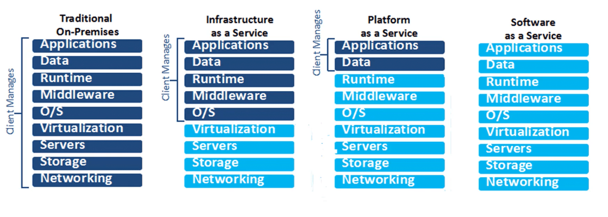There are four types of cloud deployment models: Public, Private, Community, and Hybrid. Every deployment model is defined according to where the infrastructure for the environment is located.

In the public cloud, you can host websites, web apps. Private cloud is for sensitive data. If you have a website and sensitive data, you can go with a Hybrid cloud. Community cloud allows systems and services accessible by a group of organisations. Each cloud deployment model satisfies different organisational needs, so you must choose a model that will fulfil your organisation’s needs.

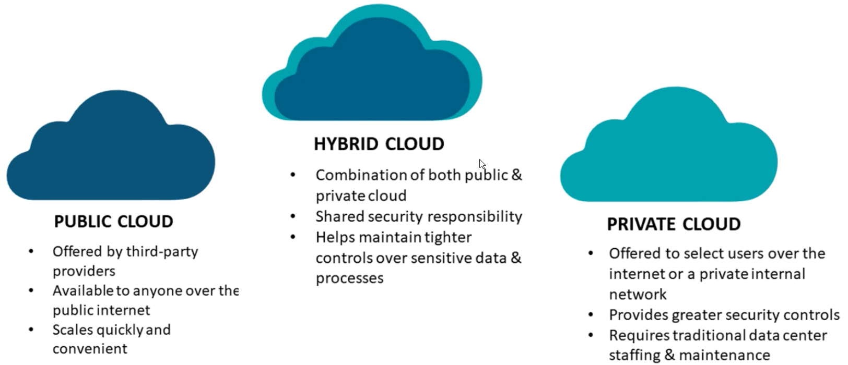

The main types of [cloud computing](https://k21academy.com/amazon-web-services/aws-solutions-architect/cloud-service-models/) include software as a service, platform as a service, and infrastructure as a service.

**Amazon Web Service**

[Amazon Web Services (AWS)](https://k21academy.com/amazon-web-services/overview-of-amazon-web-services-concepts/) is the world’s most comprehensive and broadly adopted cloud platform. It provides on-demand cloud computing services to individuals, companies and government organizations on a paid subscription basis.



* AWS has more than 200+ services upon running.
* It has over 81 availability zones in 24 Regions.
* The platform is developed with a combination of infrastructure as a service (IaaS), platform as a service (PaaS), and packaged software as a service (SaaS) offering.

AWS provide a wide range of services that most branded companies use. Like Netflix, BBC, Facebook, Spotify, LinkedIn

.

**Microsoft Azure**

**Azure**is a cloud computing service provided by **Microsoft**. Collection of various cloud computing services, including remotely hosted and managed versions of proprietary Microsoft technologies, used to build, test, deploy and manage applications in the cloud.



* Offer almost 200+ Services.
* It has 60 regions available in 140 countries which is huge comparing to other cloud providers.

Some famous brands like Adobe, HP, eBay, Samsung, Rolls-Royce using Azure.

**Google Cloud Platform**

[Google Cloud Platform](https://k21academy.com/google-cloud/introduction-to-google-cloud-platform/) provides various cloud computing services needed to develop, deploy, scale, monitor and operates a cloud. The services are the same as running google’s products like Google Search, Gmail, Youtube and Google Drive.



* With 100+ Services up on running.
* GCP offers 27 regions with 82 total zones.

PayPal, Twitter, Airbus, Toyota trust on Google cloud platform.

**AWS, Azure, GCP Tools and Services**

AWS, Azure GCP tools and services are divided into categories like Compute, Storage, Networking etc., in the table mentioned below.

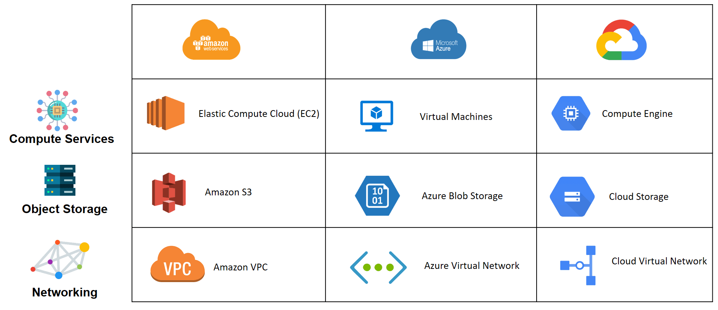

**Check Out:**[What is AWS Auto Scaling](https://k21academy.com/amazon-web-services/aws-solutions-architect/aws-auto-scaling/)?

**AWS vs Azure vs GCP Comparison**

Now let’s compare each cloud provider in its respective areas

**History And Open Source**

History is also essential while comparing cloud providers. Because the more experience you have, the more powerful you will be. Being the oldest of the bunch, AWS started its journey in early 2006. Azure came into the market in 2010, where GCP launched in the year **2008.**

|  |
| --- |
| **History And Open Source** |
| **AWS Logo** | **Azure** | **Google Cloud Platform** |
| AWS came into the market in the Year **2006** | Azure Started services in Year **2010** | GCP Launched in the year **2008** |
| AWS is Friendly with the open-source model from the beginning. | Azure has not so good a relationship with the open-source community. | GCP offers managed open source services that are tightly integrated into Google Cloud. |
| Large and Complex scale offerings of services that can potentially manipulate. | Low-Quality Support | Quite costly support fee of about $150 per month for the silver class, which is the most basic of services |

**Service Integration**

Service integration is a system of tools and technologies that combines various applications, systems, repositories, and real-time exchange of data and processes.

|  |
| --- |
| **Service Integration** |
| **AWS Image** | **Azure** | **Google Cloud Platform** |
| AWS allows users to integrate Services easily Amazon EC2, Amazon S3, Beanstalk etc. | AWS allows users to integrate Services easily Azure VM, Azure App Service, SQL databases etc | GCP allows users to integrate services Compute Engine, Cloud Storage, Cloud SQL etc. |

**Also Read:**Our blog post on [**AWS Solutions Architect Salary**](https://k21academy.com/amazon-web-services/aws-solutions-architect/aws-solution-architect-salary/).

**GCP vs Azure vs AWS Market Share**

Whenever the market share for a particular business is high, that basically implies many businesses or companies practising that specific technology. AWS has the maximum market share. In that case, a lot of companies are investing in AWS.

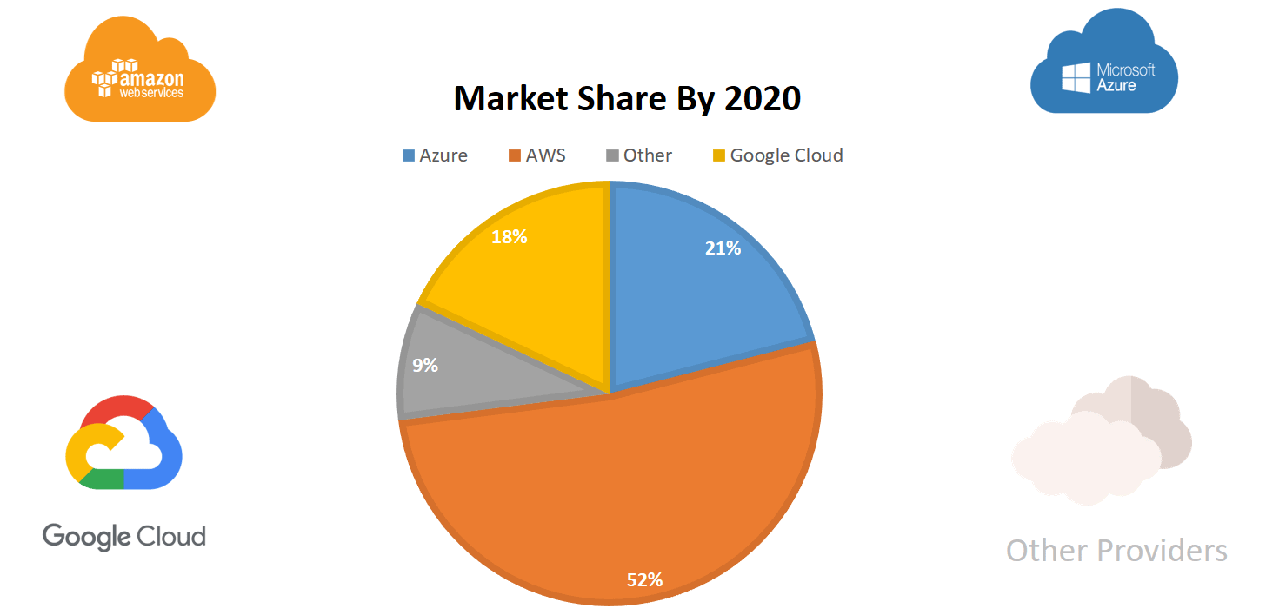

**Managing Packages**

If you take any software, you will need a package manager working on Angular or any node-based framework. You will need a node package manager(NPM) and manage this NPM; you will need a package manager.

|  |
| --- |
| **Managing Packages** |
| **AWS logo 3** | **Azure** | **GCP** |
| In AWS, if you have to manage a package, you need to integrate external software or a third party software like Artifactory. | Azure has a package manager tool called Azure Artifacts to manage the packages like Nuget, Maven, etc. | Artefact Registry is a single place for your organisation to manage container images and language packages (such as Maven and npm) |

**Job Role**

AWS vs Azure vs GCP certification can open the door to many high-paying, up-and-coming careers in IT. But, exactly which jobs are you qualified for? There is a wide range of job opportunities available to people. Let’s look at some of them.

**Amazon Web Service:** Operational Support Engineer, Cloud Software Engineer, System Integrator — Cloud, DevOps Engineer, AWS Solutions Architect

**Microsoft Azure:** Azure Administrator, Azure Administrator, Azure Solution Architect, Azure DevOps Engineer

**Google Cloud Platform:** Solution Architect, Cloud Developer, Cloud Administrator, Cloud DevOps Engineer, Operational Support Engineer

**Also Check:**Our blog post on [**AWS WAF Rules**](https://k21academy.com/amazon-web-services/aws-solutions-architect/aws-waf/).

**Average Salary: Cloud Solution Architect**

Azure vs AWS vs GCP cloud solution Architect certification can open the door to many high-paying jobs. The average salary of Azure vs AWS vs GCP cloud solution Architect

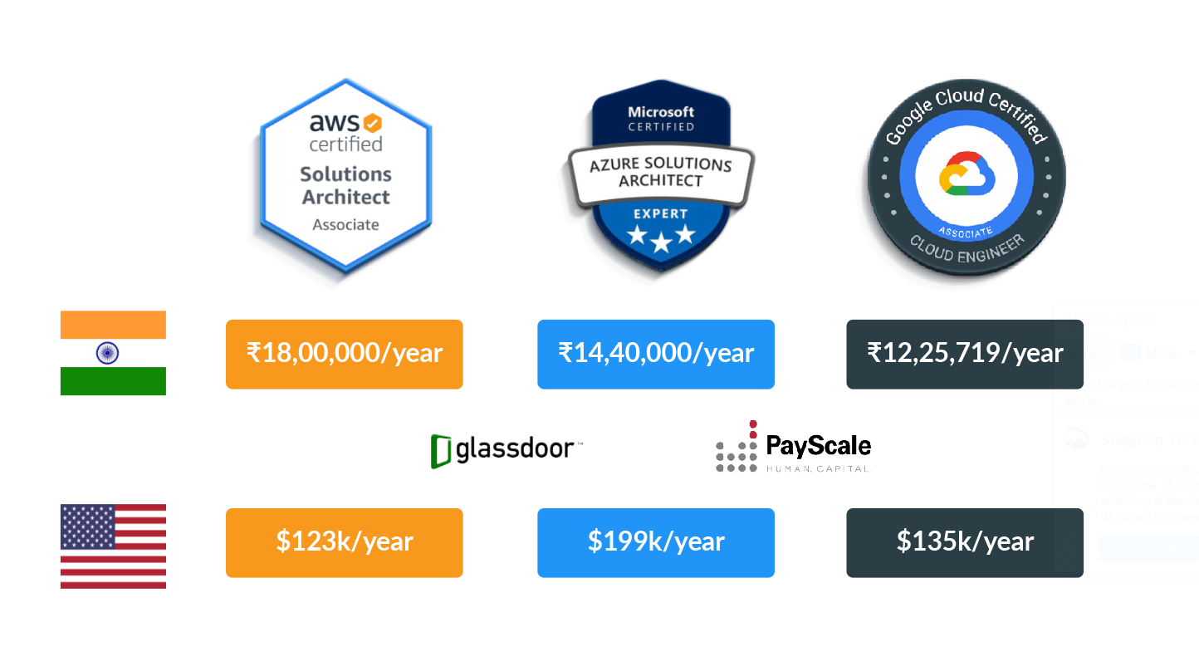

**India :**

* AWS Solution Architect: INR 18,00,000/year
* Azure Solution Architect: INT 14,40,000/year
* Google Cloud Engineer: INR 12,25,719/year

**USA  :**

* AWS Solution Architect: USD 123k/year
* Azure Solution Architect: USD 199k/year
* Google Cloud Engineer: USD 135k/year

**Read More:**About [**AWS Cloud Storage**](https://k21academy.com/amazon-web-services/aws-solutions-architect/aws-storage-overview-types-benefits/).

**AWS vs Azure vs GCP Pros and Cons**

Every cloud provider in the market famous for its unique way of serving solutions. But there are also some cons lets have a look at the Pros and cons.

|  |
| --- |
| **AWS vs Azure vs GCP Pros.** |
| **https://k21academy.com/wp-content/uploads/2020/12/download-1.png** | **Azure** | **https://k21academy.com/wp-content/uploads/2021/05/gcp-logo.png** |
| AWS is a Stablish market leader. | Azure is Open to Hybrid Cloud systems. | GCP specialises in high compute offerings like Big data, Machine Learning. |
| High Transfer Stability: Minimal data loss during server and storage transfer. | Easy integration with Microsoft tools and software. | Easy integration with other GCP Services like Compute Engine, Kubernetes Engine, or App Engine. |
| Easy Availability of Data: users can choose to store data close to their location. | Azure has a more profound knowledge of enterprise needs. | Well-detailed documentation, including an API reference guide. |
| 54 Azure regions available across 140 countries ( which is higher in all cloud giants ) | Higher Availability Zones (76 ) with 24 Countries. | Outstanding reputation in the open-source community |

|  |
| --- |
| **AWS vs Azure vs GCP Cons.** |
| **https://k21academy.com/wp-content/uploads/2020/12/download-1.png** | **Azure** | **https://k21academy.com/wp-content/uploads/2021/05/gcp-logo.png** |
| Incomplete and weak Hybrid Strategy | Integration with non-Microsoft is complex. | Google’s App Engine is limited to Java, Python, PHP and Google Go. |
| No demonstrated support for hybrid cloud outputs is still in its nascence | Restrictive Platform, Less flexible with non-windows server platforms | The cost of downloading data from Google Cloud Storage is relatively high |
| Large and Complex scale offerings that can potentially manipulate. | Low-Quality Support | Quite costly support fee of about $150 per month for the silver class, which is the most basic of services |

**Cloud Providers Worldwide Adoption**

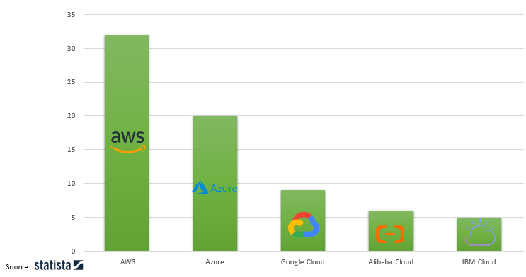

After analyzing various parameters, We found that in the war of AWS vs Azure vs Google Cloud. AWS is scoring more points than Azure and Google Cloud. However, it’s hard to say that up to when AWS will wear the leading cloud platform’s crown. No doubts Azure and GCP Cloud offer top-level Services and features; that’s why any of these cloud platforms can be the leader in the future.