What Is Cloud Computing Architecture: Benefits, Components & More

Cloud computing architecture is simple; it clearly states the components and subcomponents embedded in it There’s no question that cloud computing is here to stay. It touches every part of our lives today, offering many advantages in terms of flexibility, storage, sharing, maintenance, and much more.

A standard internet connection or a virtual network provides us access to cloud-based applications and services like Google Docs, Skype, and Netflix. Most companies are shifting their businesses into the cloud as they require significant storage, which [cloud platforms](https://www.simplilearn.com/top-cloud-platforms-article) provide. A cloud computing architecture provides higher bandwidth to its users due to which data over the cloud can be used from anywhere across the world at any time. Due to its architecture, it not only shares resources among client source consumers but also with open source communities like Microsoft and Red hat.

But how exactly does cloud computing work? In our guide, we explain everything there is to know about cloud computing architecture.

Post Graduate Program In Cloud Computing

What is Cloud Computing?

[Cloud computing](https://www.simplilearn.com/tutorials/cloud-computing-tutorial/what-is-cloud-computing) refers to services like storage, databases, software, analytics, and other platforms that are accessible via the internet. It is any service that can be delivered without being physically close to the hardware. For example, Netflix uses cloud computing for its video streaming services. Another example is G Suite, which runs entirely on the cloud.

Simply put, Cloud Computing refers to the delivery of on-demand resources (such as a  server, database, software, etc.) over the internet. It also gives the ability to build, design, and manage applications on the cloud platform.



Note: Companies offering these computing services are referred to as cloud providers.

Cloud Computing Service Providers

A few of the most popular cloud computing service providers include:

* [Microsoft Azure](https://www.simplilearn.com/tutorials/azure-tutorial/what-is-azure)
* [Amazon Web Services (AWS)](https://www.simplilearn.com/tutorials/aws-tutorial/what-is-aws)
* [Google Cloud](https://www.simplilearn.com/tutorials/cloud-computing-tutorial/google-cloud-vs-aws)
* Alibaba Cloud
* IBM Cloud
* Oracle
* Salesforce
* SAP
* Rackspace Cloud
* [VMWare](https://www.simplilearn.com/tutorials/cloud-computing-tutorial/vmware-workstation)

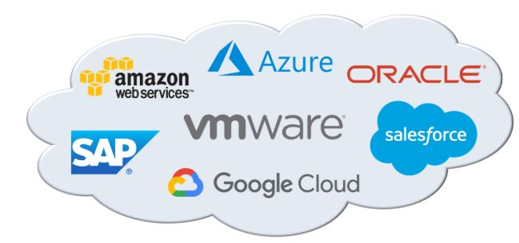

As one of the top three cloud providers available, there are plenty of career opportunities related to GCP. Simplilearn’s [Google cloud certification](https://www.simplilearn.com/google-cloud-architect-certification-training-course) provides you with the foundation you will need to start or enhance your current career working with this comprehensive cloud platform. Get started today!

Now, that we know the basics of cloud computing, let’s move on and learn about cloud computing architecture.

Cloud Architect (AWS & Azure) Masters Program

Cloud Computing Architecture

Cloud Computing Architecture is divided into two parts, i.e., front-end and back-end. Front-end and back-end communicate via a network or internet. A diagrammatic representation of cloud computing architecture is shown below:

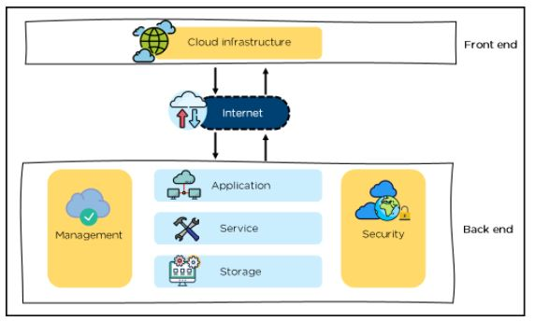

Cloud Computing Architecture

Front-End

* It provides applications and the interfaces that are required for the cloud-based service.
* It consists of client’s side applications, which are web browsers such as Google Chrome and Internet Explorer.
* Cloud infrastructure is the only component of the front-end. Let's understand it in detail.

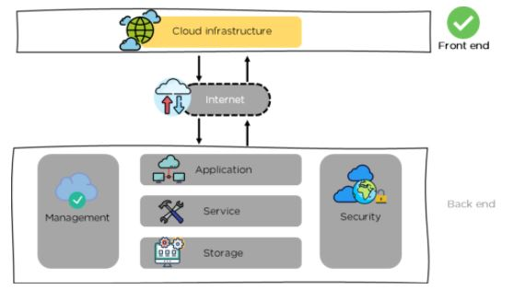

Front-end - Cloud Computing Architecture

* Cloud infrastructure consists of hardware and software components such as data storage, server, virtualization software, etc.
* It also provides a Graphical User Interface to the end-users to perform respective tasks.

Moving ahead, let’s understand what the back-end is.

Back-End

It is responsible for monitoring all the programs that run the application on the front-end

It has a large number of data storage systems and servers. The back-end is an important and huge part of the whole cloud computing architecture, as shown below:

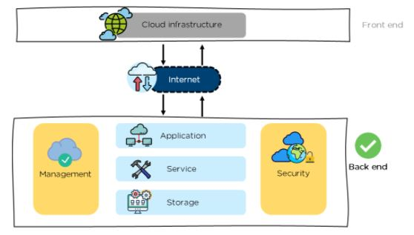

Back-end - Cloud Computing Architecture

The components of the back-end cloud architecture are mentioned below. Let's understand them in detail one by one.

Application

* It can either be a software or a platform
* Depending upon the client requirement, the application provides the result to the end-user (with resources) in the back end

Service

* Service is an essential component in cloud architecture
* Its responsibility is to provide utility in the architecture
* In a Cloud, few widely used services among the end-users are storage application development environments and web services

.

Storage

* It stores and maintains data like files, videos, documents, etc. over the internet
* Some of the popular examples of storage services are below:
  + [Amazon S3](https://www.simplilearn.com/tutorials/aws-tutorial/aws-s3)
  + Oracle Cloud-Storage
  + Microsoft Azure Storage
* Its capacity varies depending upon the service providers available in the market

Management

* Its task is to allot specific resources to a specific task, it simultaneously performs various functions of the cloud environment
* It helps in the management of components like application, task, service, security, data storage, and cloud infrastructure
* In simple terms, it establishes coordination among the cloud resources

Security

* Security is an integral part of back-end cloud infrastructure
* It provides secure cloud resources, systems, files, and infrastructure to end-users
* Also, it implements security management to the cloud server with virtual firewalls which results in preventing data loss

Now, that we know the architecture of cloud computing, let’s move on and learn about the benefits of the architecture.

Benefits of Cloud Computing Architecture

The cloud computing architecture is designed in such a way that:

* It solves latency issues and improves data processing requirements
* It reduces IT operating costs and gives good accessibility to access data and digital tools
* It helps businesses to easily scale up and scale down their cloud resources
* It has a flexibility feature which gives businesses a competitive advantage
* It results in better disaster recovery and  provides high security
* It automatically updates its services
* It encourages remote working and promotes team collaboration

Going ahead, let’s have a look at the components of cloud computing architecture.

Cloud Computing Architecture Components

Some of the important components of Cloud Computing architecture that we will be looking into are as follows:

* Hypervisor
* Management Software
* Deployment Software
* Network
* Cloud Server
* Cloud Storage

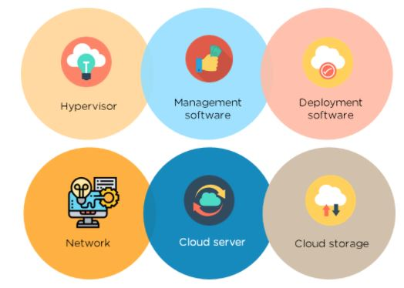

Components of Cloud architecture

Hypervisor

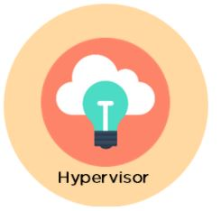

* It is a virtual machine monitor which provides Virtual Operating Platforms to every user
* It also manages guest operating systems in the cloud
* It runs a separate virtual machine on the back end which consists of software and hardware
* Its main objective is to divide and allocate resources

Management Software



* Its responsibility is to manage and monitor cloud operations with various strategies to increase the performance of the cloud
* Some of the operations performed by the management software are:

***compliance auditing*** :

Compliance audit is **an assessment as to whether the provisions of the applicable laws, rules and regulations made there under and various orders and instructions issued by the competent authority are being complied with**.

**a compliance audit could be issued to determine a textile mill is following the EPA (or Environmental Protection Act) guidelines for disposing waste**. The EPA could send someone from their business, or they could hire a third party to assess the mill and send in the results.

* + **management of overseeing disaster:**It also involves a systematic approach to managing the responsibilities of disaster prevention, preparedness, response, and recovery.
  + **E.g an organization's method of regaining access and functionality to its IT infrastructure after events like a natural disaster, cyber attack**
  + ***contingency plans:***

A contingency plan is a plan for a “what if” scenario that could ruin your project or business.

* + A simple example of a contingency plan is to **back up all website data in case your site gets hacked**. If this scenario happens, you can then restore the data after regaining access and changing passwords. If you're not prepared, you might have to recreate your entire website from memory
  + Deployment Software

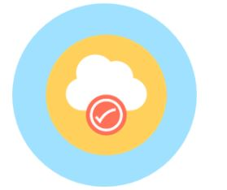

* It consists of all the mandatory installations and configurations required to run a cloud service
* Every deployment of cloud services are performed using a deployment software
* The three different models which can be deployed are the following:



* [SaaS](https://www.simplilearn.com/what-is-saas-article) - Software as a service hosts and manages applications of the end-user.

Example: Gmail



Image_Name: PaaS

* [PaaS](https://www.simplilearn.com/what-is-paas-article) - Platform as a service helps developers to build, create, and manage applications.

Example: [Microsoft Azure](http://www.simplilearn.com/tutorials/cloud-computing-tutorial/aws-vs-azure)



* [IaaS](https://www.simplilearn.com/saas-paas-iaas-quick-comparison-article) - Infrastructure as a service provides services on a pay-as-you-go pricing model.

Network



* It connects the front-end and back-end. Also, allows every user to access cloud resources
* It helps users to connect and customize the route and protocol
* It is a virtual server which is hosted on the cloud computing platform
* It is highly flexible, secure, and cost-effective

Cloud Storage

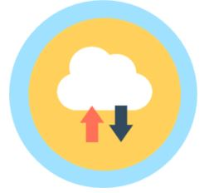

* Here, every bit of data is stored and accessed by a user from anywhere over the internet
* It is scalable at run-time and is automatically accessed
* Data can be modified and retrieved from cloud storage over the web