OBJECT ORIENTED ANALYSIS AND DESIGN
Course Code : SWE2018 Slot : L9+L10
Lab Assignment - 3
Name : S.Deepan
Reg No : 19MIS0102

Scenario :
ABC Engineering college has decided to provide online quiz system to its student in various streams. The system will comprise of a database containing questions and answers on various subjects under various streams. The student will be able to login to the system through various desktop PCs available in the campus. The student will be able to take up a quiz view his/her performance over a period of time. The student will be able to take a break from a quiz only once for a maximum of 15 minutes. The quiz will comprise of only multiple choice questions. The duration of the quiz will be 1 hour and the student will be asked 50 questions. The system shall provide immediate feedback to the student whether he/she has passed or failed in the attempt based on the criteria after answering all questions.
The individual lecturers will be responsible for generating the questions and answers for the question bank. The lecturers shall enter the moderated questions and answers in the question bank. The lecturers shall also manage their student’s details in the system as part of which necessary login and password shall be created. The lecturers can view the performance history of their students and provide feedback to the student in the system.
At the end of the semester the lecturers shall print a consolidated performance history of each student and provide it to their student with their comments.

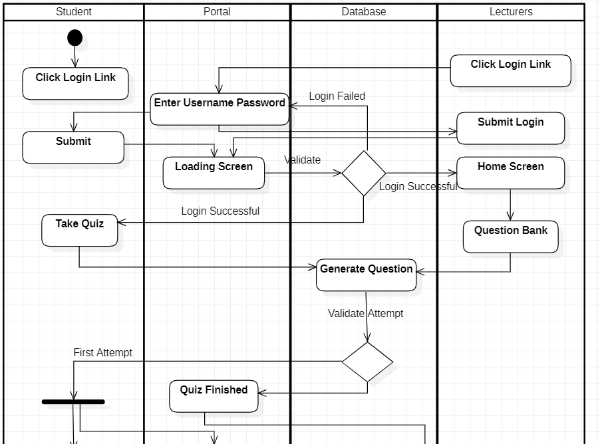
Activity diagram for scenario 1 :
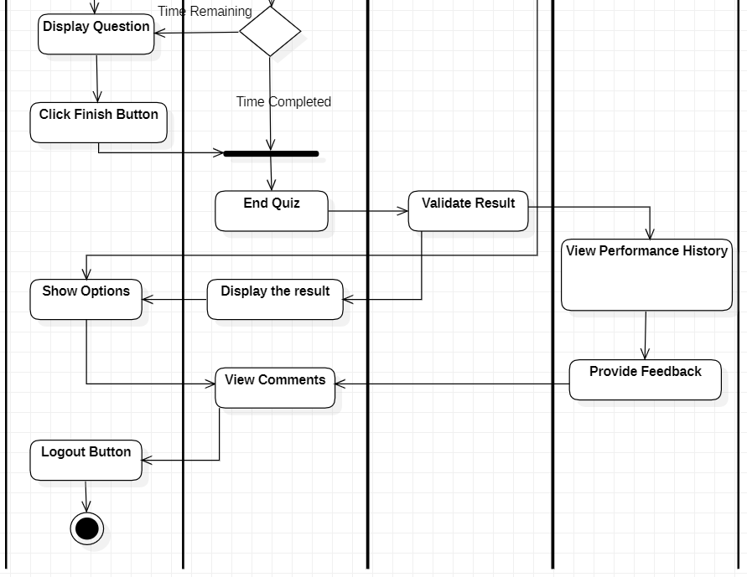
19MIS0102

Component Diagram for scenario 1 :

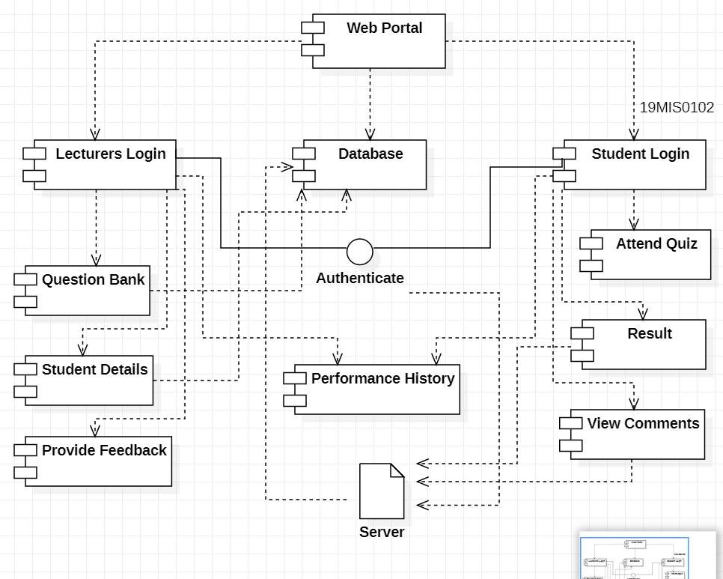

Deployment Diagram for scenario 1 :

