Customer Engagement & Product Utilization Analytics for Retention Strategy

RESEARCH PAPER

Submitted By
S.Deepanjali
.
ABSTRACT
The banking sector increasingly depends on customer engagement and product utilization analytics to improve customer retention and reduce churn risk. Traditional retention approaches mainly focus on demographic and financial indicators, while behavioral engagement patterns and relationship strength provide deeper insights into customer loyalty. This project focuses on analyzing customer churn behavior using customer engagement, banking product utilization, and financial activity data.
The project utilizes a banking customer dataset containing attributes such as credit score, geography, gender, age, account balance, number of products, credit card ownership, active membership status, estimated salary, and churn indicators. Data analysis and visualization techniques were implemented using Python libraries including Pandas, Plotly, and Streamlit.
Exploratory Data Analysis (EDA) was performed to identify relationships between customer activity, product usage, and churn behavior. Customer engagement profiles were created to classify customers into different behavioral segments such as highly engaged customers, low product users, and high-value disengaged customers. Interactive dashboards and KPI panels were developed to monitor churn trends, customer engagement levels, and high-risk customer segments.
The analysis revealed that inactive customers and customers with fewer banking products have significantly higher churn probabilities. High-balance inactive customers were identified as critical retention risks. The project proposes engagement-driven retention strategies, product bundling approaches, and proactive monitoring systems to improve customer loyalty and reduce churn.
This research demonstrates how behavioral analytics and customer relationship analysis can support data-driven retention strategies in the banking sector.

1. INTRODUCTION
Customer retention has become one of the most important challenges in the modern banking industry. With increasing competition among financial institutions, retaining existing customers is often more cost-effective than acquiring new customers. Customer churn, which refers to customers leaving a bank or discontinuing banking services, directly impacts profitability, customer trust, and long-term business growth.
Traditional customer retention strategies mainly focus on demographic and financial indicators such as income, balance, and credit score. However, these indicators alone are insufficient to fully understand customer loyalty and retention behavior. In recent years, customer engagement and product utilization analytics have gained importance in identifying customer relationship strength and predicting churn risk.
Customer engagement refers to how actively customers interact with banking services and products. Similarly, product utilization measures the depth of the customer’s relationship with the bank through the number of products and services used. Customers with higher engagement levels and multiple banking products generally demonstrate stronger loyalty and lower churn probability.
This project focuses on analyzing customer churn behavior using engagement-driven analytics and product utilization patterns. The study uses banking customer data to identify behavioral trends associated with customer retention and churn. Important factors such as customer activity status, account balance, number of products, credit score, and estimated salary are analyzed to evaluate their relationship with churn behavior.
Exploratory Data Analysis (EDA), interactive visualizations, and customer segmentation techniques are implemented using Python-based analytics tools including Pandas, Plotly, and Streamlit. The project also includes the development of an interactive dashboard for monitoring customer engagement, churn patterns, product utilization, and high-risk customer segments.
The primary objective of this project is to provide actionable business insights that help banks design more effective retention strategies, improve customer loyalty, and proactively identify customers at high risk of churn. The project demonstrates how behavioral analytics and relationship-strength analysis can support data-driven decision-making in the banking sector.

2. PROBLEM STATEMENT
Banks collect large volumes of customer data related to financial transactions, account balances, product usage, and customer demographics. However, many financial institutions still struggle to accurately identify the behavioral factors that influence customer retention and churn. Traditional retention strategies often focus mainly on financial indicators such as balance and salary, while customer engagement and relationship strength are frequently overlooked.
Customers with high account balances or strong financial backgrounds may still discontinue banking services due to low engagement, limited product adoption, or weak interaction with the bank. Similarly, customers using only a single banking product are more likely to switch to competitors offering better service combinations and personalized engagement strategies.
Another major challenge faced by banks is the inability to identify high-value customers who are silently becoming disengaged. These customers may appear financially stable but demonstrate low activity levels and weak product utilization, increasing their churn risk. Without proper engagement analytics and retention monitoring systems, banks may lose valuable customers without early warning signs.
In addition, many existing retention systems lack interactive analytical tools that can dynamically monitor customer engagement, product utilization patterns, and churn behavior. This limits the ability of decision-makers to design targeted retention campaigns and personalized customer relationship strategies.
Therefore, there is a need for a data-driven analytical system that evaluates customer retention from a behavioral and engagement perspective rather than relying only on demographic or financial attributes. This project aims to address these challenges by analyzing customer engagement, product utilization, and relationship strength using interactive analytics and visualization techniques to support effective retention strategy design in the banking sector.

3. OBJECTIVES
The main objective of this project is to analyze customer engagement and product utilization patterns to understand their impact on customer retention and churn behavior in the banking sector. The project focuses on identifying behavioral factors that influence customer loyalty and relationship strength using data-driven analytics and interactive visualization techniques.

Primary Objectives
- To evaluate the relationship between customer engagement and churn behavior.
- To analyze the impact of product utilization and number of banking products on customer retention.
- To identify disengaged yet high-value customers who are at risk of churn.
- To measure customer relationship strength using behavioral and engagement indicators.
- To develop an interactive dashboard for customer retention analytics and monitoring.

Secondary Objectives
- To support engagement-driven retention strategies in the banking sector.
- To improve product bundling and cross-selling decisions using customer behavior insights.
- To identify high-risk customer segments through engagement profiling.
- To visualize churn trends and customer engagement patterns using interactive graphs and KPI dashboards.
- To provide actionable business recommendations for improving customer loyalty and reducing churn risk.

4. DATASET DESCRIPTION
The dataset used in this project contains banking customer information related to customer demographics, financial status, engagement behavior, and churn indicators. The dataset is designed to support customer retention analysis by identifying factors influencing customer churn and relationship strength. The data includes customer account details, product utilization information, activity status, and estimated financial characteristics.
The dataset consists of 10,000 customer records and multiple attributes used for engagement analysis, churn prediction, and retention strategy evaluation. The target variable in the dataset is the “Exited” column, which indicates whether a customer has churned or remained with the bank.

Column Name | Description
Year | Year of customer record
CustomerId | Unique customer identifier
Surname | Customer surname
CreditScore | Customer creditworthiness score
Geography | Customer location (France, Spain, Germany)
Gender | Male or Female
Age | Customer age
Tenure | Number of years with the bank
Balance | Customer account balance
NumOfProducts | Number of banking products used
HasCrCard | Credit card ownership status
IsActiveMember | Customer activity status
EstimatedSalary | Estimated annual salary
Exited | Churn indicator (Target Variable)

Target Variable Description
The “Exited” column represents customer churn behavior and acts as the target variable in the analysis. The variable contains binary values:
- 0 → Customer retained by the bank
- 1 → Customer exited or churned from the bank
This target variable is used to analyze customer retention patterns and evaluate the relationship between engagement, product utilization, and churn risk.

5. METHODOLOGY
The methodology of this project focuses on analyzing customer engagement and product utilization patterns to understand customer retention behavior in the banking sector. The project was implemented using Python-based data analytics and visualization tools. The overall methodology consists of multiple stages including data collection, preprocessing, exploratory data analysis, engagement profiling, KPI analysis, dashboard development, and business insight generation.

5.1 Data Collection
The dataset used in this project contains banking customer information related to demographics, financial behavior, product utilization, and customer churn indicators. The dataset includes 10,000 customer records with attributes such as credit score, geography, gender, age, balance, number of products, activity status, estimated salary, and churn status.

5.2 Data Preprocessing
Data preprocessing was performed to prepare the dataset for analysis and visualization. Irrelevant columns such as customer identifiers and surnames were excluded from analytical processing. Data quality was verified by checking missing values, data types, and attribute consistency.
The following preprocessing activities were performed:
- Removal of unnecessary attributes for analysis
- Verification of missing values
- Data type inspection and validation
- Feature selection for retention analysis
- Creation of engagement-based customer segments

5.3 Exploratory Data Analysis (EDA)
Exploratory Data Analysis techniques were used to identify patterns and relationships between customer engagement and churn behavior. Various visualizations were created to analyze customer retention trends based on activity status, product utilization, account balance, geography, and engagement behavior.
The following analyses were performed:
- Churn distribution analysis
- Customer engagement analysis
- Product utilization analysis
- Geography-wise churn analysis
- Balance and churn relationship analysis
- Customer engagement profiling

5.4 Customer Engagement Profiling
A behavioral segmentation approach was implemented to classify customers into different engagement categories based on activity status, account balance, and product utilization patterns.
The engagement profiles created in the project include:
- Highly Engaged Customers
- High Value Disengaged Customers
- Low Product Users
- Moderate Customers
This profiling helps identify customers with strong loyalty as well as customers at high risk of churn.

5.5 Dashboard Development
An interactive analytics dashboard was developed using Streamlit and Plotly to visualize customer retention metrics and churn behavior dynamically. The dashboard includes KPI cards, interactive filters, and multiple analytical charts for customer engagement analysis.
The dashboard features include:
- Customer churn monitoring
- Product utilization analytics
- Geography-based customer analysis
- Engagement profile visualization
- High-risk customer detection
- Interactive filtering and KPI metrics

5.6 Tools and Technologies Used
The following tools and technologies were used in the project:
Tool / Technology | Purpose
Python | Data analysis and dashboard development
Pandas | Data preprocessing and analysis
Plotly | Interactive data visualization
Streamlit | Dashboard development
Jupyter Notebook | Jupyter Notebook
VS Code | Project development environment

5.7 Business Insight Generation
Based on analytical findings and engagement profiling, business recommendations were generated to improve customer retention strategies. The project focuses on identifying disengaged customers, improving product adoption, and supporting proactive customer engagement initiatives.

6. EXPLORATORY DATA ANALYSIS (EDA)
Exploratory Data Analysis (EDA) was performed to understand customer behavior patterns, engagement levels, product utilization trends, and customer churn characteristics. Interactive visualizations were created using Plotly to analyze relationships between customer activity, product adoption, geography, account balance, and churn behavior.
The EDA process helped identify high-risk customer segments, behavioral trends, and retention-related insights that support engagement-driven customer retention strategies.

6.1 Customer Churn Distribution

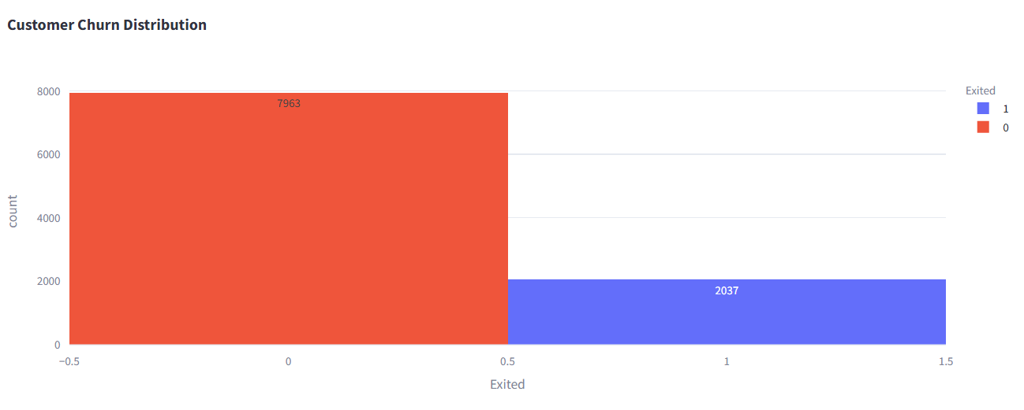

Explanation
The customer churn distribution graph represents the number of customers who remained with the bank and customers who exited the bank.
- Value “0” represents retained customers.
- Value “1” represents churned customers.
The analysis shows that a larger percentage of customers were retained, while a smaller portion exited the bank. However, the churned customer segment is still significant and requires focused retention strategies.
This analysis helps banks understand the overall churn rate and evaluate customer retention performance.

6.2 Customer Engagement vs Churn

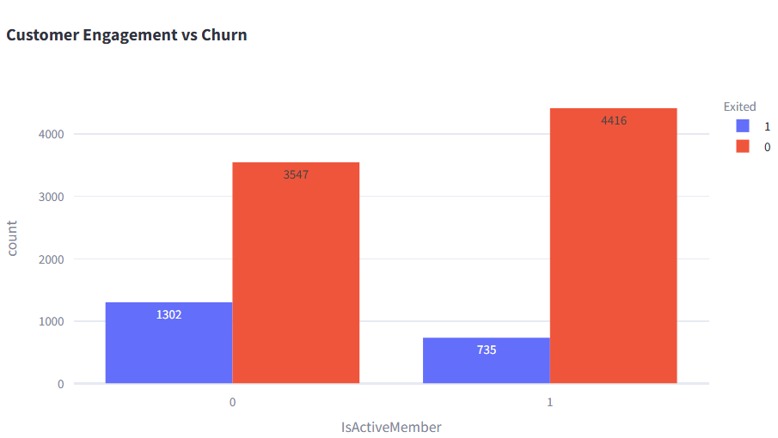

Explanation
This graph analyzes the relationship between customer activity status and churn behavior.
- Active members are represented by value “1”.
- Inactive members are represented by value “0”.
The analysis reveals that inactive customers have a higher churn rate compared to active customers. Customers who actively engage with banking services demonstrate stronger retention behavior and lower churn probability.
This indicates that customer engagement plays a major role in customer loyalty and retention.

6.3 Product Utilization vs Churn
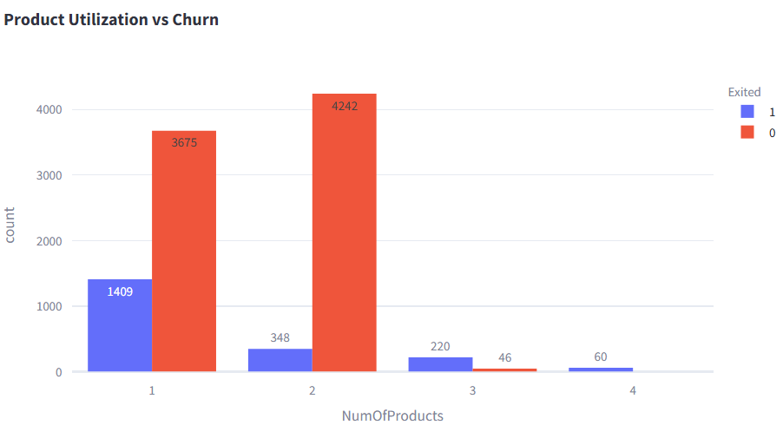

Explanation
This graph evaluates how the number of banking products used by customers affects churn behavior.
The analysis shows that customers using fewer banking products are more likely to churn, while customers with multiple products demonstrate higher retention levels.
This indicates that product utilization strengthens customer relationships and improves long-term loyalty.

6.4 Geography-wise Churn Analysis
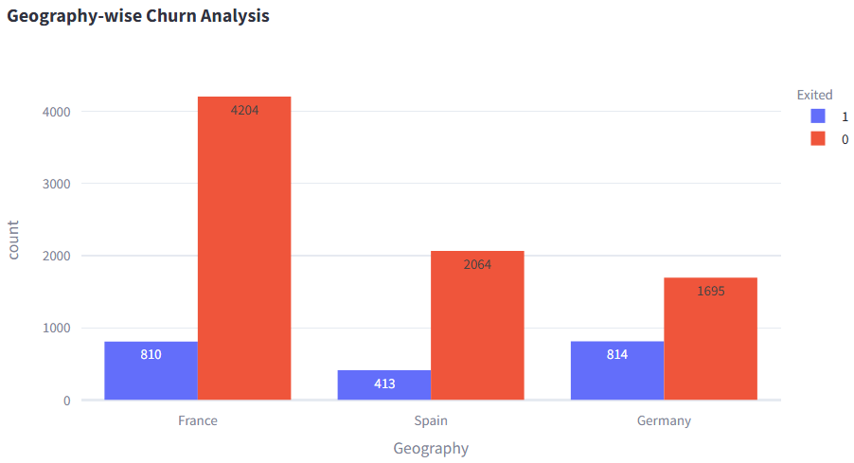

Explanation
This graph analyzes customer churn behavior across different geographic regions including France, Germany, and Spain.
The analysis shows that churn behavior varies across countries, indicating that regional customer behavior and banking engagement levels influence retention patterns.
This insight helps banks design region-specific customer retention strategies.

6.5 Balance vs Customer Churn
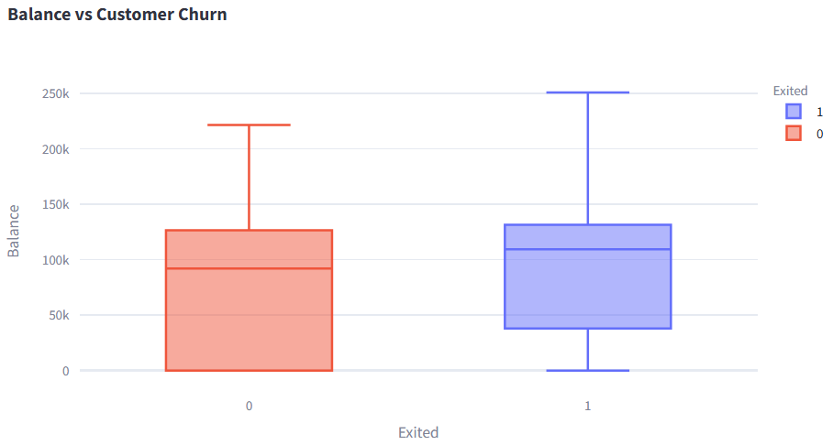

Explanation
This graph analyzes the relationship between customer account balance and churn behavior.
The analysis identifies that some customers with high account balances still exited the bank. This indicates that financial strength alone does not guarantee customer loyalty.
High-balance inactive customers were identified as an important high-risk segment requiring proactive engagement strategies.

6.6 Customer Engagement Profiles
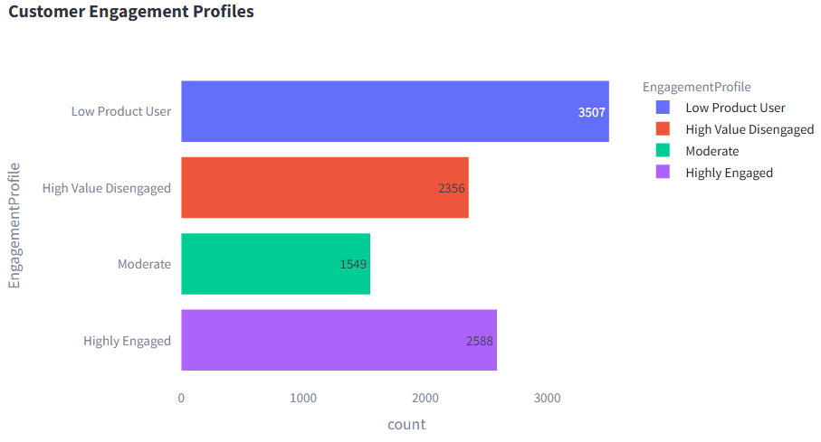

Explanation
This graph represents customer segmentation based on engagement behavior and product utilization patterns.
Customers were categorized into different profiles including:
- Highly Engaged Customers
- High Value Disengaged Customers
- Low Product Users
- Moderate Customers
The analysis helps identify loyal customers as well as high-risk disengaged customers who require targeted retention strategies.
Customer engagement profiling improves behavioral understanding and supports personalized customer relationship management.
7. DASHBOARD IMPLEMENTATION
An interactive customer retention analytics dashboard was developed using Streamlit and Plotly to visualize customer engagement, product utilization, and churn behavior dynamically. The dashboard provides real-time analytical insights through interactive charts, KPI cards, customer segmentation analysis, and filtering mechanisms.
The dashboard was designed to help users monitor customer retention trends, identify high-risk customer groups, and analyze engagement behavior efficiently through interactive visualizations.

7.1 Dashboard Features
The dashboard includes several analytical and visualization features to support customer retention analysis.

KPI Metrics
The dashboard displays important Key Performance Indicators (KPIs) including:
- Total Customers
- Churn Rate
- Active Customers
- High-Risk Customers
These KPI cards provide a quick overview of customer retention performance and engagement levels.

Interactive Filters
Interactive filtering options were implemented to improve analytical flexibility and user interaction. The filters allow users to dynamically analyze customer data based on:
- Geography
- Number of Products
- Account Balance Range
These filters help users perform customized analysis and identify customer trends more effectively.

Interactive Visualizations
Multiple interactive charts were developed using Plotly to analyze customer churn and engagement patterns. The dashboard visualizations include:
- Customer Churn Distribution
- Customer Engagement vs Churn
- Product Utilization Analysis
- Geography-wise Churn Analysis
- Balance vs Churn Analysis
- Customer Engagement Profiles
The interactive graphs allow users to zoom, hover, filter, and analyze customer behavior dynamically.

7.2 High-Risk Customer Detection
A high-risk customer detection mechanism was implemented to identify customers with:
- Low engagement levels
- High account balances
- Weak product utilization
- Inactive membership status
This feature helps banks proactively identify customers who may churn in the future and supports targeted retention strategies.

7.3 Dashboard Technologies
The dashboard was implemented using the following technologies:
Technology | Purpose
Streamlit | Interactive dashboard development
Plotly | Interactive data visualization
Pandas | Data processing and analytics
Python | Backend analytical implementation

7.4 Dashboard Benefits
The dashboard provides several business and analytical benefits including:
- Real-time customer retention monitoring
- Improved customer engagement analysis
- Early identification of churn risks
- Better product utilization insights
- Interactive business decision support
- Dynamic customer segmentation analysis
The interactive dashboard improves analytical efficiency and supports data-driven customer retention strategies in the banking sector.

8. RESULTS AND FINDINGS
The analysis of customer engagement and product utilization patterns provided several important insights related to customer retention and churn behavior in the banking sector. Exploratory Data Analysis (EDA), engagement profiling, and dashboard analytics helped identify high-risk customer segments and important behavioral trends affecting customer loyalty.

8.1 Customer Churn Findings
The churn analysis revealed that a significant percentage of customers exited the bank, indicating the importance of effective customer retention strategies. Although the majority of customers remained with the bank, the churned customer segment represented a critical business concern requiring proactive engagement initiatives.

8.2 Customer Engagement Insights
The analysis showed a strong relationship between customer activity status and retention behavior. Active customers demonstrated lower churn probability, while inactive customers were more likely to leave the bank.
This finding indicates that customer engagement plays a major role in maintaining customer loyalty and strengthening long-term customer relationships.

8.3 Product Utilization Findings
The analysis identified that customers using multiple banking products were more likely to remain with the bank. Customers with only a single banking product demonstrated higher churn tendencies.
This suggests that product diversification and cross-selling strategies can improve customer retention and relationship strength.

8.4 High-Risk Customer Identification
One of the major findings of the project was the identification of high-value disengaged customers. Several customers with high account balances were inactive and demonstrated increased churn risk.
This indicates that financial strength alone does not guarantee customer loyalty. Banks must focus on behavioral engagement and relationship management in addition to financial indicators.

8.5 Geography-Based Findings
Customer churn behavior varied across geographic regions such as France, Germany, and Spain. This indicates that regional customer behavior and banking engagement patterns influence retention performance.
Geography-based insights can support region-specific customer engagement and retention strategies.

8.6 Dashboard Findings
The interactive dashboard successfully visualized customer churn trends, engagement patterns, product utilization behavior, and high-risk customer segments. The dashboard improved analytical understanding through interactive filtering, KPI monitoring, and dynamic visualizations.
The dashboard provides an efficient platform for monitoring customer retention performance and supporting data-driven business decisions.

8.7 Overall Findings
The overall analysis demonstrates that customer engagement, activity level, and product utilization significantly influence customer retention behavior. Customers with strong engagement and multiple product relationships showed higher loyalty, while disengaged customers with limited product usage demonstrated higher churn risk.
The project successfully identified important customer retention indicators and provided actionable insights for improving customer loyalty and reducing churn in the banking sector.

9. RECOMMENDATIONS
Based on the analysis of customer engagement, product utilization, and churn behavior, several recommendations are proposed to improve customer retention and strengthen customer relationships in the banking sector.

9.1 Improve Customer Engagement Programs
The analysis revealed that inactive customers demonstrate significantly higher churn risk. Banks should implement customer engagement initiatives such as personalized communication, mobile banking promotions, reward programs, and regular customer interaction campaigns to improve customer activity levels.

9.2 Encourage Multi-Product Adoption
Customers using multiple banking products showed stronger retention behavior compared to single-product users. Banks should promote product bundling and cross-selling strategies by offering combined services such as savings accounts, credit cards, loans, insurance, and digital banking solutions.
Increasing product utilization can strengthen customer relationships and reduce churn probability.

9.3 Monitor High-Value Disengaged Customers
The project identified high-balance inactive customers as an important high-risk segment. Banks should proactively monitor these customers through engagement tracking systems and provide personalized retention strategies including premium services, loyalty rewards, and relationship management support.

9.4 Implement Predictive Retention Systems
Banks should adopt predictive analytics and behavioral monitoring systems to identify potential churn risks at an early stage. Real-time dashboards and engagement analytics can help organizations take proactive actions before customers leave the bank.

9.5 Enhance Customer Relationship Management
Improving customer relationship management strategies can increase customer satisfaction and loyalty. Banks should focus on personalized banking experiences, faster customer support, and targeted engagement campaigns based on customer behavior and product usage patterns.

9.6 Region-Specific Retention Strategies
Since churn behavior differs across geographic regions, banks should design region-specific engagement strategies based on customer behavior patterns, cultural preferences, and regional banking trends.

9.7 Strengthen Digital Banking Engagement
Digital banking services should be enhanced to improve customer convenience and interaction. Mobile banking applications, digital payment systems, and personalized digital notifications can improve customer engagement and retention performance.

9.8 Continuous Retention Monitoring
Banks should continuously monitor customer engagement metrics, product utilization trends, and churn indicators through interactive analytical dashboards. Regular monitoring can improve decision-making and support long-term customer retention strategies.
The implementation of these recommendations can help banks improve customer loyalty, strengthen customer relationships, reduce churn risk, and enhance overall business performance.

10. CONCLUSION
This project focused on analyzing customer engagement and product utilization patterns to understand their impact on customer retention and churn behavior in the banking sector. The study demonstrated that customer engagement, activity levels, and product utilization are important indicators of customer loyalty and relationship strength.
Using Exploratory Data Analysis (EDA), customer segmentation, and interactive visualizations, the project successfully identified behavioral patterns associated with customer churn. The analysis revealed that inactive customers and customers using fewer banking products have a higher probability of churn. Additionally, high-balance inactive customers were identified as an important high-risk segment requiring proactive retention strategies.
An interactive analytics dashboard was developed using Streamlit and Plotly to visualize customer churn behavior, engagement trends, product utilization patterns, and high-risk customer segments dynamically. The dashboard provides real-time analytical insights through KPI monitoring, interactive filtering, and engagement profiling features.
The project also demonstrated the importance of behavioral analytics in designing customer retention strategies. The findings suggest that customer loyalty is influenced not only by financial strength but also by engagement behavior and relationship depth with the bank.
Based on the analytical findings, several recommendations were proposed including improving customer engagement programs, encouraging multi-product adoption, implementing proactive retention monitoring systems, and enhancing digital banking interaction.
Overall, the project successfully achieved its objectives by providing data-driven insights into customer retention behavior and supporting engagement-based retention strategy development in the banking sector.

Future Scope
The project can be further enhanced by integrating machine learning models for customer churn prediction and real-time retention monitoring systems. Advanced predictive analytics, AI-driven customer segmentation, and automated engagement recommendation systems can further improve customer retention performance and business decision-making.

11. REFERENCES
- Python Software Foundation. Python Programming Language. Available at: https://www.python.org/
- Pandas Documentation. Python Data Analysis Library. Available at: https://pandas.pydata.org/
- Plotly Documentation. Interactive Data Visualization Library. Available at: https://plotly.com/python/
- Streamlit Documentation. Interactive Dashboard Development Framework. Available at: https://streamlit.io/
- Scikit-learn Documentation. Machine Learning Library for Python. Available at: https://scikit-learn.org/
- Jupyter Notebook Documentation. Interactive Computing Environment. Available at: https://jupyter.org/
- Banking Customer Churn Dataset used for educational and analytical purposes.
- Customer Retention and Engagement Analytics concepts referred from banking analytics and data science study materials.

