Department of Computer Science & Engineering

**Minor Project Synopsis (DECEMBER-MAY 2017)**

**Group Number: 26**

|  |  |  |
| --- | --- | --- |
| **S No.** | **Class Roll No.** | **Name** |
| 1 | 55 | Deepanjan Kowar |

**Project Title: Online Payroll System**

**Problem Statement:** The purpose of developing this software project is to fully automate salary system for an organization i.e. Bhilai Institute of Technology, Durg. This software is capable of calculating monthly salaries and tax of employees of that organization. On the basis of certain formulas it will generate files as an output such as salary slips.

**Type of Project:** Network Based Application

**Software Requirements:**

# Operating System - Any

* Browser - Any (Google Chrome Recommended)
* Front End - PHP, HTML, CSS
* Back End - MySQL

**Hardware Requirements:**

# Memory minimum of 512MB RAM (1 GB Recommended)

* Hard disk of 40 GB
* Printer

**Proposed Methodology:**

The most suitable and appropriate software development methodology I found for the software development is waterfall software development model, which gives a clear view about the software to achieve the goal.

As in this model all the phases are in a sequence and are dependent with one another, therefore a phase cannot be started until the previous phase is completed and fully documented. This approach is most appropriate for our project, because all the requirements and goals of our project are very clear.

Secondly, it is easy to do work in components and waterfall model is providing this approach. After the completion of all the phases individually, they are integrated together. This model is very economical and risk free due to its sequential approach.

**Solution Strategy:**

I applied 3-tier architecture in the development of our web application due to reliability, re-usability, flexibility and security. Making change in one layer has no efficient on other layers, so, less work is required for maintenance and error correction.

*User Interface :* It is easy to use and easy to understand user interface. User interacts with the web server through interface and performs different tasks like employee registration or salary calculation etc. Web browser is required to run the user interface.

*Web Server :* In this project apache is used as web server. Web server is used for secure communication between user interface and database server. Web server receives the request from client and sends them to the database. Similarly, it takes data from the database against the client’s request and forwards it to the client.

*Database Server :* MySql server is used in this project to handle database operations. The client does not directly interact with database; rather it goes through web server in order to keep the database secure from an unauthorized access. It is also called a third tier in the three-tier architecture as implemented in this project.

**ER Diagram:**

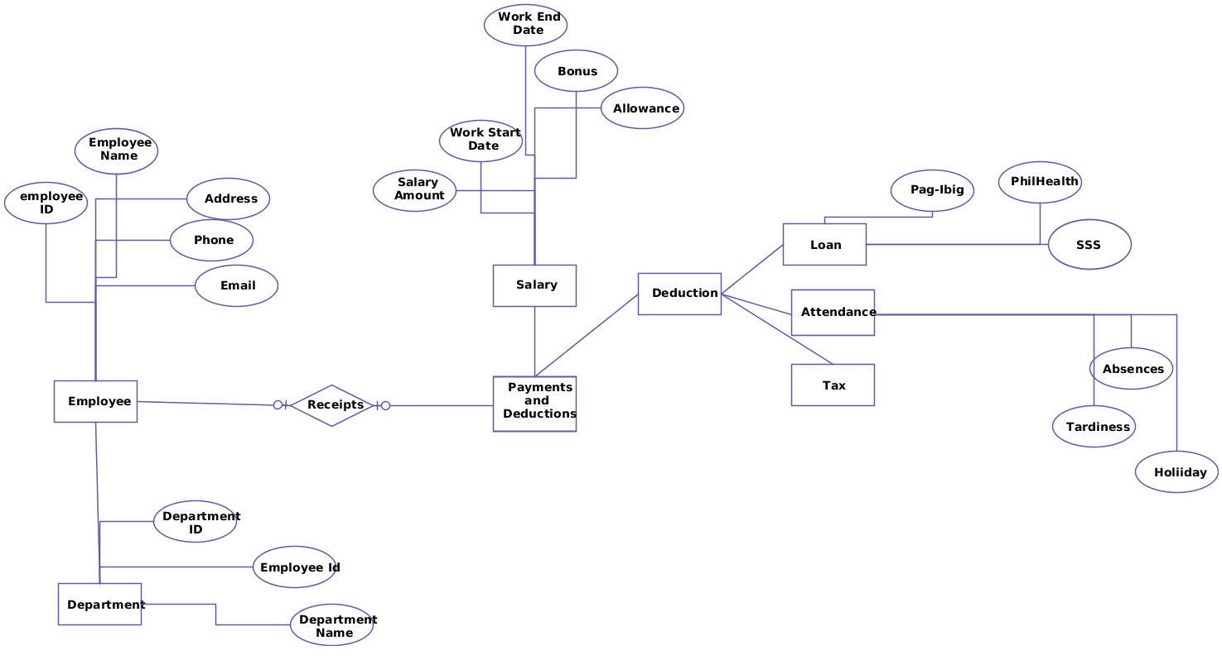

**Student (Signature with Date) Project Guide (Signature with Date)**