CONCEPT 01
The Merge Operation, vLLM, PagedAttention,
and Measuring Baseline Performance
From Adapter to Deployed Model — Everything That Happens Between Activity 0 and Activity 1

PART 1: WHAT 'MERGING' ACTUALLY MEANS

At the end of Activity 0, you have two separate things on disk:

meta-llama/Llama-3.1-8B-Instruct (base model, ~16GB in FP16, on HuggingFace)
cybersec_analyst_lora/
adapter_config.json (~2KB — describes the LoRA config)
adapter_model.safetensors (~150MB — just the A and B matrices)

The adapter is TINY compared to the base model. It contains only the learned deltas for the layers you targeted (q_proj, k_proj, v_proj, o_proj, gate_proj, up_proj, down_proj across 32 transformer blocks).

The Merge Equation
Recall from Concept 02: at inference time, LoRA adds the adapter delta to the base weights:

output = W × input + (alpha/r) × (B × A) × input
= [W + (alpha/r) × (B × A)] × input

The term (alpha/r) × (B × A) is computed at every forward pass when running with a separate adapter. Merging bakes this into W permanently:

Before merge: W_base (frozen), A, B (adapter)
After merge: W_merged = W_base + (alpha/r) × (B × A)

This is a one-time matrix addition per targeted layer. After merging, A and B matrices are discarded. The result is a single, self-contained model that behaves exactly like the adapter-equipped model — but with zero runtime overhead from LoRA computation.

Why Merge for Inference?
Two reasons:
- Serving simplicity: vLLM, TGI, and other inference engines work best with standard HuggingFace model checkpoints. Loading a base model + adapter dynamically adds complexity.
- Inference speed: The adapter delta computation ((alpha/r) × B × A × input) adds FLOPs at every forward pass, every layer, every token. After merging, this overhead is zero — the fused weight matrix is used directly.

The downside: once merged, you lose the ability to swap adapters dynamically (vLLM's --enable-lora mode keeps them separate for multi-adapter serving). For our purposes — one adapter, one deployment — merging is the right call.

The Merge Code (What Activity 1 Does)
from peft import PeftModel
from transformers import AutoModelForCausalLM, AutoTokenizer
import torch

# Step 1: Load base model in FP16
base_model = AutoModelForCausalLM.from_pretrained(
"meta-llama/Llama-3.1-8B-Instruct",
torch_dtype=torch.float16,
device_map="cpu" # merge on CPU — no GPU memory needed
)

# Step 2: Load adapter on top of base
peft_model = PeftModel.from_pretrained(base_model, "./outputs/cybersec_analyst_lora")

# Step 3: Merge and unload — W_merged = W_base + (alpha/r) × B × A
merged_model = peft_model.merge_and_unload()

# Step 4: Save as a standard HuggingFace checkpoint
# After this, the saved folder is indistinguishable from any Llama checkpoint
merged_model.save_pretrained("./outputs/cybersec_analyst_merged")
tokenizer.save_pretrained("./outputs/cybersec_analyst_merged")

After merge_and_unload(), the saved checkpoint is a plain HuggingFace model. vLLM loads it with zero knowledge that LoRA was involved.

PART 2: WHY FP16 FOR THE BASELINE

Activity 1 deploys the merged model in FP16 (16-bit floating point). This is the unoptimized baseline — we want to measure performance before any inference-time optimization.

The FP16 Memory Math
Llama-3.1-8B merged model in FP16:
8.03 billion parameters × 2 bytes = 16.06 GB VRAM

A10G GPU has 24 GB VRAM.
Remaining for KV cache, activations: ~7.9 GB

This is why we need a GPU with ≥24 GB VRAM for the baseline. The model barely fits, with enough room left for serving a few concurrent requests.

Compare this to the quantized variants (Activity 2):

Precision | VRAM (8B model) | Activity
FP16 (baseline) | ~16 GB | Activity 1 ← we are here
FP8 | ~8 GB | Activity 2
INT8 | ~8 GB | Activity 2
INT4 | ~4 GB | Activity 2

The baseline (FP16) gives us the accuracy ceiling and the performance floor. Activities 2–5 trade memory and sometimes accuracy for speed.

PART 3: HOW vLLM WORKS — THE ENGINE WE'RE DEPLOYING INTO

vLLM is the de facto standard for high-throughput LLM inference. Before we benchmark against it, you need to understand what it does differently from naive HuggingFace model.generate().

The Naive Approach — Why HuggingFace Generation Is Slow in Production
When you call model.generate() in HuggingFace for multiple concurrent requests:
- Each request gets its own full GPU memory allocation
- The KV cache (keys and values for each attention head, each layer) is pre-allocated for the maximum sequence length — even if the actual sequence is much shorter
- Memory is allocated in contiguous blocks — if request A finishes and frees memory, that memory can't be given to request B (fragmentation)
- Batching is static — you batch requests at the start, wait for the longest one to finish, then batch again

This wastes 60–80% of GPU memory on padding and pre-allocation, and kills throughput for concurrent requests.

PagedAttention — The Core vLLM Innovation
PagedAttention (Kwon et al., 2023) solves the KV cache memory problem. The insight comes from virtual memory in operating systems.

The problem with contiguous KV cache allocation:
Request A: 512 tokens → needs 512 × (32 layers × 2 × 128 heads × head_dim) = fixed block
Request B: 1024 tokens → needs 2× as much

If A finishes, its block is 512 tokens of free memory.
B can't use that fragmented space — it needs 1024 contiguous tokens.
Result: memory fragmentation, cannot fully utilize GPU.

PagedAttention's solution: divide KV cache into fixed-size pages (e.g., 16 tokens each). Maintain a page table — just like a CPU's virtual memory system — that maps logical token positions to physical pages.
Logical view (request A, 512 tokens):
[Block 0: tokens 0-15] → [Block 1: tokens 16-31] → ... → [Block 31: tokens 496-511]

Physical memory (interleaved with other requests):
Physical page 4 ← holds tokens 0-15 of request A
Physical page 11 ← holds tokens 0-15 of request B

Freed pages from finished requests CAN be immediately reused for new requests.
No fragmentation. Near-100% memory utilization.

The key operations:
- Append: When a new token is generated, append its KV to the current page. When the page is full, allocate a new page (any free physical page — no contiguity needed)
- Attention computation: The attention kernel is modified to handle non-contiguous KV storage via the page table lookup
- Eviction: When memory is tight, pages can be swapped to CPU RAM (like virtual memory paging) — vLLM supports this but it's slow

Continuous Batching
Traditional batching: batch 8 requests → run until all 8 finish → batch the next 8.

vLLM's continuous batching: as soon as one request in the current batch finishes, immediately insert a waiting request into the batch. The GPU is never idle between requests.
Time → → → → → → → →
Slot 1: [Request A: 45 tokens] [Request E: starts immediately] ...
Slot 2: [Request B: 23 tokens][Request D starts here] ...
Slot 3: [Request C: 67 tokens ......................] [Request F starts] ...

Continuous batching + PagedAttention together explain why vLLM achieves 10–30× higher throughput than naive HuggingFace serving for concurrent requests.

PART 4: THE TWO PERFORMANCE METRICS — TTFT AND THROUGHPUT

These two metrics measure completely different things. Conflating them is the most common mistake in inference engineering.

Metric | Definition | Driver | Primary Use Case
TTFT | Time from request sent to FIRST token received | Prefill compute, queue wait, network RTT | Chatbots, code completion, real-time apps
Throughput | Total output tokens/sec across ALL concurrent requests | Memory bandwidth, batch size, model size | API serving cost, batch processing
VRAM Usage | Peak GPU memory occupied by model + KV cache | Model precision, sequence length, concurrency | Capacity planning, concurrent request limits
Perplexity | exp(avg cross-entropy on test set); lower = better | Model quality, domain alignment | Accuracy regression detection between variants

TTFT — Time To First Token
Definition: The time between sending the request and receiving the FIRST generated token.

What drives TTFT:
- Prefill computation: Before generating any output, the model processes the entire input prompt through all 32 transformer layers. For a 512-token prompt: 512 × 32 × (attention + MLP) operations. Pure compute.
- Queue wait: If other requests are being processed, your request waits in a queue.
- Network RTT: If the server is remote, add round-trip latency.

Why TTFT matters: User-perceived responsiveness. A chatbot that takes 3 seconds to show ANY output feels broken, even if it then streams fast. For real-time applications (voice, code completion), TTFT is THE metric.

Baseline TTFT for Llama-3.1-8B FP16 on A10G:
Short prompt (128 tokens): ~100–200ms
Medium prompt (512 tokens): ~300–500ms
Long prompt (2048 tokens): ~1–2 seconds

What reduces TTFT:
- KV cache prefix sharing (Activity 3): shared system prompts pre-computed once
- Speculative decoding (Activity 4): draft model prefills faster
- Quantization (Activity 2): fewer bytes to move through memory → faster prefill

Throughput — Tokens Per Second
Definition: Total output tokens generated across all requests per second (aggregate, not per-request).

What drives throughput:
- Memory bandwidth: Once the KV cache is built (prefill done), decoding is memory-bound — the bottleneck is loading the 16GB model weights from HBM to compute cores for each token step
- Batch size: Larger batches amortize the weight-loading cost across more tokens simultaneously
- Model size: Larger models → more bytes to move → lower throughput per token

Baseline throughput for Llama-3.1-8B FP16 on A10G:
Single request: ~40–60 tokens/second
Batch of 16 requests: ~400–600 tokens/second total (25–40 per request, but 10× more done)

The TTFT vs Throughput Tradeoff
These metrics pull in opposite directions:
- Larger batches → higher throughput, higher TTFT (requests wait longer to start)
- Smaller batches → lower TTFT, lower throughput
- vLLM's continuous batching finds a good operating point automatically

Never optimize for one metric without reporting the other. An inference system that achieves 5000 tok/s throughput but 10-second TTFT is unusable as a chatbot, even though the throughput number looks impressive.

PART 5: THE ACTIVITY 1 BENCHMARK ARCHITECTURE

Here is exactly what Activity 1 builds and measures:

┌─────────────────────────────────────────────────────────────────────┐
│ ACTIVITY 1 ARCHITECTURE │
├─────────────────────────────────────────────────────────────────────┤
│ │
│ STEP 1: MERGE │
│ merge.py: base_model + LoRA adapter → merged_model (FP16) │
│ Output: ./outputs/cybersec_analyst_merged/ (~16GB) │
│ │
│ STEP 2: SERVE │
│ vllm_server.py launches: │
│ python -m vllm.entrypoints.openai.api_server │
│ --model ./outputs/cybersec_analyst_merged │
│ --dtype float16 │
│ --max-model-len 4096 │
│ --port 8000 │
│ │
│ STEP 3: BENCHMARK │
│ benchmark/client.py sends concurrent requests: │
│ - Concurrency levels: [1, 4, 8, 16, 32] │
│ - Prompt lengths: [128, 256, 512, 1024, 2048] tokens │
│ - Output lengths: [64, 128, 256] tokens │
│ - Measures: TTFT per request, throughput per concurrency level │
│ │
│ STEP 4: EVALUATE ACCURACY │
│ evaluation/perplexity.py: │
│ - Computes perplexity on held-out cybersec test set │
│ - Runs 6 qualitative prompts from Activity 0 eval.py │
│ │
│ STEP 5: REPORT │
│ reporting/report_generator.py: │
│ - Reads benchmark JSON → generates markdown + HTML report │
│ - Saves baseline_results.json │
│ - All later activities compare against these numbers │
│ │
└─────────────────────────────────────────────────────────────────────┘

Why OpenAI-Compatible API?
vLLM exposes an OpenAI-compatible REST API (chat completions endpoint). This means:
- The benchmark client uses the same code as any OpenAI client — trivially portable
- You can test with curl, Python's openai library, or any LLM framework
- Future activities (2–5) use the same API endpoint — only the server config changes

# The benchmark client is just an OpenAI client pointed at localhost
from openai import OpenAI

client = OpenAI(base_url="http://localhost:8000/v1", api_key="not-needed")
response = client.chat.completions.create(
model="./outputs/cybersec_analyst_merged",
messages=[{"role": "user", "content": prompt}],
max_tokens=256,
temperature=0.1,
)

Measuring TTFT with Streaming
To accurately measure TTFT, you need streaming — otherwise the client waits for the full response before getting any timing:
import time

start = time.perf_counter()
stream = client.chat.completions.create(
model=model_name,
messages=messages,
max_tokens=256,
stream=True, # ← enables streaming
)

first_token_time = None
full_response = ""

for chunk in stream:
if first_token_time is None and chunk.choices[0].delta.content:
first_token_time = time.perf_counter() # ← TTFT captured here
ttft = first_token_time - start
full_response += chunk.choices[0].delta.content or ""

end = time.perf_counter()
total_tokens = len(full_response.split())
throughput = total_tokens / (end - first_token_time) # decode phase only

PART 6: WHAT THE BASELINE NUMBERS TELL YOU

After Activity 1, you will have a JSON file that looks like this:
{
"model": "cybersec_analyst_merged_fp16",
"gpu": "A10G 24GB",
"vram_used_gb": 16.8,
"vram_available_for_kv_cache_gb": 7.2,
"results": {
"concurrency_1": {
"ttft_p50_ms": 180,
"ttft_p95_ms": 340,
"throughput_tokens_per_sec": 52
},
"concurrency_8": {
"ttft_p50_ms": 620,
"ttft_p95_ms": 1100,
"throughput_tokens_per_sec": 390
},
"concurrency_16": {
"ttft_p50_ms": 1400,
"ttft_p95_ms": 2600,
"throughput_tokens_per_sec": 520
}
},
"accuracy": {
"perplexity_base_model": 18.4,
"perplexity_merged_model": 9.7,
"perplexity_reduction_pct": 47.3
}
}

This file becomes the baseline that every subsequent activity compares against. Activity 2 → same format, lower VRAM. Activity 4 → same format, lower TTFT. The story is told in the delta.

The GitHub README story: "I took an FP16 baseline and systematically applied each optimization, measuring the real-world impact at each step." The baseline_results.json is proof that you started from real numbers, not hand-waved estimates.

PART 7: THE vLLM STARTUP SEQUENCE — WHAT HAPPENS WHEN YOU LAUNCH THE SERVER

Understanding this prevents confusion when reading server logs:

1. MODEL LOADING (~30–60 seconds)
vLLM loads the model weights from disk into GPU HBM
FP16: moves 16GB from NVMe → RAM → GPU PCIe → HBM
Progress bar shows weight loading %

2. GRAPH COMPILATION (30–90 seconds, first-time only)
vLLM uses CUDA graphs for fast inference
Pre-compiles computation graphs for different batch sizes and sequence lengths
Cached after first run — subsequent starts skip this

3. KV CACHE INITIALIZATION
vLLM computes how many PagedAttention pages fit in remaining VRAM
Formula: (total_vram - model_vram - overhead) / page_size
With FP16 on A10G: (24GB - 16.8GB - 0.5GB) / (per-page bytes)
Logs: "GPU blocks: 412, CPU blocks: 0"
Each GPU block = 16 tokens of KV cache for all layers

4. READY
"Application startup complete."
API listening at 0.0.0.0:8000

5. REQUEST PROCESSING (continuous)
Each request: tokenize → scheduler picks batch → prefill → decode → respond

When you see "GPU blocks: 412" in the logs, you know exactly how many concurrent 16-token pages are available for KV cache.
- Activity 3 (prefix caching) increases effective blocks by reusing pages for shared prefixes
- Activity 2 (quantization) reduces model VRAM, freeing more blocks
- Activity 4 (speculative decoding) adds a draft model — watch for "draft model blocks" in logs

Summary: The Activity 1 Flow
WHAT WE START WITH:
cybersec_analyst_lora/ adapter from Activity 0 (~150MB)
meta-llama/Llama-3.1-8B-Instruct base model on HuggingFace

WHAT WE DO:
1. Merge: peft.merge_and_unload() → save merged FP16 model (~16GB)
2. Serve: Launch vLLM with OpenAI-compatible API
3. Benchmark: Sweep concurrency levels and prompt lengths → TTFT + throughput matrix
4. Evaluate: Perplexity on held-out cybersec test set + qualitative responses
5. Report: Generate baseline_results.json + human-readable report

WHAT WE MEASURE:
TTFT: How long until the first token? (user experience metric)
Throughput: How many tokens/sec across all concurrent requests? (cost metric)
VRAM: How much GPU memory does the model occupy? (capacity metric)
Perplexity: Did the merge preserve the fine-tuning quality? (accuracy metric)

WHAT WE GET:
outputs/cybersec_analyst_merged/ ← the merged FP16 model
results/baseline_results.json ← the numbers every later activity beats
results/baseline_report.md ← human-readable summary

THE STORY:
"FP16 baseline: 16.8GB VRAM, 52 tok/s at concurrency 1, 180ms P50 TTFT.
This is the starting point. Activities 2-5 will systematically improve it."

Next: Concept 05 covers quantization in depth — what FP8, INT8, and INT4 mean at the hardware level, how vLLM's built-in quantization works, and the accuracy-memory-speed tradeoff you navigate in Activity 2.

PART 8: THE DEPLOYMENT INFRASTRUCTURE — WHERE THE MODEL ACTUALLY RUNS

8.1 What kind of server is this? (The honest answer)
In Activity 1, the “server” is a single Lambda Cloud VM — one Linux machine with one A10G GPU. There is no Kubernetes cluster, no pod spec, no deployment.yaml, no load balancer, no container registry. Lambda Cloud gives you a bare Ubuntu VM. You SSH in, install dependencies, and run a Python process. That process IS the server. This is not a simplification for learning purposes — this is also how most early-stage production LLM deployments actually start. Understanding the single-machine stack deeply is a prerequisite to understanding what Kubernetes adds later.
8.2 The full stack on the Lambda instance
Lambda Cloud A10G Instance (Ubuntu 22.04)
┌───────────────────────────────────────────────────────────────────────────┐
│ Your Laptop (SSH) ──────────────────────────────────────────────────│
│ │
│ tmux session │
│ ┌─────────────────────────────────────────────────────────────────┐ │
│ │ pane 0: vllm_server.py (subprocess) port 8000 │ │
│ │ pane 1: benchmark/client.py → localhost:8000 │ │
│ └─────────────────────────────────────────────────────────────────┘ │
│ │
│ NVIDIA A10G GPU (24GB HBM3) │
│ ┌──────────────────────────┐ ┌──────────────────────────┐ │
│ │ Model Weights 16.8GB │ │ KV Cache pages ~6.7GB │ │
│ │ (FP16, 32 layers) │ │ (PagedAttention) │ │
│ └──────────────────────────┘ └──────────────────────────┘ │
└────────────────────────────────────────────────────────────────────────────┘
Key points about this setup: (1) There is no separate “server machine” and “client machine” — both vLLM and the benchmark client run on the same Lambda instance, communicating over localhost. This means network latency is near-zero and not a factor in the benchmark numbers. (2) tmux is used so the server stays alive if your SSH connection drops — without tmux, closing the terminal kills the vLLM process. (3) vllm_server.py launches vLLM as a child process using subprocess.Popen(), not as a Python import — this keeps vLLM’s CUDA context isolated and allows clean shutdown via process.terminate().
8.3 The vllm_server.py launch sequence in detail
When you run python -m activity1_baseline.vllm_server, the following happens in sequence:
Step | What happens
1. Validation | Checks vLLM version (≥ 0.5.0), verifies merged model directory has config.json + *.safetensors + tokenizer files. Fails fast with a clear error message before spending VRAM.
2. Build CLI cmd | Constructs: python -m vllm.entrypoints.openai.api_server --model <path> --host 0.0.0.0 --port 8000 --dtype float16 --max-model-len 4096 --gpu-memory-utilization 0.90 --tensor-parallel-size 1 --served-model-name cybersec-analyst-fp16 --enforce-eager
3. subprocess.Popen() | Launches vLLM as a child process. stdout/stderr are inherited (not captured), so you see vLLM’s logs directly in the terminal. Returns a Popen handle for lifecycle management.
4. Health polling | Polls GET http://localhost:8000/health every 2 seconds. vLLM returns HTTP 200 OK only after all four startup phases complete (weights loaded + CUDA graphs compiled + KV cache initialized + HTTP server bound). If still 404/connection refused, keeps waiting up to 120 seconds.
5. GPU report | Queries GET /v1/models to confirm the served model name. Calls nvidia-smi to report VRAM used/free/total — confirms the model loaded at expected size and shows how much space is available for KV cache pages.

PART 9: vLLM REST API REFERENCE — ENDPOINTS, PAYLOADS, AND STREAMING

vLLM’s OpenAI-compatible server (vllm.entrypoints.openai.api_server) is built on FastAPI internally. It is not a FastAPI application you write — it is vLLM’s own built-in server that happens to expose an API identical to OpenAI’s. This means any client written for OpenAI’s API (curl, OpenAI Python SDK, LangChain, etc.) works against vLLM without modification, just by changing the base URL.
9.1 The three endpoints you need to know
Endpoint | Method | Purpose and response
/health | GET | Liveness/readiness check. Returns HTTP 200 OK with empty body once the server is fully ready. Returns 503/connection-refused while starting up. Used by vllm_server.py’s health-polling loop to know when to hand off to the benchmark client. Note: no /v1 prefix — it is /health not /v1/health.
/v1/models | GET | Returns a JSON list of loaded models. Includes the served-model-name (cybersec-analyst-fp16), max_model_len, and creation timestamp. Used by vllm_server.py to confirm the correct model is serving after startup.
/v1/chat/completions | POST | The main inference endpoint. With stream: false, returns a single JSON object after generation completes. With stream: true, returns an SSE stream of JSON chunks (one per token). This is the only endpoint the benchmark client calls. It is OpenAI-compatible — identical to api.openai.com/v1/chat/completions.
9.2 The request payload — exactly what client.py sends
POST http://localhost:8000/v1/chat/completions
Content-Type: application/json
{
"model": "cybersec-analyst-fp16",
"messages": [{"role": "user", "content": "Explain CVE-2021-44228..."}],
"max_tokens": 128,
"temperature": 0.1,
"stream": true ← REQUIRED for TTFT measurement
}
9.3 The SSE streaming response format
Server-Sent Events (SSE) is an HTTP/1.1 protocol where the server keeps the TCP connection open and pushes newline-delimited text chunks as they are produced. This is how all streaming LLM APIs work — OpenAI, Anthropic, Gemini, and vLLM all use this same format. The client reads an open HTTP response body line by line. Each line is either a data event or blank (separator). vLLM sends one chunk per generated token.
# Raw bytes received on the open TCP connection (one line per token):
data: {"id":"cmpl-abc","choices":[{"delta":{"role":"assistant","content":""},"index":0}]}
data: {"id":"cmpl-abc","choices":[{"delta":{"content":"CVE"},"index":0}]} ← TOKEN 1: first_token_time = perf_counter() set HERE
data: {"id":"cmpl-abc","choices":[{"delta":{"content":"-20"},"index":0}]} ← TOKEN 2
data: {"id":"cmpl-abc","choices":[{"delta":{"content":"21"},"index":0}]} ← TOKEN 3
# ... many more tokens ...
data: [DONE] ← Stream terminal signal
Each data: line is stripped of its prefix, parsed as JSON, and the content field extracted from choices[0].delta.content. The first chunk with non-empty content is when TTFT is recorded. The empty role chunk (first line above) is vLLM’s convention for signalling the start of the assistant turn — it has content: "" which the code skips (if content: check). The [DONE] sentinel is not valid JSON — the code explicitly checks for it before calling json.loads().
Why streaming is required for TTFT: With stream: false, the server generates all tokens before sending any response. The HTTP response arrives as a single JSON object after all tokens are generated. TTFT would equal total latency — meaningless as a metric. With stream: true, the server sends each token immediately as it is generated. The client records first_token_time at the moment the first non-empty content chunk is received. This is the real TTFT: the time from request send to the user seeing the first character.

PART 10: BENCHMARK CLIENT ARCHITECTURE — ASYNCIO, HTTPX, AND PRECISE TIMING

10.1 asyncio vs threads — the precise comparison
Both asyncio and threads achieve concurrency — multiple tasks making progress — but through fundamentally different mechanisms. The choice matters for benchmarking LLM APIs.
 | asyncio (what we use)
Model | Single OS thread. Python’s event loop manages many coroutines cooperatively.
Context switch | A Python function call (~100ns). No kernel involvement, no register save/restore.
Memory per task | ~1–2KB per coroutine frame (just the local variables and the call stack in heap).
Blocking on I/O | Coroutine calls await. It yields to event loop. Event loop picks next ready coroutine. No CPU wasted.
CPU during wait | Near-zero. Event loop sits in epoll()/select() until a socket has bytes ready.
GIL impact | Irrelevant — single thread. No GIL contention possible.
Best for | I/O-bound work: network requests, streaming responses, anything where you spend most time waiting for bytes.
 | Threading (NOT used)
Model | N OS threads. OS scheduler runs them preemptively — can switch at any instruction.
Context switch | Kernel-mode operation (~1–10 microseconds). Saves/restores all CPU registers, flushes TLB.
Memory per thread | ~1–8MB per thread (kernel stack + Python thread state + OS bookkeeping).
Blocking on I/O | Thread blocks inside socket.recv(). OS marks it as “sleeping.” Other threads run. Thread “wakes up” when bytes arrive.
CPU during wait | Near-zero too — sleeping threads use no CPU. But the wake-up cost is a kernel interrupt + context switch.
GIL impact | CPython’s GIL means only one thread executes Python bytecode at a time anyway. Threads give you OS-level blocking I/O multiplexing, not true Python parallelism.
Best for | CPU-bound parallel work (where GIL is released: NumPy, C extensions). Wrong tool for network I/O.
The critical misconception to correct: When request A takes 10 seconds to stream its response, requests B through Z are NOT queued up idle. This would be true in a naive synchronous loop — but with asyncio, all 32 coroutines are simultaneously making progress. Here is what is actually happening: request A does await response.aiter_lines() to receive its next token chunk. That await yields control to the event loop. The event loop immediately runs the next coroutine that has bytes ready — perhaps request B just received its first token, so B processes it. Then C. Then D. Meanwhile A’s next chunk arrives on the socket (epoll signals it), so A goes back to the ready queue and processes its next token when the event loop reaches it again. All 32 are making progress at the rate the server delivers their tokens. CPU is only consumed when there are bytes to process — not while waiting.
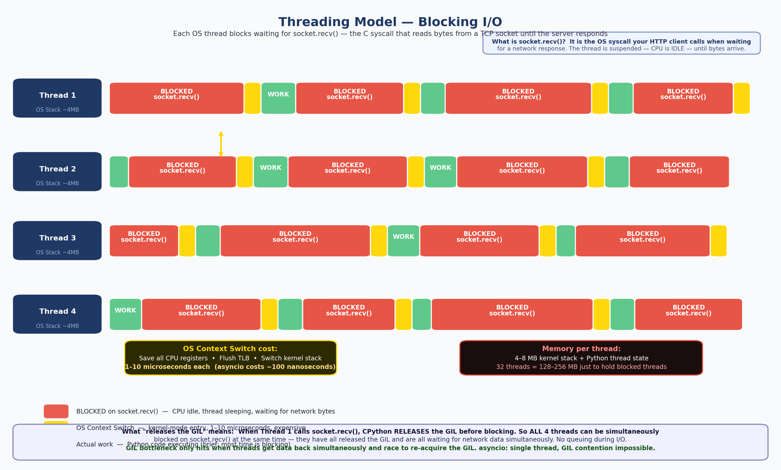
Figure 1: Thread model — blocking I/O, OS context switch cost (~1-10μs), GIL contention
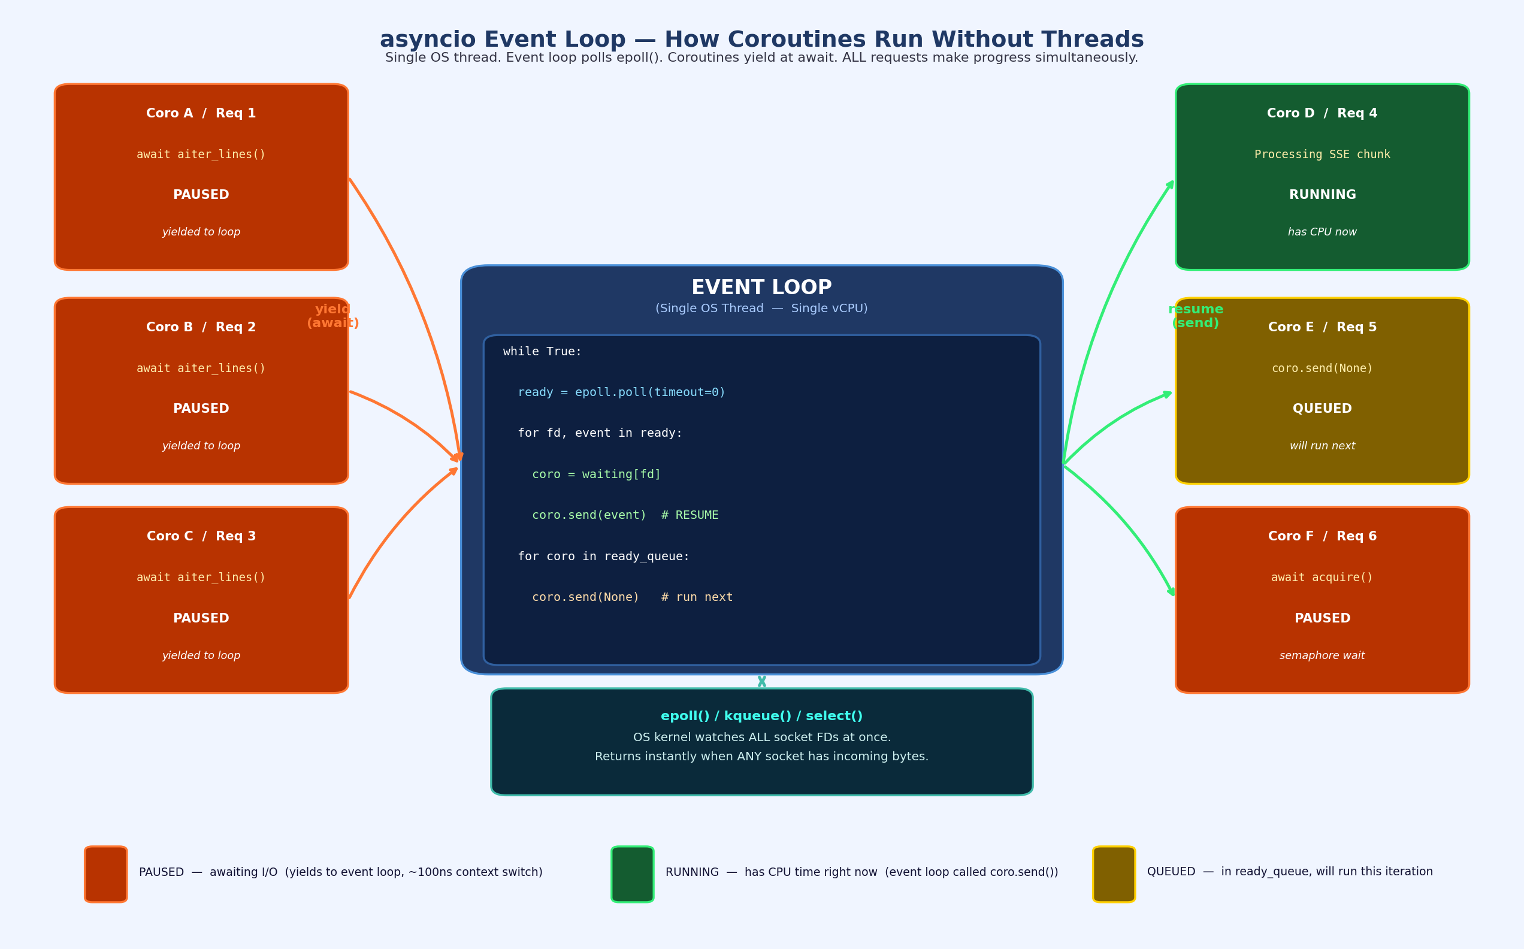
Figure 2: asyncio event loop — epoll, yield at await, ~100ns resume cost, no OS involvement
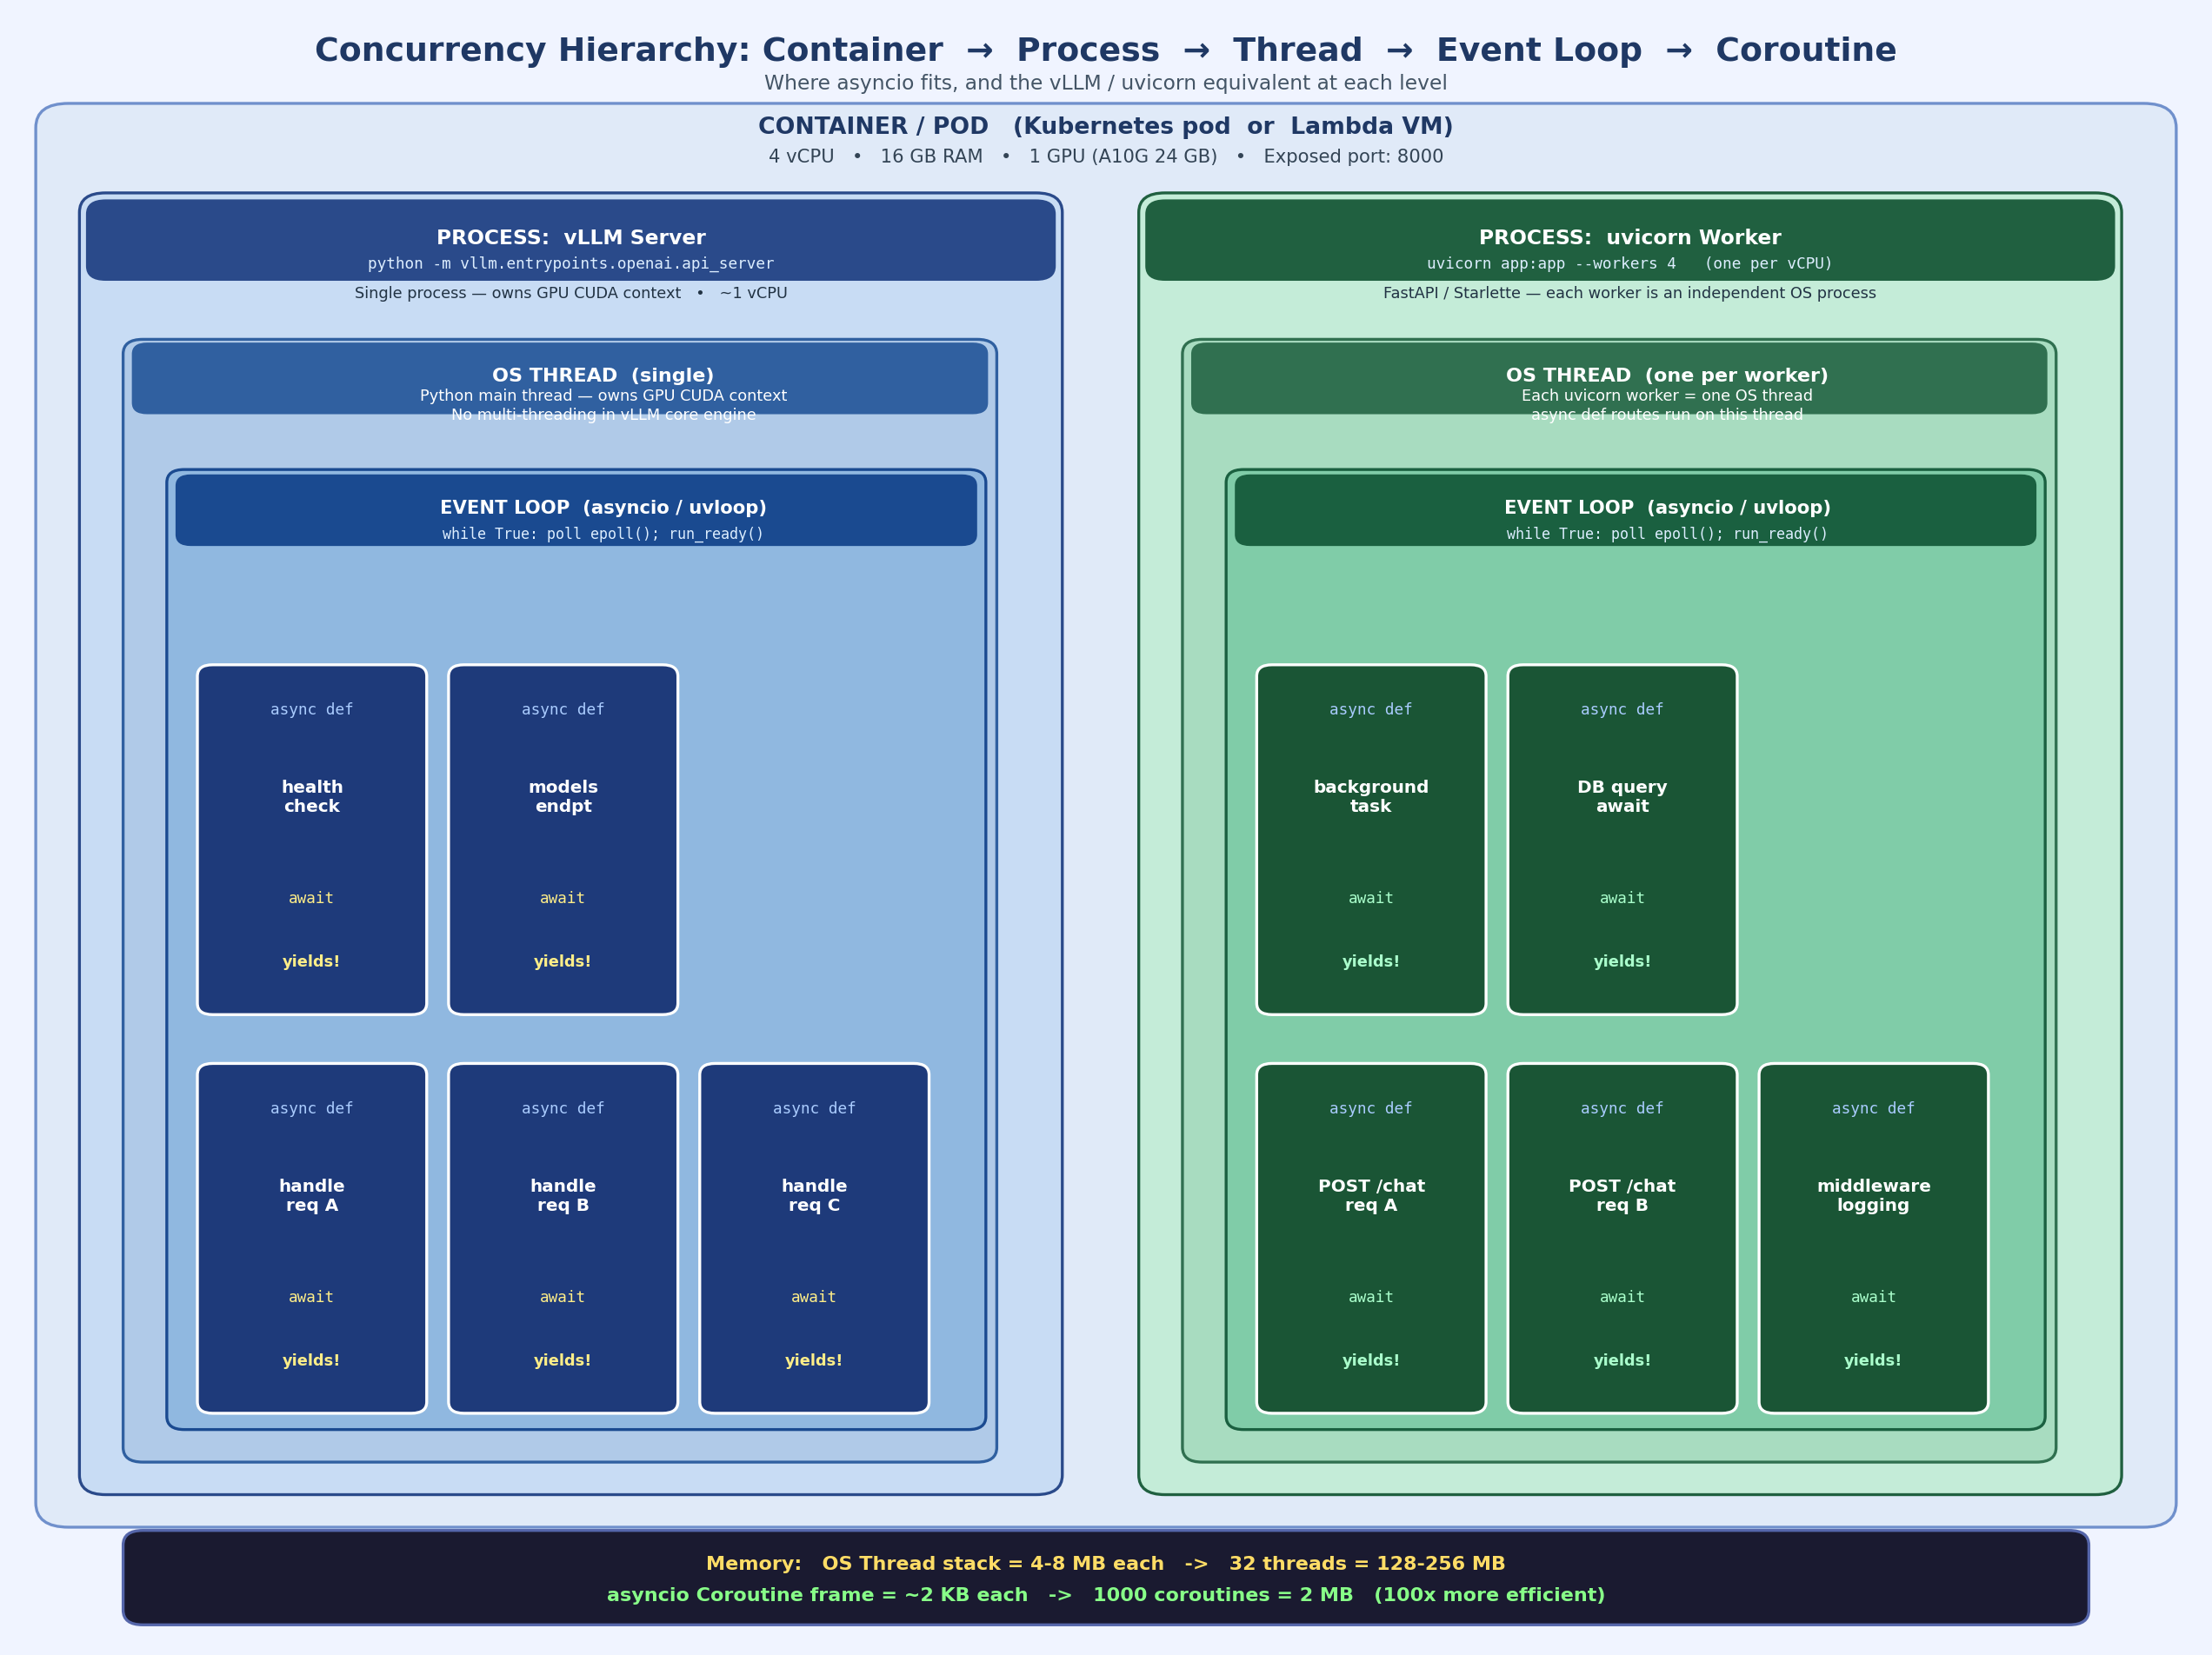
Figure 3: Container → Process → OS Thread → Event Loop → Coroutine — with vLLM/uvicorn equivalents
10.2 Why HTTPX instead of the OpenAI Python SDK
The OpenAI SDK is designed for application code, not benchmarking. It abstracts the SSE protocol and yields ChatCompletionChunk objects through an async iterator. The problem: the iterator yields a chunk object, not a raw network event. By the time your code receives the chunk object, the SDK has already read the raw bytes, parsed the JSON, and constructed the object — all in layers that add non-deterministic latency. You cannot reliably place a timestamp at the byte-receipt boundary using the SDK.
HTTPX’s client.stream() opens the HTTP response and gives you direct access to the response body byte stream. response.aiter_lines() yields each \n-terminated line as it arrives off the socket — not buffered. Your timestamp is placed at the exact moment the first non-empty data: line is yielded by the async generator, which is the closest possible approximation to “when the server sent the first token.” This is why HTTPX is the correct tool for TTFT benchmarking.
10.3 time.perf_counter() — the correct tool for sub-millisecond timing
Timer | OS clock used | Use for
time.perf_counter() | CLOCK_MONOTONIC (Linux). Sub-microsecond resolution. Never goes backward. | Benchmarking elapsed time (TTFT, request duration). Correct choice.
time.time() | CLOCK_REALTIME (wall clock). Can jump backward due to NTP synchronization. | Timestamps in log files and results JSON. Wrong for duration measurement.
10.4 Semaphore-based concurrency model — why a ceiling, what it maps to in production
The benchmark sweeps concurrency levels [1, 4, 8, 16, 32]. For concurrency=8, the benchmark does NOT fire 8 requests and then wait for all to complete before firing more. It uses asyncio.Semaphore(8) — a counter that limits how many coroutines are simultaneously inside the critical section. The benchmark creates all num_requests tasks at once (e.g., 20 tasks), but the semaphore ensures at most 8 are in-flight at any moment. When one request completes, the semaphore is released and the next queued task immediately starts. This simulates a real worker pool with a fixed concurrency ceiling, which is exactly how production API gateways and load balancers work.
Why not fire all 20 at once? Measurement validity. If you fire all 20 simultaneously with no ceiling, the server sees concurrency=20 for the first few requests, then concurrency=15, then 10, then 5 as they complete at different times. Your “concurrency=8 benchmark” would actually average over a continuously shifting load level — meaningless as a controlled measurement. The semaphore maintains exactly 8 in-flight throughout the entire measurement window, giving you clean, reproducible steady-state numbers.
Is the semaphore an OS-level queue? No. The semaphore is a Python-level data structure maintained by asyncio’s event loop. It is a counter (integer) plus an internal waiters list (a deque of coroutines waiting to acquire). There is no OS kernel involvement. When a coroutine calls await semaphore.acquire() and the count is 0, it is appended to the waiters deque and yields to the event loop. When another coroutine calls semaphore.release(), the count goes up and the first waiter is moved to the ready queue. The event loop then runs it at the next iteration.
In a production system, this same pattern is implemented at multiple layers:
Layer | How concurrency ceiling is configured
vLLM scheduler (closest equivalent) | --max-num-seqs: max concurrent sequences in the scheduler. Requests beyond this are queued in vLLM’s internal request queue before prefill even starts.
Nginx reverse proxy | limit_req zone=api rate=100r/s burst=20: allows bursts up to 20, delays beyond that. proxy_pass to backend with keepalive pool.
HAProxy | maxconn per backend server: queues new connections when backend is at capacity.
Gunicorn (WSGI/ASGI) | worker count × threads per worker = max concurrent Python handlers.
AWS ALB | Target group max_connections: load balancer queues requests when backend connections are saturated.
Envoy / Istio | circuit_breakers.max_requests: Envoy drops requests beyond this with 503 if the downstream is overloaded.
asyncio.Semaphore (this benchmark) | Semaphore(N): in-process Python counter. Benchmark-specific. Not a network component.
Your Optum scenario — 100 concurrent requests on one pod with no ceiling: This is correct behavior for a specific type of test, and here is the precise distinction. When you send 100 concurrent requests with no semaphore, you are testing what the server does under burst overload — answering “what happens when 100 users hit the endpoint simultaneously?” The vLLM scheduler has its own internal ceiling (--max-num-seqs, often 64 by default). If you send 100 requests and max-num-seqs=64, vLLM queues 36 of them. Those 36 requests have inflated TTFT because they waited in the scheduler queue before prefill even started. Without measuring this distinction, your P95 TTFT hides the fact that 36% of users experienced queue wait time on top of their actual inference latency. For the LoraForge benchmark, we use a semaphore because we want to answer a different question: “at steady-state concurrency=8, what is P50 TTFT?” The semaphore gives us clean steady-state numbers. The Optum burst test gives you capacity planning data. Both are correct — they answer different questions.
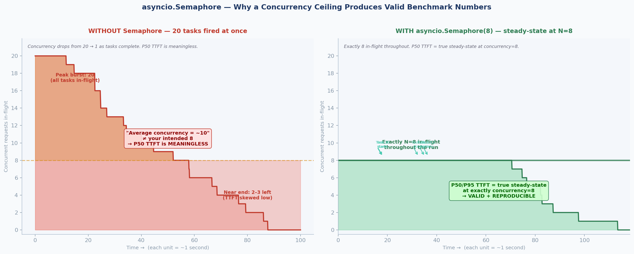
Figure 4: Semaphore validity — without ceiling (noise floor collapses) vs with ceiling (clean measurement)
10.5 Warmup requests and why they matter
The first few requests after server startup are always slower than steady-state because: (1) CUDA kernel launch overhead — GPU kernels for attention and matmul are compiled and cached on first use (even with --enforce-eager, per-operation CUDA launches have one-time JIT overhead); (2) PagedAttention page allocator cold-start — the first requests trigger page allocation logic that is fast but not free; (3) OS-level caching — the first read of model weight pages from HBM may involve TLB misses. The benchmark discards warmup_requests=5 results before starting the timed measurement window. Without warmup, the first 5 requests in a 20-request run would have inflated TTFT numbers, biasing P50 and P95 upward.
10.6 The complete measurement sequence for one request
# Timeline of a single send_streaming_request() call:
T=0.000s request_start = perf_counter()
T=0.001s TCP connect + HTTP POST headers sent to localhost:8000
[server: tokenize prompt, schedule batch, prefill phase (KV compute)]
T=0.185s first "data:" SSE line arrives with non-empty content
T=0.185s first_token_time = perf_counter()
TTFT = 0.185 - 0.000 = 185ms ← this is what baseline_results.json records
[decode phase: token 2, 3, 4... arrive via SSE stream]
T=1.420s "data: [DONE]" received; total_time = 1.420s; output_tokens ≈ 128
Throughput is computed over the wall-clock time from when the first request was dispatched to when the last completed: total_output_tokens / wall_time_seconds. This measures aggregate throughput — how fast the server produced tokens across all concurrent requests combined — not per-request throughput. At concurrency=1, throughput equals the single-stream decode speed. At concurrency=16, it reflects how well vLLM’s continuous batching fills GPU compute.
PART 11: FASTAPI CONCURRENCY BOTTLENECK — sync def vs async def
11.1 The primary bottleneck in FastAPI (the RingCentral answer)
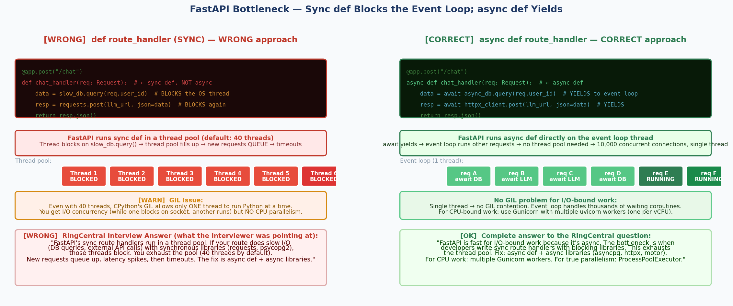
Figure 5: FastAPI bottleneck — sync def exhausts thread pool; async def cooperates with event loop

