1.Introduction and Problem Statement Definition:

The Problem Statement:

To design a Web Database application (using php and MySQL ) to store information about international T20 cricket matches (Men). The Database will store information about the cricket matches and the information can be used to produce a score card (for any match,given the match-id). The user can enter the match-id in the system and the system can generate the full score card for the match.

The full score card for a particular match will consist of the overall Match ,batting and bowling statistics ( Team-wise and Player-wise and Innings-wise) :

-For Batsman Statistics (An example layout is show in Fig 1.1):

- Batsman Name
- Runs taken by each batsman
- Strike rate of each batsman
- Number of 4s and 6s
- Extras (No. of wides, no-balls)
- Number of balls faced
- Current status (batting/out)
- Overall Team Score (Total Runs/Wickets Fallen)

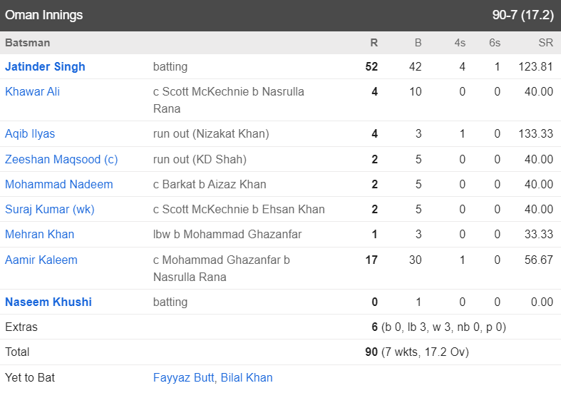

Fig 1.1 : Batsman Statistics Layout

-For Bowler Statistics (An example layout is show in Fig 1.2):

- Bowler Name
- Number of overs bowled
- Numbers of maiden overs delivered
- Number of wickets taken
- Number of Wide balls and No–balls delivered
- Economy of the Bowler

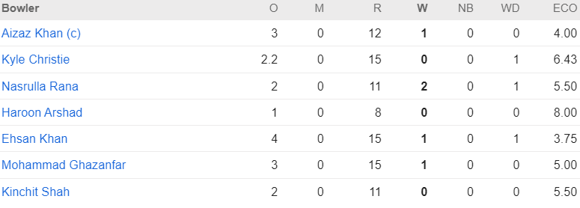
Fig 1.2 : Bowler Statistics Layout

-Overall Match Statistics (An example layout is show in Fig 1.3):

- Match-id
- Date & Time of the Match
- Toss Info (who won and what they choose)
- Venue Info (Stadium Name and Location)
- Umpires
- The name of the Players for each Team(11 Players each)
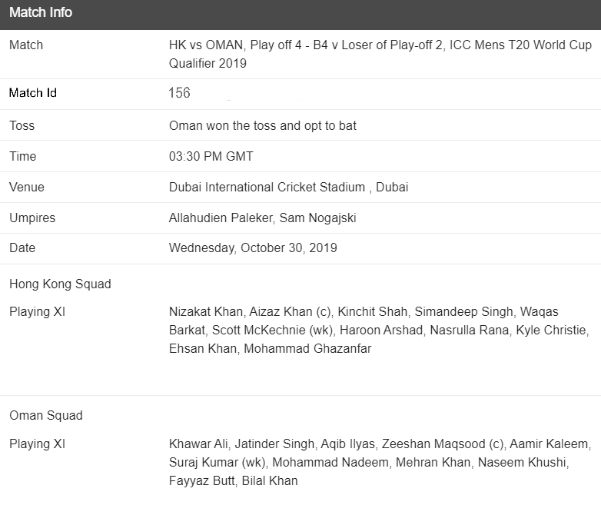

Fig 1.3 : Overall Match’s Statistics Layout

Every statistic will be displayed for the current match only.

The Database will store information about each of the individual player of the Teams and their statistics (like debut-date,age,total number of runs and wickets,total number of matches played,etc).
The statistics of each player will be updated after each ball of every Match (i.e. the statistics of each player will remain updated).

A general Overview of the game:

T20 International is a form of cricket, played between 2 of the international members of the international members of the ICC, in which each team faces 20 overs. The 2 teams are made up of 11 players each. The cricket match consists of 2 innings, in which one of the teams bats while the other team fields and bowls for 20 overs. The aim of the batting team is to score runs while the aim of the fielding team is to bowl ten people out and close the batting teams’ innings. After the first innings is over, the target runs is set and the bowling team (in the first innings) have to bat and reach the target. The match ends when either the 20 overs are over or the team reaches its target. At the end the team with the highest number of runs is declared as the winner.

