Name : Deepanraj.S

NM id : au621421106036

**Noise pollution monitoring (IoT)**

We surely can’t imagine a world without sound. Sound is one of an integral part of our day to day life, everything just becomes monotonous without the presence of audio. But too much of anything is dangerous, with the advent of automobiles, loudspeakers, etc. sound pollution has become a threat in recent days. So, in this project, we will build an **IoT decibel meter** to measure sound in a particular place and record the value in a graph using IoT. A device like this will be useful in places like hospitals and schools to track and monitor the sound levels and take action accordingly. Previously we have also built an Air pollution meter to monitor air quality using IoT.

A **sound level meter** is employed for acoustic (sound that travels through the air) measurements. The simplest sort of microphone for sound level meters is the capacitor microphone, which mixes precision with stability and reliability. The diaphragm of the microphone responds to changes in air pressure caused by sound waves. That’s why the instrument is usually mentioned as a **sound pressure level (SPL) Meter**.

Sound level meters are commonly utilized in sound pollution studies for the quantification of various sorts of noise, especially for industrial, environmental, mining, and aircraft noise. The reading from a sound level meter doesn't correlate well to human-perceived loudness, which is best measured by a loudness meter. Specific loudness may be a compressive nonlinearity and varies at certain levels and certain frequencies. These metrics also can be calculated in several other ways.

Here we are going to make an **IoT based decibel meter** that will **measure the sound in decibels(dB)** using a sound sensor and display it to the LCD display along with that, it will also be pushing the readings to the **Blynk IoT platform** making it accessible from across the world.

**Diagram:**

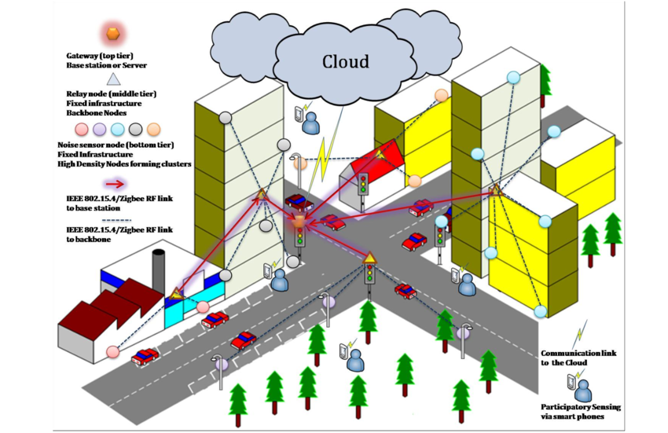

**Program:**

Monitoring noise pollution typically involves capturing audio data and analyzing it to assess noise levels. You can use Python and various libraries to create a simple noise pollution monitoring program. Here's a basic example using the `pyaudio` library for audio capture and `numpy` for data processing:

1. First, you need to install the necessary libraries if you haven't already. You can install them using `pip`:

pip install pyaudio numpy

2. Next, create a Python program to record audio and monitor noise levels:

import pyaudio

import numpy as np

import math

# Define the parameters for audio capture

FORMAT = pyaudio.paInt16

CHANNELS = 1

RATE = 44100

CHUNK = 1024

THRESHOLD = 0.02 # Adjust this threshold based on your environment

# Initialize PyAudio

audio = pyaudio.PyAudio()

# Open the audio stream

stream = audio.open(format=FORMAT, channels=CHANNELS,

rate=RATE, input=True,

frames_per_buffer=CHUNK)

print("Listening for noise...")

while True:

try:

# Read audio data

data = stream.read(CHUNK)

audio_data = np.frombuffer(data, dtype=np.int16)

# Calculate the root mean square (RMS) to measure noise level

rms = math.sqrt(np.mean(np.square(audio_data))

# Check if noise level exceeds the threshold

if rms > THRESHOLD:

print(f"Noise level: {rms:.2f}")

except KeyboardInterrupt:

break

print("Monitoring stopped.")

# Close the audio stream

stream.stop_stream()

stream.close()

# Terminate PyAudio

audio.terminate()

This program continuously records audio in chunks and calculates the root mean square (RMS) to measure the noise level. If the noise level exceeds the predefined threshold, it will be printed to the console. You can adjust the `THRESHOLD` variable to set the level at which noise should be considered "pollution."

Remember that this is a basic example, and a complete noise pollution monitoring system would likely involve more features, such as data logging, visualization, and possibly more advanced noise analysis techniques. Depending on your specific requirements, you can expand and customize this program accordingly.