LAB Assignment 5
Operating Systems (UCS-303)
Name - Deepansha 2X13

Q1. Write a program to:
• Create a child process using fork().
• Print the process IDs (PID, PPID) in both parent and child.

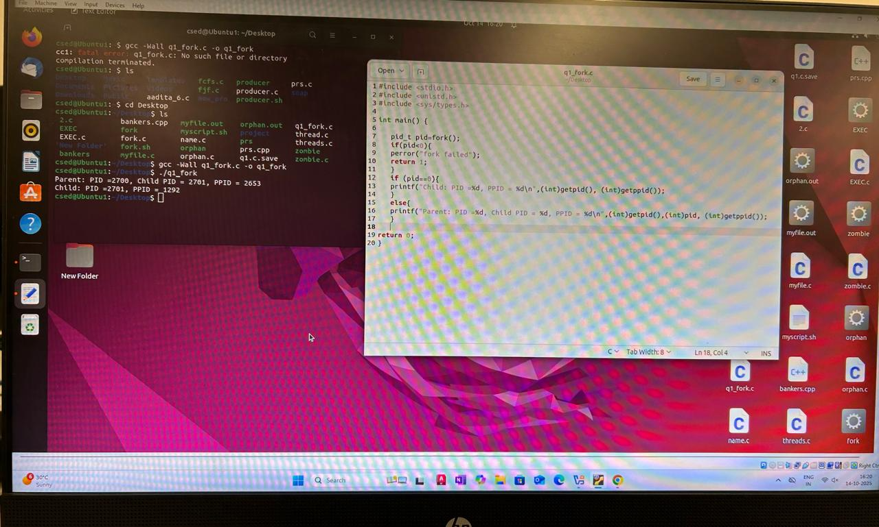

Q2. Write a program to:
• Demonstrate creation of an orphan process using fork() and sleep().
• Demonstrate creation of a zombie process (child exits before parent calls wait ()).
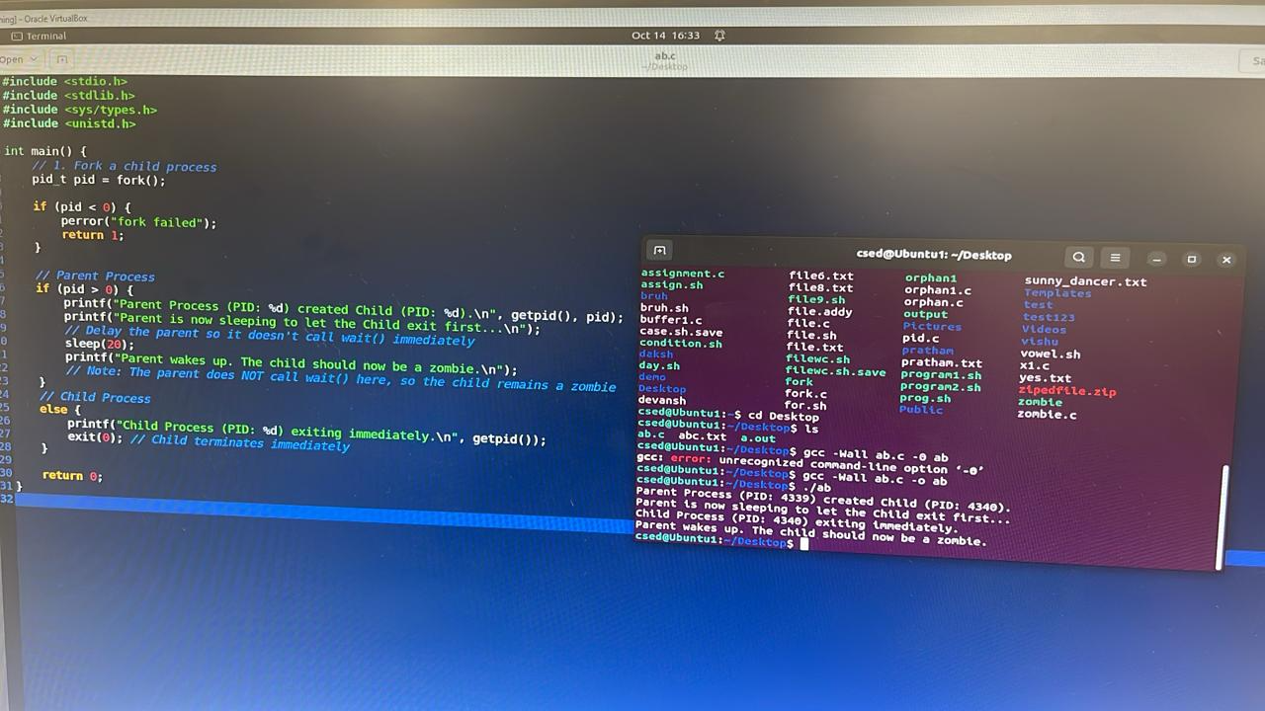

Q3. Write a program that accepts two small numbers (< 50) as arguments and then sums the two in a child process. The sum should be returned by the child to the parent as its exit status and the parent should print the sum
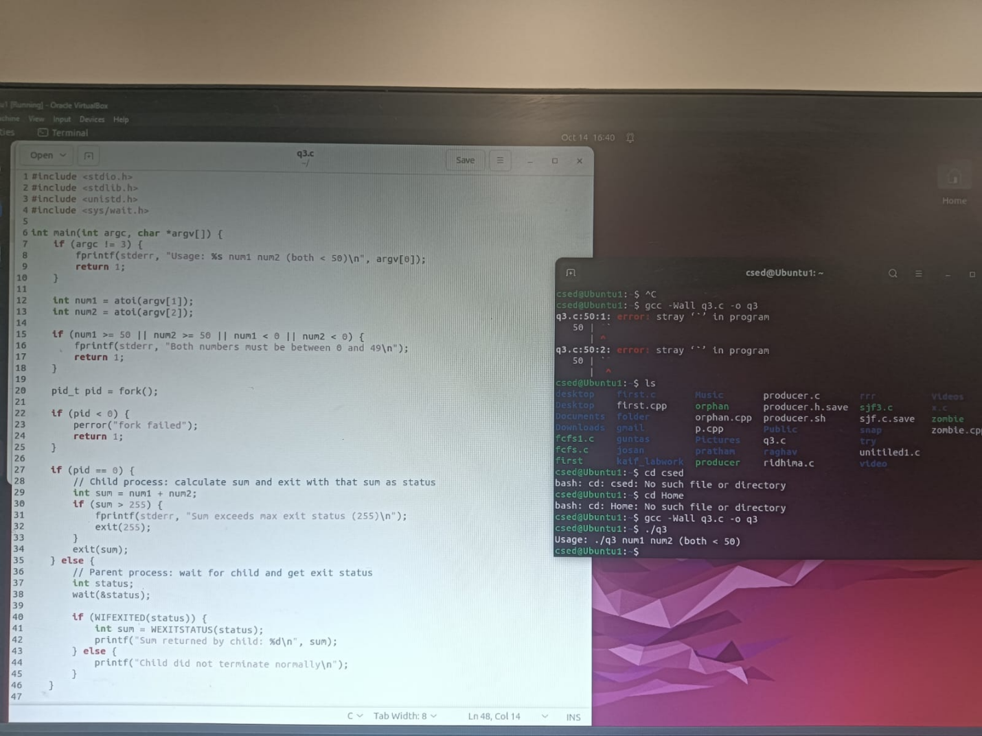
Q4. Predict the output of the following program. #include #include #include int main() { int x = 10; pid_t pid; pid = fork(); // create child process if (pid < 0) { // error in fork perror("fork failed"); return 1; } if (pid == 0) { // Child process printf("Child: Initially x = %d\n", x); x = x + 5; // modify x in child printf("Child: Modified x = %d\n", x); } else { // Parent process wait(NULL); // wait for child to finish printf("Parent: x = %d\n", x); } return 0; }
ANSWER-
Child: Initially x = 10
Child: Modified x = 15
Parent: x = 10
Q5. Create a file ‘seeking’ and write some content e.g.
1234567890abcdefghijklmnopqrstuvwxyz and save it. Predict the output of following
code:
#include
#include
#include
#include
#include
int main() {
int f;
char buff[10];
f = open("seeking", O_RDWR); // open the file "seeking" in read+write mode
if (f < 0) {
perror("open");
return 1;
}
// read first 10 bytes and print
read(f, buff, 10);
write(1, buff, 10);
// move file pointer 10 bytes ahead from current
lseek(f, 10, SEEK_CUR);
// read next 10 bytes and print
read(f, buff, 10);
write(1, buff, 10);

ANSWER-1234567890uvwxyz
Q6. PROG1 OUTPUT
Answer - Pointer is at 10 position

Q6. PROG2 OUTPUT
Answer- x1x2x3x4x5

Q7
.OUTPUT-10 11 OR 11 10

