Software Engineering Assignment: Comprehensive Technical Analysis of Selenium WebDriver
Submitted by: T.Mahidhar
Registration No: 25MIC7280
Submitted to: PROF Manimuthu

1. Executive Summary
This document provides a highly detailed, continuous technical analysis of Selenium WebDriver, emphasizing its role in modern Software Quality Assurance (QA). As web applications scale into complex ecosystems driven by asynchronous JavaScript, microservices, and dynamic DOMs, manual testing has become fundamentally inadequate. Selenium WebDriver bridges this gap by offering a programmatic interface that mimics human interaction at a fraction of the time. This paper explores the tool's core architectural paradigms, ranging from W3C protocol interactions to distributed test execution via Selenium Grid, design patterns like Page Object Model (POM), and advanced integrations with Continuous Integration (CI) pipelines. By dissecting these components, we demonstrate how Selenium ensures software reliability, accelerates time-to-market, and maintains code quality in agile development cycles.

2. Introduction to Web Automation Ecosystem
Web automation has evolved from simple record-and-playback plugins to robust, code-first frameworks. The Selenium suite represents the gold standard in this evolution. It allows software engineers to author resilient test scripts that validate user journeys, data integrity, and UI state across a multitude of browsers and platforms.

2.1 Selenium vs. Modern Competitors
While Selenium remains the industry leader, understanding its position requires comparing it against emerging frameworks like Cypress and Playwright. The table below illustrates the core differences:
Feature | Selenium WebDriver | Cypress | Playwright
Architecture | W3C WebDriver (Out-of-process) | Runs inside the browser (Node.js) | WebSocket connection (CDP)
Language Support | Java, Python, C#, JS, Ruby | JavaScript / TypeScript only | JS/TS, Python, C#, Java
Browser Support | Chrome, Firefox, Safari, Edge | Chromium, Firefox, WebKit | Chromium, WebKit, Firefox
iFrame / Tab Support | Excellent (Multiple Tabs/Windows) | Limited (Single Tab execution) | Excellent (Multiple Contexts)
Best For | Cross-browser, heavy enterprise apps | Fast frontend developer tests | Modern parallel execution apps

3. Architectural Design and Communication Protocol

3.1 The W3C WebDriver Client-Server Model
The architecture of Selenium WebDriver is fundamentally based on a client-server model. Previously, in Selenium 3, the JSON Wire Protocol was used to encode and decode requests. This led to overhead and occasional flakiness. Selenium 4 revolutionized this by adopting the W3C (World Wide Web Consortium) WebDriver standard natively.
- Language Bindings (Client): Engineers write scripts using Selenium libraries (e.g., in Java). These libraries expose user-friendly methods like `driver.findElement()`.
- W3C WebDriver Protocol: The API calls from the bindings are converted into standard HTTP RESTful requests (POST, GET, DELETE) formatted in JSON. Because both the client and the server follow W3C, no intermediate encoding/decoding proxy is required.
- Browser Driver (Server): Executables like ChromeDriver.exe act as a local server. They receive the HTTP requests, parse them, and execute native system-level commands on the actual browser instance.
- Real Browser: The browser executes the physical action (e.g., clicking a button) and returns the HTTP response back down the chain to the IDE.
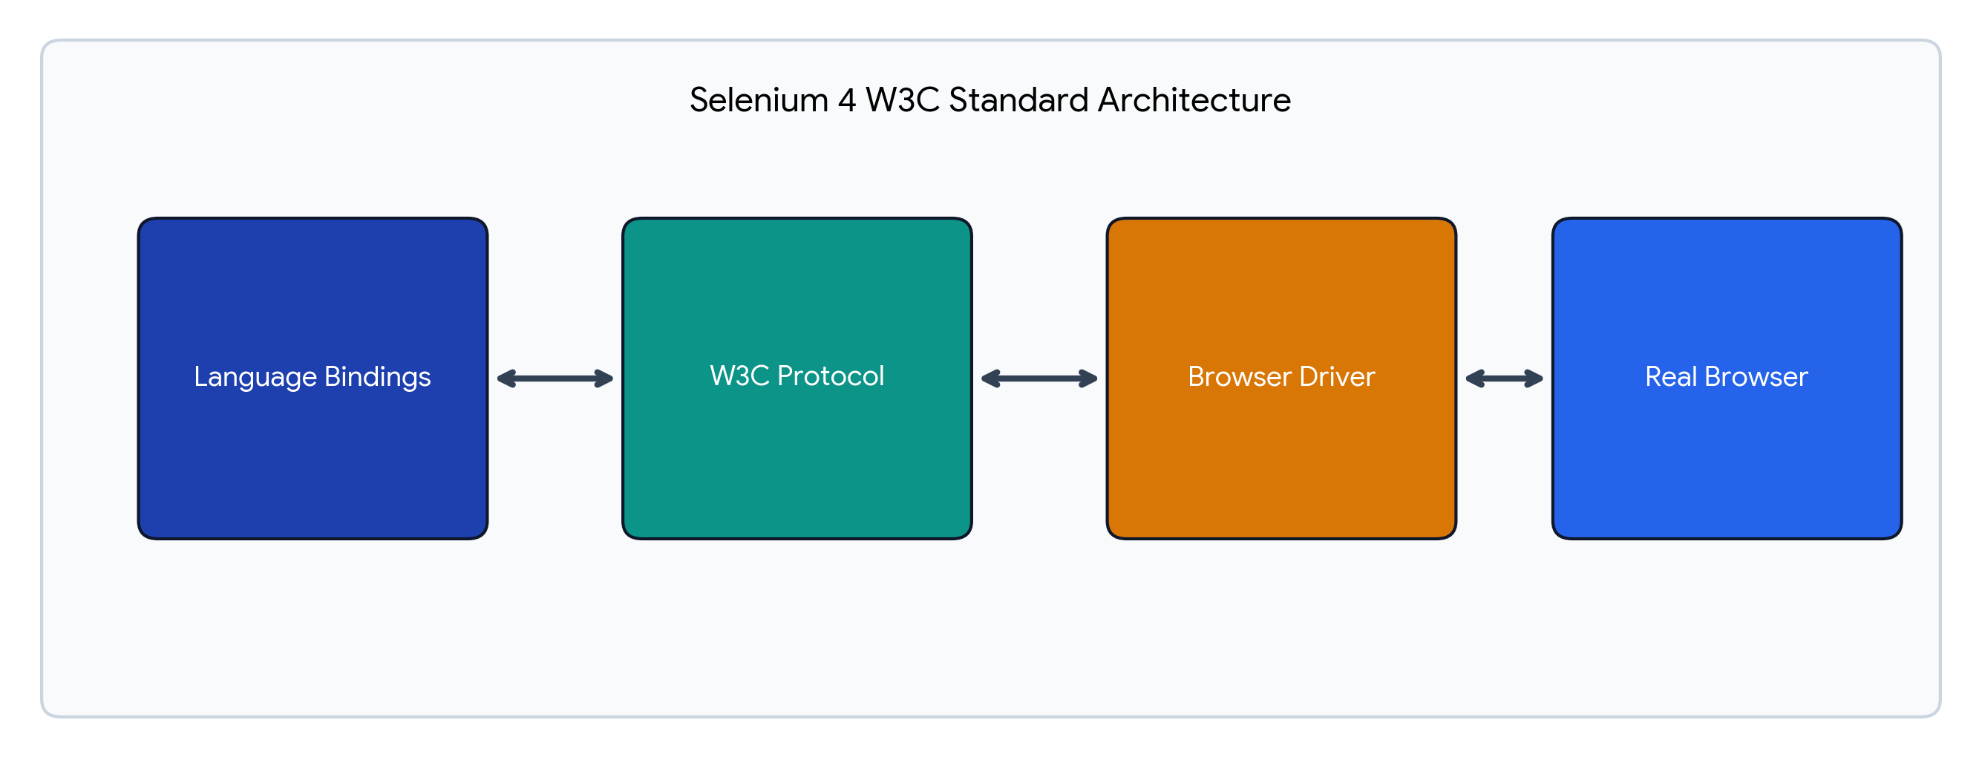
Figure 1: Selenium 4 W3C Standard Architecture

4. WebDriver API and Element Identification Strategies
At the heart of any web automation script is the ability to reliably locate WebElements within the DOM (Document Object Model). A poorly chosen locator strategy is the primary cause of 'flaky' tests (tests that pass and fail randomly).

4.1 Deep Dive into Locator Strategies
Selenium provides multiple locator strategies, each with distinct advantages in terms of execution speed and structural resilience.
Locator Type | Execution Speed | Resilience / Use Case
ID / Name | Fastest | Highly resilient. Should always be the first choice if developers assign unique IDs.
CSS Selector | Very Fast | Best balance of speed and power. Ideal for styling attributes. Does not support upward DOM traversal.
XPath | Moderate | Most powerful. Supports upward/downward traversal and complex text matching. Can be brittle if absolute paths are used.
LinkText | Fast | Used strictly for <a> anchor tags. Relies on exact text match.
Relative Locators | Moderate | Introduced in Selenium 4. Finds elements visually (above, below, near). Excellent for dynamic data grids.

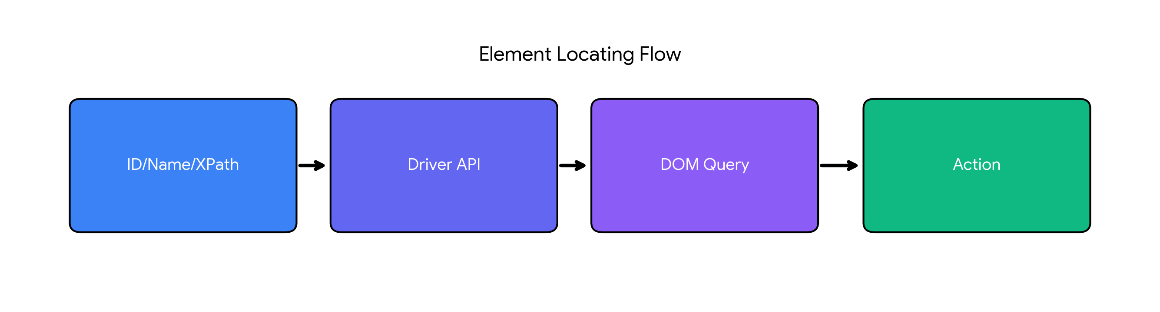
Figure 2: Element Identification and Interaction Pipeline

4.2 The Actions Class and Complex Gestures
Modern web applications frequently require complex user gestures that go beyond simple clicks and keystrokes. Selenium handles this via the Actions API, which builds a chain of commands and executes them simultaneously.
- Drag and Drop: Essential for Kanban boards or file upload UIs. Syntax: `actions.dragAndDrop(sourceElement, targetElement).perform()`.
- Hover/MouseOver: Used to reveal dropdown menus dynamically generated by JavaScript. Syntax: `actions.moveToElement(menuItem).perform()`.
- Composite Keystrokes: Selecting multiple items by holding keys. Syntax: `actions.keyDown(Keys.CONTROL).click(item1).click(item2).keyUp(Keys.CONTROL).perform()`.

5. Synchronization, Waits, and Exception Handling
Web applications load asynchronously. If Selenium attempts to interact with an element before it is fully rendered and attached to the DOM, the script will crash. Proper synchronization is critical for stability.

5.1 Advanced Wait Strategies
- Implicit Wait: Configured once during driver initialization. It tells the WebDriver to poll the DOM for a specified duration when trying to find an element. While easy to implement, it applies globally and can mask performance issues.
- Explicit Wait (WebDriverWait): Applied dynamically to specific elements. It pauses execution until a specific condition is met, such as `ExpectedConditions.elementToBeClickable()`. This is the industry standard for robust frameworks.
- Fluent Wait: An extension of Explicit Wait that allows engineers to define the polling frequency (e.g., check every 500ms) and explicitly ignore certain exceptions during the wait period (e.g., ignoring `NoSuchElementException` until the timeout is reached).

5.2 Common WebDriver Exceptions
Understanding and handling exceptions is a major part of a QA engineer's role. Common exceptions include:
- NoSuchElementException: Thrown when the locator provided does not match any element in the DOM.
- StaleElementReferenceException: Thrown when an element was found, but the DOM subsequently refreshed via AJAX, making the stored reference 'stale'. The solution is to re-locate the element.
- ElementClickInterceptedException: Thrown when an element is present, but obscured by another element (e.g., a loading spinner or modal overlay).

6. Framework Design: The Page Object Model (POM)
As automation suites grow to hundreds of test cases, maintaining them becomes a logistical nightmare if test logic and element locators are combined in the same file. The Page Object Model (POM) solves this via structural separation.
- Object-Oriented Mapping: Every webpage in the application (e.g., Login Page, Dashboard Page) is represented as a Class file.
- Encapsulation of Locators: All locators (XPaths, IDs) are stored as private variables within the Page Class.
- Action Methods: The Page Class exposes public methods (e.g., `login(username, password)`) that the Test Class calls. The Test Class handles assertions, completely oblivious to the underlying HTML structure.
- PageFactory: In Java, PageFactory enhances POM by using the `@FindBy` annotation, which initializes elements dynamically and lazily, reducing memory overhead.
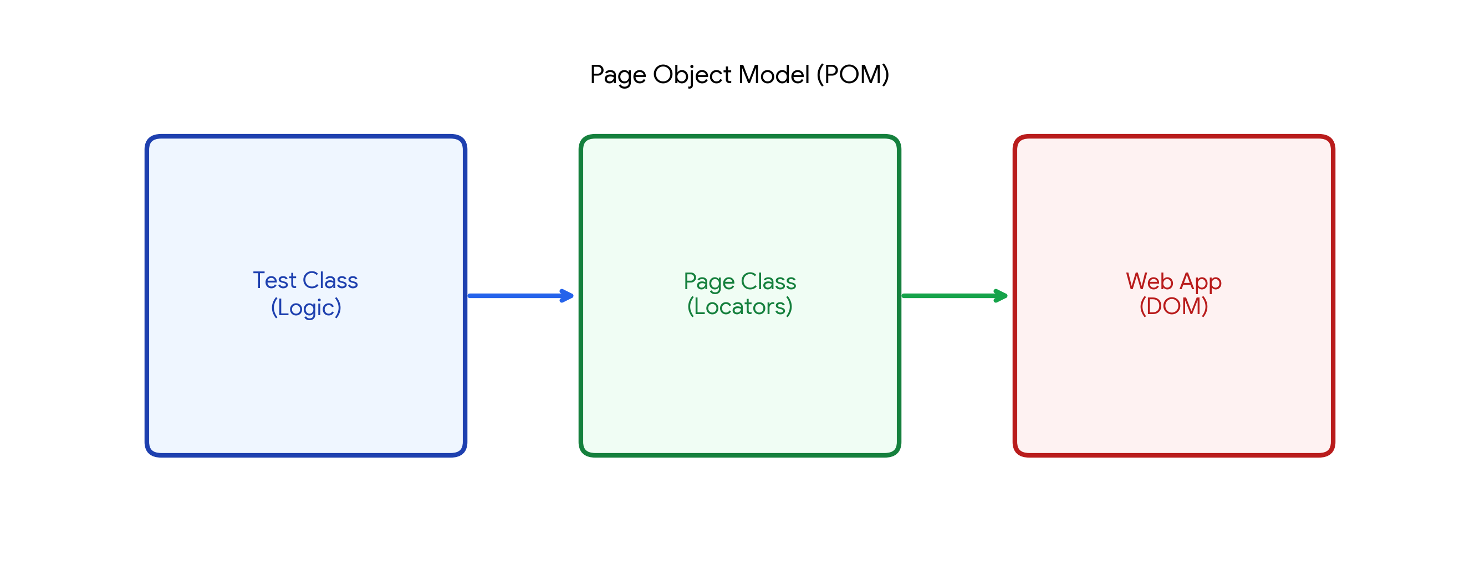
Figure 3: Page Object Model (POM) Architecture

7. Scalability: Selenium Grid and Distributed Testing
Executing a regression suite of 1,000 tests sequentially on a single machine could take hours. Selenium Grid solves this by parallelizing execution across multiple machines, nodes, and operating systems.

7.1 Grid Architecture
Selenium Grid 4 features a fully distributed, Docker-friendly architecture:
- Router/Hub: The central entry point that receives all test requests and routes them based on requested capabilities (e.g., 'Requires Chrome v110 on Linux').
- Distributor & Session Queue: Manages the state of all available nodes. If a matching node is busy, the test is queued.
- Node: The physical or virtual machine containing the browser executable where the test physically runs.
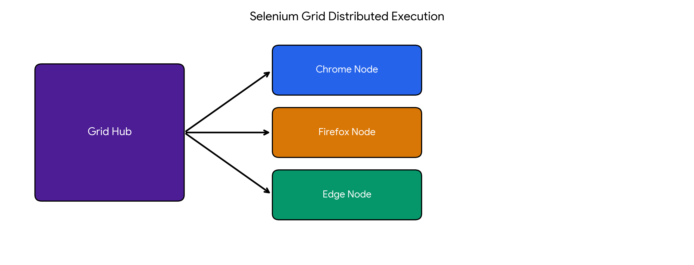
Figure 4: Selenium Grid Distributed Execution

7.2 CI/CD Pipeline Integration
In modern DevOps, testing must be continuous. Selenium integrates seamlessly into Continuous Integration pipelines (e.g., Jenkins, GitLab CI).
- Headless Execution: For CI servers running without GUI monitors (Linux servers), WebDriver supports 'Headless Mode', which executes tests in memory, vastly improving speed and resource consumption.
- Pipeline Trigger: Code pushed to a Git repository triggers the CI server to compile the code and execute the Selenium suite against the staging environment automatically.
- Reporting: Tools like Allure or ExtentReports generate rich HTML dashboards with screenshots of failed tests, notifying developers of defects immediately via Slack or email.
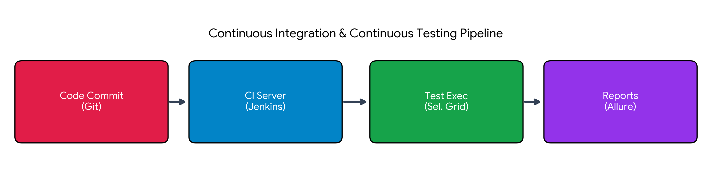
Figure 5: Continuous Integration Testing Pipeline

8. Advanced Capabilities: Chrome DevTools Protocol (CDP)
Selenium 4 introduced native support for CDP, unlocking backend-level browser manipulation previously unavailable to standard WebDriver scripts.
- Network Interception: QA engineers can mock API responses, simulate slow 3G network conditions, or test how the UI handles 500 Internal Server Error responses without altering the actual backend.
- Geo-Location Spoofing: Applications dependent on location services (like Uber or food delivery) can be tested by injecting fake Latitude and Longitude coordinates directly into the browser's sensor engine.
- Console Log Extraction: Tests can automatically capture browser console errors (e.g., JavaScript crashes) and attach them to test reports for deeper developer debugging.

9. Conclusion
Selenium WebDriver represents a critical infrastructure component for modern software engineering teams. Its transition to the W3C standard has mitigated historical stability issues, while the integration of CDP and advanced relative locators ensures it remains competitive with newer frameworks. By utilizing robust architectural patterns like the Page Object Model, mastering intelligent synchronization with Explicit Waits, and deploying scalable parallel execution networks via Selenium Grid and Jenkins, organizations can achieve a high degree of automation maturity. This drastically reduces the manual testing burden, accelerates release cycles, and ensures the delivery of high-quality, defect-free web applications to end-users.

10. References
1. Selenium Official Documentation, 'WebDriver API & Architecture', https://www.selenium.dev/documentation/webdriver/
2. W3C Standard, 'WebDriver Specification', World Wide Web Consortium, https://w3c.github.io/webdriver/
3. Selenium Grid 4 Setup and Distributed Testing, https://www.selenium.dev/documentation/grid/
4. Fowler, Martin. 'PageObject Pattern', Enterprise Architecture Patterns, 2013.
5. 'Selenium 4 Features and CDP Integration', Software Testing Help, 2023.

