**KIET Group Of Institutions**

**Project** - AI-based Number Guessing Game

NAME – Deepanshu Pal

BRANCH – CSE (AI)

SECTION – B

UNIV. ROLL NO - 202401100300095

INTRODUCTION

The AI-Based Number Guessing Game is an interactive program that challenges the user to guess a randomly generated number within a specific range. The goal of the project is to implement artificial intelligence techniques to optimize the guessing process, making the game more engaging and efficient. This project demonstrates fundamental AI principles, including search algorithms and probability-based decision-making, while also enhancing user experience through interactive gameplay.

METHODOLOGY

The project follows these steps:

* **Technology Used**: Python programming language with libraries such as random for number generation and time for delay effects.
* **Algorithm**: The AI uses a binary search algorithm to guess the number efficiently.
* **User Interaction**: The program prompts the user to think of a number within a given range, and the AI attempts to guess it by analyzing the user's feedback (higher or lower hints).
* **Loop & Conditions**: The game continues until the AI correctly guesses the number.

CODE

# prompt: AI-Based Number Guessing Game

import random

def number_guessing_game():

    """

    A simple AI-based number guessing game.

    The AI will try to guess a number you're thinking of between 1 and 100.

    """

    print("Think of a number between 1 and 100.")

    print("I will try to guess it.")

    low = 1

    high = 100

    guess = 0

    attempts = 0

    while True:

        guess = (low + high) // 2  # Binary search approach

        attempts += 1

        response = input(f"Is your number {guess}? (Type 'higher', 'lower', or 'correct'): ").lower()

        if response == "correct":

            print(f"I guessed your number in {attempts} attempts!")

            break

        elif response == "higher":

            low = guess + 1

        elif response == "lower":

            high = guess - 1

        else:

            print("Invalid input. Please type 'higher', 'lower', or 'correct'.")

if __name__ == "__main__":

    number_guessing_game()

**Screenshots & Output**

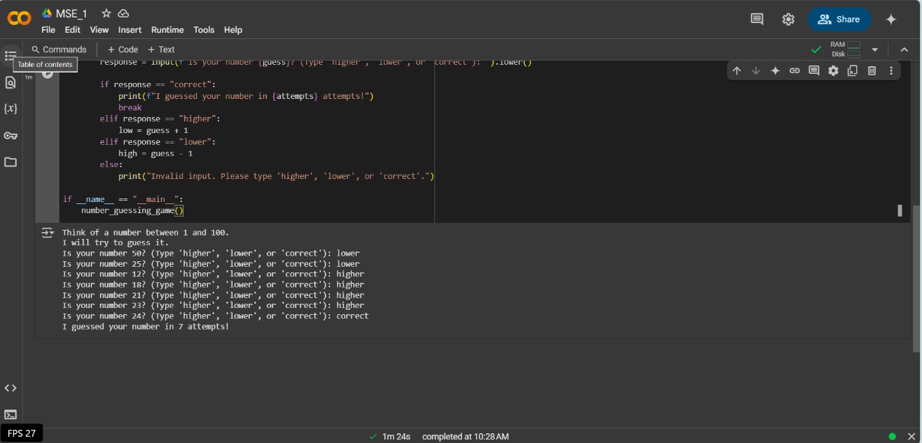

CONCLUSION

The AI-Based Number Guessing Game effectively demonstrates the use of algorithms in interactive applications. By employing binary search logic, the AI can efficiently determine the user's number with minimal attempts. This project highlights fundamental AI concepts and can be further enhanced by incorporating machine learning techniques to predict user behaviour and optimize guessing strategies.