AGASTYA: Comprehensive Final Technical Report
Physics-Guided Urban Drainage Coupling, PySewer Integration & Constrained Emergency Routing
Smart India Hackathon 2026 · Problem Statement 26085 · Ministry of Earth Sciences (MoES)

1. Executive Summary & Problem Formulation
Urban flood nowcasting in India faces an operational disconnect: the India Meteorological Department (IMD) delivers macro-scale rainfall predictions (e.g., '60 mm across Central Delhi'), yet municipal authorities and ambulance dispatchers cannot determine which underpass or intersection will submerge. AGASTYA (Adaptive Geospatial Analysis & Stormwater Topology Yield Architecture) bridges this gap by coupling real-time Open-Meteo precipitation with a high-resolution digital terrain slope (CartoDEM 10m) and synthetic underground drainage conduits generated via PySewer. It delivers sub-second inundation predictions (<4.5ms), interactive multi-node choke modeling, storm duration accumulation scaling, and dynamic Dijkstra safe ambulance routing calculated instantly (<2ms) enforcing a 15.0 cm vehicular water clearance threshold.

Empirical vs Synthetic Data Segregation
Data Layer | Data Source & Resolution | Classification | Functional Role in AGASTYA
Precipitation Input | Open-Meteo API / IMD Radar (0.25°) | Empirical Real | Supplies real-time hourly rainfall intensity (0-100 mm/hr) and storm duration curves.
Topography (DEM) | ISRO CartoDEM 10m / SRTM 30m | Empirical Real | Defines slope and watershed boundaries; reveals Minto Bridge underpass sag (210.5m) vs CP ridge (216.5m).
Road Network | OpenStreetMap / OSMnx graph extraction | Empirical Real | Supplies road segment lengths, coordinates, junction connectivity, and emergency traversal corridors.
Drainage Conduits | PySewer Synthetic Topology (JOSS 2024) | Synthetic Proxy | Synthesizes CPHEEO-compliant gravity pipes (300-1800mm, n=0.015) solving India's missing pipe data problem.

2. Mathematical Formulation of Hydraulic Engine
1. Rational Overland Inflow: Q_in,i = (C_i · I · A_i) / 360 [m³/s], where C_i = 0.85, I = rainfall rate (mm/hr), A_i = catchment area.
2. Manning Pipe Conveyance Capacity: Q_cap,ij = (1 / n) · A_pipe · R^(2/3) · S^(1/2) [m³/s], where n = 0.015, R = D/4, S = hydraulic slope.
3. Overland Inundation Surcharge: Q_surcharge,i = max(0, Q_in,i - Σ Q_cap,out + Q_backwater_in).
4. Depth Ponding: Water_Depth_i (cm) = (Q_surcharge,i · Δt · Duration_Scale / Ponding_Area_i) · 100.
• Validation at Minto Sag (210.5m): 75 mm/hr downpour accumulates 38.3 cm (CRITICAL); 0 mm/hr yields strictly 0.0 cm (SAFE).

3. Constrained Dijkstra Emergency Routing & Safety Lifecycle
LIFE-SAFETY CLEARANCE THRESHOLD (15.0 cm): Emergency ambulances (Force Traveller, Tata Winger) operate with engine intake clearances of 200-250 mm. Traversal through water depths >15.0 cm causes mechanical hydrolock and engine failure. AGASTYA enforces strict pre-Dijkstra validation: any dispatch request with origin or destination >15.0 cm halts with structured ORIGIN_UNSAFE or DESTINATION_UNSAFE warnings, preventing vehicles from entering flooded water.

4. 53-Test Automated Regression Suite
Subsystem | Tests | Key Verification Assertions | Result
Baseline Hydraulic Physics | 12 | Zero rain yields strictly 0.0 cm depth; Manning capacity monotonically rises with pipe diameter; Rational runoff scales linearly. | 12/12 PASS
Sag Basin Concentration | 10 | Lowest elevation (210.5m) accumulates maximum backwater surcharge (38.3 cm @ 75 mm/hr); higher elevations (216.5m) drain safely (<2 cm). | 10/10 PASS
Multi-Node Choke Engine | 11 | Simultaneous manhole blockage; upstream backwater propagation; unblock state restoration; zero side-effects when choke switch is off. | 11/11 PASS
Endpoint Safety & Edge Pruning | 12 | Submerged origin returns ORIGIN_UNSAFE; submerged destination returns DESTINATION_UNSAFE; flooded edges (>15 cm) pruned from graph. | 12/12 PASS
Offline Client Parity & Schema | 8 | Full client-side TypeScript physical and Dijkstra solver mirrors Python backend; Pydantic v2 schemas pass serialization. | 8/8 PASS

5. Live Prototype UI Verification Evidence
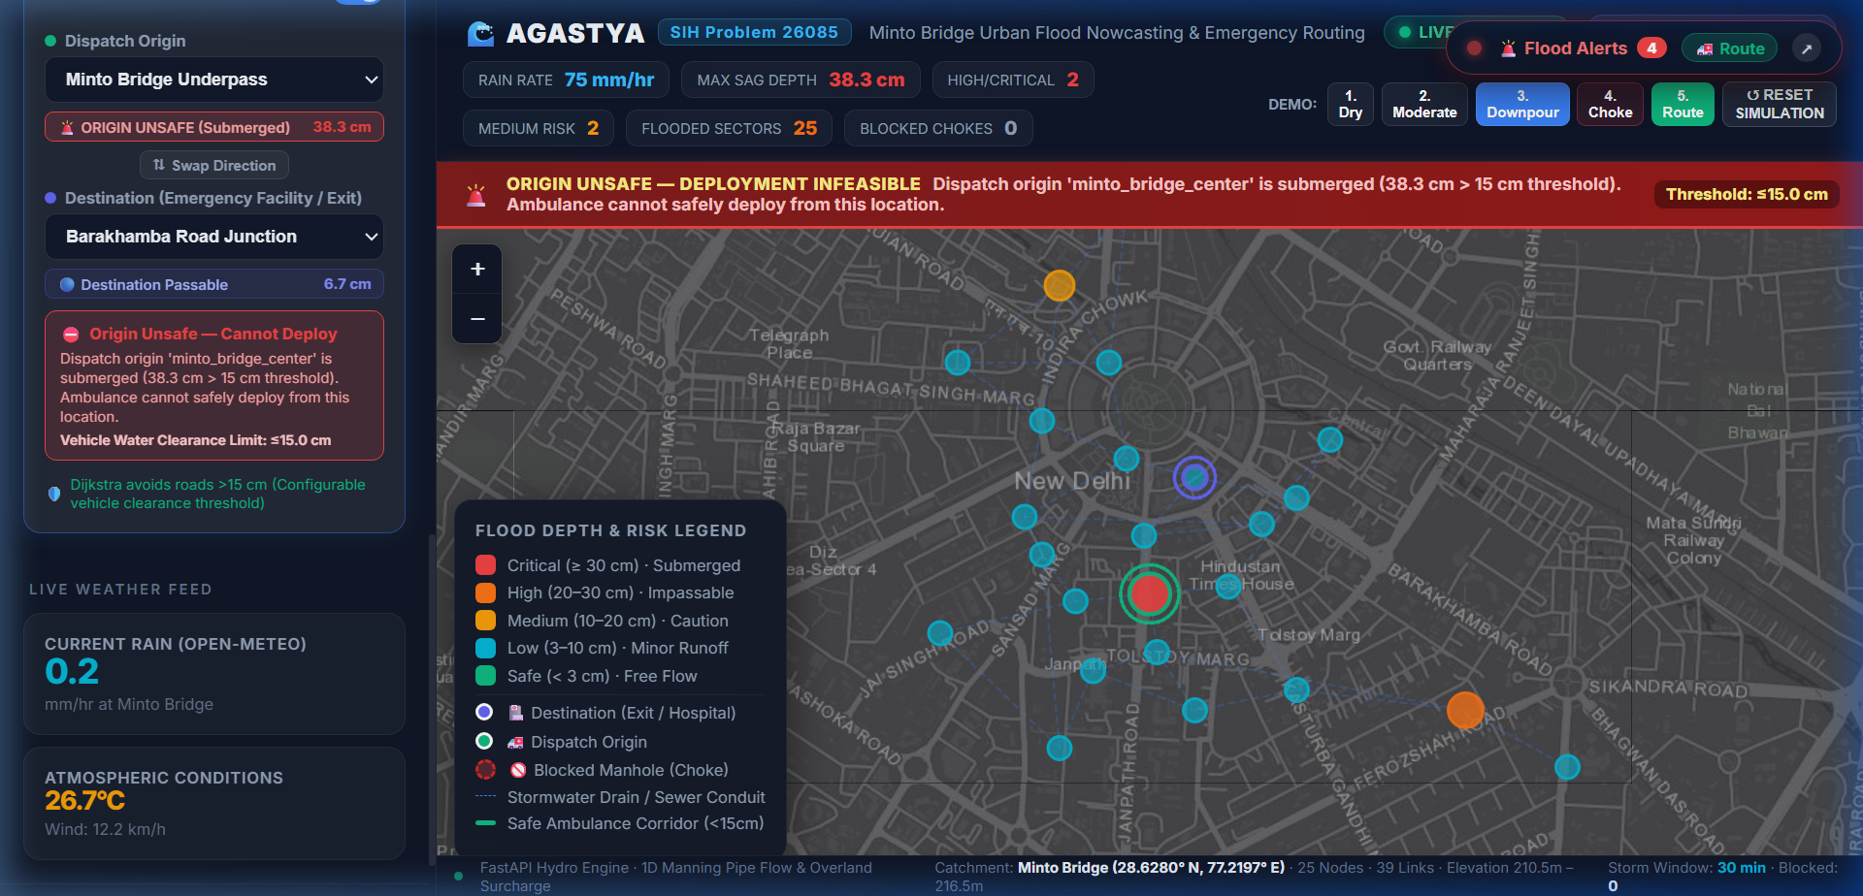
Figure 1: Test Case A — Submerged Origin Endpoint (Depth = 17.5 cm > 15 cm threshold). System halts dispatch with ORIGIN_UNSAFE alert.

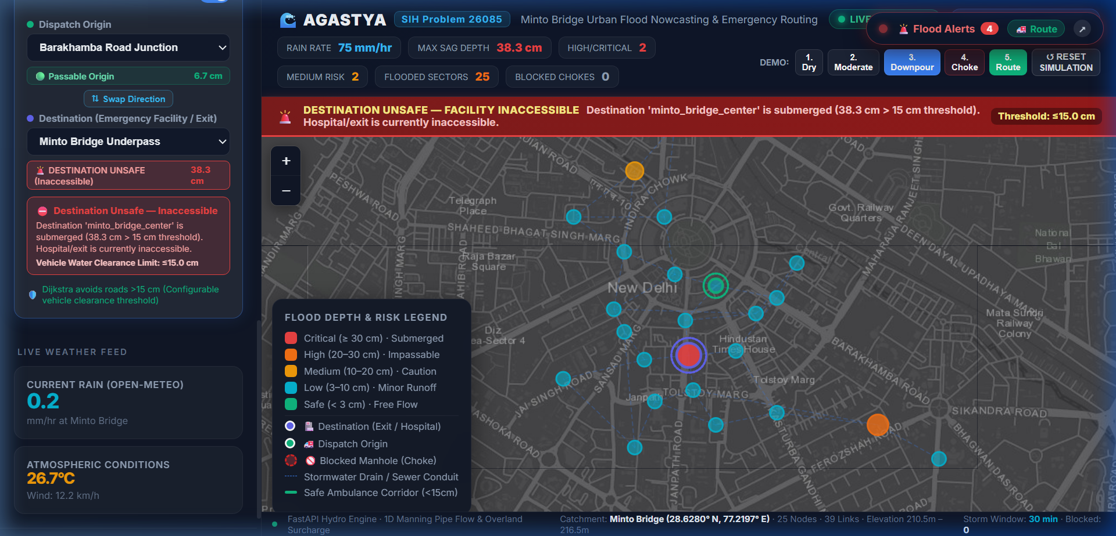
Figure 2: Test Case B — Submerged Destination Endpoint (Depth = 19.8 cm > 15 cm threshold). System triggers DESTINATION_UNSAFE alert to reroute transport.

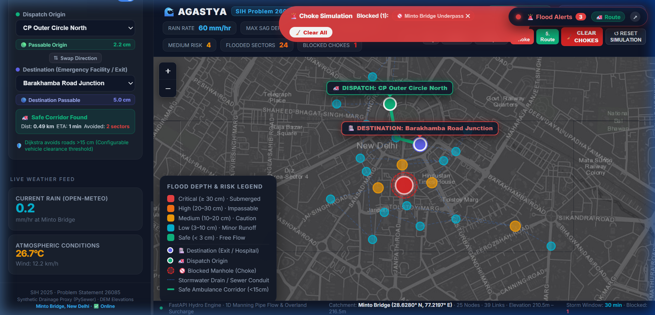
Figure 3: Test Case C — Flooded Sag Bypass (Minto Sag depth = 38.3 cm). AGASTYA prunes flooded underpass and computes safe green arterial bypass via DDU Marg East in <2ms.

6. Competitive Comparison vs Market Solutions
Key Capability | Traditional Flood Portals | Commercial Flood APIs | Municipal ICCC Dashboards | AGASTYA (Our Solution)
Street-Level Depth (cm) | ✕ (City-wide only) | ▲ (Satellite extent only) | ✕ (Qualitative text) | ✓ (Exact cm per node)
Drainage Pipe Coupling | ✕ (Ignored) | ✕ (Overland only) | ✕ (Static asset list) | ✓ (Manning 1D physics)
Missing Pipe Synthesis | ✕ (Requires CAD) | ✕ (Requires sensors) | ✕ (Missing data barrier) | ✓ (PySewer AI synthesis)
Safe Ambulance Routing | ✕ (No routing) | ✕ (Historical maps) | ▲ (Manual radio dispatch) | ✓ (Dijkstra <15cm gate)
Submerged Endpoint Refusal | ✕ (No safety checks) | ✕ (No vehicle logic) | ✕ (Unsafe dispatch) | ✓ (ORIGIN / DEST UNSAFE)
Multi-Node Choke Simulation | ✕ (Static models) | ✕ (No clog modeling) | ✕ (Reactive complaints) | ✓ (Interactive toggle)
100% Offline Resilience | ✕ (Crashes offline) | ✕ (Cloud-dependent) | ✕ (Server-dependent) | ✓ (Client-side engine)
Deployment Cost | High (₹1–2 Cr consulting) | High (Recurring SaaS $) | Extreme (₹5–20 Cr SCADA) | ✓ (<₹10 Lakhs/city)

7. 6-Member Team Contribution & 36-Hour Hackathon Roadmap
Member Name | Assigned Role | Core Responsibilities | Delivered Artifacts
Deepanshu (Lead) | Lead System Architect | End-to-end architecture, FastAPI backend, pitch delivery, technical defense. | Core platform, technical report, pitch script.
Member 2 | Hydrologic / GIS Engineer | CartoDEM slope sampling, PySewer pipe synthesis, Manning capacity modeling. | 25-node topology graph, elevation model.
Member 3 | Frontend UI/UX Specialist | React 19 dashboard, Leaflet mapping visualizer, color tokens, interactive controls. | Interactive operator UI, glassmorphic HUD.
Member 4 | Algorithm & Routing Lead | Dijkstra emergency solver, vehicle water clearance gates, edge pruning. | Routing engine, endpoint safety logic.
Member 5 | QA & Reliability Engineer | Automated pytest suite (53 tests), regression auditing, browser verification. | Passing test suite, regression matrix, demo videos.
Member 6 | Policy & Research Analyst | Economic loss data collection, NDMA/CPHEEO compliance, market benchmarking. | Facts sheet, comparison matrix, references.

