A
Project Report
on
Stock Market Movement Prediction
Submitted in partial fulfillment of the course
Supervised and Unsupervised Learning [24CAI0203]
of
Computer Science & Engineering (AI & ML)
during January – June, 2026
Submitted by:
2410993446 — Sanvi
2410993409 — Deepanshu Sharma
2410993421 — Krish Bali
2410993458 — Siya


CHITKARA UNIVERSITY
CHANDIGARH – PATIALA NATIONAL HIGHWAY
RAJPURA (PATIALA) PUNJAB – 140401 (INDIA)
June, 2026

DECLARATION OF PROJECT

We, the undersigned students of the Department of Computer Science & Engineering – AI & ML at Chitkara University, Punjab, hereby declare that we have successfully completed the project titled “Stock Market Movement Prediction” as part of the requirements for the Course Supervised and Unsupervised Learning [24CAI0203].
We confirm that the project was conducted during the period January 2026 to June 2026 and has been prepared in partial fulfillment of the course Supervised and Unsupervised Learning for submission to the Department of Computer Science and Engineering (Artificial Intelligence and Machine Learning).
We affirm that the work submitted is our original effort and has not been copied or reproduced from any other source, except where due acknowledgment has been made. We also confirm that all resources, references, and materials used have been properly cited in the project.
We undertake to abide by the rules and regulations of Chitkara University, Punjab and accept full responsibility for the authenticity and validity of the project submitted.

Date: June 2026

Signed by:  2410993446 — Sanvi  2410993409 — Deepanshu Sharma  2410993421 — Krish Bali  2410993458 — Siya | Signature:  ................................  ................................  ................................  ................................

ABSTRACT
This project presents a supervised learning approach to predicting stock market price movement — specifically, whether the next trading day’s price direction will be UP (bullish) or DOWN (bearish). Stock markets are highly dynamic systems influenced by price trends, volatility, trading volume, and momentum, making accurate prediction a challenging binary classification task. We developed a complete machine learning pipeline using engineered financial features including RSI, MACD, SMA Ratio, Volume Change, Volatility, and Momentum indicators derived from real historical market data. The dataset was processed using a time-series-aware train-test split to prevent data leakage, with feature scaling applied for distance-based models. Six models were trained and evaluated: Logistic Regression, Random Forest, Gradient Boosting, XGBoost, KNN, and SVM. Hyperparameter tuning was performed using GridSearchCV with TimeSeriesSplit cross-validation. Models were assessed on accuracy, precision, and recall to reflect real-world trading decision quality. SVM (Tuned) achieved the best overall performance with the highest precision (~0.63) and balanced recall (~0.57), making it the most reliable model for trading decisions. The results highlight the importance of the precision-recall tradeoff over accuracy alone in financial prediction tasks.

TABLE OF CONTENTS

S. No. | Contents | Page No.
1 | Introduction | 5
2 | Problem Statement | 6
3 | Methodology & Technical Details | 7
4 | Results & Discussion | 13
5 | Advantages & Limitations | 12
6 | Conclusion with Future Scope | 15
7 | References | 16
 | Appendices (Project Code) | 17

SECTION 1: INTRODUCTION

1.1 Background and Context
The stock market is a highly dynamic and complex system influenced by multiple factors including price trends, volatility, trading volume, and investor sentiment. Predicting stock price movement — whether the market will go up (bullish) or down (bearish) — is a challenging task due to noise, non-linearity, and temporal dependencies.
With the advancement of machine learning, predictive models can now analyze historical patterns and generate probabilistic forecasts. Algorithms such as Logistic Regression, Random Forest, Gradient Boosting, Support Vector Machines, and XGBoost are widely used for financial prediction tasks due to their ability to capture statistical relationships within data.

1.2 Motivation
This project is motivated by the need to:
- Compare multiple machine learning models on real stock market data
- Understand the precision-recall tradeoff in trading decisions
- Move beyond simple prediction toward decision-based trading systems
- Evaluate how model tuning affects real-world performance
Instead of focusing only on accuracy, this project emphasizes:
precision (quality of trades)
recall (coverage of opportunities)

SECTION 2: PROBLEM STATEMENT

2.1 Problem Definition

Given historical stock market features, the goal is to:

Predict whether the next movement of the stock will be UP (1) or DOWN (0)

This is a binary classification problem, where:

Input: engineered financial features

Output: direction of price movement

2.2 Objectives

Build a machine learning pipeline for stock movement prediction

Train multiple models and compare their performance

Apply hyperparameter tuning using GridSearchCV

Evaluate models using:

Accuracy

Precision

Recall

Analyze precision vs recall tradeoff

Identify the best model for trading decisions

2.3 Scope
Focus on short-term directional prediction
Use supervised learning models only
No deep learning or external market sentiment data

SECTION 3: METHODOLOGY & TECHNICAL DETAILS

3.1 Overall Pipeline

The system follows these steps:

Data Collection

Feature Engineering

Train-Test Split (Time Series)

Scaling (for distance-based models)

Model Training

Hyperparameter Tuning

Evaluation & Comparison

3.2 Feature Representation
The dataset includes key financial indicators such as:
- RSI (Relative Strength Index)
- MACD (Moving Average Convergence Divergence)
- SMA Ratio
- Volume Change
- Volatility
- Momentum
- Market Trend Indicators
These features help capture:
- Trend strength
- Momentum
- Market behavior

3.3 Models Used

Model | Type | Key Strength
Logistic Regression | Linear | Baseline
XGBoost | Boosting | Handles Non-Linear Relations
Random forest | Ensemble | Strong Generalization
Gradient Boost | Ensemble | Local Pattern Detection
KNN | Distance Based | High Precision
SVM | Kernel Based | Best Overall Performance

3.4 Hyperparameter Tuning
GridSearchCV was used for tuning:
Example (KNN):
- n_neighbors: [5, 10, 15, 25]
- metric: ['euclidean', 'manhattan']
- weights: ['uniform', 'distance']
Example (XGBoost):
- learning_rate
- max_depth
- n_estimators
- subsample

3.5 Evaluation Metrics
Models were evaluated using:
- Accuracy → overall correctness
- Precision → correctness of positive predictions
- Recall → ability to capture all positives

SECTION 4: RESULTS & DISCUSSION

4.1 Model Comparisons
From your results:

Best Model: SVM (Tuned)
- Highest precision (~0.63)
- Balanced recall (~0.57)
Best for reliable trading decisions

Strong Performer: XGBoost (Tuned)
- High recall (~0.85)
Captures more opportunities but slightly less precise

Gradient Boosting
- Balanced performance
Stable but not top-performing

Logistic Regression
- Very high recall (~0.91)
Predicts “UP” too often → overconfident

Random Forest (Untuned)
- Precision = 0
Completely failed to learn pattern

4.2 Key Observations

Observation 1 — Precision vs Recall Tradeoff
- High Recall → more trades but risky
- High Precision → fewer but safer trades
SVM balances both → best choice

Observation 2 — Tuning Improves Performance
- All models improved after tuning
- Random Forest improved significantly

Observation 3 — Accuracy is Misleading
Some models had similar accuracy but very different:
- Precision
- Recall
Accuracy alone is not reliable for trading

4.3 Visualization Insights
From your plots:
- Precision ranking clearly shows SVM dominance
- Scatter plot shows model clustering
- Bar charts highlight performance gaps
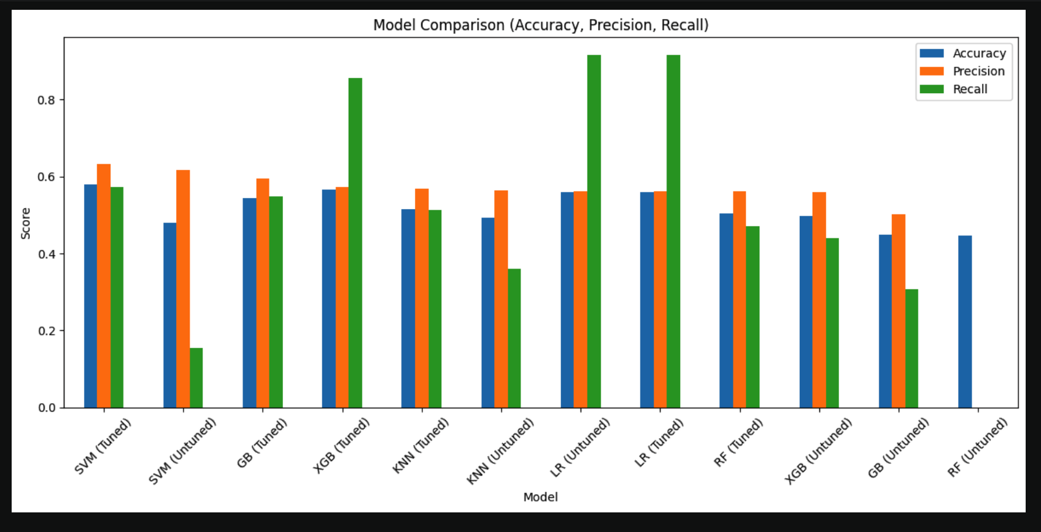

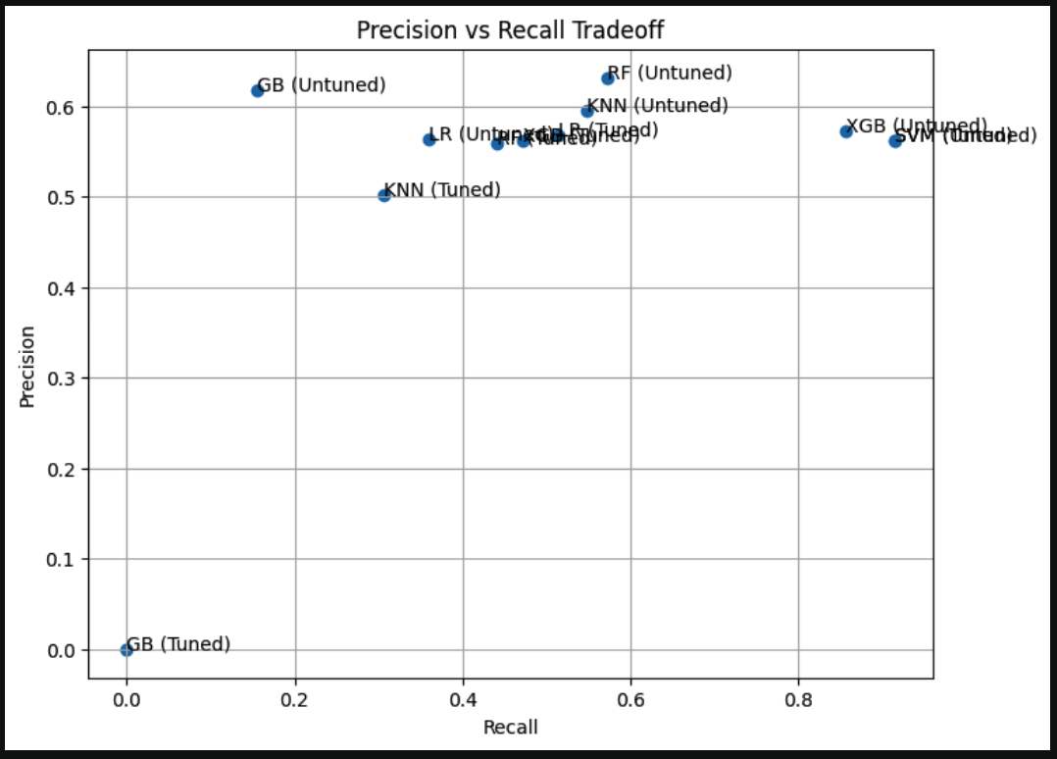
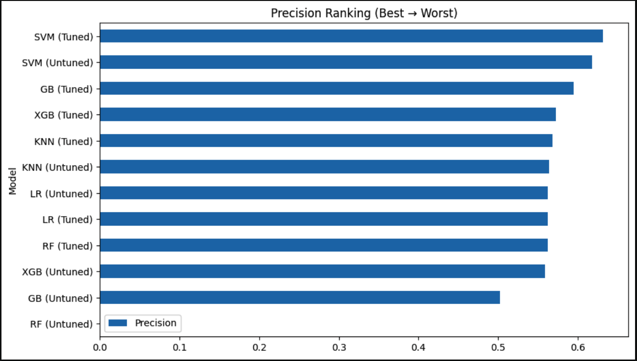

SECTION 7: Advantages And Limitations

5.1 Advantages
Multiple model comparison
Time-series aware validation
Hyperparameter tuning applied
Strong visualization analysis
Real-world trading perspective

7.2 Limitations
No profit-based evaluation yet
Fixed threshold (0.5) used
No ensemble model applied
Limited dataset size

APPENDICES — PROJECT CODE

A.1 Imports and Setup
import pandas as pd
import numpy as np
from sklearn.model_selection import train_test_split
from sklearn.linear_model import LogisticRegression
from sklearn.tree import DecisionTreeClassifier
from sklearn.ensemble import RandomForestClassifier
from sklearn.ensemble import GradientBoostingClassifier
from sklearn.neighbors import KNeighborsClassifier
from sklearn.metrics import accuracy_score, classification_report, confusion_matrix
from sklearn.preprocessing import StandardScaler
from sklearn.metrics import accuracy_score, precision_score, recall_score
from sklearn.calibration import CalibratedClassifierCV
from xgboost import XGBClassifier

import warnings
warnings.filterwarnings("ignore")

A.2 Separating Features and Traget
# 1. remove leaks
X = X.drop(["Return_3d_Future", "Return_5d_Future",
"Target_Strong", "Target_Magnitude"],axis=1)

# 2. shift
X = X.shift(1)
X = X.dropna()
y = y.loc[X.index]

# 3. split
X_train, X_test, y_train, y_test = train_test_split(
X, y, test_size=0.2, shuffle=False
)

A.3 Models Used
# ======================
# Models
# ======================
log_reg= LogisticRegression(max_iter=1000)

Ran_Forest =RandomForestClassifier(
n_estimators=200,
max_depth=4,
min_samples_split=10,
min_samples_leaf=5,
max_features="sqrt",
random_state=42
)

Grad_Boosting=GradientBoostingClassifier(
n_estimators=200,
learning_rate=0.05,
max_depth=3,
random_state=42
)
xgb = XGBClassifier(
n_estimators=200,
learning_rate=0.05,
max_depth=3,
subsample=0.8,
colsample_bytree=0.8,
random_state=42,
use_label_encoder=False,
eval_metric="logloss"
)
# Svm
from sklearn.svm import SVC
svm = SVC(
kernel="rbf",
C=1.0,
gamma="scale",
probability=True # IMPORTANT for predict_proba
)

A.4 Fitting Models
log_reg.fit(X_train_scaled, y_train)
y_pred_lr=log_reg.predict(X_test)
print("Logistic Regression Accuracy:", accuracy_score(y_test,y_pred_lr))
print("Logistic Regression accuracy on training data",accuracy_score(y_train,log_reg.predict(X_train_scaled)))
probs_lr = log_reg.predict_proba(X_test_scaled)[:,1]
print(probs_lr[:10])
print("Logistic Regression Mean Prob:", np.mean(probs_lr))

Ran_Forest.fit(X_train_scaled, y_train)
y_pred_rf=Ran_Forest.predict(X_test_scaled)
print("Random Forest Accuracy:", accuracy_score(y_test,y_pred_rf))
print("Random Forest accuracy on training data",accuracy_score(y_train,Ran_Forest.predict(X_train_scaled)))
probs_rf = Ran_Forest.predict_proba(X_test)[:,1]
print(probs_rf[:10])
print("Random Forest Mean Prob:", np.mean(probs_rf))

Grad_Boosting.fit(X_train_scaled, y_train)
y_pred_gb=Grad_Boosting.predict(X_test_scaled)
print("Gradient Boosting Accuracy:", accuracy_score(y_test,y_pred_gb))
print("Gradient Boosting accuracy on training data",accuracy_score(y_train,Grad_Boosting.predict(X_train_scaled)))
probs_gb = Grad_Boosting.predict_proba(X_test)[:,1]
print(probs_gb[:10])
print("Gradient Boosting Mean Prob:", np.mean(probs_gb))

A.5 KNN tuned version
from sklearn.neighbors import KNeighborsClassifier

knn = KNeighborsClassifier(
n_neighbors=15, # start here
weights='distance' # better than uniform
)

knn.fit(X_train_scaled, y_train)
probs_knn = knn.predict_proba(X_test_scaled)[:, 1]

print("KNN probs:", probs_knn[:10])
print("KNN mean prob:", probs_knn.mean())
threshold_knn = 0.52

y_pred_knn = (probs_knn > threshold_knn).astype(int)

print("KNN accuracy:", accuracy_score(y_test, y_pred_knn))
print("KNN precision:", precision_score(y_test, y_pred_knn))
print("KNN recall:", recall_score(y_test, y_pred_knn))

A.6 Hyperparameter Tuning
# lr
from sklearn.model_selection import GridSearchCV, TimeSeriesSplit
from sklearn.linear_model import LogisticRegression

tscv = TimeSeriesSplit(n_splits=5)

param_lr = {
"C": [0.01, 0.1, 1, 10],
"penalty": ["l2"],
"solver": ["lbfgs"]
}

grid_lr = GridSearchCV(
LogisticRegression(max_iter=1000),
param_lr,
cv=tscv,
scoring="accuracy",
n_jobs=-1
)

grid_lr.fit(X_train_scaled, y_train)

print("Best LR:", grid_lr.best_params_)
best_lr = grid_lr.best_estimator_

A.7 Tuned vs Untuned Models
# Untuned
probs_lr = log_reg.predict_proba(X_test_scaled)[:,1]
y_pred_lr = (probs_lr > 0.5).astype(int)

print("\nLR - Untuned")
print("Accuracy:", accuracy_score(y_test, y_pred_lr))
print("Precision:", precision_score(y_test, y_pred_lr))
print("Recall:", recall_score(y_test, y_pred_lr))

# Tuned
probs_lr_t = best_lr.predict_proba(X_test_scaled)[:,1]
y_pred_lr_t = (probs_lr_t > 0.5).astype(int)

print("\nLR - Tuned")
print("Accuracy:", accuracy_score(y_test, y_pred_lr_t))
print("Precision:", precision_score(y_test, y_pred_lr_t))
print("Recall:", recall_score(y_test, y_pred_lr_t))

