ChatDocs
  - Software Requirements Specification

Version 1.0
March 2026

Prepared by: Deeoanshu
Roll No: 2310990236
Contents
1. Introduction 4
1.1 Purpose 4
1.2 Project Overview 4
1.3 Scope 4
1.3.1 In Scope 4
1.3.2 Out Of Scope 4
1.4 Intended Audience 5
1.5 Definitions and Acronyms 5
2. Overall Description 7
2.1 Product Perspective 7
2.2 Product Functions 8
2.3 User Classes and Characteristics 9
2.4 Design and Implementation Constraints 9
2.5 Success Criteria 9
3. System Features (Functional Requirements) 10
3.1 User Authentication 10
3.2 Document Management 12
3.3 Chat and Q&A Interface 13
3.4 RAG Pipeline 15
3.5 Chat History 17
3.6 Session Management 17
3.7 Requirements Traceability Summary 17
4. External Interface Requirements 18
4.1 User Interface 18
4.2 Software Interfaces 18
4.3 Communication Interfaces 19
5. Non-Functional Requirements 20
5.1 Performance 20
5.2 Security 20
5.3 Scalability 20
5.4 Availability and Reliability 21
5.5 Maintainability 21
5.6 Usability 21
5.7 Summary of all Non-Functional Requirements 22
6. System Architecture 23
6.1 Architectural Overview 23
6.2 Component Descriptions 24
6.3 Data Flow 24
6.4 Deployment Architecture 27
6.5 Security Architecture 28
Appendix A: MongoDB Schema Design 29
A.1 Overview 29
A.2 Users Collection 30
A.3 Documents Collection 30
A.4 Sessions Collection 31
A.5 Chats Collection 31
Appendix B: API Reference 33
B.1 Overview 33
B.2 Authentication Endpoints 33
B.3 Document Endpoints 35
B.4 Chat Endpoints 36
B.5 Python RAG Microservice Endpoints (Internal Only) 37

Introduction

Purpose
This Software Requirements Specification (SRS) document describes the functional and non-functional requirements for ChatDocs, a full-stack AI-powered document interaction web application. It is intended to serve as the authoritative reference for the design, development, and evaluation of the system.

Project Overview
ChatDocs enables authenticated users to upload documents (PDF) and query their content through a conversational AI interface. The system employs a Retrieval-Augmented Generation (RAG) pipeline to provide contextually accurate responses grounded in the uploaded documents. Key capabilities include user authentication, document management, vector-based semantic search, LLM-powered Q&A, and persistent chat history. The system is built as a MERN stack application with a Python-based AI microservice and is intended for deployment on Cloud Platform.

Scope

In Scope
The following capabilities are included within the scope of this project:
- User registration and login with JWT-based authentication
- Document upload support for PDF format
- Document chunking and embedding via Python RAG microservice
- Vector-based semantic search over uploaded documents
- Natural language Q&A powered by Groq
- Persistent chat history stored in MongoDB
- Session-based chat scoped to authenticated users

Out Of Scope
The following features are considered future enhancements and are not part of the current release:
- Real-time multi-user document collaboration
- Mobile native applications (iOS / Android)
- Support for image, audio, or video file formats
- Fine-tuning or training of LLM models
- Admin dashboard or user management panel
- Offline functionality

Intended Audience
This document is intended for the following audiences:
Developers:
- Reference for implementing frontend, backend, and AI microservice components
- Guidance on API contracts, data models, and system interactions
Academic Evaluators:
- Assessment of system design, architecture decisions, and requirement completeness
System Architects:
- Validation of component design, integration patterns, and technology choices
Testers:
- Basis for deriving functional and non-functional test cases

Definitions and Acronyms
The following terms and acronyms are used throughout this document:
Term | Definition
SRS | Software Requirements Specification
RAG | Retrieval-Augmented Generation - a technique that retrieves relevant document chunks and passes them as context to an LLM before generating a response
LLM | Large Language Model - an AI model capable of understanding and generating natural language (e.g. Groq, Gemini)
JWT | JSON Web Token - a compact, URL-safe token used for stateless user authentication
API | Application Programming Interface
REST | Representational State Transfer - an architectural style for designing networked APIs
MERN | MongoDB, Express.js, React.js, Node.js - a full-stack JavaScript framework
Vector DB | Vector Database - a database optimized for storing and searching high-dimensional embedding vectors (e.g. Pinecone)
Embedding | A numerical vector representation of text used for semantic similarity search
Chunking | The process of splitting a large document into smaller segments for embedding and retrieval
Dense Vector | A high-dimensional numerical vector capturing semantic meaning, generated by Gemini embeddings
Sparse Vector | A keyword-based vector generated by BM25Encoder capturing exact term signals
Hybrid Search | A retrieval technique combining dense and sparse vectors to achieve best of both semantic and keyword-based retrieval
BM25 | A sparse keyword-based ranking algorithm used to generate sparse vectors for hybrid search
Dynamic Alpha Weighting | A technique that automatically adjusts the balance between dense and sparse vectors based on query length. Alpha=0.3 for short queries, Alpha=0.7 for long queries
Cohere Reranking | A cross-encoder model (rerank-v3.5) that re-scores retrieved chunks using both the query and chunk together for improved relevance scoring
Pinecone | A cloud-hosted vector database used to store and query hybrid vectors (dense + sparse)
PDF | Portable Document Format
UI | User Interface
FR | Functional Requirement
NFR | Non-Functional Requirement
SHALL | Mandatory requirement. The system must implement this without exception
SHALL NOT | Absolute prohibition. The system must never do this
SHOULD | Recommended but not mandatory. Expected in most cases unless a valid reason exists
MAY | Optional. The system can implement this at the developer's discretion

Overall Description

Product Perspective
ChatDocs is a standalone web application developed as an academic project. It is not a component of a larger existing system. The application integrates with the following external systems and services:
- Gemini API for dense embedding vector generation only
- Groq API for LLM inference and query reformulation
- Cohere API for cross-encoder reranking of retrieved chunks
- MongoDB Atlas for cloud-hosted persistent storage of users, documents, and chat history
- Pinecone for vector-based semantic similarity search (TBD)
The system is composed of four internal components that communicate over HTTP. The React frontend communicates exclusively with the Express backend. The Express backend acts as the central coordinator, handling authentication, persisting data to MongoDB, and proxying AI-related requests to the Python RAG microservice internally.

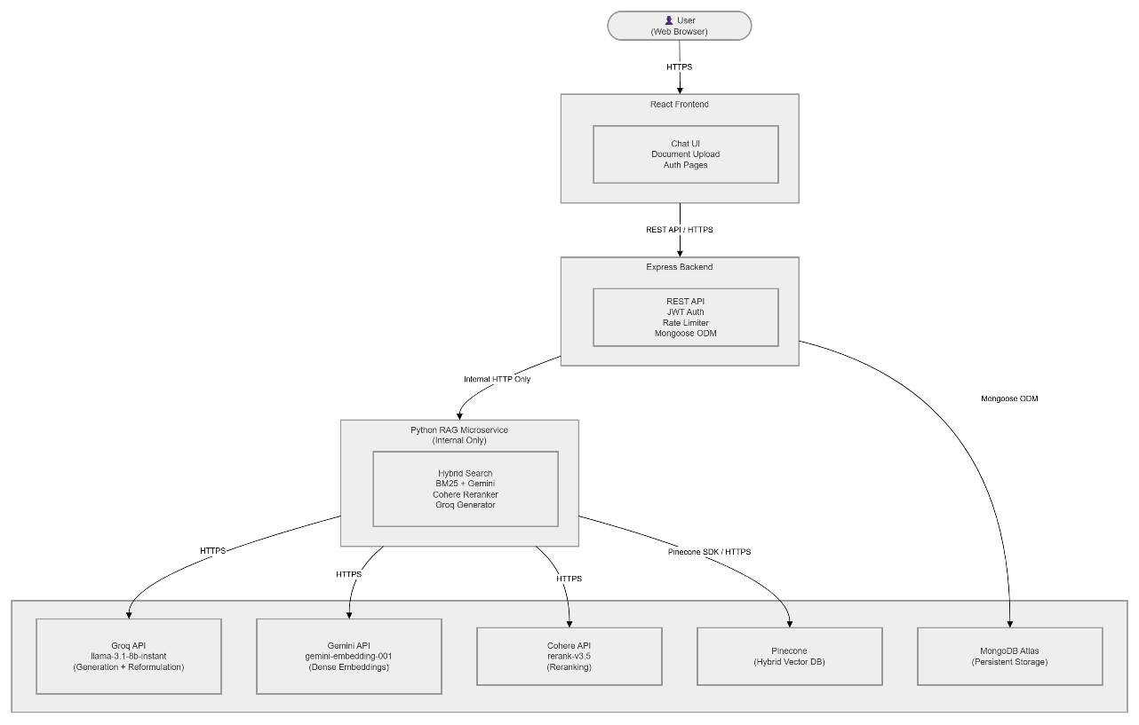
Figure 1: System Context Diagram

Product Functions
The following summarizes the high-level functions of ChatDocs:
- User Authentication: Register and log in securely using JWT-based authentication with bcrypt password hashing
- Document Upload: Upload PDF files (up to 10MB) through the React UI
- Document Processing: Automatically chunk and embed uploaded documents via the Python RAG microservice and store vectors in the vector database
- Conversational Q&A: Ask natural language questions and receive AI-generated answers grounded in the content of uploaded documents
- Chat History: View and revisit previous conversations, persisted per user session in MongoDB
- Session Management: Each chat session is scoped to the authenticated user and tracked independently
- Rate Limiting: Requests are limited to 20 per 15 minutes per user to prevent abuse
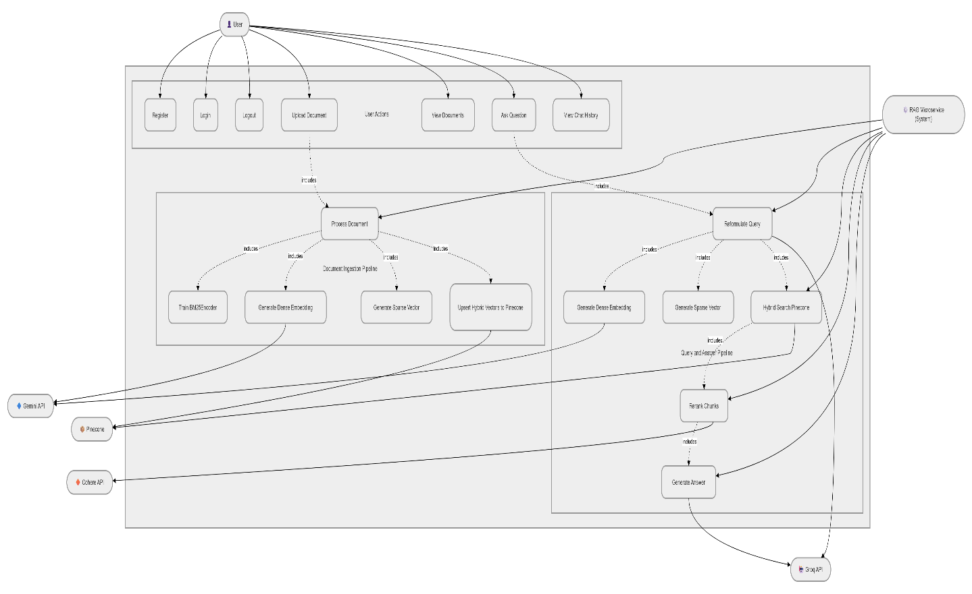
Figure 2: Use Case Diagram

User Classes and Characteristics
- Registered User: Primary user of the system. Can register, log in, upload documents, and interact with the chat interface. Expected to have basic web literacy. No technical knowledge required.
- Guest / Unauthenticated User: Can only access the login and registration pages. All document and chat features are restricted until authentication is completed.
- System Administrator: Responsible for managing deployment infrastructure on GCP, MongoDB Atlas, and Docker. Has no dedicated UI within the application.

Design and Implementation Constraints
- API Key Security: All third-party API keys (Groq, Gemini, Cohere, Pinecone) SHALL be stored exclusively as environment variables on the backend. They SHALL NOT be exposed to the frontend or the end user under any circumstances.
- File Size Limit: Document uploads are constrained to a maximum of 10MB per file.
- Supported File Types: Only PDF format is supported.
- Microservice Isolation: The Python RAG microservice SHALL NOT be directly accessible from the public internet. It is called internally by the Express backend only.
- Rate Limiting: The Express backend enforces a limit of 20 requests per 15-minute window per authenticated user.
- Database: MongoDB Atlas is the designated cloud database. Local MongoDB instances may be used during development only.

Success Criteria
The ChatDocs system shall be considered successfully implemented when all of the following criteria are met:
- A user can successfully register, log in, and log out using JWT-based authentication
- A user can upload a PDF file and receive confirmation that it has been processed
- The RAG pipeline correctly chunks, embeds, and stores document vectors in the vector database
- A user can ask a natural language question and receive a relevant, document-grounded response from the LLM
- Chat history is correctly persisted in MongoDB and retrievable by session ID

System Features (Functional Requirements)
The functional requirements define the specific behaviors and functions the ChatDocs system must support. Each requirement is assigned a unique identifier for traceability.

User Authentication
ID | Requirement
FR-01 | The system shall allow new users to register using a full name, email address, and password
FR-02 | The system SHALL hash all passwords using bcrypt before storing them in MongoDB
FR-03 | The system SHALL return a signed JWT token upon successful login
FR-04 | The system SHALL reject login attempts with incorrect credentials and return an appropriate error message
FR-05 | The system SHALL protect all document and chat routes from unauthenticated access
FR-06 | The system SHALL invalidate the session upon user logout
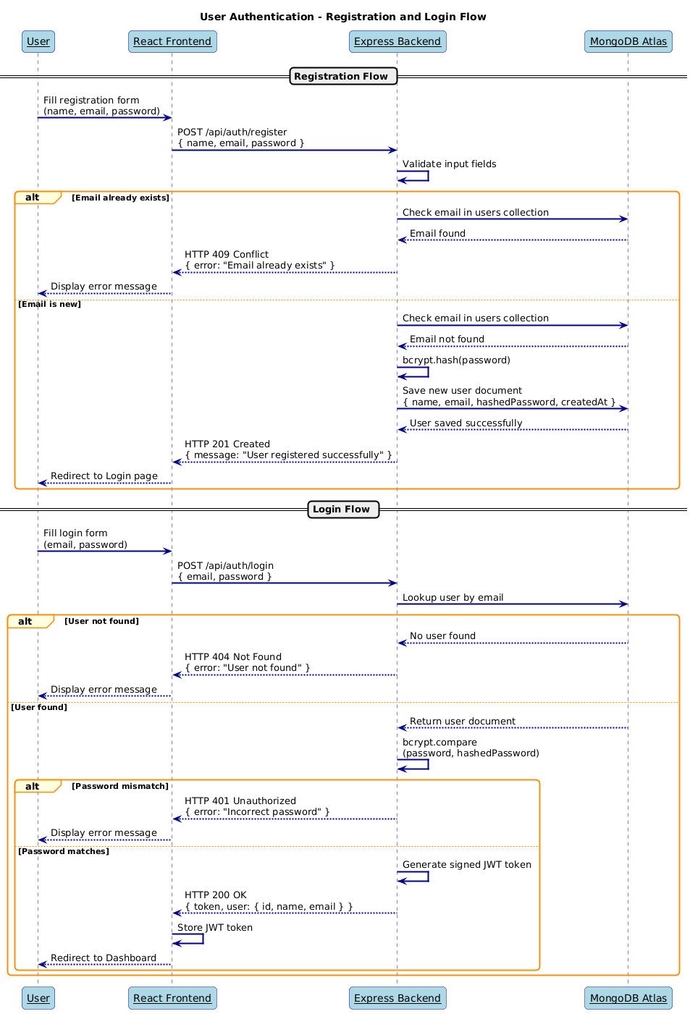
Figure 3: Sequence Diagram - Login and Registration

Document Management
ID | Requirement
FR-07 | The system SHALL allow authenticated users to upload documents in PDF format
FR-08 | The system SHALL reject any file exceeding 10MB in size and return a descriptive error
FR-09 | The system SHALL reject file formats other than PDF
FR-10 | The system SHALL store document metadata (filename, size, upload time, user ID) in the MongoDB documents collection
FR-11 | The system SHALL forward the uploaded document to the Python RAG microservice for chunking and embedding after successful upload

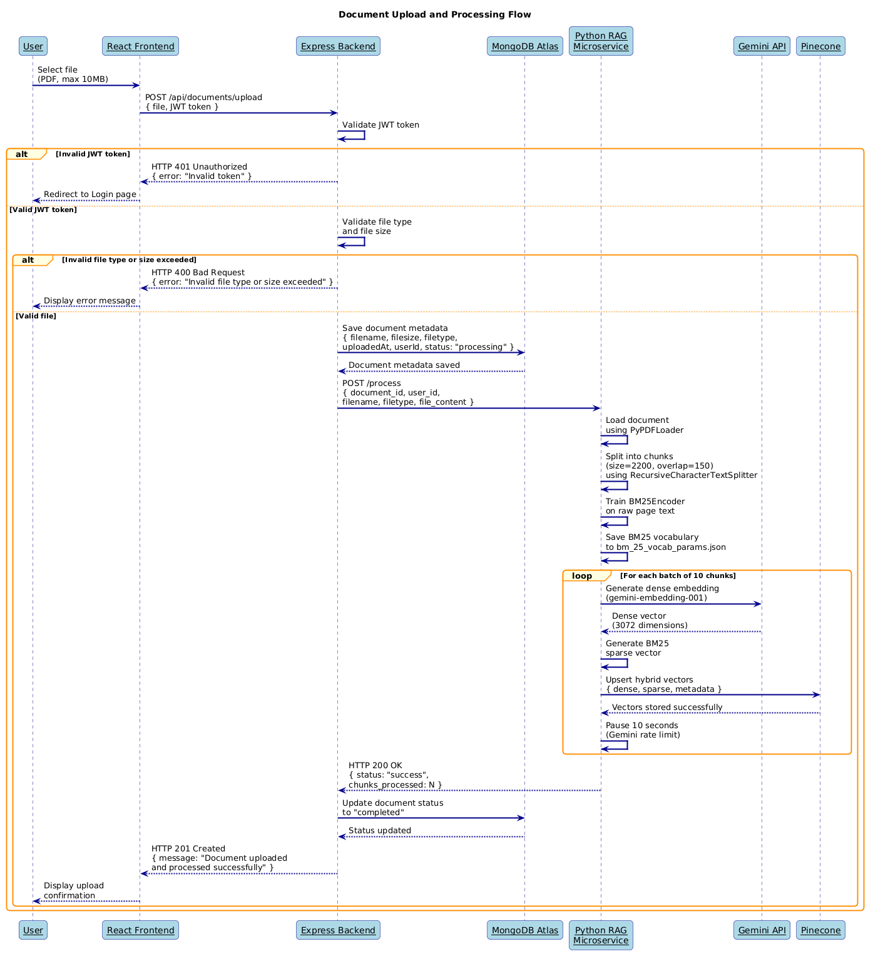
Figure 4: Sequence Diagram - Document Upload and Processing

Chat and Q&A Interface
ID | Requirement
FR-12 | The system SHALL allow authenticated users to send a natural language question through the chat interface
FR-13 | The system SHALL forward the user query to the Python RAG microservice via an internal HTTP request
FR-14 | The system SHALL retrieve the top 3 most relevant chunks from Pinecone using hybrid search combining dense Gemini embeddings and sparse BM25 vectors with Dynamic Alpha Weighting
FR-15 | The system SHALL construct a prompt using the retrieved chunks as context and send it to the Groq LLM API (llama-3.1-8b-instant).
FR-16 | The system SHALL return the LLM-generated response to the React frontend for display
FR-17 | The system SHALL save both the user message and the AI response in the MongoDB chats collection with role, content, and timestamp

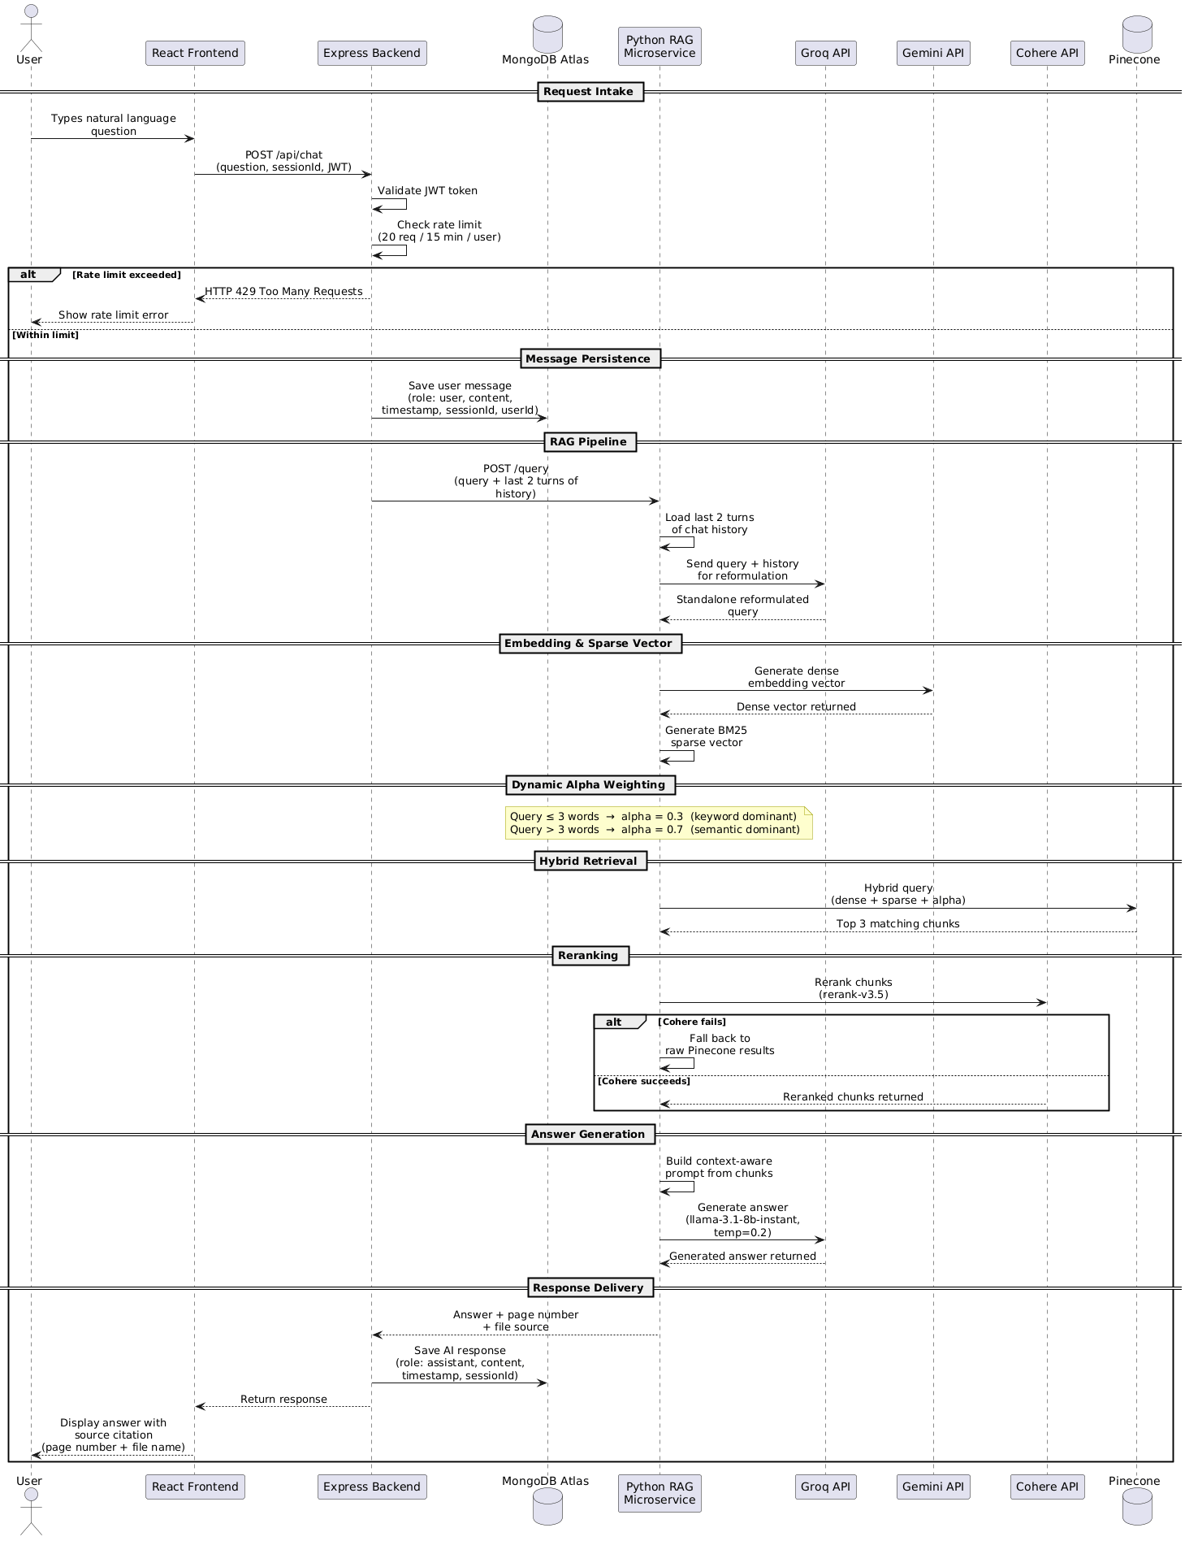
Figure 5: Sequence Diagram - Chat and Q&A Flow

RAG Pipeline
ID | Requirement
FR-18 | The RAG microservice SHALL split uploaded documents into text chunks using RecursiveCharacterTextSplitter with chunk size of 2200 characters and overlap of 150 characters
FR-19 | The RAG microservice SHALL generate dense embedding vectors for each chunk using Google Gemini (gemini-embedding-001) with 3072 dimensions
FR-20 | The RAG microservice SHALL generate sparse keyword vectors for each chunk using a trained BM25Encoder
FR-21 | The RAG microservice SHALL train the BM25Encoder on the raw document text to learn domain-specific vocabulary before encoding
FR-22 | The RAG microservice SHALL upload hybrid vectors (dense + sparse) along with metadata (document ID, chunk index, page number, file name) to Pinecone using dotproduct metric
FR-23 | The RAG microservice SHALL apply Dynamic Alpha Weighting during retrieval: alpha=0.3 for queries of 3 words or fewer (keyword-dominant) and alpha=0.7 for queries longer than 3 words (semantic-dominant)
FR-24 | The RAG microservice SHALL retrieve the top 3 most relevant hybrid chunks from Pinecone for each query
FR-25 | The RAG microservice SHALL rerank the retrieved chunks using Cohere rerank-v3.5 cross-encoder model for improved relevance scoring
FR-26 | The RAG microservice SHALL fall back to raw Pinecone results if the Cohere reranking call fails
FR-27 | The RAG microservice SHALL construct a context-aware prompt using the reranked chunks and pass it to Groq (llama-3.1-8b-instant) for final answer generation
FR-28 | The RAG microservice SHALL return the generated answer along with source metadata (page number, file name) to the Express backend

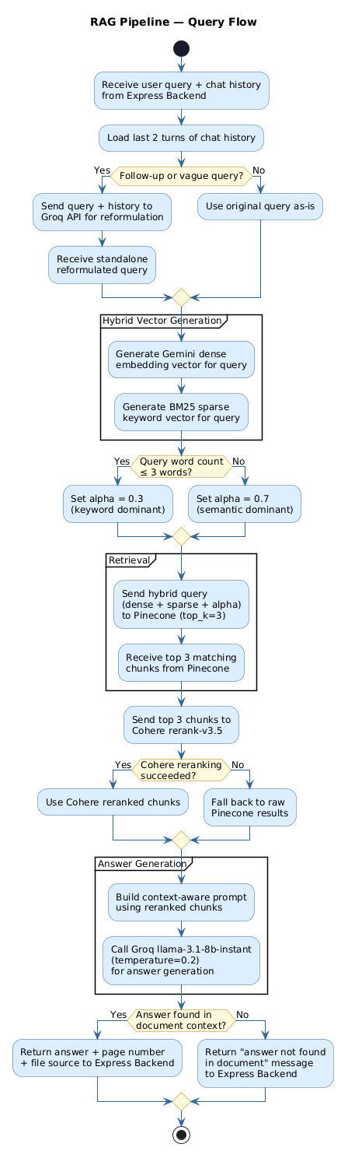
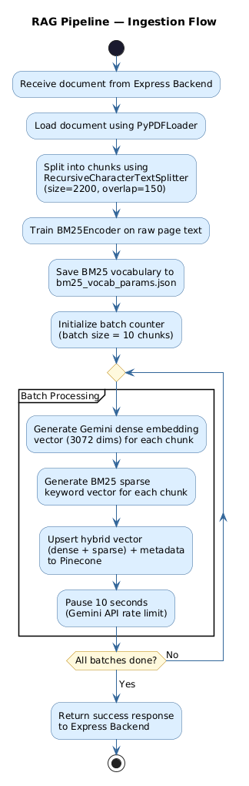

Figure 6: Activity Diagram - RAG Pipeline

Chat History
ID | Requirement
FR-29 | The system SHALL persist every user message and AI response in the MongoDB chats collection
FR-30 | The system SHALL associate each chat message with a session ID, user ID, role (user or assistant), content, and timestamp
FR-31 | The system SHALL allow authenticated users to retrieve the full chat history for a specific session
FR-32 | The system SHALL only return chat history belonging to the currently authenticated user
FR-33 | The system SHALL display chat history in chronological order in the React frontend

Session Management
ID | Requirement
FR-34 | The system SHALL create a new session when a user initiates a new conversation
FR-35 | The system SHALL associate each session with the authenticated user ID
FR-36 | The system SHALL prevent users from accessing sessions that do not belong to them

Requirements Traceability Summary
The table below summarizes all functional requirements by module for quick reference and traceability during development and evaluation.
Module | Requirement IDs | Total
User Authentication | FR-01 to FR-06 | 6
Document Management | FR-07 to FR-11 | 5
Chat and Q&A Interface | FR-12 to FR-17 | 6
RAG Pipeline | FR-18 to FR-28 | 11
Chat History | FR-29 to FR-33 | 5
Session Management | FR-34 to FR-36 | 3
Total | FR-01 to FR-36 | 36

External Interface Requirements
Non-functional requirements define the quality attributes and constraints of the ChatDocs system. These requirements govern how the system performs its functions rather than what functions it performs.

User Interface
- The frontend SHALL be built using React.js and accessible through any modern web browser (Chrome, Firefox, Edge) without any installation
- The UI SHALL include a registration page and login page accessible to unauthenticated users only
- The UI SHALL include a document upload page where authenticated users can upload PDF
- The UI SHALL include a document list page showing all documents uploaded by the authenticated user
- The UI SHALL include a real-time chat interface where users can type questions and receive AI-generated responses
- The chat interface SHALL display messages in chronological order with clear visual distinction between user messages and AI responses
- The chat interface SHALL display source citations (page number and file name) alongside each AI-generated response
- The UI SHALL display appropriate error messages for failed uploads, invalid file types, rate limit violations, and authentication failures
- The UI SHALL never display any API keys, internal service URLs, or backend environment variables

Software Interfaces
External Service | Purpose | Interface Type
Express Backend | Handles all client requests from React | REST API over HTTP/HTTPS
MongoDB Atlas | Persistent storage for users, documents, chats, sessions | Mongoose ODM over secured connection string
Python RAG Microservice | Document processing and Q&A | Internal REST API over HTTP (not public)
Groq API (llama-3.1-8b-instant) | Query reformulation and answer generation | REST API over HTTPS using Groq API key
Google Gemini API (gemini-embedding-001) | Dense embedding vector generation | REST API over HTTPS using Gemini API key
Cohere API (rerank-v3.5) | Cross-encoder reranking of retrieved chunks | REST API over HTTPS using Cohere API key
Pinecone | Hybrid vector storage and similarity search | Pinecone SDK over HTTPS using Pinecone API key

Communication Interfaces
- All communication between the React frontend and Express backend SHALL use HTTP/HTTPS REST protocol
- All requests to protected Express routes SHALL include a valid JWT token in the Authorization header using Bearer schema
- The Express backend SHALL communicate with the Python RAG Microservice over internal HTTP only. This communication SHALL NOT be exposed to the public internet
- All communication between the Python RAG Microservice and external APIs (Groq, Gemini, Cohere, Pinecone) SHALL use HTTPS
- All API keys SHALL be passed as environment variables and included only in server-side request headers. They SHALL never appear in any client-facing request or response
- The system SHALL use standard HTTP status codes for all API responses

Non-Functional Requirements

Performance
ID | Requirement
NFR-01 | The system SHALL return a complete chat response (including RAG pipeline and LLM generation) within 10 seconds under normal operating conditions
NFR-02 | The document upload and processing (chunking, embedding, Pinecone upsert) SHALL complete within 120 seconds for a document of 10MB or less
NFR-03 | The React frontend SHALL load the initial page within 3 seconds on a standard broadband connection
NFR-04 | The Express backend SHALL respond to authentication requests (login, register) within 2 seconds
NFR-05 | The system SHALL support at least 10 concurrent users without significant degradation in response time

Security
ID | Requirement
NFR-06 | All passwords SHALL be hashed using bcrypt before storage in MongoDB. Plain text passwords SHALL never be stored
NFR-07 | All protected API routes SHALL require a valid JWT token in the Authorization header
NFR-08 | JWT tokens SHALL have a defined expiry time after which the user must re-authenticate
NFR-09 | All API keys (Groq, Gemini, Cohere, Pinecone) SHALL be stored exclusively as server-side environment variables and SHALL never be exposed in any client-facing request, response, or frontend code
NFR-10 | The Python RAG Microservice SHALL not be accessible from the public internet and SHALL only accept requests from the Express backend
NFR-11 | File uploads SHALL be validated for both file type and file size on the server side regardless of client-side validation
NFR-12 | All communication between the client and server SHALL use HTTPS in production
NFR-13 | MongoDB connection strings SHALL be stored as environment variables and never hardcoded in source code

Scalability
ID | Requirement
NFR-14 | The Pinecone vector database SHALL be capable of scaling to accommodate a growing number of document embeddings without requiring architectural changes
NFR-15 | MongoDB Atlas SHALL be used as the cloud database to ensure managed scaling of persistent storage
NFR-16 | Each service (frontend, backend, RAG microservice) SHALL be independently deployable and scalable without affecting other services

Availability and Reliability
ID | Requirement
NFR-17 | The system SHALL target an uptime of 99% during active usage periods
NFR-18 | The RAG microservice SHALL gracefully fall back to raw Pinecone results if the Cohere reranking API call fails, ensuring uninterrupted service
NFR-19 | The system SHALL return descriptive error messages for all failure scenarios including invalid input, service unavailability, and rate limit violations
NFR-20 | The system SHALL not crash or produce undefined behavior when an unsupported file type or oversized file is uploaded

Maintainability
ID | Requirement
NFR-21 | The codebase SHALL follow a modular architecture with clear separation of concerns across the React frontend, Express backend, and Python RAG microservice
NFR-22 | All system prompts for Groq (answer generation and query reformulation) SHALL be stored in separate text files and not hardcoded in source code
NFR-23 | Environment variables SHALL be managed using a .env file with a corresponding .env.example template committed to the repository
NFR-24 | The system SHALL not crash or produce undefined behavior when an unsupported file type or oversized file is uploaded

Usability
ID | Requirement
NFR-25 | The chat interface SHALL display AI responses with source citations (page number and file name) so users can verify answer origins
NFR-26 | The system SHALL display clear and descriptive error messages for all user-facing failure scenarios
NFR-27 | The document upload interface SHALL show confirmation feedback after a successful upload and processing
NFR-28 | The chat interface SHALL clearly distinguish between user messages and AI-generated responses through visual differentiation

Summary of all Non-Functional Requirements
Module | IDs
Performance | NFR-01 to NFR-05
Security | NFR-06 to NFR-13
Scalability | NFR-14 to NFR-17
Availability and Reliability | NFR-18 to NFR-20
Maintainability | NFR-21 to NFR-24
Usability | NFR-25 to NFR-28
Total | NFR-01 to NFR-28

System Architecture

Architectural Overview
ChatDocs follows a microservices-based architecture composed of four independently deployable services. The React frontend communicates exclusively with the Express backend via REST API. The Express backend acts as the central coordinator, handling authentication, data persistence, and internal routing to the Python RAG microservice. The Python RAG microservice handles all AI-related operations and communicates with three external AI services (Groq, Gemini, Cohere) and Pinecone vector database.

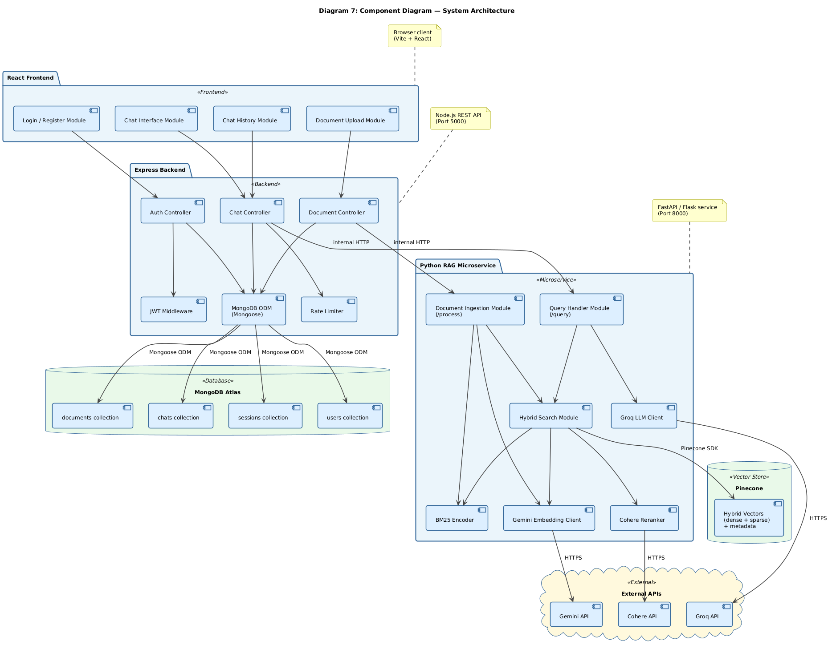
Figure 7: Component Diagram — System Architecture

Component Descriptions
Component | Technology | Responsibility
React Frontend | React.js | Renders UI, handles user input, displays chat responses and source citations, communicates with Express via REST
Express Backend | Node.js + Express.js | Handles authentication, rate limiting, document metadata storage, chat history persistence, proxies requests to RAG microservice
Python RAG Microservice | Python + FastAPI or Flask | Document ingestion, hybrid embedding, Pinecone vector storage, query reformulation, hybrid retrieval, Cohere reranking, Groq answer generation
MongoDB Atlas | MongoDB | Persistent cloud storage for users, sessions, documents, and chat history
Pinecone | Vector Database | Stores and retrieves hybrid vectors (dense + sparse) for semantic and keyword-based document search
Groq API | llama-3.1-8b-instant | LLM inference for query reformulation (temperature=0.0) and answer generation (temperature=0.2)
Gemini API | gemini-embedding-001 | Generates 3072-dimensional dense embedding vectors for document chunks and user queries
Cohere API | rerank-v3.5 | Cross-encoder reranking of top 3 retrieved Pinecone chunks for improved relevance scoring

Data Flow
Document Ingestion Flow:
- User uploads document via React frontend
- Express backend validates JWT token
- Express backend validates file type and size
- Express saves document metadata to MongoDB
- Express forwards document to Python RAG microservice /process endpoint
- RAG microservice chunks document (size=2200, overlap=150)
- RAG microservice trains BM25Encoder on raw page text and saves vocabulary
- For each batch of 10 chunks: Gemini generates dense vector, BM25 generates sparse vector
- RAG microservice upserts hybrid vectors with metadata to Pinecone
- Success response returned to React via Express
Query and Answer Flow:
- User submits question via React chat interface
- Express validates JWT token and checks rate limit
- Express saves user message to MongoDB chats collection
- Express forwards query and last 2 turns of chat history to RAG microservice /query endpoint
- Groq reformulates query into a standalone query
- Gemini generates dense embedding for reformulated query
- BM25 generates sparse vector for reformulated query
- Dynamic Alpha Weighting applied (alpha=0.3 for short queries, alpha=0.7 for long queries)
- Pinecone hybrid search returns top 3 chunks
- Cohere rerank-v3.5 reranks chunks (fallback to raw results if Cohere fails)
- Context-aware prompt built using reranked chunks
- Groq llama-3.1-8b-instant generates final answer
- RAG microservice returns answer with page number and file source
- Express saves AI response to MongoDB chats collection
- React displays answer with source citation in chat interface

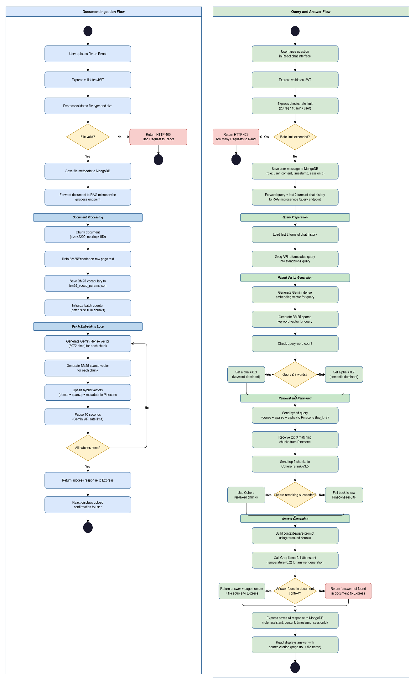
Figure 8: Activity Diagram — End-to-End Data Flow

Deployment Architecture
All services are containerized using Docker and orchestrated locally using Docker Compose. In production, each service is deployed as an independent container on a cloud platform supporting Docker-based deployments.
The system SHALL be deployed on a cloud platform supporting containerized Docker deployments. Google Cloud Platform (Cloud Run) is the preferred deployment target, with Railway and Render as alternative options. All three platforms support Docker containers and environment variable configuration required by this system
Service | Container | Deployment Target
React Frontend | Docker container (Node.js build) | GCP Cloud Run / Railway / Render
Express Backend | Docker container (Node.js 18+) | GCP Cloud Run / Railway / Render
Python RAG Microservice | Docker container (Python 3.10+) | GCP Cloud Run / Railway / Render
MongoDB | MongoDB Atlas (cloud-hosted, no container) | MongoDB Atlas Cloud
Pinecone | Pinecone cloud service (no container) | Pinecone Cloud

Local Development:
- All three application containers (React, Express, Python RAG) are orchestrated using Docker Compose
- MongoDB Atlas is accessed remotely via connection string during both local development and production
- Pinecone is accessed remotely via Pinecone SDK during both local development and production
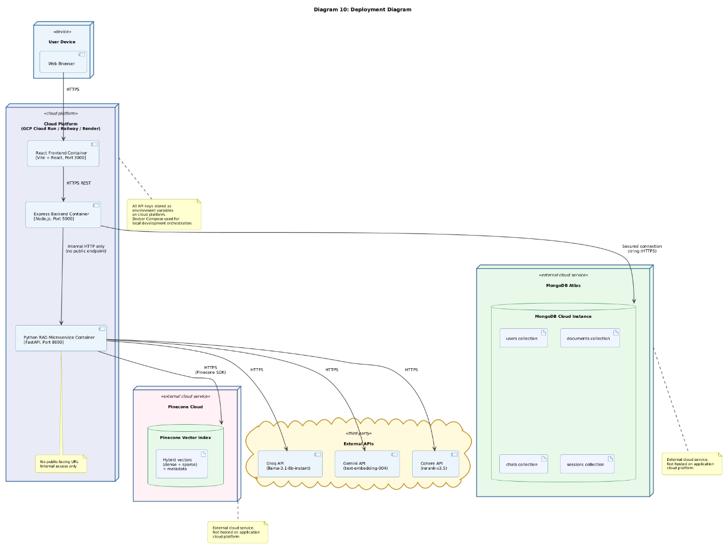
Figure 9: Deployment Diagram — System Infrastructure

Security Architecture
- The Python RAG Microservice is deployed without a public URL. It is accessible only via internal service-to-service communication from the Express backend
- All API keys (Groq, Gemini, Cohere, Pinecone) and the MongoDB connection string are stored as cloud platform environment variables and never hardcoded in source code
- JWT middleware on Express intercepts and validates every request to protected routes before any business logic is executed
- bcrypt password hashing ensures that even in the event of a database breach, plain text passwords are not exposed
- Rate limiting on Express (20 requests per 15 minutes per user) prevents abuse of the chat endpoint and protects against excessive LLM API usage
- File validation is enforced on the server side for both file type and file size regardless of any client-side validation

Appendix A: MongoDB Schema Design

A.1 Overview
ChatDocs uses MongoDB Atlas as its cloud database. The database consists of 4 collections: users, documents, chats, and sessions. All documents use MongoDB default ObjectId as the primary identifier.

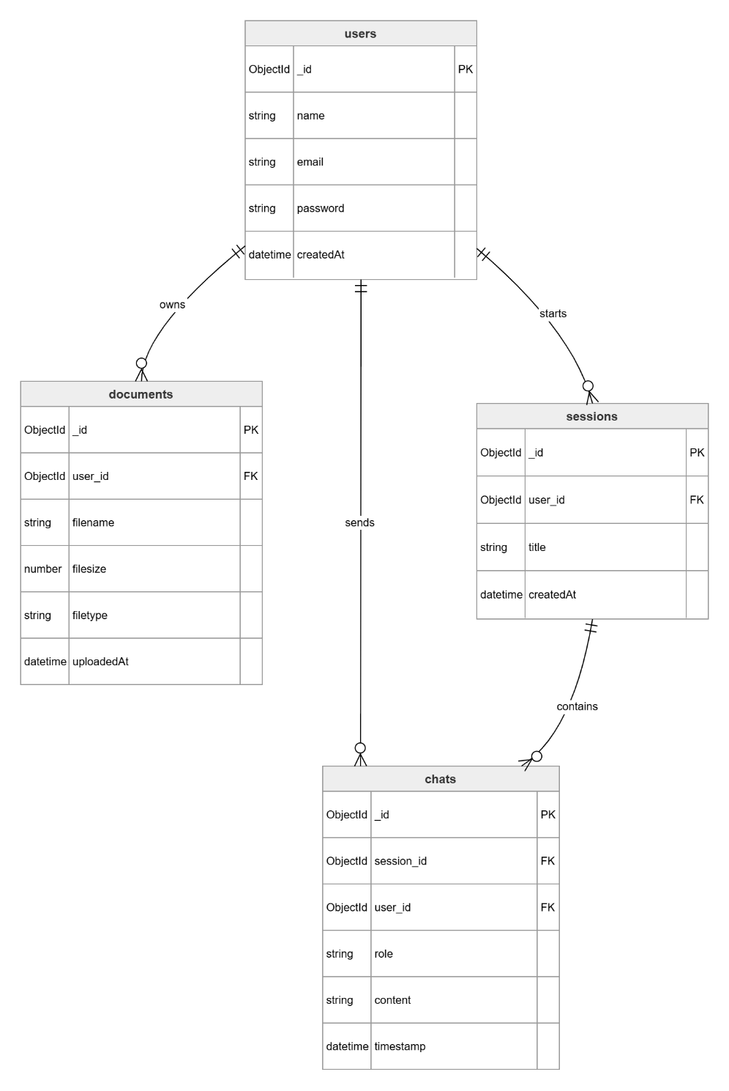
Figure 10: ER Diagram — Database Schema

A.2 Users Collection
Purpose: Stores registered user account information
Field | Type | Required | Description
_id | ObjectId | Yes | Auto-generated unique identifier
name | String | Yes | Full name of the user
email | String | Yes | Unique email address used for login
password | String | Yes | bcrypt hashed password. Plain text never stored
createdAt | Date | Yes | Timestamp of account creation

Constraints:
- email field must be unique across the collection
- password field must always contain a bcrypt hash never a plain text string
Example Document:
{
"_id": "64f1a2b3c4d5e6f7a8b9c0d1",
"name": "Deepanshu Jindal",
"email": "deepanshu@email.com",
"password": "$2b$10$hashedpasswordhere",
"createdAt": "2024-01-15T10:30:00.000Z"
}

A.3 Documents Collection
Purpose: Stores metadata of all uploaded documents. Actual file content is processed and stored in Pinecone as vectors. Raw files are not persisted in MongoDB.
Field | Type | Required | Description
_id | ObjectId | Yes | Auto-generated unique identifier
user_id | ObjectId | Yes | Reference to the user who uploaded the document
filename | String | Yes | Original name of the uploaded file
filesize | Number | Yes | Size of the file in bytes
filetype | String | Yes | File format: PDF, TXT, or DOCX
uploadedAt | Date | Yes | Timestamp of when the document was uploaded
processingStatus | String | Yes | Current status of RAG processing: pending, processing, completed, failed

Example Document:
{
"_id": "64f1a2b3c4d5e6f7a8b9c0d2",
"user_id": "64f1a2b3c4d5e6f7a8b9c0d1",
"filename": "lecture_notes.pdf",
"filesize": 2048576,
"filetype": "PDF",
"uploadedAt": "2024-01-15T11:00:00.000Z",
"processingStatus": "completed"
}

A.4 Sessions Collection
Purpose: Stores individual chat sessions. Each session represents one conversation between the user and the AI about their documents.
Field | Type | Required | Description
_id | ObjectId | Yes | Auto-generated unique identifier
user_id | ObjectId | Yes | Reference to the user who owns this session
title | String | No | Optional auto-generated title for the session based on first message
createdAt | Date | Yes | Timestamp of when the session was created

Example Document:
{
"_id": "64f1a2b3c4d5e6f7a8b9c0d3",
"user_id": "64f1a2b3c4d5e6f7a8b9c0d1",
"title": "Questions about lecture notes",
"createdAt": "2024-01-15T11:05:00.000Z"
}

A.5 Chats Collection
Purpose: Stores all individual chat messages across all sessions. Each document represents a single message, either from the user or the AI assistant.
Field | Type | Required | Description
_id | ObjectId | Yes | Auto-generated unique identifier
user_id | ObjectId | Yes | Reference to the user who owns this message
session_id | ObjectId | Yes | Reference to the session this message belongs to
role | String | Yes | Role of the message sender: user or assistant
content | String | Yes | Text content of the message
sources | Array | No | Array of source citations returned by RAG (page number and filename)
timestamp | Date | Yes | Timestamp of when the message was created

Example Document (User Message):
{
"_id": "64f1a2b3c4d5e6f7a8b9c0d4",
"session_id": "64f1a2b3c4d5e6f7a8b9c0d3",
"user_id": "64f1a2b3c4d5e6f7a8b9c0d1",
"role": "user",
"content": "What is a Binary Search Tree?",
"sources": [],
"timestamp": "2024-01-15T11:06:00.000Z"
}

Example Document (AI Response):
{
"_id": "64f1a2b3c4d5e6f7a8b9c0d5",
"session_id": "64f1a2b3c4d5e6f7a8b9c0d3",
"user_id": "64f1a2b3c4d5e6f7a8b9c0d1",
"role": "assistant",
"content": "A Binary Search Tree is a node-based data structure...",
"sources": [
{ "filename": "lecture_notes.pdf", "page": 42 },
{ "filename": "lecture_notes.pdf", "page": 43 }
],
"timestamp": "2024-01-15T11:06:05.000Z"
}

Appendix B: API Reference

B.1 Overview
The ChatDocs REST API is served by the Express backend. All protected endpoints require a valid JWT token passed in the Authorization header using the Bearer schema. All request and response bodies use JSON format except for file uploads which use multipart/form-data encoding.
Base URL (Local Development):
http://localhost:5000

Base URL (Production):
https://your-cloud-deployment-url

Authentication Header Format:
Authorization: Bearer <jwt_token>

API Summary:
Endpoint | Method | Auth | Description
/api/auth/register | POST | No | Register a new user
/api/auth/login | POST | No | Login and receive JWT token
/api/documents/upload | POST | Yes | Upload a document
/api/documents | GET | Yes | Get all documents for logged in user
/api/chat | POST | Yes | Send a message and get AI response
/api/chat/:sessionId | GET | Yes | Get chat history for a session
/process | POST | Internal | RAG microservice document processing
/query | POST | Internal | RAG microservice query and answer

Notes:
- /process and /query are internal RAG microservice endpoints and are not accessible from the public internet
- All endpoints return standard HTTP status codes as defined in Section 4.3

B.2 Authentication Endpoints
POST /api/auth/register
Description: Register a new user account
Authentication Required: No
Request Body:
Field | Type | Required | Description
name | String | Yes | Full name of the user
email | String | Yes | Unique email address
password | String | Yes | Plain text password (hashed by server)

Response - Success (HTTP 201):
{
"message": "User registered successfully"
}

Response - Failure:
Status code | Reason
400 | Missing required fields
409 | Email already exists
500 | Internal server error

POST /api/auth/login
Description: Login with existing credentials and receive a JWT token
Authentication Required: No
Request Body:
Field | Type | Required | Description
email | String | Yes | Registered email address
password | String | Yes | Plain text password

Response - Success (HTTP 200):
{
"token": "eyJhbGciOiJIUzI1NiIsInR5cCI6IkpXVCJ9...",
"user": {
"id": "64f1a2b3c4d5e6f7a8b9c0d1",
"name": "Deepanshu Sharma",
"email": "deepanshu@email.com"
}
}
Response - Failure:
Status code | Reason
400 | Missing required fields
404 | User not found
401 | Incorrect password
500 | Internal server error

B.3 Document Endpoints
POST /api/documents/upload
Description: Upload a document for processing by the RAG microservice
Authentication Required: Yes
Request Format: multipart/form-data
Field | Type | Required | Description
file | File | Yes | Document file (PDF max 10MB)

Response - Success (HTTP 201):
{
"message": "Document uploaded and processed successfully",
"document": {
"id": "64f1a2b3c4d5e6f7a8b9c0d2",
"filename": "lecture_notes.pdf",
"filesize": 2048576,
"filetype": "PDF",
"uploadedAt": "2024-01-15T11:00:00.000Z",
"processingStatus": "completed"
}
}
Response - Failure:
Status code | Reason
400 | Invalid file type or file exceeds 10MB
401 | Missing or invalid JWT token
500 | Internal server error or RAG processing failure

GET /api/documents
Description: Retrieve all documents uploaded by the authenticated user
Authentication Required: Yes
Request Body: None
Response - Success (HTTP 200):
{
"documents": [
{
"id": "64f1a2b3c4d5e6f7a8b9c0d2",
"filename": "lecture_notes.pdf",
"filesize": 2048576,
"filetype": "PDF",
"uploadedAt": "2024-01-15T11:00:00.000Z",
"processingStatus": "completed"
}
]
}
Response - Failure:
Status code | Reason
401 | Missing or invalid JWT token
500 | Internal server error

B.4 Chat Endpoints
POST /api/chat
Description: Send a user message and receive an AI-generated response grounded in uploaded documents
Authentication Required: Yes
Request Body:
Field | Type | Required | Description
message | String | Yes | Natural language question from the user
session_id | String | Yes | ID of the current chat session

Response - Success (HTTP 200):
{
"response": "A Binary Search Tree is a node-based data structure...",
"sources": [
{ "filename": "lecture_notes.pdf", "page": 42 },
{ "filename": "lecture_notes.pdf", "page": 43 }
],
"session_id": "64f1a2b3c4d5e6f7a8b9c0d3"
}
Response - Failure:
Status code | Reason
401 | Missing or invalid JWT token
429 | Rate limit exceeded (20 requests per 15 minutes)
500 | Internal server error or LLM generation failure

GET /api/chat/:sessionId
Description: Retrieve the full chat history for a specific session
Authentication Required: Yes
URL Parameter:
Parameter | Type | Description
sessionId | String | The ID of the session to retrieve history for

Response - Success (HTTP 200):
{
"session_id": "64f1a2b3c4d5e6f7a8b9c0d3",
"messages": [
{
"role": "user",
"content": "What is a Binary Search Tree?",
"timestamp": "2024-01-15T11:06:00.000Z"
},
{
"role": "assistant",
"content": "A Binary Search Tree is a node-based data structure...",
"sources": [
{ "filename": "lecture_notes.pdf", "page": 42 }
],
"timestamp": "2024-01-15T11:06:05.000Z"
}
]
}
Response - Failure:
Status code | Reason
401 | Missing or invalid JWT token
403 | Session does not belong to authenticated user
404 | Session not found
500 | Internal server error

B.5 Python RAG Microservice Endpoints (Internal Only)
These endpoints are internal to the system and are NOT accessible from the public internet. They are called exclusively by the Express backend.
POST /process
Description: Accepts an uploaded document, chunks it, generates hybrid embeddings and stores vectors in Pinecone
Caller By: Express backend after successful document upload
Request Body:
Field | Type | Required | Description
document_id | String | Yes | MongoDB document ID for metadata reference
user_id | String | Yes | ID of the user who uploaded the document
filename | String | Yes | Original filename
filetype | String | Yes | File format: PDF
file_content | Binary | Yes | Raw file content

Response - Success (HTTP 200):
{
"status": "success",
"message": "Document processed and vectors stored in Pinecone",
"chunks_processed": 45
}
Response - Failure:
Status code | Reason
400 | Invalid or unsupported file format
500 | Embedding generation or Pinecone upsert failure

POST /query
Description: Accepts a user query and chat history, performs hybrid retrieval, reranking and LLM generation, returns a grounded answer
Caller By: Express backend on every chat message
Request Body:
Field | Type | Required | Description
query | String | Yes | User natural language question
user_id | String | Yes | ID of the authenticated user
chat_history | Array | Yes | Last 2 turns of conversation (role + content pairs)

Response - Success (HTTP 200):
{
"answer": "A Binary Search Tree is a node-based data structure...",
"sources": [
{ "filename": "lecture_notes.pdf", "page": 42 },
{ "filename": "lecture_notes.pdf", "page": 43 }
]
}
Response - Failure:
Status code | Reason
400 | Missing query or user_id
500 | Embedding, retrieval, reranking or LLM generation failure

