NAME – DEEPANSHU SHARMA
SAP ID – 590028556
BATCH NO – 19
TOPIC – 1. TIME COMPARISON OF LINEAR AND BINARY SEARCH
2. COMPARISON OF BUBBLE SORT , INSERTION SORT , QUICK SORT , MERGE SORT

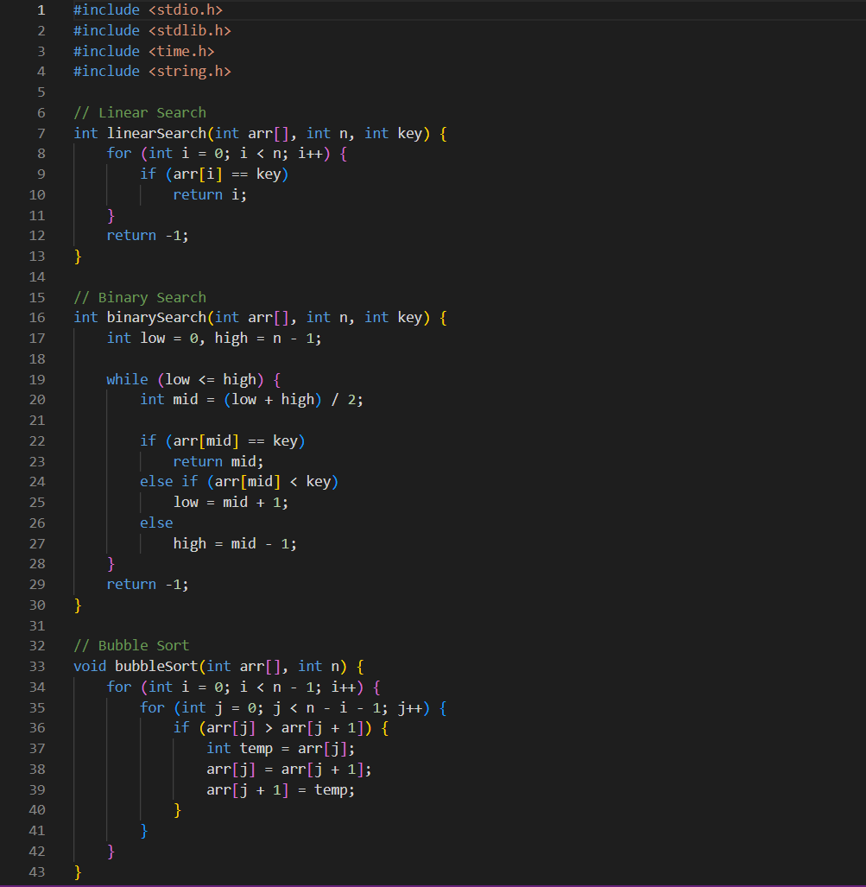
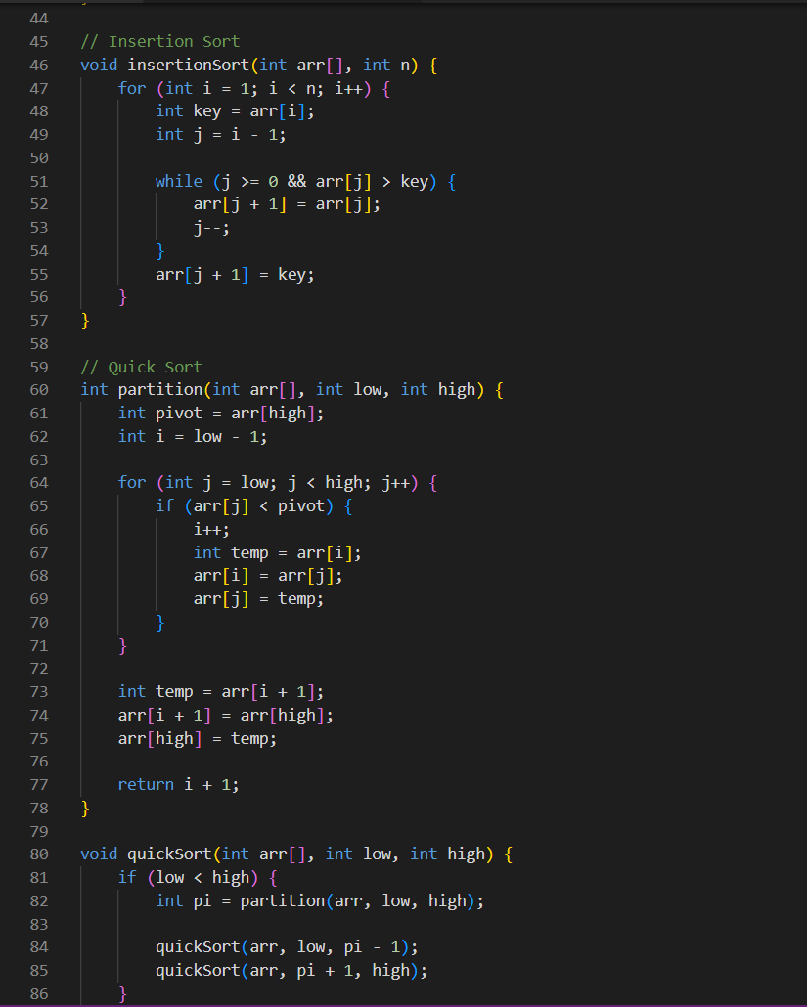
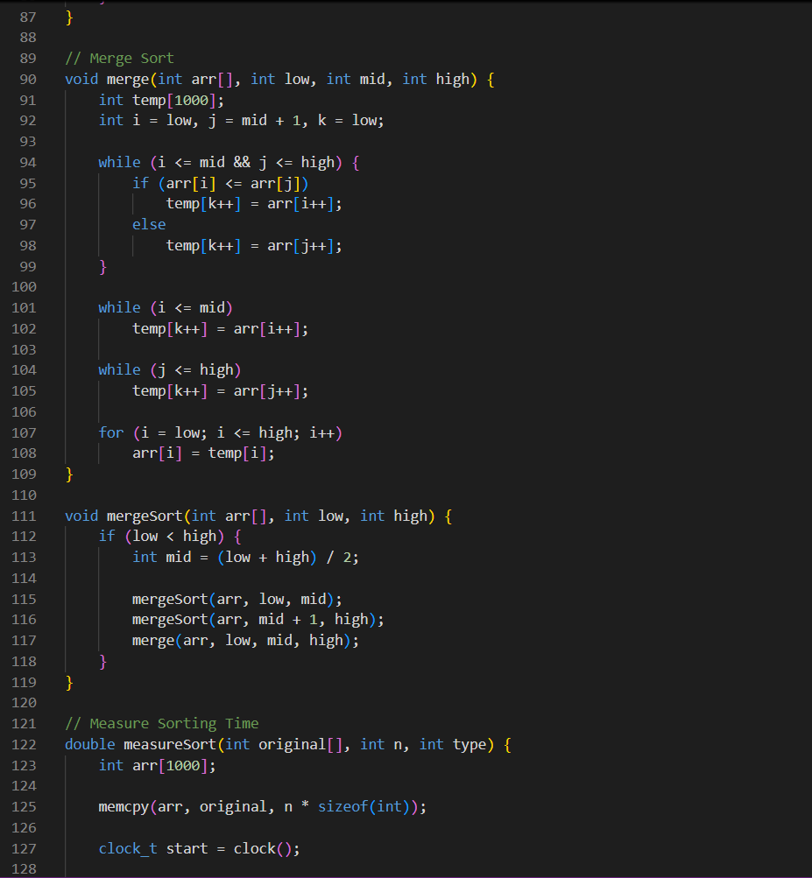
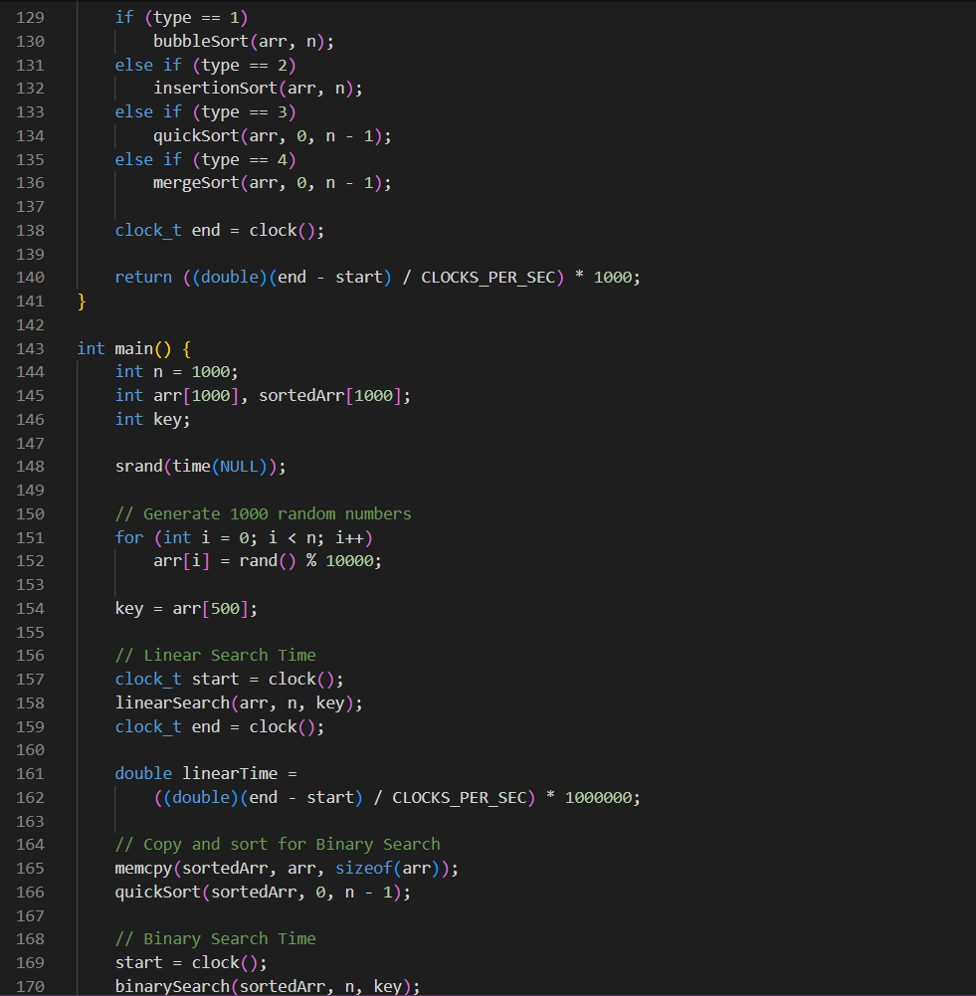
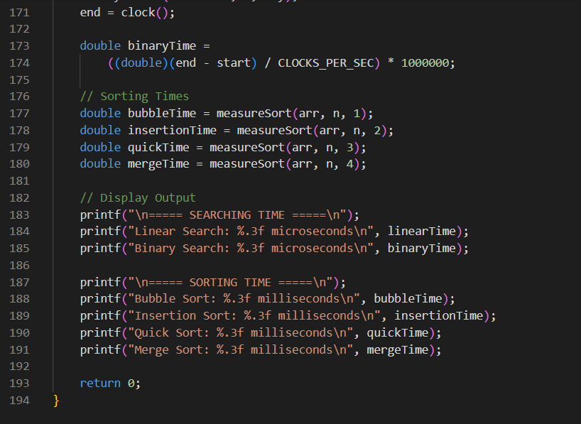
OUTPUT
