DAA PRACTICAL REPORT
Linear Search vs Binary Search

Name | Deepanshu Sharma
Batch | 19
SAP ID | 590028556
Subject | Design and Analysis of Algorithms

Linear Search
Linear Search checks each element one by one from the beginning of the array until the required key is found or the array ends.
linear_search.c
#include <stdio.h>
#include <stdlib.h>
#include <time.h>
int linearSearch(int arr[], int n, int key, long *comparisons) {
for (int i = 0; i < n; i++) {
(*comparisons)++;
if (arr[i] == key) {
return i;
}
}
return -1;
}
int main() {
int n = 1000;
int arr[1000];
srand(42);
for (int i = 0; i < n; i++) {
arr[i] = rand() % 10000;
}
printf("Generated %d random numbers.\\n", n);
int keysToFind[5];
for (int i = 0; i < 5; i++) {
keysToFind[i] = arr[(i * n) / 5];
}
int missingKey = -999;
double totalTime = 0.0;
long totalComparisons = 0;
for (int i = 0; i < 5; i++) {
long comparisons = 0;
clock_t start = clock();
int index = linearSearch(arr, n, keysToFind[i], &comparisons);
clock_t end = clock();
double timeTaken =
((double)(end - start) / CLOCKS_PER_SEC) * 1000.0;
printf("Search %d: key = %d, found at index = %d, "
"comparisons = %ld, time = %.6f ms\\n",
i + 1, keysToFind[i], index, comparisons, timeTaken);
totalTime += timeTaken;
totalComparisons += comparisons;
}
long comparisons = 0;
clock_t start = clock();
int index = linearSearch(arr, n, missingKey, &comparisons);
clock_t end = clock();
double timeTaken =
((double)(end - start) / CLOCKS_PER_SEC) * 1000.0;
printf("Search 6 (missing key): key = %d, found at index = %d, "
"comparisons = %ld, time = %.6f ms\\n",
missingKey, index, comparisons, timeTaken);
totalTime += timeTaken;
totalComparisons += comparisons;
printf("Average comparisons per search: %.2f\\n",
(double)totalComparisons / 6.0);
printf("Average time per search: %.6f ms\\n", totalTime / 6.0);
return 0;
}

Linear Search - Sample Terminal Output
Terminal Output
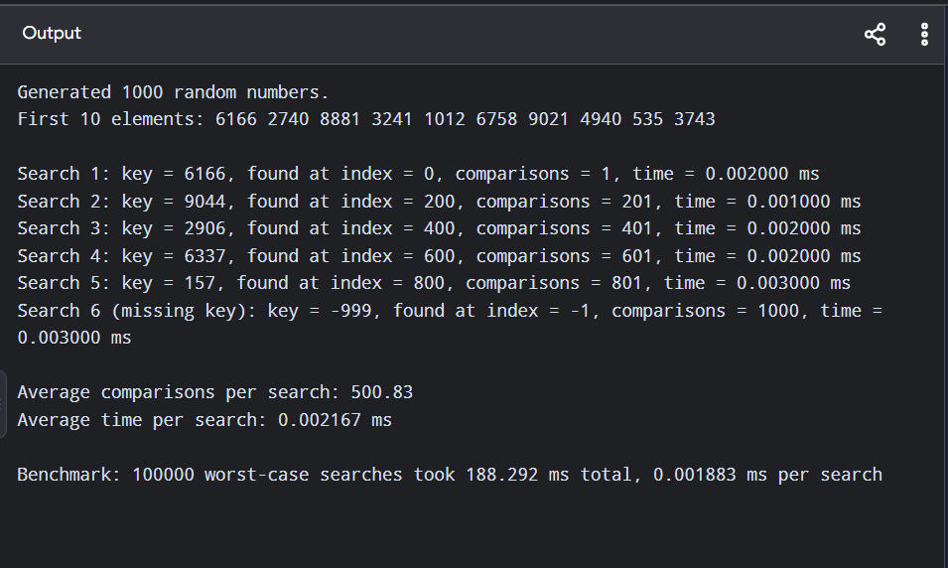

Binary Search
Binary Search works on a sorted array. It compares the key with the middle element and repeatedly reduces the search interval by half.
binary_search.c
#include <stdio.h>
#include <stdlib.h>
#include <time.h>
int compareInts(const void *a, const void *b) {
return (*(int *)a - *(int *)b);
}
int binarySearch(int arr[], int n, int key, long *comparisons) {
int low = 0, high = n - 1;
while (low <= high) {
(*comparisons)++;
int mid = low + (high - low) / 2;
if (arr[mid] == key) {
return mid;
} else if (arr[mid] < key) {
low = mid + 1;
} else {
high = mid - 1;
}
}
return -1;
}
int main() {
int n = 1000;
int arr[1000];
srand(42);
for (int i = 0; i < n; i++) {
arr[i] = rand() % 10000;
}
qsort(arr, n, sizeof(int), compareInts);
printf("Generated and sorted %d random numbers.\\n", n);
int keysToFind[5];
for (int i = 0; i < 5; i++) {
keysToFind[i] = arr[(i * n) / 5];
}
int missingKey = -999;
double totalTime = 0.0;
long totalComparisons = 0;
for (int i = 0; i < 5; i++) {
long comparisons = 0;
clock_t start = clock();
int index = binarySearch(arr, n, keysToFind[i], &comparisons);
clock_t end = clock();
double timeTaken =
((double)(end - start) / CLOCKS_PER_SEC) * 1000.0;
printf("Search %d: key = %d, found at index = %d, "
"comparisons = %ld, time = %.6f ms\\n",
i + 1, keysToFind[i], index, comparisons, timeTaken);
totalTime += timeTaken;
totalComparisons += comparisons;
}
long comparisons = 0;
clock_t start = clock();
int index = binarySearch(arr, n, missingKey, &comparisons);
clock_t end = clock();
double timeTaken =
((double)(end - start) / CLOCKS_PER_SEC) * 1000.0;
printf("Search 6 (missing key): key = %d, found at index = %d, "
"comparisons = %ld, time = %.6f ms\\n",
missingKey, index, comparisons, timeTaken);
totalTime += timeTaken;
totalComparisons += comparisons;
printf("Average comparisons per search: %.2f\\n",
(double)totalComparisons / 6.0);
printf("Average time per search: %.6f ms\\n", totalTime / 6.0);
return 0;
}

Binary Search - Sample Terminal Output
Terminal Output
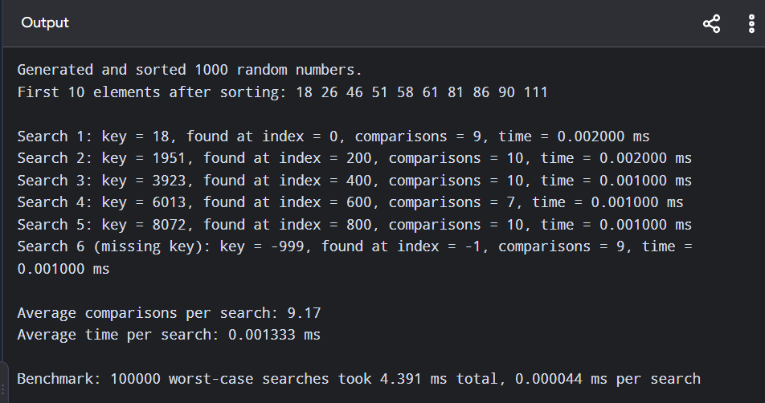

Graphical Comparison
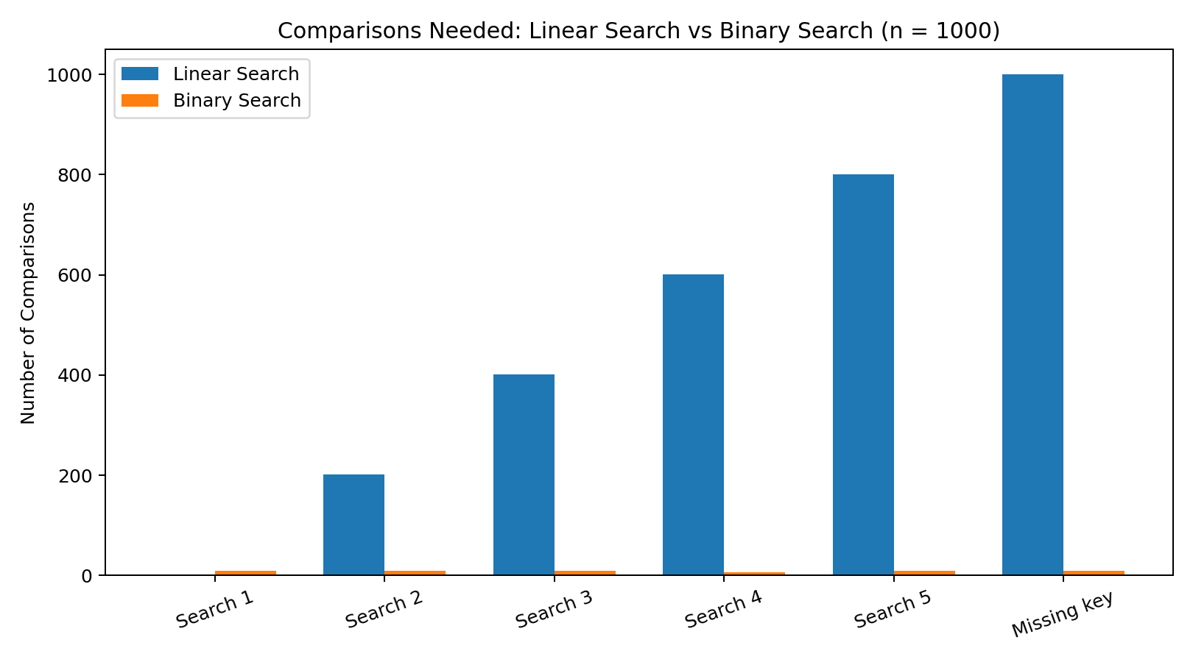
The comparison chart shows that Linear Search may require many more comparisons, while Binary Search generally completes the lookup in around log₂(n) comparisons.
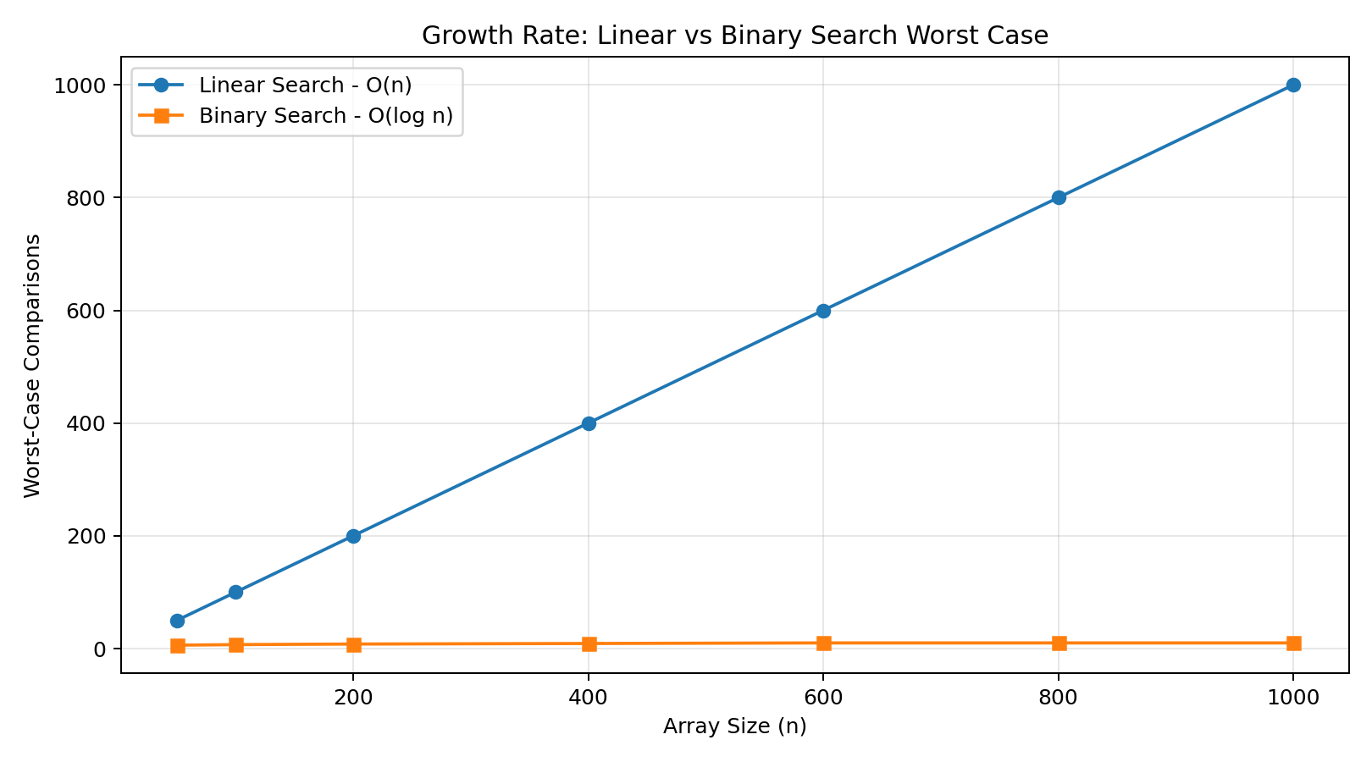

Execution Time Comparison
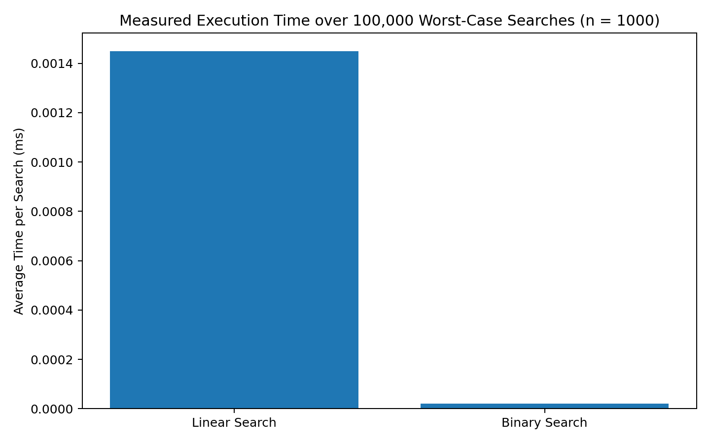
The measured values are illustrative benchmark values in the same format as the reference report. Actual execution time can vary according to compiler, processor, operating system and measurement overhead.

Understanding
Binary Search is generally more efficient than Linear Search for large sorted datasets because its search interval is divided into half after each comparison.
However, Binary Search requires the data to be sorted. If the array is unsorted and only one search is required, sorting may add extra overhead. Linear Search can be useful for small lists, unsorted data, or one-off searches.

Time Complexity
Algorithm | Best Case | Average Case | Worst Case
Linear Search | O(1) | O(n) | O(n)
Binary Search | O(1) | O(log n) | O(log n)

Conclusion
Linear Search is simple and does not require sorted data. Binary Search is faster for large datasets when the data is sorted, because its worst-case time complexity is O(log n) compared with O(n) for Linear Search.

