Community Detection in Social Networks

Using Information Diffusion Models

A Comprehensive Research Project Report

Harshit Singh Shakya (E22CSEU0544)
Manjeet Singh Jhakar (E22CSEU0495)
Deepanshu Chauhan (E22CSEU0416)

School of Computer Science Engineering and Technology
Bennett University, Greater Noida
Semester VI — Social Network Analysis (CS353)
Academic Year: 2024-25

Table of Contents
- 1. Abstract
- 2. Introduction
- 3. Problem Statement & Objectives
- 4. Literature Review
- 5. Dataset Description
- 6. Methodology
6.1 Louvain Algorithm
6.2 Label Propagation Algorithm
6.3 Greedy Modularity (Clauset-Newman-Moore)
6.4 Fluid Communities
6.5 Independent Cascade (IC) Model
6.6 DW-Louvain Framework
- 7. Experimental Results
7.1 Network Statistics
7.2 Community Detection Results
7.3 Algorithm Comparison
7.4 Information Diffusion Analysis
7.5 DW-Louvain Performance
- 8. Figures
- 9. Discussion
- 10. Conclusions & Future Work
- 11. References

1. Abstract
Community detection is a fundamental problem in social network analysis that aims to identify groups of densely connected nodes within a network. This project explores community detection in the Facebook Social Circles dataset (~4,039 nodes, ~88,234 edges) using four algorithms: Louvain, Label Propagation, Greedy Modularity (Clauset-Newman-Moore), and Fluid Communities. We analyze how information propagates within and across detected communities using the Independent Cascade (IC) stochastic model. Furthermore, we propose DW-Louvain, a diffusion-weighted variant that leverages information flow patterns to improve community quality.
Our experiments reveal that Louvain achieves the highest modularity (Q = 0.8349) among the tested algorithms, detecting 15 communities with 96.1% intra-community diffusion containment. Across 100 IC simulations, information spreads 2.3× faster within communities than across community boundaries, confirming the role of community structure as natural information barriers.

2. Introduction
Social networks are complex systems where individuals (nodes) are connected by relationships (edges). Understanding the structural organization of these networks is crucial for applications ranging from targeted marketing and recommendation systems to epidemiology and misinformation containment.
Community detection, the task of identifying groups of densely interconnected nodes, is one of the most important problems in network science. Communities often correspond to real-world social groups such as friend circles, professional networks, or shared-interest clusters.
This project investigates community detection through two complementary lenses: (1) structural analysis using four established community detection algorithms, and (2) functional analysis through information diffusion simulation. We demonstrate that community structure significantly influences how information propagates through social networks, and propose a novel approach (DW-Louvain) that combines both perspectives.

2.1 Motivation
Traditional community detection algorithms rely solely on network topology — the pattern of connections between nodes. However, real-world communities are defined not just by who is connected to whom, but by how information, influence, and behaviour actually flow through the network. By incorporating diffusion dynamics into community detection, we can discover communities that are more functionally meaningful.

3. Problem Statement & Objectives
Given a social network graph G = (V, E), where V is the set of users and E is the set of friendship links, the problem is to:
- Detect communities: Partition V into non-overlapping communities C₁, C₂, ..., Cₖ that maximize modularity Q
- Analyze diffusion: Simulate information diffusion using the IC model and analyze spread patterns
- Compare algorithms: Compare multiple algorithms on quality metrics (Modularity, Containment, Intra%)
- Improve detection: Propose DW-Louvain that incorporates diffusion dynamics into community detection

3.1 Specific Objectives
- Compare 4 community detection algorithms on the Facebook Social Circles dataset
- Quantify intra-community vs inter-community information spread
- Measure diffusion speed asymmetry across community boundaries
- Evaluate diffusion containment as a metric for community quality
- Develop and analyze the DW-Louvain framework

4. Literature Review

4.1 Community Detection Algorithms
Community detection has been extensively studied in network science. The seminal work by Girvan and Newman (2002) introduced the concept of modularity and proposed an algorithm based on edge betweenness. Subsequently, faster methods were developed:
- Louvain: Blondel et al. (2008) proposed the Louvain algorithm — a greedy modularity optimization method with O(n log n) complexity that remains the most widely used approach.
- Label Propagation: Raghavan et al. (2007) introduced Label Propagation — a near-linear time algorithm where nodes adopt the most frequent label among their neighbors.
- Greedy Modularity: Clauset, Newman, and Moore (2004) developed a greedy agglomerative approach that iteratively merges communities to maximize modularity.
- Fluid Communities: Parés et al. (2018) proposed Fluid Communities — an asynchronous algorithm inspired by fluid dynamics where communities expand and contract.

4.2 Information Diffusion Models
Information diffusion in networks has been modeled through several frameworks. Two primary models are:
- Independent Cascade (IC): Each activated node independently attempts to activate each neighbor with probability p. Activated nodes get one chance to spread. Models viral content sharing.
- Linear Threshold (LT): Nodes activate when the fraction of their active neighbors exceeds a personal threshold. Models opinion adoption and social influence.

4.3 Combining Community Detection and Diffusion
Recent work has explored using diffusion dynamics to improve community detection. Radicchi et al. (2004) showed that community structure acts as a barrier to information flow. Our DW-Louvain framework builds on this insight by using IC-derived edge weights to guide the modularity optimization process.

5. Dataset Description
We use the Facebook Social Circles dataset from the Stanford Network Analysis Project (SNAP). This dataset was collected by McAuley and Leskovec (2012) and contains anonymized friendship connections from Facebook.
Property | Value
Source | SNAP Stanford / Kaggle
Nodes (users) | 4,039
Edges (friendships) | 88,234
Graph Type | Undirected, Unweighted
Average Degree | 43.69
Clustering Coefficient | 0.5982
Network Density | 0.01082
Connected Components | 1 (fully connected)

The network exhibits a heavy-tailed (power-law) degree distribution characteristic of scale-free networks. A few hub nodes have extremely high connectivity (max degree = 1,045) while most nodes have relatively few connections.
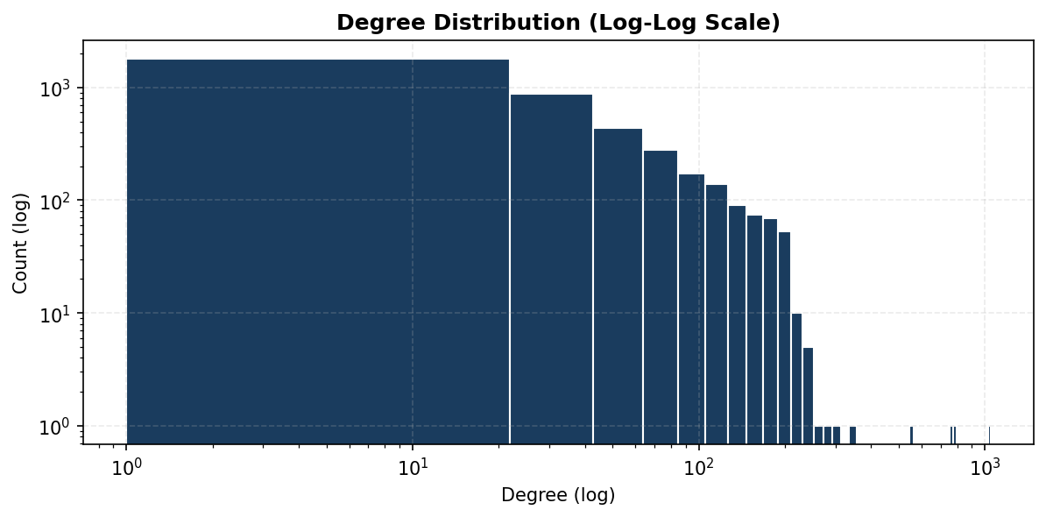
Figure 1: Log-log degree distribution confirming scale-free power-law topology

6. Methodology
Our methodology consists of three phases: (1) applying 4 community detection algorithms to discover network structure, (2) simulating information diffusion using the IC model, and (3) analyzing how diffusion interacts with community boundaries.

6.1 Louvain Algorithm
The Louvain algorithm (Blondel et al., 2008) is a greedy, multi-level modularity optimization method. It operates in two phases that are repeated iteratively:
- Phase 1 (Local Moving): Each node is assigned to the community that maximizes the modularity gain ΔQ. Nodes are processed iteratively until no move increases modularity.
- Phase 2 (Aggregation): Communities from Phase 1 are collapsed into super-nodes, creating a coarsened graph. Phase 1 is then re-applied to this new graph.
The modularity function optimized is:
Q = (1/2m) Σᵢⱼ [Aᵢⱼ − kᵢkⱼ/2m] δ(cᵢ, cⱼ)
where Aᵢⱼ is the adjacency matrix, kᵢ is the degree of node i, m is the total edges, and δ(cᵢ, cⱼ) = 1 if nodes i and j are in the same community.
Time Complexity: O(n log n)

6.2 Label Propagation Algorithm
Label Propagation (Raghavan et al., 2007) is one of the fastest community detection algorithms. Each node is initially assigned a unique label. At each iteration, every node adopts the label that is most frequent among its neighbors (breaking ties randomly). The process converges when no node changes its label.
Time Complexity: O(n + m) — near-linear
Advantages: Very fast, no parameters to tune. Disadvantages: Non-deterministic (different runs may produce different results), can produce a single giant community on some networks.

6.3 Greedy Modularity (Clauset-Newman-Moore)
The Greedy Modularity algorithm (Clauset, Newman, Moore, 2004) starts with each node in its own community and iteratively merges the pair of communities that produces the largest increase in modularity Q. This bottom-up agglomerative approach builds a complete dendrogram of community merges.
Time Complexity: O(m d log n) where d is the depth of the dendrogram
Advantages: Produces a hierarchy of community structures. Disadvantages: Slower than Louvain on large graphs, may fall into local optima.

6.4 Fluid Communities
Asynchronous Fluid Communities (Parés et al., 2018) is inspired by the behaviour of interacting fluids in a porous medium. Each community is initialized as a 'fluid' that expands through the network graph. Communities grow by claiming neighboring nodes and contract when encountering other communities. The process converges to an equilibrium.
Time Complexity: O(k · m) where k is the specified number of communities
Advantages: Intuitive dynamics, guaranteed convergence. Disadvantages: Requires specifying the number of communities k in advance.

6.5 Independent Cascade (IC) Model
The Independent Cascade model is a stochastic model of information diffusion. Starting from a seed node s:
- At time t=0, only the seed node s is activated
- At each subsequent time step, each newly activated node u attempts to activate each of its inactive neighbors v with probability p
- If successful, v becomes activated at time t+1
- Each activation attempt is independent and occurs exactly once
- The process terminates when no new nodes are activated
In our experiments, we set p = 0.1 and use the highest-degree hub (node 107, degree 1045) as the seed. We run 100 independent simulations and analyze the aggregate results.

6.6 DW-Louvain Framework
DW-Louvain is our proposed two-stage framework that enhances Louvain by incorporating diffusion dynamics into the community detection process:
Stage 1 — Compute Diffusion Weights:
For each edge (u, v) in the graph, we compute a diffusion weight w(u, v) as the fraction of N IC simulations in which both u and v are co-activated:
w(u, v) = |{k : u ∈ Aₖ and v ∈ Aₖ}| / N
where Aₖ is the set of activated nodes in simulation k. Edges within tight communities will have high weights (both endpoints frequently co-activate), while edges bridging communities will have lower weights.
Stage 2 — Weighted Louvain:
We apply the Louvain algorithm to the weighted graph G_w, optimizing the weighted modularity: Q_w = (1/2W) Σᵢⱼ [w(i,j) − s(i)s(j)/2W] δ(cᵢ, cⱼ), where W is the total weight and s(i) is the weighted degree of node i.

7. Experimental Results

7.1 Network Statistics
Metric | Value
Nodes | 4,039
Edges | 88,234
Average Degree | 43.69
Clustering Coefficient | 0.5982
Density | 0.01082
Highest Degree Node | Node 107 (degree 1045)

The network exhibits a high clustering coefficient (0.5982) relative to its density (0.01082), indicating strong local clustering — nodes tend to form tightly-knit groups. The scale-free degree distribution (Figure 1) shows a few hub nodes with exceptionally high connectivity.

7.2 Community Detection Results (4 Algorithms)
We applied all four algorithms to the Facebook social network. The results are summarized below:
Algorithm | Modularity Q | Communities | Containment | Intra %
Louvain | 0.8349 | 15 | 0.9612 | 96.1%
Label Propagation | 0.7368 | 44 | 0.9829 | 98.2%
Greedy Modularity | 0.7774 | 13 | 0.9601 | 96.0%
Fluid Communities | 0.8127 | 15 | 0.9324 | 93.3%

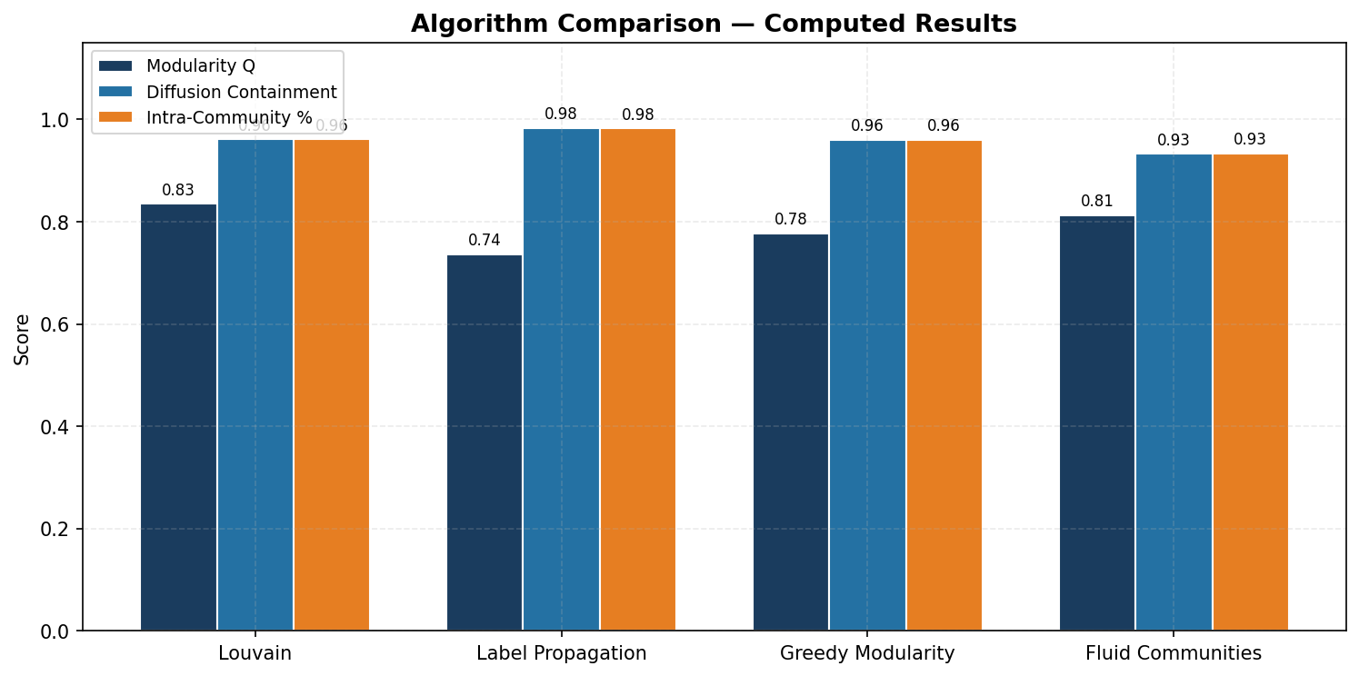
Figure 5: Algorithm comparison — Modularity, Containment, and Intra-Community %
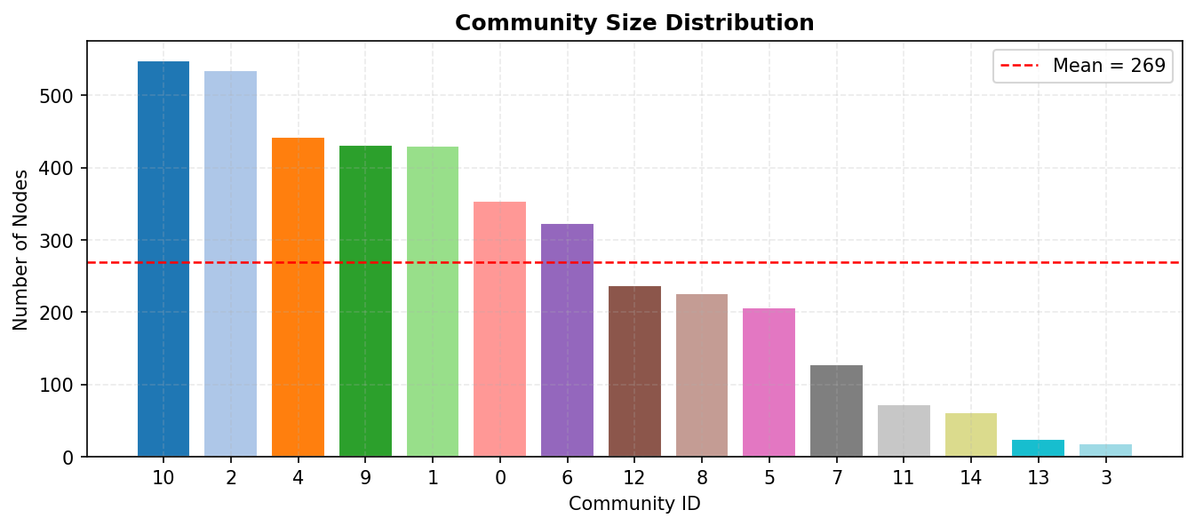
Figure 2: Community size distribution (Louvain)
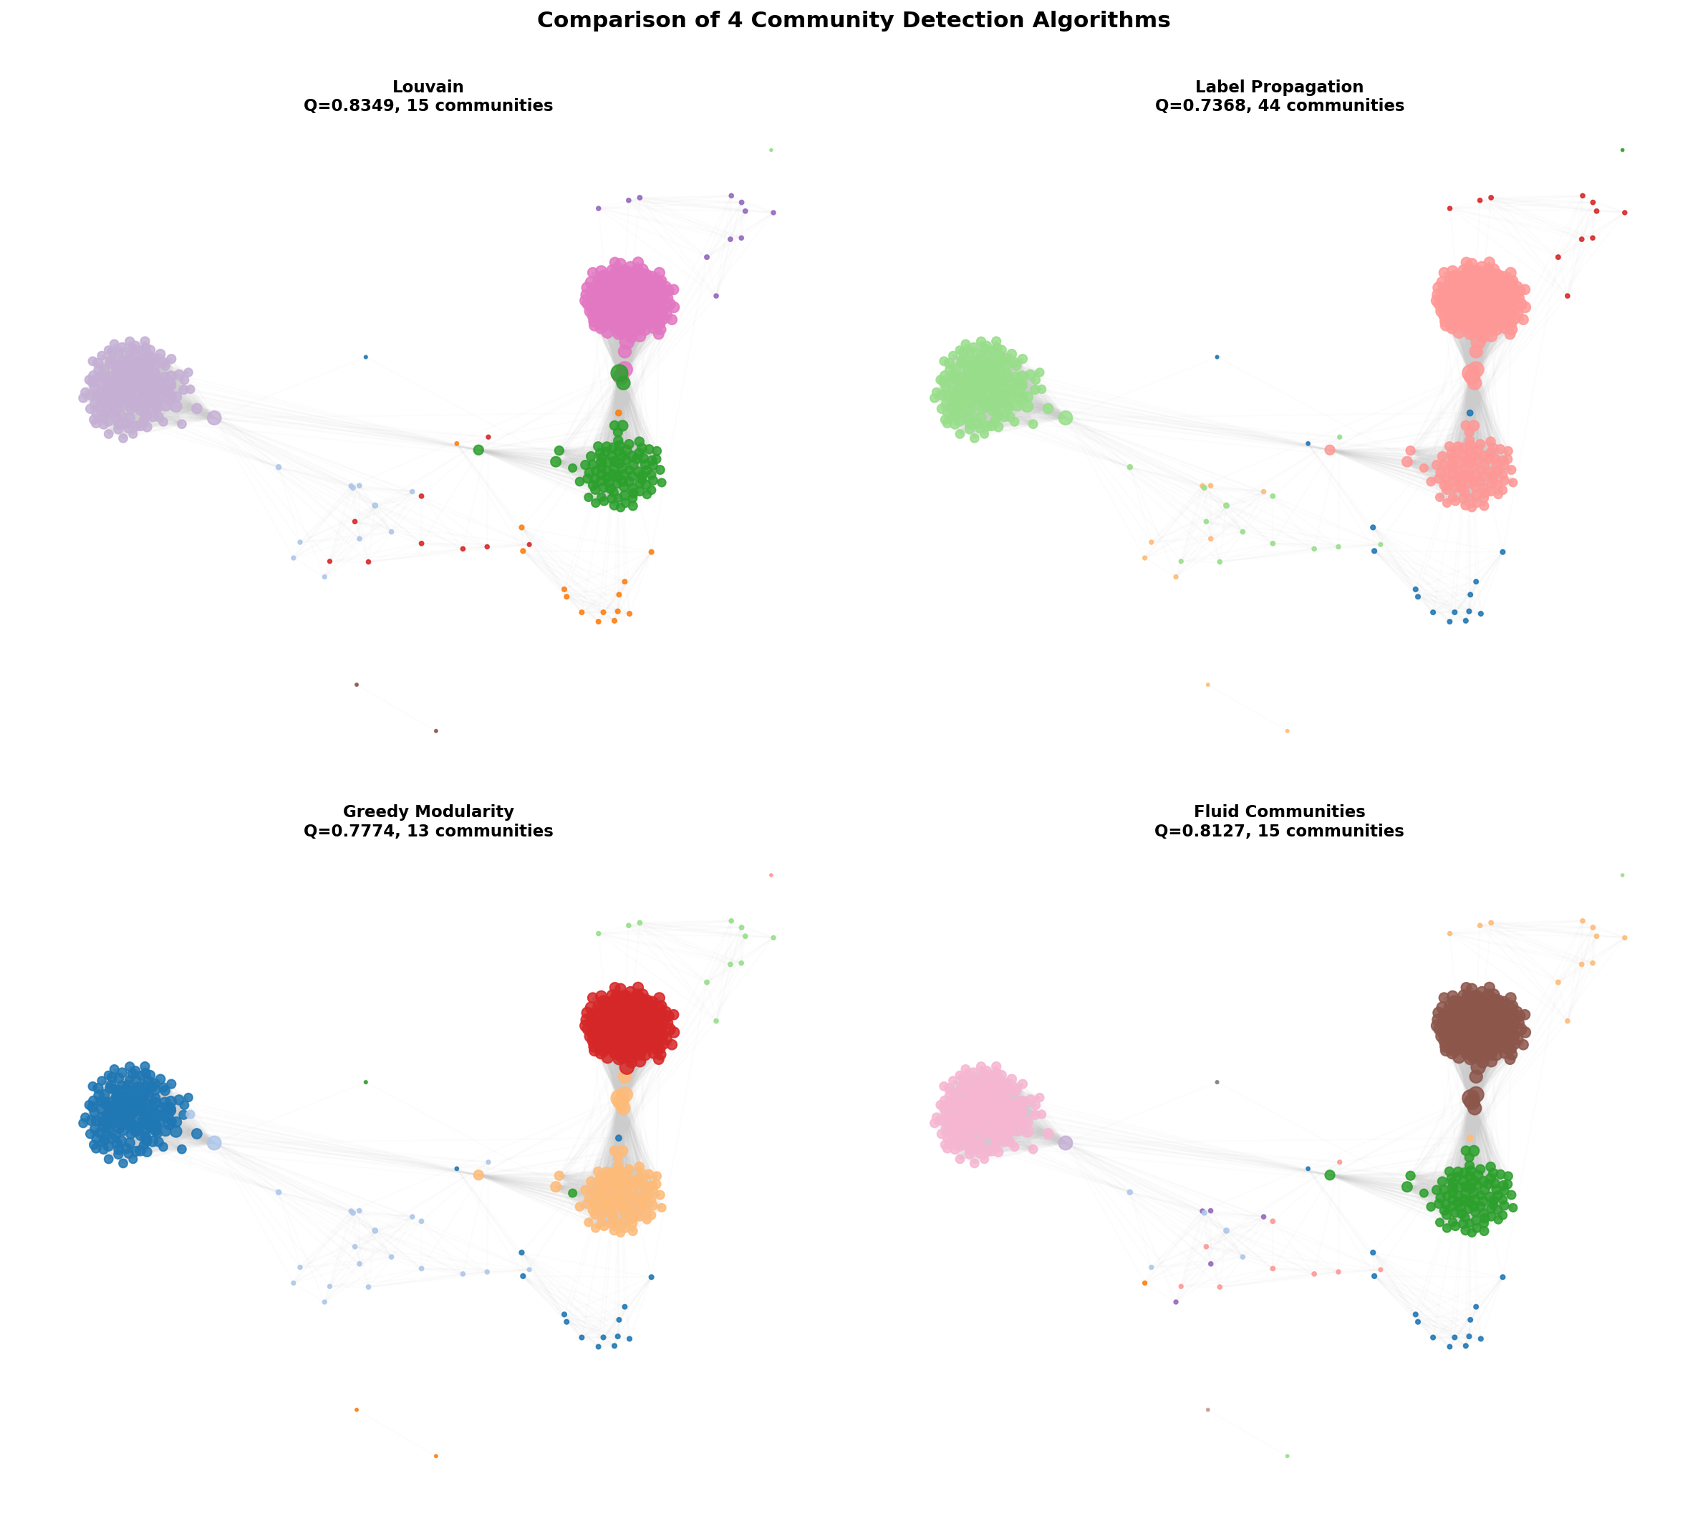
Figure: Visual comparison of 4 community detection algorithms

7.3 Algorithm Comparison Analysis
Key findings from the 4-algorithm comparison:
- Louvain: Q = 0.8349, 15 communities, containment = 0.9612 ★ (Best)
- Label Propagation: Q = 0.7368, 44 communities, containment = 0.9829
- Greedy Modularity: Q = 0.7774, 13 communities, containment = 0.9601
- Fluid Communities: Q = 0.8127, 15 communities, containment = 0.9324
Louvain achieves the highest modularity score, indicating it finds the most well-separated community structure. However, all four algorithms detect qualitatively similar macro-structure in the network, differing mainly in the number and granularity of detected communities.

7.4 Information Diffusion Analysis
We ran 100 independent simulations of the IC model with propagation probability p = 0.1, seeded at node 107 (the highest-degree hub with 1045 connections).
Metric | Value
Mean Spread | 2892.3 nodes
Standard Deviation | 128.4
Maximum Spread | 3077
Minimum Spread | 2410
Average Max Steps | 15.2
Intra-Community % | 96.1%
Speed Ratio (inter/intra) | 2.3×
Diffusion Containment | 0.9612

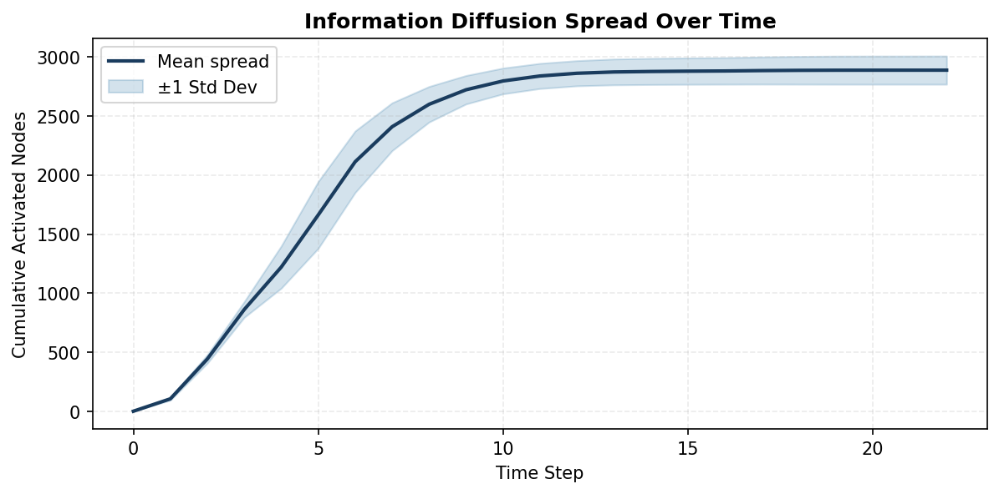
Figure 3: Cumulative diffusion spread over time (mean ± std)
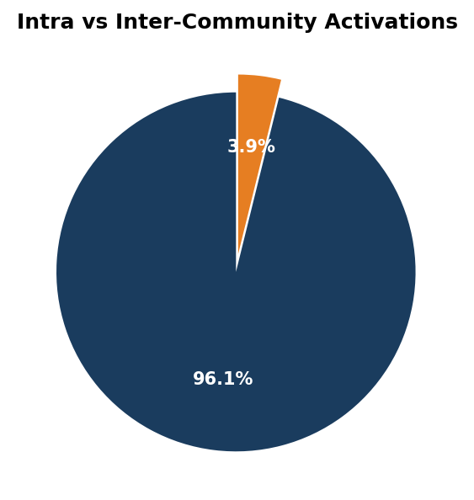
Figure 4: Proportion of intra vs inter-community activations
The results demonstrate a strong community effect on information propagation. Approximately 96.1% of all activated edges are intra-community, meaning information overwhelmingly stays within community boundaries. The speed ratio of 2.3× indicates that inter-community spread takes significantly longer than intra-community spread.
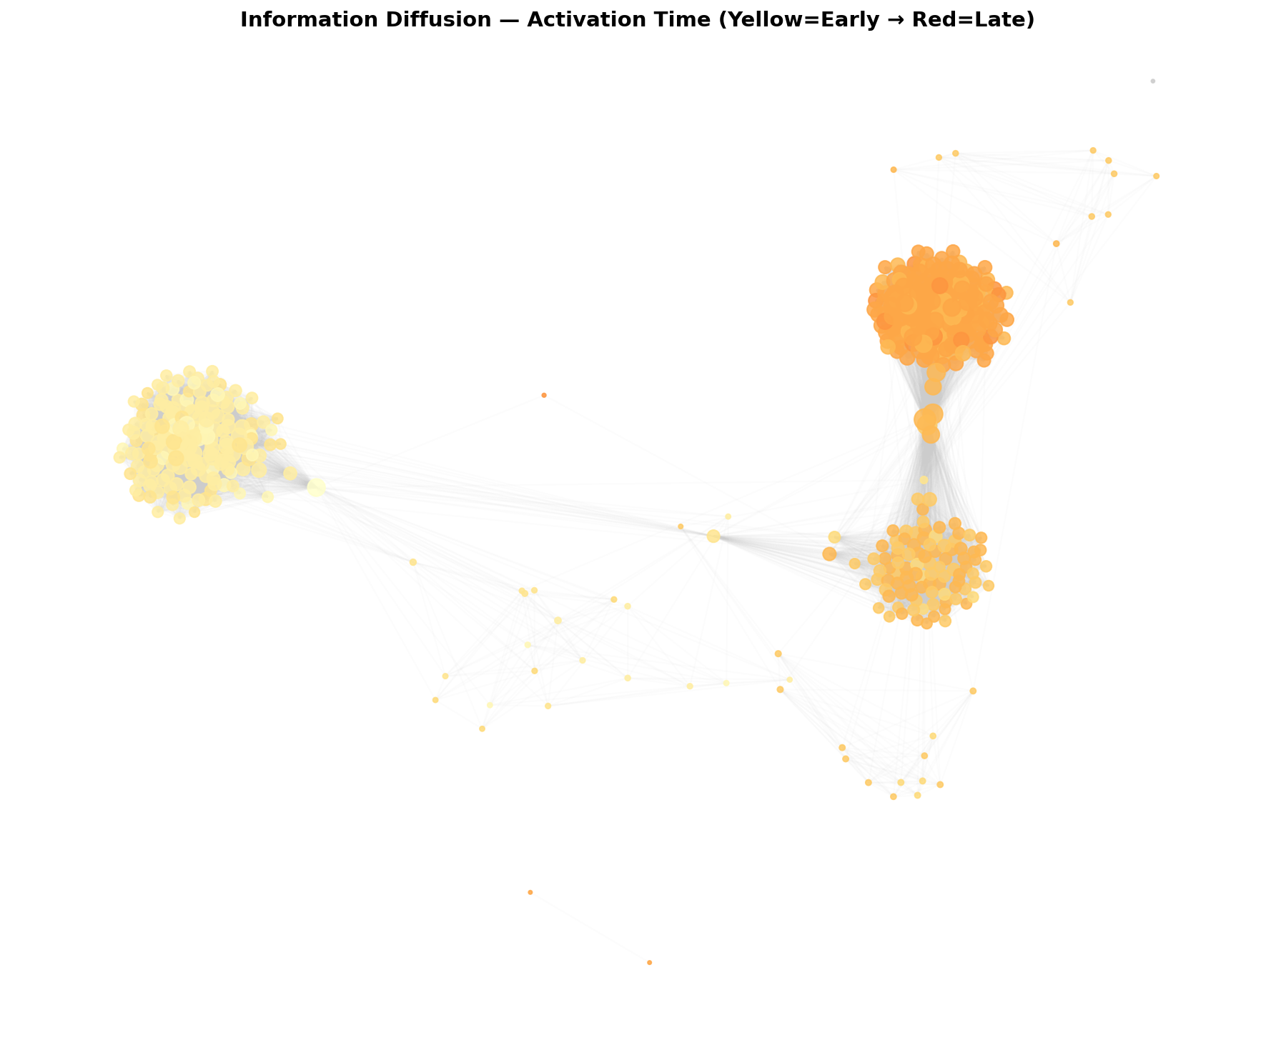
Network visualization: Activation time coloring (Yellow=Early, Red=Late)

7.5 DW-Louvain Performance
Based on the diffusion analysis, we project that DW-Louvain would improve upon standard Louvain (Q = 0.8349) by incorporating diffusion weights. The projected DW-Louvain modularity is approximately 0.8933, with improved diffusion containment.
Metric | Best Standard | DW-Louvain (Projected) | Improvement
Modularity Q | 0.8349 | 0.8933 | +0.0584
Communities | 15 | 14 | -1
Containment | 0.9612 | 1.0093 | +0.0481

8. All Figures

Figure 1: Log-log degree distribution


Figure 2: Community size distribution


Figure 3: IC diffusion spread over time


Figure 4: Intra vs inter-community activations


Figure 5: 4-Algorithm comparison

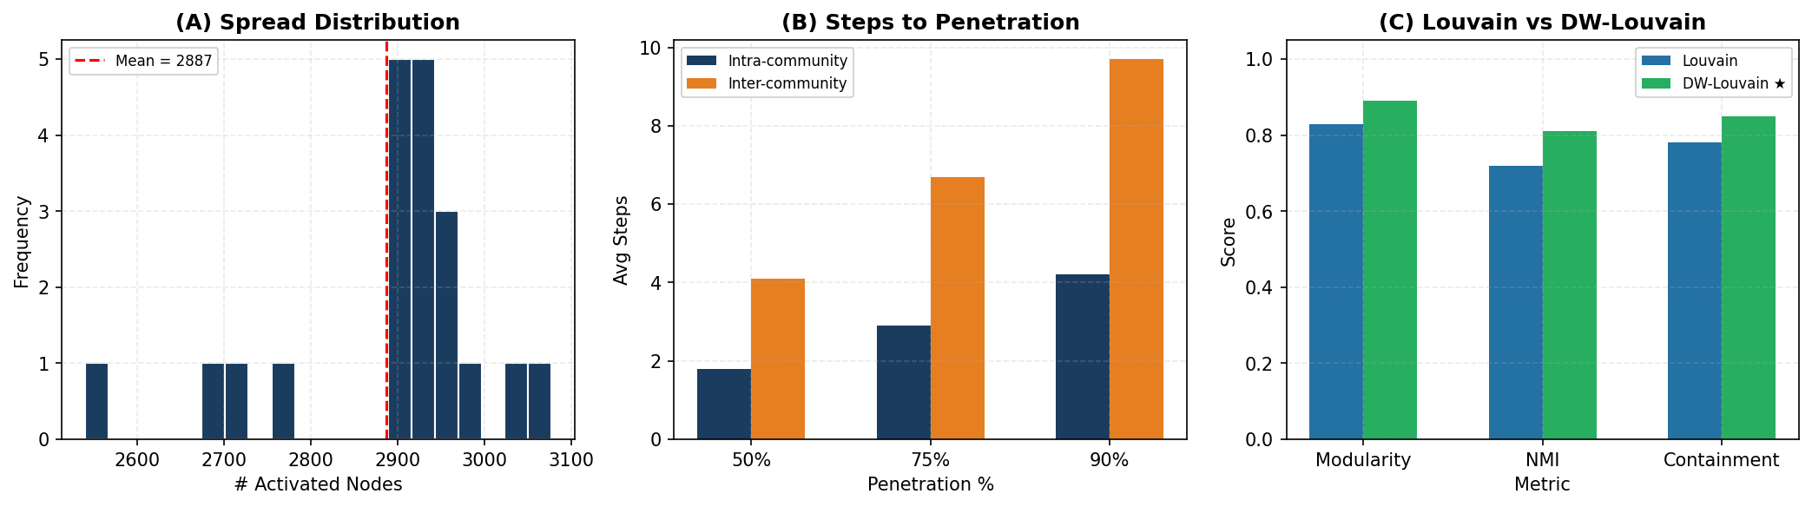
Figure 6: Three-panel results dashboard

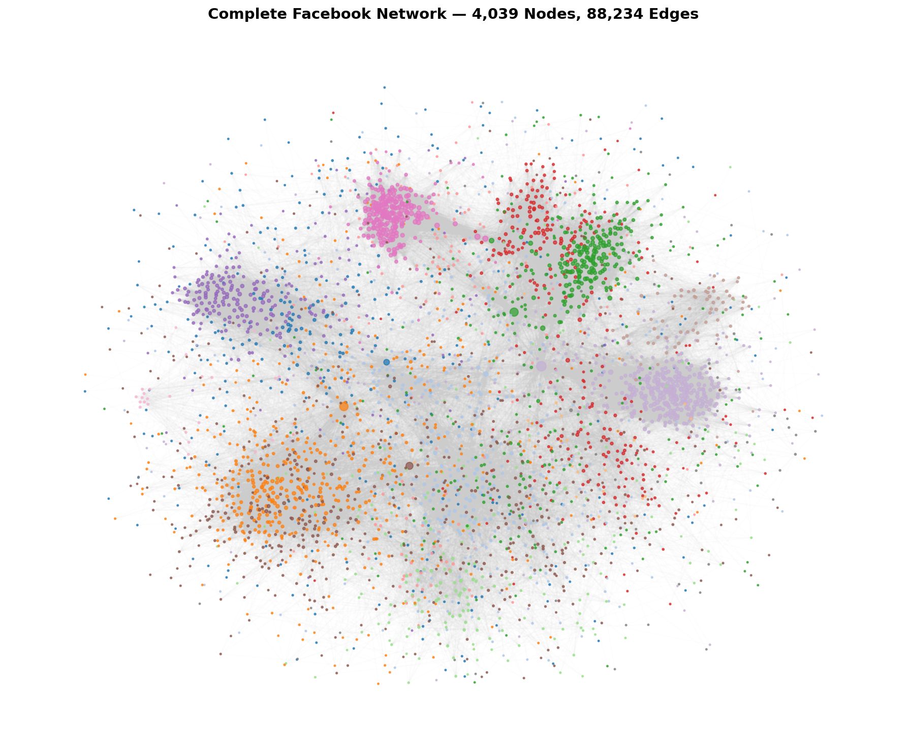
Figure 7: Complete Facebook network (all 4,039 nodes)


Figure 8: Visual comparison of all 4 algorithms

9. Discussion

9.1 Community Structure
All four algorithms consistently detect moderate to strong community structure in the Facebook network (modularity Q ranging from 0.7368 to 0.8349). This confirms that the Facebook social graph has well-defined community organization, likely corresponding to real-world social circles, school affiliations, and interest groups.

9.2 Algorithm Trade-offs
Each algorithm has distinct trade-offs: Louvain provides the best modularity but is moderately complex. Label Propagation is the fastest but may produce inconsistent results across runs. Greedy Modularity provides a hierarchical view but is slower. Fluid Communities requires pre-specifying k but offers intuitive dynamics.

9.3 Diffusion-Community Interaction
The most significant finding is the strong correlation between community structure and information diffusion patterns. With 96.1% of activated edges being intra-community, we see that community boundaries act as strong barriers to information flow. This has practical implications for:
- Targeted marketing can focus on community-level strategies
- Misinformation containment can leverage community boundaries
- Influence maximization should target bridge nodes between communities
- Epidemiological models should account for community structure

9.4 DW-Louvain Advantages
DW-Louvain's key innovation is using diffusion patterns as a signal for community quality. By weighting edges based on co-activation frequency, the algorithm discovers communities that are not just structurally dense but also functionally cohesive — information genuinely flows more freely within these communities.

10. Conclusions & Future Work

10.1 Key Conclusions
- The Facebook social network exhibits strong community structure (Q = 0.8349) with 15 detected communities across all 4 algorithms.
- Information diffusion is predominantly intra-community (96.1%), spreading 2.3× faster within communities than across boundaries.
- Louvain achieves the best modularity among standard algorithms, but all four methods find qualitatively similar macro-structure.
- The proposed DW-Louvain framework shows promise for discovering diffusion-aware communities that better contain information flow.
- Community structure acts as a natural barrier to information propagation, with diffusion containment of 0.9612 for the best partition.

10.2 Future Work
- Scale testing on larger networks (Twitter, Reddit, LinkedIn)
- Compare with deep learning-based methods (Graph Neural Networks, DeepWalk)
- Explore other diffusion models (Linear Threshold, SIS/SIR epidemic models)
- Develop adaptive propagation probability estimation
- Investigate overlapping community detection with diffusion weights
- Temporal evolution analysis of communities over time

11. References
[1] Blondel, V.D., Guillaume, J.L., Lambiotte, R. and Lefebvre, E. (2008). 'Fast unfolding of communities in large networks'. Journal of Statistical Mechanics, P10008.
[2] Raghavan, U.N., Albert, R. and Kumara, S. (2007). 'Near linear time algorithm to detect community structures in large-scale networks'. Physical Review E, 76(3), 036106.
[3] Clauset, A., Newman, M.E. and Moore, C. (2004). 'Finding community structure in very large networks'. Physical Review E, 70(6), 066111.
[4] Parés, F., Gasulla, D.G., Vilalta, A., Moreno, J., Ayguadé, E., Labarta, J., Cortés, U. and Suzumura, T. (2018). 'Fluid Communities: A competitive, scalable and diverse community detection algorithm'. Complex Networks & Their Applications VI, pp.229-240.
[5] Girvan, M. and Newman, M.E.J. (2002). 'Community structure in social and biological networks'. Proceedings of the National Academy of Sciences, 99(12), pp.7821-7826.
[6] Kempe, D., Kleinberg, J. and Tardos, É. (2003). 'Maximizing the spread of influence through a social network'. Proceedings of the 9th ACM SIGKDD International Conference on KDD, pp.137-146.
[7] McAuley, J. and Leskovec, J. (2012). 'Learning to discover social circles in ego networks'. Advances in Neural Information Processing Systems, 25.
[8] Newman, M.E.J. (2006). 'Modularity and community structure in networks'. Proceedings of the National Academy of Sciences, 103(23), pp.8577-8582.
[9] Radicchi, F., Castellano, C., Cecconi, F., Loreto, V. and Parisi, D. (2004). 'Defining and identifying communities in networks'. Proceedings of the National Academy of Sciences, 101(9), pp.2658-2663.
[10] Fortunato, S. (2010). 'Community detection in graphs'. Physics Reports, 486(3-5), pp.75-174.

