PROJECT REPORT OF INDUSTRY ORIENTED HANDS-ON EXPERIENCE (IOHE)
ON
PetCare
submitted in partial fulfilment of the requirements for the award of degree of

BACHELOR OF ENGINEERING
In
COMPUTER SCIENCE AND ENGINEERING

Submitted by: Supervised By:
Deepanshu (2211981139) Dr. Ajay Kumar
Jasmeet (2211981179) Professor
Manjul 2211981219) Chitkara University Rajpura, Punjab

DEPARTMENT OF COMPUTER SCIENCE AND ENGINEERING

CHITKARA UNIVERSITY INSTITUTE OF ENGINEERING AND TECHNOLOGY
CHITKARA UNIVERSITY, PUNJAB, INDIA

ABSTRACT

1.1 Problem Background
Imagine you're a busy urban pet parent in a bustling Indian city like Mumbai or Delhi. Your furry best friend—maybe a playful Labrador or a loyal Indie—needs reliable daycare while you're at work, but finding a trustworthy creche feels like a treasure hunt. Apps exist for bookings, but they're scattered, unreliable, or just don't deliver that peace of mind. You worry: Is the place clean? Will they handle allergies or emergencies? Meanwhile, heart wrenching scenes unfold on the streets—stray dogs scavenging in the rain, injured and alone, their eyes pleading for a chance.
Stray welfare hits hard too. In India, millions of these street-smart survivors roam our cities, facing hunger, traffic dangers, and diseases. Good-hearted folks spot a gentle pup and want to help—report it for feeding, medical aid, or adoption—but where do they turn? Fragmented services mean one platform might handle creche slots, another lists vague adoption options, and nothing connects the dots for community reporting or chats. Legal hurdles pile on: paperwork for adoption is a nightmare, supply of loving homes doesn't match the demand, and isolated strays stay overlooked.
It's a cycle of frustration and missed connections—pets left without care, strays without hope, and communities siloed instead of united. Petcare steps in as that warm, all-in-one friend: book creches seamlessly, post stray sightings with photos for quick community input, and spark responsible rehoming through comments and interactions. All mobile-friendly, making it easy for anyone to join the kindness chain right from their phone.

1.2 Objective of the Project
- Build a full-stack web app which bridges pet creches with owners.
- Easy searching, comparing and bookings of creches.
- Create a vibrant, friendly hub for pet lovers to connect and share.
- Build a thriving community where pet lovers unite to post about their pets, share stories, tips.
- Drive adoptions and welfare via interactive user comments on stray animal posts.
- Boost creches bookings by 30-50%

1.3 Proposed Solution
- Unified Full-Stack Web App: Bridges pet creches with owners via intuitive search, comparison, and booking; doubles as a community hub for stray welfare.

- Core User Features:
  - Secure login via JWT authentication.
  - Browse filtered grids (e.g., by location, pet size).
  - Book creche services directly.
  - Comment on posts for inquiries, fostering real-time community interaction.
- Backend Tech Stack:
  - JSON files for lightweight data storage for users.
  - Cloudinary for secure cloud-based image uploads.
  - Real-time comments enabled on community posts.
- Major Components:
  - Authentication module.
  - Postings/listings engine with integrated comments.
  - Booking system.
  - Admin dashboard.
- Key Benefits: Seamless rehoming and service matching without formal centre liabilities.

1.4 Key Features or Functionality
- JWT Authentication: Secure logins, user profiles with pet details.
- Creche Bookings: Calendars for availability, integrated payments.
- Stray Postings: Mobile photo uploads via Cloudinary, health/location details.
- Search & Grids: Filters (location, size, ratings), moderated public listings.
- Real-time Comments: Community interaction on stray posts for inquiries/adoption.
- Admin Dashboard: Manage users, approve posts, monitor bookings.

1.5 Technology / Method Used
- Frontend: React.js: Dynamic, responsive UI with hooks (useState, useEffect, useContext) for state management, routing, and forms. Vite used as the build tool for fast development.
- Backend: Express.js & Node.js: Scalable RESTful APIs for authentication, CRUD operations, JWT-based security, and community post management.
- Database: JSON Files: Lightweight data storage using Node.js built-in fs module for users, creche listings, bookings, and community posts stored in users.json, locationinfo.json, and posts.json.
- Authentication: JWT (JSON Web Tokens): Secure session management with bcrypt password hashing for safe user registration and login.
- Media: Cloudinary: Secure photo uploads and optimizations for creche images, profile pictures, and community post photos.
- Security: bcrypt for password hashing and Owner Secret Key system to prevent unauthorized creche owner registrations.

Expected Outcomes & Benefits
- Creche Utilization Boost: Increase local bookings by 30-50% through targeted search, comparisons, and real-time availability.
- Stray Rehoming Impact: Enable 100+ strays rehomed annually via photo posts, detailed info, and interactive comments.
- Owner Stress Reduction: Seamless bookings eliminate fragmented app hunting and reliability worries.
- Interactive Community: Fosters rehoming through user comments, inquiries, and direct connections.
- Scalable Growth: Verified listings build trust, driving organic user expansion and engagement.
- Enhanced Pet Welfare: Real-time stray reporting connects communities with feeders/vets faster.
- Economic Uplift: More creche revenue supports local businesses and job creation.

1.7 Original Contribution Statement
The originality of this project lies in developing the first platform to integrate creche booking services with a community space for pet lovers to connect and promote stray animal adoptions.
Future enhancements may include:
- AI-based creche recommendation system.
- Video tour integration for creches.
- Online payment gateway
- Pet health record upload/download
- Mobile application support
- Automated booking reminder notifications
These enhancements will further improve owner convenience and pet welfare efficiency.

1.8 Class Diagram
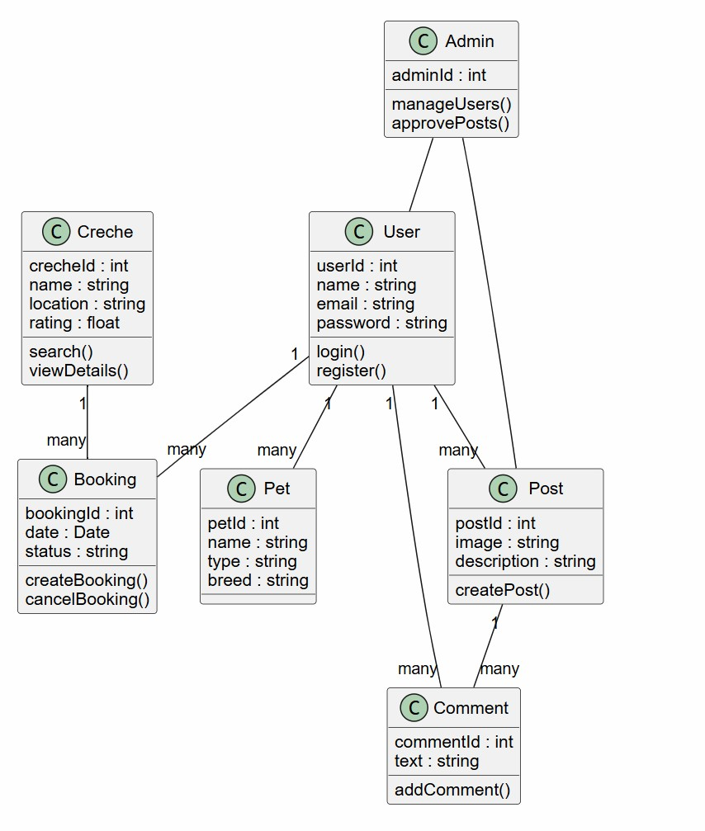

1.8.1 ER Diagram

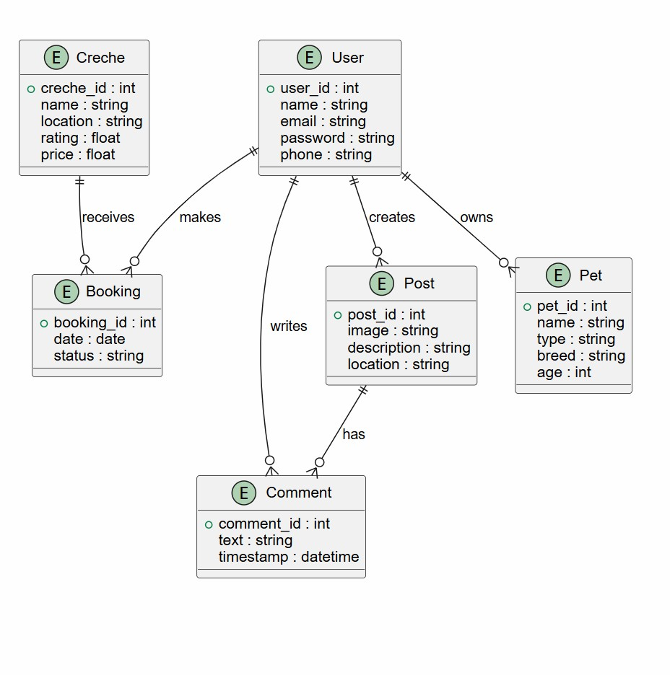

1.10 Current project photos
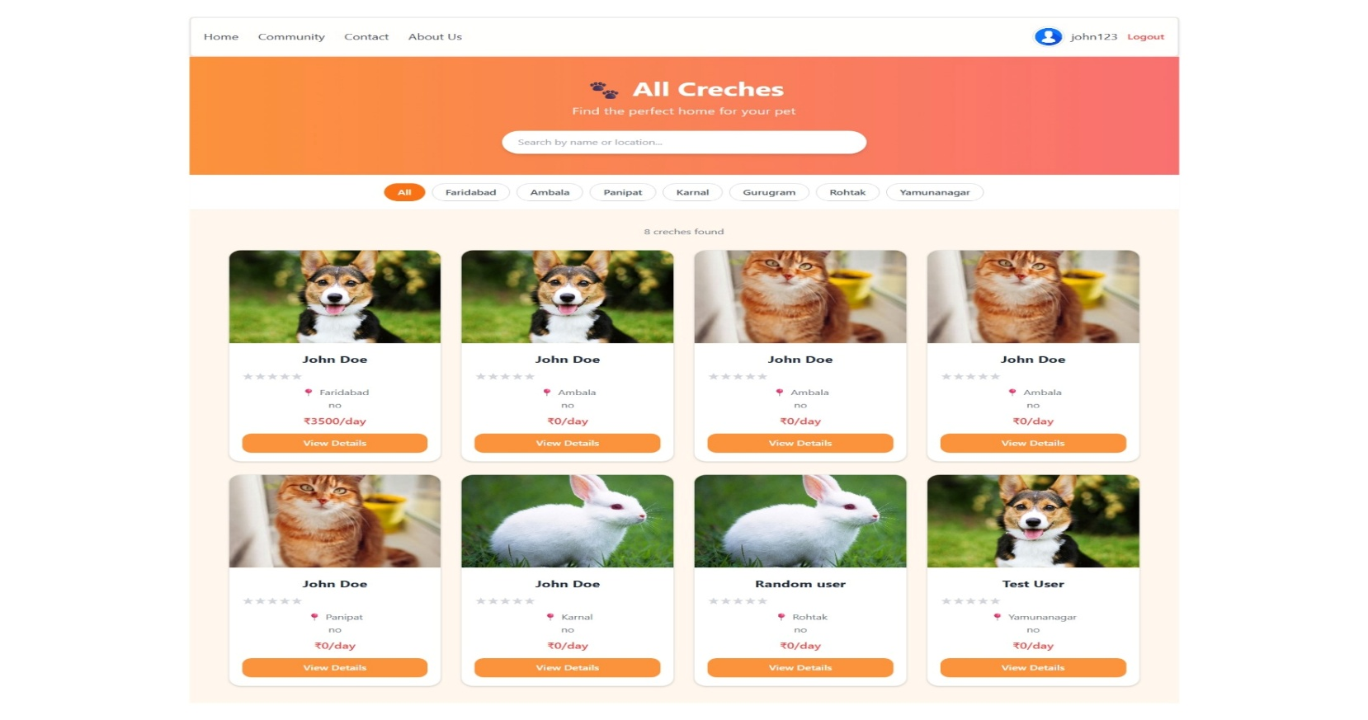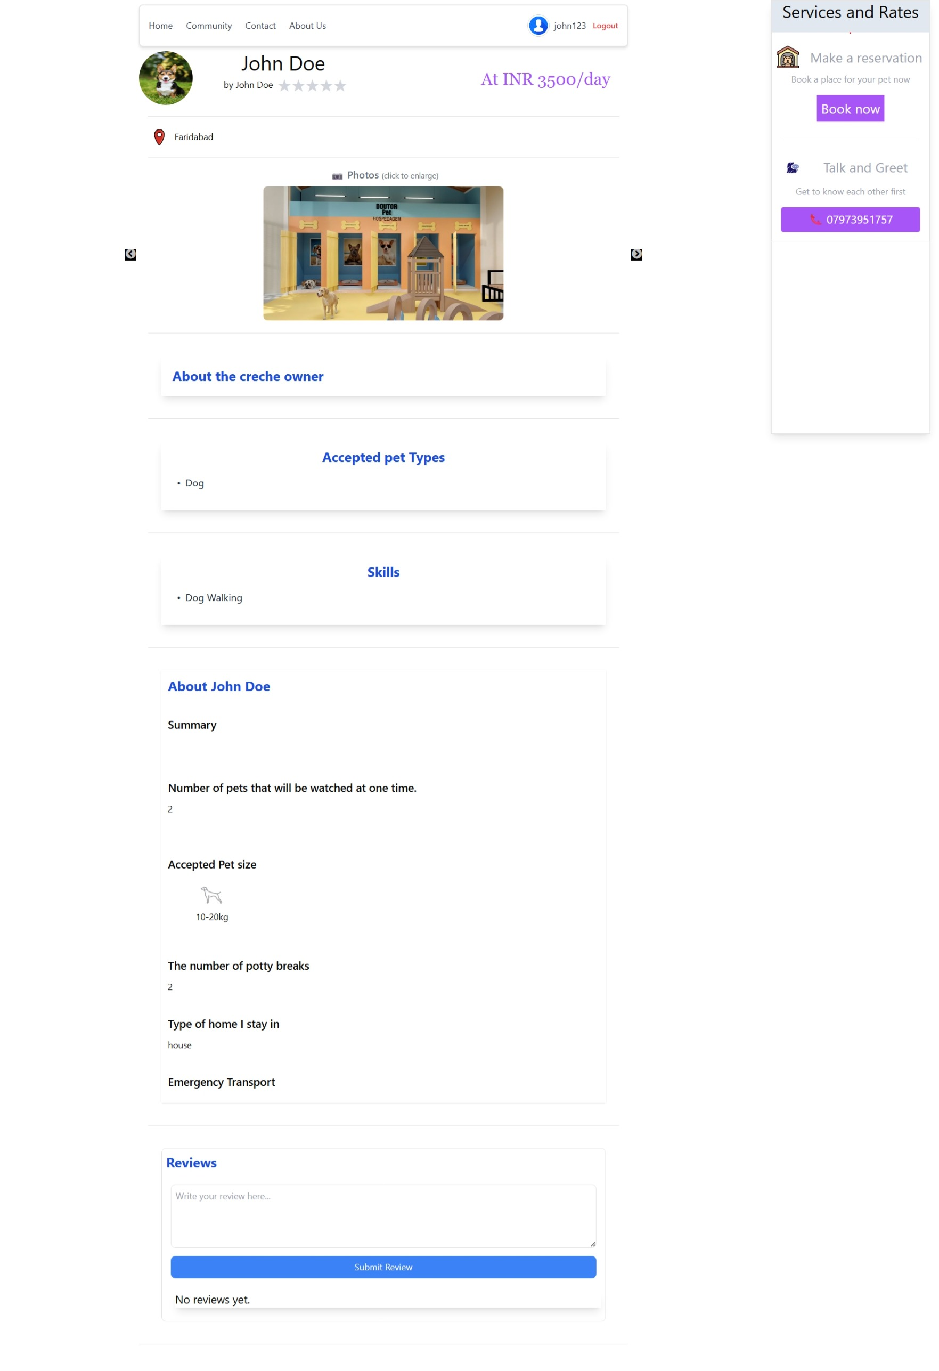

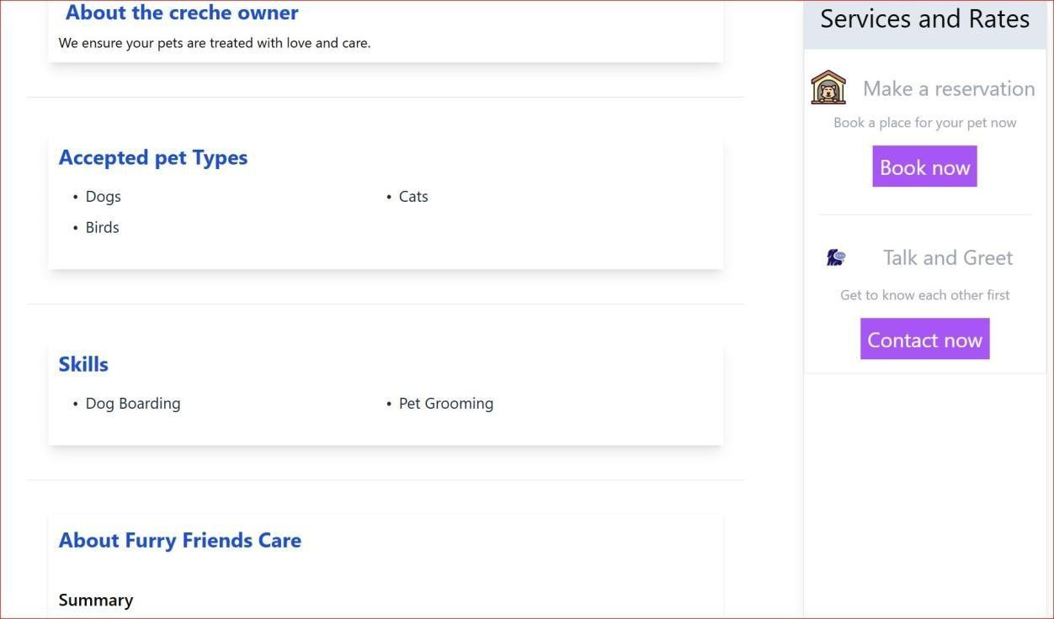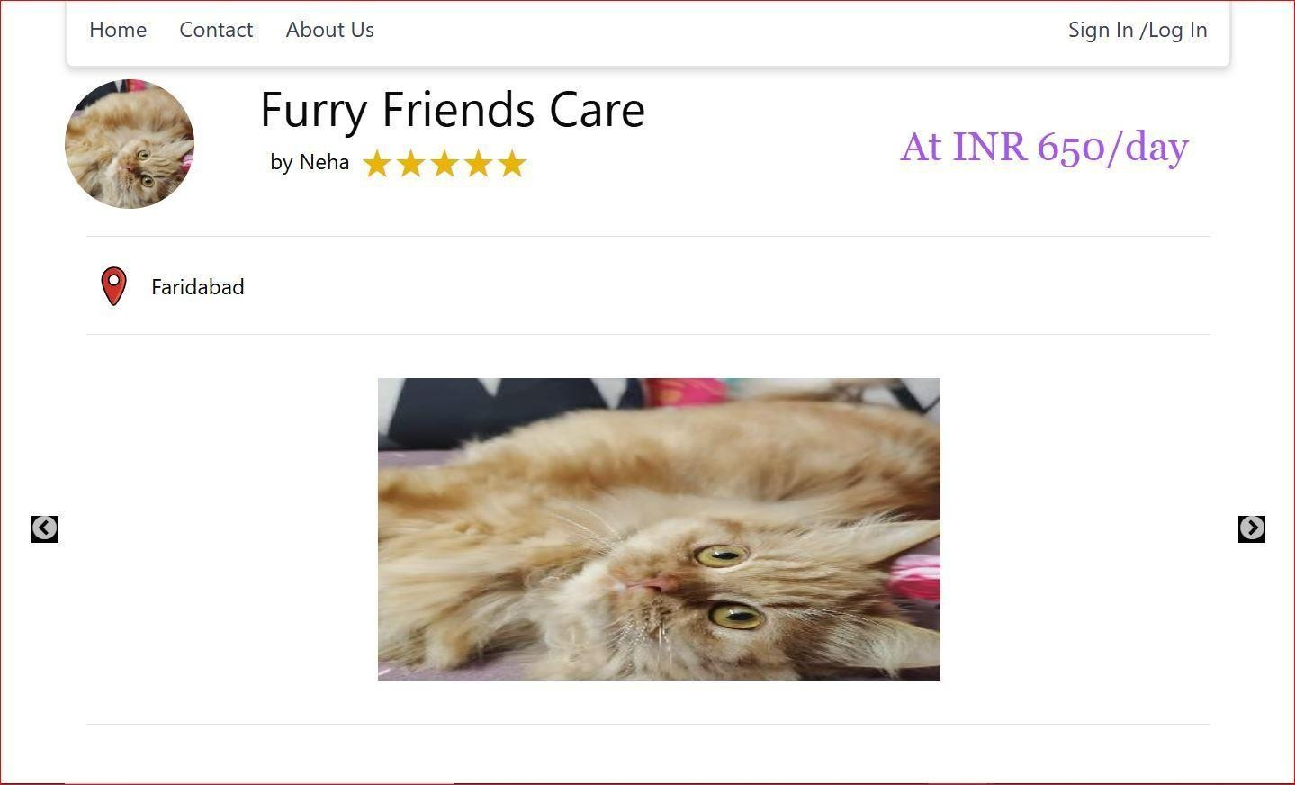

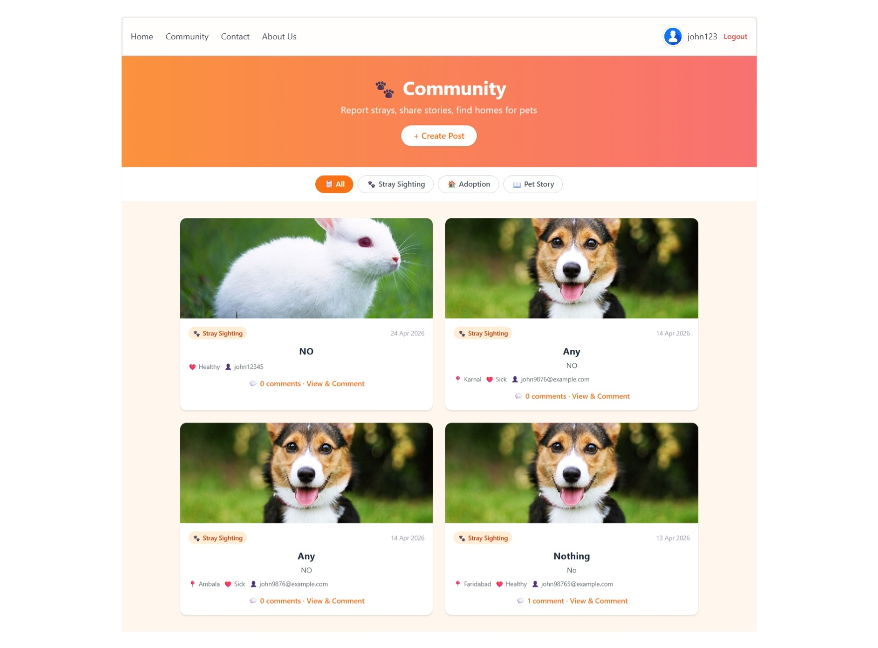

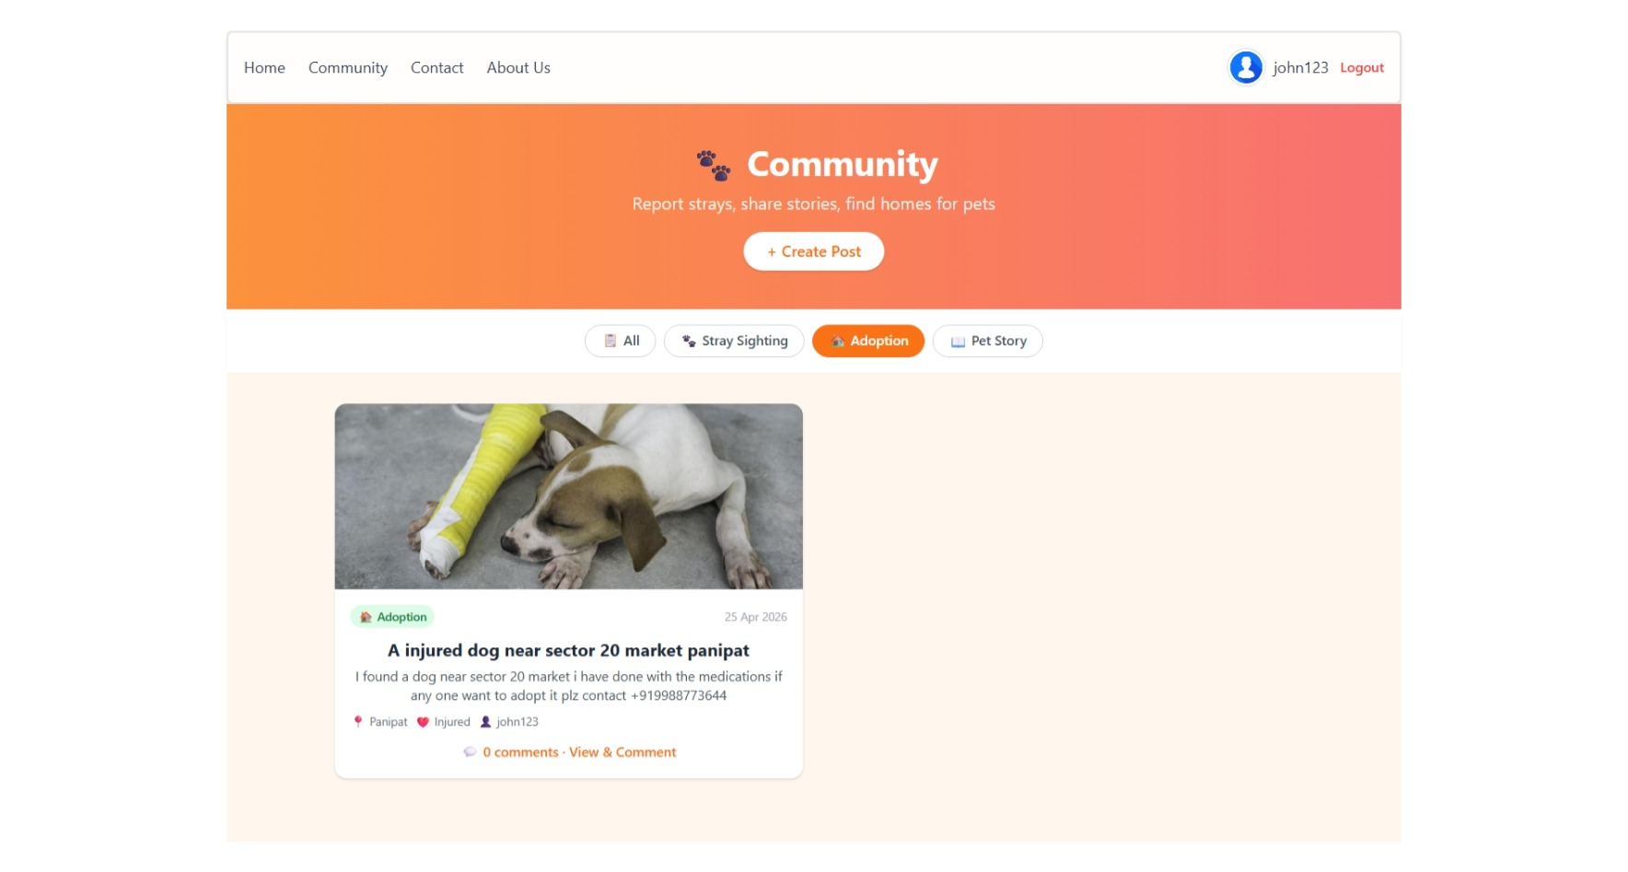
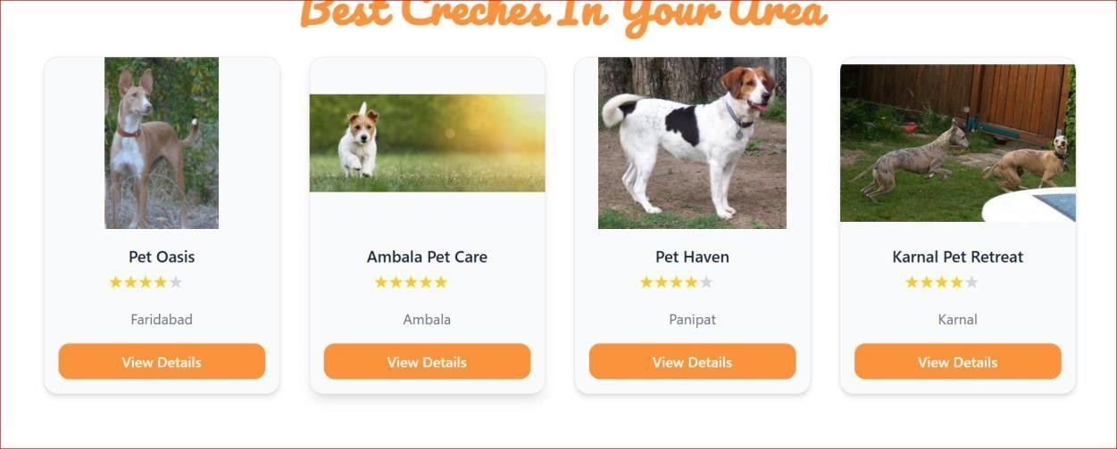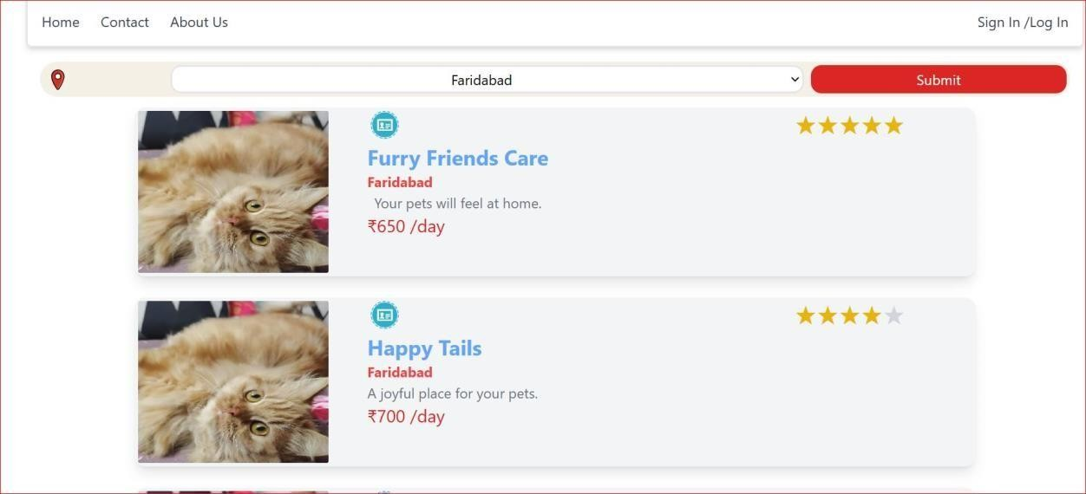
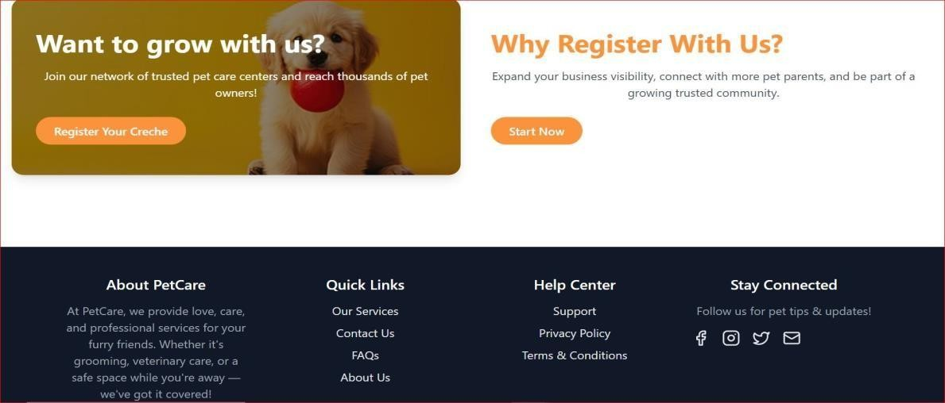

1.11 Conclusion and Future Scope

Conclusion:

The PetCare project was conceived with a clear and purposeful vision — to eliminate the fragmentation that pet owners and animal welfare enthusiasts face in India today. Through careful planning, consistent development, and iterative problem-solving, the platform has been successfully built as a comprehensive, full-stack web application that brings together creche booking services, stray animal welfare tools, and a vibrant pet-lover community under one unified roof.
The system fulfils every core objective set at the outset of the project. Pet owners can now register securely, browse verified creche listings with filters for location, pet size, and ratings, and complete bookings directly through the platform — eliminating the frustration of scattered apps and unreliable phone calls. The community posting module allows any user to upload photographs of stray animals along with their health status and location, enabling real-time comments and interactions that actively drive adoptions and welfare support across neighbourhoods.
On the technical side, the project demonstrates a clean and scalable architecture. The backend, built with Node.js and Express.js, handles authentication through JWT tokens and bcrypt password hashing, ensuring that every user session is secure. Cloudinary integration provides reliable, optimised cloud storage for all media uploads. The frontend, developed in React.js with Vite, delivers a responsive and intuitive interface that works seamlessly across devices and screen sizes. The Admin Dashboard gives platform administrators complete control over user management, post moderation, and booking oversight.
Beyond its technical achievements, PetCare represents something more meaningful — a platform that connects people around a shared love for animals and a collective responsibility toward those who cannot speak for themselves. It bridges the gap between pet businesses and the communities they serve, and gives everyday citizens a simple, accessible way to make a difference in the lives of stray animals.
In summary, PetCare is not just a functional web application — it is a step toward a more compassionate and connected pet care ecosystem in India.

Future Scope:-

While PetCare in its current form successfully addresses the core needs of its users, the platform has been designed with scalability in mind, and there are several meaningful directions in which it can grow.
The most impactful near-term enhancement would be the integration of an AI-based creche recommendation engine. By analysing a user's pet profile, past booking history, location, and stated preferences, the system could intelligently suggest the most suitable creche options — transforming the experience from a manual search into a personalised service.
An online payment gateway integration is equally important for the platform's commercial viability. Currently, bookings are confirmed manually, which introduces delays and friction. Connecting a secure payment solution such as Razorpay or Stripe would allow pet owners to pay, receive confirmations, and manage cancellations entirely within the app.
The development of native mobile applications for both iOS and Android is another high-priority future goal. A dedicated mobile app would extend PetCare's reach to users who primarily engage through smartphones and would enable push notifications for booking reminders, stray post alerts, and community updates.
Pet health record management is a feature that would add significant long-term value. Allowing owners to upload, store, and share vaccination certificates and medical histories within the platform would make PetCare an indispensable tool for responsible pet ownership and would also help creche operators make informed decisions about the animals they care for.
Video tour integration for creche facilities would allow pet parents to take a virtual look inside a creche before committing to a booking, dramatically improving trust and conversion rates. Finally, automated booking reminder notifications sent via email or SMS would reduce no-shows and improve the overall reliability of the service for creche operators.
Together, these enhancements would evolve PetCare from a functional web platform into a comprehensive, AI-powered ecosystem for pet care and animal welfare across India.

References:-

- Fielding, R. T. (2000). Architectural Styles and the Design of Network-based Software Architectures. Doctoral Dissertation, University of California, Irvine.
- Mozilla Developer Network (MDN). (2024). JavaScript Reference Documentation. Retrieved from https://developer.mozilla.org
- React Documentation. (2024). React – A JavaScript Library for Building User Interfaces. Retrieved from https://react.dev
- Node.js Foundation. (2024). Node.js Documentation. Retrieved from https://nodejs.org/en/docs
- Express.js. (2024). Express – Fast, Unopinionated, Minimalist Web Framework for Node.js. Retrieved from https://expressjs.com
- Cloudinary. (2024). Cloudinary Documentation – Image and Video Management. Retrieved from https://cloudinary.com/documentation
- Auth0. (2023). JSON Web Tokens Introduction. Retrieved from https://jwt.io/introduction
- bcrypt.js. (2024). bcryptjs – Optimised bcrypt in JavaScript. Retrieved from https://www.npmjs.com/package/bcryptjs
- Vite. (2024). Vite – Next Generation Frontend Tooling. Retrieved from https://vitejs.dev
- React Router. (2024). React Router Documentation. Retrieved from https://reactrouter.com
- Government of India. (2011). Prevention of Cruelty to Animals Act, 1960 – Amended Guidelines. Ministry of Environment, Forest and Climate Change.
- World Health Organization. (2023). Rabies and Stray Animal Population Management in South-East Asia. WHO Regional Office for South-East Asia.

DECLARATION

I hereby certify that the work which is being presented in the project report entitled “Pet Care” in partial fulfilment of requirement for the award of the degree of Bachelor of Engineering (Computer Science and Engineering) submitted in the department of Computer Science and Engineering at Chitkara University Institute of Engineering and Technology, Chitkara University, Punjab, India, is an authentic record of my own work carried out under the supervision of < Dr. Ajay Kumar >. The matter presented in this project report has not been submitted in any other university/institute for the award of any degree.

Place: Rajpura Deepanshu (2211981139)
Date : 10-04-2026 Jasmeet (2211981179)
Manjul (2211981219)

This is to certify that the above statement made by the candidate is correct to the best of my knowledge and belief.

Dr. Ajay Kumar
Professor
Department of Computer Science and Engineering
Chitkara University Institute of Engineering and Technology,
Chitkara University, Punjab, India

