BlastRadius: Graph-Based Change Impact Prediction and Dependency Analysis for Software Repositories
BITE497J – Project I
Submitted in partial fulfillment of the requirements for the degree of
Bachelor of Technology
in
Information Technology
by
PRISHA VADHAVKAR (23BIT0010)
SANSKRITI SINGH (23BIT0256)
DEEPANSHU (23BIT0264)
Under the guidance of
Dr. Yoga Raja C A
School of Computer Science Engineering and Information Systems
VIT, Vellore

November, 2026

BlastRadius: Graph-Based Change Impact Prediction and Dependency Analysis for Software Repositories
BITE497J – Project I
Submitted in partial fulfillment of the requirements for the degree of
Bachelor of Technology
in
Information Technology
by
PRISHA VADHAVKAR (23BIT0010)
SANSKRITI SINGH (23BIT0256)
DEEPANSHU (23BIT0264)
Under the guidance of
Dr. Yoga Raja C A
School of Computer Science Engineering and Information Systems
VIT, Vellore
November, 202

DECLARATION
We hereby declare that the BITE497J – Project I thesis entitled “BlastRadius: Graph-Based Change Impact Prediction and Dependency Analysis for Software Repositories” submitted by us, for the award of the degree of Bachelor of Technology in Information Technology, School of Computer Science Engineering and Information Systems to VIT is a record of Bonafide work carried out by us under the supervision of Dr. Yoga Raja C A, Assistant Professor Sr. Grade 1, SCORE, VIT, Vellore.
We further declare that the work reported in this thesis has not been submitted and will not be submitted, either in part or in full, for the award of any other degree or diploma in this institute or any other institute or university.

Place: Vellore
Date:
Prisha Vadhavkar (23BIT0010)
Sanskriti Singh (23BIT0256)
Deepanshu (23BIT0264)
Signature of the Candidates

CERTIFICATE
This is to certify that the BITE497J – Project I thesis entitled “BlastRadius: Graph-Based Change Impact Prediction and Dependency Analysis for Software Repositories” submitted by Prisha Vadhavkar (23BIT0010), Sanskriti Singh (23BIT0256) and Deepanshu (23BIT0264), SCORE, VIT, for the award of the degree of Bachelor of Technology in Information Technology, School of Computer Science Engineering and Information Systems, is a record of bonafide work carried out by them under my supervision during the period 06.07.2026 to 03.11.2026, as per the VIT code of academic and research ethics.
The contents of this report have not been submitted and will not be submitted either in part or in full, for the award of any other degree or diploma in this institute or any other institute or university. The thesis fulfills the requirements and regulations of the University and in my opinion meets the necessary standards for submission.
Place: Vellore
Date:
Signature of the Guide
Internal Examiner External Examiner
Head of the Department
Department of Information Technology

ACKNOWLEDGEMENT
It is our pleasure to express with a deep sense of gratitude to our BITE497J – Project I guide Dr. Yoga Raja C A, Assistant Professor Sr. Grade 1, School of Computer Science Engineering and Information Systems, Vellore Institute of Technology, Vellore for the constant guidance and continual encouragement in our endeavour. Our association with our guide is not confined to academics only, but it is a great opportunity on our part to work with an intellectual and an expert in the field of Software Engineering — Software Maintenance and Evolution and Mining Software Repositories.
We would like to express our heartfelt gratitude to Honorable Chancellor Dr. G Viswanathan; respected Vice Presidents Dr. Sankar Viswanathan, Dr. Sekar Viswanathan, Vice Chancellor Dr. V. S. Kanchana Bhaaskaran; Pro-Vice Chancellor Dr. Partha Sharathi Mallick; and Registrar Dr. Jayabarathi T.
Our whole-hearted thanks to Dean Dr. Daphne Lopez, School of Computer Science Engineering and Information Systems, Head, Department of Information Technology, Dr. Arivuselvan K, Information Technology Project Coordinator Dr. Suganya P, SCORE School Project Coordinator Dr. Karthikeyan P, all faculty, staff and members working as limbs of our university for their continuous guidance throughout our course of study in unlimited ways.
It is indeed a pleasure to thank our parents and friends who persuaded and encouraged us to take up and complete our project successfully. Last, but not least, we express our gratitude and appreciation to all those who have helped us directly or indirectly towards the successful completion of the project.
Place: Vellore
Date: Prisha Vadhavkar
Sanskriti Singh
Deepanshu

EXECUTIVE SUMMARY
Change impact analysis tools are evaluated against labels such as *files that were edited together* (co-change) or *tests that can statically reach the changed code* (reachability). Neither label records what actually happened: which tests failed in continuous integration (CI) because of a change. No public dataset links a code change to the individual tests it caused to fail. BlastRadius builds that dataset. We mined GitHub Actions runs for Java and Python repositories, parsed per-test verdicts from CI logs, resolved a base run for every change, and labelled a test as fault-revealing only if it failed at the head commit, did not fail at the base, and did not flip on the same commit. The pipeline is deterministic and reproducible from raw logs with one command. On the frozen rebuild (numbers snapshot paper-numbers-v1.1) it yields 4,168 fault-revealing labels on 762 strict, flake-filtered instances covering 2,466 distinct tests, test-identifier binding of 94.29% (combined) and 63.83% (full confidence), and a pseudonymised release bundle that passes secret-scan and canary checks. As an example use of the dataset, we measure how well two simple predictors recover the tests that actually failed: at k = 10 over 576 instances, co-change recovers 4.64% of the failing test files (61/1,316) and a historical failure-frequency baseline 39.44% (519/1,316), after a leakage fix and a double-counting fix. Gate 1 (5,000 labels) is not met, and parser precision is reported only on development corpora, not independently. A commit-pinned code-property graph layer over three repositories (427 graphs) supports graph queries within a 100 ms budget. The dataset, BR-Bench, targets the MSR 2027 Data & Tool Showcase.

CONTENTS
Page No.
Acknowledgement iv
Executive Summary v
Table of Contents vi
List of Figures ix
List of Tables xi
Abbreviations xii
Symbols and Notations xiii
1 INTRODUCTION 1
1.1 Objective 2
1.2 Motivation 3
1.3 Background 4
1.4 Organisation of the Report 8
2 LITERATURE SURVEY, PROJECT DESCRIPTION AND GOALS 9
2.1 Literature Survey 9
2.2 Closest Related Work Beyond the Approved List 13
2.3 Research Gap (Problem Definition) 15
2.4 Project Description 16
2.5 Research Questions 16
2.6 Goals and Their Status 17
3 TECHNICAL SPECIFICATION 19
3.1 Software Stack 19
3.2 Hardware and Resource Constraints 21
3.3 External Interface: The GitHub REST API 22
3.4 Scope Constraints 23
3.5 Data Artifacts 24
3.6 Requirements 25
4 DESIGN APPROACH AND DETAILS 27
4.1 Design Approach / Materials and Methods 27
4.2 Codes and Standards 43
4.3 Constraints, Alternatives and Trade-offs 44
5 SCHEDULE, TASKS AND MILESTONES 46
5.1 Timeline 46
5.2 Phases of Work 47
5.3 Go/No-Go Gates 48
5.4 Team Responsibilities 48
5.5 Recorded Decisions During the Semester 49
5.6 Risks and Their Treatment 50
6 PROJECT DEMONSTRATION 51
6.1 One-Command Reproduction 51
6.2 Regenerating Tables and the Freshness Guard 52
6.3 Corpus Dashboard 53
6.4 Graph Layer 55
6.5 Release Bundle 56
6.6 Worked Example: From Log Line to Label 57
6.7 Test Suite 58
6.8 Demonstration Logistics 58
6.9 Agentic Workflow: From User Story to Deployment 59
7 RESULT AND DISCUSSION 63
7.1 Dataset Figures 63
7.2 Parser Defect and Fix 65
7.3 Test-Identifier Binding 66
7.4 Graph Layer Results 68
7.5 Reproducibility and Release 72
7.6 Parser Precision 74
7.7 RQ1: Divergence Measurement 75
7.8 Engineering Quality 76
7.9 Gate Summary 77
7.10 Threats to Validity 78
7.11 Lessons Learned 79
8 SUMMARY 80
8.1 Key Results 80
8.2 Honest Negatives 81
8.3 Lessons 81
8.4 Recommendations and Future Work 81
9 REFERENCES 83
APPENDIX A

LIST OF FIGURES
Figure No. | Title | Page No.
1.1 | The Three Research Camps and the Gap BlastRadius Fills | 2
1.2 | Comparing CI Outcomes at the Head and Base Commits of a Pull Request | 6
2.1 | Related Work Grouped by the Ground-Truth Label It Relies On | 13
3.1 | Layered View of the BlastRadius Software Stack | 20
3.2 | Lifecycle of Data from the Raw Store to the Release Bundle | 24
4.1 | System Architecture of BlastRadius | 27
4.2 | Capture Sequence of the Harvester | 30
4.3 | Preference Order of Test-Result Sources | 31
4.4 | Stages of Parsing a Raw CI Log into Test Outcomes | 32
4.5 | Canonicalising Test Names into the Project Join Key | 33
4.6 | The Fault-Revealing Set as a Set Difference | 34
4.7 | Base-Run Resolution Procedure | 35
4.8 | Reproducible Table Generation with the Freshness Guard | 38
4.9 | Graph Layer Pipeline | 40
4.10 | Schematic Example of Test Nodes Bound to Source Nodes | 41
4.11 | Why the Graph Uses a Multigraph Keyed by Edge Type | 42
5.1 | Gantt Chart of the Project Schedule | 47
6.1 | Sequence of the Project Demonstration | 51
6.2 | Terminal Summary of make all on the Mini-Corpus | 52
6.3 | Freshness Guard Refusing to Run on a Stale Artifact | 53
6.4 | Streamlit Corpus Dashboard Panels | 55
6.5 | Excerpt of a Commit-Pinned Graph File | 56
6.6 | Output of the Graph Query Primitives | 56
6.7 | Release Bundle Checksum Manifest | 57
6.8 | Test-Suite Summary | 58
6.9 | Agents Tab of the Demo Site: Five Agents and Three Scenarios | 60
6.10 | Build Failure, Notification and Regression Report in the Third Scenario | 61
7.1 | Positives Before and After the Canonical Rebuild | 63
7.2 | Gate 1: Positives Against the 5,000 Threshold | 64
7.3 | Affected Test IDs by Repository | 66
7.4 | Binding Rates Against the Gate 1.5 Threshold | 67
7.5 | Commit-Pinned Graphs Built per Repository | 68
7.6 | Incremental-Versus-Cold Divergence and Its Fix | 69
7.7 | Graph-Node Binding by Repository | 70
7.8 | Graph Query Latency per Repository Against the 100 ms Budget | 71
7.9 | Release Bundle Checks | 73
7.10 | Growth of the Main Test Suite | 76
7.11 | Summary of Go/No-Go Gate Outcomes | 77

LIST OF TABLES
Table No. | Title | Page No.
2.1 | Comparison of the Approved Literature with BlastRadius | 12
2.2 | Closest Related Datasets and Tools | 14
2.3 | Project Goals and Their Status | 17
3.1 | Software Stack as Used | 19
3.2 | GitHub Objects Captured by the Harvester | 22
3.3 | Main Data Artifacts | 24
3.4 | Non-Functional Requirements and Budgets | 25
4.1 | Edge-Case Rules of the Labelling Engine | 36
4.2 | Silent Failures and Their Detectors | 38
4.3 | Graph Query Primitives | 42
4.4 | Codes and Standards Followed | 43
4.5 | Design Decisions, Alternatives and Rationale | 44
5.1 | Project Milestones | 46
5.2 | Go/No-Go Gates | 48
5.3 | Division of Responsibilities | 49
5.4 | Key Decisions Recorded During the Semester | 49
5.5 | Principal Risks and Treatments | 50
6.1 | Demonstration Checklist | 58
6.2 | The Five Agents of the Workflow | 59
7.1 | Dataset Figures Before and After the Canonical Rebuild | 63
7.2 | Scope of the Parameter-Type Parsing Defect | 65
7.3 | Test-Identifier Binding | 66
7.4 | Graph Layer Mini-Corpus | 68
7.5 | Graph-Node Binding Rate per Repository | 69
7.6 | Graph Layer Performance Against Budgets | 70
7.7 | Parser Precision on Development Corpora (Holdout v5 Not Scored) | 74
7.8 | RQ1 at k = 10 over 576 Instances | 75

LIST OF ABBREVIATIONS
API | Application Programming Interface
AST | Abstract Syntax Tree
BR-Bench | BlastRadius Benchmark (the released dataset)
CI | Continuous Integration
CIA | Change Impact Analysis
D-nn | Numbered project design decision (decision log)
DOI | Digital Object Identifier
FQCN | Fully Qualified Class Name
GHA | GitHub Actions
GNN | Graph Neural Network
HMAC | Hash-based Message Authentication Code
IA | Impact Analysis
JSON | JavaScript Object Notation
LLM | Large Language Model
MSR | Mining Software Repositories (conference)
PAT | Personal Access Token
PR | Pull Request
PTS | Predictive Test Selection
RQ | Research Question
RTS | Regression Test Selection
SHA | Commit hash (Secure Hash Algorithm)
WSL | Windows Subsystem for Linux

SYMBOLS AND NOTATIONS
T_head_fail | Set of tests failing at the head commit
T_base_fail | Set of tests failing in the resolved base run
T_flaky | Tests that flip on an identical commit
T_reveal | Fault-revealing tests (Eqn. 4.1)
C, R, F | Co-change, static-reachability and fault-revealing impact sets
J(A, B) = |A ∩ B| / |A ∪ B| | Jaccard overlap between two sets
A \ B | Set difference: elements of A that are not in B
n/d | A rate written as numerator / denominator (project convention)

CHAPTER 1
INTRODUCTION
Every developer asks the same question before merging a change: which tests will this change actually break? The question sounds simple, yet it sits at the centre of how modern software is built and maintained. A pull request that modifies a parser, a configuration loader or a shared utility can break tests that live far away from the edited lines, in modules whose connection to the change is invisible in the diff. Conversely, a change that touches many files may leave every test green. Knowing in advance which tests are at risk would let teams run the right tests first, review risky changes more carefully and spend less compute on continuous integration (CI) runs that only confirm what was already known.
Existing research answers neighbouring questions rather than this one. Change Impact Analysis (CIA) predicts which program elements are likely to be co-changed with an edited element; its labels are mined from Git history, which records what developers edited together rather than how defects propagate through a system. Regression Test Selection (RTS) predicts which tests can reach the change through static or dynamic dependencies, as in tools such as Ekstazi and STARTS; these selections are safe over-approximations of the affected tests, not observations of what failed. Predictive Test Selection (PTS) predicts which tests will fail, using real CI outcomes as the label. PTS uses the right label, but the published work comes from Meta and Google and relies on proprietary data that no one outside those organisations can access.
The situation is therefore a triangle with a missing corner (Fig. 1.1). The CIA camp has public data with the wrong label. The RTS camp has principled but over-approximate labels. The PTS camp has the right label but no public data. BlastRadius closes this triangle by building a public, execution-grounded dataset, named BR-Bench, that pairs a code change with the individual tests that actually failed in GitHub Actions CI. The dataset makes it possible, for the first time on open-source software, to ask how well the labels used by the impact-analysis community agree with the regressions that CI really observes.
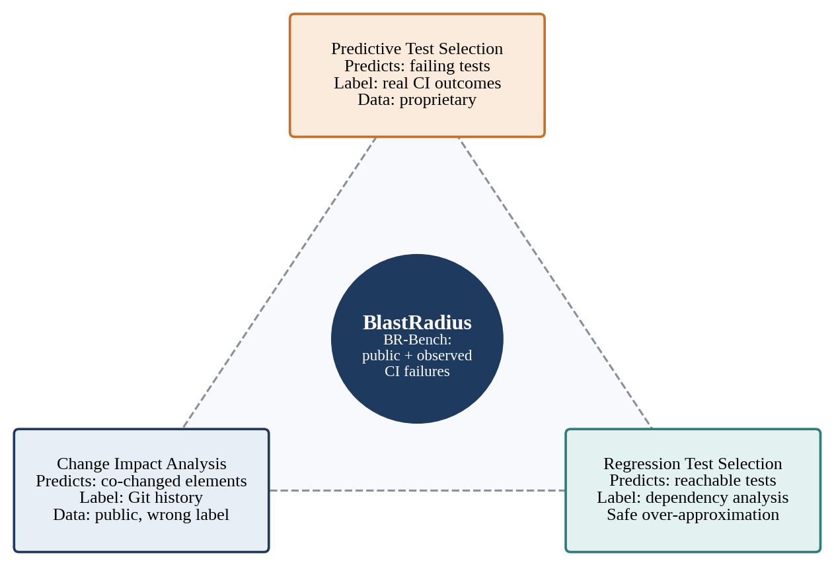
Fig. 1.1 The Three Research Camps and the Gap BlastRadius Fills
The project title approved at the Zeroth Review on 16 July 2026 is BlastRadius: Graph-Based Change Impact Prediction and Dependency Analysis for Software Repositories, with the working subtitle Execution-Grounded Change Impact Prediction for Modern CI. The approved abstract already committed the project to evaluation against CI/CD test outcomes; during the semester the team prioritised that half of the evaluation, because that is where the gap in the literature lies. This report describes the resulting data pipeline, the labelling methodology, the commit-pinned code-property graph layer built as the dependency-analysis substrate, and the results measured on the canonical rebuild of the dataset in October 2026.

1.1 Objective
The project has four objectives. Each of them is stated so that its completion can be checked against a concrete artifact or measurement rather than a description.
- Build an execution-grounded dataset (BR-Bench) that links code changes to the individual tests that actually failed in GitHub Actions CI, with per-test verdicts parsed from real CI logs and a resolved base run for every change.
- Use the dataset to measure how far the proxy labels used by the field diverge from what really fails, specifically the co-change label used by change impact analysis and the static-reachability label used by regression test selection.
- Build a commit-pinned code-property graph of the source code (files, classes, methods and tests, together with their call, import and containment dependencies) as the substrate for dependency analysis and for future graph-based features.
- Keep the entire pipeline deterministic and reproducible, so that every number reported in this document and in the planned paper can be regenerated from raw logs with a single command.
The claimed contribution is the dataset and the measurement, not a new prediction algorithm. This was recorded early in the project as design decision D-02. The reasoning is that a narrow claim fully supported by evidence is more valuable than a broad claim partly supported. A learned predictor that loses to simple baselines would still be a publishable finding, because the dataset is what makes the comparison possible in the first place. For the same reason the report is careful to distinguish what was built and measured from what was planned and cut from scope; the latter appears only as future work.
The target venue for the research output is the MSR 2027 Data and Tool Showcase track, which publishes datasets and tools that other researchers can reuse. The abstract deadline is 5 November 2026 and the paper deadline is 10 November 2026. The course deliverable, BITE497J Project I, covers the full system including the graph layer, which was deliberately kept out of the paper (decision D-48).

1.2 Motivation
The first motivation is cost. Running the full test suite on every change is slow and expensive, and in large projects the suite can take far longer than the change took to write. Teams therefore want to run only the tests that matter for a given change, and to run the most likely failures first so that a broken change is reported quickly. Every technique that tries to do this, whether it is called impact analysis, test selection or test prioritisation, depends on some notion of which tests a change affects.
The second motivation is evaluation. Impact-analysis research has been evaluated for decades against labels that do not record test failures. Co-change labels say that two files were edited in the same commit; they say nothing about whether editing one of them broke anything. Reachability labels say that a test could execute the changed code; they do not say whether it did, or whether the change altered its outcome. As a result it is genuinely unknown how well the methods of the field predict real regressions. A method that scores well against co-change could be poor at finding failing tests, and the field has had no public instrument to check.
The third motivation is replication. Meta reported that its predictive test selection system caught 99.9% of regressions while running about a third of the impacted tests. The result is striking, but because the data is proprietary it has never been replicated on open-source software. A public dataset with the same kind of label would allow researchers to test whether results of this kind hold outside a single industrial monorepo, and to compare learned predictors with the static and historical proxies on equal terms.
The fourth motivation is timing, and it shaped the whole schedule. GitHub Actions is now the dominant CI system for open-source projects, and its run logs are publicly accessible through the GitHub REST API. However, the logs and artifacts of public repositories expire after 90 days. Run metadata such as conclusions and commit hashes persists, but the per-test detail lives only in the logs and artifacts. Data that is not captured now is lost permanently. For this reason the harvester, the component that captures raw CI data, was treated as the most time-critical part of the project and was built first, before any parser, label or graph.

1.3 Background
This section introduces the concepts on which the rest of the report depends. Readers familiar with CI systems and software-engineering research can skim it; the definitions given here are used consistently in later chapters.

1.3.1 Continuous Integration and GitHub Actions
Continuous integration is the practice of building and testing every change automatically as soon as it is pushed, so that defects are found while the change is still small and fresh in the author's mind. GitHub Actions is the CI service built into GitHub. A repository defines one or more workflows as YAML files; each workflow is triggered by events such as a push or the opening of a pull request. A single execution of a workflow is a workflow run, identified by a run id and associated with the commit (SHA) it tested. A run consists of one or more jobs, each of which executes a sequence of steps on a runner machine and ends with a conclusion such as success, failure, cancelled or timed out.
Several features of GitHub Actions matter for mining test outcomes. Matrix builds run the same job several times with different parameters, for example on several operating systems or language versions; each instance is a matrix leg, and a test may fail on one leg and pass on another. Job logs contain the console output of every step, including the output of the test runner. Artifacts are files that a workflow chooses to upload, such as JUnit XML reports. Check-run annotations are structured messages attached to a check run; some reporting actions emit one annotation per failing test, including the test name and file path. Annotations are the most structured source and persist longer than logs, while logs and artifacts are subject to the 90-day retention limit for public repositories.

1.3.2 Pull Requests, Head SHA and Base SHA
Most changes to open-source projects arrive as pull requests (PRs). A PR proposes merging a branch into a target branch such as main. The commit at the tip of the PR branch is the head SHA; the commit on the target branch against which the change is compared is the base SHA. Each push to the PR branch produces a new head SHA and typically triggers a new workflow run. A change is evaluated by comparing what CI observed at the head commit with what it observed at the base commit (Fig. 1.2). A test that fails at the head but not at the base is evidence that the change broke it; a test that already failed at the base is a pre-existing failure and says nothing about the change.
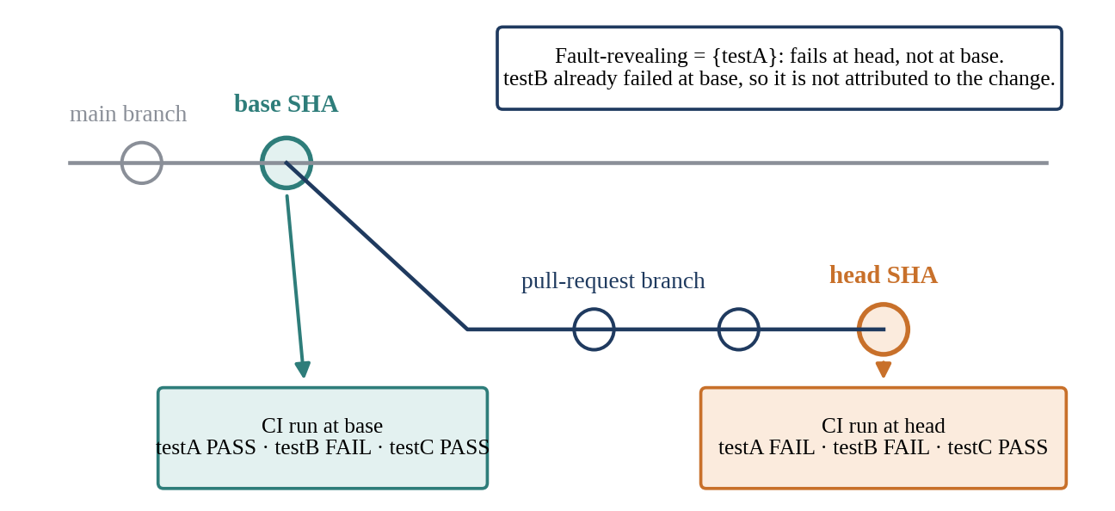
Fig. 1.2 Comparing CI Outcomes at the Head and Base Commits of a Pull Request
An important consequence follows. If one looks only at the final merge commit of a PR, the CI pipeline is almost always green, because developers fix failures before merging. The interesting failures live in the intermediate pushes. The unit of observation in BlastRadius is therefore the pair (head SHA, workflow run), not the pull request as a whole, so that red runs on intermediate commits are retained as evidence.

1.3.3 Test Frameworks and Build Tools
The project covers two language ecosystems. In Java, tests are usually written with JUnit and executed by a build tool. Maven runs tests through its Surefire plugin and prints per-class summaries and error lines to the console; Gradle runs tests through its test task and prints failure blocks and a summary. Both can write JUnit XML reports. JUnit 5 adds parameterised tests, in which one test method runs several times with different arguments and each invocation is reported with a display name. In Python, the dominant framework is pytest, which identifies each test by a node id composed of the file path, an optional class and the function name, optionally followed by parameter values in square brackets. Each ecosystem reports failures differently, which is why test-result parsing is a substantial part of the work.

1.3.4 Test-Result Parsing
A raw CI log is not a list of test verdicts. It is console text interleaved with build output, colour escape codes, timestamps, collapsible group markers and, in parallel builds, interleaved lines from several workers. Test-result parsing is the process of turning this text, or a structured report where one exists, into per-test records that say which test ran, in which job and run, and whether it passed or failed. Because every later stage depends on these records, parser precision was planned to be measured on a hand-labelled holdout of logs that were never used during development; Section 7.6 states what was and was not measured.

1.3.5 Flaky Tests
A flaky test is a test that passes and fails on the same code. Flakiness arises from timing assumptions, concurrency, test-order dependence, network access, randomness and resource limits on shared CI machines. Flaky failures contaminate any label derived from CI outcomes, because a failure that would have happened without the change is wrongly attributed to it. The most direct evidence of flakiness is a test that produces different verdicts on two runs of the identical commit. BlastRadius treats flakiness as a first-class problem: it filters same-commit flips, compares against the base run, tracks flip rates and reports headline numbers on a strict, flake-filtered split.

1.3.6 Change Impact Analysis, Regression Test Selection and Predictive Test Selection
Change impact analysis estimates the set of program elements affected by a change, often called the impact set. Techniques range from static dependency analysis and program slicing to mining of version histories for elements that tend to change together. Regression test selection chooses a subset of an existing test suite to re-run after a change; safe techniques guarantee not to omit any test whose outcome could change, which pushes them towards over-approximation. Predictive test selection learns, from historical CI outcomes, which tests are likely to fail for a given change. Chapter 2 surveys representative work in each area and positions BlastRadius against it.

1.3.7 Code-Property Graphs and Static Analysis
Static analysis examines source code without running it. A parser turns each source file into an abstract syntax tree (AST), a tree whose nodes are syntactic constructs such as classes, methods, calls and imports. tree-sitter is a widely used parser generator that produces concrete syntax trees for many languages quickly and without requiring a build. From these trees one can construct a code-property graph: nodes for files, classes, methods and tests, and typed edges for containment (a file contains a class, a class contains a method), calls, imports and test-to-code relationships. Graph queries such as shortest-path distance or k-hop neighbourhood then express how close a test is to a changed element. Because the graph is built without compiling the code, it is necessarily unsound in known ways, for example with dynamic dispatch and reflection; Chapter 4 states which unsoundness was accepted and why.

1.3.8 Mining Software Repositories
Mining Software Repositories (MSR) is the research community that studies software development by analysing the data that development leaves behind: version histories, issue trackers, code review records and CI logs. Its annual conference includes a Data and Tool Showcase track for reusable datasets and tools. Work in this community is judged heavily on the provenance, reproducibility and documentation of its data, which is why BlastRadius places so much weight on deterministic rebuilds, recorded design decisions and published datasheets.

1.4 Organisation of the Report
Chapter 2 surveys the literature approved at the Zeroth Review and the closest related datasets, states the research gap and research questions, and summarises the goals and their status. Chapter 3 gives the technical specification: the software stack, resource constraints, scope decisions and data artifacts. Chapter 4 presents the design approach in detail, including the architecture, the harvester, the parsers, the test-identifier normaliser, the labelling engine with base-run resolution, the graph layer, the applicable codes and standards, and the trade-offs considered. Chapter 5 gives the schedule and milestones, Chapter 6 describes the project demonstration, and Chapter 7 reports the results and discusses them, including results that did not meet their targets. Chapter 8 summarises the work and outlines future directions, Chapter 9 lists the references, and Appendix A contains sample code and supporting material.

CHAPTER 2
LITERATURE SURVEY, PROJECT DESCRIPTION AND GOALS
This chapter positions BlastRadius within the existing literature, states the gap that the project addresses, and describes the system and its goals. Section 2.1 reviews the seven references approved at the Zeroth Review. Section 2.2 discusses the closest related work outside that list, including the datasets and tools that a reviewer would most likely compare BR-Bench against. Sections 2.3 to 2.6 state the research gap, describe the project, list the research questions and summarise the status of each goal.

2.1 Literature Survey
The seven references approved at the Zeroth Review span more than two decades of change impact analysis. They differ in language, granularity and technique, but they share one property that matters for this project: none of them validates its impact set against the tests that actually failed in a real CI pipeline. Each is summarised below, followed by a statement of how BlastRadius differs.

2.1.1 Borg, Wnuk, Regnell and Runeson (2017)
Borg et al. study change impact analysis as a recommendation problem in an industrial, safety-critical setting. In such settings, engineers must document the impact of every change for certification, and the authors build a recommendation system that suggests impacted artifacts based on the history of previous change requests. Their ground truth comes from change-request records: the artifacts that engineers previously recorded as impacted. The work is valuable because it is grounded in a real industrial process and evaluated with practitioners.
BlastRadius differs in its ground truth and its reproducibility. Our ground truth is observed CI test failure on a public, multi-project corpus, whereas theirs is a single proprietary system that cannot be reproduced outside the organisation. Their label records what engineers believed was impacted; ours records which tests went red. The two are complementary, but only the latter can be shared and re-measured by other researchers.

2.1.2 Huang et al. (2022)
Huang et al. propose change-patterns mapping, a way of boosting existing change impact analysis tools by mining historical change patterns, that is, the coupling between entities that were changed together, and mapping them onto the current analysis task in a cross-project setting. Entities in the initial impact set that exhibit a change pattern similar to the mapped one have their impact confidence increased. The authors report accuracy improvements when the method is applied on top of established tools such as ImpactMiner, JRipples and ROSE.
The key difference is the dependent variable. Change-patterns mapping predicts what changes together; BlastRadius records which tests fail. Their label class, co-change, is precisely one of the proxies that our measurement compares against observed failures. A method that is excellent at predicting co-change is not necessarily good at predicting regressions, and BR-Bench is designed to measure the size of that difference.

2.1.3 Dai, Wang, Jin, Gong and Yang (2022)
Dai et al. present an improved static change impact analysis for C programs. Static analysis of C must contend with pointers, macros and the preprocessor, and the work refines how impact propagates through program dependencies to obtain more accurate impact sets than earlier static approaches.
BlastRadius differs in language, validation and output. The work targets C and is static-only, with no validation against CI outcomes and no test-level output. Our graph layer is build-free and targets Java and Python, and our labels are validated against execution: a test is labelled only when CI observed it failing at the head commit and not at the base.

2.1.4 Zhao, Yang, Xiang and Xu (2002)
Zhao et al. support architectural evolution through architectural slicing. They analyse a formal description of a software architecture and compute which components and connectors are affected by a change, so that architects can reason about impact before implementation. The analysis is component-level and analytical rather than empirical.
This work is a conceptual ancestor of dependency-based impact analysis: the idea that impact propagates along explicit structural relationships is the same idea that underlies our code-property graph. The difference is scale and evidence. Zhao et al. work at the architecture level on models; BlastRadius works at the method level on real source code and checks its labels against what CI observed.

2.1.5 Angerer, Prähofer and Grünbacher (2016)
Angerer et al. address change impact analysis for configurable software, in which a single code base yields many product variants depending on configuration options. A change can affect some variants and not others, so impact must be computed over the configuration space as well as over code. The authors propose a modular, variability-aware analysis that avoids analysing every variant separately.
The problem is orthogonal to ours: BlastRadius analyses a single repository at a single commit, as built by its CI configuration. Their insight is nevertheless a useful lens. A change to build or CI configuration can alter which tests run at all, and matrix builds in GitHub Actions are a lightweight form of variability. Our labelling engine handles the latter explicitly by taking the union of failures across matrix legs and recording the number of legs.

2.1.6 Zhang, Gu, Lin and Zhao (2008)
Zhang et al. analyse change impact in AspectJ programs. They decompose the difference between two program versions into atomic changes, such as an added method, a changed method body or a changed advice, and compute which tests are affected by each atomic change. The approach extends the atomic-change idea from object-oriented programs to aspect-oriented ones, where advice can alter behaviour far from the point of definition.
Their atomic-change taxonomy informs how BlastRadius thinks about change types, for example distinguishing a change to a test file from a change to production code. The difference is validation: their impact sets were not validated against execution in a real CI pipeline, whereas every positive label in BR-Bench corresponds to an observed failure.

2.1.7 Gupta and Gupta (2015)
Gupta and Gupta present an approach that computes the set of functions impacted by a change and prioritises them, so that a developer or tester can attend to the most likely impacts first. The output is a ranked list of impacted functions, evaluated on small illustrative examples.
This is the closest of the seven in output shape, because BlastRadius also aims, in its future predictor, to produce a ranking. However, their approach was validated on small examples without CI outcomes, and it ranks functions rather than tests. BR-Bench provides exactly the missing element: a set of tests that actually failed, against which a ranking can be scored.

2.1.8 Comparison
Table 2.1 summarises the seven approved references and the difference between each and BlastRadius. The single-line synthesis is that none of these seven validates its impact set against the tests that actually failed in a real CI pipeline, because until now no public dataset made that possible.
Table 2.1 Comparison of the Approved Literature with BlastRadius
# | Reference | What it does | How BlastRadius differs
1 | Borg et al. (2017), TSE 43(7) | Recommendation-system CIA in one industrial safety-critical setting; ground truth from change-request records | Ground truth is observed CI test failure on a public multi-project corpus; theirs is a single proprietary system
2 | Huang et al. (2022), TSE 48(7) | Mines change patterns from history; labels are co-change | Different dependent variable: they predict co-change, we record which tests go red; co-change is one of the proxies we measure
3 | Dai et al. (2022), Computer Communications 182 | Improved static CIA for C programs | C and static-only, no CI validation or test-level output; ours is build-free Java/Python, validated against execution
4 | Zhao et al. (2002), JSME 14(5) | Architectural slicing; component-level impact | Architecture-level and analytical versus method-level and empirical; a conceptual ancestor
5 | Angerer et al. (2016), ICSME | Variability-aware CIA for configurable software | Orthogonal problem (configuration space); a useful lens on configuration changes
6 | Zhang et al. (2008), ICSM | Atomic-change decomposition for AspectJ programs | Taxonomy informs ours; theirs is unvalidated against execution
7 | Gupta & Gupta (2015), IJSSOE 5(2) | Computes and prioritises impacted functions | Closest in output shape (a ranking), but validated on small examples and ranks functions, not tests

2.2 Closest Related Work Beyond the Approved List
A reviewer evaluating BR-Bench would compare it with several datasets and tools that are not in the approved list. They are discussed here because the novelty of the project is defined by the difference from them. Fig. 2.1 groups the approved references and the most important related work by the kind of label they rely on.
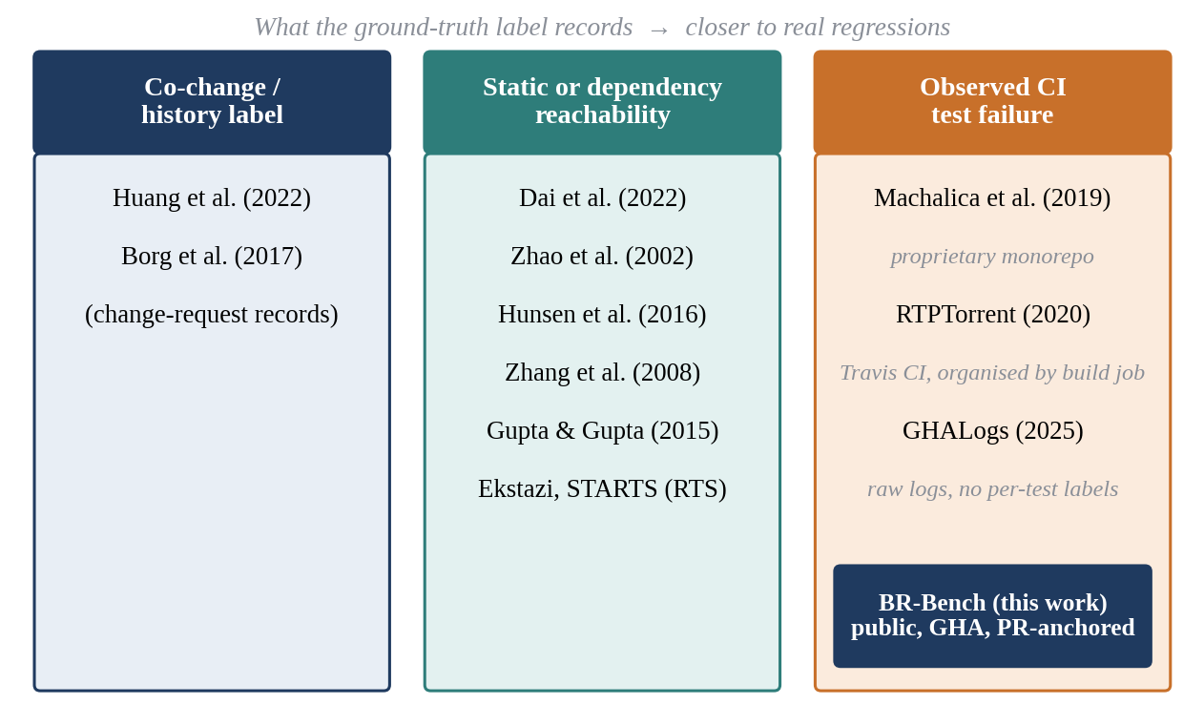
Fig. 2.1 Related Work Grouped by the Ground-Truth Label It Relies On

2.2.1 Predictive Test Selection at Meta
Machalica et al. (2019) describe predictive test selection at Meta: a model trained on historical CI outcomes chooses which tests to run for each change. This uses the right label, observed failures, and reported strong results on a proprietary monorepo with an internal build system. No public artifact was released, so the result cannot be replicated or compared on open-source software. BR-Bench is intended to provide the data that makes such replication possible.

2.2.2 RTPTorrent
RTPTorrent (Mattis et al., 2020) is an open dataset for evaluating regression test prioritisation, built from Java projects on Travis CI. It does contain test outcomes, which makes it the closest public precedent. It differs from BR-Bench in four ways: it predates the GitHub Actions era and the decline of Travis CI for open-source projects, it covers a single language, it is organised by build job rather than by pull request with an explicit diff, and it was built for prioritisation rather than for linking a changed file to a failing test.

2.2.3 GHALogs
GHALogs (Moriconi et al., 2025) is a large public corpus of raw GitHub Actions run logs presented at the MSR 2025 Data and Tool Showcase. It is an excellent substrate, but it stops at the log: it does not parse per-test verdicts, does not link runs to pull-request diffs, does not de-flake, and does not label fault revelation. The gap between having the logs and having labelled (change, failing test) pairs is the entire engineering contribution of BlastRadius.

2.2.4 Other Related Work
Several further strands of work are relevant. The SWE-bench family of benchmarks evaluates whether an agent can fix a bug given a failing test; these are agent-evaluation benchmarks, whereas BR-Bench is a prediction benchmark that asks which tests a diff will turn red. Ekstazi (Gligoric et al., 2015) and STARTS (Legunsen et al., 2017) are regression test selection tools for Java that select tests by dynamic file dependencies and static class dependencies respectively; both are safe over-approximations rather than observations.
DeFlaker (Bell et al., 2018) detects flaky tests by checking whether a failing test executed any changed code; its heuristic informs the flakiness filters of BlastRadius. Graphify is the open-source code-graph extractor that the project forked for its graph layer; its zero-hop proximity heuristic is a useful baseline concept for graph-based impact. Finally, Chianti (Ren et al., 2004) is a classical change impact analysis tool for Java that decomposes edits into atomic changes and determines affected tests using call graphs. Chianti requires a build and JVM instrumentation at every analysed commit, which is impractical when the corpus spans many repositories and hundreds of historical commits each; this is the main reason BlastRadius uses a build-free static graph.
Table 2.2 Closest Related Datasets and Tools
Work | Label or output | Data | Gap relative to BR-Bench
Meta PTS (Machalica et al., 2019) | Failing tests (observed) | Proprietary monorepo | No public artifact; cannot be replicated
RTPTorrent (Mattis et al., 2020) | Test outcomes for prioritisation | Public; Java on Travis CI | Pre-GitHub-Actions; single language; organised by build job, not PR diff
GHALogs (Moriconi et al., 2025) | Raw run logs | Public; GitHub Actions | No per-test verdicts, no diff link, no de-flaking, no labels
Ekstazi, STARTS | Reachable tests | Tool output | Safe over-approximation, not observation
DeFlaker (Bell et al., 2018) | Flaky-test flags | Tool output | Informs our filters; not a change-to-test dataset
Chianti (Ren et al., 2004) | Affected tests via atomic changes | Tool output | Needs a build and instrumentation per commit
SWE-bench family | Bug fixes by agents | Public | Agent evaluation, not test-failure prediction

2.3 Research Gap (Problem Definition)
The literature reviewed above leads to a precise statement of the problem. There is no public, execution-grounded, pull-request-anchored, multi-language dataset that links a code change to the individual tests it caused to fail. Without one, the field cannot measure whether its impact-analysis methods predict real regressions. Each element of this statement excludes a class of existing work. Public excludes industrial predictive test selection. Execution-grounded excludes co-change and reachability labels. Pull-request-anchored excludes datasets organised by build job without a diff. Multi-language excludes single-language corpora. Individual tests excludes job-level or build-level pass/fail data.
The problem is also defined by what it is not. BlastRadius does not claim to be a safe regression test selection tool; it makes no safety guarantee. It does not claim a state-of-the-art predictor. It does not attempt cross-repository impact, in which a change in one repository breaks tests in another. Stating these non-goals is part of defining the problem, because each of them would require a different corpus and a different ground truth.

2.4 Project Description
BlastRadius is a data pipeline plus an analysis layer. It consists of seven components, each of which is described in detail in Chapter 4:
- Harvester. Mines GitHub Actions data in the order pull requests, commits, workflow runs, jobs and finally logs, annotations and artifacts, within the GitHub API rate limits, and stores the raw responses immutably.
- Parser suite. Turns raw CI logs into per-test outcome records for Gradle, Maven and pytest.
- Test-identifier normaliser. Maps every test to one canonical test_id, which is the join key for the whole project.
- Labelling engine. Resolves a base run for each change and labels the fault-revealing tests.
- Measurement and tables. Analysis scripts that regenerate every reported number with one command, make tables.
- Graph layer. Commit-pinned code-property graphs with test nodes bound to test_id, plus a query API.
- Release builder. Produces a pseudonymised, checksummed dataset bundle with a datasheet.
The components form a strict pipeline: each consumes only the validated output of the previous one, and no stage is allowed to run ahead of the data it depends on. This ordering, harvester first, then parsers, labels, graph and analysis, was a deliberate rule of the project. It ensured that effort was never spent on a model or a visualisation while the data beneath it was still unverified.

2.5 Research Questions
The roadmap defines four research questions. Let C be the co-change impact set of a change, R its static-reachability set and F its fault-revealing set, that is, the tests labelled as broken by the change.
RQ1: How much do co-change, reachability and fault-revelation impact sets diverge? The divergence is reported as Jaccard overlaps together with the precision and recall of each proxy against the fault-revealing set:
J(C, F) = |C ∩ F| / |C ∪ F|, J(R, F) = |R ∩ F| / |R ∪ F| (2.1)
Precision(X) = |X ∩ F| / |X|, X ∈ {C, R} (2.2)
Recall(X) = |X ∩ F| / |F|, X ∈ {C, R} (2.3)
In Eqn. 2.1 the Jaccard overlap is 1 when two sets are identical and 0 when they are disjoint. In Eqn. 2.2 the precision of a proxy measures how many of its predicted tests actually failed, and in Eqn. 2.3 its recall measures how many of the failing tests it found.
RQ2: Which change characteristics predict divergence? For example, whether changes to test files, build configuration or dependency versions behave differently from changes to production code.
RQ3: Can a learned model trained on execution outcomes beat both proxies? This question requires the learned predictor, which was cut from the scope of this semester. It is retained as future work and is not answered in this report.
This question is answered by the dataset figures, the binding rates, the parser-fix case study and the parser precision on the development corpora. An independent parser-precision figure was not measured (decision D-53); Chapter 7 states this plainly.

2.6 Goals and Their Status
Table 2.3 lists the goals of the project and their status at the time of writing. The status column is deliberately literal: a goal is marked done only if its artifact exists and was verified, and goals that were cut are marked as not built rather than described as partially complete.
Table 2.3 Project Goals and Their Status
Goal | Status
Harvester and raw corpus | Done
Parsers (Gradle, Maven, pytest) and canonical test_id | Done; a parameter-type parsing defect was found and fixed in October (Section 7.2)
Labelling engine with base-run resolution | Done; rebuilt from raw data in October (decision D-49)
Reproducible tables (make tables) with a freshness guard | Done
Graph layer (commit-pinned graphs, test binding, query API) | Done for a 3-repository mini-corpus (decision D-48)
Local release bundle, pseudonymisation, datasheet draft | Published on Zenodo (v0.1); v0.2 built and validated, deposit pending
One-command reproduction (make all) | Done: mini-corpus reproduction 511.09 s of its 900 s budget; whole make all 16 min 35 s including tests; make tables about eight minutes
Independent parser precision (holdout v5) | Not measured: no blind human labels were completed; v5 left unscored (decision D-53)
RQ1 measurement (co-change and baselines) | Done: scored on 576 instances at k = 10 after the D-52 corrections; numbers frozen at paper-numbers-v1.1
Learned predictor, GNN, GitHub Action | Not built: cut from scope
Demo site (static replay) | Built: Overview, Live run (with a blast-radius picture) and Results views over exported data; make demo runs the walkthrough live. Further chart panels in progress

CHAPTER 3
TECHNICAL SPECIFICATION
This chapter specifies the technical environment of BlastRadius: the software stack actually used, the hardware and external resource constraints, the external interface to GitHub, the scope decisions that bound the system, the data artifacts it produces, and the functional and non-functional requirements against which it is evaluated. Where a choice was the subject of a recorded design decision, the decision number is given so that the rationale can be traced in the decision log.

3.1 Software Stack
Table 3.1 lists the software stack as it was actually used, and Fig. 3.1 shows how the layers depend on one another. The guiding principle was that everything should run on a student laptop without a database server, a cluster or a paid service, and that every dependency should be pinned so that a rebuild produces identical output.
Table 3.1 Software Stack as Used
Layer | Technology
OS / environment | Windows 11 + WSL2 Ubuntu 24.04 (all work runs inside WSL)
Language | Python 3.11.15
Package manager | uv (lockfile-based)
Data handling | pandas, pyarrow (Parquet), requests
Storage | Parquet files + DuckDB (embedded SQL, no server; decision D-06)
Code parsing (graph layer) | tree-sitter grammars via a stripped fork of Graphify (vendored as graphifyy 0.9.45, Apache-2.0 with MIT-licensed portions)
Graph library | NetworkX (MultiDiGraph)
Testing | pytest, with real checked-in fixtures and no mocks
Dashboard | Streamlit (8 read-only panels for corpus monitoring)
Version control | Git + GitHub
Build / orchestration | GNU Make (make tables, make all)
Development method | AI-assisted agentic coding (Claude Code) under a strict architect → operator → agent loop with human verification of every change

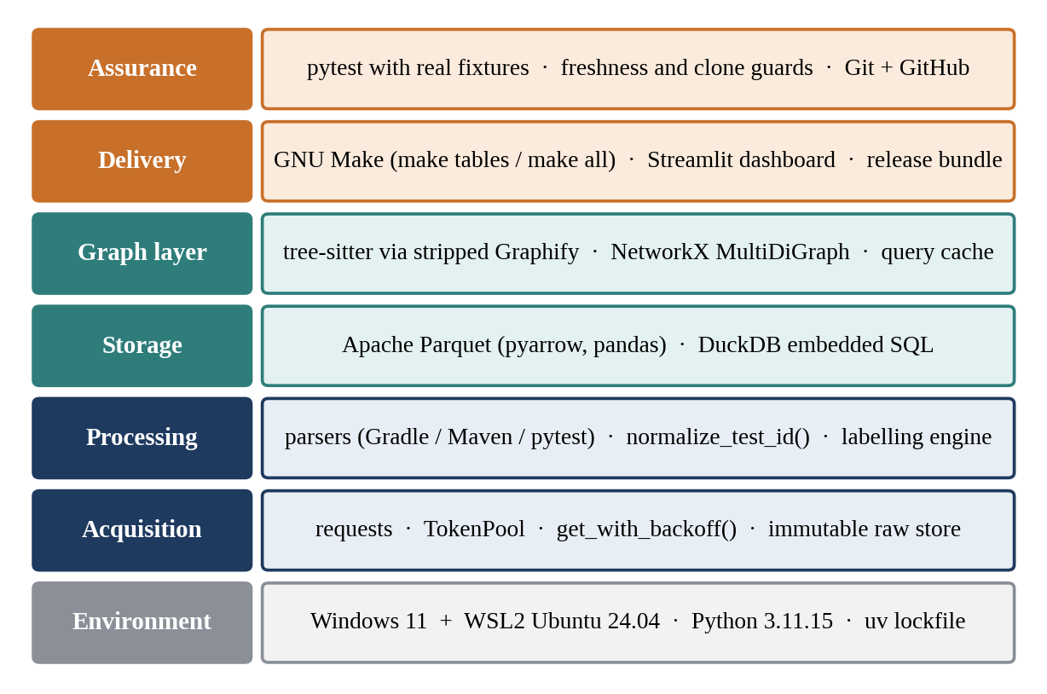
Fig. 3.1 Layered View of the BlastRadius Software Stack

3.1.1 Environment and Language
All development and all runs take place inside Windows Subsystem for Linux 2 (WSL2) running Ubuntu 24.04. Running inside Linux avoids differences in path handling, line endings and shell behaviour that would otherwise make outputs differ between team members' machines. Python 3.11.15 is pinned exactly, and dependencies are managed with uv, whose lockfile records the precise version of every package. A fresh environment created from the lockfile is therefore identical to the one used to produce the reported numbers.

3.1.2 Data Handling and Storage
Raw API responses are stored as compressed files in an immutable raw store. All derived data is stored as Apache Parquet, a columnar format that is compact, typed and readable by pandas, pyarrow and DuckDB. DuckDB is an embedded analytical SQL engine: it runs inside the Python process, reads Parquet files directly and needs no server. Decision D-06 chose this combination over server databases such as MongoDB or Postgres and over graph databases such as Neo4j, because it is laptop-scale, has no operational overhead and is standard in the MSR community.

3.1.3 Graph Layer Libraries
The graph layer parses Java and Python source with tree-sitter grammars through a stripped fork of the open-source Graphify extractor, vendored into the repository so that its exact version is fixed. Graphs are held in memory as NetworkX MultiDiGraph objects, which allow several typed edges between the same pair of nodes, and are serialised as compressed node-link JSON. Query results are cached per (repository, commit) in DuckDB.

3.1.4 Testing, Dashboard and Orchestration
Every data-touching function is tested with pytest against real fixtures checked into the repository, such as real CI log excerpts, rather than against mocks. A Streamlit dashboard with eight read-only panels allows any team member to inspect corpus health without running scripts. GNU Make orchestrates the pipeline: make tables regenerates every reported table from raw data, and make all additionally runs the full test suite.

3.1.5 Development Method
The project used AI-assisted agentic coding with Claude Code, but under a strict division of roles. An architect role decided what to build next and how it would be proven; the coding agent executed one scoped, testable task at a time; and a human operator ran the task, inspected the raw output, verified claims personally and authorised every commit. Every commit was authored by a student operator. This loop exists to prevent a specific failure: an agent that is fully capable of a task but unscoped, producing plausible output that nobody verified. Section 4.1.11 describes the verification discipline in more detail.

3.2 Hardware and Resource Constraints
The project operates within four resource constraints, listed below. The last of them, log expiry, is the only constraint that could not be relaxed by spending more time or effort.
- Compute. Everything runs on a student laptop. GPU work for a graph neural network was planned to run on a free hosted notebook service, but the model was not built, so no GPU was used.
- API rate limits. The GitHub REST API allows 5,000 requests per hour per token, and the project uses three tokens. All HTTP traffic goes through a single function, get_with_backoff(), which tracks quota, honours Retry-After, applies exponential backoff and maintains resumable cursors.
- Storage. The roadmap budget is 200–500 GB for raw logs and at most 150 GB for the graph store.
- Log retention. GitHub Actions logs for public repositories expire after 90 days. This is the project's only immovable deadline, and it determined that the harvester was built and run first.
The rate-limit constraint deserves emphasis because it shapes the harvester's design. A naive crawler that ignores rate limits is not merely slow; it fails silently. When quota is exhausted, some requests return errors or partial pages, and a crawler that does not check for them will report success while having captured only part of the data. Routing every request through one function makes it possible to log every request, to check for rate-limit responses after a run, and to compare the number of requests actually made with the number expected.

3.3 External Interface: The GitHub REST API
BlastRadius interacts with exactly one external system, the GitHub REST API. The harvester walks the API from the coarsest to the finest object: it lists pull requests in each repository, lists every commit in each pull request, finds the workflow runs for each head commit, lists the jobs of each run, and finally fetches the check runs and their annotations, the uploaded artifacts and the job logs. Each response is written to the raw store unmodified, and parsing happens later, outside the capture loop. This separation, capture wide and parse narrow, means that a parsing bug can always be fixed by re-parsing, whereas a capture that never happened cannot be recovered after the logs expire.
Table 3.2 GitHub Objects Captured by the Harvester
Object | What it provides | Retention
Pull request | Number, state, base and head branches | Persistent
PR commits | Every head SHA in the life of the PR | Persistent
Workflow run | Run id, workflow id, head SHA, conclusion, timestamps | Persistent metadata
Job | Per-job conclusion; one job per matrix leg | Persistent metadata
Check-run annotations | Structured per-test failure messages where a reporting action is used | Persist beyond 90 days
Artifacts | Uploaded files such as JUnit XML reports | 90 days for public repositories
Job logs | Full console output including test-runner output | 90 days for public repositories

3.4 Scope Constraints
Four scope decisions bound the system. They are recorded in the decision log so that the reasons survive beyond the people who made them.
- Languages: Java and Python only (D-03). Java gives comparability with the regression test selection literature, whose main tools and datasets are Java-based. Python gives scale, because it has a very large GitHub Actions population. TypeScript was planned as a stretch goal and was cut.
- No LLM anywhere in the reproducible core (D-17). Harvesting, parsing, labelling, graph construction, features and every reported number are produced by deterministic code. The vendored Graphify extractor included an LLM-based extraction pass, which was deleted rather than disabled.
- Determinism. Every output is seeded where randomness is involved and sorted where order could vary. A result that is not reproducible is excluded from the dataset and from this report.
- Frozen schemas. The data schemas in docs/SCHEMAS.md were frozen in Week 2 of the project. Any change requires a recorded decision, because a silent change to a field or key would break every downstream join.
The no-LLM rule is worth explaining, given that the project itself was built with an AI coding agent. The distinction is between the tool used to write code and the code that produces the data. An agent may help write a deterministic parser, and the parser is then tested and committed like any other code. What is forbidden is a pipeline stage whose output depends on a model call at run time, because such a stage cannot be reproduced exactly by another researcher, and an MSR dataset that cannot be reproduced is of limited value.

3.5 Data Artifacts
Table 3.3 lists the main data artifacts. They flow from the immutable raw store through regenerable intermediate files to the derived tables and the release bundle, as shown in Fig. 3.2.
Table 3.3 Main Data Artifacts
Artifact | Contents
Raw store (data/raw/) | Immutable harvested logs, annotations and run metadata
parsed_outcomes.parquet | One row per parsed test outcome from a log
base_outcomes.parquet | Parsed outcomes of base runs
outcomes.parquet / instances | One row per (instance, test) observation, and one row per (head_sha, workflow_run) instance
binding.parquet | Binding of each test_id to a test file in the repository
CORPUS_PIN.json | Pin of the exact corpus population used
docs/CLONE_PINS.json | Pinned commit per cloned repository, used for binding (D-50)
data/graphs/graph_{repo}_{sha}.json.gz | Commit-pinned code-property graphs
release/v0.1/ | Pseudonymised BR-Bench bundle with SHA-256 checksum manifest

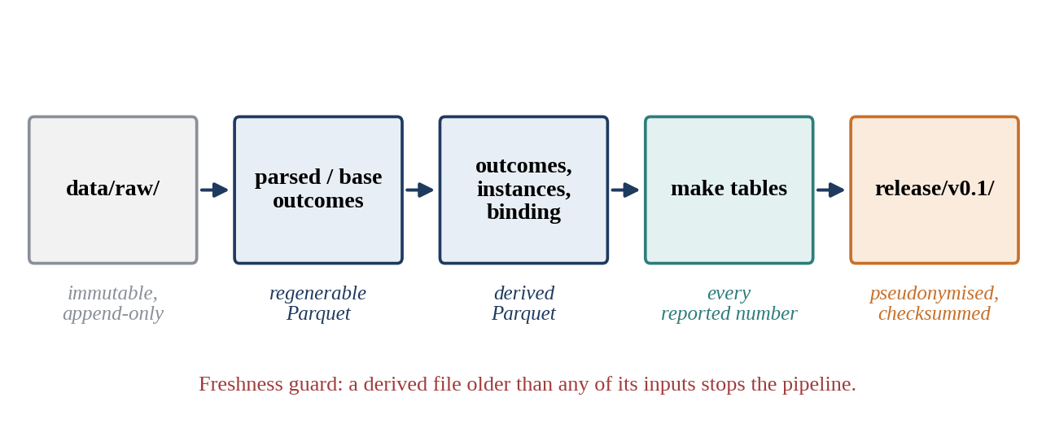
Fig. 3.2 Lifecycle of Data from the Raw Store to the Release Bundle
Two artifacts in the table deserve comment. CORPUS_PIN.json fixes the exact population of repositories and instances that the analysis uses, so that adding a repository later cannot silently change earlier numbers. docs/CLONE_PINS.json fixes the commit at which each cloned repository is inspected when binding test identifiers to files. Before this pin existed, binding used each clone's live HEAD, and the binding rate drifted as upstream projects received new commits (Section 7.3).

3.6 Requirements

3.6.1 Functional Requirements
- Capture, for each repository in the corpus, the pull requests, commits, workflow runs, jobs, annotations, artifacts and logs needed to reconstruct per-test outcomes, without exceeding the API rate limits.
- Parse Gradle, Maven and pytest output into per-test records with a status of pass or fail, a job and run reference and a canonical test identifier.
- For each (head SHA, workflow run) instance, resolve a base run of the same workflow, or record that none exists, and compute the fault-revealing set.
- Detect and remove tests that flip on the same commit, and produce a strict split on which headline numbers are reported.
- Bind each canonical test identifier to a test file in the repository at a pinned commit, and report binding as two numbers.
- Build a code-property graph for a given repository and commit, bind its test nodes to canonical identifiers and answer distance and neighbourhood queries.
- Regenerate every reported table from raw data with one command, and refuse to run if any derived artifact is stale.
- Produce a release bundle with pseudonymised author identities, a secret scan, a canary check and a checksum manifest.

3.6.2 Non-Functional Requirements
Table 3.4 Non-Functional Requirements and Budgets
Requirement | Target
Reproducibility | Every reported number regenerates from raw logs with make tables
End-to-end reproduction | make all on the mini-corpus in under 15 minutes
Graph query latency | ≤ 100 ms per query
Incremental graph build | ≤ 10 s per commit transition
Cold graph build | ≤ 10 min per repository
Determinism | Seeded and sorted outputs; no LLM in the core
Privacy | Author logins pseudonymised with keyed HMAC-SHA256; key never committed
Test discipline | Every data-touching function tested against real fixtures

The budgets in Table 3.4 come from the project roadmap. They are reported against measured values in Chapter 7, including the budget that was not met (the incremental graph build).

CHAPTER 4
DESIGN APPROACH AND DETAILS
This chapter describes how BlastRadius is designed and why. Section 4.1 presents the design approach and methods, starting from the overall architecture and following the data through each stage of the pipeline, then describing the graph layer and the release builder. Section 4.2 lists the codes and standards the project follows, and Section 4.3 discusses the constraints, the alternatives considered and the trade-offs accepted.

4.1 Design Approach / Materials and Methods

4.1.1 System Architecture
Fig. 4.1 shows the architecture of the system. Data enters at the top from a sampling frame of candidate repositories and flows downwards through the harvester, the parser suite, the labelling engine and the binding stage to the reproducible tables and the release bundle. The graph layer branches off to the side: it consumes the same canonical test identifiers but produces a separate deliverable for this course, and its numbers are not used in the planned paper (decision D-48).
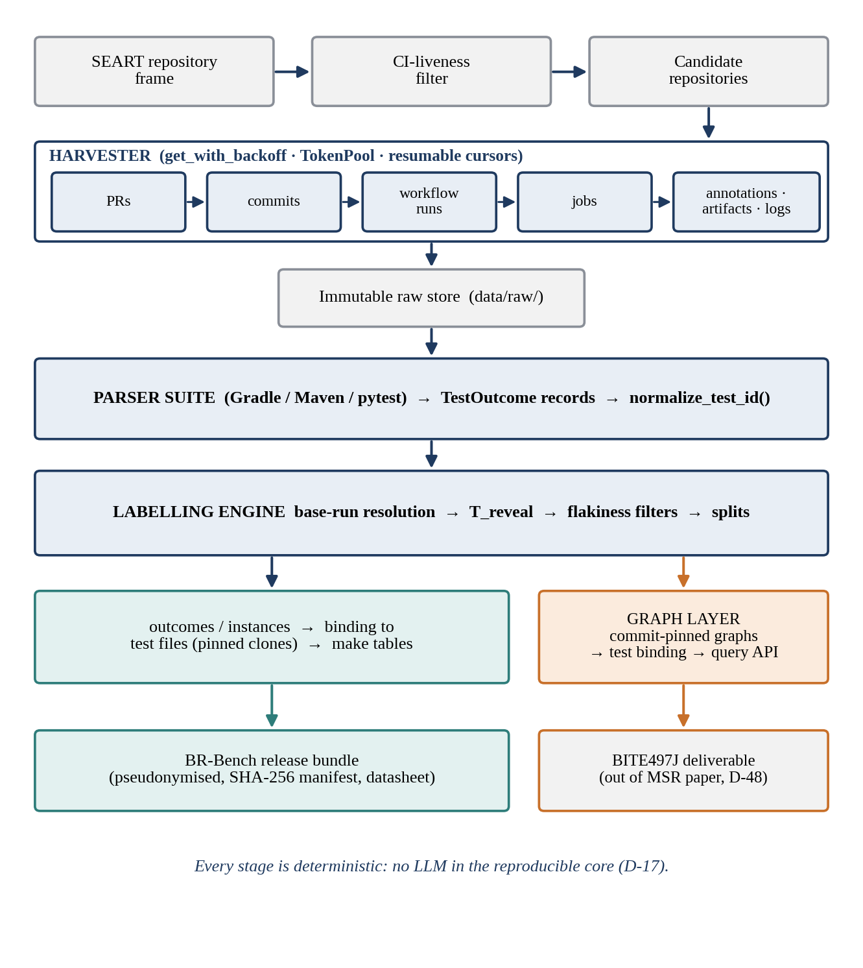
Fig. 4.1 System Architecture of BlastRadius
Three architectural principles run through the design. The first is immutability at the bottom: the raw store is append-only, and every later artifact can be regenerated from it. The second is one source of truth per concept: there is one function that issues HTTP requests, one normaliser that produces test identifiers and one script per reported table. The third is determinism throughout: no stage depends on wall-clock order, unseeded randomness or a model call, so a rebuild from the same raw data produces byte-for-byte comparable outputs.

4.1.2 Repository Sampling
The candidate repositories were drawn from SEART GitHub Search, a published sampling instrument for MSR studies that indexes GitHub repositories by many characteristics (Dabic et al., 2021). Using a citable instrument with a recorded query is materially stronger than selecting popular repositories by hand, because another researcher can reproduce the frame. The query selected Java and Python repositories that were active, licensed, not forks and receiving pull requests. A second stage filtered the frame for CI liveness through the GitHub API, keeping repositories with recent workflow runs and at least one workflow whose name or steps indicate that it runs tests, and excluding workflows that only release, deploy, publish documentation or lint.
Each criterion removes repositories from which the ground truth cannot be constructed: without CI activity there are no outcomes, without a test workflow there are no test verdicts, without a licence the derived data cannot be redistributed, and without pull requests there are no instances. The criteria are therefore eligibility conditions rather than a matter of convenience. The resulting population is biased towards popular, actively maintained projects that use CI; that is a characteristic of the sample rather than a defect, since it is the same population that the test-selection literature studies. The binding stage reported in Chapter 7 operates on 43 cloned repositories, and the graph layer operates on a 3-repository mini-corpus chosen to cover one pytest, one Gradle and one Maven project.

4.1.3 Harvester
The harvester is the component on the critical path, because the data it captures expires. Its design follows the principle capture wide, parse narrow: it stores raw API responses to disk without interpreting them, so that no parsing decision made under time pressure can lose information. Fig. 4.2 shows the order in which it walks the GitHub object model.
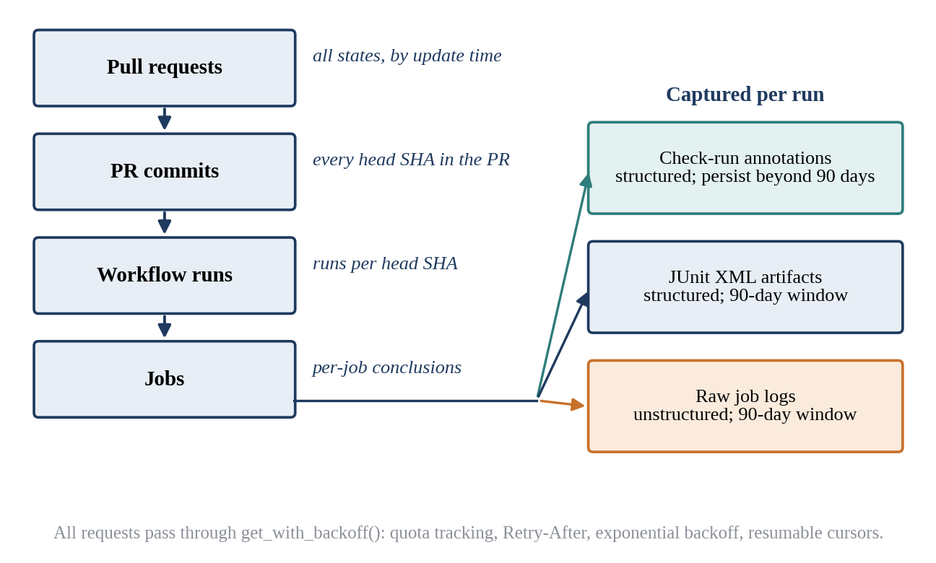
Fig. 4.2 Capture Sequence of the Harvester
The harvester walks every commit of every pull request, not only the final one. This matters because of survivorship bias: by the time a pull request is merged, its CI is usually green, since developers fix failures before merging. The failing runs that carry the ground truth occur on intermediate pushes. Treating each (head SHA, workflow run) pair as an instance keeps these runs.
All requests pass through one function, get_with_backoff() in the rate-limit module. It draws from a pool of three personal access tokens, tracks the remaining quota of each from the response headers, honours Retry-After on rate-limit responses, retries transient failures with exponential backoff and records every request to a request log. Progress is recorded in resumable cursors, so an interrupted run continues where it stopped instead of re-fetching. The single entry point has a second benefit beyond correctness: because every request is logged in one place, a run can be audited afterwards for rate-limit responses and for request counts that do not match expectations.
Tokens are stored in an environment file that is excluded from version control and is never printed. Scripts confirm that a token is configured by checking its key name and that its value is non-empty, never by displaying it.

4.1.4 Log-Source Preference
The same test failure can often be recovered from several sources, and they differ greatly in reliability. BlastRadius prefers sources in the order shown in Fig. 4.3. Check-run annotations come first because they are structured, one per failing test, and persist beyond the 90-day window. JUnit XML artifacts come next because they are machine-readable reports produced by the test framework itself. Raw job logs are the fallback: they are always present while unexpired, but they must be parsed with framework-specific rules. Docker re-execution, in which base and head commits are rebuilt and re-tested in a fixed environment, was planned only for a small gold subset and was not built.
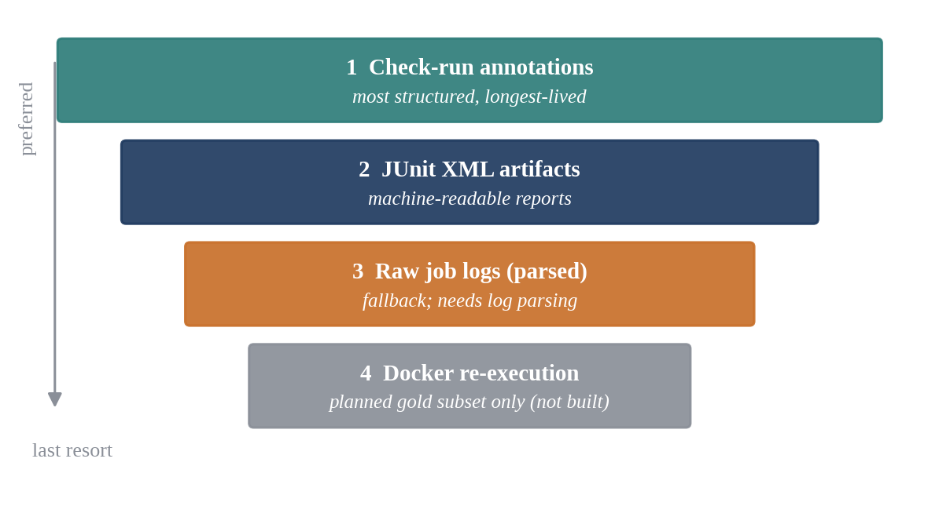
Fig. 4.3 Preference Order of Test-Result Sources

4.1.5 Parser Suite
The parser suite turns raw logs into TestOutcome records. Each record identifies the run and job, the repository and head commit, the canonical test identifier and the verdict. Fig. 4.4 shows the stages through which a log passes.
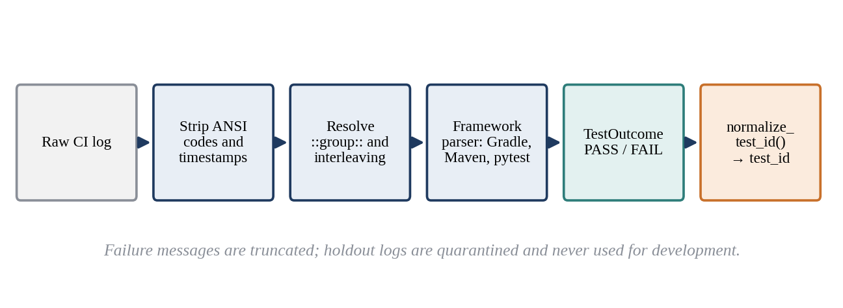
Fig. 4.4 Stages of Parsing a Raw CI Log into Test Outcomes
Before any framework rule is applied, the log is cleaned. GitHub Actions prefixes every line with a timestamp, and test runners emit ANSI colour codes; both are stripped so that patterns match the text a developer would see. Lines inside ::group:: blocks are handled so that collapsible sections do not hide or split test output, and interleaved output from parallel workers is handled so that a failure line is attributed to the right test. Failure messages are truncated to a bounded length, because a single stack trace can otherwise dominate the size of the dataset without adding labelling value.
Framework-specific parsers then recognise test results. The Gradle parser reads the failure blocks and summary that Gradle prints for its test task; the Maven parser reads Surefire's per-class summaries and error lines; and the pytest parser reads the short test summary and the per-test status lines. Each parser emits the same record type, so the stages after parsing do not need to know which framework produced a record.
Parser quality is measured, not assumed, with one stated limit. Forty logs (holdout v5) were set aside as a holdout that is never used during development, to be labelled blind by hand from the full logs with no parser output visible (decision D-38) and scored exactly once (decision D-37). That independent labelling was not completed, so holdout v5 stays unscored (decision D-53) and the reported precision comes from development corpora only, marked as not independent. An earlier holdout, v4, was voided because its expected test classes had been derived by rule rather than labelled by hand. During the October parser fix described in Section 7.2, all holdout rows were quarantined so that no holdout log was used to debug the fix.

4.1.6 Test Identity and the Normaliser
Every stage of the project joins data on one key: the canonical test_id. The parsers produce it, the labelling engine groups by it, the binding stage maps it to files and the graph layer binds test nodes to it. If two stages produced different identifiers for the same test, every join between them would silently lose rows. Decision D-09 therefore mandates a single normaliser, normalize_test_id(), which extends the identifier module of the vendored Graphify code rather than introducing a second implementation (Fig. 4.5).
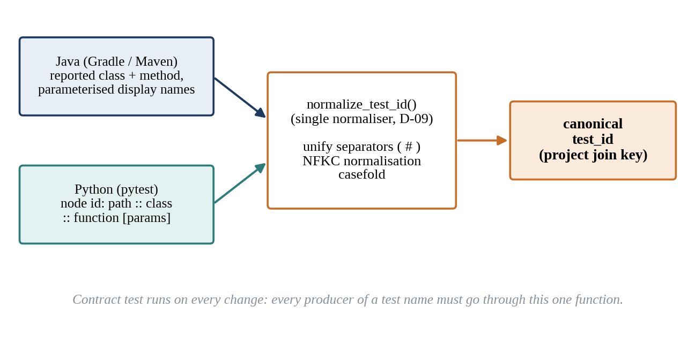
Fig. 4.5 Canonicalising Test Names into the Project Join Key
The normaliser unifies the way frameworks name tests. For Java, a test is identified by its fully qualified class name and method name, joined with # as the class/method separator, and parameterised display suffixes are handled so that every invocation of a parameterised test maps to the same method. For pytest, the node id is decomposed into path, class and function. The resulting string is normalised with Unicode NFKC normalisation and casefolding, so that visually identical names that differ in Unicode representation or letter case compare equal. A contract test runs on every change and fails if any producer of test names bypasses the normaliser or if the normaliser's output changes for its reference inputs.

4.1.7 Ground-Truth Definition and the Labelling Engine
The ground truth of BR-Bench is defined by a single set expression. For an instance consisting of a head commit and a workflow run, let T_head_fail be the set of tests failing at the head, T_base_fail the set failing in the resolved base run, and T_flaky the set of tests that flip verdict on an identical commit. The fault-revealing set is:
T_{reveal} = T_{head_fail} \ T_{base_fail} \ T_{flaky} (4.1)
In Eqn. 4.1 the backslash denotes set difference. A test is fault-revealing for a change if it failed at the head commit, did not fail in the base run and did not flip on the same commit. Fig. 4.6 illustrates the sets involved: failures shared by head and base are pre-existing and are excluded, and flaky tests are removed from what remains.
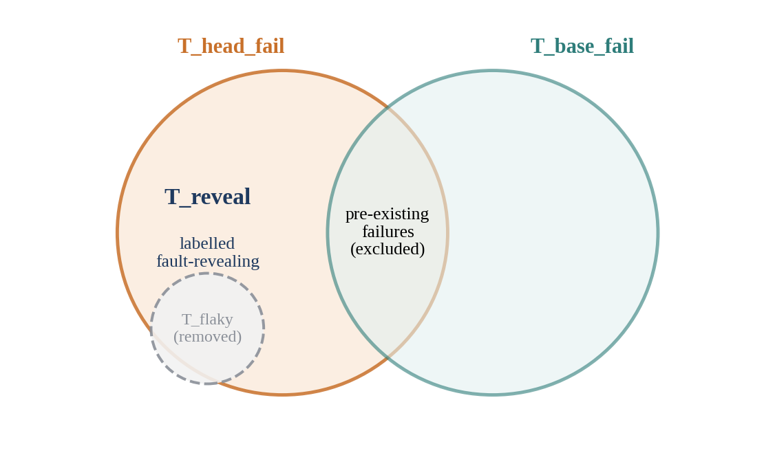
Fig. 4.6 The Fault-Revealing Set as a Set Difference
Computing T_base_fail requires a base run, and finding one is the hardest correctness problem in the project. The base commit of a pull request may never have been run by the same workflow, the workflow may have been renamed, or the base run may itself have been cancelled. The labelling engine resolves the base run with the procedure in Fig. 4.7 and Algorithm 4.1.
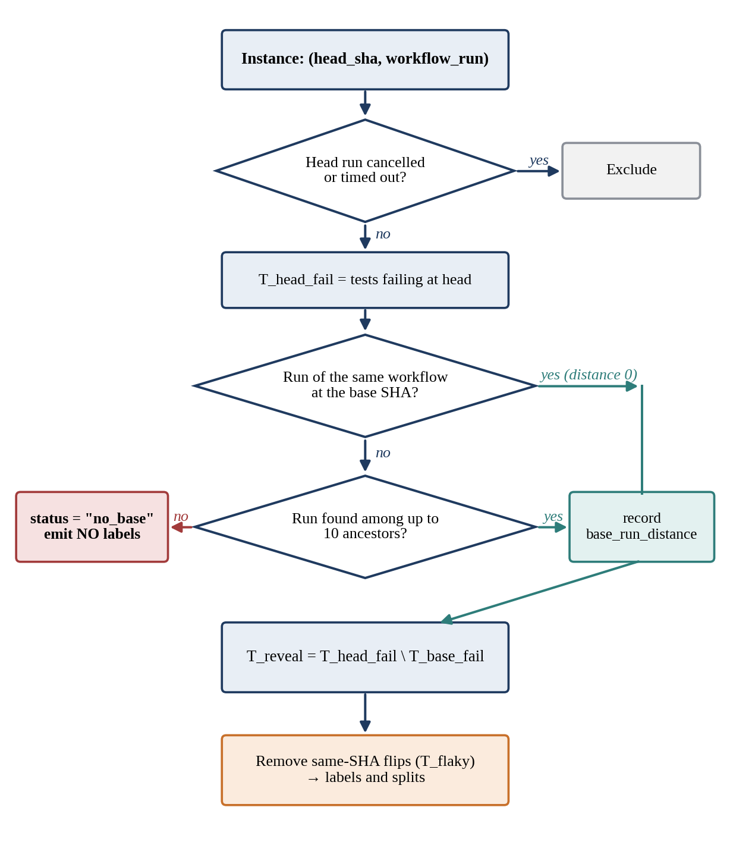
Fig. 4.7 Base-Run Resolution Procedure
Algorithm 4.1 Base-run resolution and labelling (pseudocode)
for each instance (head_sha, workflow_run):
if head run is cancelled or timed out:
exclude instance
T_head_fail <- tests failing at head_sha
base <- most recent run of the SAME workflow at base_sha
if base is None:
walk back up to 10 ancestors of base_sha
base <- first ancestor run of the same workflow
record base_run_distance
if base is None:
status <- "no_base" # emit NO labels
continue
T_reveal <- T_head_fail - T_base_fail(base)
T_reveal <- T_reveal - tests that flip on head_sha
emit labels; union failures across matrix legs (D-12)

The most important line in Algorithm 4.1 is the no_base branch. An empty base failure set must never be read as "the base was green". If an instance with no resolvable base were treated as having a clean base, every failure at the head would be labelled fault-revealing, including failures that already existed on the target branch, and false positives would be manufactured at scale. The engine therefore distinguishes an observed empty failure set, which is evidence of a green base, from a missing base run, which is absence of evidence, and emits no labels at all for the latter. This invariant is asserted in tests, and the rate of no_base instances and the distribution of base_run_distance are reported rather than hidden.
Several further edge cases arise in practice. They are resolved by the rules in Table 4.1, each of which errs towards excluding an uncertain label rather than emitting a possibly wrong one.
Table 4.1 Edge-Case Rules of the Labelling Engine
Case | Rule
Head run cancelled or timed out | Excluded
Test exists at head but not at base | Not fault-revealing (new_test = True)
Test exists at base but not at head | Excluded
Matrix builds (several OS or version legs) | Union of failures across legs; n_matrix_legs recorded (D-12)
base_run_distance > 0 | Kept, with the distance recorded as a quality column
No base run within 10 ancestors | status = "no_base"; no labels emitted

The rule for new tests deserves explanation. A test that did not exist at the base commit cannot have been broken by the change; if it fails at the head, the failure says more about the new test than about regression. It is therefore marked as new and not counted as fault-revealing. For matrix builds, a test that fails on any leg is counted as failing for the instance, and the number of legs is recorded so that analyses can account for instances with many legs.

4.1.8 Flakiness Handling and Splits
Flaky failures are the most common source of false positives in labels derived from CI. BlastRadius applies three mechanisms. Same-SHA flip detection marks a test as flaky for a commit if two runs of the identical commit give it different verdicts; this is the strongest evidence of flakiness and costs nothing, because re-runs are already visible through the API. The broken-trunk filter is built into Eqn. 4.1 through the comparison with the base run: a test that also fails at the base is not attributed to the change. A rolling flip rate tracks how often each test changes verdict over time, so that chronically unstable tests can be identified.
Labels affected by these filters are annotated rather than silently dropped, and the dataset is released in splits. Headline numbers are always computed on the strict split, which applies the flakiness filters, while less filtered splits are available for sensitivity analysis. Reporting both converts a threat to validity into a measured property of the dataset.

4.1.9 Binding Test Identifiers to Files
A test identifier parsed from a log is only useful for impact analysis if it can be connected to the source code. Binding maps each canonical test_id to a test file in the repository. For Java, the fully qualified class name suggests a path under the conventional test source roots; for Python, the node id already contains a path. A binding is exact when the expected path exists, and a suffix match when only the trailing part of the path or name can be matched, for example because the log omitted the package name.
Binding is reported as two numbers (decision D-47): the combined rate, counting exact and suffix matches, and the full-confidence rate, counting exact matches only. Reporting only the combined figure would overstate how reliably tests are connected to code; reporting only the exact figure would understate how much of the corpus is usable. Both are always given together.
Binding is performed against a pinned commit of each cloned repository (decision D-50). Earlier, binding used whatever commit each clone's HEAD happened to point to, so the reported rate drifted as upstream projects received new commits. A guard also rejects incomplete or corrupt clones; an interrupted clone had once caused git to resolve paths against the BlastRadius repository itself, which produced matches that were plausible but meaningless.

4.1.10 Reproducible Tables and the Freshness Guard
Every number in this report and in the planned paper is produced by a script in the analysis directory and regenerated by make tables. A number that cannot be regenerated this way is not reported. Fig. 4.8 shows the flow, including the freshness guard that was added after the October discovery that derived artifacts had silently gone stale (Section 7.1).
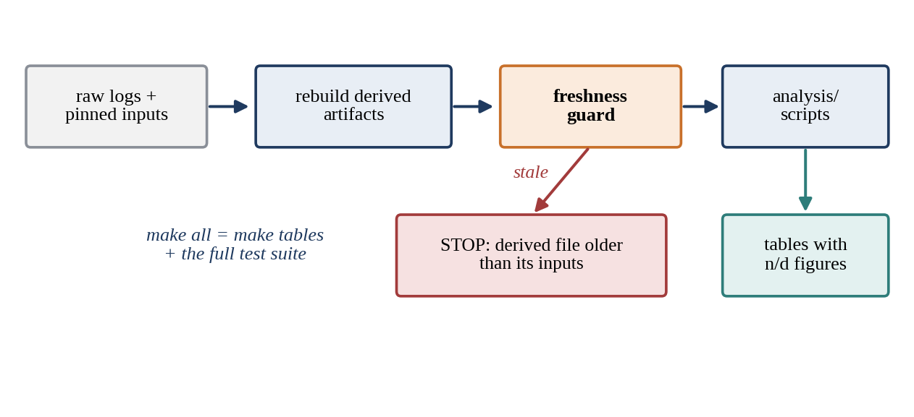
Fig. 4.8 Reproducible Table Generation with the Freshness Guard
The freshness guard compares the modification time of every derived artifact with that of its inputs and stops the pipeline if any derived file is older than something it depends on. Without the guard, a table script would read whatever file was on disk and print plausible numbers, even if that file had been produced from parse output that no longer existed. Rates are reported in the project convention n/d, with both numerator and denominator written out, so that a reader can see the size of the population behind every percentage.

4.1.11 Verification Discipline and Silent-Failure Detectors
The most dangerous failures in a data pipeline are silent: the pipeline runs, produces numbers and reports no error, but the numbers are wrong. The absence of an exception is not evidence that a run worked. BlastRadius therefore pairs each known silent failure with an explicit detector whose output is inspected after every relevant run (Table 4.2).
Table 4.2 Silent Failures and Their Detectors
Silent failure | What it looks like | Detector
Binding collapse | Everything downstream runs but produces noise | Binding rate per repository and commit, with sampled unbound IDs inspected
no_base read as green | False positives manufactured at scale | Assert the status field; publish the no_base rate and base_run_distance distribution
Rate-limit exhaustion | Partial pages returned; run reports success | Scan the request log for rate-limit responses; compare request counts with expectations
Parser stops matching | Coverage drops while instance count rises | Per-parser coverage and precision on held-out logs
Flaky positives | Label counts inflate | Same-SHA flip detection; headline on the strict split
Stale artifacts | Plausible numbers from an old file | Freshness guard; check timestamps and row counts, not just presence
Matrix legs dropped | Positives quietly lost | Assert n_matrix_legs present; union rule (D-12)
Corrupt or partial clone | Binding against the wrong repository | Complete-clone guard; pinned clone commits (D-50)

The verification discipline extends to how work was done. Each change to the code was a single scoped task with one measurable acceptance condition. The coding agent was required to report raw artifacts, such as test output, diffs and specific field values, rather than prose claims that tests had passed. Where a test had hand-computable expected values, those values were treated as ground truth: if the test failed, the code was fixed, never the test. A human operator inspected every report before authorising a commit. Several of the defects reported in Chapter 7 were caught precisely because this discipline demanded evidence where an error message was absent.

4.1.12 Graph Layer Design
The graph layer provides the dependency-analysis half of the approved project title. It builds, for a given repository and commit, a code-property graph whose nodes are files, classes, methods and tests and whose edges are containment, calls, imports and test-to-code relationships. Fig. 4.9 shows the pipeline.
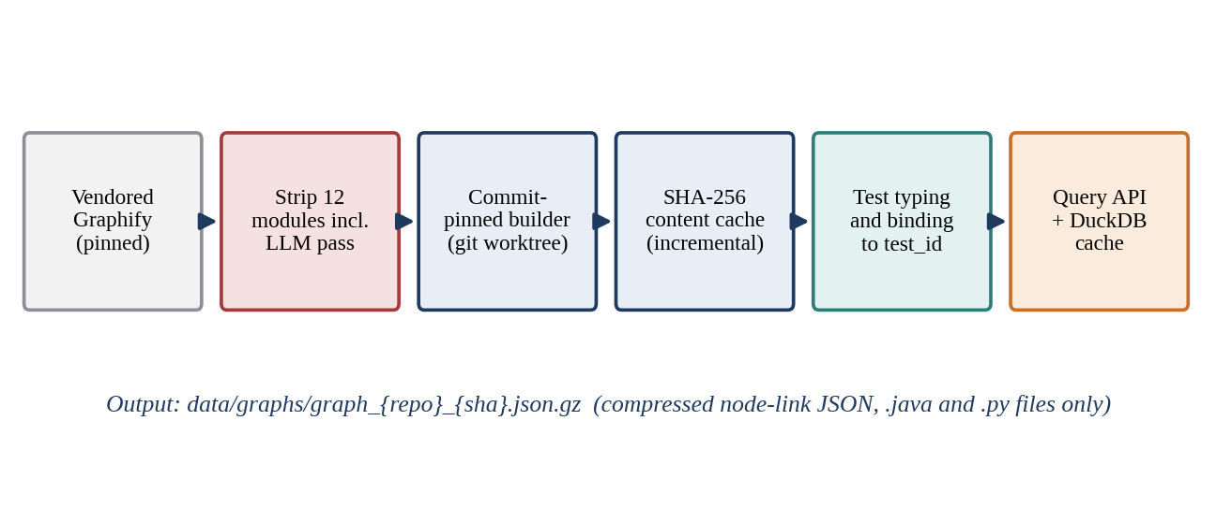
Fig. 4.9 Graph Layer Pipeline
Source and strip. Rather than write a multi-language extractor from scratch, the team forked Graphify, an open-source code-graph extractor licensed under Apache-2.0, and vendored it at a pinned upstream commit. Twelve modules were deleted, including the LLM extraction pass, ingestion, exporters, database push functions and query logging, for a diff of 20,158 lines removed and 253 added. Only the deterministic tree-sitter path remains. The vendored test suite showed zero regressions against its baseline after the strip, confirming that the deletions did not damage the extraction path that was kept.
Commit-pinned builder. To build the graph of a repository at a commit, the builder creates a git worktree at that commit, runs extraction on .java and .py files only, and writes compressed node-link JSON keyed by repository and SHA. Pinning the graph to a commit is essential: the label refers to the code as it was at the base or head commit, not as it is today.
Incremental build. Consecutive commits differ in only a few files, so rebuilding every file is wasteful. A content cache keyed by the SHA-256 hash of each file avoids re-parsing unchanged files. A blocking test asserts that the incrementally built graph is exactly equal to a graph built from scratch for the same commit. This test caught a real defect, described in Section 7.4.
Test nodes and binding. Test files and methods are typed using path conventions and AST signals such as test annotations, and test nodes are bound to canonical test_id values through the shared normaliser, so that a test in the graph and a test in the CI outcomes are recognised as the same entity. Edges from tests to source code come from three strategies with distinct confidences: direct tests edges derived from calls, references and imports in the test; tests_by_convention edges derived from naming conventions such as a class ParserTest testing a class Parser; and tests_by_layout edges derived from mirrored directory layouts such as src/test and src/main. Fig. 4.10 shows these relationships on a schematic example.
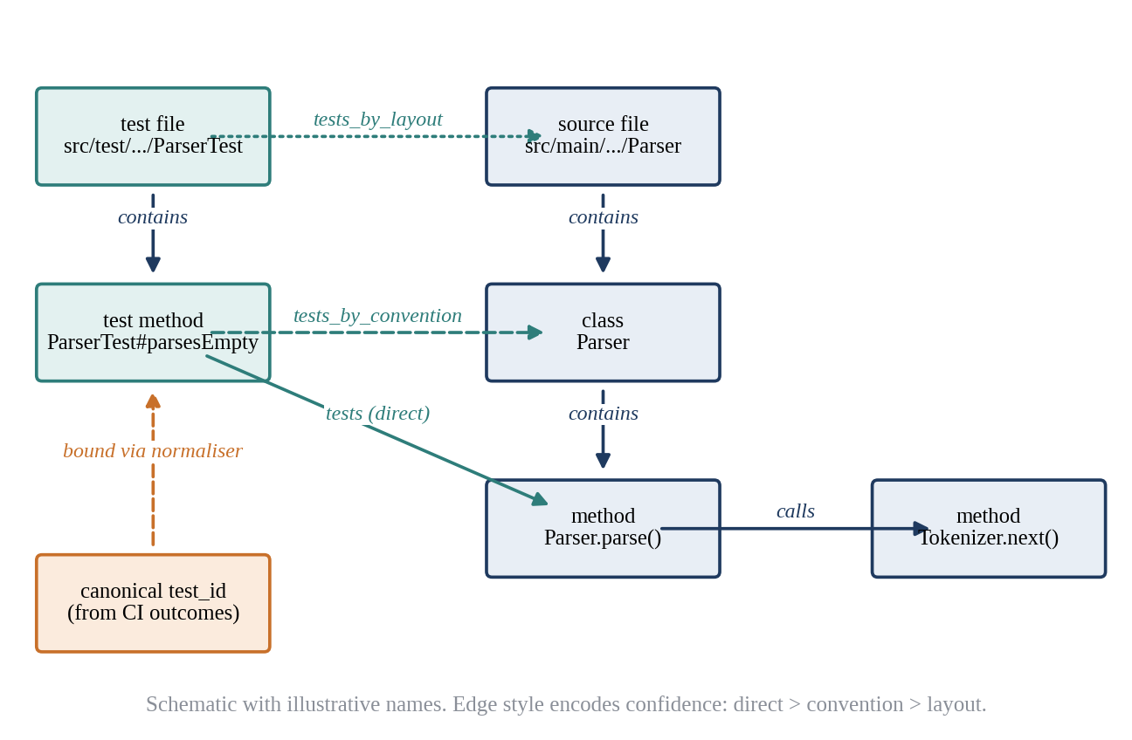
Fig. 4.10 Schematic Example of Test Nodes Bound to Source Nodes
Storage model. The graph is stored as a NetworkX MultiDiGraph keyed by edge type. This was a correction rather than an initial choice: with a single-edge directed graph, adding a derived tests edge between a test method and a source method overwrote the structural calls edge it was derived from (Fig. 4.11). A multigraph keeps both, so derived edges can never destroy the evidence they come from.
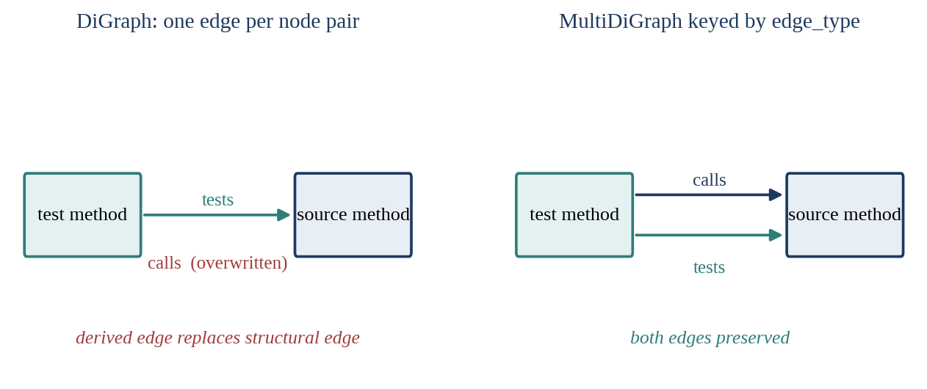
Fig. 4.11 Why the Graph Uses a Multigraph Keyed by Edge Type
Query API. Five primitives answer the questions that impact analysis asks of the graph (Table 4.3). Results are cached per (repository, SHA) in DuckDB, so repeated queries against the same commit are answered from the cache.
Table 4.3 Graph Query Primitives
Primitive | Question it answers
shortest_path_length | How far apart are two nodes in the dependency graph?
min_distance_to_any_changed | How close is a test to the nearest changed element?
k_hop_neighborhood | Which nodes lie within k hops of a given node?
same_community | Do two nodes fall in the same graph community?
pagerank_delta | How does a PageRank-based centrality score compare across graphs?

Accepted unsoundness. A build-free static graph is wrong in known ways, and the design states them rather than hiding them. It is unsound: it misses dependencies created by reflection, dynamic dispatch through unresolved types, dependency injection and configuration-driven behaviour. It is also imprecise: matching calls by name can create edges that never occur at run time, especially in dynamically typed Python. Regression test selection tools aim for safety, the guarantee that no affected test is omitted; BlastRadius explicitly does not. Its graph produces evidence to be measured against observed CI outcomes, and that measurement is only possible because the dataset exists.
Scope. Decision D-48 records the graph layer as a BITE497J deliverable. Graph-derived numbers are not used in the MSR paper, which relies on the dataset and the co-change measurement. The graph layer was built on a three-repository mini-corpus; the other repositories were not built.

4.1.13 Release Builder and Privacy
The release builder assembles the BR-Bench bundle from the derived tables. Because the data contains GitHub author logins, it pseudonymises them with keyed HMAC-SHA256: each login is replaced by a keyed hash, so that the same author maps to the same pseudonym across the dataset without the login being recoverable by anyone who does not hold the key. The key is never committed, and the build refuses to run without it, a requirement added after an earlier build had shipped live logins locally; that build was never published. The builder also runs a secret scan over the bundle, verifies a canary string and writes a SHA-256 checksum manifest so that users can verify the integrity of the files they download.

4.2 Codes and Standards
BlastRadius follows the codes and standards listed in Table 4.4. Most are conventions of the open-source and research-data communities rather than formal standards, but each was applied consistently and is checked by tooling where possible.
Table 4.4 Codes and Standards Followed
Area | Standard or convention
Python packaging | pyproject.toml with a uv lockfile
Commit messages | Conventional prefixes (feat:, fix:, docs:, data:, build:); every commit authored by the student operator
Data formats | Apache Parquet; node-link JSON for graphs; SHA-256 checksums
Dataset documentation | Datasheets for Datasets (Gebru et al., 2021)
Privacy | Author logins pseudonymised with keyed HMAC-SHA256; key never committed
Licences | Code MIT; data CC BY 4.0 (decided 9 October 2026); vendored Graphify Apache-2.0 with MIT portions
Schemas | docs/SCHEMAS.md frozen in Week 2; changes require a recorded decision
Decision log | Numbered decisions D-01 to D-53, each with rationale; superseded figures recorded with their replacements

The datasheet follows the structure proposed by Gebru et al., which asks dataset creators to document motivation, composition, collection process, preprocessing, uses, distribution and maintenance. Writing the datasheet alongside the pipeline, rather than after it, forced several decisions to be made explicitly, such as how author identities are protected and which instances are excluded and why.

4.3 Constraints, Alternatives and Trade-offs
Every major design choice involved alternatives that were seriously considered. Table 4.5 lists the most important, the alternatives and the reason for the choice made.
Table 4.5 Design Decisions, Alternatives and Rationale
Decision | Alternatives considered | Why this choice
DuckDB + Parquet (D-06) | MongoDB, Postgres, Neo4j | No server, laptop-scale, standard in the MSR community
Java + Python only (D-03) | Adding TypeScript | Time; Java gives comparability with RTS tools, Python gives scale
Fork Graphify | Native compilers or LSP/SCIP per language | Build-free, multi-language, tested; the cost is accepted unsoundness (dynamic dispatch, reflection)
Static graph without builds | Running builds at every commit (as Chianti or Ekstazi need) | Building every historical commit is impractical at corpus scale
No LLM in the core (D-17) | LLM-assisted extraction | Every graph and number must be exactly reproducible
Measurement as the contribution (D-02) | Claiming a state-of-the-art predictor | A narrow, fully supported claim beats a broad, partly supported one
Graph layer out of the paper (D-48) | Using graph features in the paper | Time; the paper relies on the dataset and the co-change measurement
Binding against pinned clone commits (D-50) | Binding against each clone's live HEAD | Live HEAD made figures drift as upstream repositories changed

Two of these trade-offs shape how the results should be read. The first is the choice of a static, build-free graph. It makes the graph layer feasible at all, because compiling hundreds of historical commits of many repositories, each with its own build configuration, is impractical for a student team. The price is accepted unsoundness, which is why graph-based numbers are presented as properties of the graph rather than as claims about which tests a change affects.
The second is the decision to make the dataset and the measurement the contribution. It means that the project does not need a winning model to be successful, but it also means that the dataset must be beyond reproach: every label must be justified, every superseded number recorded and every gate reported honestly. Chapter 7 follows that standard, including where the results fell short of their targets.
Finally, there is a constraint that no design could remove: the 90-day retention of GitHub Actions logs. It forced the harvester to run before the parsers, the labels and the graph were ready, which in turn forced the design to separate capture from interpretation. In hindsight this separation was one of the most valuable features of the system, because it allowed the October rebuild from raw logs (Section 7.1) without any loss of data.

CHAPTER 5
SCHEDULE, TASKS AND MILESTONES
BlastRadius was planned around one immovable deadline, the 90-day expiry of GitHub Actions logs, and two academic deadlines: the BITE497J reviews and the MSR 2027 Data and Tool Showcase submission. This chapter presents the schedule as it was executed, the phases of work, the go/no-go gates that governed progress, the division of responsibilities among the team and the main risks that the schedule had to absorb.

5.1 Timeline
Table 5.1 lists the milestones in order, and Fig. 5.1 shows the same information as a Gantt chart. Bars for work spanning a month are drawn across the month in which the work took place; single-day events are drawn as short bars.
Table 5.1 Project Milestones
Period | Milestone
16 Jul 2026 | Zeroth Review: abstract and title approved
4 Aug 2026 | Phase 0 starts: harvester, token pool, rate governor
Aug 2026 | Corpus capture; schemas frozen (Week 2); live dashboard
Aug–Sep 2026 | Phase 1: parsers, test_id normaliser, labelling engine, base resolution, co-change mining
31 Aug 2026 | Graph layer cut from the MSR paper's scope
Sep 2026 | Parser defects fixed (D-46); binding reported as two numbers (D-47); holdout v4 voided (D-38)
27–28 Sep 2026 | Handover of graph layer to Prisha; D-48 records the graph layer as a course deliverable
28 Sep – 2 Oct 2026 | Graph layer built: strip, builder, equivalence test, test binding, query API, write-up
3 Oct 2026 | Parameter-type parsing fix; stale-artifact discovery; full rebuild from raw (D-49); freshness guard; holdout v5 worksheet; release bundle; make all
Early Oct 2026 | All 43 repositories re-cloned; binding pinned to fixed commits (D-50)
5–9 Oct 2026 | Guide pre-final review
21 Oct 2026 | Final review and report upload
5 Nov / 10 Nov 2026 | MSR 2027 Data and Tool Showcase: abstract / paper deadlines

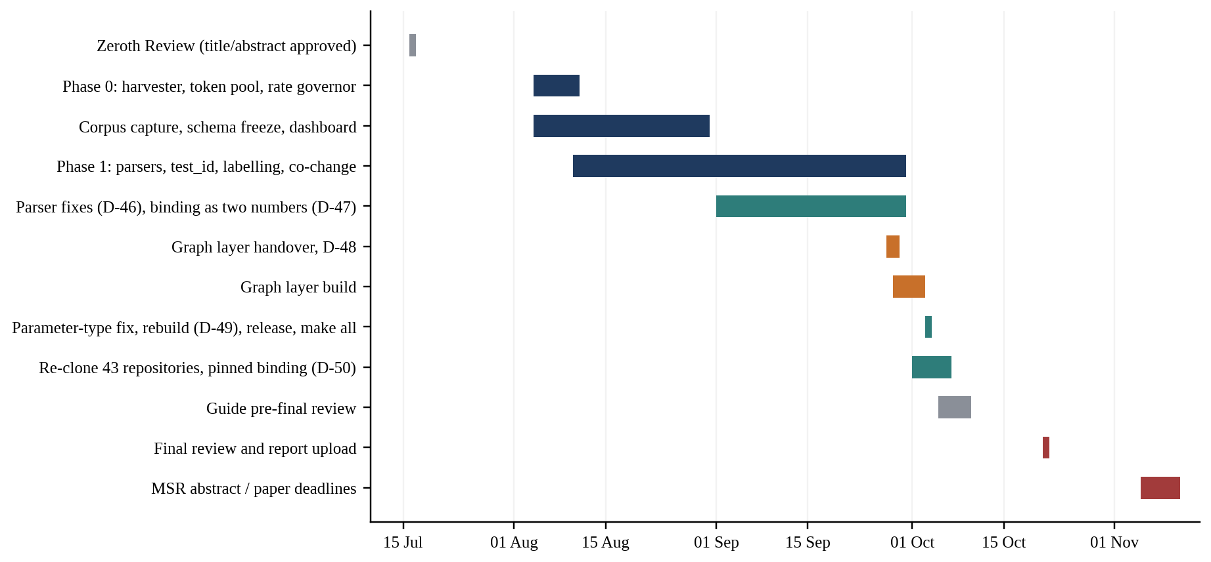
Fig. 5.1 Gantt Chart of the Project Schedule

5.2 Phases of Work

5.2.1 Phase 0: The Harvester
Phase 0 began on 4 August 2026 and had a single purpose: start capturing data before it expired. Its tasks were to establish the sampling frame, build the token pool and rate governor, write the capture loop, scale it to the candidate repositories, put up the corpus dashboard and freeze the schemas. Nothing else was allowed to start until the harvester was running, because every day of delay meant a day of CI history permanently lost. The schemas were frozen in Week 2 so that the parsers and labelling engine could be written against a stable contract.

5.2.2 Phase 1: Corpus Construction and Ground Truth
Phase 1, in August and September, turned raw data into labels. It produced the parser suite for Gradle, Maven and pytest, the canonical test-identifier normaliser, the labelling engine with base-run resolution and flakiness handling, and the co-change mining that provides the comparison arm of the measurement. Much of the work in this phase was verification: defects were found in parsers and in instrumentation, and several were fixed with recorded decisions (Section 5.5).

5.2.3 Graph Layer
The graph layer was originally part of the paper's plan. On 31 August it was cut from the paper's scope because the time available before submission was better spent on the dataset. It remained a BITE497J deliverable, which decision D-48 recorded at the handover on 27–28 September. Between 28 September and 2 October the layer was built end to end: the Graphify strip, the commit-pinned builder, the incremental-versus-cold equivalence test, test-node binding, the query API and a technical write-up.

5.2.4 Consolidation
The first week of October was a consolidation phase. On 3 October the parameter-type parsing defect was fixed, the stale-artifact problem was discovered and every interim artifact was rebuilt from raw logs (D-49). The freshness guard was added, the holdout v5 worksheet was prepared for hand labelling, the local release bundle was built and make all was run end to end. In early October all 43 repositories were re-cloned and binding was pinned to fixed commits (D-50).

5.3 Go/No-Go Gates
The roadmap defines four gates at which progress is checked against a measurable criterion before further work is built on top. A gate is not a formality: if a gate fails, the plan says what to do instead of continuing as if it had passed. The gates and their criteria are listed in Table 5.2; their outcomes are reported in Chapter 7.
Table 5.2 Go/No-Go Gates
Gate | Criterion | Purpose
Gate 1 | ≥ 5,000 fault-revealing positives | Enough positive labels to support the measurement and a future model
Gate 1.5 | Test binding ≥ 70% | Labels can be connected to source code; otherwise graph features are noise
Gate 2 | RQ1 result solid | The core measurement holds up before it is written up
Gate 3 | Model beats the best baseline (p < 0.05) | Not applicable: the model was not built

5.4 Team Responsibilities
Work was divided by pipeline stage so that each member owned a coherent part of the system and could be held to its acceptance criteria. Table 5.3 shows the split. During the semester the remaining implementation was handed over to Prisha, who completed the parser fix, the rebuild, the release bundle and the end-to-end reproduction in addition to the graph layer.
Table 5.3 Division of Responsibilities
Member | Responsibility
Deepanshu (23BIT0264) | Data engineering and ML: harvester, labelling engine, critical path
Prisha Vadhavkar (23BIT0010) | Graph layer and tool; later the remaining implementation (parser fix, rebuild, release, reproduction)
Sanskriti Singh (23BIT0256) | Parsers and measurement: baselines, statistics, figures

The team worked in a loop with three roles. An architect role decided what to build next and how it would be proven; a coding agent executed one scoped task at a time; and a human operator ran the task, pasted the raw output back for review and authorised commits. Integration was planned around a regular checkpoint at which all branches were merged, the full pipeline was run on the mini-corpus, the dashboard was reviewed and the test-identifier contract test was confirmed green. Keeping branches short-lived prevented the divergence that makes late integration painful.

5.5 Recorded Decisions During the Semester
The decision log grew from D-01 to D-53 over the semester (D-51 was never assigned). Several decisions changed the project's direction or its reported numbers, and they are summarised in Table 5.4 because they explain why the results in Chapter 7 look the way they do.
Table 5.4 Key Decisions Recorded During the Semester
Decision | Summary
D-02 | The contribution is the dataset and the measurement, not a new predictor
D-03 | Java and Python only; TypeScript cut
D-06 | DuckDB + Parquet; no database server
D-08 | Project name BlastRadius; dataset name BR-Bench
D-09 | One test-identifier normaliser, extending the vendored identifier module
D-12 | Matrix builds: union of failures across legs; number of legs recorded
D-17 | No LLM in the reproducible core
D-37 / D-38 | Holdout scored exactly once; labelled by hand from full logs with no parser output visible; holdout v4 voided
D-46 | Parser defects fixed
D-47 | Binding reported as two numbers: combined and full confidence
D-48 | Graph layer is a BITE497J deliverable; graph numbers not used in the paper
D-49 | All interim artifacts rebuilt from raw logs after the stale-artifact discovery
D-50 | Binding performed against pinned clone commits
D-52 | RQ1 method corrections after the leakage audit: co-change mined per instance from commits strictly before the run, symmetric partner lookup, historical baseline counted once per (test, instance)
D-53 | Independent parser precision not measured for the MSR 2027 submission; holdout v5 left unscored; development-corpus figures reported as not independent

5.6 Risks and Their Treatment
The roadmap maintained a register of threats to the project. The most important are listed below with the treatment adopted. Several of them are not merely schedule risks but threats to the validity of the dataset, and their treatment appears again in the design (Chapter 4) and the discussion (Chapter 7).
Table 5.5 Principal Risks and Treatments
Risk | Effect if ignored | Treatment
Log expiry after 90 days | Ground truth permanently lost | Harvester built and run first; annotations preferred because they persist
Survivorship bias in merged PRs | Positive class disappears at merge commits | Instances are (head SHA, workflow run) pairs across every push
Flaky test contamination | False positives inflate labels | Same-SHA flips, base comparison, flip rates; headline on the strict split
Build-system fragmentation | Parsers cannot cover all ecosystems | Java and Python only; one parser per framework, one output record
Log parsing errors | Wrong or missing test names | Structured sources first; hand-labelled holdout; quarantine during fixes
Labels observational, not causal | Reviewers question attribution | Strict definition with base comparison; Docker gold subset planned as future work
Single person on the critical path | Absence stalls the pipeline | Named backups; later handover of implementation within the team

CHAPTER 6
PROJECT DEMONSTRATION
A data pipeline is harder to demonstrate than an application with a user interface, because its main product is a set of files and numbers. The demonstration for the final review is therefore designed to show three things: that the pipeline runs end to end from raw data with one command, that its integrity guards actually stop bad runs, and that a single real CI failure can be traced from a raw log line to a fault-revealing label and the test file it is bound to. Fig. 6.1 shows the order of the demonstration.
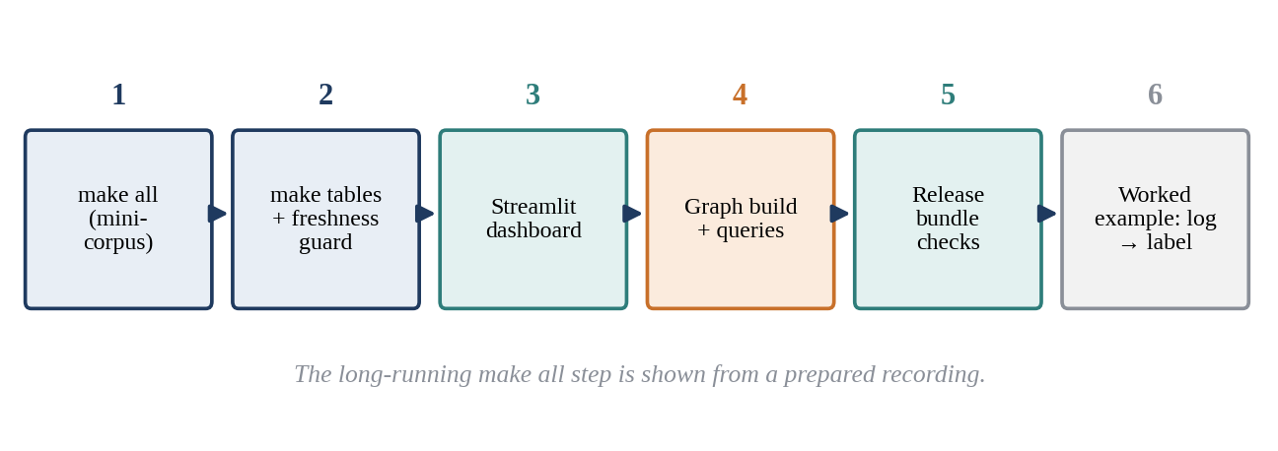
Fig. 6.1 Sequence of the Project Demonstration
Screenshots for this chapter are captured from the team's own runs and inserted in the marked places before submission. No screenshot in this report is simulated; where a capture has not yet been inserted, the placeholder says so.

6.1 One-Command Reproduction
The first item demonstrates reproducibility. make all runs the full test suite and then rebuilds the derived artifacts on the three-repository mini-corpus. The 15-minute budget (target T5.6b, 900 s) governs the reproduction step, not the test suite. On the most recent run (8 October 2026) the reproduction took 511.09 s of its 900 s budget (T5.6b met), and make all as a whole exited 0 in 16 min 35 s, because the 787 tests run first (787 passed, 1 skipped in 528.38 s when run on their own). An earlier run on another machine took 9 min 47.23 s in total (655 passed, 1 skipped, after a graph-query performance fix), and the first run took 13 min 59.96 s (632 passed, 12 skipped). make tables alone regenerates every reported number offline in about eight minutes. Because make all takes well over ten minutes, a prepared recording is shown during the review rather than running it live, and the terminal summary is shown as a still image.
Listing 6.1 The two top-level commands
make all # rebuild derived artifacts, regenerate tables, run the full test suite
make tables # regenerate every reported table from raw data

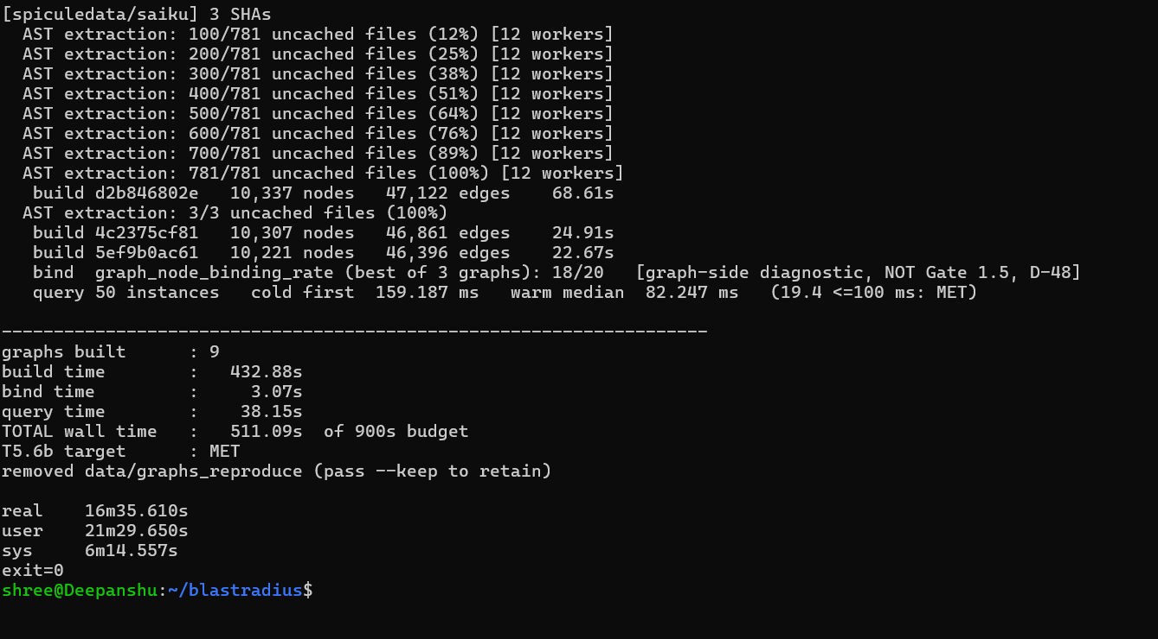
Fig. 6.2 Terminal Summary of make all on the Mini-Corpus

6.2 Regenerating Tables and the Freshness Guard
The second item shows make tables regenerating every reported table from raw data, and then shows the freshness guard refusing to run. To trigger the guard, an input file is touched so that it becomes newer than a derived artifact that depends on it; the next invocation of make tables stops with an error naming the stale artifact instead of printing numbers. This demonstrates the lesson of the October rebuild described in Section 7.1: a table script that silently reads a stale file produces plausible but wrong numbers, and the only defence is an explicit check.

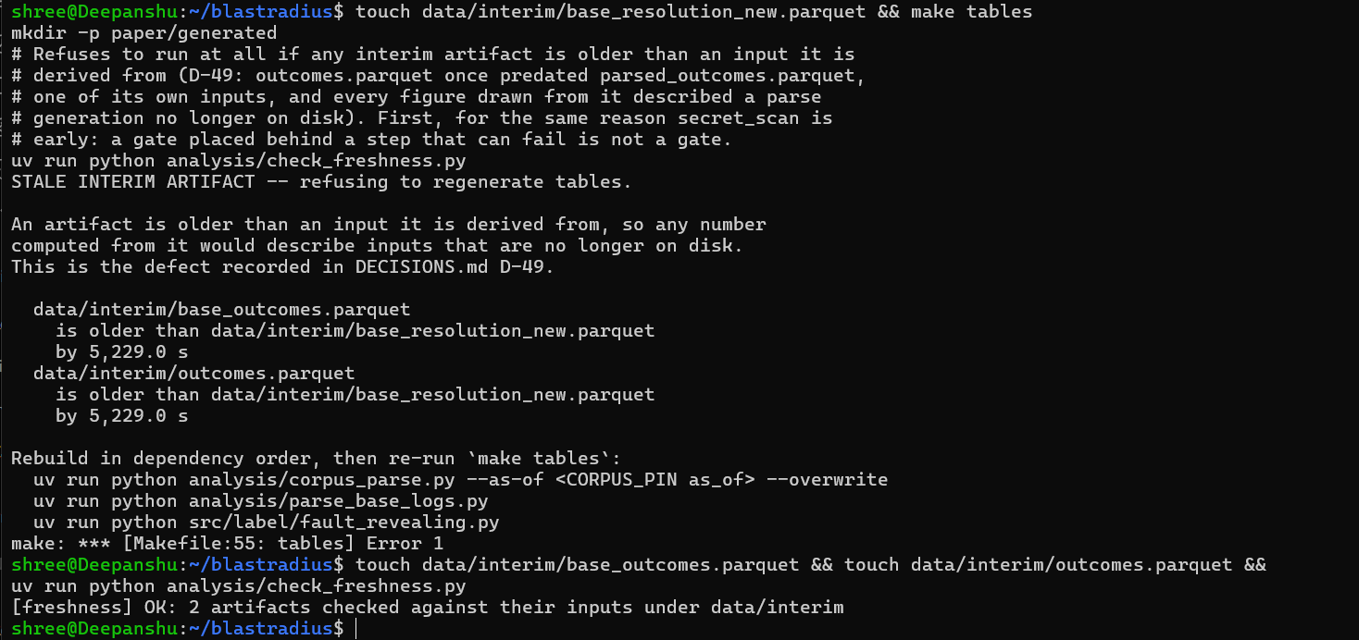
Fig. 6.3 Freshness Guard Refusing to Run on a Stale Artifact

6.3 Corpus Dashboard
The third item is the Streamlit corpus dashboard. Its eight read-only panels summarise the corpus so that any team member can check its health without running scripts. During the demonstration the panels are used to show the size and composition of the corpus and to explain how monitoring during the harvest made it possible to notice problems, such as repositories that produce no parseable outcomes, while there was still time to act.

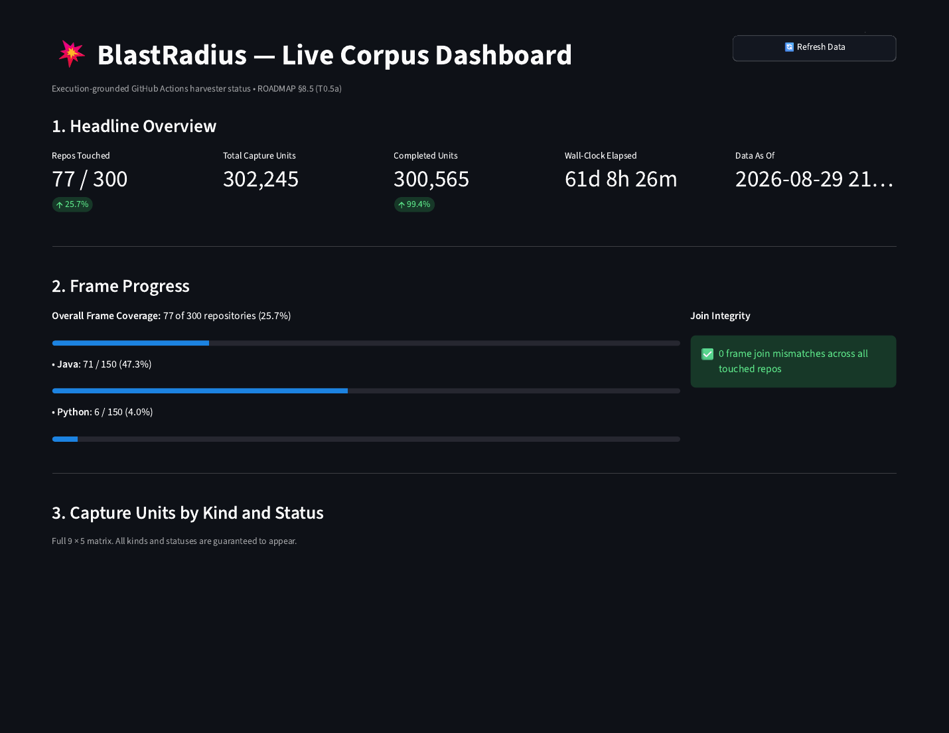
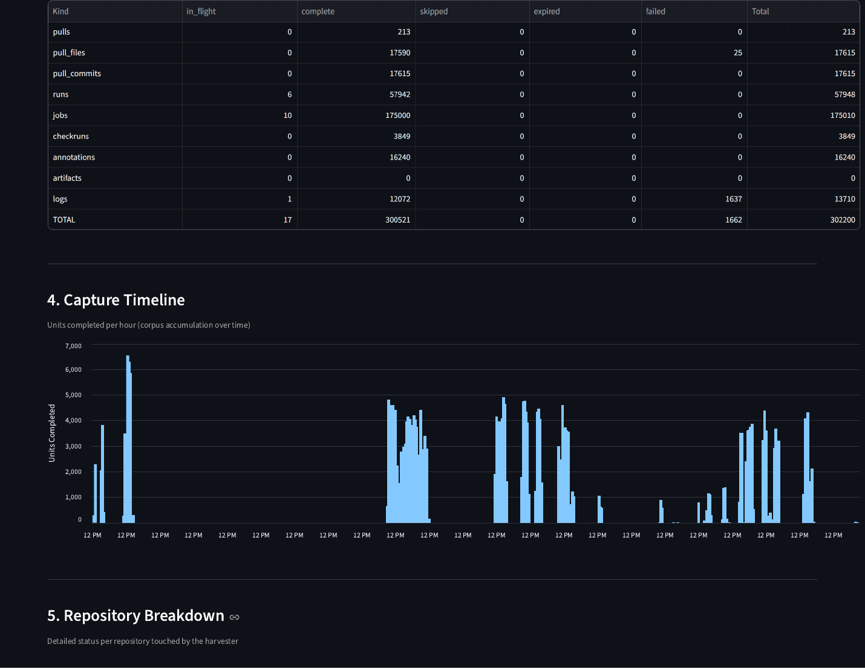
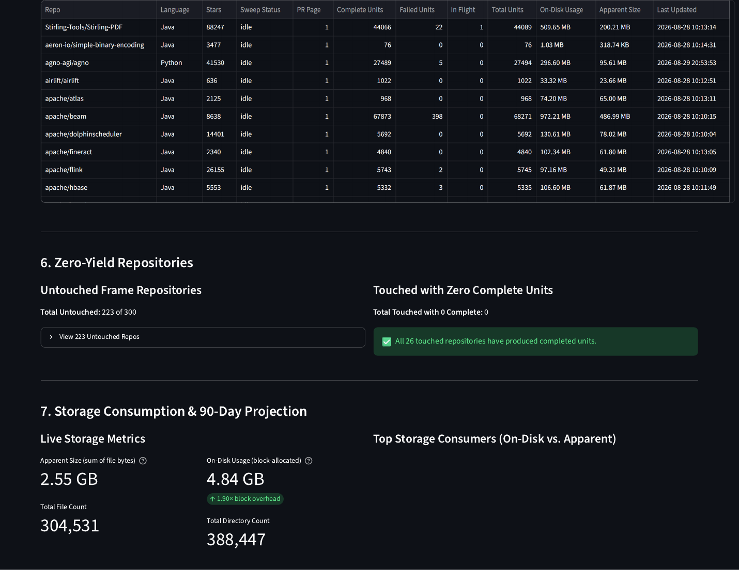
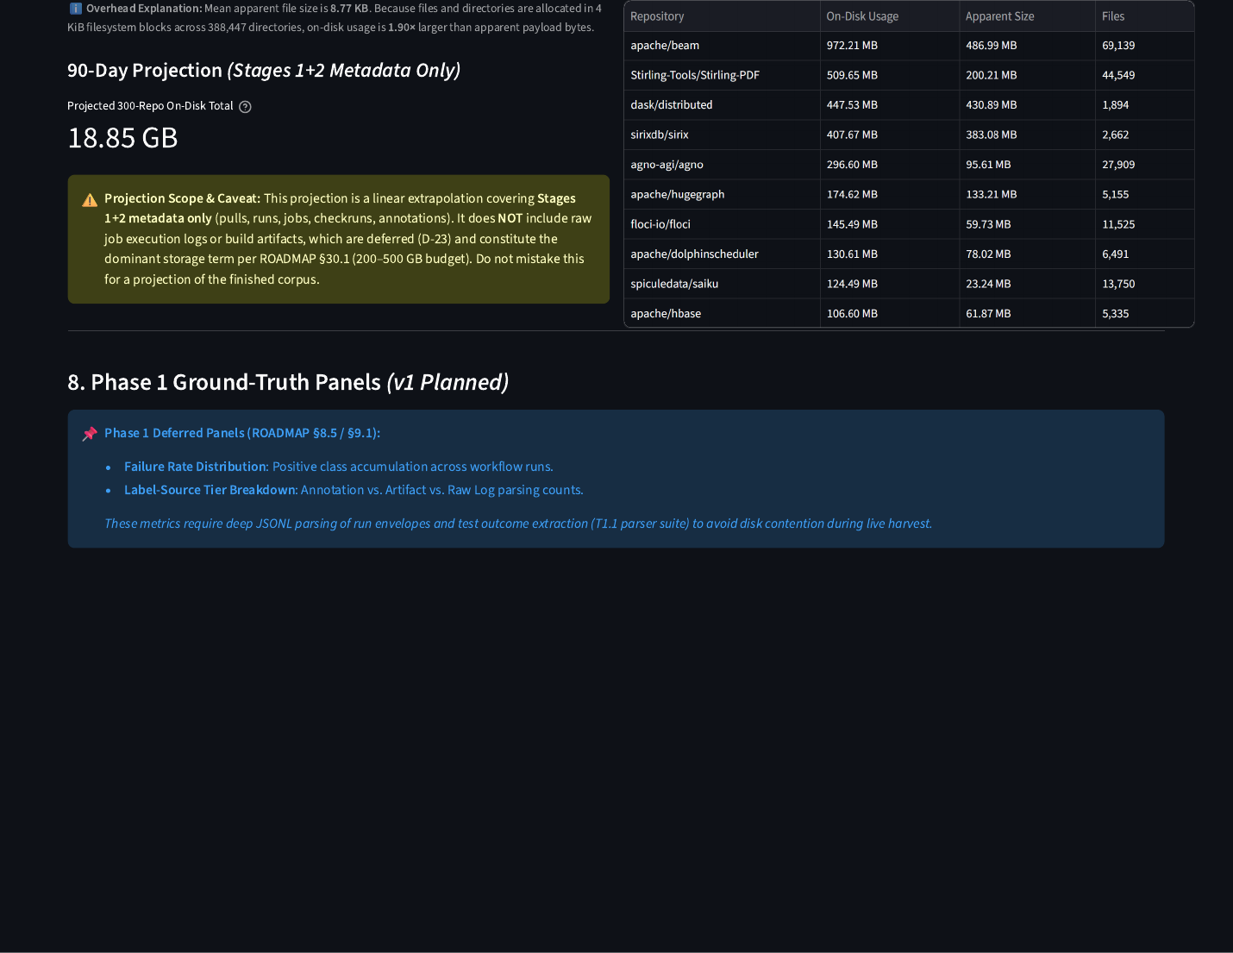
Fig. 6.4 Streamlit Corpus Dashboard Panels

6.4 Graph Layer
The fourth item demonstrates the graph layer. A commit-pinned graph is built for one commit of a mini-corpus repository, producing a compressed node-link JSON file named by repository and SHA. The query primitives are then run against it: a k-hop neighbourhood around a source method, and the minimum distance from a test node to the changed code. The bound test nodes are shown with their canonical test_id values and the type of edge that connects them to source code, which makes visible the difference between direct, convention-based and layout-based bindings.

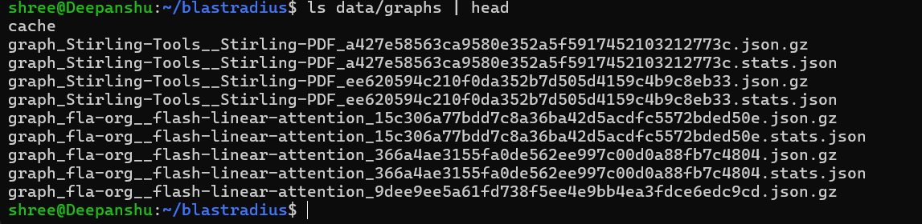
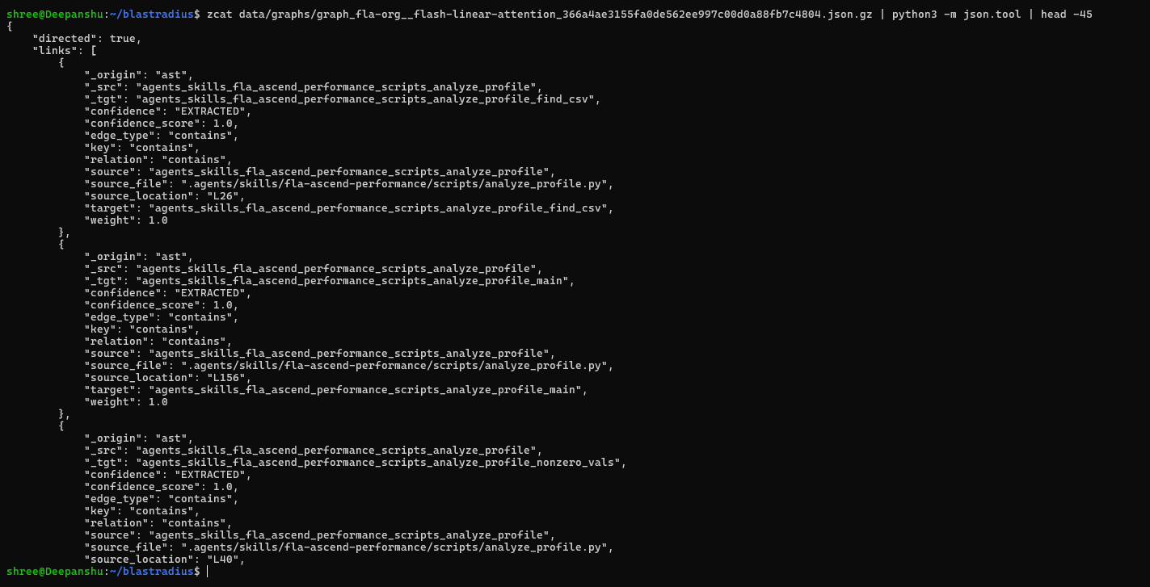
Fig. 6.5 Excerpt of a Commit-Pinned Graph File

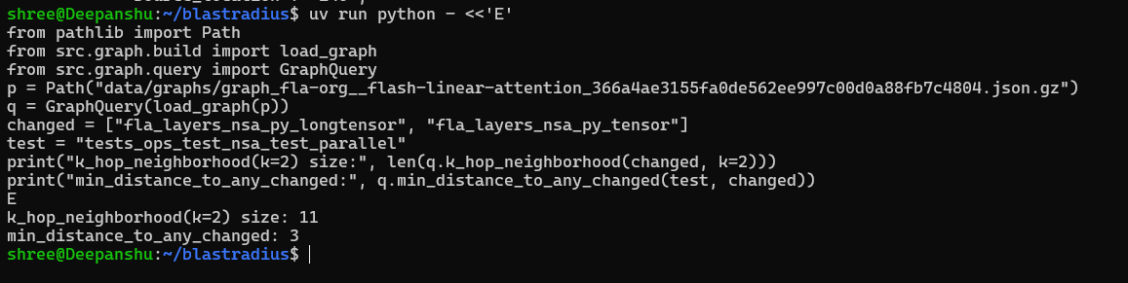
Fig. 6.6 Output of the Graph Query Primitives

6.5 Release Bundle
The fifth item opens the local release bundle. It shows the SHA-256 checksum manifest, the pseudonymised author column in which logins are replaced by keyed hashes, and the results of the secret scan and the canary check. It also shows that the build refuses to run when the pseudonymisation key is absent, which is the guard added after an earlier unpublished build had included live logins.

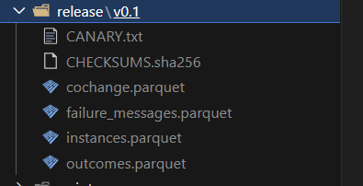
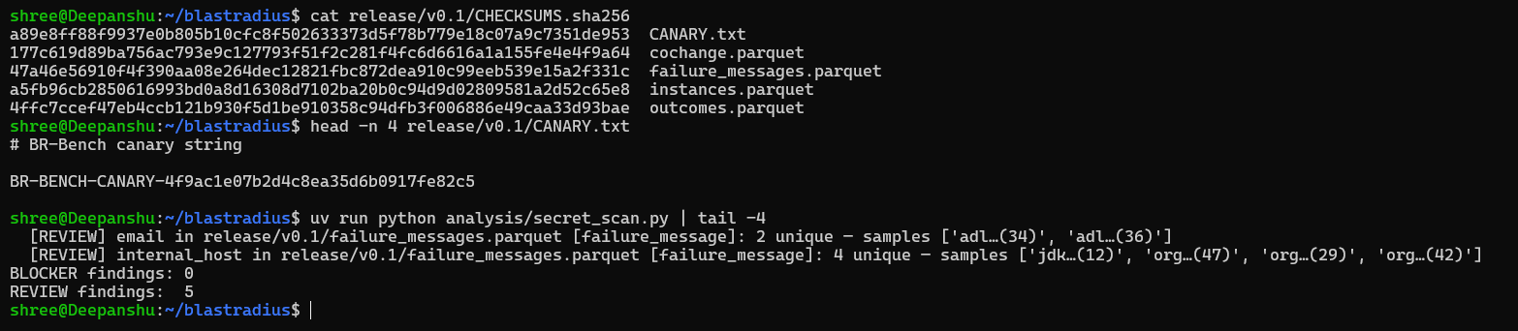
Fig. 6.7 Release Bundle Checksum Manifest

6.6 Worked Example: From Log Line to Label
The final item traces one real CI failure end to end, which is the clearest way to explain what BR-Bench contains. The steps are:
- Open the raw job log of a failed workflow run in the raw store and locate the line in which the test runner reports the failing test.
- Show the corresponding row in the parsed outcomes, with its run id, job id, head commit and verdict.
- Show the canonical test_id produced by normalize_test_id() for that row.
- Show the resolved base run for the instance, its base_run_distance and the verdict of the same test in the base run.
- Show that the test appears in the fault-revealing set, that it was not removed as a same-SHA flip, and which split it belongs to.
- Show the binding row that maps the test_id to a test file at the pinned clone commit, and whether the binding is exact or a suffix match.
Walking through a real example answers most questions about the dataset more convincingly than aggregate statistics do. It shows that every label has a provenance chain back to an observed log line, and it shows where each guard in the pipeline applies.

6.7 Test Suite
Finally, the test-suite summary is shown. The main suite grew from 451 passing tests at the graph-layer baseline to 655 at the end of the October run, to 782 at the paper-numbers-v1 freeze and to 787 passing (1 skipped) on the full run of 8 October 2026, and to 821 passing (3 skipped) on 9 October, after the v0.2 release builder, the agent workflow and the reachability scaffold were added. Every data-touching function is tested against real fixtures checked into the repository rather than against mocks.

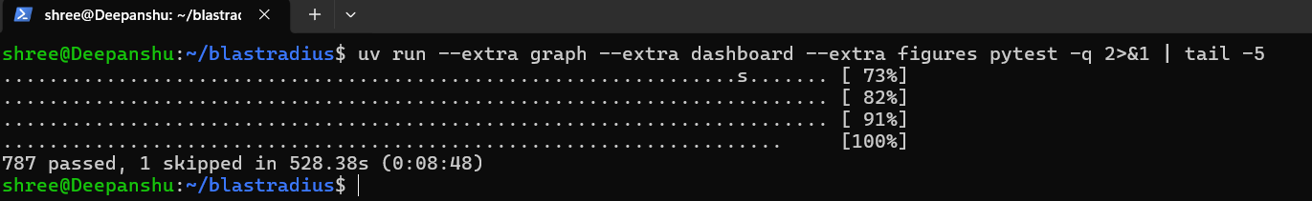
Fig. 6.8 Test-Suite Summary

6.8 Demonstration Logistics
Table 6.1 Demonstration Checklist
Item | Shown as | Fallback
make all | Prepared recording + still summary | Still image of terminal summary
make tables and freshness guard | Live | Recording
Corpus dashboard | Live (local Streamlit) | Screenshots
Graph build and queries | Live on one commit | Saved query output
Release bundle | Live file browser | Screenshot of manifest
Worked example | Live, prepared instance | Annotated slides
Demo site and make demo | Live (local Next.js replay site) and make demo in a second terminal | Screenshots of the Overview and Live run views

Each live item has a fallback, because a demonstration that depends on network access or a long-running process can fail for reasons unrelated to the work. The fallbacks are prepared from the same runs as the live items, so they show the same numbers.
The final review also includes a demo site that replays one real instance through the pipeline stages. Its Overview view shows the scale of the corpus and the headline RQ1 finding, and its Live run view draws the code-graph neighbourhood of a change (changed files at the centre, dependants in rings by distance) with the tests that actually failed and the files each predictor selected marked on it. It is a static replay of exported data (Figs. A.1 to A.3 in Appendix A show it), so every number on it is read from the same generated tables as this report; make demo runs the same walkthrough live in the terminal.

6.9 Agentic Workflow: From User Story to Deployment
After the pre-final review the project gained an agentic workflow that carries the impact analysis into the everyday path of a change. Five agents hand work to each other, from a user story to a deployed, regression-tested change (Table 6.2). The workflow lives in src/agents/ and is a separate demonstration path (decision D-55): the agents may call a language model, so nothing in the reproducible pipeline imports them, and no number they produce appears in Chapter 7, in the release bundle or in the paper.
Table 6.2 The Five Agents of the Workflow
Agent | Input | What it does | Output
1. Impact Analysis | User story, codebase | Matches the story to source files, builds the commit-pinned code graph (Section 4.1.12) and finds the tests that depend on those files by reverse reachability; raises the risk of tests that failed before | Impact analysis document (impact.md) and impact.json
2. Coding | Impact analysis, codebase | Writes the change on a new branch, with a language model or a recorded change set offline; every changed Python file must compile | Changed files, commit, pull request
3. PR Reviewer | Pull request, impact analysis | Checks that the changed files lie inside the impact scope, compiles them, runs the tests at risk and reads the CI status | Review; on approval it merges and returns the merge commit id
4. Build & Deploy | Commit id, branch | Builds at the commit (full test suite, Maven or Gradle), packages and deploys; on GitHub it dispatches a workflow | Deployed package, or a notification when the build fails
5. Regression Suite | Impact analysis, regression suite | Runs the selected scope and the full suite | Test report with impact recall

The Impact Analysis Agent applies the project's own finding. In RQ1 (Section 7.7) historical failure frequency recovered 519 of the 1,316 tests that actually failed (39.44%) and co-change recovered 61 (4.64%). The agent therefore scores a test at risk as 0.55 × graph proximity + 0.15 × the overlap between the story and the test's name + 0.3 × the test's past failure rate, and reports co-change only as a weak hint. The failure history comes from the Regression Suite Agent's earlier reports, so the workflow learns from its own runs.
Fig. 6.9 shows the Agents tab of the demo site, which replays three recorded scenarios on a small sample library (shopcart, 15 tests). The user story is the same in each: “As a shopper, I want to apply the discount code FESTIVE20 at checkout to get 20% off my cart total, capped at Rs 500.” The Impact Analysis Agent puts 7 of the 15 tests at risk, the pricing and cart tests, and leaves the tax, catalogue, inventory and receipt tests out.
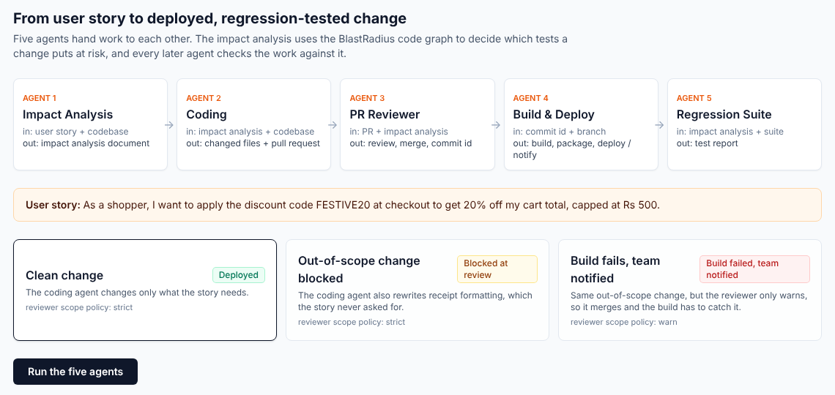
Fig. 6.9 Agents Tab of the Demo Site: Five Agents and Three Scenarios
Clean change. The change edits pricing.py and adds three tests. The reviewer approves and merges, the build passes and the package is deployed, and the regression report passes with 10 of 18 tests selected and 18 of 18 passing in the full suite.
Out-of-scope change. The change also rewrites receipt formatting, which the story did not ask for. The reviewer's scope check fails and it requests changes, so nothing is merged.
Reviewer in warn mode. The same change meets a reviewer that only warns. It merges, the full build fails on the two receipt tests, the Build & Deploy Agent sends a build_failed notification and deploys nothing, and the regression report shows an impact recall of 0/2, because both failures lie outside the predicted scope (Fig. 6.10).
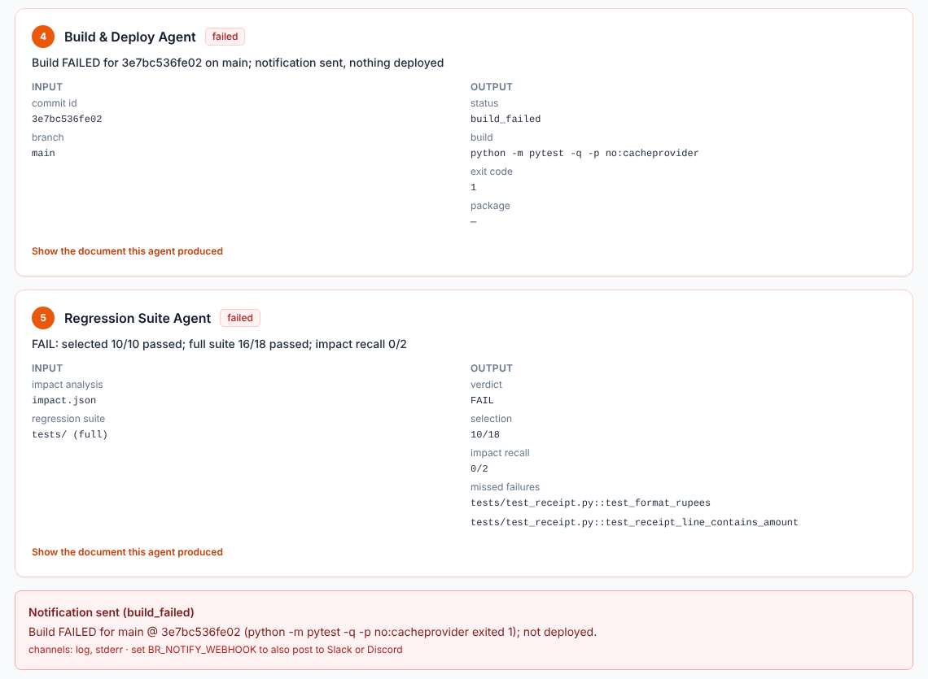
Fig. 6.10 Build Failure, Notification and Regression Report in the Third Scenario
The demonstration runs fully offline with make agents-demo. Without a language model the story is matched to code by keywords, the Coding Agent replays recorded change sets, and pull requests live in a local forge whose merges are real git merges. With an API key the model interprets the story and writes the code; with a GitHub token the agents open and merge real pull requests and dispatch build workflows. Eleven tests run all three scenarios on the checked-in sample repository. Static reachability cannot see dynamic dispatch or reflection, so the impact scope is a ranked scope rather than a safety guarantee; the full-suite build and the regression report are the checks on it.
The same impact analysis also runs on any public repository. The Analyze a repo tab of the demo site, and its command-line twin make analyze REPO=<url> STORY="...", shallow-clones a GitHub repository, builds its commit-pinned code graph and returns the impact analysis document for the given story. The route accepts only github.com URLs, serves only localhost, and supports Python and Java repositories. On three public repositories tried during development it returned a result in 2 to 7 seconds: pallets/itsdangerous (2 of 37 tests at risk), pallets/markupsafe (26 of 26) and apache/commons-cli (457 of 576), the last two showing how far static reachability spreads in small, tightly connected code bases.

CHAPTER 7
RESULT AND DISCUSSION
This chapter reports what BlastRadius measured on the frozen rebuild (numbers snapshot paper-numbers-v1.1, October 2026) and discusses what the measurements mean. All figures come from regenerable scripts. Rates are written as n/d with both numerator and denominator, and wherever a figure replaced an earlier one, the earlier value is stated alongside it. Results that did not meet their targets are reported in the same way as those that did, and values that were not measured are stated as not measured rather than estimated.

7.1 Dataset Figures
Table 7.1 gives the headline dataset figures from the canonical rebuild (decision D-49), together with the values they superseded. Fig. 7.1 shows the same comparison graphically.
Table 7.1 Dataset Figures Before and After the Canonical Rebuild
Figure | Superseded value (stale artifacts) | Canonical value
Fault-revealing positives | 4,194 | 4,168
Strict-split positives | 778 | 762
Test IDs present only in a vanished parse generation | 33 | 0

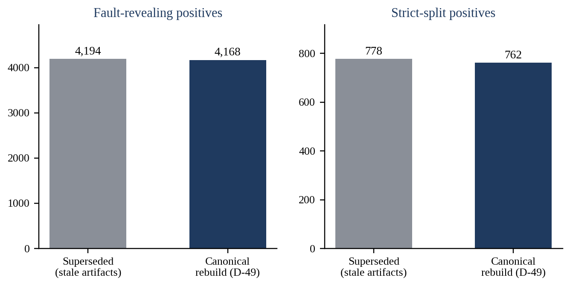
Fig. 7.1 Positives Before and After the Canonical Rebuild
On the canonical rebuild the dataset contains 4,168 fault-revealing labels on 762 strict, flake-filtered instances covering 2,466 distinct tests. Counting every split it is 897 instances and 4,384 labels; the relaxed split has 770 instances and 4,214 labels. Gate 1 required at least 5,000 positives. Gate 1 is therefore not met in either form: 4,168 / 5,000 labels (the primary reading, D-44) and 762 / 5,000 instances (Fig. 7.2).
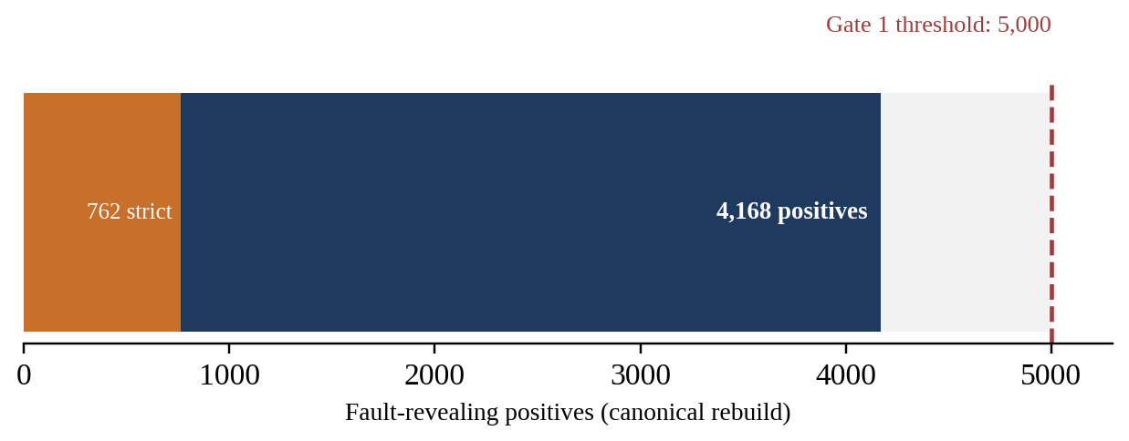
Fig. 7.2 Gate 1: Positives Against the 5,000 Threshold

7.1.1 Discussion: The Stale-Artifact Discovery
The rebuild was triggered by a discovery that illustrates why this project treats silent failures as its main enemy. While working on the October parser fix, the team found that the label files on disk had never been regenerated after a re-parse on 2 September. The tables reported until then had therefore been computed from labels derived from parse output that no longer existed. Nothing had crashed and no warning had been printed; the numbers were simply out of date. The clearest symptom was a set of 33 test identifiers that appeared in the labels but in no current parse output.
The response was to rebuild every interim artifact from the raw logs (D-49) rather than patch the affected files, because a rebuild from immutable inputs is the only way to be certain that nothing else is stale. After the rebuild the number of test identifiers present only in a vanished parse generation fell from 33 to 0, positives moved from 4,194 to 4,168 and strict positives from 778 to 762. A freshness guard was then added so that make tables stops if any derived file is older than its inputs. The differences are small, but the principle is not: a dataset whose numbers cannot be traced to current code and current data is not reproducible, however close the numbers happen to be.
The shortfall against Gate 1 has two consequences. First, the dataset is smaller than planned for training a learned model, which reinforces the decision to make the dataset and the measurement the contribution. Second, the strict split, on which headline numbers are reported, is much smaller than the full positive set, which shows how much of the raw failure signal is removed by the flakiness and base-comparison filters. That ratio is itself a finding about how noisy raw CI failures are as labels.
Data quality and attrition. Same-commit flakiness is low: 62 / 11,557 runs (0.54%) contained a test that flipped on the same commit. The larger loss is the base run: 5,520 / 12,581 failed runs (43.88%) have no usable base run and are excluded rather than labelled; where a base run was found, its distance from the head has median 0, 90th percentile 2 and maximum 10 commits. The repository funnel runs 3,671 (SEART export) → 2,646 (CI-live) → 2,333 (test-intent workflow) → 300 (sampled) → 76 (swept) → 37 (with a strict instance). The run funnel runs 165,349 (runs discovered) → 12,581 (failed) → 6,586 (failed-job log on disk) → 1,774 (parsed head failure) → 1,348 (base resolved) → 897 (known base failure set) → 762 (strict instances). Only 0.46% of discovered runs become a strict instance, which is the practical cost of requiring execution-grounded, base-checked labels.
Failure classes. The 4,168 strict labels were classified by a regular expression on the recorded failure message. 729 (17.49%) are code-level assertion failures, 89 (2.14%) are environment failures such as an unavailable GPU, 112 (2.69%) are timeouts and 3,238 (77.69%) are unknown, mostly because no message was recorded. The environment and timeout labels are reported, not removed, and the classification is a lower bound.

7.2 Parser Defect and Fix
In October a defect was found in the parsing of JUnit 5 parameterised tests from Gradle logs. For such tests the parser read a method's parameter type, for example Path, boolean, AggType or StreamingType, as the declaring class of the test. The resulting test_id named a class that did not exist, so the affected tests could not be matched across runs or bound to files.
Table 7.2 Scope of the Parameter-Type Parsing Defect
Measure | Value
Affected outcome rows | 60 rows, out of 20,299 outcome rows
Affected distinct test IDs | 21, out of 5,958 distinct test IDs
Logs examined | 2,664 non-holdout logs
Holdout rows quarantined | 152 rows across 122 holdout logs

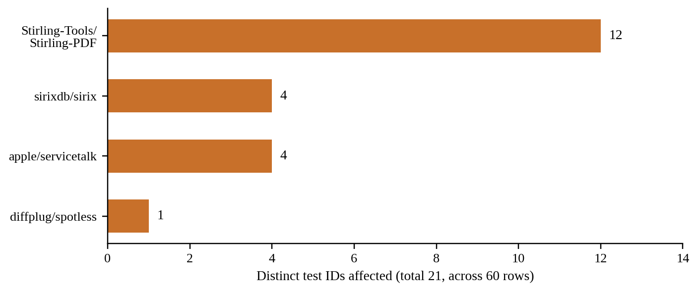
Fig. 7.3 Affected Test IDs by Repository
Four repositories were affected: Stirling-Tools/Stirling-PDF with 12 IDs, sirixdb/sirix with 4, apple/servicetalk with 4 and diffplug/spotless with 1 (Fig. 7.3). After the fix, no rows were affected. The 21 incorrect IDs were withdrawn and 21 corrected IDs were introduced, one to one, and 5,964 IDs were unchanged. During the fix all 152 holdout rows across 122 holdout logs were quarantined, so that no holdout log was used to debug the change and the unconsumed v5 corpus stays untouched.
The defect is small in proportion, 60 rows out of 20,299, but it is instructive. It did not cause any error, and the instance count kept rising while it was present. It was found only because identifiers were inspected directly. The one-to-one replacement of withdrawn and corrected IDs is the evidence that the fix changed exactly what it intended to change and nothing else.

7.3 Test-Identifier Binding
Table 7.3 reports binding of canonical test identifiers to test files at pinned clone commits (decision D-50), and Fig. 7.4 compares the current figures with the superseded ones.
Table 7.3 Test-Identifier Binding
Measure | Value
Binding rows | 5,985
Combined (exact + suffix match) | 5,643 / 5,985 = 94.29%
Full confidence (exact) | 3,820 / 5,985 = 63.83%
Clones | 43 / 43 repositories, pinned commits
Superseded | D-47: 5,622 / 5,985 combined, 3,819 / 5,985 full confidence; another machine: 5,623 and 3,801

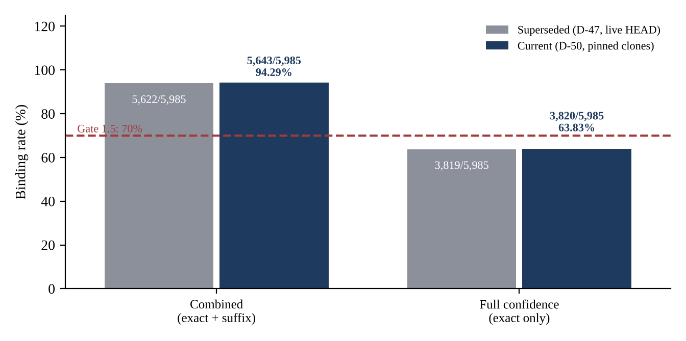
Fig. 7.4 Binding Rates Against the Gate 1.5 Threshold
Gate 1.5 required binding of at least 70%. It is met on the combined measure (94.29%) and not met at full confidence (63.83%). Following decision D-47, both numbers are always reported together, because either one alone would mislead. The combined figure shows that most test identifiers can be connected to a file; the full-confidence figure shows that a substantial share of those connections rely on suffix matching rather than an exact path.
The movement from the superseded figures is small (combined 5,622 → 5,643; full confidence 3,819 → 3,820) but its cause matters. Binding previously used each clone's live HEAD, so the figure was a property of when a machine last fetched: three machines gave 5,622 / 3,819, 5,623 / 3,801 and 5,643 / 3,820. Pinning each clone to a fixed commit (D-50) makes the figures permanent and reproducible. While re-cloning, a guard was also added to reject incomplete or corrupt clones, after an interrupted clone had caused git to resolve to the BlastRadius repository itself.
The gap between combined and full-confidence binding is largely explained by logs that do not carry full package names. In Gradle logs from some repositories, such as Stirling-PDF, tests are reported without packages (D-39), so the binding stage can only match the trailing part of the class name. Section 7.4 shows the same effect in the graph layer.

7.4 Graph Layer Results
The graph layer was built and evaluated on a three-repository mini-corpus covering the three build tools (Table 7.4). Its numbers are a course deliverable and are not used in the MSR paper (D-48).
Table 7.4 Graph Layer Mini-Corpus
Repository | Build tool | Base SHAs built
fla-org/flash-linear-attention | pytest | 107
Stirling-Tools/Stirling-PDF | Gradle | 140
spiculedata/saiku | Maven | 180

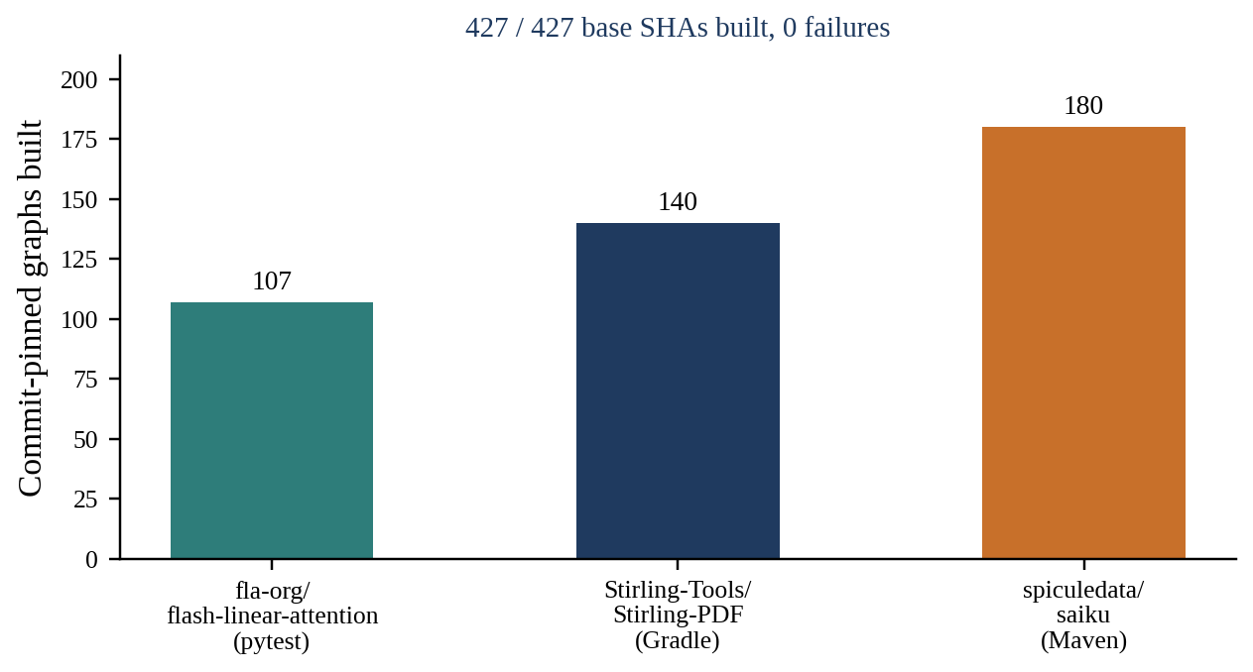
Fig. 7.5 Commit-Pinned Graphs Built per Repository

7.4.1 Builds
All 427 of 427 base SHAs were built, with 0 failures (Fig. 7.5). Each build produced a compressed node-link JSON file keyed by repository and SHA.

7.4.2 Incremental-Versus-Cold Equivalence
The first implementation of incremental building followed the literal design: re-extract the changed files and splice the resulting subgraph into the previous commit's graph. The blocking equivalence test showed that this diverged from a cold build on 4 of 4 commit transitions tested, with up to 207 spurious nodes and 1,443 wrong edges. The cause was that Graphify's Java import resolver only indexes the files extracted in the same call, so a subgraph extracted from a few changed files resolved imports differently from a full extraction. The fix passes the full file list to every extraction and takes incrementality from the SHA-256 content cache instead. The equivalence test now passes exactly (Fig. 7.6).
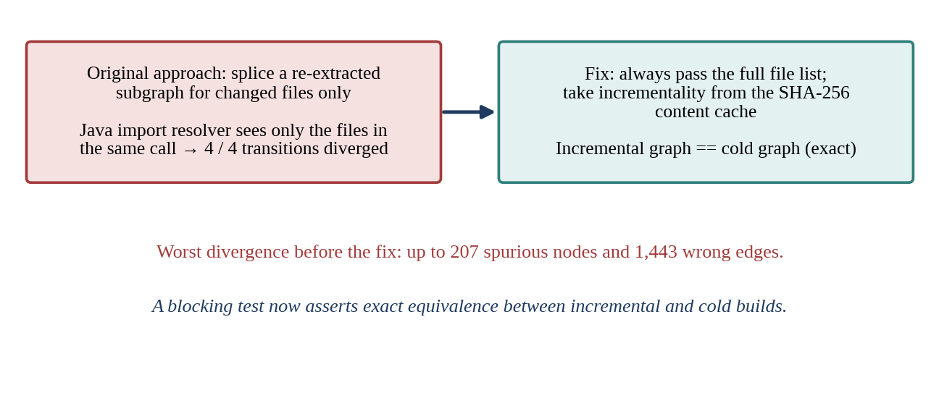
Fig. 7.6 Incremental-Versus-Cold Divergence and Its Fix

7.4.3 A Second Defect Caught by Tests
A second defect was caught by fixture tests. Emitting tests edges during extraction overwrote the calls edges they were derived from in 7 of 29 fixture edges, because the graph was a single-edge directed graph in which a new edge between the same two nodes replaces the old one. Moving to a MultiDiGraph keyed by edge type, as described in Section 4.1.12, fixed it.

7.4.4 Graph-Node Binding
Table 7.5 reports how many of each repository's distinct test identifiers from the CI outcomes were bound to a test node in the graph. The denominator is the number of distinct test IDs in that repository's outcomes. Fig. 7.7 shows the split between exact and loose bindings.
Table 7.5 Graph-Node Binding Rate per Repository
Repository | Exact | Loose | Total | Typed graphs used
fla-org/flash-linear-attention | 36/37 | 0/37 | 36/37 | 107/107
Stirling-Tools/Stirling-PDF | 4/307 | 271/307 | 275/307 | 35/140
spiculedata/saiku | 20/20 | 0/20 | 20/20 | 20/180

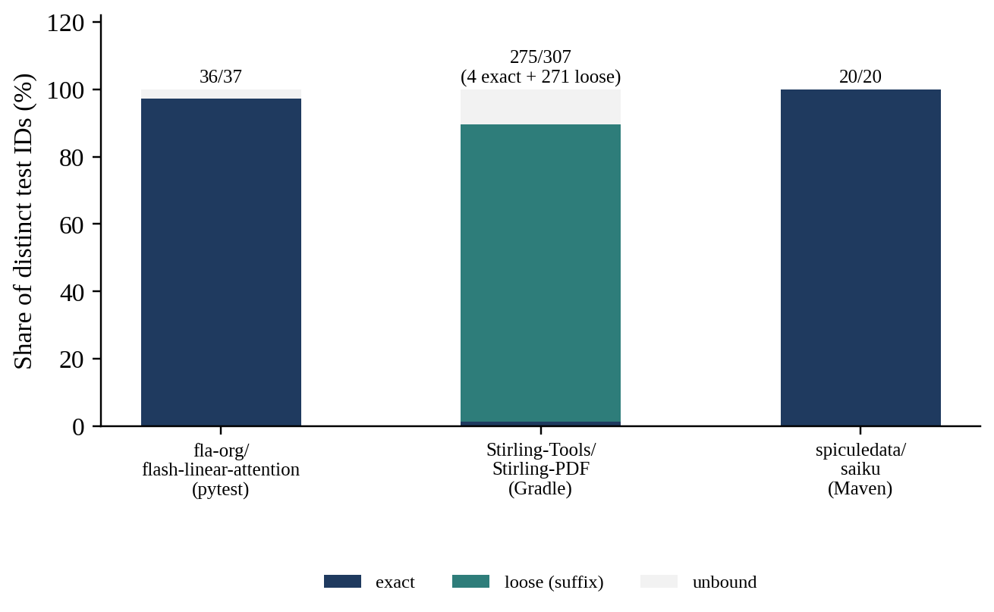
Fig. 7.7 Graph-Node Binding by Repository
The pytest and Maven repositories bind almost entirely exactly. Stirling-PDF binds 275 of 307 test IDs, but only 4 exactly and 271 through loose suffix matches, because its Gradle logs carry no package names (D-39). The graph layer therefore inherits the same limitation as file-level binding, and for the same reason. The last column shows that typed-graph coverage is partial for Stirling-PDF and saiku: not every built graph carried the test typing used for binding.

7.4.5 Performance Against Budgets
Table 7.6 compares measured performance with the budgets from the roadmap, and Fig. 7.8 shows query latency per repository.
Table 7.6 Graph Layer Performance Against Budgets
Budget | Result | Status
Query latency ≤ 100 ms | 47.7 / 99.7 / 43.5 ms per repository | Met (99.7 ms is at the limit)
Incremental build ≤ 10 s | 25–29 s (only 4–7 of ~951 files re-parsed; whole-corpus passes dominate) | Not met
Cold build ≤ 10 min | Met on the mini-corpus only; the other ~40 repositories were not built | Partial

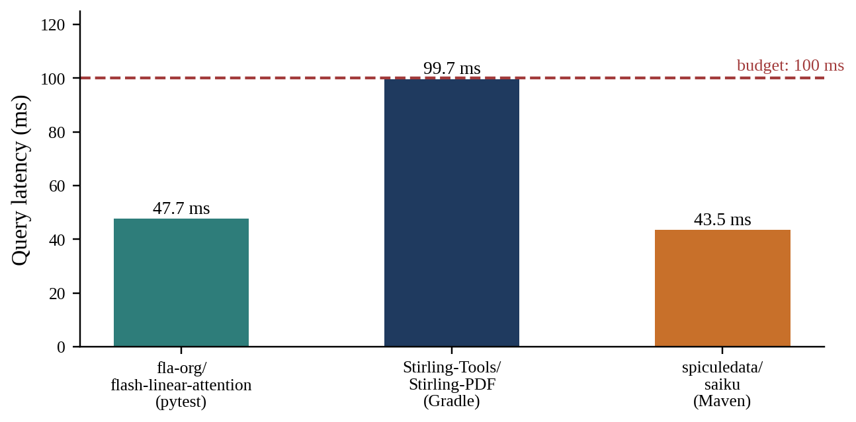
Fig. 7.8 Graph Query Latency per Repository Against the 100 ms Budget
The query budget is met, though Stirling-PDF at 99.7 ms is at the limit and leaves no headroom. The incremental build budget is not met: an incremental build takes 25–29 s even though only 4–7 of roughly 951 files are re-parsed. The time is dominated by passes over the whole corpus that run regardless of how many files changed, a direct consequence of the equivalence fix, which passes the full file list to every extraction. Correctness was chosen over speed here; making those passes incremental is future work. The cold-build budget was met on the mini-corpus, but the remaining repositories were not built, so it is reported as partial.

7.4.6 Known Limitations of the Graph Layer
- Layout binding fires only for the Maven/Gradle src/test ↔ src/main convention; it fires 0 times on Python.
- Layout edges connect every node of a test file to the target file and class, which produces extra low-confidence edges.
- Typed-graph coverage is partial (Table 7.5).
- The graph is static and build-free, so it is unsound for reflection, dynamic dispatch and dependency injection, and imprecise where calls are matched by name.

7.4.7 Graph Reachability Against Real Failures
The project title promises graph-based change impact prediction, so the last step was to score the graph against the fault-revealing labels: for each strict instance in the mini-corpus, the tests that reach a changed file in the graph built at the instance’s base commit are compared with the tests that actually failed, next to co-change and failure history on the same instances (analysis/reachability_mini.py, with seven tests on a checked-in fixture). The population could not be formed offline. Of the 79 strict instances in the three repositories, 36 have a resolved base commit, but none of those 36 base commits could be checked out locally: the 22 for fla-org/flash-linear-attention are absent from the clone, and the 14 for spiculedata/saiku are present only without their file contents (a partial clone). The scoring code is therefore ready but has produced no numbers; fetching those commits and rerunning the script is the next step, and its result will be reported as n/d with the population at each filter.

7.5 Reproducibility and Release
make all exited 0. On the latest run (8 October 2026) the mini-corpus reproduction took 511.09 s against its 900 s budget (T5.6b met) and the whole command took 16 min 35 s including the test suite (787 passed, 1 skipped). Earlier runs on another machine took 9 min 47.23 s in total (655 passed, 1 skipped) and, before a graph-query performance fix, 13 min 59.96 s (632 passed, 12 skipped). make tables regenerates every reported number offline in 7 min 43 s on the final code commit. This is the strongest single piece of evidence for the reproducibility claim: the full pipeline, from raw data to tables, runs with one command on a laptop, with the reproduction step inside its budget.
The local release bundle was built and checked as shown in Fig. 7.9. It contains 165,349 instances, 12,766 outcomes and 175,204 co-change rows with author_login pseudonymised, and an HMAC round-trip check verified the mapping for 1,791 / 1,791 distinct authors. The secret scan reported 0 blockers; it raised 5 review findings, all of which were examined and found to be false positives. The canary string was verified and a SHA-256 checksum manifest was written.
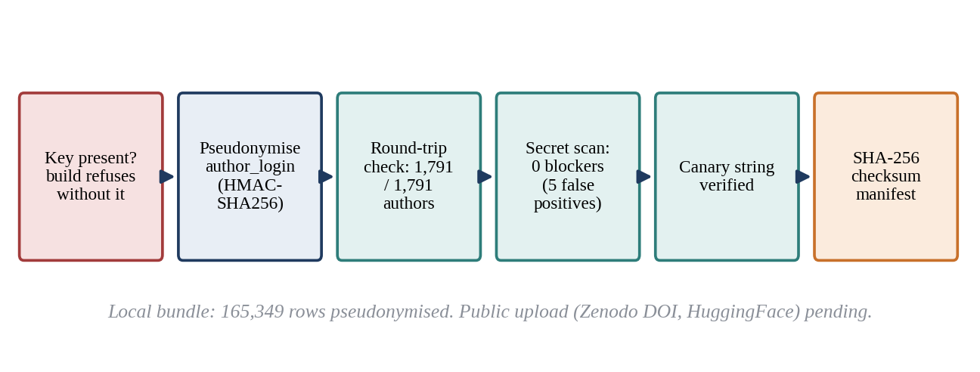
Fig. 7.9 Release Bundle Checks
The build now refuses to run without the pseudonymisation key. This guard was added after an earlier build had shipped live logins in the local bundle; that build was never published. The release bundle was published on Zenodo on 9 October 2026 under DOI 10.5281/zenodo.23250262 and is licensed CC BY 4.0; the source code is MIT and is archived on Zenodo as release v1.0.0 under DOI 10.5281/zenodo.23250690. The upload to HuggingFace is pending. Publishing is one-way, because a DOI cannot be withdrawn and the files in the record cannot change; corrections ship as a new version.
The shipped schema is narrower than the design specification. In release v0.1 the instances table carries the base commit (base_sha) but base_run_id is null for all 165,349 rows, and the outcomes table carries only run_id, test_id and split, plus a leaked pandas index column. Base-run resolution, per-test head and base statuses, same-commit flip flags and the bound test file are computed by the pipeline and regenerated by make tables, but they are not shipped as columns; the datasheet records this as a limitation. Release v0.2 (decision D-54) closes most of this gap without changing any row count or any reported number. It adds base_run_id for the 7,061 runs whose base was resolved, a base_status for all 165,349 runs (exact_green 4,245, exact 1,858, ancestor 591, branch_prior 367, no_base 5,520, not_attempted 152,768), base_run_distance, typed run_started_at timestamps and the changeset columns (null for the 17,364 runs without a changeset). The outcomes table gains the bound test_file, label_source, parser_confidence, status_head, the number of matrix legs aggregated (more than one for 690 of 4,384 pairs), binding_status, binding_confidence, duration_s and a failure-message hash, and loses the pandas index column. A schema validator (task T1.6a) checks every column, type, nullability and value domain: it passes on v0.2 and rejects v0.1 with 20 violations. Release v0.2 is built and validated locally and will be deposited as a new version of the same Zenodo record.

7.6 Parser Precision
Parser precision is reported only on the development corpora (Table 7.7). On the fixture corpus (40 logs, 46 expected test identifiers) precision and recall are both 46 / 46 and classification accuracy is 40 / 40; on holdout v1 (20 logs, 30 expected identifiers) precision and recall are both 30 / 30. Neither figure is independent of development. The parsers were built and tuned against the fixture logs, and holdout v1 became a development set under D-37 because it drove three parser fixes, so its 100% is a fit number and may not be read as held-out performance.
The independent measurement planned in D-37 and D-38, holdout v5 (40 logs labelled blind by hand from the full logs, scored exactly once), was not carried out. No blind human labelling was completed in time; one attempt was machine-assisted, made from log excerpts only, and was discarded. The v5 corpus has never been scored and remains unconsumed, and its worksheet stays blank in the repository. Decision D-53 records this: the independent precision figure is reported as not measured. If a blind human labeller completes the worksheet from the full fixtures before the camera-ready deadline (24 January 2027), v5 will be scored once under D-37.
Table 7.7 Parser Precision on Development Corpora (Holdout v5 Not Scored)
Corpus | Expected IDs | Precision (n/d) | Independent of development?
Fixture corpus (40 logs) | 46 | 46 / 46 (100.00%) | No (development)
Holdout v1 (20 logs) | 30 | 30 / 30 (100.00%) | No (development, D-37)
Holdout v5 (40 logs) | n/a | Not scored (D-53) | Not measured

The history of the holdout is part of the result. Holdout v4 was voided because its expected test classes had been derived by rule rather than labelled by hand, which would have made the precision measurement circular: a parser would have been scored against expectations produced by logic similar to its own. The v5 worksheet was prepared for blind hand labelling but never completed, and that is why no independent figure is claimed.

7.7 RQ1: Divergence Measurement
RQ1 asks how far the co-change proxy diverges from the fault-revealing set. This section is a demonstration of what the dataset enables, not the main claim of the work. Following D-52, each method proposes up to k test files for a change and is scored against the strict fault-revealing test files of that instance. Of the 762 strict instances, 734 have ground truth bound to a test file, and the all-partner co-change proxy fires on 576 of them at k = 10 (78.47%); every method is scored on those same 576 instances. Co-change partners are mined per instance from commits strictly before the run started (trailing 365 days, support of at least 2, symmetric lookup), and the historical-frequency baseline uses only the strict labels of runs that started earlier, once per (test, instance). Static reachability depends on the graph layer, which is out of the paper (D-48), so RQ1 here compares co-change and two simple baselines with fault-revelation.
Table 7.8 RQ1 at k = 10 over 576 Instances (Mean Precision, Recall, Jaccard; Micro Recall)
Predictor | Mean P | Mean R | Mean J | Micro recall (hits / actual)
Co-change, all partner files | 0.011 | 0.051 | 0.010 | 61 / 1,316 (4.64%)
Co-change, conventional test files only | 0.054 | 0.087 | 0.038 | 101 / 1,316 (7.67%)
Changed files themselves (changeset baseline) | 0.039 | 0.245 | 0.037 | 224 / 1,316 (17.02%)
Historical failure frequency | 0.185 | 0.517 | 0.178 | 519 / 1,316 (39.44%)

As an example use of the dataset, co-change recovers about 5% of the test files that actually failed (61 / 1,316, 4.64%), while a simple historical failure-frequency baseline recovers 39.44% (519 / 1,316). Restricting co-change to conventional test files raises its mean recall only to 0.087, and merely proposing the changed files themselves reaches 0.245. The ordering holds for Java (mean recall 0.034 for co-change against 0.496 for history) and for Python (0.123 against 0.601). Co-change reflects which files developers edit together, not which tests break, and the gap is large.
Audit. The first computation of RQ1 was wrong in three ways, found by a per-instance leakage audit and fixed under D-52. Co-change had leaked future commits: the static table was mined to 29 August 2026, so 713 / 713 audited instances were scored with a window ending after the run started, and 640 / 713 (89.76%) had a mined commit dated after the run began that touched a changed file. The historical baseline had counted each failure once per split, giving 224,758 evidence rows for 78,399 distinct (run, test) labels. And the co-change table was looked up in one direction only. After the fixes the audit finds 0 / 713 co-change violations and 0 / 762 baseline violations. At k = 10 the mean recall of co-change moved from 0.082 to 0.051 and that of history from 0.522 to 0.517, so the leak had flattered co-change and the correction widens the gap. Environment failures (89 / 4,168 labels, 2.14%) and timeouts (112 / 4,168, 2.69%) remain in the strict set; removing them does not change the ordering of the methods.
RQ1 is therefore measured, and Gate 2 is evaluated on that basis; the frozen tables contain no significance test, so this report treats Gate 2 as measured rather than as formally passed. Gate 3 is not applicable, because the model it would test was not built.

7.8 Engineering Quality
The implementation is evaluated not only by its outputs but by the evidence that those outputs are correct. The main suite grew from 451 passing tests at the graph-layer baseline to 655 at the end of the October run, to 782 at the paper-numbers-v1 freeze and to 787 passing (1 skipped) on 8 October (Fig. 7.10) and to 821 passing (3 skipped) on 9 October, after the v0.2 release builder, the agent workflow and the reachability scaffold were added. Every data-touching function is tested against real checked-in fixtures rather than mocks, so a test fails when the code mishandles real data and not merely when it deviates from a mocked expectation.
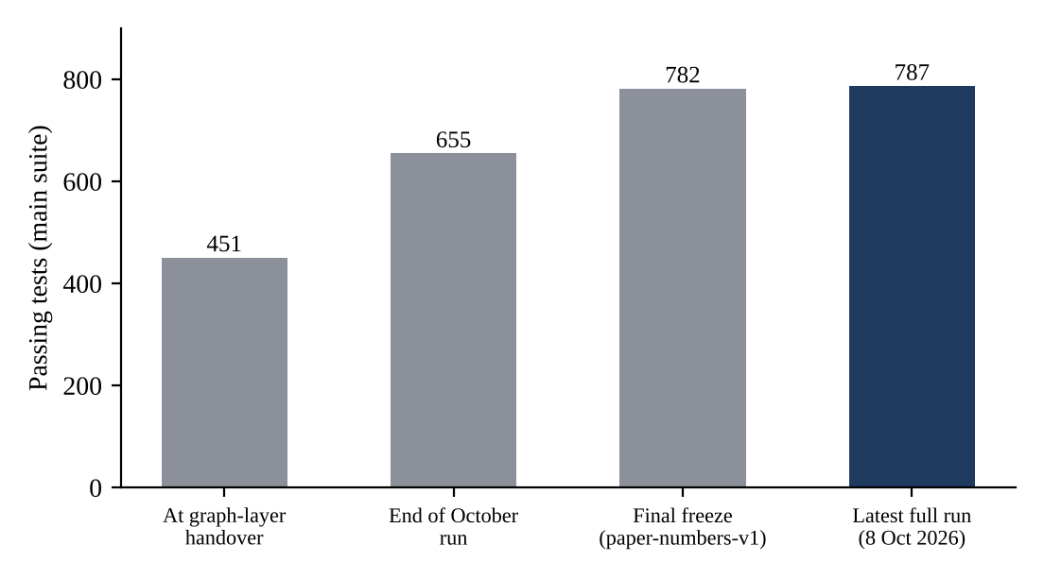
Fig. 7.10 Growth of the Main Test Suite
Six integrity guards were added during the semester, each in response to a specific failure or risk:
- Freshness guard on derived artifacts, after the stale-artifact discovery (Section 7.1).
- Complete-clone guard, after an interrupted clone resolved to the wrong repository (Section 7.3).
- Pinned-commit binding, after binding figures drifted with upstream HEADs (Section 7.3).
- Release-key requirement, after an unpublished build included live logins (Section 7.5).
- Incremental-versus-cold graph equivalence test, which caught the import-resolution divergence (Section 7.4).
- Per-instance leakage audit, which found that co-change had read future commits and that the history baseline double-counted evidence (Section 7.7).
The decision log was maintained from D-01 to D-53 (D-51 was never assigned), and every superseded figure is recorded with its replacement. This is what allows this chapter to state, for every changed number, what it replaced and why.

7.9 Gate Summary
Fig. 7.11 summarises the gates. Gate 1 is not met in either form, Gate 1.5 is met on the combined measure and not at full confidence, Gate 2 is measured but not backed by a significance test, and Gate 3 is not applicable.
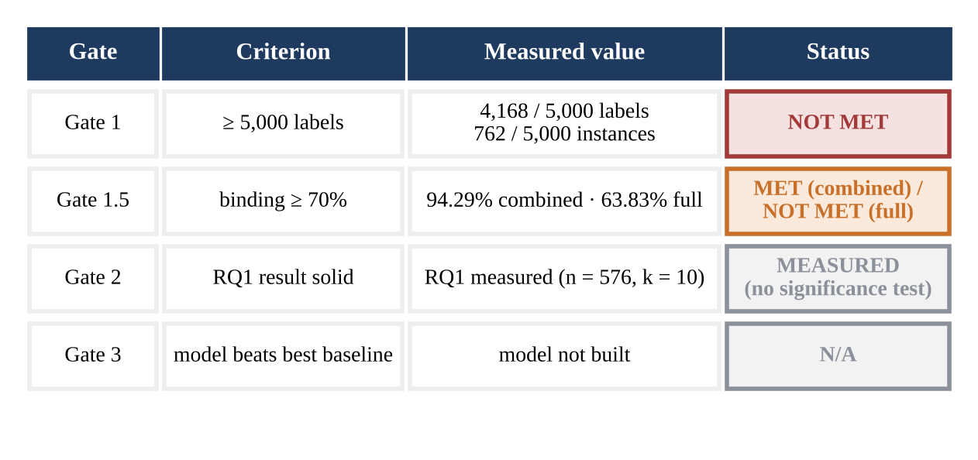
Fig. 7.11 Summary of Go/No-Go Gate Outcomes

7.10 Threats to Validity

7.10.1 Construct Validity
The fault-revealing label is observational. Observing that a test failed at the head and not at the base, on a run that contained a change, strongly suggests that the change caused the failure, but it does not prove it; the environment, dependencies or runner could have changed between the two runs. The base comparison, the same-SHA flip filter and the strict split reduce this risk but cannot remove it. The planned remedy, a gold subset in which base and head are re-executed in a fixed Docker environment to obtain causal labels, was not built and is future work.
Environment-related failures also remain in the strict set. By a regular expression on the failure message, 89 / 4,168 labels (2.14%) are environment failures and 112 / 4,168 (2.69%) are timeouts, but 3,238 / 4,168 (77.69%) are unclassified, so these are lower bounds. The corpus is also dominated by a few projects and contains only a small number of Python repositories, which limits what can be said by language.

7.10.2 Internal Validity
Errors in parsing, base resolution or binding could distort the labels. The design addresses each with a detector (Table 4.2), and this chapter reports cases where detectors found real defects. Parser precision is not independently measured (D-53): the 46 / 46 and 30 / 30 figures come from development corpora, so the accuracy of the parsing stage on unseen logs is not quantified. The historical-frequency baseline orders runs by start time, because completion time is not recorded, so a run still executing when an instance started could not be excluded from its evidence. Instances without a resolvable base are excluded rather than labelled, which avoids false positives but may bias the dataset towards repositories with regular CI on their main branches.

7.10.3 External Validity
The corpus consists of popular, actively maintained Java and Python projects that use GitHub Actions. Results may not transfer to other languages, to projects without CI, to private industrial code or to other CI systems. This population is, however, the one studied by the regression test selection and test prioritisation literature, so results remain comparable with that work.

7.10.4 Reliability
Every reported number is regenerated from raw data by make tables, guarded against stale inputs, and the full pipeline runs with make all in under 15 minutes on a laptop. Raw logs that have expired on GitHub cannot be re-harvested, which is why the raw store and the release bundle, rather than the live API, are the basis for reproduction.

7.11 Lessons Learned
The most important lesson of the project concerns silent failures. Four of the defects described in this chapter, the stale artifacts, the partial clone, the parameter-type mis-parse and the incremental-graph divergence, produced no error at all. Each was caught only because an explicit detector existed or because someone inspected actual values instead of trusting the absence of an error. A pipeline that runs without complaint is not thereby a pipeline that works.
A second lesson concerns supersession. Numbers changed several times during the semester, sometimes by very small amounts. Recording every superseded figure with its replacement and its cause made each change explainable and made it impossible for an outdated number to survive unnoticed in a table or slide.
A third lesson concerns scope. Cutting the predictor and the graph layer's role in the paper was uncomfortable, but it concentrated effort on the part of the project that is genuinely new: a public, execution-grounded dataset. A fourth concerns measurement itself: the first RQ1 numbers were wrong because the co-change table had read future commits, and only a per-instance audit exposed it. The negative results reported here, the unmet Gate 1, the full-confidence binding below 70%, the missing independent parser precision and the incremental build over budget, are themselves useful findings for anyone building on BR-Bench.

CHAPTER 8
SUMMARY
BlastRadius set out to answer a question that impact-analysis research has approached only indirectly: which tests does a change actually break? The project built a deterministic, reproducible pipeline that runs from raw GitHub Actions logs to a labelled, execution-grounded dataset, BR-Bench, linking code changes to the individual tests that failed in CI. It also built a commit-pinned code-property graph layer as the dependency-analysis substrate named in the approved title.

8.1 Key Results
- 4,168 fault-revealing labels on 762 strict, flake-filtered instances (2,466 distinct tests); all splits together are 897 instances and 4,384 labels. This supersedes 4,194 and 778 from stale artifacts.
- Test-identifier binding of 94.29% combined (5,643 / 5,985) and 63.83% at full confidence (3,820 / 5,985), at pinned clone commits across 43 repositories.
- An RQ1 demonstration: at k = 10 over 576 instances, co-change recovers 61 / 1,316 (4.64%) of the failing test files and historical failure frequency recovers 519 / 1,316 (39.44%), after a leakage fix and a double-counting fix that were found by audit.
- A graph layer over 427 commit-pinned graphs on a three-repository mini-corpus, with 0 build failures, exact incremental-versus-cold equivalence and query latency within the 100 ms budget.
- One-command reproduction: make all exits 0; the mini-corpus reproduction took 511.09 s of its 900 s budget and the whole command 16 min 35 s including the 787 tests of that run; the suite now has 821 passing tests (3 skipped); make tables regenerates every reported number offline in about eight minutes.
- A pseudonymised local release bundle of 165,349 instances, 12,766 outcomes and 175,204 co-change rows that passes the HMAC round-trip, secret-scan and canary checks and carries a SHA-256 checksum manifest.

8.2 Honest Negatives
Several targets were not met, and they are stated here as plainly as the results above:
- Gate 1 was not met in either form: 4,168 / 5,000 labels and 762 / 5,000 instances.
- Full-confidence binding is below 70% (63.83%), although combined binding (94.29%) meets Gate 1.5.
- The incremental graph build takes 25–29 s, over its 10 s budget.
- The learned predictor, the GNN and the GitHub Action were not built. The demo site is a static replay of exported data, not a hosted service.
- Parser precision was not independently measured (D-53): the 46 / 46 and 30 / 30 figures are development-corpus fit numbers. Environment failures (89) and timeouts (112) remain among the 4,168 strict labels.

8.3 Lessons
The central lesson is that silent failures are caught only by explicit detectors, never by the absence of errors. Stale artifacts, a partial clone, parameter-type mis-parsing and a divergence between incremental and cold graph builds all produced plausible output with no error message. Each was found because the project demanded evidence: timestamps, row counts, one-to-one ID mappings and exact equivalence tests. The second lesson is that recording every superseded figure, with its replacement and cause, is what makes a changing dataset trustworthy. The third is that a narrow, fully supported claim is worth more than a broad one: by making the dataset and the measurement the contribution, the project can report its negative results without undermining its value.

8.4 Recommendations and Future Work
The following directions extend the work, roughly in order of how directly they build on what exists:
- Independent parser precision: a blind human labeller completes the holdout v5 worksheet from the full fixtures before the camera-ready deadline (24 January 2027), after which it is scored once under D-37.
- Extend the published dataset: add a HuggingFace card with the datasheet (the Zenodo record 10.5281/zenodo.23250262 is already published under CC BY 4.0); ship the base run, per-test statuses and test-file binding as columns in a later version.
- Learned predictor and RQ3: train gradient-boosted trees and a graph neural network on execution outcomes and compare them with the co-change and reachability proxies.
- Static reachability at corpus scale: build graphs for all repositories so that the reachability arm of RQ1 can be measured.
- Static reachability at corpus scale: build graphs for all repositories so that the reachability arm of RQ1 can be measured.
- Per-instance-SHA binding: bind each test to files at the commit of its own instance rather than at a single pinned commit per repository.
- Docker re-execution gold subset: re-run base and head commits in a fixed environment to obtain causal labels and measure agreement with the observational labels.
- Python layout binding and faster incremental builds that avoid whole-corpus passes.
- GitHub Action and hosted demo, so that developers can see predicted impact on their own pull requests; the current demo site is a static replay.
- Extending the corpus beyond the 90-day window through continued harvesting.
BR-Bench is intended to be a starting point rather than an end. Its value lies in making a previously unmeasurable question measurable: whether the methods of change impact analysis predict the regressions that real CI pipelines observe.

CHAPTER 9
REFERENCES
Angerer, F., Prähofer, H., & Grünbacher, P. (2016). Modular change impact analysis for configurable software. In Proceedings of the IEEE International Conference on Software Maintenance and Evolution (ICSME) (pp. 468–472). IEEE.
Bell, J., Legunsen, O., Hilton, M., Eloussi, L., Yung, T., & Marinov, D. (2018). DeFlaker: Automatically detecting flaky tests. In Proceedings of the 40th International Conference on Software Engineering (ICSE) (pp. 433–444). ACM.
Borg, M., Wnuk, K., Regnell, B., & Runeson, P. (2017). Supporting change impact analysis using a recommendation system: An industrial case study in a safety-critical context. IEEE Transactions on Software Engineering, 43(7), 675–700.
Dabic, O., Aghajani, E., & Bavota, G. (2021). Sampling projects in GitHub for MSR studies. In Proceedings of the 18th International Conference on Mining Software Repositories (MSR) (pp. 560–564). IEEE.
Dai, P., Wang, Y., Jin, D., Gong, Y., & Yang, W. (2022). An improving approach to analyzing change impact of C programs. Computer Communications, 182, 60–71. https://doi.org/10.1016/j.comcom.2021.10.039
Gebru, T., Morgenstern, J., Vecchione, B., Vaughan, J. W., Wallach, H., Daumé III, H., & Crawford, K. (2021). Datasheets for datasets. Communications of the ACM, 64(12), 86–92.
Gligoric, M., Eloussi, L., & Marinov, D. (2015). Practical regression test selection with dynamic file dependencies. In Proceedings of the 2015 International Symposium on Software Testing and Analysis (ISSTA) (pp. 211–222). ACM.
Gupta, C., & Gupta, V. (2015). Software change impact analysis: An approach to compute and prioritize impacted functions in software systems. International Journal of Systems and Service-Oriented Engineering, 5(2), 44–55. https://doi.org/10.4018/IJSSOE.2015040103
Hagberg, A. A., Schult, D. A., & Swart, P. J. (2008). Exploring network structure, dynamics, and function using NetworkX. In Proceedings of the 7th Python in Science Conference (SciPy) (pp. 11–15).
Huang, Y., Jiang, J., Luo, X., Chen, X., Zheng, Z., Jia, N., & Huang, G. (2022). Change-patterns mapping: A boosting way for change impact analysis. IEEE Transactions on Software Engineering, 48(7), 2376–2398. https://doi.org/10.1109/TSE.2021.3059481
Legunsen, O., Shi, A., & Marinov, D. (2017). STARTS: STAtic regression test selection. In Proceedings of the 32nd IEEE/ACM International Conference on Automated Software Engineering (ASE), Tool Demonstrations (pp. 949–954). IEEE.
Machalica, M., Samylkin, A., Porth, M., & Chandra, S. (2019). Predictive test selection. In Proceedings of the 41st International Conference on Software Engineering: Software Engineering in Practice (ICSE-SEIP) (pp. 91–100). IEEE.
Mattis, T., Rein, P., Dürsch, F., & Hirschfeld, R. (2020). RTPTorrent: An open-source dataset for evaluating regression test prioritization. In Proceedings of the 17th International Conference on Mining Software Repositories (MSR) (pp. 385–396). ACM.
Moriconi, F., Durieux, T., Falleri, J.-R., Troncy, R., & Francillon, A. (2025). GHALogs: Large-scale dataset of GitHub Actions runs. In Proceedings of the 22nd International Conference on Mining Software Repositories (MSR), Data and Tool Showcase Track. IEEE.
Raasveldt, M., & Mühleisen, H. (2019). DuckDB: An embeddable analytical database. In Proceedings of the 2019 International Conference on Management of Data (SIGMOD), Demonstrations (pp. 1981–1984). ACM.
Ren, X., Shah, F., Tip, F., Ryder, B. G., & Chesley, O. (2004). Chianti: A tool for change impact analysis of Java programs. In Proceedings of the 19th ACM SIGPLAN Conference on Object-Oriented Programming, Systems, Languages, and Applications (OOPSLA) (pp. 432–448). ACM.
Zhang, S., Gu, Z., Lin, Y., & Zhao, J. (2008). Change impact analysis for AspectJ programs. In Proceedings of the IEEE International Conference on Software Maintenance (ICSM) (pp. 87–96). IEEE.
Zhao, J., Yang, H., Xiang, L., & Xu, B. (2002). Change impact analysis to support architectural evolution. Journal of Software Maintenance and Evolution: Research and Practice, 14(5), 317–333.
Software and Websites
Graphify [Computer software]. (n.d.). GitHub repository safishamsi/graphify, commit 0738af373af9cf5c95f862cc5f3327fd96b4ea23. https://github.com/safishamsi/graphify
tree-sitter [Computer software]. (n.d.). GitHub documentation. https://tree-sitter.github.io/tree-sitter/
BlastRadius project repository [Computer software]. (2026). https://github.com/DeepanshuOP/blastradius

APPENDIX A
This appendix collects supporting material: the reproduction commands, illustrative sketches of the key rules described in Chapter 4, excerpts from the decision log and the outline of the dataset datasheet. Code listings marked illustrative explain the logic in compact form; the corresponding excerpts from the repository are to be inserted where indicated.

A.1 Reproduction Commands
All commands run inside WSL2 Ubuntu from the repository root, after creating the environment from the uv lockfile and providing the API tokens and the pseudonymisation key in the git-ignored environment file. Token values are never printed.
Listing A.1 Top-level reproduction commands
# 1. regenerate every reported table from raw data (stops if any artifact is stale)
make tables

# 2. full reproduction on the mini-corpus: rebuild, tables and the full test suite
make all

The reproduction guide in the repository (docs/REPRODUCE.md) states the prerequisites and the measured output. The environment is WSL2 Ubuntu with Python 3.11 managed by uv, and the reproduction makes no network call, needs no API token and calls no language model. make tables sets BR_OFFLINE=1, so any step that later gains a network call fails loudly instead of fetching. The network-bound base-run resolution is a separate explicit target, make resolve-bases, which refuses to run without tokens.
Listing A.1b Commands from docs/REPRODUCE.md
uv sync --extra graph
make all # pytest + the mini-corpus reproduction
make tables # regenerates every number that reaches the paper
make demo # read-only walkthrough of one strict instance
make resolve-bases # network + token; NOT part of make tables

A.2 Base-Run Resolution Rule (Illustrative)
Listing A.2 Illustrative sketch of base-run resolution (not the repository code)
def resolve_base(instance, runs_by_sha, ancestors):
"""Return (base_run, distance) or (None, None) -> status 'no_base'."""
wf = instance.workflow_id
for distance, sha in enumerate([instance.base_sha] + ancestors[:10]):
same_wf = [r for r in runs_by_sha.get(sha, []) if r.workflow_id == wf]
if same_wf:
return max(same_wf, key=lambda r: r.run_started_at), distance
return None, None

base, dist = resolve_base(inst, runs_by_sha, ancestors)
if base is None:
inst.status = "no_base" # an EMPTY base set is NOT a green base
labels = [] # emit no labels for this instance
else:
t_reveal = head_fail - base_fail(base) - same_sha_flips(inst.head_sha)

The corresponding excerpt from the repository (src/label/fault_revealing.py) shows the same logic: runs with status no_base emit no labels, the relaxed split drops tests that also failed at the base, and the strict split additionally drops same-commit flips.
Listing A.2b Excerpt from src/label/fault_revealing.py
for _, row in res_df.iterrows():
r_id = row['run_id']
status = row['status']
if status == 'no_base':
continue
if r_id not in runs_with_head_outcomes:
head_no_tests_count += 1
continue
elif status == 'exact_green':
valid_runs.append(r_id)
elif status in ['exact', 'ancestor', 'branch_prior']:
if r_id in runs_with_base_outcomes:
valid_runs.append(r_id)
else:
no_output_count += 1
...
relaxed_labels = head_labels[~head_labels['in_base']][['run_id', 'test_id']].copy()
...
strict_mask = ~relaxed_labels.apply(is_flaky, axis=1)
strict_labels = relaxed_labels[strict_mask][['run_id', 'test_id']].copy()

A.3 Freshness Guard (Illustrative)
Listing A.3 Illustrative sketch of the freshness check (not the repository code)
def check_fresh(derived, inputs):
newest_input = max(p.stat().st_mtime for p in inputs)
if derived.stat().st_mtime < newest_input:
raise SystemExit(f"STALE: {derived} is older than its inputs; rebuild first")

The corresponding excerpt from the repository (analysis/check_freshness.py) compares the modification time of each derived artifact with each of its inputs and reports every artifact that is older; make tables runs it first.
Listing A.3b Excerpt from analysis/check_freshness.py
for artifact, inputs in sorted(table.items()):
artifact_path = root / artifact
if not artifact_path.exists():
skipped.append(f"{artifact} (artifact absent)")
continue
artifact_mtime = artifact_path.stat().st_mtime_ns
for input_name in inputs:
input_path = root / input_name
if not input_path.exists():
skipped.append(f"{artifact} <- {input_name} (input absent)")
continue
input_mtime = input_path.stat().st_mtime_ns
if artifact_mtime < input_mtime:
findings.append(
Staleness(
artifact=artifact,
artifact_mtime_ns=artifact_mtime,
input_name=input_name,
input_mtime_ns=input_mtime,
)
)
return findings, skipped

A.4 Binding Reported as Two Numbers (Illustrative)
Listing A.4 Illustrative sketch; values shown are those reported in Table 7.3
n = len(binding) # 5,985 rows
exact = (binding.match == "exact").sum() # 3,820
suffix = (binding.match == "suffix").sum()
print(f"combined {exact + suffix}/{n}") # 5,643/5,985 = 94.29%
print(f"full confidence {exact}/{n}") # 3,820/5,985 = 63.83%

A.5 Using normalize_test_id() and a Query Primitive
Listing A.5 shows normalize_test_id() on one Java and one pytest identifier taken from the corpus, and on a Gradle console line from the contract tests; each output is the canonical test_id (class#method for Java, path::name for Python), with parameters removed.
Listing A.5 normalize_test_id() inputs and canonical outputs (src/parse/test_ids.py)
org.apache.zeppelin.integration.PersonalizeActionsIT#testDynamicFormAction
-> org.apache.zeppelin.integration.PersonalizeActionsIT#testDynamicFormAction
tests/ops/test_parallax.py::test_parallel
-> tests/ops/test_parallax.py::test_parallel
com.example.FooTest > testBar(String) [1] FAILED
-> com.example.FooTest#testBar
Listing A.5b runs the two query primitives on one commit-pinned graph of fla-org/flash-linear-attention, for two changed nodes and one failing test of a real instance. The output was produced on the authors' machine (Fig. 6.6 shows the same run).
Listing A.5b k_hop_neighborhood() and min_distance_to_any_changed() on one mini-corpus graph
from pathlib import Path
from src.graph.build import load_graph
from src.graph.query import GraphQuery
p = Path("data/graphs/graph_fla-org__flash-linear-attention_366a4ae3155fa0de562ee997c00d0a88fb7c4804.json.gz")
q = GraphQuery(load_graph(p))
changed = ["fla_layers_nsa_py_longtensor", "fla_layers_nsa_py_tensor"]
test = "tests_ops_test_nsa_test_parallel"
print("k_hop_neighborhood(k=2) size:", len(q.k_hop_neighborhood(changed, k=2)))
print("min_distance_to_any_changed:", q.min_distance_to_any_changed(test, changed))
# output:
# k_hop_neighborhood(k=2) size: 11
# min_distance_to_any_changed: 3

A.6 Decision Log Excerpts
Table A.1 Excerpts from the Decision Log
Decision | Context | Decision taken
D-48 | Graph layer cut from the MSR paper's scope on 31 Aug; handover at end of Sep | Graph layer is a BITE497J deliverable; graph-derived numbers are not used in the paper
D-49 | Labels on disk had not been regenerated after the 2 Sep re-parse; 33 test IDs present only in a vanished parse generation | Rebuild all interim artifacts from raw logs; add a freshness guard; positives 4,194 → 4,168, strict 778 → 762
D-50 | Binding against each clone's live HEAD drifted as upstream repositories changed | Re-clone all 43 repositories and bind against pinned commits recorded in docs/CLONE_PINS.json
D-52 | The leakage audit found future commits in co-change, double-counted baseline evidence and a one-sided lookup | Mine co-change per instance before the run, look partners up symmetrically, count baseline labels once per (test, instance); RQ1 co-change recall at k = 10 moved from 0.082 to 0.051
D-53 | No blind human labels were completed for holdout v5; one machine-assisted attempt was discarded | Report parser precision only from development corpora, marked not independent; independent figure reported as not measured; v5 left unscored

A.7 Datasheet Outline
The BR-Bench datasheet follows the sections proposed by Gebru et al. (2021):
- Motivation: why the dataset was created and what gap it fills.
- Composition: instances, labels, splits, excluded cases and known limitations.
- Collection process: sampling frame, harvester, rate limits and the 90-day window.
- Preprocessing and labelling: parsing, normalisation, base-run resolution and flakiness filters.
- Uses: intended uses (measurement, benchmarking predictors) and uses to avoid (safety claims).
- Distribution: licence, hosting, DOI and checksums.
- Maintenance: versioning, errata and contact.

A.8 Additional Screenshots
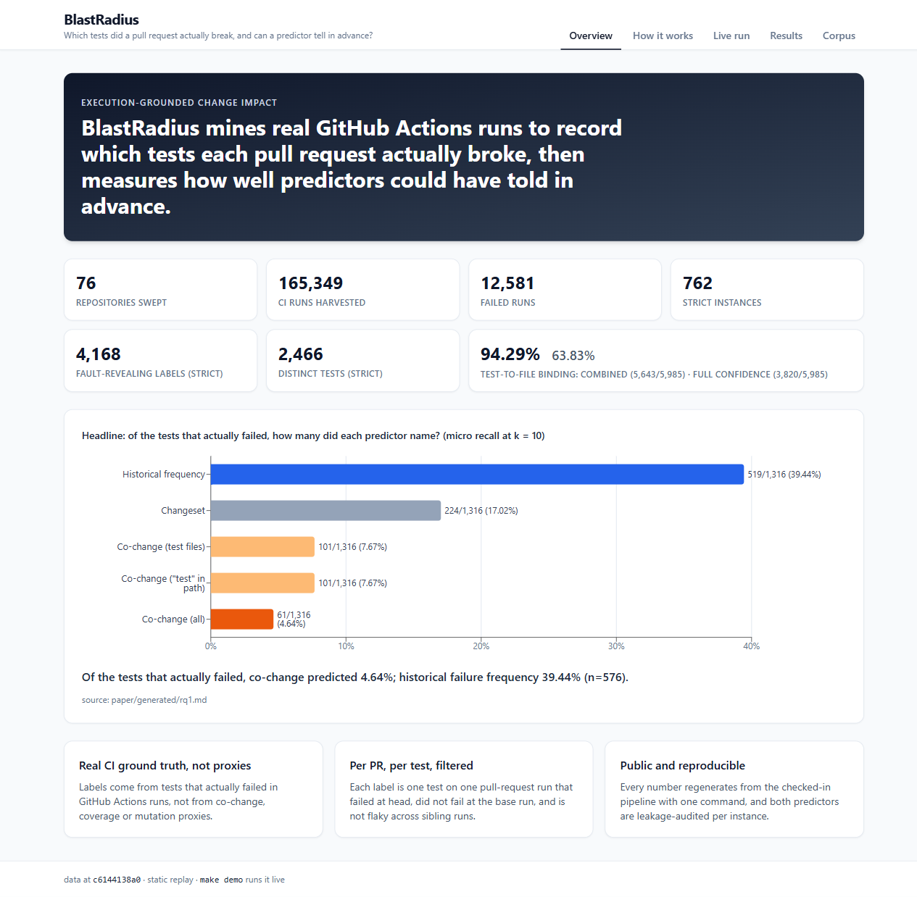
Fig. A.1 Demo site Overview tab: scale of the corpus and the headline RQ1 finding
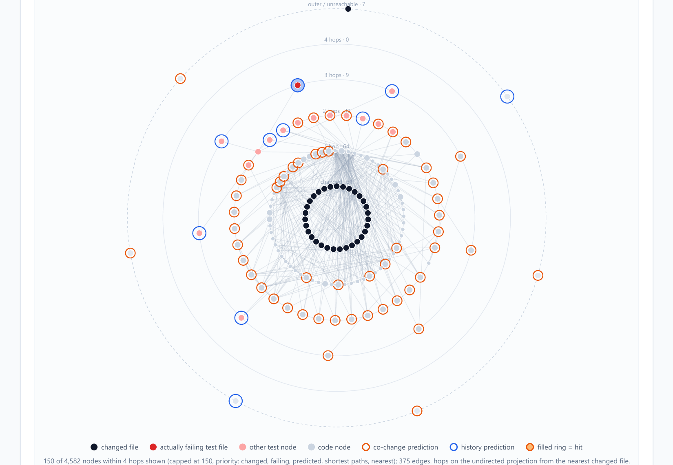
Fig. A.2 Demo site, Live run, stage 7: blast-radius picture of the change (changed files at the centre, rings by hop distance, failing test files in red, co-change picks in orange, history picks in blue)
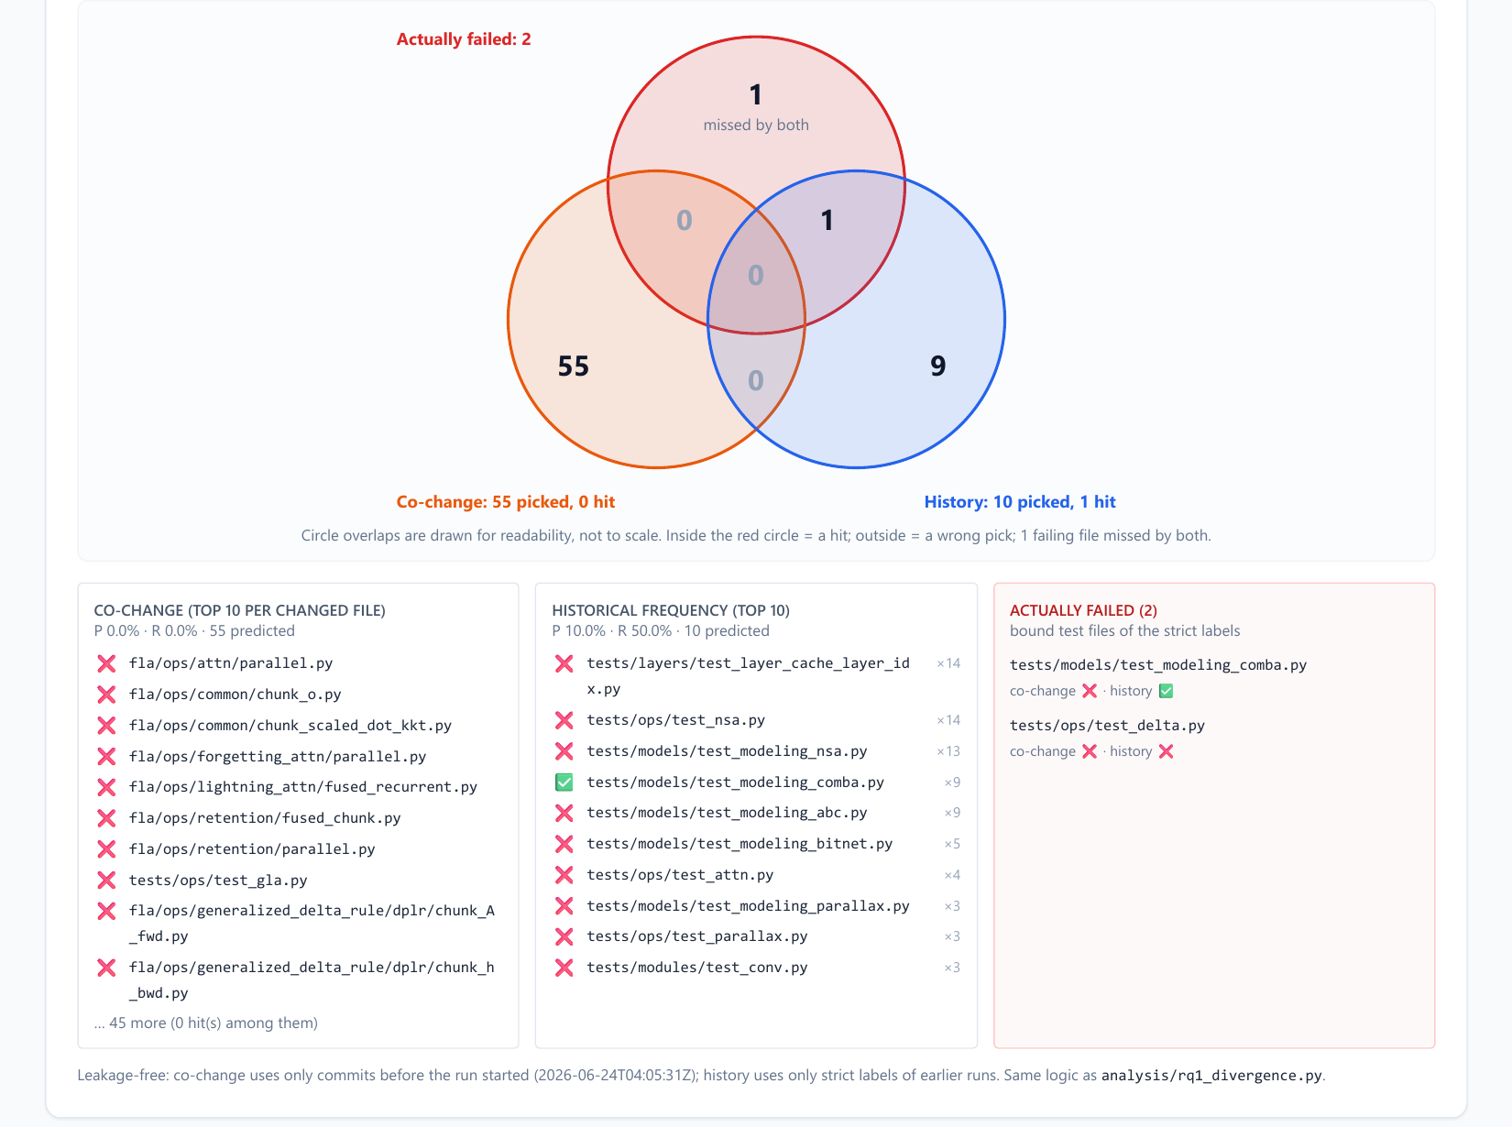
Fig. A.3 Demo site, Live run, stage 8: overlap of the failing test files with the co-change and historical-frequency picks, and the two prediction lists

