**SHUBHANGI JAISWAL**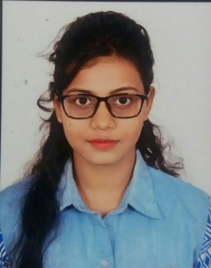

Address: E/14 M.P.H.B Colony Kanchghar, Jabalpur (M.P.)

Contact no: +91 8770263861 / 7697657504

Email: shubhangijaiswal47@gmail.com

# CAREER OBJECTIVE

To attain knowledge working with an organization which serves my desire to develop my skills and work with best of my knowledge and became an asset for the company and my career.

# EDUCATIONAL QUALIFICATION

|  |  |  |  |
| --- | --- | --- | --- |
| **Examination Passed** | **Board/ University** | **Percentage** | **Year Of Passing** |
| MASTER OF COMPUTER APPLICATION -  2020 batch | Gyan Ganga Institute of Technology and Sciences (RGPV) | 7.84(GRADE) | 2020 |
| BACHELOR OF COMPUTER APPLICATION | St.Aloysius College (RDVV) | 62.77% | 2018 |
| 12th | M.P Board | 63.08% | 2015 |
| 10th | M.P Board | 66% | 2012 |

# Trainings / Projects Undertaken:

|  |  |  |
| --- | --- | --- |
| **Name of Institute /Organization** | **Project Title** | **Duration** |
| Gyan ganga institute  Of technology and sciences | Feed Back Monitoring system | 6 month |
| St.Aloysius College | Hospital Management system | 4 months |
| St.Aloysius College | Jewellery Shop Management system | 4 months |
| St.Aloysius College | Live Website on ONLINE SHOPPING | 6 months |

# Certifications:

* **Certified course of WEB DESIGNING from Acrostic IT Solutions.**
* **Certificate of participation in ‘GLOBAL UNDERSTANDING’.**

# TECHNICAL SKILLS:

* Programming language: C, C++, java.
* HTML , CSS , Jscript , c# ,Mysql ,PHP.

# Personal Details:

* **Father’s Name : Mr. Sanjay Jaiswal**
* **Mother’s Name : Mrs. Poonam Jaiswal**
* **Date of Birth                        :      18 – FEB - 1996**
* **Gender                                  :      FEMALE**
* **Languages Known               : HINDI, ENGLISH**

# DECLARATION

I here by declare that the above information is true and to the best of my knowledge and in future if any information is found to be false then I shall be fully responsible for the consequences.

PLACE : Jabalpur SHUBHANGI JAISWAL

DATE :