Distribution

Q1. Imulate 30 rolls with =RANDBETWEEN(1,6). What is the probability of rolling a 3
Exactly 5 times (Hint: Use BINOM.DIST)
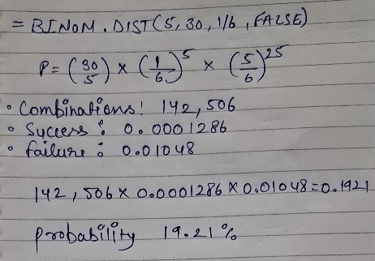
Ans1.

Q2.

