NAME - SHAMBHAVI CHAUKIYAL

21BAI10236

Consider shakes.txt and write regular expressions in Python to
A. Find words with inflectional morpheme as :
1. s
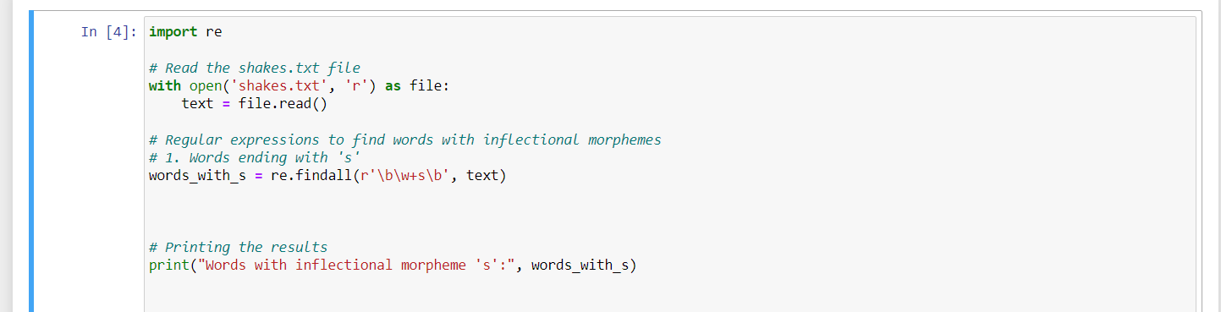
OUTPUT
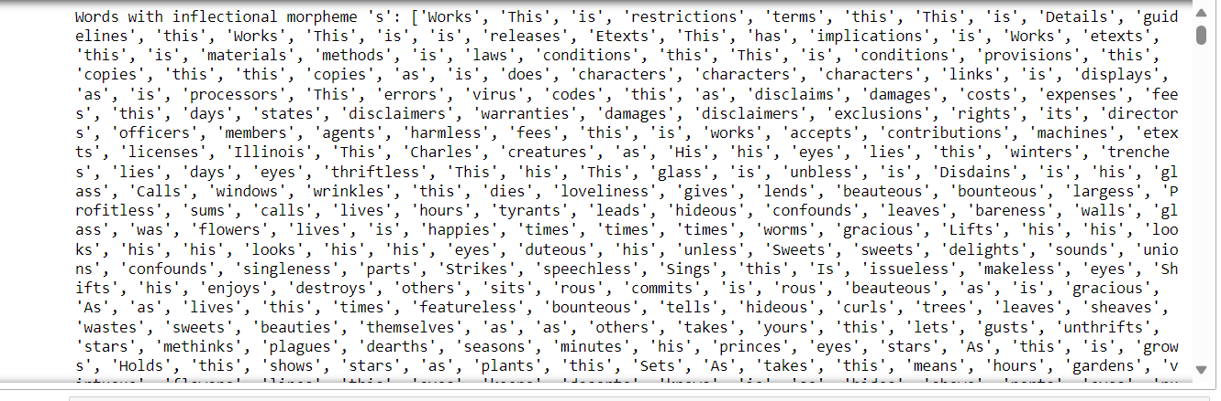

2. es

OUTPUT
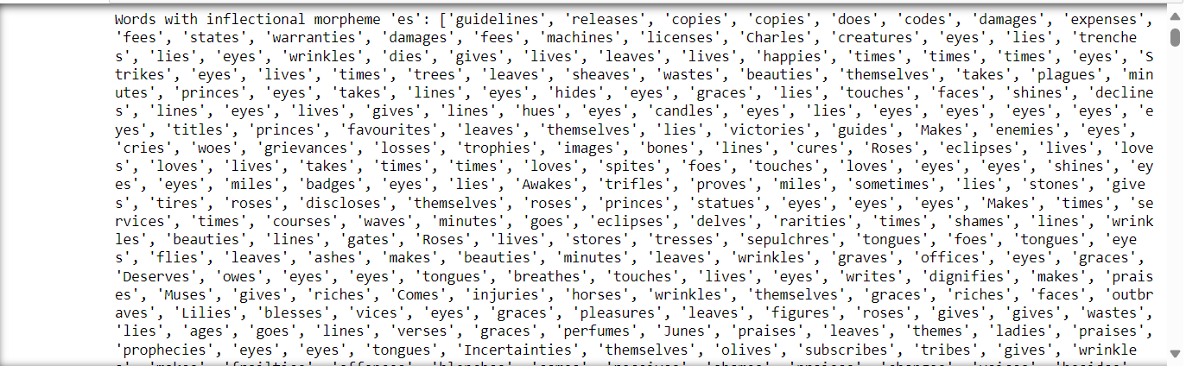
3. ing

OUTPUT
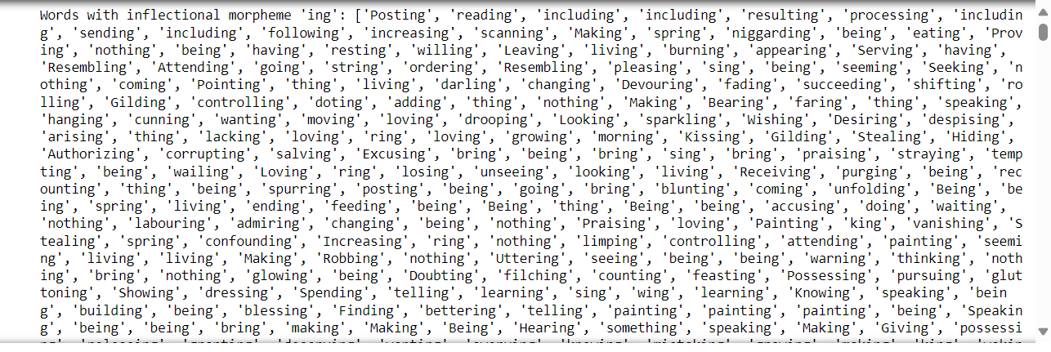
4 ed

OUTPUT-
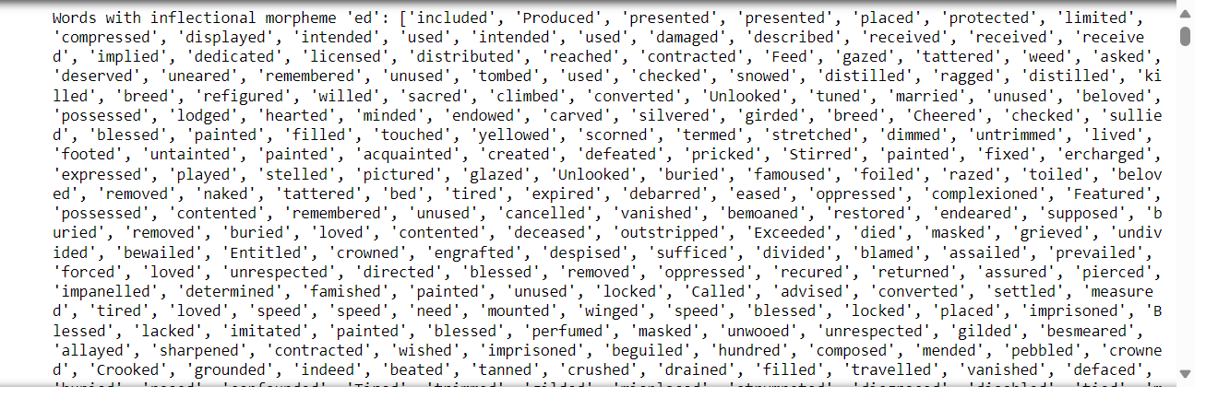

Find word pairs which are morphemes of each other in the file [For example woman-women, man-men, cut-cat, put-pat, put-cut]
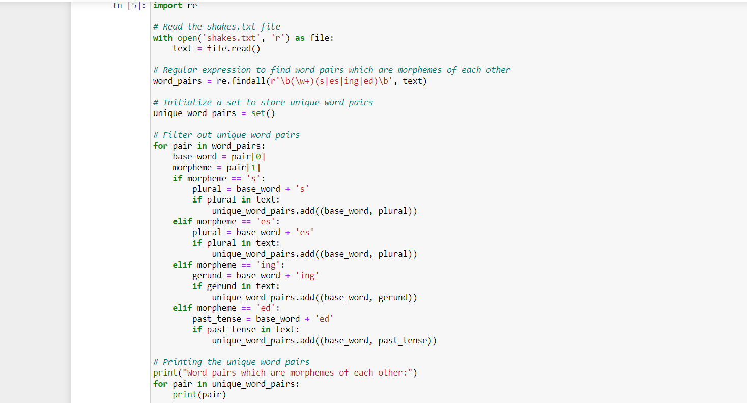

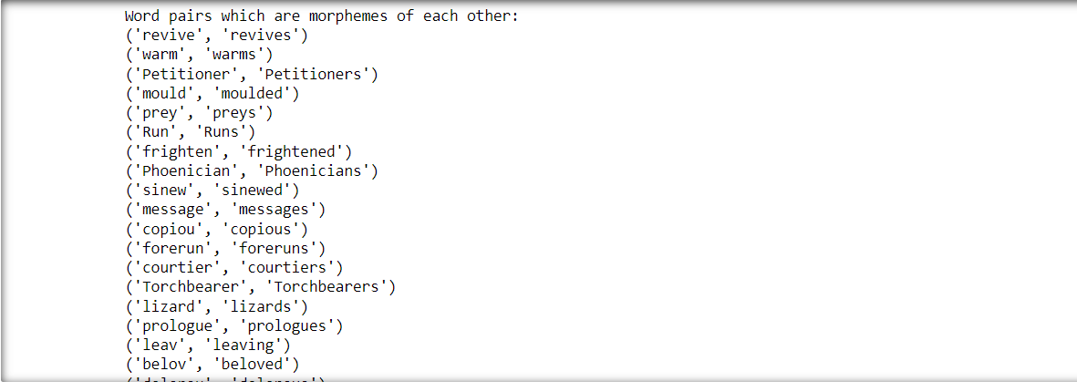
OUTPUT

