CIE
COPYRIGHT INFORMATION EXTRACTION FORM
TITLE : BudgetFlow
SCHOOL : Chitkara University, Rajpura, Punjab
Name : Divam Singh, Deepak Chandel, Gourav Goyal, Devansh Kaushal
Roll No/ Employee Code : 2210991526, 2210991481, 2210991584, 2210991494

All MEMBERS DETAILS INCLUDING SUPERVISOR
NAME | EMP CODE/ROLL | ADDRESS WITH EMAIL AND MOBILE NO.
Divam Singh | 2210991526 | Chitkara University Punjab, Rajpura, India-140401  divam1526.be22@chitkara.edu.in (8078119852)
Deepak Chandel | 2210991481 | Chitkara University Punjab, Rajpura, India-140401  deepak1481.be22@chitkara.edu.in (7807298700)
Gourav Goyal | 2210991584 | Chitkara University Punjab, Rajpura, India-140401  gourav1584.be22@chitkara.edu.in (8837622644)
Devansh Kaushal | 2210991494 | Chitkara University Punjab, Rajpura, India-140401  devansh1494.be22@chitkara.edu.in (8580807703)
Dr.Rajat Takkar (Mentor/Supervisor) | CET1004342 | Chitkara University Punjab, Rajpura, India-140401  Rajat.takkar@chitkara.edu.in (94670 26112)

ABSTRACT

1.1 Problem Background
Managing money has become more challenging in recent years because most transactions are now digital. People use UPI, debit cards, credit cards, online subscriptions, and shopping apps almost daily. Since payments happen quickly and frequently, it becomes difficult to keep track of how much is actually being spent. Many students and working professionals do not maintain proper records of their expenses. Some rely on memory, while others use different apps that do not show a complete financial picture. Over time, this leads to overspending and weak savings habits. A practical and easy system is therefore required to manage finances more clearly. Users may better see their spending habits and arrange their financial information in one location with the use of such a system. In the end, this promotes long-term financial stability and better financial discipline. In order to improve planning and decision-making, it also seeks to give users a comprehensive picture of their financial actions. A subscription site also makes it easier for users to monitor ongoing costs and steer clear of unforeseen fees. Better planning and tracking of everyday financial activities are made possible by the calendar page's time-based transaction view. These additional features make it easier for customers to keep organized and conscious of their financial obligations. All things considered, the system offers a more thorough and effective method for managing personal finances.

1.2 Objective of the Project
The objective of BudgetFlow is to build a web-based application that helps users track income and expenses in one place, set spending limits, and understand their financial condition in a simple and organized way. it seeks to give consumers a comprehensive picture of their financial transactions in order to facilitate improved planning and decision-making. By providing data in an understandable way, the technology also seeks to improve financial transparency. It also assists users in spotting spending trends and places where costs might be cut. In the end, the software helps users establish sound financial practices and long-term financial security. To manage recurrent costs and track financial activity over time, the system also has calendar and subscription tools. By using the subscription option, consumers may monitor their regular payments and prevent missing deadlines. The calendar display aids users in keeping an organized eye on daily, weekly, and monthly financial transactions. Together, these characteristics improve general money management and raise financial knowledge. Because of its user-friendly design, people may readily incorporate the system into their daily life.

1.3 Proposed Solution / System Overview
BudgetFlow is designed as a centralized platform where users can enter their daily transactions without complication. Instead of switching between different tools, users can manage everything within a single system. Expenses are grouped into categories, and monthly budgets can be set based on user preference. The application provides a basic dashboard that displays income, expenses, and remaining balance in visual form so that users can quickly understand their financial position. The system includes user login functionality, transaction storage, budget monitoring, and data presentation features that work together to create a smooth experience. Additionally, it guarantees quick access to financial records at all times and data consistency. Furthermore, future improvements and the incorporation of more sophisticated financial analysis functions are made possible by the platform's scalable design.

1.4 Key Features or Functionality
• User registration and secure login
• Add, edit, and delete transactions
• Categorization of expenses
• Monthly budget setting
• Graphical financial summaries
• Auto-reminders before due date
• See all transactions for that day

1.5 Technology / Method Used
• Frontend: React.js
• Backend: Node.js, Express.js
• Database: MongoDB
• APIs used for communication between frontend and backend

ER Diagram:-

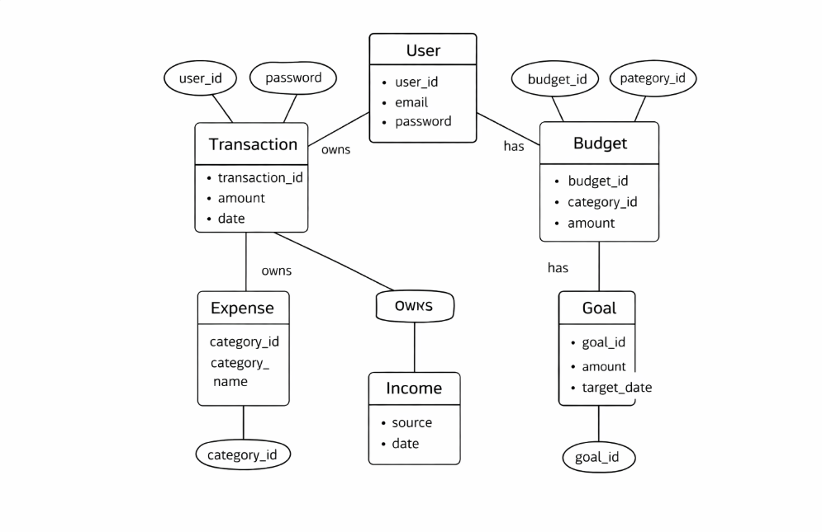

1.6 Expected Outcome & Benefits
BudgetFlow aims to improve financial awareness by helping users clearly see where their money goes. By regularly tracking expenses, users can make better decisions, reduce unnecessary spending, and improve savings habits. It allows users to create financial objectives and track their success over time. The system also offers insights that make it easier to spot spending trends and make better financial decisions. By displaying data in an easy-to-understand graphic style, the application also seeks to improve financial transparency. Additionally, it helps users reach their long-term financial objectives and maintain regular budgeting practices. Better control over recurring payments and time-based financial tracking are made possible with the addition of subscription and calendar functionality. These tools make sure consumers are aware of impending costs and don't forget to make crucial payments. All things considered, the approach encourages improved financial self-control and effective money management in day-to-day living.

1.7 Original Contribution Statement
The project provides a straightforward and practical budgeting tool that focuses on usability and real-world financial management needs. By providing an easy-to-use interface, it aims to make financial tracking easier for consumers. By giving users precise insights into their income and expenses, the system improves spending habits. Additionally, by creating a budget and keeping a close eye on it, it promotes financial discipline. The project's overall goal is to increase everyday users' access to and efficiency with personal finance management. For improved financial organization, it also has calendar and subscription features. These enhancements make it easier for customers to keep track of upcoming payments and manage recurrent spending. Planning and control are enhanced by the calendar view, which offers a transparent timeline of financial operations. For simplicity, the system is built to integrate many financial tools into a single platform. All things considered, it improves the user experience by making finance management more organized and effective.

1.8 Result

Signup Page:

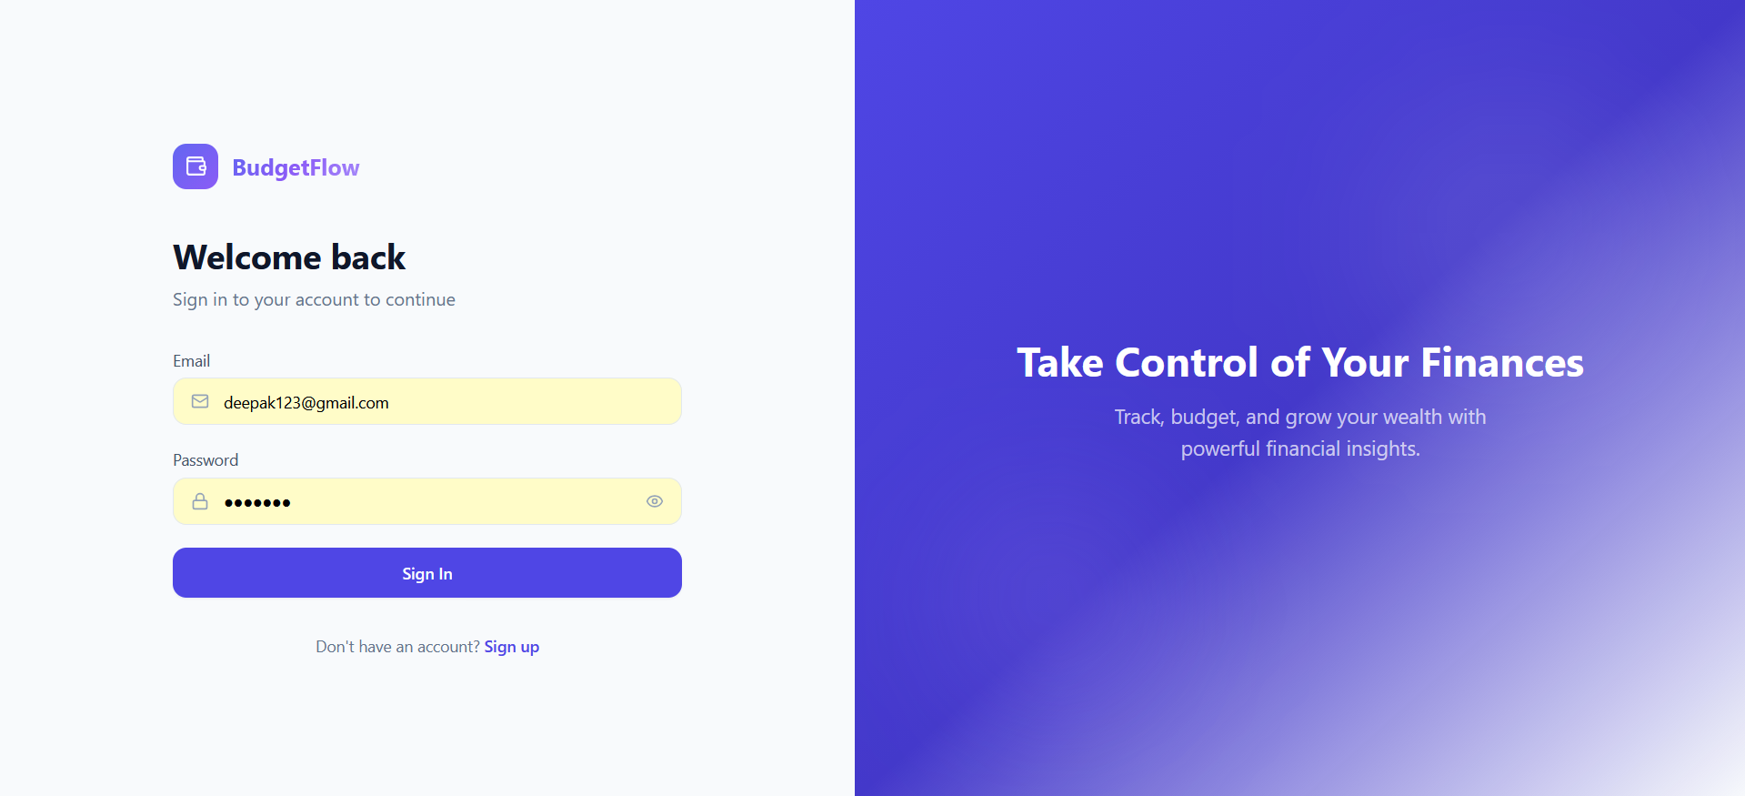

Home page:

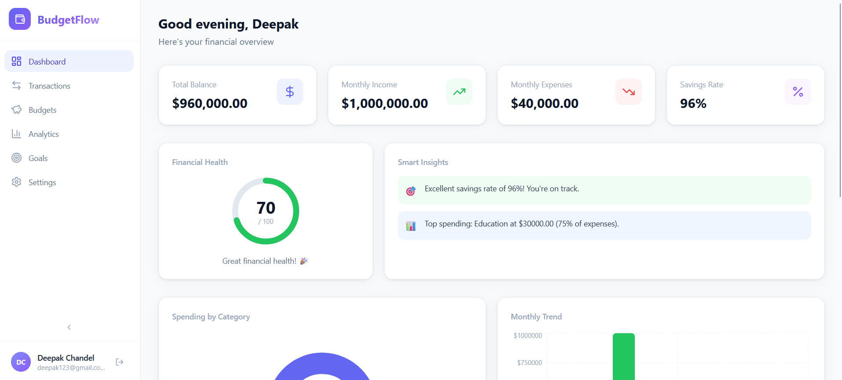

Transaction page:

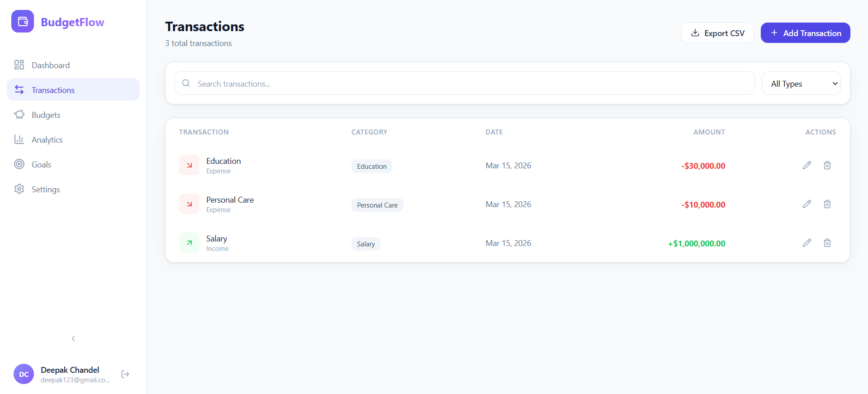

Subscription page:
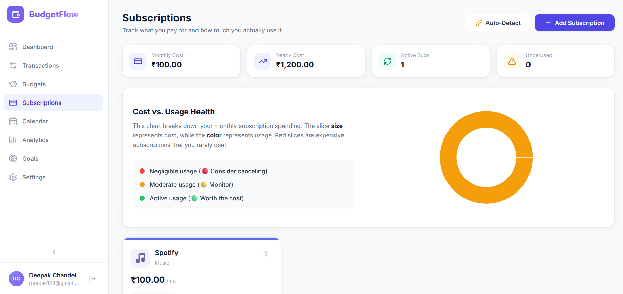

Calendar page:
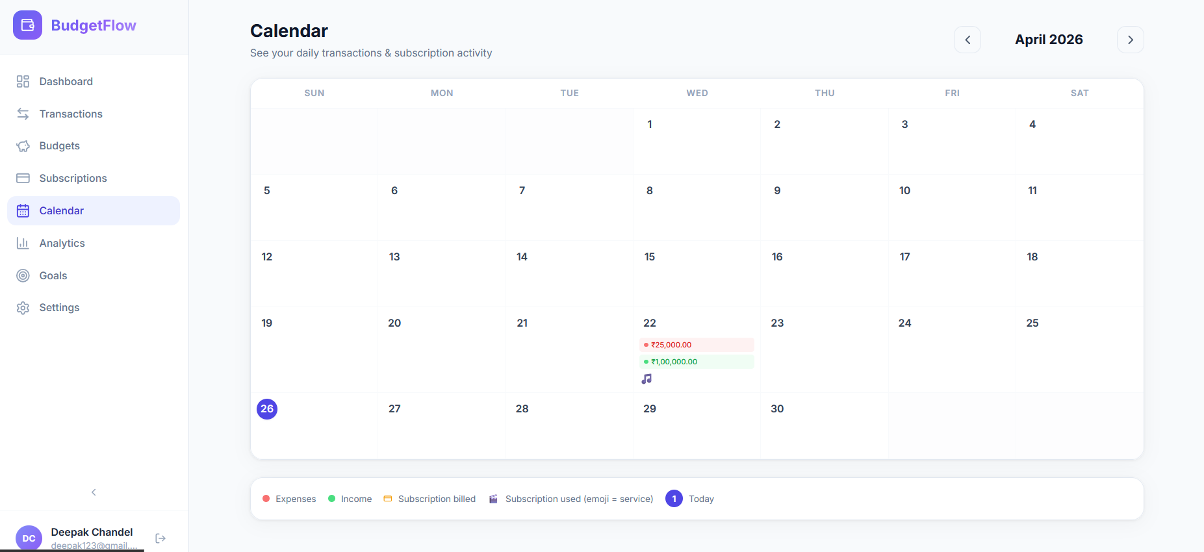

Analytics page:
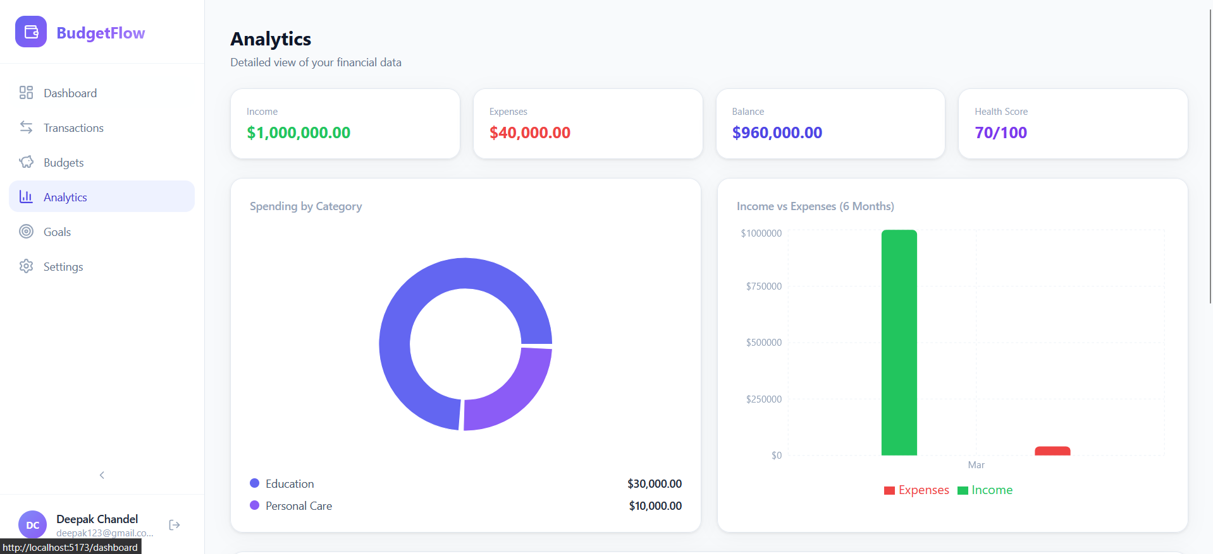

Setting page:
